

**Gender Recognition From Bangla Handwritten Dataset**

**Project Work**

**By**

**Sudipta Das (A01-1112-117-005-2018)**

**Koustav Bal (A01-1112-117-026-2018)**

**Debarpan Goswami (A0 1-1112-117-009-2018)**

**Under the supervision of Dr. Chayan Halder**

**Department of Computer Science**

**Ramakrishna Mission Vivekananda Centenary College**

**Rahara, Kolkata - 700118**

**DECLARATION**

We the undersigned solemnly declare that the project report **Gender Recognition from Bangla Handwritten Dataset** is based on our own work carried out during the course of our study under the supervision of **Dr. Chayan Halder** for partial fulfillment of the requirements for awarding of the degree of Bachelor of Science (B.Sc.) is a record of the project work carried out byus.We assert the statements made and conclusions drawn are an outcome of our project work. We further declare that the work contained in the report is original and has been done by us under the general supervision of our supervisor. The work has not been submitted to any other Institution for any other degree/diploma/certificate or in this university or any other University of India or abroad. We have followed the guidelines provided by the Institution in writing the report. Whenever we have used materials (data, theoretical analysis, and text) from other sources, we have given due credit to them in the text of the report and given their details in the references.

Sudipta Das Koustav Bal Debarpan Goswami

(A01-1112-117-005-2018) (A01-1112-117-026-2018) (A01-1112-117-009-2018)

**CERTIFICATE**

I hereby certify that the Project titled “Gender Recognition from Bangla Handwritten Dataset” which is submitted by Sudipta Das (A01-1112-117-005-2018), Koustav Bal (A01-1112-117-026-2018), Debarpan Goswami (A01-1112-117-009-2018), for partial fulfillment of the requirements for awarding of the degree of Bachelor of Science (B.Sc.) is a record of the project work carried out by the students under my guidance and supervision. To the best of my knowledge, this work has not been submitted in any part or fulfillment for any Degree or Diploma to this University or elsewhere.

Place: Rahara

Date:

**Dr.** **Chayan Halder**

**(SUPERVISOR)**

Department of Computer Science

RAMAKRISHNA MISSION VIVEKANANDA CENTENARY COLLEGE



**(External Examiner(s))** **(External Examiner(s))**

**Acknowledgement**

We gratefully acknowledge our respected Principal Maharaj for giving inspiration and motivation. We are grateful to our advisor, **Dr. Chayan Halder,** Assistant professor, Department of Computer Science, **Ramakrishna Mission Vivekananda Centenary College**, Kolkata-700118 for his guidance on the related area of this Project work and continuous support.

We are also very much thankful to all our respected teachers, whose valuable teaching and research ideas have continuously motivated me. I am also thankful to all other respected staff members of our department. Finally, my deepest admiration goes to my parents for their all-out support throughout my life.

Sudipta Das Koustav Bal Debarpan Goswami

(A01-1112-117-005-2018) (A01-1112-117-026-2018) (A01-1112-117-009-2018)

**CONTENTS**

**1. Abstract**

**2. Introduction**

**3. Objective**

**4. Motivation**

**5. Related Works**

**6. Dataset**

**7. Methodology**

**7.1 The architecture of an artificial neural network**

**7.2 Network Architecture (Our proposed Neural Network is MLP)**

**7.3 Multilayer Perceptions or MLP**

**7.4 Visualization of Our Proposed Methodology**

**7.5 Dataset preparation with image Interpolation**

**7.6 Training Model**

**8. Results and Discussion:**

**8.1 (Experiment 1)-Training with Tanh Activation function**

**8.2 (Experiment 2)-Training with ReLu activation**

**9. Conclusion and Future Scope**

**10. References**

**1.Abstract:-**

Handwriting-based gender classiﬁcation is a well-researched problem that has been approached mainly by traditional machine learning techniques. In this paper, we propose a basic artificial neural network which is implemented by the Multilayer Perceptron approach.We have used a considerably small dataset which is a part of a relatively bigger dataset to reach some encourageable results.We have conducted two experiments to understand the contrast between the convergence of the two experiments.

**2.Introduction:-**

Gender classiﬁcation by handwriting analysis is a well-research subject, assuming that one’s gender can be predicted based on their handwriting style. Though there has been a considerable amount of research on this subject, it is still considered a challenging problem. In fact, neither computed analysis nor human beings have achieved high accuracy results for this task yet.

The basic assumption is that various demographic properties can be learned by studying the unique and distinctive features of a person’s handwriting, for example, gender, handedness ( whether the person is left/right-handed), age , nationality, etc. Indeed, human handwriting is used to examine and investigate human characteristics in many fields of applications, such as mail sorting, bank check veriﬁcation, personality proﬁling, historical document analysis, and criminological/forensic investigations.

Most of the recent techniques to gender classiﬁcation from handwritten dataset have grown mainly around the similar a little datasets,like the training and testing of these functions have been conﬁned typical to a handful dataset, like the Devanagari Characters Dataset, KHATT datasets.

Basically, we present a gender classiﬁcation method using Multilayer Perceptron(MLP), which is respectively easy and eﬃcient. We have used a part of a large and diverse dataset, the EKUSH offline dataset which consists of 120 different characters from the Bangla language collected from **1500** various writers.

**3.Objective:-**

The objective of this project is to determine whether the gender of the writer is male or female or the original one that he or she claims.

**Motivation:-**

The motivation in this paper is mainly twofold:

(1) Propose an improved gender classiﬁcation method.

(2) It has potential in the field of forensics to detect forgery and fraud.

**5. Related Works:-**

Several machine learning techniques have been applied during the past two decades to the handwriting gender classification task. These approaches are based typically on feature extraction and training classifiers; see Table 1 below (extended from Gattal et al. [10]), for an overview. Cha et al. [8] trained an artificial neural network (ANN) in order to classify demographic sub-categories (such as gender, handedness, and age group) by using their own uppercase letter dataset. Later, they extended their work [5] to train a feed-forward neural network for feature extraction and classification, using enhancement techniques as bagging and boosting. Their improved gender classifier achieved an accuracy rate of 77.5% using 800 writing samples for training and 400 samples for testing. Liwicki et al. [13] applied support vector machines (SVM) and Gaussian mixture models (GMM) to gender classification on the IAM-OnDB handwriting dataset. Their classifier achieved accuracy rates of 62% and 67%, respectively, using SVM and GMM. Youssef et al. [21] proposed using wavelet domain local binary patterns (WDLBP) to train several SVM classifiers on both English and Arabic handwritings. Their classifier achieved an accuracy rate of 74.3% on (a subset of) the QUWI dataset. Al-Maadeed et al. [4] proposed using geometric features to classify age, gender, and nationality. Their proposed method applies random forests and kernel discriminant analysis for both text-dependent and text-independent classifications (i.e., same/different texts, respectively, of different writers are used for training and testing). Their classifier achieved an overall accuracy of 73% on the QUWI dataset. Bouadjenek et al. [6] proposed extracting local descriptors, such as histogram of oriented gradients (HoG), local binary patterns (LBP), and grid features for offline handwriting, and then classifying them by SVM. Their method achieved an accuracy rate of 74% on the IAM offline dataset. Likewise, Bouadjenek et al. [7] used local descriptors, such as gradient local binary patterns (GLBP) and HoG to train an SVM classifier to predict age, gender, and handedness. Their classifier achieved accuracy rates in the range of 69%–74% on the IAM-OnDB and KHATT datasets. Similarly, Siddiqi et al. [20] enhanced handwriting features by computing local and global features (e.g., inclination, texture, curvature, legibility, etc.), which are then used in ANN and SVM classifiers to distinguish between genders. Their classifier achieved accuracy rates of 68.75% and 73.02%, respectively, on the QUWI and MSHD datasets. Mirza et al. [16] concentrated on the visual appearance of handwriting to investigate its effect on a writer’s gender. They extract textural information by applying a bank of Gabor filters to handwriting images from the QUWI dataset. They then use the mean and standard deviation of each handwriting plus its Fourier transform as input features for a feed-forward neural network. Their classifier achieved an accuracy rate of 70% on the QUWI dataset. Akbari et al. [2] extracted a feature vector based on a series of wavelet subbands quantized to produce a probabilistic finite state automaton. This feature vector is then used to train ANN and SVM classifiers on the QUWI and MSHD datasets, and perform text-dependent and text-independent, as well as script dependent and script-independent classifications (i.e., same/different languages, respectively, used for training and testing). They also introduced cross-database evaluations. To enhance accuracy rates on the gender task, Ahmed et al. [1] used bagging, voting, and stacking of various classifiers based on some of the textural features mentioned earlier. They achieved accuracy rates in the range of 79%–85% on (a subset of) the QUWI dataset. Gattal et al. [10] proposed using textural information from handwriting as the discriminative attribute between genders. They used image binarization and oriented basic image features. Their classifier achieved accuracy rates of 71%, 76%, and 68% on the QUWI dataset, according to the protocols of ICDAR 2013, ICDAR 2015, and ICFHR 2016, respectively. Finally, Morera et al. [17] were the first to apply a deep CNN for classifying a writer’s demographics. They proposed the same architecture for both gender and handedness, as well as an architecture for the combined 4-class problem. Their gender classifier achieved accuracy rates of 80.72% and 68.9%, respectively, on the IAM-OnDB and KHATT datasets. To summarize, most of the surveyed methods exploit knowledge about the domain to extract certain features from the above datasets, and then train a machine learning module to classify these extracted features. In contrast, we present in this work a deep learning module, which performs essentially automated feature extraction and classification, in a rather simple and efficient manner (requires no tedious preprocessing, and is far less complex than the system reported, e.g., by Morera et al. [17]).

**6. Dataset-**

We have prepared two sets of which one is the training set and another is the test set.The train set consists about 70% of the images of each writer and the test set has about 30% the images of each writer. We are using Ekush Offline dataset downloaded from [23]. All the images were pre-labelled so external labeling was not required.

An example of our sample image:-



*Fig-1:Showing a sample image from the Ekush dataset*

Our proposed dataset, the ‘Ekush offline handwritten Bangla Dataset’ contains 1500 male handwriting samples and 1500 female handwritten samples. Each participant received a standard form, and was asked to write a letter in Bangla without any writing restrictions (e.g., pen type, pressure, etc.). In addition, each character was asked to provide gender.

Now as our system requirements are not fit for handling such a huge dataset so we shrunk the data and made our own dataset(unlabelled) which comprises of 30830 images in the form of filename maleDigits.csv and femaleDigits.csv which can be accessed from [24] and [25] respectively.The images are converted into pixel data with each of size 783 so that it will be easier to feed the MLP model for classification.

**7. Methodology:-**

**ReLU (Rectified Linear Unit) Activation Function**

**Activation Function**-A Neural Network consists of layers of nodes which learn to map examples of inputs to outputs through the hidden layers of different levels.For a given node,the inputs are multiplied by the weights in the node and summed together.This value is known as the summed activation functions.The summed activation is then transformed via an activation function and defines the specific output or activation of the node.

**ReLU**-It is referred to as the simplest activation function where no transformation is required at all.It is highly used as a network which comprises linear activation functions that are very easy to train,but on the other hand cannot learn complex mapping functions.  
However,this function is widely used in the output layer for networks that predict a quantity (like regression problems)

The ReLU is a simple calculation that returns the value provided as input directly, or the value 0.0 if the input is 0.0 or less than 0.0.

The function is linear for values greater than zero,meaning it has a lot of desirable properties of a linear activation function when training a network using backpropagation.

Because the Relu is linear for half of the input domain and non-linear for the other half it is referred to as the piecewise function of a hinge function.

**Advantages of using ReLU-**

Computational Simplicity-The rectifier function is easy to implement which only requires a max() function.Representational Sparsity-An important benefit of this function is that it can output a true zero value.Linear Behavior-The rectifier function mostly looks and acts as a linear activation function.

**Tanh or Hyperbolic Tangent Activation function:**Tanh is also similar to sigmoid activation function but better.The range of Tanh is from (-1 to 1)

Tanh is also a sigmoidal (S-shaped)

**Advantages of using Tanh activation function are:**

The negative outputs will be mapped strongly negative but the zero inputs will be mapped zero in the tanh graph.The function is differentiable.The function being monotonic whereas its derivative is not monotonic.The tanh function is basically used for classification between two classes.Hence we use it for training our model.

**7.1 The architecture of an artificial neural network:**

To understand the concept of the architecture of an artificial neural network, we have to understand what a neural network is made of. In order to define a neural network that consists of a large number of artificial neurons, which are termed units arranged in a sequence of layers. Let us look at various types of layers available in an artificial neural network.

**Artificial Neural Network primarily consists of three layers:**

**Input Layer:** It accepts inputs in several different formats provided by the programmer.

**Hidden Layer:** This layer presents in-between input and output layers. It performs all the calculations to find hidden features and patterns.

**Output Layer:** The input goes through a series of transformations using the hidden layer, which finally results in output that is conveyed using this layer.

The artificial neural network takes input and computes the weighted sum of the inputs and includes a bias. This computation is represented in the form of a transfer function.

What is Artificial Neural Network

It determines the weighted total is passed as an input to an activation function to produce the output. Activation functions choose whether a node should fire or not. Only those who are fired make it to the output layer. There are distinctive activation functions available that can be applied upon the sort of task we are performing.

**7.2 Network Architecture (Our proposed Neural Network is MLP)**

A neural network is a series of algorithms that endeavors to recognize underlying relationships

in a set of data through a process that mimics the way the human brain operates. In this sense,

Neural networks refer to systems of neurons, either organic or artificial in nature.

ANN basically is a computational model designed which consists of several processing elements that receive inputs and deliver outputs based on their predefined activation functions(In this model like we are using Tanh and ReLU).

**7.3 Multilayer Perceptions or MLP:**

These are the classical type of neural network.They are always composed of one or more layers of neurons.Here, data is fed to the input layer,there can be one or multiple hidden layers which help provide abstraction following the predictions which are made in the output layer.

MLPs are suitable for classification problems where inputs are assigned a class and are categorically labeled.

They are also suitable for regression problems where a real valued quantity(here gender classification) is predicted with a given set of inputs.

MLP is considered to be very flexible and can be used to make it learn a mapping from inputs to outputs.

MLPs are really feasible for tabular datasets(both images and text).

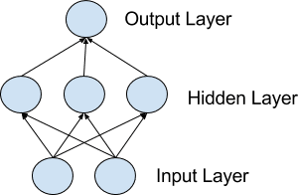

*Fig2-The simple structure of an MLP*

*Image link:* [*https://machinelearningmastery.com/wp-content/uploads/2018/04/Network.png*](https://machinelearningmastery.com/wp-content/uploads/2018/04/Network.png)

**7.4 Visualization of Our Proposed Methodology**

We have designed the visualization of our proposed methodology in two ways: after preprocessing and normalizing the image data samples from the database, we have split the entire database into a train set,test set. We have used the train set to train the model with handwritten Bangla text images, and finally we have used the test set to test the model predictions on unseen data.

Our proposed writer identification system from handwritten Bangla text images, can be visualized as follows

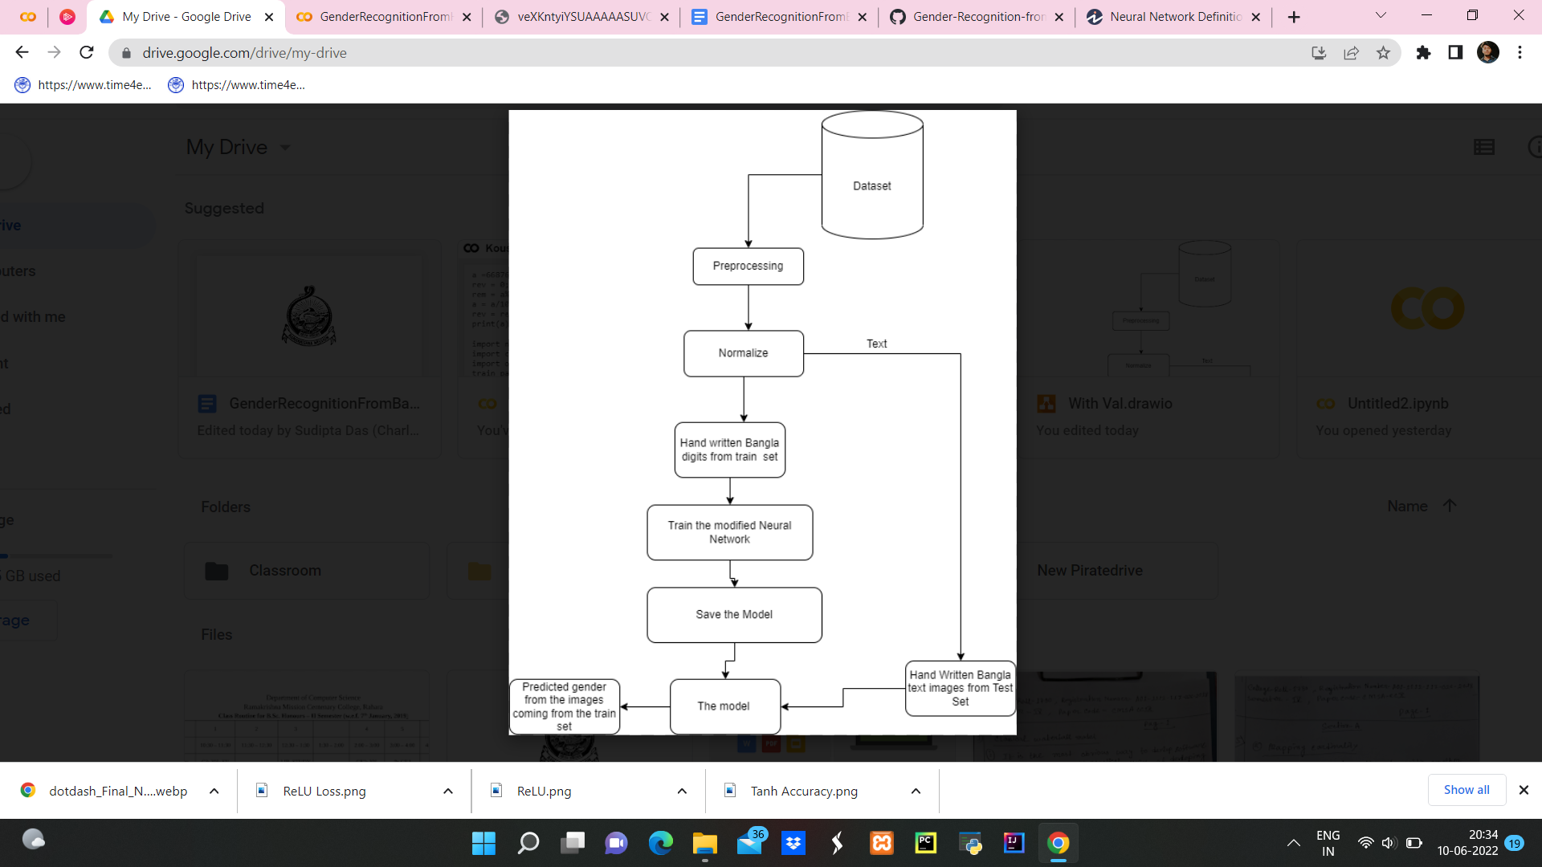

*Fig-3:This figure shows the flowchart*

**7.5 Dataset preparation with image Interpolation:**

Preparing datasets, e.g. train set, test set and validation set from a large database is a very important task. The performance of a deep learning model is directly related to the quality of the data by which the model is being trained. Before splitting into train set, validation set and test set we have first preprocess the handwritten bangla text images. In the preprocessing step we have only done the resize operation on the images. The images from the database have a variety of shapes (e.g. 2480X2036). Our task was to convert all these variable shapes into one standard input image shape to train, test and validate the deep learning model. We have chosen the target

image size as 256X256(because our model accepts an image as input of size 256X256).But when we were trying to directly resize the images from their original size(e.g. 2480X2036) to the target size(256X256) the handwritten images were distorted.

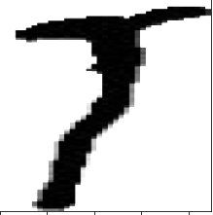

*Fig-4:Distorted Image before resizing*

In fig-4 an example of a distorted image is shown. With these types of distorted images of the handwritten Bangla text images our model is unable to extract features automatically from the image and for this reason the model will be unable to learn the pattern of the handwriting for a particular writer. To eliminate the occurrence of distortions after resizing the images, we have used image interpolation method. Image interpolation tries to achieve a good approximated value for a pixel’s intensity based on neighboring pixel values [22]. The image interpolation technique basically tries to approximate the best pixel value for a particular pixel after resizing the image to avoid the visual loss of the image. We have used a special type of image interpolation algorithm known as area interpolation to resize our images. In figure 8 the result we got after performing the area interpolation is shown.

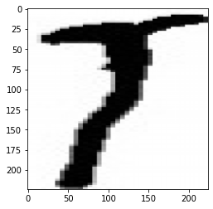

*Fig5 :Image after interpolation*

After performing area interpolation we got a much better result which is shown in fig-5. That is why we have used the area interpolation method to resize all other handwritten bangla text images from the database.

After the preprocessing task(only resizing the images) we have normalized all images of the database. Normalization is a process which changes the pixel intensity values(in the case of image data) and ensures that each input data has a similar data distribution which helps our deep learning model to learn the pattern of the handwritten text faster.

In a research work done by Sola et al. [23], the authors have found that input data normalization with certain criteria before the training process is very useful to obtain a good result and also significantly fasten the calculations. This paper [23] shows how data normalization plays a very crucial role in improving the results of a model to predict the value of several variables of a PWR nuclear power plant.After the normalization process completes we split our entire database into two parts.

The Ekush dataset provides annotated data for the problem and now has a total of 30803 data samples.The training and testing samples are divided in 90:10(which means 90% is in the train set and 10% test set).

Input Dimension: Size of Image: 28 x 28

Output Dimension:

**7.6 Training Model:**

For this particular project we have used different hyperparameters like- *batch size,number of iterations,learning rate,optimizer, etc* to give best results.

We have conducted two experiments with variations in hidden layers,activation functions(Tanh,ReLU),learning rate and epoch.

Our model basically takes in each data and categorically labels them.Then after the normalization process the dataset is split into training and test sets,where 27747 data out of 30830(roughly 90%) is sent to train set and about 3083 data left is sent to the test set(the rest 10%.

After this we used SGD(Stochastic gradient descent) optimizer while calculating the number of epochs needed by the formula:

. $Epochs=iterations÷ \frac{totaldata}{minibatch}$

Then we are going to conduct two experiments one by one and see the accuracy and loss curves in both cases and in contrast to both we will judge which functions converge to the result with less loss count.

**8. Results and Discussion:**

**8.1 (Experiment 1)-Training with Tanh Activation function**

For this experiment the hidden layer number is brought down to one and Tanh activation function is used with 128 neurons. This gives an accuracy of 57.9630 . For this particular set of

problems, the learning rate has shown no effect as 0.0001 is used here but no promising increase is shown.

The total data is 30830, batch size 100. Iterations 40000, Learning rate 0.0001. The optimizer we have used is SGD, number of hidden layer 1, and the activation function is Tanh.

The results of our first experiment are shown in the table below with contrast with the second experiment.

$Epochs=40000 ÷ 27747 / 100 =144.15$

Accuracy: 57.9630 and the Loss: 0.6897

The accuracy and loss curves are shown as the following:

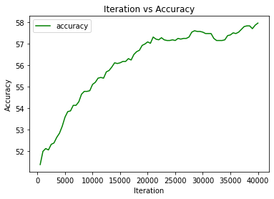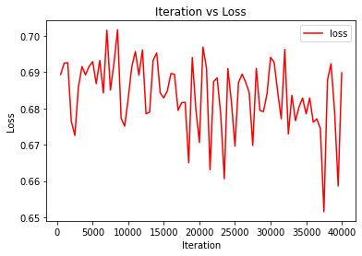

*Accuracy Curve Loss Curve*

**8.2 (Experiment 2)-Training with ReLU activation**

For this experiment the hidden layer number is brought down to one and Tanh activation function is used with 128 neurons. This gives an accuracy of 61.9850 . For this particular set learning rate has shown no effect as 0.001 is used here but no promising increase is shown.

The total data is 30830, batch size 128. Iterations 40000, Learning rate 0.001. The optimizer we have used is SGD, and the activation function is ReLU,number of hidden layers 1.

The results of our second experiment are shown below in the table with contrast to the first exp.

$Epochs= 40000 ÷ 27747/100 = 144.15$

Accuracy: 61.9850 and the Loss: 0.5941

The accuracy and loss curves are shown as the following:

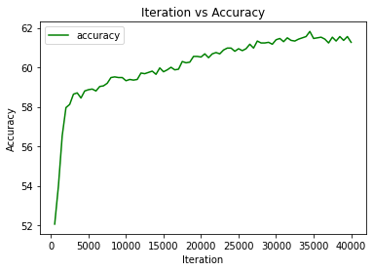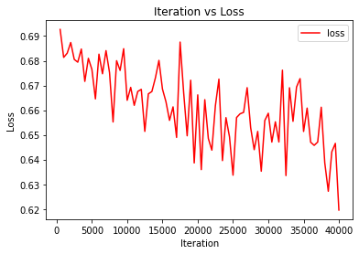

*Accuracy Curve Loss Curve*

| **Hyperparameters** | **Experiment Setup No.1** | **Experiment Setup No.2** |
| --- | --- | --- |
| Batch Size | 100 | 100 |
| No.of iterations | 40000 | 40000 |
| Epochs | 144 | 144 |
| Learning Rate | 0.0001 | 0.001 |
| No.of hidden neurons | 128 | 128 |
| Activation Function | Tanh | ReLU |
| Optimizer | SGD | SGD |
| Accuracy | 57.9630 | 61.9850 |

Table representing a comparative study between two experiments

**9. Conclusion and Future Scope:**

In this project we have propounded a simple neural network based on Multilayer Perceptron for Gender Recognition from handwritten bangla text images. We have devised a simple neural network architecture as per our requirements for the gender recognition task. For this project we have used an offline dataset called The Ekush Dataset.Then keeping in mind our systems specs we have shrunk the dataset into a dataset containing 30830 images only that too in the tabular pixel format so that it would be easy to feed it to the MLP.We have done preprocessing and normalization on handwritten bangla text images from the database. To select the model with optimum accuracy we have conducted 2 different experiments on our model both of the experiments are unique in their own way. The accuracies we have got from these 2 experiments are 57% and 61% respectively.

In the future to make our Gender Recognition model more resilient,we will make the gender recognition model on level. Extracting valuable features automatically from a full document of handwritten Bangla letter image is a very challenging task for the MLP model due to the complexity of the Bangla script as Bengali itself is a semantic language.

To make a good gender recognition system we may also design a CNN (Convolutional Neural Network and modify it’s layers to extract the features of our images more efficiently and give a justifiable output in the output layer which is also known as softmax.We have to also develop a way to handle the actual size of the Ekush dataset so that we can work with the whole data in order to enhance our accuracy and reduce the loss of data.

**10. References:**

[1] Ahmed, M., Rasool, A.G., Afzal, H., Siddiqi, I.: Improving handwriting based gender classification using ensemble classifiers. Expert Syst. Appl. 85, 158–168 (2017)

[2] Akbari, Y., Nouri, K., Sadri, J., Djeddi, C., Siddiqi, I.: Wavelet-based gender detection on off-line handwritten documents using probabilistic finite state automata. Image Vis. Comput. 59, 17–30 (2017)

[3] Al Maadeed, S., Ayouby, W., Hassa¨ıne, A., Aljaam, J.M.: QUWI: An Arabic and English handwriting dataset for offline writer identification. In: International Conference on Frontiers in Handwriting Recognition, pp. 746–751. IEEE (2012)

[4] Al Maadeed, S., Hassaine, A.: Automatic prediction of age, gender, and nationality in offline handwriting. EURASIP J. Image Video Process. 2014(1), 10 (2014)

[5] Bandi, K.R., Srihari, S.N.: Writer demographic classification using bagging and boosting. In: Proceedings of the 12th International Graphonomics Society Conference, pp. 133–137 (2005)

[6] Bouadjenek, N., Nemmour, H., Chibani, Y.: Local descriptors to improve off-line handwriting-based gender prediction. In: 6th International Conference of Soft Computing and Pattern Recognition, pp. 43–47. IEEE (2014)

[7] Bouadjenek, N., Nemmour, H., Chibani, Y.: Age, gender and handedness prediction from handwriting using gradient features. In: 13th International Conference on Document Analysis and Recognition, pp. 1116–1120. IEEE (2015)

[8] Cha, S.H., Srihari, S.N.: A priori algorithm for sub-category classification analysis of handwriting. In: Proceedings of the Sixth International Conference on Document Analysis and Recognition, pp. 1022–1025. IEEE (2001)

[9] Djeddi, C., Gattal, A., Souici-Meslati, L., Siddiqi, I., Chibani, Y., El Abed, H.: LAMIS-MSHD: a multi-script offline handwriting database. In: 14th International Conference on Frontiers in Handwriting Recognition, pp. 93–97. IEEE (2014)

[10] Gattal, A., Djeddi, C., Siddiqi, I., Chibani, Y.: Gender classification from offline multi-script handwriting images using oriented basic image features. Expert Syst. Appl. 99, 155–167 (2018)

[11] Hull, J.J.: A database for handwritten text recognition research. IEEE Trans. Pattern Anal. Mach. Intell. 16(5), 550–554 (1994)

[12] King, R.N., Koehler, D.J.: Illusory correlations in graphological inference. J. Exp. Psychol. Appl. 6(4), 336 (2000)

[13] Liwicki, M., Schlapbach, A., Loretan, P., Bunke, H.: Automatic detection of gender and handedness from on-line handwriting. In: Proceedings of the 13th Conference of the Graphonomics Society, pp. 179–183 (2007)

[14] Mahmoud, S.A., et al.: KHATT: an open Arabic offline handwritten text database. Pattern Recogn. 47(3), 1096–1112 (2014)

[15] Marti, U., Bunke, H.: The IAM-database: an English sentence database for off-line handwriting recognition. Int. J. Doc. Anal. Recogn. 5, 39–46 (2002)

[16] Mirza, A., Moetesum, M., Siddiqi, I., Djeddi, C.: Gender classification from offline handwriting images using textural features. In: 15th International Conference on Frontiers in Handwriting Recognition (ICFHR), pp. 395–398. IEEE (2016)

[17] Morera, A., S´ ´ anchez, A., V´ ´ elez, J.F., Moreno, A.B.: Gender and handedness prediction from offline handwriting using convolutional neural networks. Complexity (2018). <https://www.hindawi.com/journals/complexity/2018/3891624/> (as accessed on June 9,2022 at 4:00pm)

[18] Nair, V., Hinton, G.E.: Rectified linear units improve restricted Boltzmann machines. In: Proceedings of the 27th International Conference on Machine Learning, pp. 807–814 (2010)

[19] Shackleton, V., Newell, S.: European management selection methods: a comparison of five countries. Int. J. Sel. Assess. 2(2), 91–102 (1994)

[20] Siddiqi, I., Djeddi, C., Raza, A., Souici-Meslati, L.: Automatic analysis of handwriting for gender classification. Pattern Anal. Appl. 18(4), 887–899 (2015)

[21] Youssef, A.E., Ibrahim, A.S., Abbott, A.L.: Automated gender identification for Arabic and English handwriting (2013)

[22] To draw all the block diagrams used, in this project we used an online platform known as diagrams.net. More information about the platform can be found in this link: <https://www.diagrams.net/> (as accessed on May 24,2022 at 10:28pm)

[23] Ekush Offline dataset downloaded from <https://shahariarrabby.github.io/ekush/#external> (as accessed on June 6,2022 at 2pm)

[24]maleDigits.csv: <https://raw.githubusercontent.com/ShrutiChk/Gender-Recognition-from-Bangla-Handwritten-Digits/main/maleDigits.csv> (as accessed on June 12,2022 at 10:59am)

[25]femaleDigits.csv: <https://raw.githubusercontent.com/ShrutiChk/Gender-Recognition-from-Bangla-Handwritten-Digits/main/femaleDigits.csv> (as accessed on June 12,2022 at 10:59am)

[26]Image link:<https://machinelearningmastery.com/wp-content/uploads/2018/04/Network.png>

(as accessed on June 2,2022 at 5:52pm)