Name: Sudipta Adhikary Joy
Reg : 11600923
Roll: B35
Project : Students marks percentage calculation
Course Code: INT301(open source technology)

- Firstly I created a database “student” manually using mysql.
- Establish and check the connection between database and php
- Table creation

Code:

<?php
$servername = "localhost";
$username = "dbs";
$password = "12";
$db="student";

// Create connection
$conn = new mysqli($servername, $username, $password, $db);

// Check connection
if ($conn->connect_error) {
die("Connection failed: " . $conn->connect_error);
}
echo "Connected successfully";

//TABLE CREATION
$sql = "CREATE TABLE scores (
id INT(6) UNSIGNED AUTO_INCREMENT PRIMARY KEY,
Name VARCHAR(25) NOT NULL,
Sub1 DOUBLE,Sub2 DOUBLE,Sub3 DOUBLE,Sub4 DOUBLE,Sub5 DOUBLE,
Total DOUBLE AS (Sub1+Sub2+Sub3+Sub4+Sub5),
Percent DOUBLE AS ((TOTAL/500)*100)
)";

if ($conn->query($sql) === TRUE) {
echo "Table scores created successfully";
} else {
echo "Error creating table: " . $conn->error;
}

$conn->close();
?>

Snapshot:

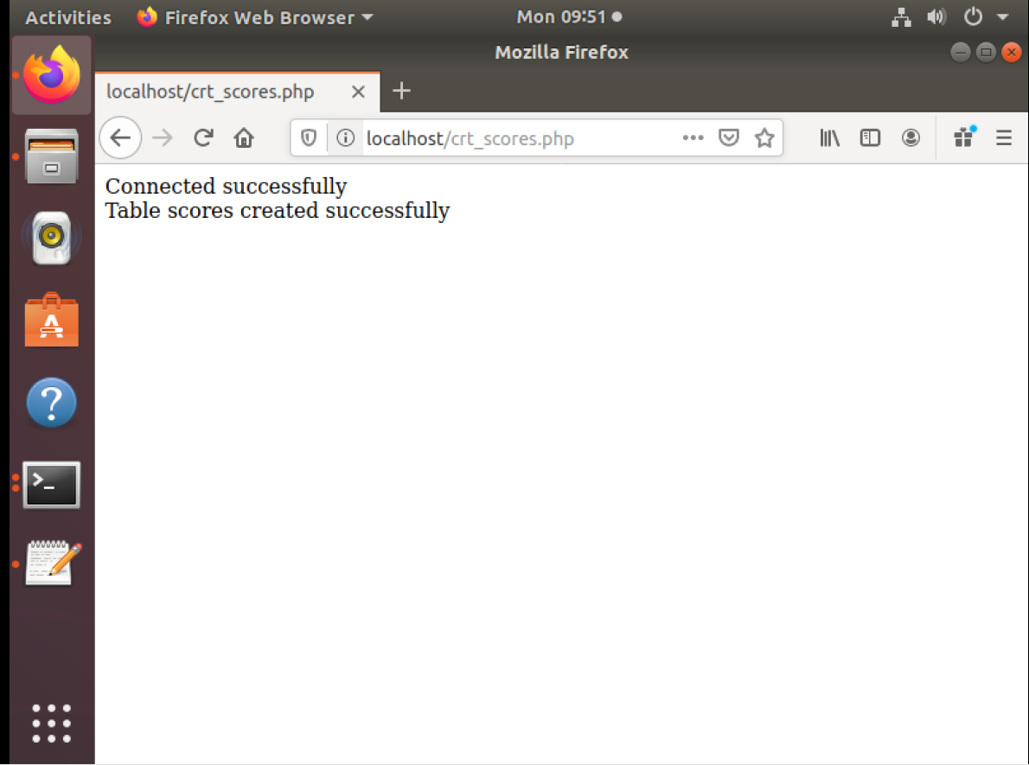

- Insert data
Run the code multiple times to insert each row with different values.
Code
<?php
$servername = "localhost";
$username = "dbs";
$password = "12";
$db="student";

// Create connection
$conn = new mysqli($servername, $username, $password, $db);

// Check connection
if ($conn->connect_error) {
die("Connection failed: " . $conn->connect_error);
}
echo "Connected successfully"."<br>";

//VALUES INSERTION
$sql = "INSERT INTO scores (Name, Sub1, Sub2, Sub3, Sub4, Sub5)
VALUES ('vardhan', 85, 88, 77, 80, 92)";
if ($conn->query($sql) === TRUE) {
echo "New record created successfully";
} else {
echo "Error: " . $sql . "<br>" . $conn->error;
}
$conn->close();
?>

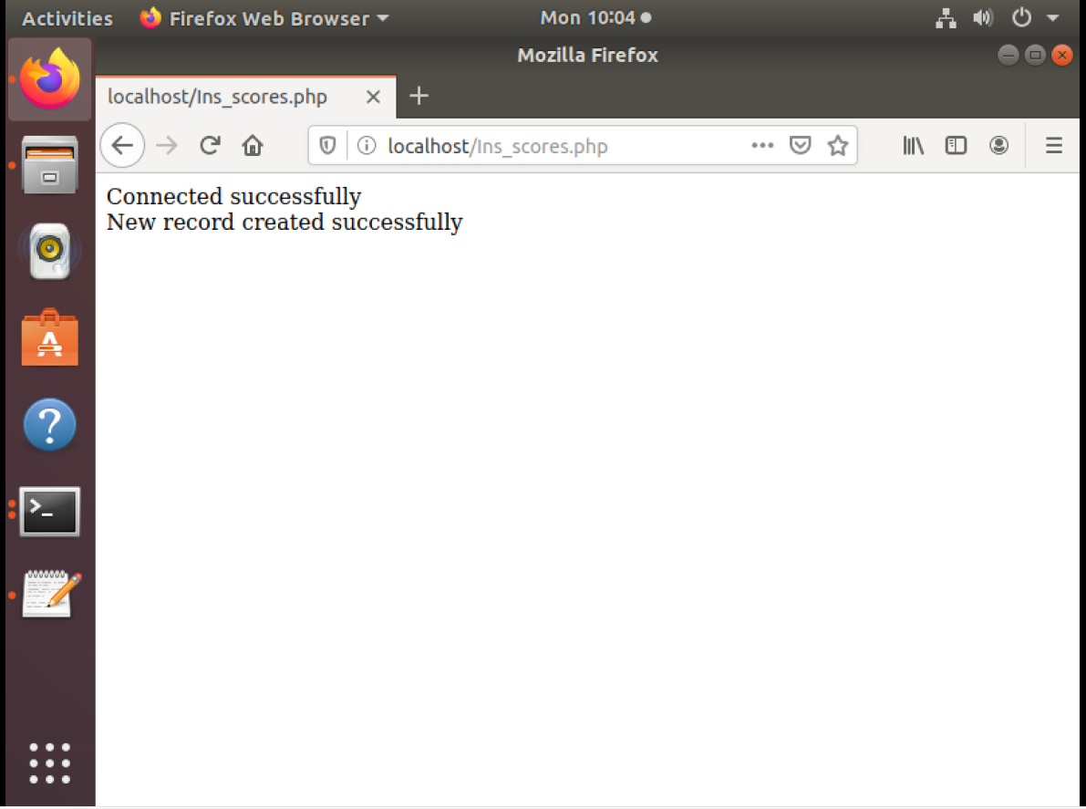

4.Select the table
Code
<?php
$servername = "localhost";
$username = "dbs";
$password = "12";
$db="student";

// Create connection
$conn = new mysqli($servername, $username, $password, $db);

// Check connection
if ($conn->connect_error) {
die("Connection failed: " . $conn->connect_error);
}
echo "Connected successfully"."<br>";

//SELECT VALUES

$sql = "SELECT id, Name, Sub1, Sub2, Sub3, Sub4, Sub5, Total, TRUNCATE(Percent,2) as per FROM scores";

if($result = $conn->query($sql)){
if ($result->num_rows > 0)
{
echo "<table>";
echo "<tr>";
echo "<th> id </th>";
echo "<th>Name </th>";
echo "<th>Sub1</th>";
echo "<th>Sub2 </th>";
echo "<th>Sub3 </th>";
echo "<th>Sub4 </th>";
echo "<th>Sub5 </th>";
echo "<th>Total </th>";
echo "<th>Percent</th>";
echo "</tr>";

while($row = $result->fetch_assoc())
{
echo "<tr>";
echo "<td>" .$row["id"]."</td>";
echo "<td>" .$row["Name"]."</td>";
echo "<td>" .$row["Sub1"]."</td>";
echo "<td>" .$row["Sub2"]."</td>";
echo "<td>" .$row["Sub3"]."</td>";
echo "<td>" .$row["Sub4"]."</td>";
echo "<td>" .$row["Sub5"]."</td>";
echo "<td>" .$row["Total"]."</td>";
echo "<td>" .$row["per"]."%"."</td>";
echo "</tr>";
}
echo "</table>";
$result->free();
}
else
{
echo "No matching records are found.";
}
}
else {
echo "ERROR: Could not able to execute $sql. " conn->error;
}
$conn->close();
?>

Snapshot:

