

About us

AOL iincorporated in Singapore to be a huge player in A&A and renovation industry.

Having being incorporated in 2016, we have vast experince in minor and major projects.

We want to create the art of living for all our customers and partners.

Our expertise is in design and built, we strive to do any projects clearing regualtions and maintaining high standards.

Projects



River Isles @ Punggol

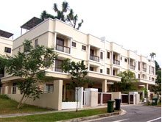

Landed property @ Jln Chermat

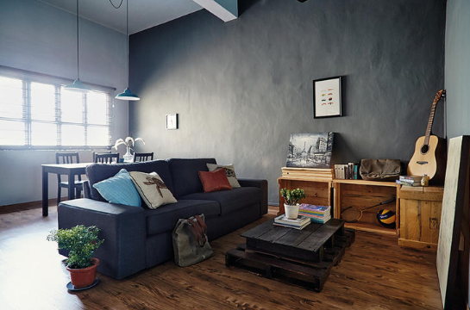

Walk up apartment @ Jln Besar



Roofing works @Sixth Avenue



Plumbing works @ Tuas

Services

Plumbing and water-proofing

Roofing

Masonary

A&A and renovation

Project Advisory