Energy-Aware Client Selection in Federated Learning as Multi-Round Budgeted Maximum Coverage: Hardness, Exact Models and Battery-Aware Greedy Algorithms
Abstract—In federated learning (FL) a server repeatedly selects devices that hold data of different groups (e.g., label classes), while the devices differ in speed and battery and every round has a deadline and an energy budget. We formalise multi-round client selection as maximising total weighted group coverage over R rounds subject to deadline, per-round energy and cardinality budgets, and battery dynamics with recharge and overflow. We prove NP-hardness by reduction from Set Cover (already for one round with unit costs), give an exact ILP, and show that single-round greedy with partial enumeration attains the optimal (1−1/e) factor for the knapsack-constrained case. We then show that the myopic round-wise greedy can lose a factor approaching 2 on an adversarial family, and propose a battery-aware greedy with price e_{k}(1+γ·depletion_{k}) and a rolling-horizon ILP. On small instances solved exactly, the myopic greedy is 5.2–7.4% below the optimum and the rolling-horizon ILP 0.8–1.8%. On large instances the battery-aware greedy raises coverage by 1.2% (paired Wilcoxon p<0.001) and cuts the number of exhausted clients by 37%; coverage correlates with FedAvg accuracy (Pearson r=0.69).
Index Terms—federated learning, client selection, submodular maximisation, budgeted maximum coverage, integer programming, battery-aware scheduling.

I. INTRODUCTION
Federated learning (FL) [1] trains a shared model on data that stay on users’ devices. In every round the server sends the current model to a subset of clients, collects their updates and aggregates them. Which clients take part matters: devices differ in speed and battery, rounds have a deadline, and the data held by the chosen clients decide how representative the update is. Always choosing fast, data-rich devices drains their batteries and biases the model [2]; choosing at random wastes rounds.
We study this as a combinatorial optimisation problem. Each client holds data of a few groups (label classes or user segments); the value of a round is the total weight of groups represented by at least one selected client, a monotone submodular coverage function. A round is limited by a deadline, an energy budget and a client cap, and every client owns a battery that participation drains and a known recharge refills. The goal is to maximise coverage over R rounds. Our contributions are:
- Model and exact ILP with an exact overflow-slack linearisation of the battery dynamics, an independent solution checker, and a fairness extension (Section III).
- NP-hardness by reduction from Set Cover, valid already for one round with unit costs, machine-verified on 632 tiny cases, and the resulting (1−1/e) inapproximability (Section IV).
- Single-round guarantees: modified greedy (½(1−1/e)) and partial enumeration (1−1/e) for the knapsack case, with measured ratios on 300 instances (Section V-A, VII-A).
- Why myopic fails: an adversarial family on which round-wise greedy achieves exactly (n+1)/(2n−1) → ½ of the optimum, which a battery price cannot repair, but a rolling-horizon ILP can (Section V-B).
- Battery-aware greedy with price e_{k}(1+γ·depletion_{k}) and its evaluation against the ILP, an upper bound, and baselines, including a FedAvg experiment (Sections V-C, VII).
II. RELATED WORK
FedAvg [1] introduced communication-efficient FL with random client sampling. FedCS [2] observed that heterogeneous resources make random sampling inefficient and selects the largest number of clients that can finish download, update and upload within a deadline. Its objective counts clients; ours maximises weighted data coverage and adds battery dynamics across rounds. A single deadline-constrained round is a budgeted maximum coverage problem: Khuller, Moss and Naor [3] give a (1−1/e)-approximation by greedy with partial enumeration, building on the analysis of submodular maximisation by Nemhauser, Wolsey and Fisher [4] and on Sviridenko’s knapsack-constrained algorithm [5]. These guarantees are per round; with batteries, rounds are coupled and per-round optimality does not compose, which is the gap we study.
III. PROBLEM FORMALISATION
A. Notation and model
Let K be the clients, G the data groups and rounds t=1,…,R. Client k holds group g iff h_{kg}=1; group g has weight w_{g}. Client k needs time τ_{k} and energy e_{k} per participation, has initial battery b⁰_{k}, capacity β_{k} and recharge ρ_{kt}≥0 in round t. A round has deadline T_{max}, energy budget E_{t} and may use at most m clients; ϱ∈[0,1] is a minimum participation fraction (ϱ=0 disables fairness). Variables: x_{kt}∈{0,1} (selected), z_{gt} (group covered), b_{kt} (battery at the start of round t) and overflow ω_{kt}≥0.
max ∑_{t=1}^{R} ∑_{g∈G} w_{g} z_{gt} (1)
z_{gt} ≤ ∑_{k} h_{kg} x_{kt} ∀g,t; x_{kt}=0 if τ_{k}>T_{max} (2)
∑_{k} x_{kt} ≤ m, ∑_{k} e_{k} x_{kt} ≤ E_{t} ∀t (3)
e_{k} x_{kt} ≤ b_{kt} ∀k,t (4)
b_{k,t+1} = b_{kt} − e_{k}x_{kt} + ρ_{kt} − ω_{kt}, b_{k,t+1} ≤ β_{k} (5)
b_{k1}=b⁰_{k}, ∑_{t} x_{kt} ≥ ⌊ϱR⌋ (eligible k) (6)
x_{kt}∈{0,1}, z_{gt}∈[0,1], b_{kt}, ω_{kt} ≥ 0 (7)
Assumptions. (A1) Deadline is a per-client eligibility test, τ_{k} ≤ T_{max}. (A2) e_{k} is constant; recharge is applied after the round and the battery is capped at β_{k}. (A3) Recharge is known to the ILP; the greedy policies use only the current battery, hence are also valid when future recharge is unknown. (A4) Coverage is binary: holding any data of a group represents it. (A5) Holdings h_{kg} and weights are time-invariant. (A6) Fairness (6) applies only to deadline-eligible clients.
Exactness of (5). The original rule b_{k,t+1}=min{β_{k}, b_{kt}−e_{k}x_{kt}+ρ_{kt}} is equivalent to (5): a larger battery only relaxes (4) and (5) in later rounds, so discarding energy beyond overflow never helps and the optima coincide. Since x is binary, z is integral at an optimum, so z can be continuous, which speeds up the solver. We also tried presolve fixing (x_{kt}=0 if e_{k}>E_{t}) and valid cumulative-energy cuts ∑_{s≤t} e_{k}x_{ks} ≤ b⁰_{k}+∑_{s<t}ρ_{ks}; they gave no speed-up with HiGHS (Section VII-B).
IV. COMPLEXITY
Theorem 1. The decision problem “is there a selection with total coverage ≥ V?” is NP-hard in the strong sense, even for R=1, unit weights, unit energies, no batteries and no fairness.
Proof. Membership in NP is clear (check constraints and coverage in polynomial time) [7]. Hardness: reduce from Set Cover [6]: universe U={u₁,…,u_{n}}, sets S₁,…,S_{p}, integer k. Create one group per element (w=1) and one client per set with h_{jg}=1 iff u_{g}∈S_{j}; set e_{j}=1, τ_{j}=0, T_{max}=1, m=E₁=k, R=1, and β_{j}=b⁰_{j}=1, ρ=0. A selection of at most k clients covers all n groups iff k sets cover U; take V=n. The construction is polynomial and all numbers are in {0,1,k}, hence strong NP-hardness. ∎
Verification. We generated random Set Cover instances (|U|=8, 8 sets), computed the minimum cover size by brute force and solved the constructed ILP for every k: the two answers agreed on 632/632 (instance, k) pairs.
Corollary 1. With unit costs and R=1 the problem is Maximum k-Coverage, so by Feige [8] no polynomial algorithm guarantees (1−1/e+ε) unless P=NP. Hence the (1−1/e) of Section V-A is optimal. If batteries are unlimited the rounds decouple into R independent budgeted coverage problems; batteries create the coupling that defeats per-round optimality (Section V-B). The pseudo-polynomial knapsack DP does not help because coverage is not additive.
V. ALGORITHMS AND ANALYSIS
A. Single round: greedy with partial enumeration
Fix a round with candidate set A, budget E and cap m. Let f(S) be the weight of groups covered by S (monotone, submodular) and Δ(k|S) the marginal gain. ROUND-GREEDY (Algorithm 1) repeatedly adds the affordable client with the largest Δ(k|S)/c_{k}, where c_{k} is a price (the true energy e_{k} by default); feasibility always uses e_{k}. The returned set is the better of the greedy set and the best single affordable client. PARTIAL-ENUM(3) tries every start set of at most three clients and completes each with ROUND-GREEDY.
Alg. 1 ROUND-GREEDY(A, c, E, m)
1 S <- {}
2 while |S| < m:
3 C <- {k in A\S : e_k <= E - e(S)}
4 k* <- argmax_{k in C} gain(k|S) / c_k
5 if gain(k*|S) = 0: break
6 S <- S + {k*}
7 return better of S and best single client

Theorem 2. For the knapsack constraint only (m=∞) and prices c=e: (a) ROUND-GREEDY with the best-single fallback is a ½(1−1/e)-approximation; (b) PARTIAL-ENUM(3) is a (1−1/e)-approximation [3], [5]. For the cardinality constraint only (c≡1, E=∞) plain greedy is a (1−1/e)-approximation [4].
Proof of (a). Let O be an optimum with e(O)≤E and let G_{i} be the first i clients picked by the idealised greedy that ignores the budget, with costs c_{i}. Let l+1 be the first pick that does not fit, so G_{l} fits and ∑_{i≤l+1} c_{i}>E. By submodularity, f(O)−f(G_{i−1}) ≤ ∑_{o∈O\G_{i−1}} Δ(o|G_{i−1}) ≤ (Δ_{i}/c_{i})·E, hence f(G_{i})−f(G_{i−1}) ≥ (c_{i}/E)(f(O)−f(G_{i−1})) and f(G_{l+1}) ≥ [1−∏_{i≤l+1}(1−c_{i}/E)] f(O) > (1−1/e) f(O), using ∑c_{i}>E and the AM–GM inequality. Because f(G_{l+1}) ≤ f(G_{l})+f({g_{l+1}}), one of G_{l} and the single client g_{l+1} (which fits alone) has value ≥ ½(1−1/e)f(O). Our implementation skips non-fitting clients and continues; by monotonicity its set is a superset of G_{l}, so the bound holds. ∎
Proof sketch of (b). Order the clients of O by the greedy rule o₁,o₂,… (each has the largest marginal gain among the remaining ones of O) and let the algorithm guess o₁,o₂,o₃ as the start set S₀. The key lemma is that the first client g_{l+1} that the greedy completion cannot afford has marginal gain at most f(S₀)/3, because it cannot exceed that of o₃. Running the chain of part (a) on the residual problem and charging the last, non-fitting client at most this small amount removes the factor ½ and yields (1−1/e); we refer to Khuller et al. [3] and Sviridenko [5] for the full algebra. Part (c) is the same chain with c_{i}/E=1/m, i.e. (1−1/m)^{m} ≤ 1/e [4]. The enumeration costs O(|K|³) greedy runs per round, which is affordable for single rounds but not inside a 30-round simulation, so Algorithms 1–2 use the plain fallback version.
The proof does not cover both a knapsack and a cardinality constraint, which is our actual setting; we therefore measure ratios empirically (Section VII-A).
B. Why the myopic greedy fails
Proposition 3. For every n there is a two-round instance on which the round-wise greedy earns exactly (n+1)/(2n−1) of the optimum, which tends to ½.
Proof. Unit weights, m=1, E=(2,1). Client A covers all n groups, e=1, battery for exactly one participation, ρ=0. Client B covers n−1 groups, e=2, battery for one participation. Client W covers one group, e=1, unlimited battery. In round 1 greedy takes A (best gain and best ratio n vs (n−1)/2). In round 2 B is unaffordable (2>1) and A is exhausted, so W is taken: total n+1. The optimum takes B in round 1 and A in round 2: 2n−1. ∎
A and B have identical depletion before round 1, so any price that depends on the battery level alone cannot separate them; fixing this requires knowing the future budget E₂.
C. Battery-aware greedy
BATTERY-AWARE (Algorithm 2) runs ROUND-GREEDY in every round with price c_{k}=e_{k}(1+γ·depletion_{k}) and depletion_{k}=1−b_{kt}/β_{k}∈[0,1], where γ≥0 is tuned. A drained client is “expensive”, so the greedy spreads participation, but the budget test still uses the true e_{k}. γ=0 recovers the myopic greedy.
Alg. 2 BATTERY-AWARE(gamma)
1 b <- b0
2 for t = 1..R:
3 A <- {k : tau_k <= Tmax and b_k >= e_k}
4 c_k <- e_k (1 + gamma (1 - b_k/beta_k))
5 S_t <- ROUND-GREEDY(A, c, E_t, m)
6 b_k <- min(beta_k, b_k - e_k*[k in S_t] + rho_kt)

Lemma 4. (i) Every schedule produced is feasible for (2)–(5). (ii) The running time is O(R·m·|K|·|G|). (iii) If b_{kt}=β_{k} and ρ_{kt}≥e_{k}, then participating leaves the next battery at β_{k}, i.e. it is free, and the price is the lowest possible (depletion 0).
Proof. (i) The candidate set enforces deadline and battery, ROUND-GREEDY enforces E_{t} and m, and batteries follow (5). (ii) Each of at most m iterations scores ≤|K| clients over |G| groups. (iii) min{β, β−e+ρ}=β iff ρ≥e. ∎
Lemma 4(iii) explains the price: clients near full capacity would waste recharge as overflow anyway, so using them is cheap; drained clients carry a real opportunity cost.
D. Rolling-horizon ILP and an upper bound
ROLLING-ILP(W) solves the ILP (1)–(7) for rounds t,…,t+W−1 from the current batteries (recharge in the window assumed known) and commits only round t; W=1 is the per-round optimum and W=R is exact. Lemma 5. Let UB=∑_{t} OPT_{t}, where OPT_{t} is the optimum of round t ignoring batteries. Then UB ≥ OPT. Proof: dropping (4)–(5) relaxes the problem and decouples rounds. ∎ We use UB when the full ILP is too large.
VI. EXPERIMENTAL SETUP
Instances. Each client holds 2–4 random groups of G; weights are integers in 1..5; τ_{k} is log-normal(0, 0.5); e_{k}=10τ_{k}/mean(τ); T_{max} is the 70% quantile of τ; β_{k}=3e_{k}, b⁰_{k}~U(0.5,1)β_{k}; recharge is r_{k}·e_{k}·U(0.5,1.5) with r_{k}~U(0.05,0.30), so a client can sustain about r_{k} participations per round; E_{t}=m·mean(e)·U(0.8,1.2) and m=max(3,⌊G/3⌋) unless stated. Methods. Random, Fastest-first, Myopic greedy (γ=0), Battery-aware (γ=1.5), Rolling ILP (W=3). Metrics. Coverage (also as % of R·∑w), fraction of rounds with every group covered, exhausted clients (eligible clients that at least once could not afford e_{k}), and Jain’s index [9] of participation counts of eligible clients. Tooling. Python 3, NumPy/SciPy [11], ILPs solved by HiGHS [10] through scipy.optimize.milp, one CPU core, fixed seeds. Every schedule is re-verified by an independent checker that recomputes batteries and objective from the 0/1 matrix.
TABLE 0. Instance generator parameters.
Parameter | Value
Clients K / groups G / rounds R | 40–100 / 12–30 / 5–30
Groups per client | 2–4 (uniform)
Group weight w_g | integer in 1..5
Time τ_k | log-normal(0, 0.5)
Energy e_k | 10·τ_k / mean(τ)
Deadline T_max | 70% quantile of τ
Capacity β_k / initial b⁰_k | 3·e_k / U(0.5,1)·β_k
Recharge ρ_kt | r_k·e_k·U(0.5,1.5), r_k~U(0.05,0.30)
Round budget E_t | m·mean(e)·U(0.8,1.2)
Clients per round m | max(3, ⌊G/3⌋) or as stated

VII. RESULTS
A. ILP validation and single-round ratios
The single-round ILP matched brute-force enumeration on all 60 tiny instances (0 mismatches). Table I gives the ratio to the ILP optimum on 150 random instances per setting (K=26, G=15, budget = 25% of eligible energy). PARTIAL-ENUM(3) was optimal on every instance; ROUND-GREEDY with fallback never fell below 0.85, far above the worst-case ½(1−1/e)≈0.316; plain cardinality greedy fell to 0.77. Running times were 0.11 ms (modified greedy) and 34.2 ms (enumeration). The LP relaxation was on average 1.9% above the optimum (max 6.9%). Ratio-greedy alone is not enough: on the instance {cost 1, value 1; cost L, value L−1}, budget L, it earns 1 while the optimum is L−1, which the best-single fallback repairs.
TABLE I. Single-round value / ILP optimum (150 instances per setting).
Algorithm | Knapsack mean | min | +cap. m=5 mean | min
Plain greedy | 0.946 | 0.773 | 0.948 | 0.773
Ratio greedy | 0.975 | 0.849 | 0.958 | 0.849
Modified greedy | 0.975 | 0.849 | 0.958 | 0.849
Partial enum. (3) | 1.000 | 1.000 | 1.000 | 1.000

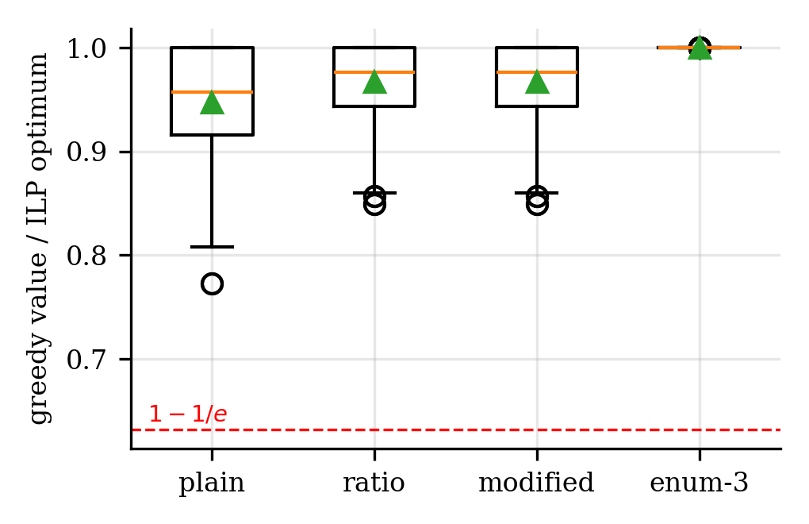
Fig. 1a. Distribution of single-round ratios to the ILP optimum (both settings pooled); dashed line: 1−1/e.
B. Small multi-round instances against the exact ILP
Table II compares policies with the exact multi-round ILP on 8 seeds per size (30 s limit; every instance with K≤20 was solved to optimality, 5/8 for K=30 with a proven bound gap of at most 2.1%, so reported gaps are relative to the incumbent). Random and Fastest lose 18–27%. Myopic greedy loses 5.2–7.4%; the battery-aware variant is not significantly different from it on these tiny instances (Wilcoxon p=0.20). Rolling ILP is within 1.8% on average. The LP relaxation is 3.2–5.1% above the optimum. Presolve and cumulative cuts did not help (mean solve time 18.2 s with vs 16.6 s without for K=30).
TABLE II. Mean gap to the exact ILP (8 seeds per size).
Policy (gap to ILP, %) | K=15,R=5 | K=20,R=8 | K=30,R=10
Random | 20.9 | 18.4 | 27.0
Fastest | 21.7 | 20.3 | 26.5
Myopic greedy | 5.2 | 7.4 | 7.2
Battery-aware | 6.1 | 6.0 | 6.2
Rolling ILP (W=3) | 0.9 | 1.8 | 0.8

C. Large instances
Table III uses 15 seeds of K=100, G=30, R=30 (A) and K=60, G=12, R=20 (B), measured against the battery-free upper bound UB (Rolling ILP, 3 s per window, only 5 seeds; on the same 5 seeds in A it reaches 93.5% against 88.8% for battery-aware and 87.8% for myopic). In A the battery-aware greedy improves on myopic by 1.2% on average, winning 14/15 instances (Wilcoxon p<0.001), and reduces exhausted clients from 40.2 to 25.3; in B the coverage gain is smaller (0.3%, p=0.08) but full-coverage rounds rise from 0.74 to 0.80 and exhausted clients halve. The heuristics need about 13 ms for K=100 and 47 ms for K=800 over 30 rounds, versus 34 s for Rolling ILP.
TABLE III. Large instances (means; *Rolling ILP: 5 seeds).
Policy | %UB (A) | Exh. (A) | Jain (A) | %UB (B) | Full (B) | Exh. (B)
Random | 63.0 | 36.7 | 0.87 | 74.6 | 0.01 | 11.7
Fastest | 64.7 | 47.8 | 0.63 | 75.0 | 0.02 | 20.4
Myopic | 89.1 | 40.2 | 0.66 | 98.5 | 0.74 | 16.4
Batt.-aware | 90.2 | 25.3 | 0.69 | 98.8 | 0.80 | 7.7
Rolling ILP* | 93.5 | 38.6 | 0.69 | 100.0 | 1.00 | 4.0

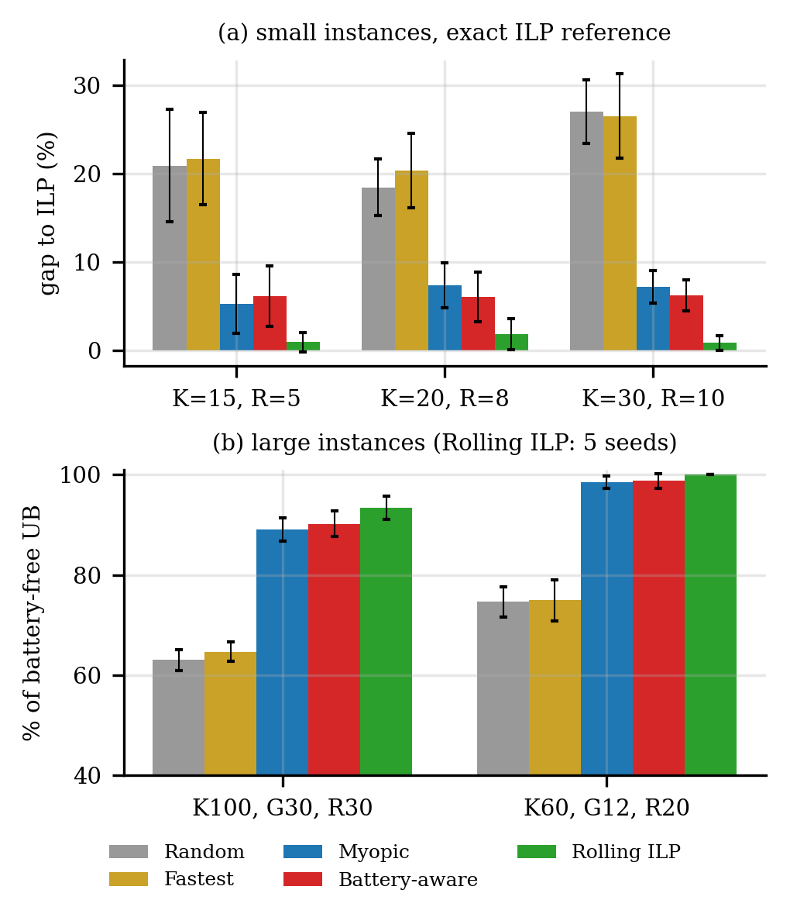
Fig. 1. (a) Gap to the exact ILP on small instances; (b) coverage relative to the upper bound on large instances (error bars: one standard deviation).
D. Tuning γ
Fig. 2 sweeps γ over 30 seeds. In the large-G setting coverage rises from 75.1% (γ=0) to 77.1% at γ=1.5 (p<0.001) and plateaus; exhausted clients fall monotonically from 36.0 to 24.0 and Jain’s index rises. In the small-G setting coverage peaks near γ≈0.5–1 (95.4% vs 94.9%) and then declines to 92.7% at γ=8, while exhausted clients fall from 14.2 to 4.2 and Jain’s index from 0.65 up to 0.79. Thus γ trades a little coverage for fairness and battery health; γ∈[1,2] is a good default.
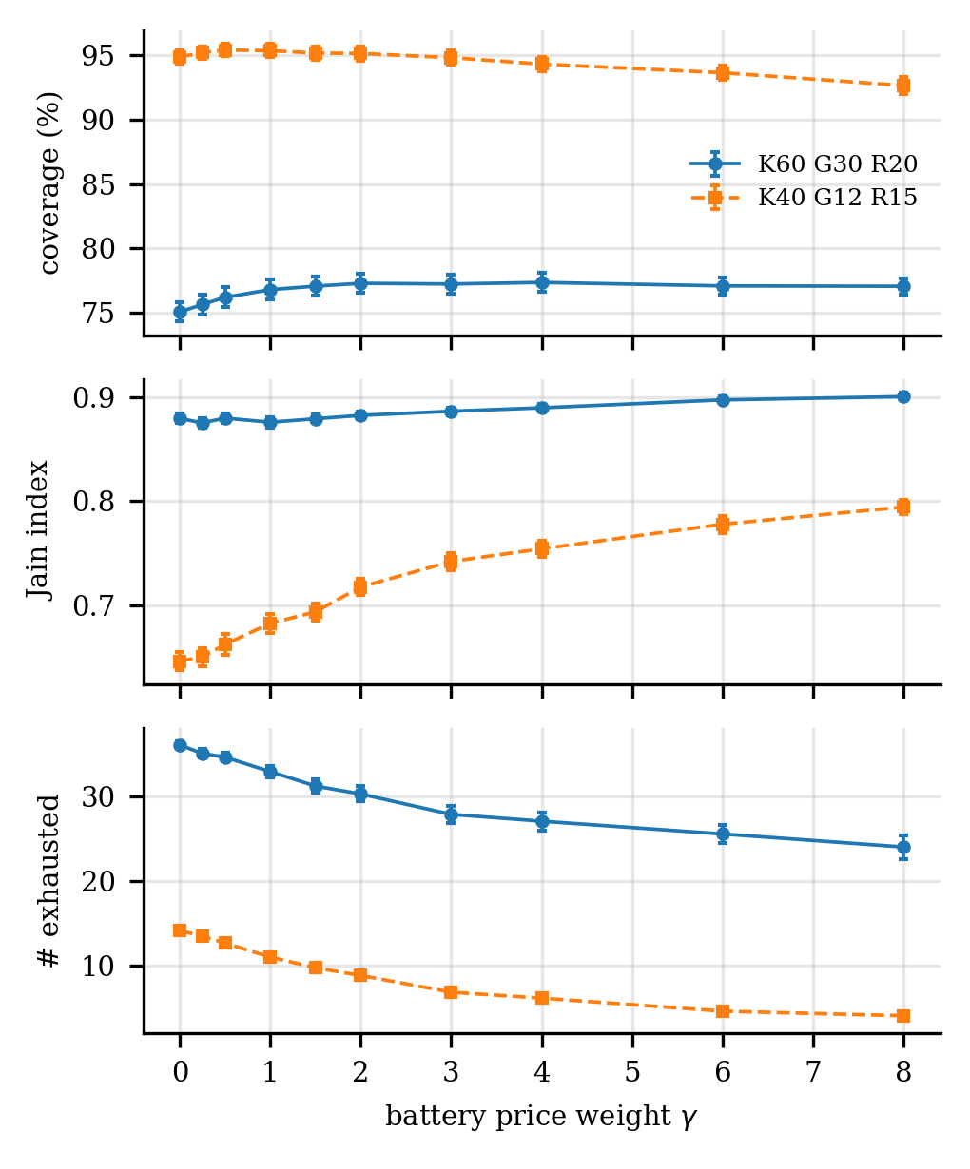
Fig. 2. Effect of the battery-price weight γ (30 seeds, mean ± s.e.).
E. Adversarial family and energy scarcity
On the family of Proposition 3 the measured ratios of the myopic greedy are 0.667, 0.579, 0.538, 0.515, 0.508 and 0.501 for n=5,…,1000, exactly (n+1)/(2n−1). The battery-aware greedy produces the identical schedule (ratio 0.501), as predicted, whereas Rolling ILP with W=2 is optimal (Fig. 3a). Fig. 3b varies recharge from 0.25× to 4×. The battery-aware gain over myopic is largest under moderate scarcity (2.0 points at 1×, with exhausted clients 19.8→10.8 at 2×) and vanishes when energy is very scarce (every client is drained) or abundant (batteries never bind), which delimits when battery awareness matters.
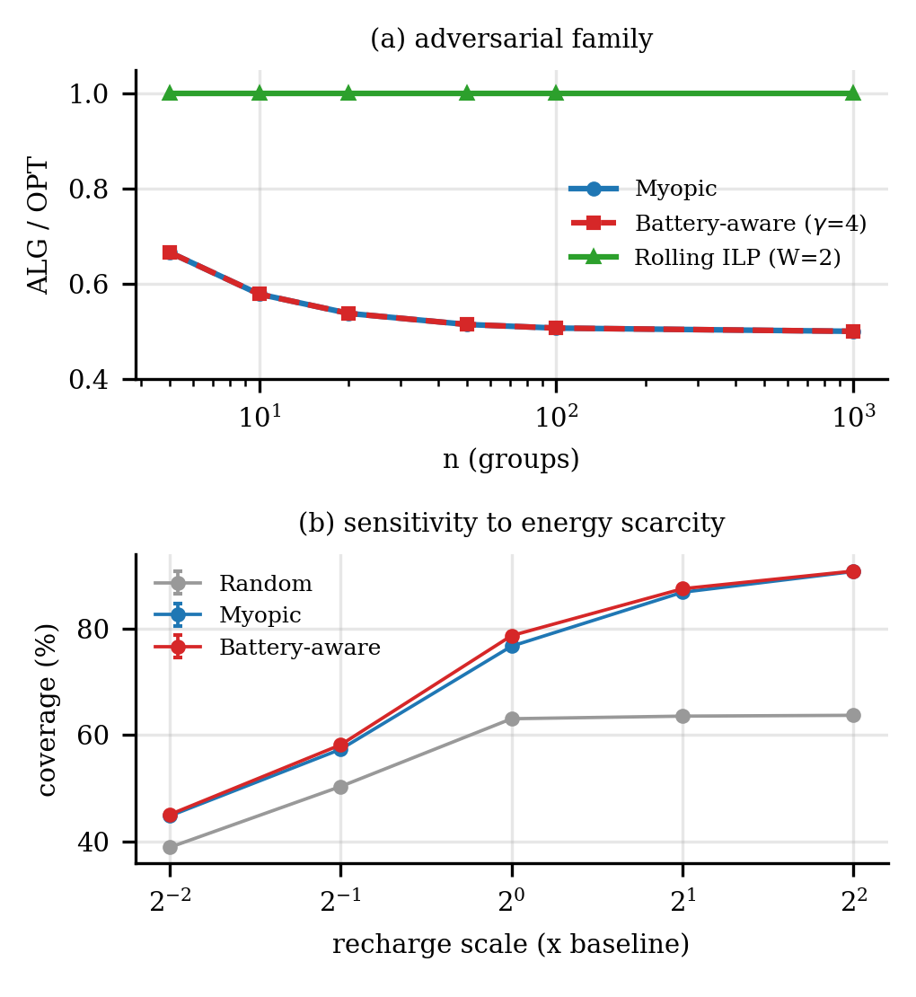
Fig. 3. (a) ALG/OPT on the adversarial family; (b) coverage vs recharge scale.
TABLE IV. Coverage (%) vs recharge scale (K=60, G=30, R=20, 30 seeds); last column: exhausted clients.
Recharge scale | Random | Myopic | Batt.-aware | Exh. M→B
0.25× | 38.9 | 44.8 | 45.1 | 42.0→42.0
0.5× | 50.3 | 57.3 | 58.2 | 42.0→42.0
1.0× | 63.1 | 76.7 | 78.7 | 36.4→32.3
2.0× | 63.6 | 86.9 | 87.5 | 19.8→10.8
4.0× | 63.7 | 90.8 | 90.9 | 8.3→3.0

F. Fairness variant
With the minimum participation constraint (6) on K=20, R=10 (8 seeds, ILP), forcing ϱ∈{0, 0.1, 0.2} costs no coverage, ϱ=0.3 costs 0.13%, ϱ=0.4 is feasible for only 2/8 instances (loss 5.1% among them), and ϱ=0.5 is infeasible for all, because batteries cannot sustain that participation rate.
G. Link to FL accuracy
We ran FedAvg (softmax regression, 2 local epochs) on the scikit-learn 8×8 digits data [12] as a stand-in for MNIST (no internet access); the 10 classes are the groups and each client holds exactly its groups’ classes. Over 192 runs (4 policies × 4 values of m × 12 seeds) mean per-round coverage and final test accuracy are strongly correlated (Pearson r=0.69, Spearman ρ=0.74; Fig. 4); accuracy rises from 80.3% at 57.1% coverage (m=2) to 89.0% at 92.6% (m=6). Coverage-driven policies (Myopic 87.5%, Battery-aware 87.8%) beat Random (84.3%) and Fastest (82.2%); the Myopic vs Battery-aware accuracy difference is within noise.
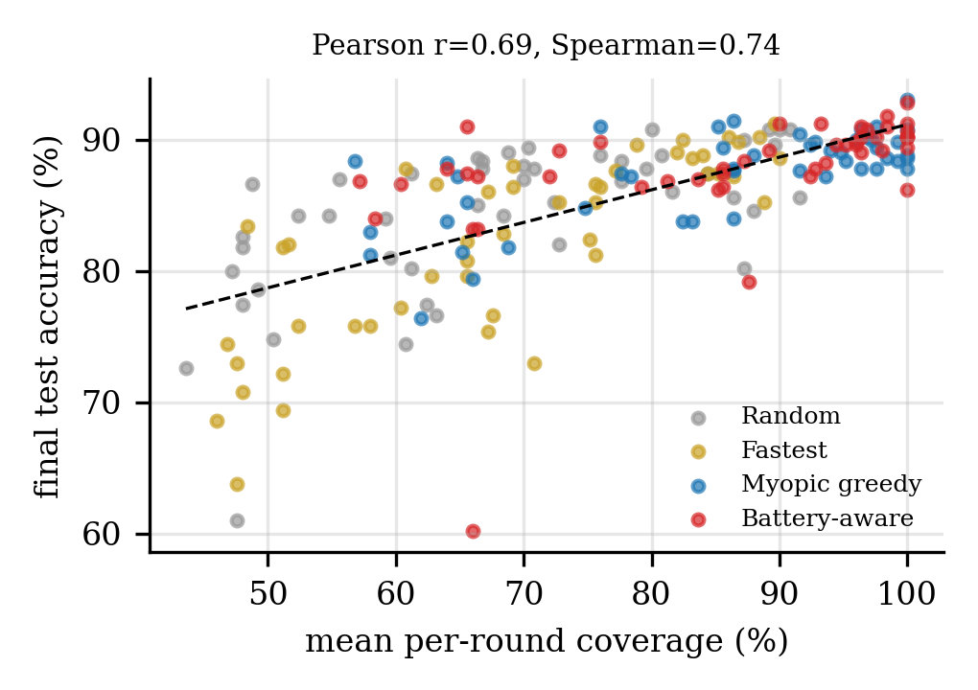
Fig. 4. Per-round coverage vs final FedAvg accuracy (dashed: linear fit).
H. Reproducibility
All code is organised as a Python package (instance generator, checker, greedy algorithms, ILPs, policies, FedAvg) plus one script per experiment (E0–E7), a figure script and a number-export script that feeds this paper. Seeds are fixed per experiment (instances 200+, 300+, 400+, 500+, 600+, 700+ for E2–E7). Every table entry is a mean over the stated number of seeds; ILP runs use a 30 s limit and incumbents are checked by the independent verifier before being used as references. Wall-clock times were measured on a single CPU core and will differ on other machines.
VIII. DISCUSSION AND LIMITATIONS
The battery price is a cheap, online-in-ρ improvement: it needs no forecast of recharge and about 10 ms per run, and it consistently reduces exhausted clients, but its coverage gain is modest (about 1–2%) and it cannot detect budget-driven traps (Proposition 3). Rolling-horizon ILP is near-optimal but needs known recharge/budgets and seconds per decision. Limitations: (i) Theorem 2 does not cover the combined knapsack+cardinality setting; (ii) the exact ILP is solved only up to about 30 clients and 10 rounds within 30 s; (iii) instances are synthetic, and the FL experiment uses a small linear model on the digits data rather than MNIST; (iv) coverage is binary (the probabilistic-coverage and online-recharge variants are left as future work, although the greedy policies are already online in ρ).
Summary of the algorithms. Random and Fastest-first run in O(R·K log K); ROUND-GREEDY and BATTERY-AWARE in O(R·m·K·G) with no guarantee beyond the single-round analysis; PARTIAL-ENUM(3) in O(K³·m·K·G) per round with a (1−1/e) guarantee for the knapsack case; ROLLING-ILP solves R NP-hard windows and is exact only for W=R. In our runs the quality ordering matched the cost ordering: Rolling ILP > Battery-aware ≳ Myopic ≫ Fastest ≈ Random.
Threats to validity. Results are synthetic and depend on the generator: we deliberately chose an energy-constrained regime (about as much sustainable participation as the cap m allows), and Table IV shows the benefit shrinks outside it. Gaps for the largest exact instances are relative to the incumbent, not a proven optimum, and the Rolling ILP row of Table III uses only five seeds because of its run time. Statistical tests are paired Wilcoxon tests over seeds; we did not correct for multiple comparisons.
IX. CONCLUSION
Multi-round energy-aware client selection is a strongly NP-hard coverage problem whose per-round core admits an optimal-factor greedy, but whose battery coupling defeats myopic selection by up to a factor approaching two. A battery-aware price improves coverage and markedly reduces exhausted clients at negligible cost, and a rolling-horizon ILP comes within about 1–2% of the exact optimum. Future work includes guarantees for the two-constraint round problem, probabilistic coverage, and unknown-recharge competitive analysis.
REFERENCES
[1] H. B. McMahan, E. Moore, D. Ramage, S. Hampson, B. A. y Arcas, “Communication-efficient learning of deep networks from decentralized data,” in Proc. AISTATS, 2017.
[2] T. Nishio and R. Yonetani, “Client selection for federated learning with heterogeneous resources in mobile edge,” in Proc. IEEE ICC, 2019.
[3] S. Khuller, A. Moss, and J. Naor, “The budgeted maximum coverage problem,” Inf. Process. Lett., vol. 70, no. 1, pp. 39–45, 1999.
[4] G. L. Nemhauser, L. A. Wolsey, and M. L. Fisher, “An analysis of approximations for maximizing submodular set functions—I,” Math. Programming, vol. 14, pp. 265–294, 1978.
[5] M. Sviridenko, “A note on maximizing a submodular set function subject to a knapsack constraint,” Oper. Res. Lett., vol. 32, no. 1, pp. 41–43, 2004.
[6] R. M. Karp, “Reducibility among combinatorial problems,” in Complexity of Computer Computations, Plenum, 1972, pp. 85–103.
[7] M. R. Garey and D. S. Johnson, Computers and Intractability: A Guide to the Theory of NP-Completeness, W. H. Freeman, 1979.
[8] U. Feige, “A threshold of ln n for approximating set cover,” J. ACM, vol. 45, no. 4, pp. 634–652, 1998.
[9] R. Jain, D. Chiu, and W. Hawe, “A quantitative measure of fairness and discrimination for resource allocation in shared computer systems,” DEC Tech. Rep. TR-301, 1984.
[10] Q. Huangfu and J. A. J. Hall, “Parallelizing the dual revised simplex method,” Math. Program. Comput., vol. 10, no. 1, pp. 119–142, 2018.
[11] P. Virtanen et al., “SciPy 1.0: fundamental algorithms for scientific computing in Python,” Nature Methods, vol. 17, pp. 261–272, 2020.
[12] F. Pedregosa et al., “Scikit-learn: machine learning in Python,” J. Mach. Learn. Res., vol. 12, pp. 2825–2830, 2011.

