# **Chapter 2: Analysis**

## **2.1 Introduction**

Analysis means the evaluation of any kind of a complex in a detailed manner to understand its identity to determines the features of it. Here, we collect all the useful details in order to create a useful and appropriate software or and application.

## **2.2 Analysis Methodologies**

Analysis is one of the most important part of developing a system which help to determine the features and functionality that an application should have. It helps to sort out all the consideration needed in the system or application which will be applicable.

To analyze the project, I choose object-oriented analysis (OOA) methodology. It mainly focuses on the nature of the project as a substitution of function of the project. This analysis deals with understanding the requirement of the customers, setting them into consecutive steps and finally designing a blueprint of the application that looks much similar to the user’s requirement. OOA technique is mostly applied in Object Oriented Programming.  OOA is designed to overcome the development related problems more efficiently.

In my project I have used following interaction diagrams:

·         Sequence Diagram

·         Class Diagram

·         Activity Diagram

Sequence Diagram represents the objects and classes involved and sequence of communication between the objects to make the runtime scenarios functional.

Class Diagram is the static model that illustrates the collection of classes, attributes, interfaces, their association and relationship with objects.

Activity diagram visualizes the flow of actions in the system that can be either in sequential or concurrent model.

This is just a brief definition of the diagrams, the brief insights and working process of each diagram will be given in the design phase.

## **2.3 Information Gathering**

Information Gathering is done to understand the requirements for the system that the customer have asked me to develop. Since the requirements of the project is not printed elsewhere rather than client’s mind, I have chosen two information gathering techniques which involves direct communication with client i.e. Interview and Questionnaire.

### **Interviews**

The best way to understand what kind of stuff the client is looking for is talking with them live. Interview is the easiest and effective way to accumulate the information. Face to face communication create better understanding and it will be easier to meet the common goal. Here are the questions that I asked the client in interview:

* How are you managing your institute now?
* What are the major areas where you are facing problem while operating the institute in a traditional way?
* Do you and your staff have computer knowledge to use and manage the application?
* In general, how many students and staff will use this application?
* What are the specific features that you want in the system?

### **Questionnaires**

In this method, a set of questions are given to an individual or a group of people for the purpose of gathering information. This is the quick and easy way of collecting the information as it can be conducted among any relevant group of people with a choice of answers. It would help to distinguish the behavior and the preference of people in a specific field.

## **2.4 Feasibility Study**

Feasibility study is the evaluation of the project to analyze its practicality. In general, it is to study whether the proposed project is appropriate for development process or not.

Feasibility study includes all the aspects of project assessment including budget estimation, essential resources, determination of critical points, timetable and so on. Before initiating the project and investing lots of time and money on it, this study is done to identify if the project is practical or not.

For my project, I have done following types of feasibility study:

### **Technical Feasibility Study**

My project is a complete website which is based on tools and technologies like HTML, CSS, MySQL, PHP and so on. For this study, we check if the existing computer system are compatible with technologies that we are going to use or not. The project will be well optimized to work perfectly across all the devices, platforms and browsers available. All the technologies that we are using are freely available and the required technical skills are manageable. From these, it is clear that Project Institute Management is technically feasible.

### **Economy Feasibility Study**

This study is carried out to determine if the cost incurred on the software development justifies the sustainability of the project with profit for the organization or not. For this project, we are using freely available technologies, existing computer system so no cost will be charged for this. The website will have hosting cost, development team wage and training costs.  The project is going to be simple and intuitive so training will be for short period and cost will be minimal. Besides the cost incurred, the project will reduce the cost of papers, marking and printing required in traditional recording keeping system and it also makes the process accurate, fast and easy. Thus, it is economically feasible.

### **Legal Feasibility Study**

Legal Feasibility Study examines whether the proposed project violates any social law, data protection regulations, and digital acts or not. For my project, I am using open source tools that have free software licenses which permit us to study, share, modify and use it. In the website, we will have a privacy policy that will clear users about the collection and usage of their data. We ensure the website is fully secure and depict no illegal activities. Therefore, this project is legally feasible.

### **Time Feasibility Study**

This assessment will ensure if the given project will be completed on time or not. I have well planned the work schedule and enforced manpower and resources accordingly to deliver project on allocated time. Thus, the project is feasible.

### **Social Feasibility Study**

This assessment determines the acceptance of the project by the users and the system managers before it is launched. The basic orientation and training on how to use the website will be given to the users so the introduction of new system will not affect the users. We ensure the user cooperation and consideration before making any advanced changes in the system. Besides, the system will make both the users and manager work convenient and systematic. So, my project is socially feasible.

## **2.5 System Requirement Specification**

It is a classification of documents which records all the description of function with the behavior of the project itself. In this analysis it consists of both functional and non-functional properties required by the project.

## **2.5.1 Functional Requirement**

Functional requirement means all the requirement which are noticed by the user while using the application or the system of the project. All the requirement plays a vital role for the particular sector according to their name. It includes all the important functionality which should be needed in the system to run smoothly and with no problem in the coming future.

List is shown below.

|  |  |  |  |  |
| --- | --- | --- | --- | --- |
| **ID** | **Title** | **Description** | **Dependency** | **Rational** |
| FR_001 | Registration | Add new operator | N/A | For securing access to system |
| FR_002 | Login | Register user can login to system. | FR_001 | To give access to valid user. |
| FR_003 | Verify password | To check if the password input is match with database store password. | FR_001,  FR_002 | For authentication. |
| FR_004 | Display dashboard | Its goal is to provide snapshot of performance. | FR_001,  FR_002 | For navigating through the system with ease. |
| FR_005 | Edit profile | Change of details if required. | FR_001,  FR_002, | To renew user information if required. |
| FR_006 | Add course | Adding new record of course | FR_002 | Add of new subject to system. |
| FR_007 | Update course | Adding new detail on old course. | FR_002,  FR_006 | For any additional information is needed to be add. |
| FR_008 | Delete course | Removal of course from database. | FR_002,  FR_006 | For removing course from institute database. |
| FR_009 | Add batch | Add of new batch by admin. | FR_002 | New batch detail are added. |
| FR_010 | Update batch | Any new information needed to be added can be done by clicking update course option. | FR_002,  FR_010 | To update batch details. |
| FR_011 | Delete batch | If the batch is graduate then admin can delete the batch information. | FR_002,  FR_010 | Erasing of old batch information. |
| FR_012 | View course details | View of all course in list. | FR_002,  FR_006 | To make system effective viewing all information in one table. |
| FR_013 | Search course | Desired course can be search by typing course name. | FR_002,  FR_006 | Search of course became easy by typing name in search box making work efficient. |
| FR_014 | Invoice generate | Generate of invoice. | FR_002,  FR_006,  FR_009 | To keep record of fee paid by student. |
| FR_015 | Logout | User can be log out of system when they desire. | FR_002 | To protect user from accessing by unauthorized people. |

Table 1: Functional Requirement

## **2.5.2 Non-Functional Requirement**

It means the requirement of the system which depends on the quality, efficiency and durability of the project which are also important to make a system strong in all the properties of the project.

List is shown below.

|  |  |  |  |
| --- | --- | --- | --- |
| **ID** | **Title** | **Description** | **Dependency** |
| NFR_001 | Usability | It defines the facility provided by the system should be easily usable with no errors or problem occurring. | NFR_002, NFR_005 |
| NFR_002 | Efficiency | The system should be efficient so that the user can achieve a certain goal with no error in his login interval of time. | NFR_002 |
| NFR_003 | Intuitiveness | The system should be easily understandable so that the user faces no problems while using the website. | NFR_010 |
| NFR_004 | Security | The system should be secure as it may contain financial details of the user while paying online or may contain personal details of the user. | NFR_008 |
| NFR_005 | Reliable | The system should be reliably strong so that the user will not hesitate while using the website. | NFR_006 |
| NFR_006 | Availability | The system should be available from any corner of the world so that they can get information about the institute and detail about the classes and many more. | NFR_005, NFR_010 |
| NFR_007 | Scalability | The system should be able to manage a number of students as well as handle a least number of students according to there intake. | N/A |
| NFR_008 | Verification | The system should be able to verify the password and the location from where the user is accessing the website for security reasons. | NFR_004 |
| NFR_009 | Quality | The system should be qualified for performing all the functional and non-functional requirement of the system | NFR_001, NFR_002, NFR_003 |
| NFR_010 | Acceptance | The system should accept all the new and old user from the user account or as a visitor for the system. | NFR_006 |

Table 2: Non-Functional Requirement

## **2.5.3 Moscow Prioritization**

|  |  |  |
| --- | --- | --- |
| **ID** | **Functional and Non-Functional Requirement** | **Moscow** |
| FR_001 | Registration | Must have |
| FR_002 | Login | Must have |
| FR_003 | Verify password | Must have |
| FR_004 | Display dashboard | Should have |
| FR_005 | Edit profile | Could have |
| FR_006 | Add course | Must have |
| FR_007 | Update course | Must have |
| FR_008 | Delete course | Should have |
| FR_009 | Add batch | Must have |
| FR_010 | Update batch | Must have |
| FR_011 | Delete batch | Should have |
| FR_012 | View course details | Must have |
| FR_013 | Search course | Should have |
| FR_014 | Invoice generate | Must have |
| FR_015 | Logout | Must have |
| NFR_001 | Usability | Should have |
| NFR_002 | Efficiency | Must have |
| NFR_003 | Intuitiveness | Must have |
| NFR_004 | Security | Must have |
| NFR_005 | Reliable | Could have |
| NFR_006 | Availability | Should have |
| NFR_007 | Scalability | Could have |
| NFR_008 | Verification | Must have |
| NFR_009 | Quality | Must have |
| NFR_010 | Acceptance | Should have |

Table 3: Moscow Prioritization

## **2.5.4 Requirement Specification**

**Software Requirement**

Programming Language: ASP.NET(MVC).

User Interface Design: HTML, BOOTSTRAP, jQuery.

Operating System: Windows 7 and above.

Server: XAMMP.

Database: SQL.

**Hardware Requirement**

Ram: 1 GB and Above.

Processor: Intel processor core to duo and above.

## **2.6 Use Case Diagram**

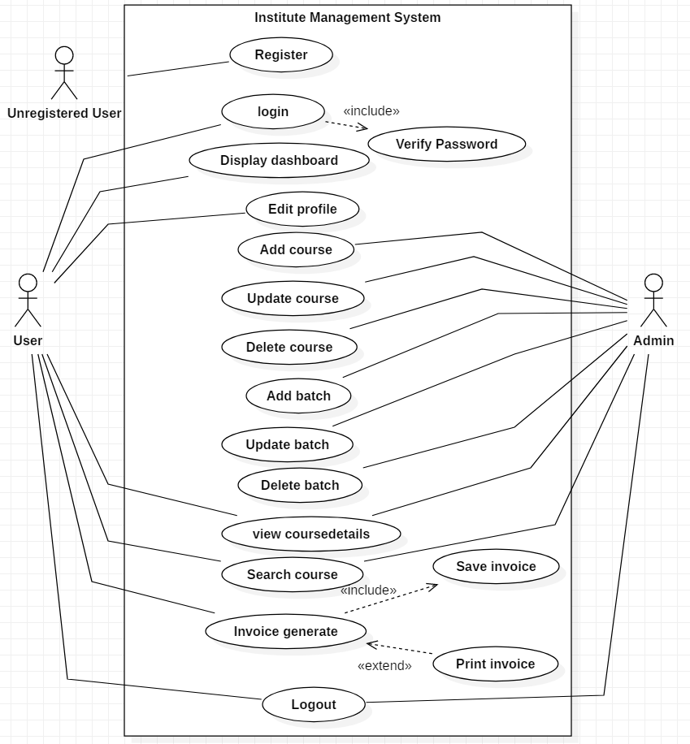

Figure 1: Use Case Diagram

It describes the relation with the users and the system including the systems functions. The topic is explained in the below table.

|  |  |  |  |  |
| --- | --- | --- | --- | --- |
| **ID** | **Use Case Title** | **Summary** | **Alternative Sequence** | **Actor** |
| UC_001 | Register | User need to register their detail to access the system and book their classes. |  | Unregistered User |
| UC_002 | Login | Two kinds of login are entered, one is admin and other is student login. It is decided when they register their account where admin can edit or delete classes. | In case of incorrect password, the message is displayed above | User, Admin |
| UC_003 | Display dashboard | Both the user is allowed in dashboard where all the events, class details and course details are available. |  | User, Admin |
| UC_004 | Edit profiles | Both the user is allowed to edit their profile for updating their mistake or need of change like there temporary address. | Message is displayed after the edit is successful. | User, Admin |
| UC_005 | Add courses | Admin adds courses. | Message is displayed after the add of course is successful. | Admin |
| UC_006 | Update course | Admin updates the courses. | Message is displayed after the update is successful. | Admin |
| UC_007 | Delete course | Admin deletes the course after the finishing the certain interval of time. | Message is displayed about the deleted course | Admin |
| UC_008 | Add batch | Admin add a certain category of class intake(batch) to let the student choose their batch for simplicity of the institute |  | Admin |
| UC_009 | Update batch | Both the student and admin can have access it so that the student can also shift their intake. | Message is displayed after updating their batch. | Admin, user. |
| UC_010 | Delete Batch | Admin can delete the old batches after the completion of their classes | Message is displayed after deleting the batch. | Admin. |
| UC_011 | View coursedetails | Both the user can access the view course detail page so that both the user can see the course details of the institute. |  | Admin, user. |
| UC_012 | Search course | Both the user can search the courses they want. |  | Admin, user. |
| UC_013 | Invoice generate | The registered students are provided with a bill for their chosen classes to pay online or pay cash. |  | User |
| UC_014 | Log out | Both the user’s logout after the completion of their use of the system. | Log out successful message is displayed. | Admin, user. |

Figure 2: Use Case

## **2.7 System Architecture**

## **2.7.1 NLA**

**Digital Skills** is an IT training institute that trains freshers and IT graduates with a wide range of technical and semi-technical skills. The institute is located in Putalisadak, Kathmandu and running their service since 2005.  Here all the works are done in a traditional way. They keep students records in ledger, use handbook/brochures for course details, does all the payment and billing manually. The whole process was time consuming and inconvenient.

So, the owner of the institute asked me to develop their institute management system as a website.

Here are his requirements:

There will be three types of users: Institute Manager (Administrator), trainers and students. Only the institute manager is granted the authority to add new course, add new students update student/course details and delete them in the website. Additionally, the institute managers can update the fee status of the students and allocate students to different batch. The manager generates the invoice of the students and keep record in database. By the end of the month, students should get alert notification about fee payment. Trainers are also given access to add the new course, update course schedule or change or delete the existing course. For students, they first need to register themselves, and the manager will verify and approve them and then only they can login. After logging in, students can only access the student materials.

**List of nouns (potential class) in the scenario:**

Types of users, Institute, Trainings, Manager, Trainers, User, Course, Batch, Students, Trainers, New Course, Existing Course, Manager, Fee, Invoice, Database, Fee Payment

**Final candidate class has been finalized following the rules given below:**

* Removed the matching, irrelevant, synonyms and outside the scope nouns
* Removed the architectural level action noun. Also, the noun that could be design during development were skipped.

Final Candidate Class

* Course
* Students
* Batch
* Fee

## **2.7.2 Initial Class Diagram**

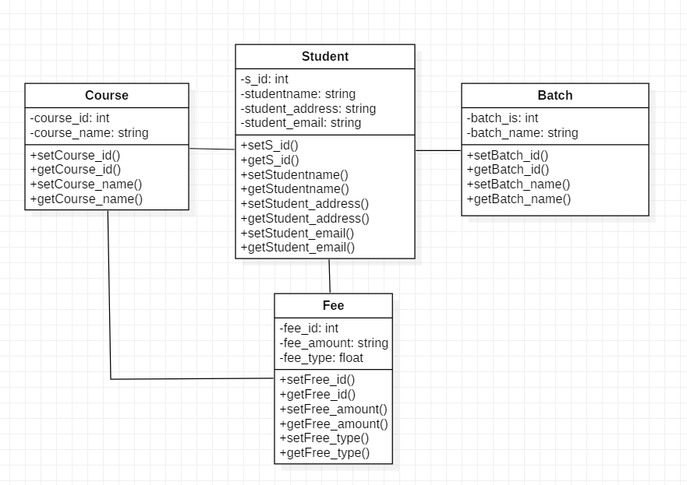

Figure 3: Initial Class Diagram

## **2.7.3 System Architecture**

3- tier system architecture is been used which holds he user interface, data storage, isolated platform and business logic. It includes client-server relation like client tier, application and database tier. It is used as all the task are separated which are handle by each layer in client-server application. Interface services are displayed to user in client tier whereas all the business logic is maintained in application tier. All the information is kept, received and saved in the data tier independently from other tiers. Its helps to keep scalability, availability and performance of the system.

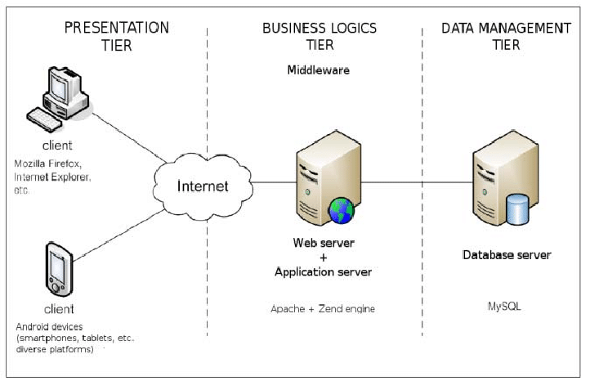

Figure 4: 3-tier System Architecture