# Chapter 3: Design

## Introduction

The development stage where all the decision are made for the making of the final product, better and smooth is known as design in programming. It is vital stage where all the user interface and logical function are planned before the coding of an application or site. Designing is executed based on all requirements of the application and the users who use the application. Here demands are converted to complete specification of application.

## 3.1 Structural Modelling

Structural Modelling is analysis technique used to analyze the relationships between object, attributes, classes and functions. (Anderson, 1988) It is meant as the procedure of illustrating the process of the system which includes modules, components and architecture.

## 3.1.1 Class Diagram

It is a type of fixed structural diagram which describes the structure of a system by viewing their methods, classes, relationships, and attributes with objects. Class diagram is part of unified modelling language. (Anon, 2019)

Importance of Class diagram:

* To show relationship between class and object as it is an object oriented application.
* To show classes included in the website and how it interacts in the system.
* To reduce maintenance time as it provides the structural diagram of the website.
* To outline all the object which the system contains and finalize relationship between them.

Notation

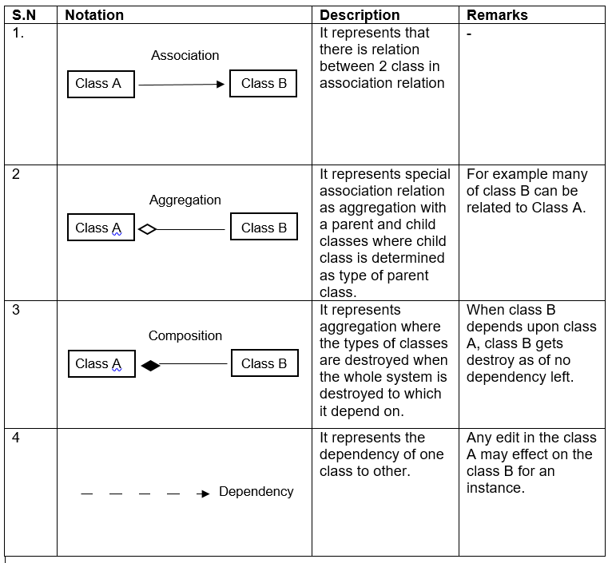

Table 1: class diagram notation

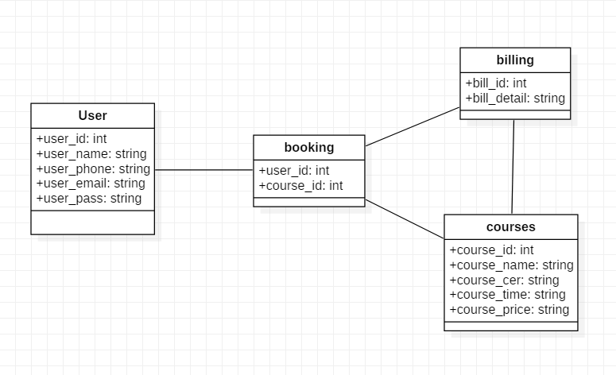

Figure 5: class diagram

## 3.1.2 Data Flow Diagram (DFD)

DFD shows the flow of the system through a business procedure where it signifies all the inputs, output, data storage and other process which occurs in the website while using as a user for the website.

Importance of data flow diagram:

* Helps to narrate the end lines of the system.
* Its structural diagram shows the execution of the web site.
* Can be included as a report in pre-implementing plans.
* Reduces data redundancy.

Notation

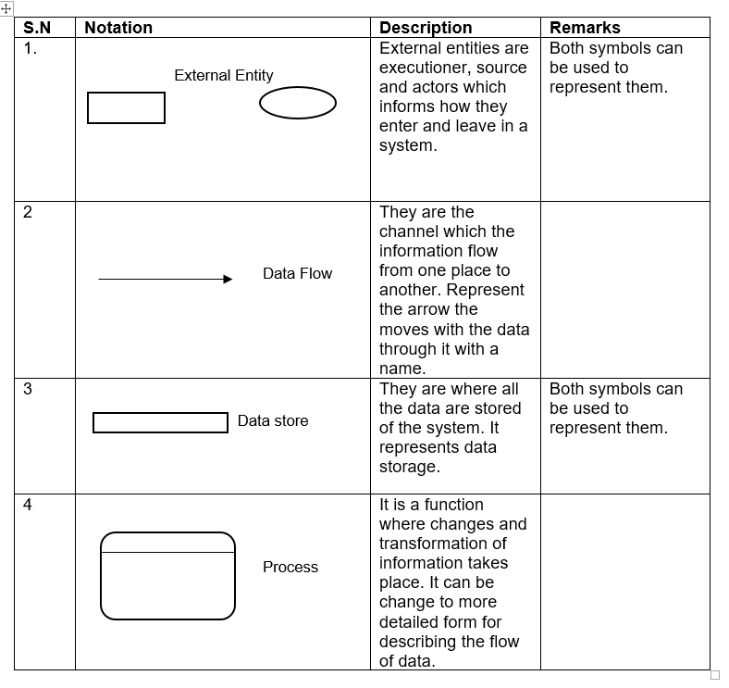

Table 2: notation diagram of DFD

**Admin DFD**

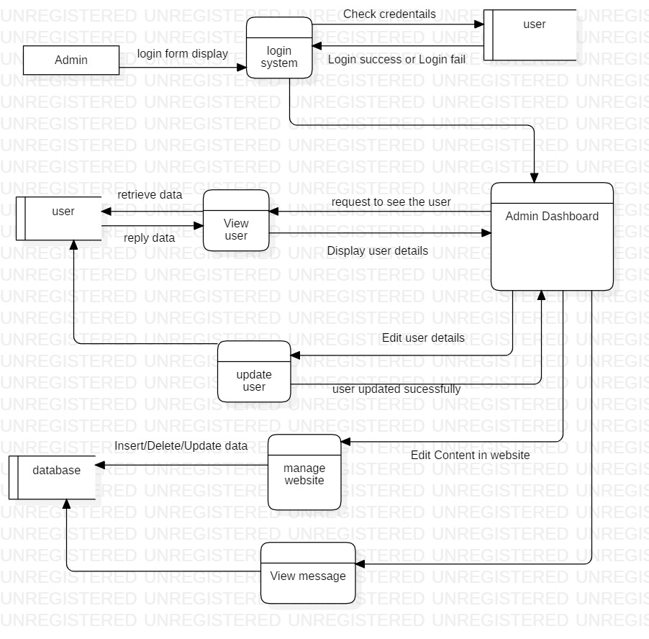

Figure 6: admin DFD

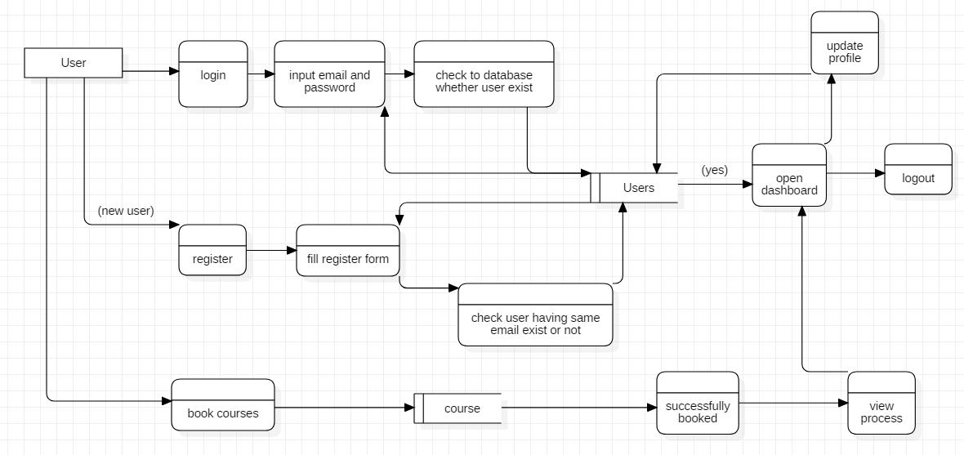

Figure 7: Workflow

The above diagram explains the flow of the activity of the system and role of the admin and user in this website. The above diagram explains that the user can login and register as a student of institute management system. Their data are stored and managed properly after they register in the website.

## Behavioral Modelling

It is social learning theory where it acts as guide for the programmers in a standard manner. It is process of presumption of people on how they react to the system giving them output. It helps to maintain the internal behavior of the system.

## 3.2.1 Activity Diagram

It is used to illustrate the flow of function in a system and help to finalize the use case diagram. It describes the flow of methods to another method in a system. (Jain, 2015)

Importance of activity diagram:

* Helps to finalize the use case diagram.
* Views the flow of function in the system.
* It simplifies and improves complicated methods.
* It describes all logic of the system in particular diagrams.

Notation

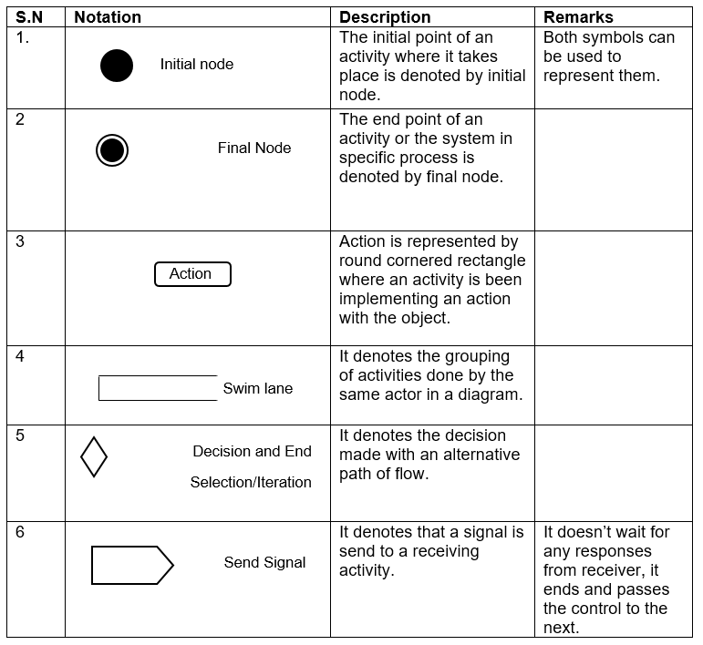

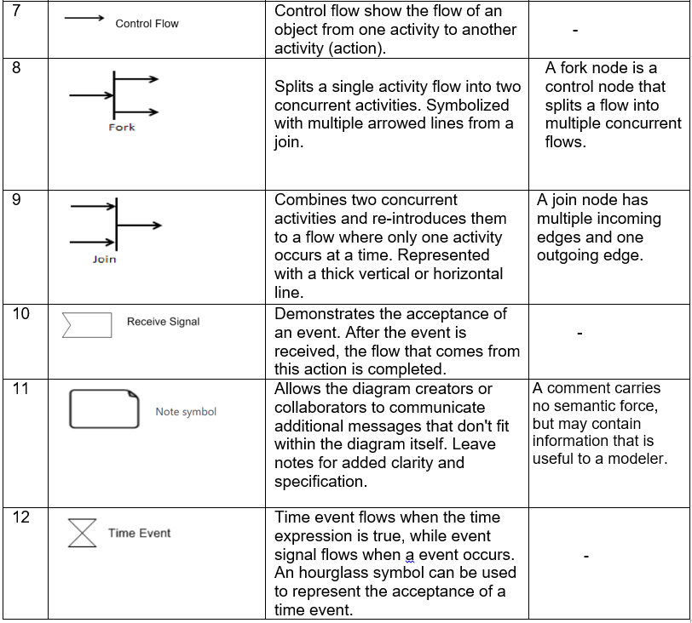

Table 3: notation of activity diagram.

Activity diagram of login and registration

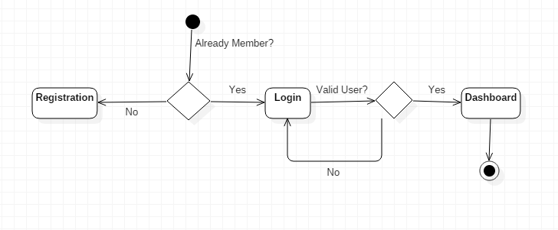

Figure 8: activity diagram of login and registration

Activity diagram of system

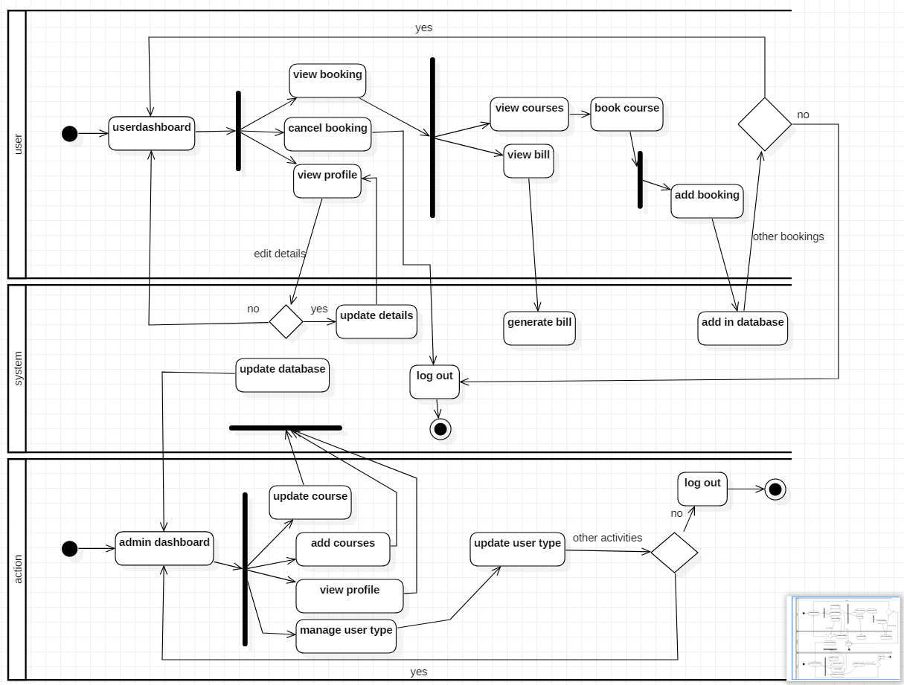

Figure 9: activity diagram of system

The diagram describes that the logged in users can control their personal profile and maintain their details as they changed it, they can book and cancel both the booking of classes or courses they will to do. The booking system validates and sends a notification of successful of a process of booking or creating an id. User can generate a bill if they will to pay it online or take a copy of it for their purpose. Admin are able to generate a report of the users

## 3.2.2 Sequence Diagram

A sequence diagram simply shows the interaction with objects in a sequential order where the interactions occurs. We also use event scenarios to represent sequence diagram. It describes how object are in a system and in what order.

Importance of Sequence diagram:

* It shows the reaction with object and its operations.
* It helps to plan and understand the function of object for future reference.
* It help to adjust the operation of the system.
* It identifies problem, interface and architectural problems.

**Notation**

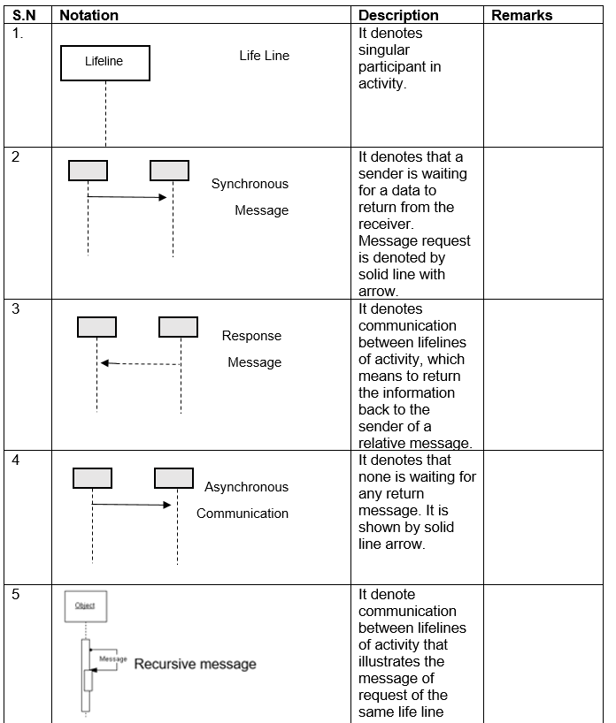

Table 4: Notation of Sequence diagram

Sequence diagram of login system.

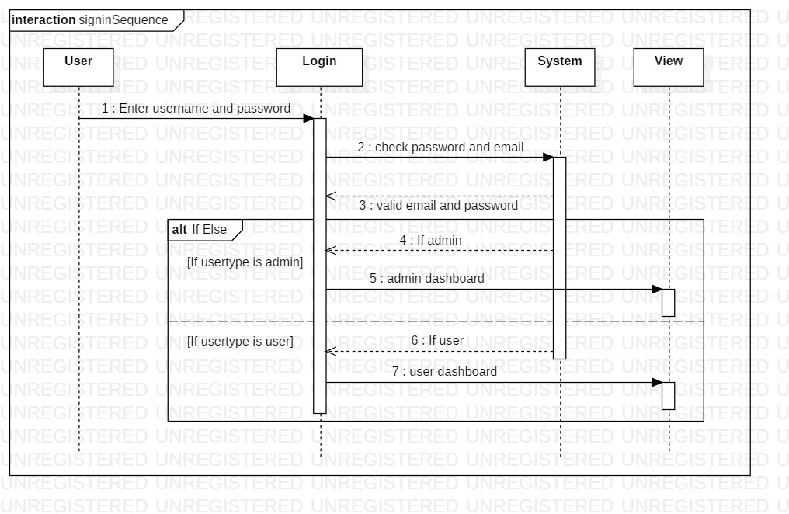

Figure 10: sequence diagram of login system

Sequence diagram of the whole system.

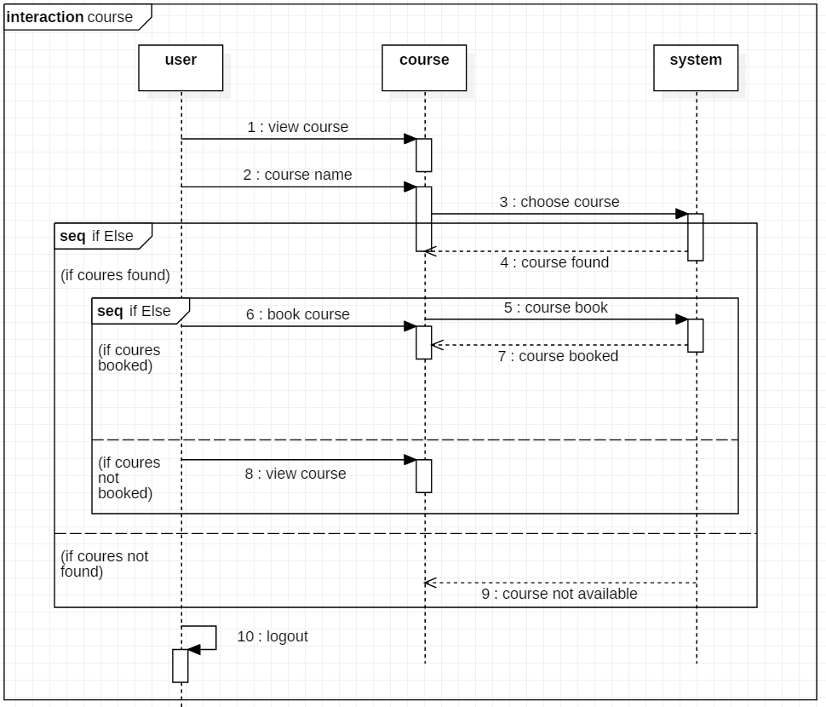

Figure 11: work flow sequence diagram

## 3.3 Database modelling

Database modelling describes the rational structure of the system showing the relationship between class and object of the system as per required. It shows how the data runs, stored and accessed. It represents the design of the database of the system.

## 3.3.1 ER Diagram

ER (Entity Relationship) diagram is a pictorial diagram illustrating the relationship between class, objects, function, etc. as per the requirement of the system and given by the client.

Importance of ER diagram:

* Object and attributes can be determined.
* Show the relation with one entity to another.
* It show the number of relation implemented in the entity.

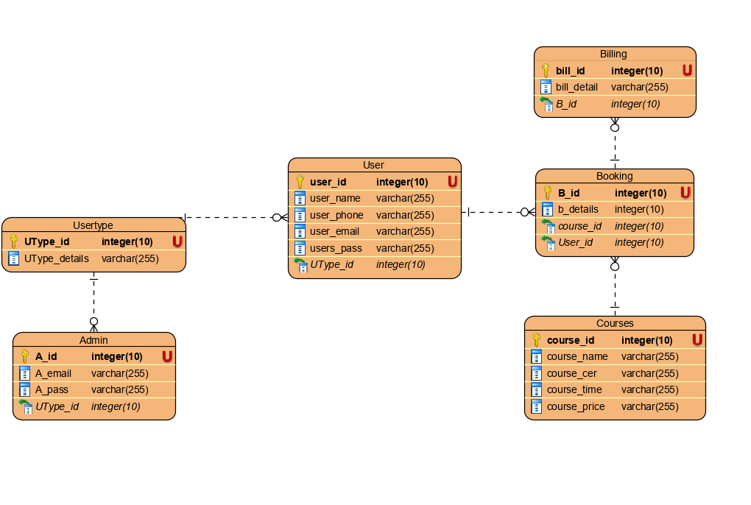

Table 5: ER diagram

## 3.3.2 Data Dictionary

It is a set of data and information which contains metadata such as table name, column name, attributes, and related information.

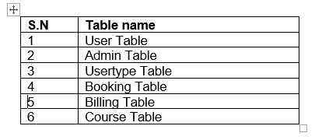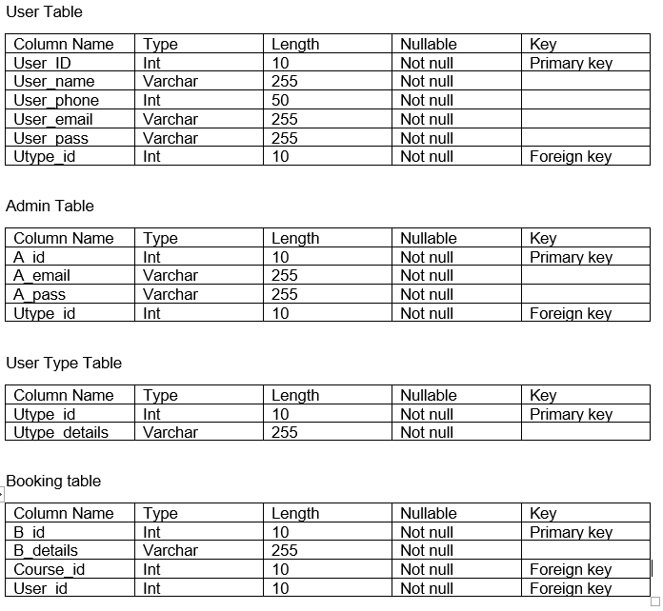

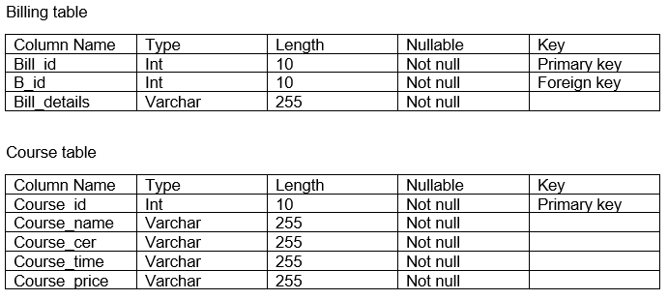

Table 6: data dictionary

## 3.4 UI modelling

The process of developing front end layout of the website or an application before implementing in the back end of the system is called UI (User Interface) modeling. UI is very important nowadays as every people trust in a friendly user interface which help them to use it in an easy and smooth order. As my project is a website it is the key component of the project. Here, I have designed my layout in an external application called Balsamic.

## 3.4.1 Prototyping

Prototype is rough sketch of the layout of the front end design of any application or a website to sort out future problems. It helps to show the client how the system work in a user interface module.

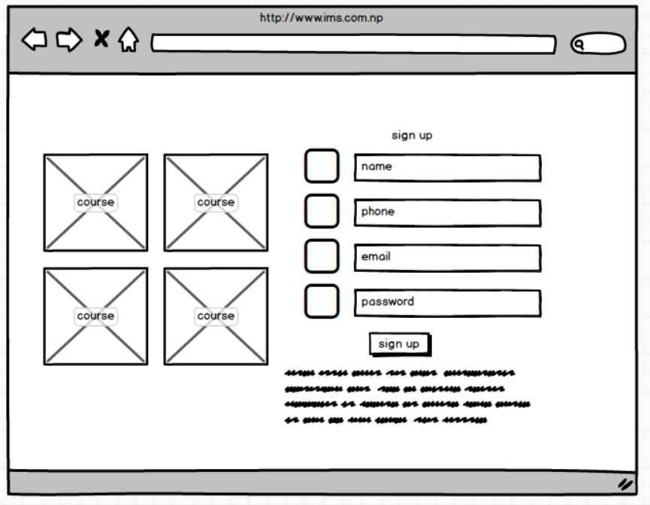

Figure 12: registration form

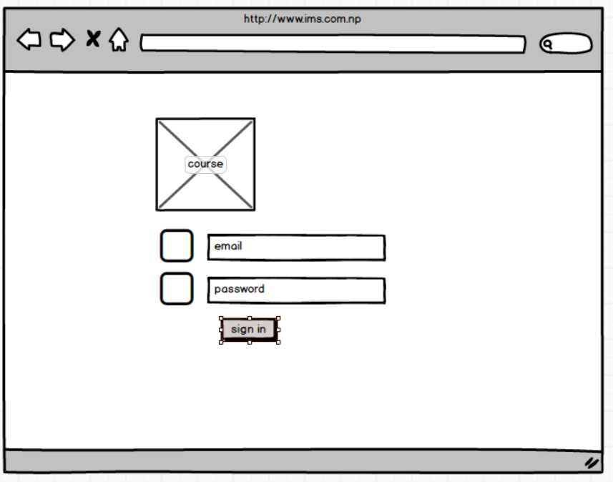

Figure 13: login form

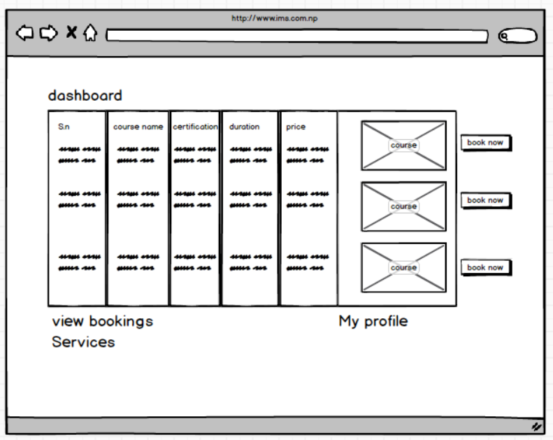

Figure 14: user dashboard and booking form

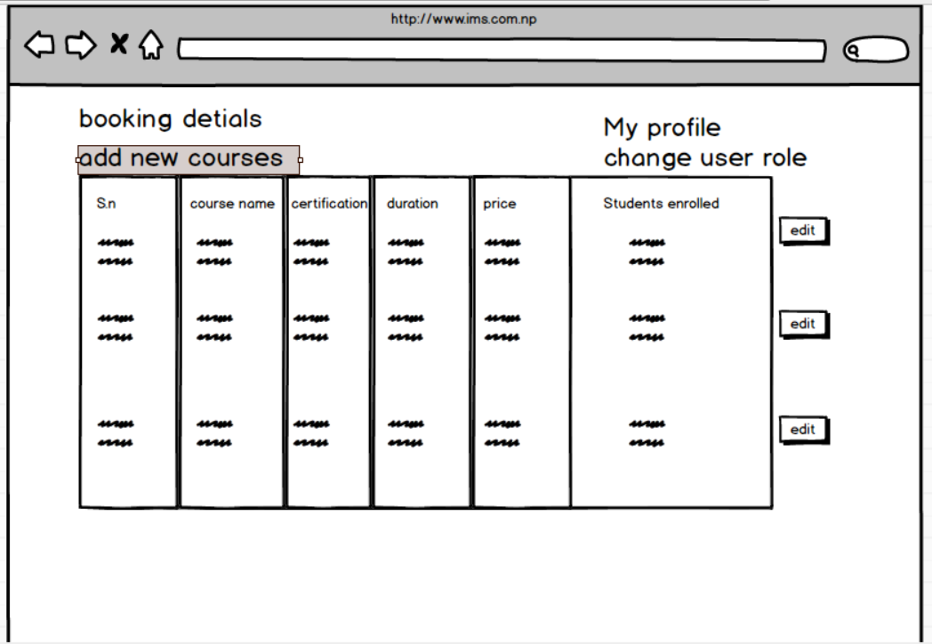

Figure 15: admin dashboard

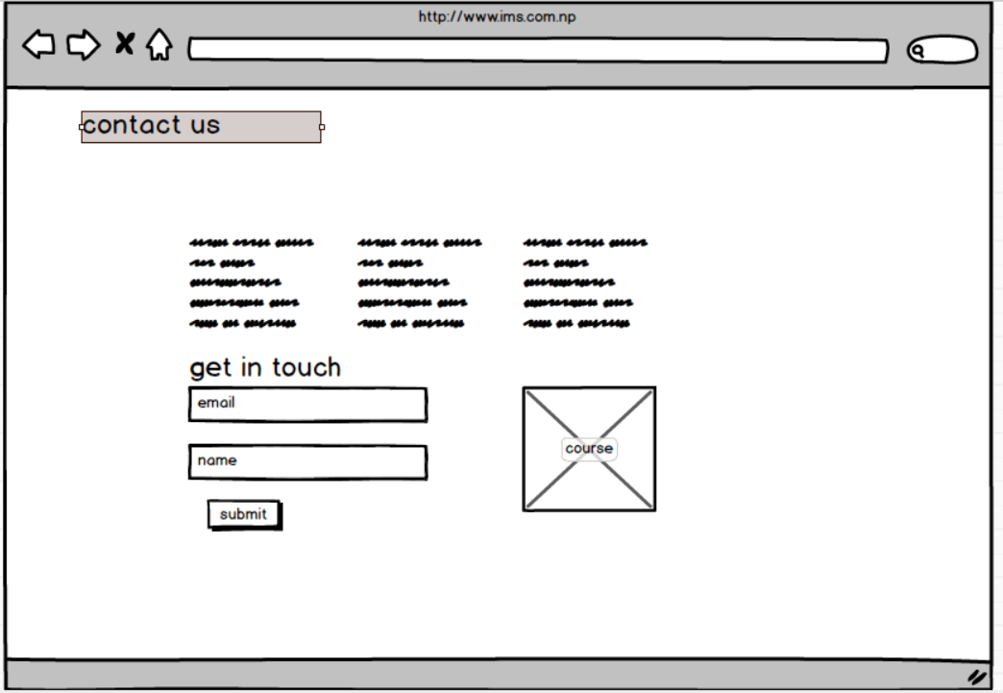

Figure 16: contact-us.php

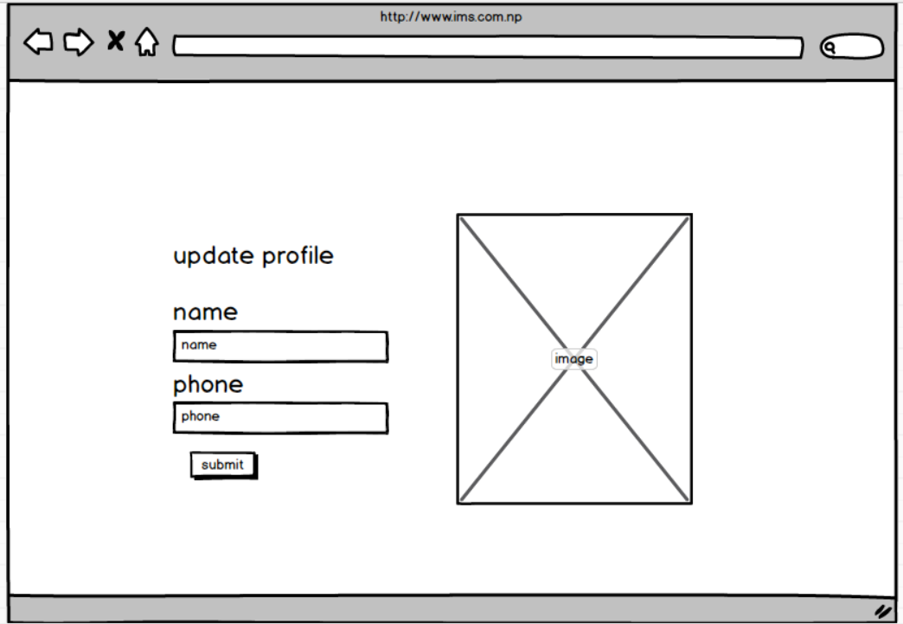

Figure 17: update profile

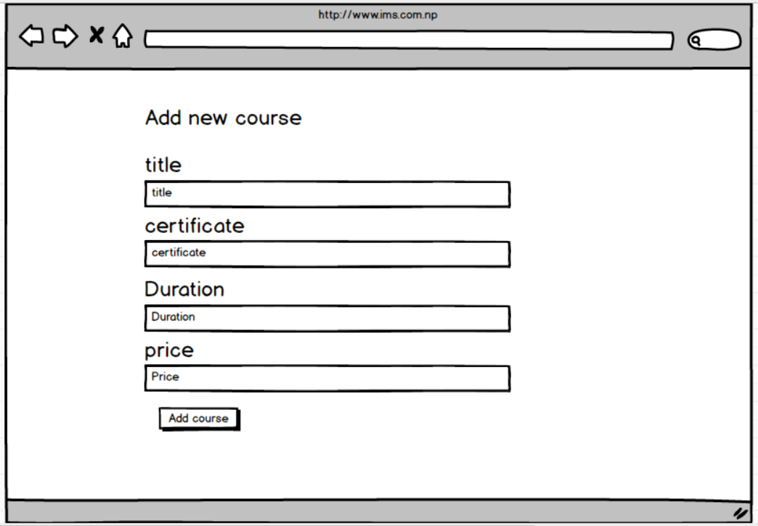

Figure 18: add course

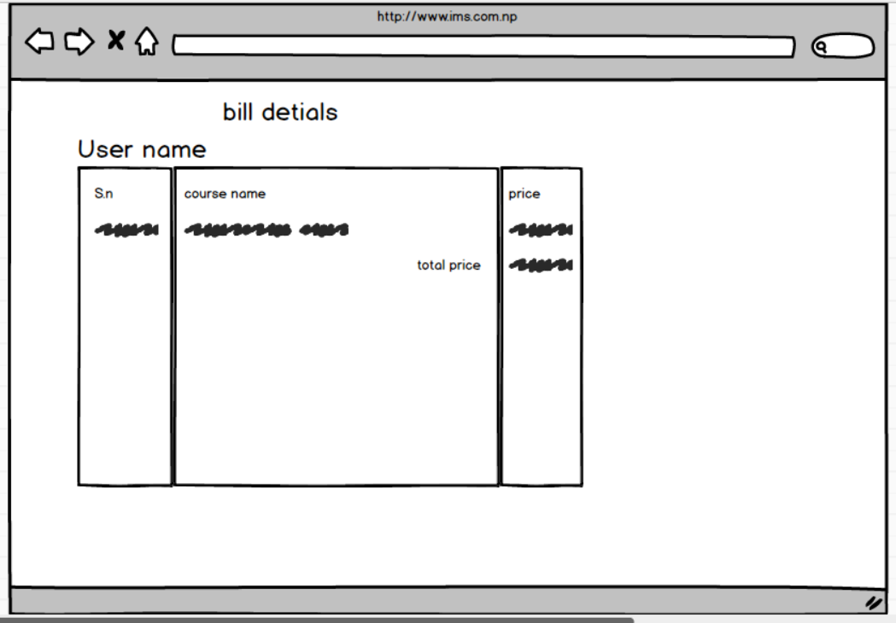

Figure 19: generate bill