

Table of Contents

Table of figures 3

Table of tables 3

Chapter 1 4

Introduction 4

1.1 Introduction of the System 4

1.2 Background of the system 4

A. Problem statement 4

1.3 Justification of the project 4

1.4 Overview if the purposed system. 5

Chapter 2 5

Scope 5

2.1 Aims of the project 5

2.2 Objectives of the project 5

2.3 Features of the project 5

2.4 Overview of the Scope 6

Chapter 3 7

Development Methodologies 7

3.1 Methodologies 7

3.2 Design Pattern 8

3.3 System Architecture 9

Chapter 4 10

Scheduling 10

4.1 WBS (Work Breakdown Structure) 10

4.2 Milestones 11

4.3 Gantt Chart 12

Chapter 5 14

Risk Management 14

Chapter 6 16

Configuration management 16

Conclusion 17

# Table of figures

Figure 1: waterfall approach 7

Figure 2 : MVC pattern 8

Figure 3 : system architecture 9

Figure 4 : WBS (work breakdown system) 10

Figure 5 : Gantt chart 13

# Table of tables

Table 1: Milestone 11

Table 2 : Gantt chart table 12

# Chapter 1

## Introduction

## Introduction of the System

Institute Management System is a website which is made for managing different kinds classes run by an Institute to maintain a sustainable business through system instead of writing into notebooks or copies. It helps to maintain a secure and efficient data of the students and the details of the classes they are involved in. The web application provides detail of every classes running with the price, time and detail about the classes in brief. The company can easily add the student as the user where they can book their classes online and even can access the details about their class details. This web application can help to keep record of student and visitor in an easier and efficient manner as well as it makes the institute available for the all the people to enquire about it from home or any place suitable.

## Background of the system

Institute Management System is a web application which may contain data retrieval, data efficiency, data entry and financial reports. For now, the institute hasn’t developed and system as it is new opened company and they have seen many problems occurred with the other institute where manually data is recorded.

### Problem statement

The aim of the system going to be built for the institute is to perform data handling in an efficient manner. The institute without the system is willing to manage the data by writing it in big register for the details of the students about their courses and fee details. The system is being built for the simplicity and automation of the recording personal data, payment reports and exam dates.

The drawbacks of institute management system for manual process are as follows:

* Manual system leads to less accuracy and reliability.
* Different kinds of storing space is needed to store in a manual order.
* Time consuming.
* Data cannot be backed up as the recording is done in an original book itself.
* Speed and accuracy are decreased.

## Justification of the project

The institute can have a number of students according to their courses and type of course running in the institute so due to unreliable number of students the institute will not be able to record all the details in a simultaneous order. The institute management has to maintain all the data according to their course involved with its fee structure. As the recording may have different kinds problem like data inefficiency, students may not prefer to give their personal information to the institute.

So, Institute Management System is developed to overcome different drawbacks that could occur in the institute while recording or even giving their payment report. The system will allow the admin of the institute to manage all kinds of data in an efficient and simple manner. The system can help to record up to a number of students as per the institute requires. The system calculates itself about fees or the payment the students has to pay for their courses.

## Overview if the purposed system.

The students can confirm their courses seat from their home and the record can be managed in an automatic order where the admin only has to check about the updates receiving about the classes and students joining the institute. The aim of the web application is to manage multiple course to single student as per he/she requires with a genuine and reliable fee structure. For managing and overcoming all the drawbacks the institute could face, this web application is created.

# Chapter 2

## Scope

## 2.1 Aims of the project

The main goal of the system is to simplify and automate the record process relating to institute like student’s details, subjects, payment reports and their exam progress.

* Increase the performance, accuracy & provide better service.
* To secure the personal data and payment report of a particular student.

## 2.2 Objectives of the project

To improve all the drawback with some features are the objectives of creating the system. Some of them are:

* Providing accurate and updated relevant details.
* To simplify and minimize paper work.
* Provide security for the data of students and clients.
* Provide payment reports according to their courses.

## 2.3 Features of the project

Some features of the system are:

* **CRUD Function**

Admin can edit the information about the details they want like add, delete and update in database.

* **Course Management**

Add courses, their duration and fees structure.

* **Student Management**

Register new students for a class.

* **Fee Management**

Show fee detail of the course and show them as paid or need to pay.

* **Dashboard**

View all the courses, student details and other information.

* **Automatic notification alert**

Notification about the number of days remaining in for the exams or finishing their courses.

## 2.4 Overview of the Scope

The function of the system is to automate the recording of students' details and managing them in an organized way. It allows the system manager to add new courses, enroll new students, update the fee structure, edit details and delete the old data. Also, the admin of the system can assign specific authority to other members of the institute such as allowing trainers to update the course, allowing accountant to keep record of fee payments and so on.

Through the system, student automatically receive alert notification regarding examination due date, course completion, fee payment, or any new notice.

# Chapter 3

## Development Methodologies

## 3.1 Methodologies

Since this project is small in size, I chose Waterfall method for its development. This is a traditional methodology that starts with the detailed planning of the project. In this Software Development life cycle methodology, all the required steps are figured out, the steps dependency is mapped and steps are carried out in such a way that you cannot move to next step until you finish the previous one.

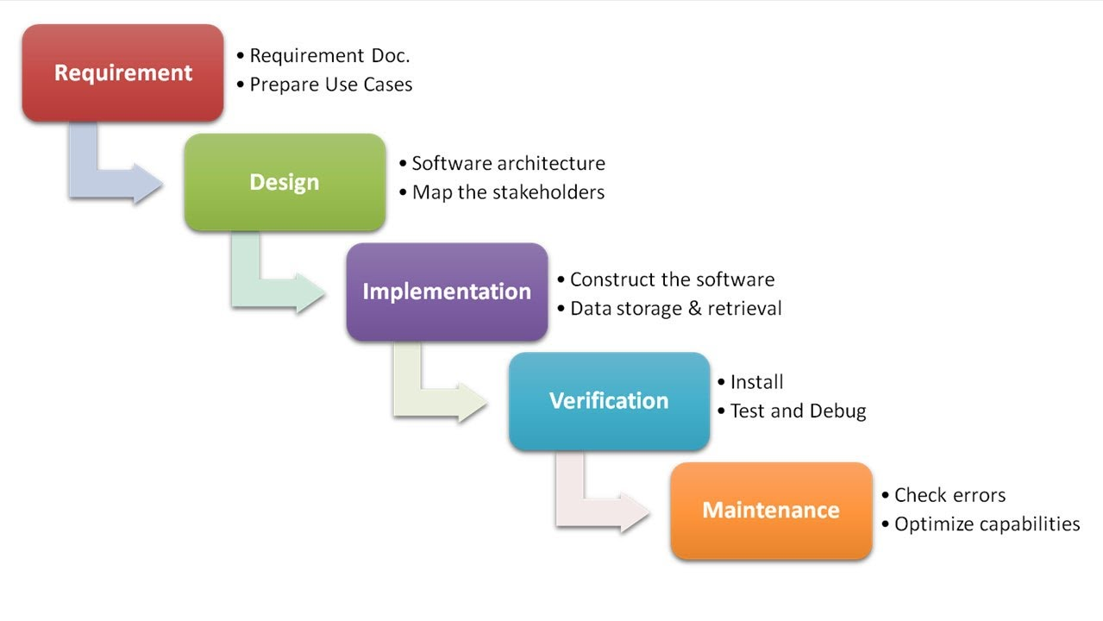

Figure 1: waterfall approach

## 3.2 Design Pattern

Among many design patterns available, I chose OOP (Object Oriented Programming) design pattern for this project, as this pattern is clean and modular, which is easy to test, debug, and maintain in the future.

Here in OOP design pattern

It involves four major principles:

* Encapsulation
* Abstraction
* Data Hiding
* Inheritance

## 3.3 System Architecture

System architecture means the abstract model of any system that defines its structure, behavior, and more views.

3 tier architecture is the software architecture that is used in application as a specific type of client-server system. It is composed of 3 layers/tiers of logical computing. They are Presentation tier, Application tier and data tier. The benefit of using this system architecture is enhanced speed of development, better scalability, performance and availability.

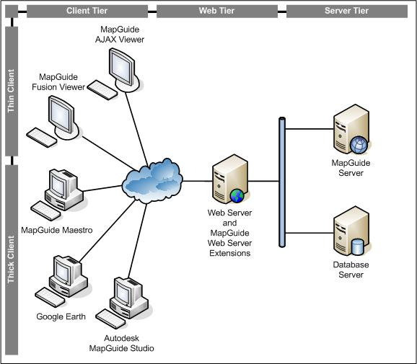

Figure 3 : system architecture

# Chapter 4

## Scheduling

## WBS (Work Breakdown Structure)

The workflow that organizes the team work to manageable process is called work breakdown structure. It is important for planning and executing the project.

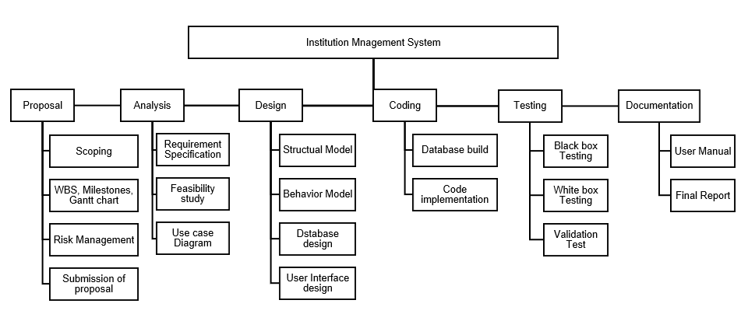

Figure 4 : WBS (work breakdown system)

## Milestones

|  |  |  |
| --- | --- | --- |
| Task Name (Milestones) | No. of days | Date |
| **Proposal**  Scoping  WBS, Milestones, Gantt chart  Risk Management  Submission of proposal | **16**  4  5  4  3 | **16th June – 1st July, 2019**  16th June – 19th June, 2019  20th June – 24th June, 2019  25th June – 28th June, 2019  29th June – 1st July, 2019 |
| **Analysis**  Requirement Specification  Feasibility study  Use Case Diagram | **28**  26  10  2 | **2nd July – 29th July, 2019**  2nd July – 17th July, 2019  18th July – 27th July, 2019  28th July – 29th July, 2019 |
| **Design**  Structural Model  Behavior Model  Database Design  User Interface design | **31**  9  8  8  6 | **30th July – 29th August, 2019**  30th July – 7th August, 2019  8th August – 15th August, 2019  16th August – 23rd August, 2019  24th August – 29th August, 2019 |
| **Coding**  Database build  Code implementation | **22**  5  17 | **30th August – 20th September, 2019**  30th August – 3rd September, 2019  4th September – 20th September, 2019 |
| **Testing**  Black Box Testing  White box Testing  Validation Test | **10**  3  5  2 | **21st September – 30th September, 2019**  21st September – 23rd September, 2019  24th September -28th September, 2019  29th September – 30th September, 2019 |
| **Final Documentation**  User Manual  Final Report | **12**  5  7 | **1st October – 12th October, 2019**  1st October – 5th October, 2019  6th October – 12th October, 2019 |
| **Total Days** | **119** |  |

Table 1: Milestone

## Gantt Chart

Gantt chart is a figure which shows task activities with time. It is made in a horizontal manner showing time span and work breakdown showing the tasks of the project.

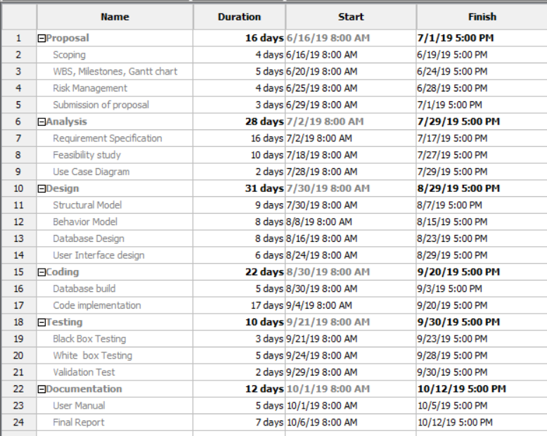

Table 2 : Gantt chart table

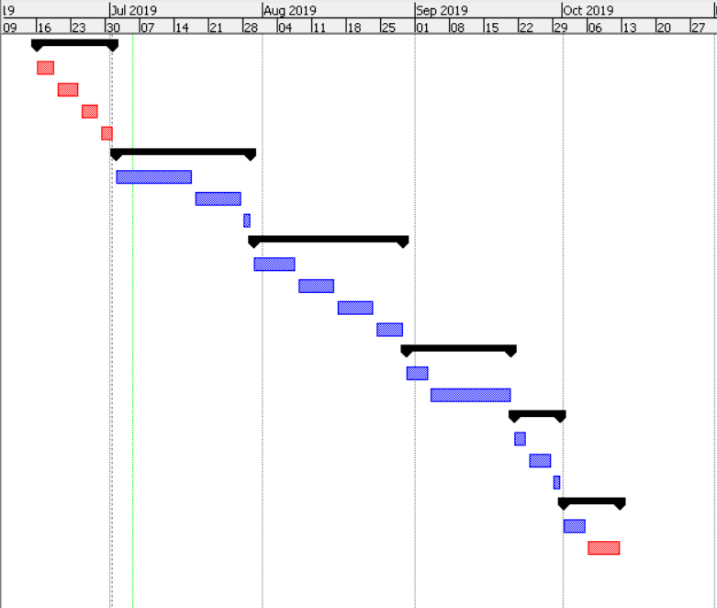

Figure 5 : Gantt chart

# Chapter 5

## Risk Management

The process of assessing, identifying and controlling threats to an organization’s fund or earning is called risk management. Threats can be from variety of sources like legal liabilities, accidents, natural disasters, strategic management error, etc.

To provide risk management following:

1. Risk Identification

This process unleashes the risk of the project. Project risk register technique can be applied.

1. Risk Analysis

After identifying the risk, the institute tries to separate the risk of it occurring and its consequences.

1. Risk evaluation and assessment

Risk is further evaluated by determining its risk portion which is combination of consequences and likelihood.

1. Risk mitigation

The organization evaluate all the risk by ranking all the risk the organization is going to face. Its preventives are risk prevention tactics, risk mitigation process and contingency plan.

1. Risk monitoring

Now we collect the data from the project risk register and use it to find and review the risks.

Likelihood table:

|  |  |
| --- | --- |
| **Likelihood** | **Value** |
| Low | 1 |
| Medium | 2 |
| High | 3 |

Risk consequences table:

|  |  |
| --- | --- |
| **Consequence** | **Value** |
| Very low | 1 |
| Low | 2 |
| Medium | 3 |
| High | 4 |
| Very high | 5 |

Risk Management table:

|  |  |  |  |  |  |
| --- | --- | --- | --- | --- | --- |
| **RID** | **Risk Name** | **Likelihood** | **Consequence** | **Impact** | **Action** |
| R1 | Requirements Change | 3 | 5 | 15 | Proper analysis of requirement in the beginning of the project. |
| R2 | Threats of virus | 2 | 3 | 6 | Antivirus installation. |
| R3 | Untrained employee | 2 | 3 | 6 | Training should be given to training. |
| R4 | Failure of server | 1 | 5 | 5 | Backup of data. |
| R5 | Improper estimation of budget | 1 | 5 | 5 | Requirement analysis should be implemented. |
| R6 | Stakeholder conflicts | 2 | 5 | 10 | Identification of stakeholder who has correct set of invest and resources. |

# Chapter 6

## Configuration management

Configuration management is a system engineering process for protecting among the physical and logical assets from the operational environment. It seeks to find the configuration item, interdependencies and functional capabilities.

We have used GitHub to manage the project and have kept the related files and folders of the project for availability.

To access the files:

<https://github.com/SuditMaharjan/Computer-Project-CP->

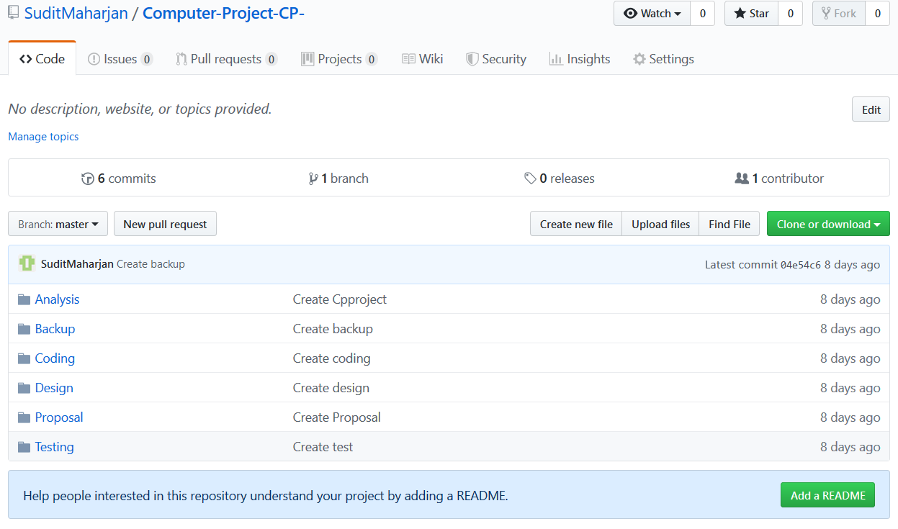

# Conclusion

This website application manages all the data related to institute and the students studying there. It can assist in an effective manner which can help the institute to handle their data and work secure and help to run in a simultaneous order. Its main target to record the student details and its courses and be managed in a detailed manner with its time and payment record. To finish the project, I have performed different kinds of analysis, study, design, etc. to execute a good web application which can fulfill all the needy requirement.