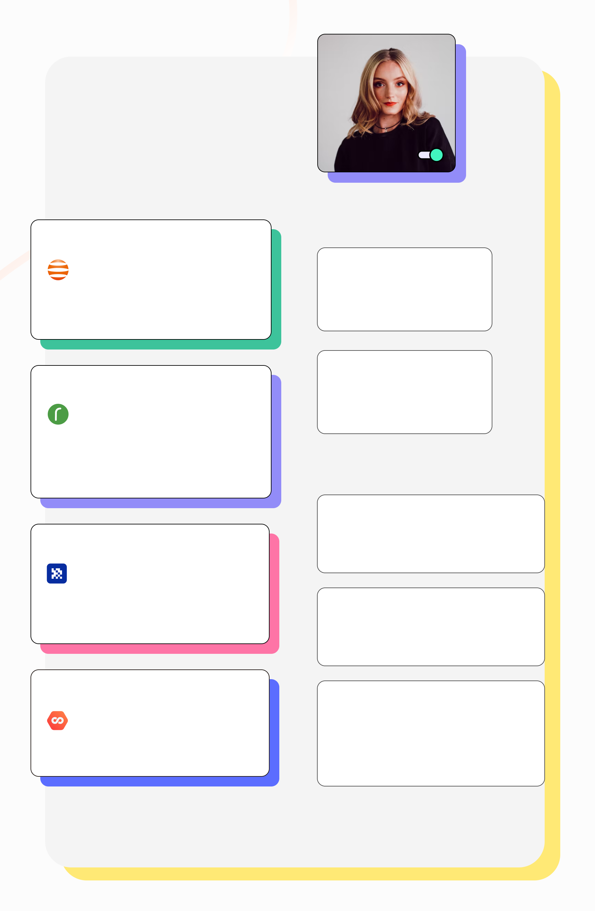

|  |
| --- |
| Katherine Monroe  UX/UI Designer |

|  |
| --- |
| Nov 2017 - Nov 2019 |

|  |
| --- |
| **UI /UX Designer - Front-end** |

|  |
| --- |
| Visual Design  Prototyping  UX Researching |

|  |
| --- |
| Principle  Web / Mobile  Front-end Dev |

|  |
| --- |
| Minsk, Belarus |

|  |
| --- |
| Transimperial |

|  |
| --- |
| June 2016 - Sep 2017 |

|  |
| --- |
| **Freelance Designer** |

|  |
| --- |
| Visual Design  Prototyping |

|  |
| --- |
| Researching  Web / Mobile |

|  |
| --- |
| It-Practik Lab |

|  |
| --- |
| Minsk, Belarus |

|  |
| --- |
| Aug 2021 - Current... |

|  |
| --- |
| **Lead UI/UX Designer** |

|  |
| --- |
| Visual Design  Prototyping  UX Researching |

|  |
| --- |
| Principle  Presentations  User Jorneys |

|  |
| --- |
| Company Name |

|  |
| --- |
| Dubai, UAE |

|  |
| --- |
| **Work experience** |

|  |
| --- |
| Nov 2019 - Aug 2021 |

|  |
| --- |
| **Senior UI/UX Designer** |

|  |
| --- |
| AppsIntegra Technology |

|  |
| --- |
| Dubai, UAE |

|  |
| --- |
| Visual Design  Prototyping  UX Researching  Front-end Dev |

|  |
| --- |
| Unity 3d Models  Principle  Presentations  Web / Mobile |

|  |
| --- |
| **Education** |

|  |
| --- |
| 2009-2015 |

|  |
| --- |
| Business Psychology |

|  |
| --- |
| Belarussian State Pedagogical University (Minsk) |

|  |
| --- |
| 2015-2016 |

|  |
| --- |
| It-Academy |

|  |
| --- |
| Full Stack Web designer  Front-end Dev (Minsk) |

|  |
| --- |
| **Skills** |

|  |
| --- |
| Software |

|  |
| --- |
| Axure, Figma, Sketch, Photoshop,  Illustrator, XD, Unity, Zeplin, Principle |

|  |
| --- |
| Front-end |

|  |
| --- |
| NPM, JavaScript, HTML, CSS, Bootstrap, Git, Lit |

|  |
| --- |
| I Can |

|  |
| --- |
| Protyping, Desktop Application, Mobile Applications, Web Sites, Admin Panels, CRM systems, Tilda, Banners, UI Kit, Brand book, Logo, OOUX, Shopify and more.................... |

|  |
| --- |
| Hobby    Photo./ .. Video ./.. Psychology ./.. Football ./.. Fishing |

|  |
| --- |
| +99 (99) 9.9999-9999 |

|  |
| --- |
| katherinem@email.com |