SUDO SAPIENT
SY OS — Phase 1 Proposal
Your production system, from buyer PO to packed carton — with a working demo of Milestone 1
Prepared for | Abhi — knitwear export factory
Prepared by | Sudo Sapient
Date | 28 October 2026
In reply to | SY OS Developer Brief: Phase 1 (26 Oct 2026)
Status | Draft for discussion

1. Summary
We read your Phase 1 brief closely and, instead of only writing back, we built the first milestone so you can click through it. The demo runs the master order sheet and the fabric follow-up & planning tab on real logic: it answers, for every colour and dia line, whether the fabric will be in-house before cutting must start — and by how many kg it falls short.
- Milestone 1 works end to end — order entry with colour × size grid, bundles, consumption, dia program, trims, amendments with reasons, repeat orders, admin-only costing and the fabric planning tab with WhatsApp-ready follow-ups.
- Milestones 2–4 work too, on sample data — trims POs and receipts, cut lots with GSM, width and consumption checks and bundle numbers, hourly sewing, checking and packing with the size-wise tracker, and a live dashboard with rule-based alerts. You can walk one order from PO to packed carton.
- Three languages — English, Hindi and Tamil on every screen. We added Hindi for the migrant workers on your floor.
- Built on your terms — Django + PostgreSQL on a server inside the factory, your Git account, full audit, no hard deletes, and every floor field ready for scanners and scales later.

2. What we understood
SY OS replaces hand-kept sheets with one connected record. The master order is the base; fabric, trims and every floor screen read from it.
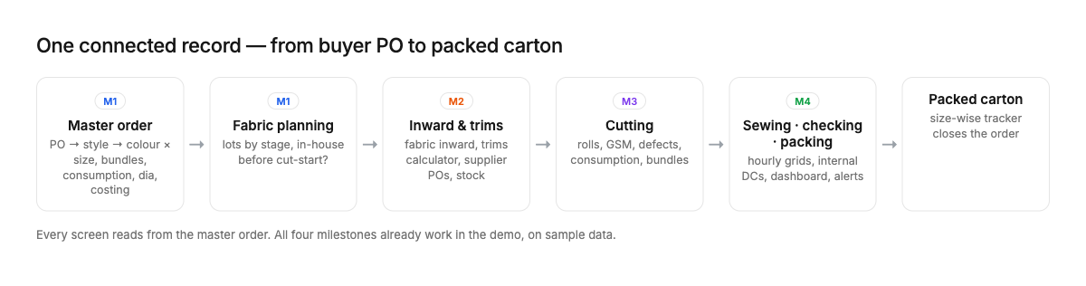
The Phase 1 flow and which milestone delivers each part

Who uses it
Role | Does | Device | Language
Admin (owner) | Everything, including costing and margins; approves POs; sets tolerances | Laptop / phone | English
Data entry | Master orders, trims POs, hourly sewing/checking/packing from slips, DCs | Office PC | English / Tamil
Fabric in-charge | Fabric lots and stages, expected dates, inward, issue to cutting | PC or tablet | Tamil
Cutting in-charge | Cut lots: rolls, GSM, width, defects, kg returned, bundle numbers | Tablet at cutting table | Tamil / Hindi
Supervisors | No entry; hourly slips to data entry; view their line board | Floor TV / tablet | Hindi / Tamil
Languages per role are our assumption — to confirm per person during discovery

3. See it working — the demo
Everything below is a screenshot of the running demo, using two realistic sample orders. SY-2611 has 2 colours × 5 sizes and 4,150 pieces, one fabric lot landing after cut-start and one dia line short-booked; both orders have trims POs, cut lots and a day of floor entries.
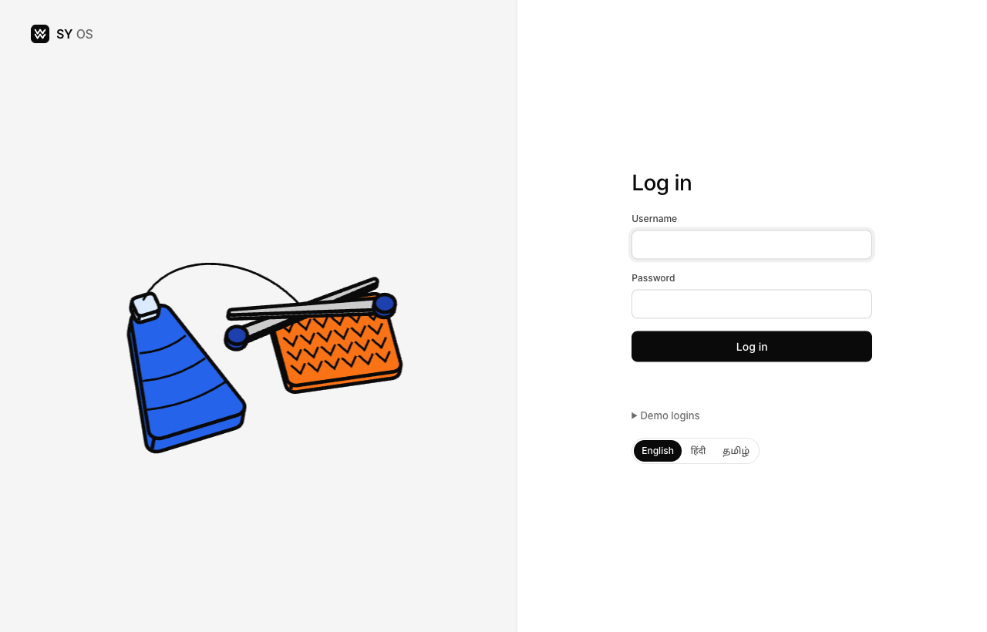
Login, with the language switch on the first screen

Orders and fabric status at a glance
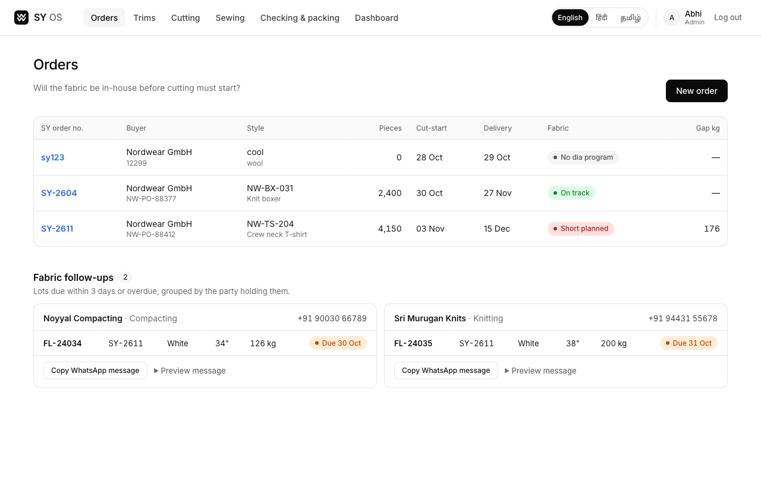
Every order with its worst fabric status and kg gap; follow-ups due in 3 days are ready to copy into WhatsApp

Master order sheet
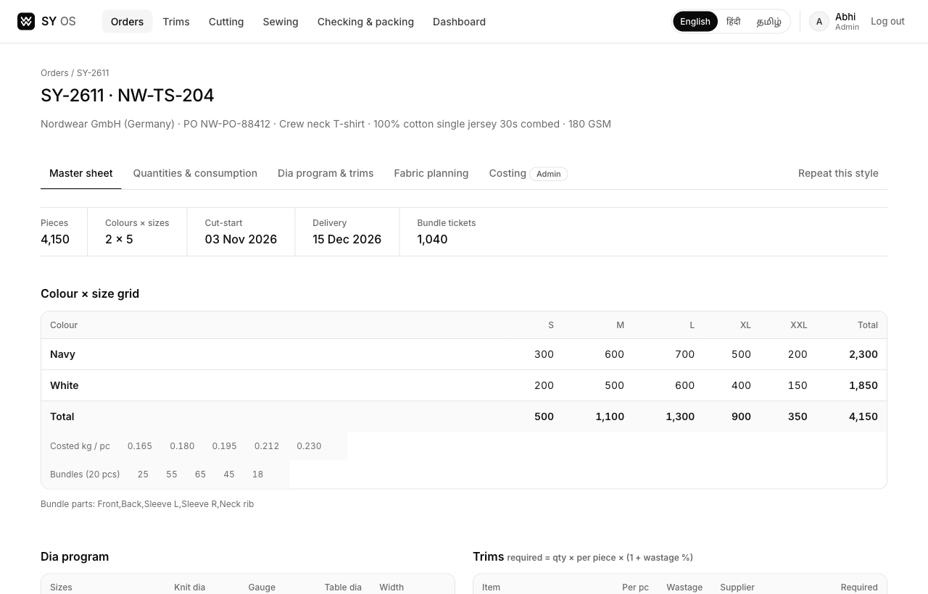
Master sheet: pieces, cut-start, delivery and bundle tickets, then the colour × size grid with consumption and bundles per size; further down, dia program, fabric needed, trims, the size-wise tracker and the amendment log

Fast, keyboard-first entry
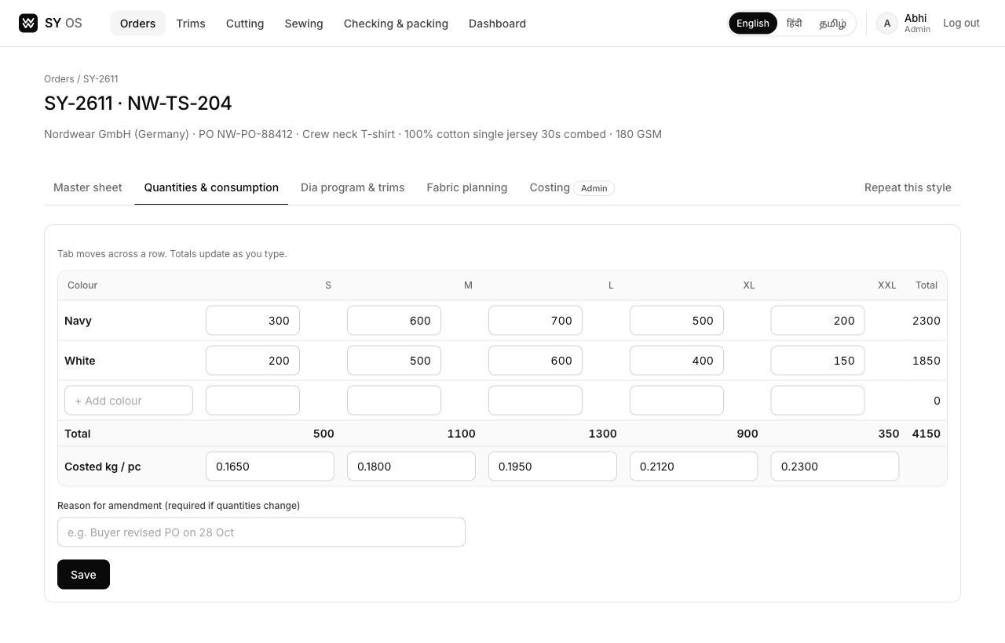
Tab through the grid, totals update as you type. Changing quantities or consumption after first entry requires a reason and is logged

Fabric follow-up & planning
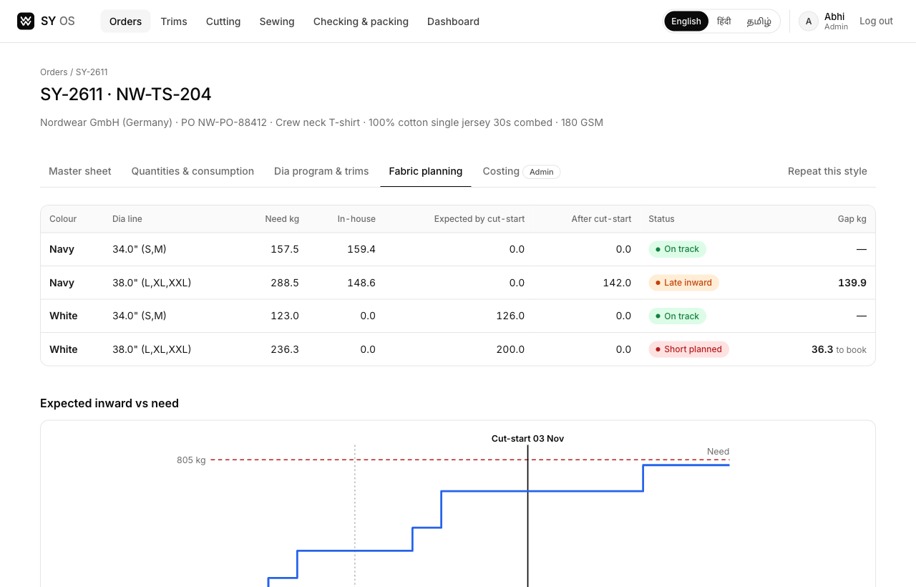
Per colour × dia line: need, in-house, expected by cut-start, after cut-start, status and kg gap. The chart shows expected inward against need and the cut-start date

Costing — admin only
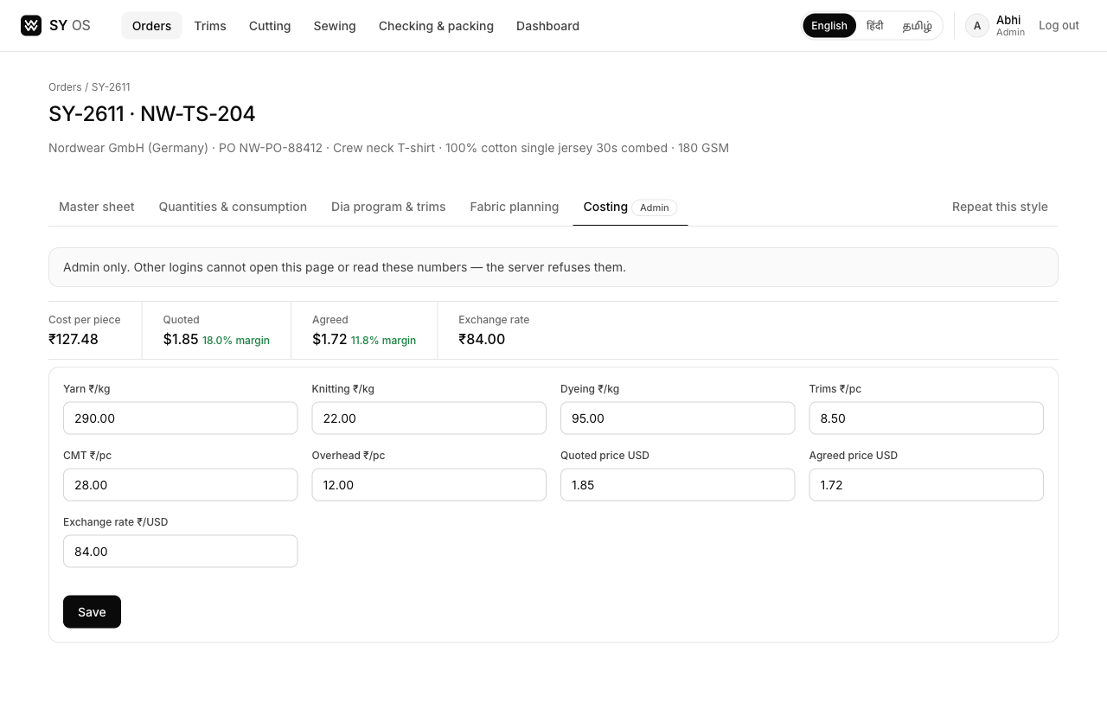
Cost per piece, quoted and agreed margin. The server refuses this page to every other login (403), so it is not just hidden

Hindi and Tamil
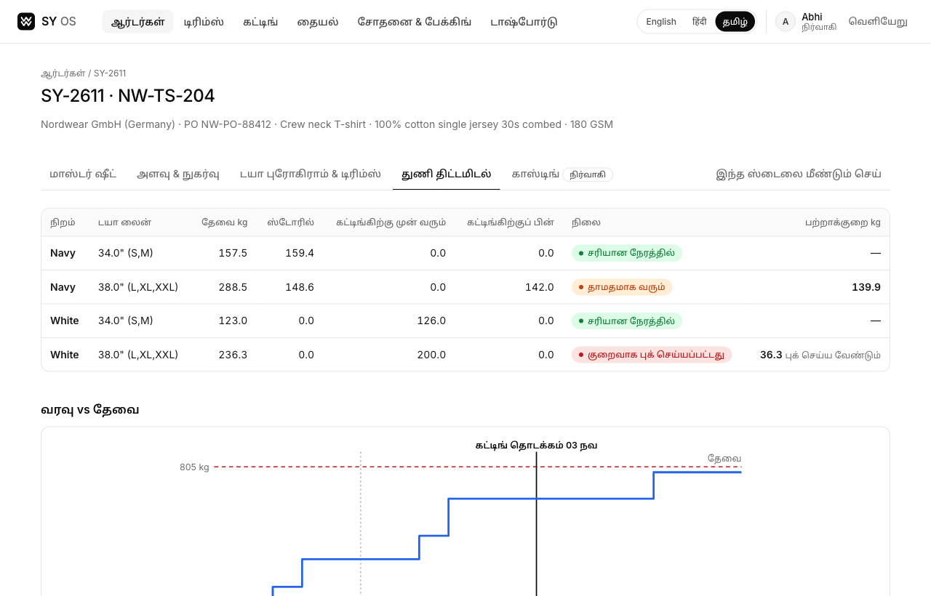
The fabric planning tab in Tamil — dates and month names are localised too
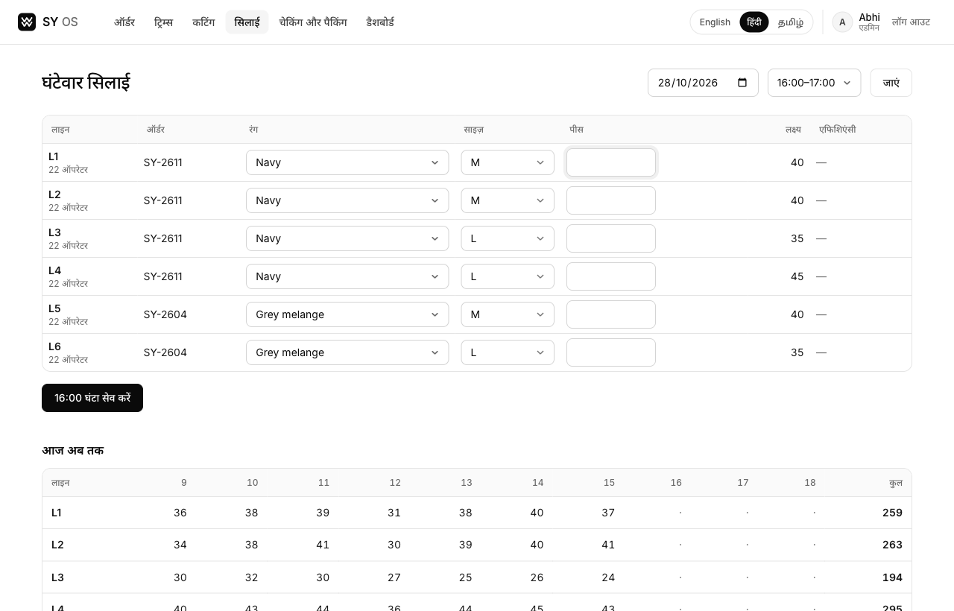
The hourly sewing grid in Hindi, for the migrant workers on the floor

Trims — calculator, POs and receipts
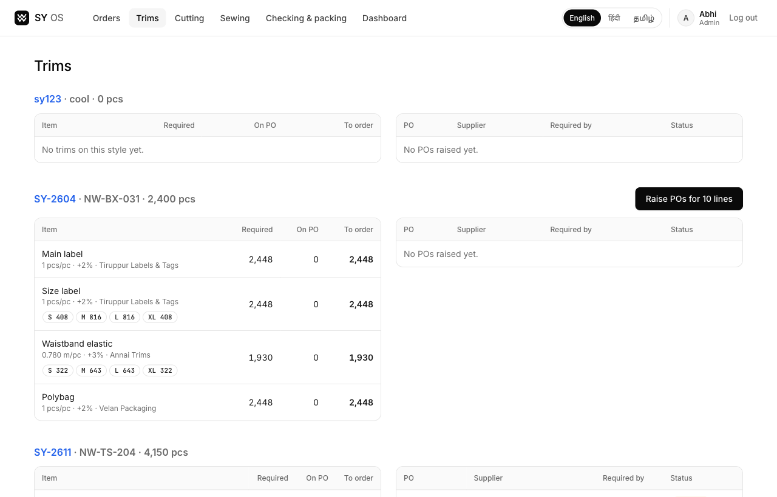
Required quantities worked out from the size grid with wastage; one click raises one PO per supplier, size-wise where needed
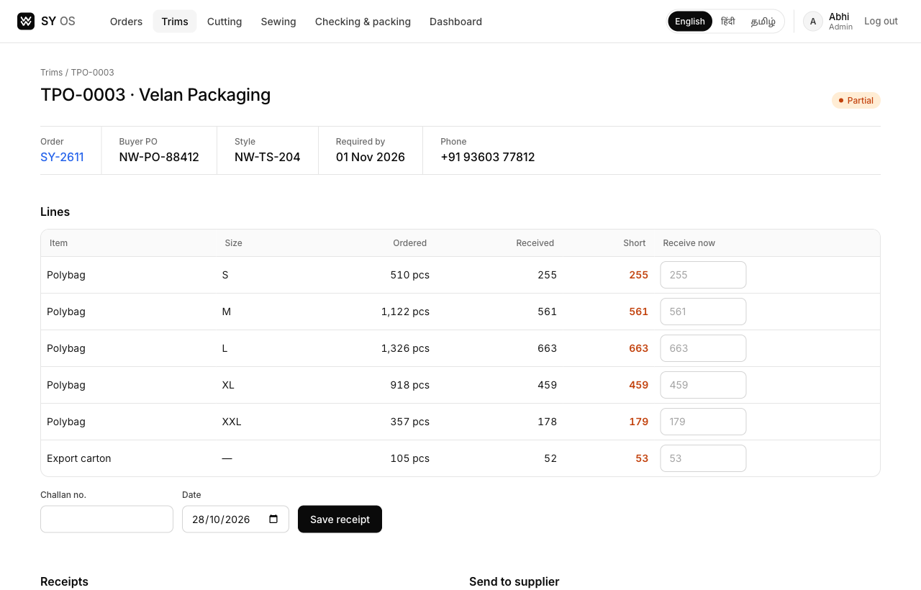
A PO with partial receipts against a challan, what is still short, and a ready WhatsApp message for the supplier

Cutting
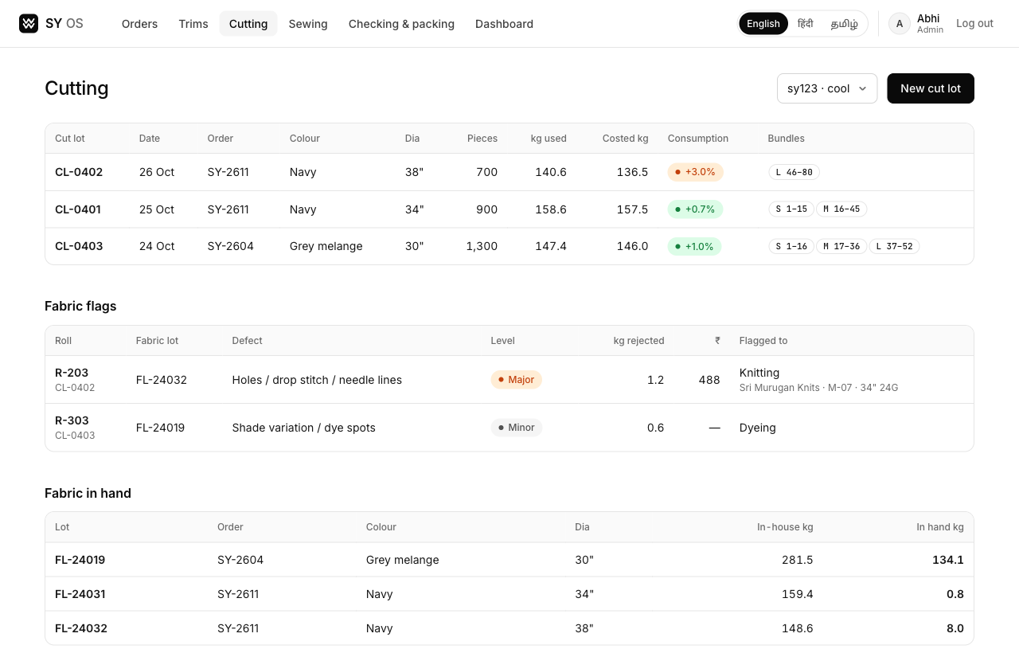
Cut lots with consumption against costed kg (green / amber / red), bundle ranges per size, defects flagged back to the knitter or dyer with machine or batch, and fabric left in hand

Hourly sewing
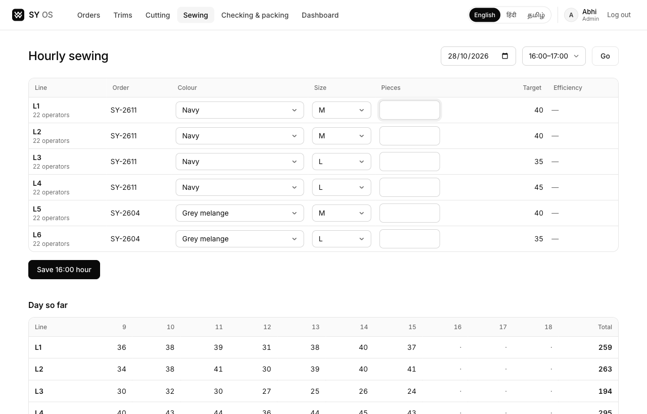
All lines for one hour on one grid; colour and size come from each line's order, and the day builds up underneath

Checking and packing
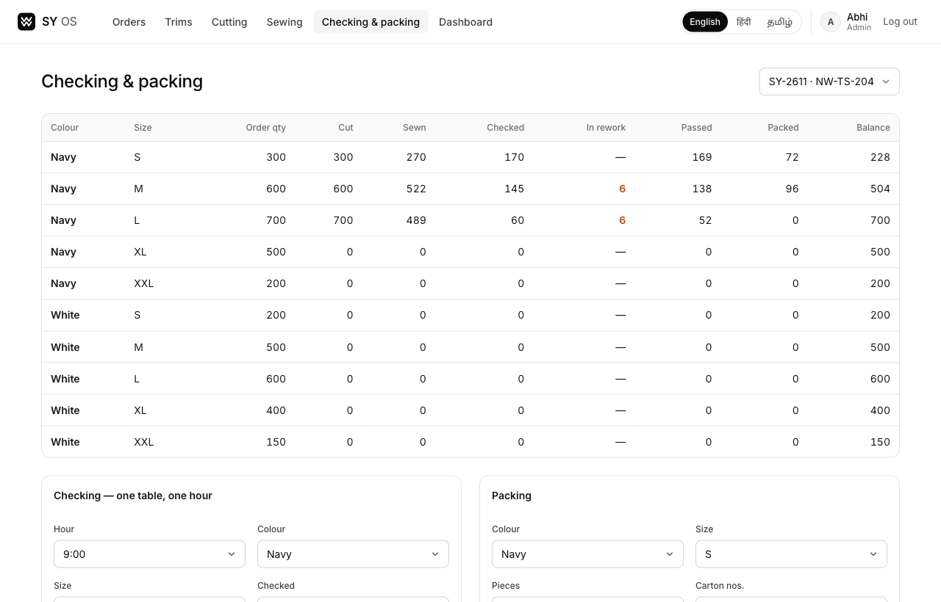
Size-wise tracker from order quantity to packed; checking can never exceed sewn and packing can never exceed passed

Dashboard
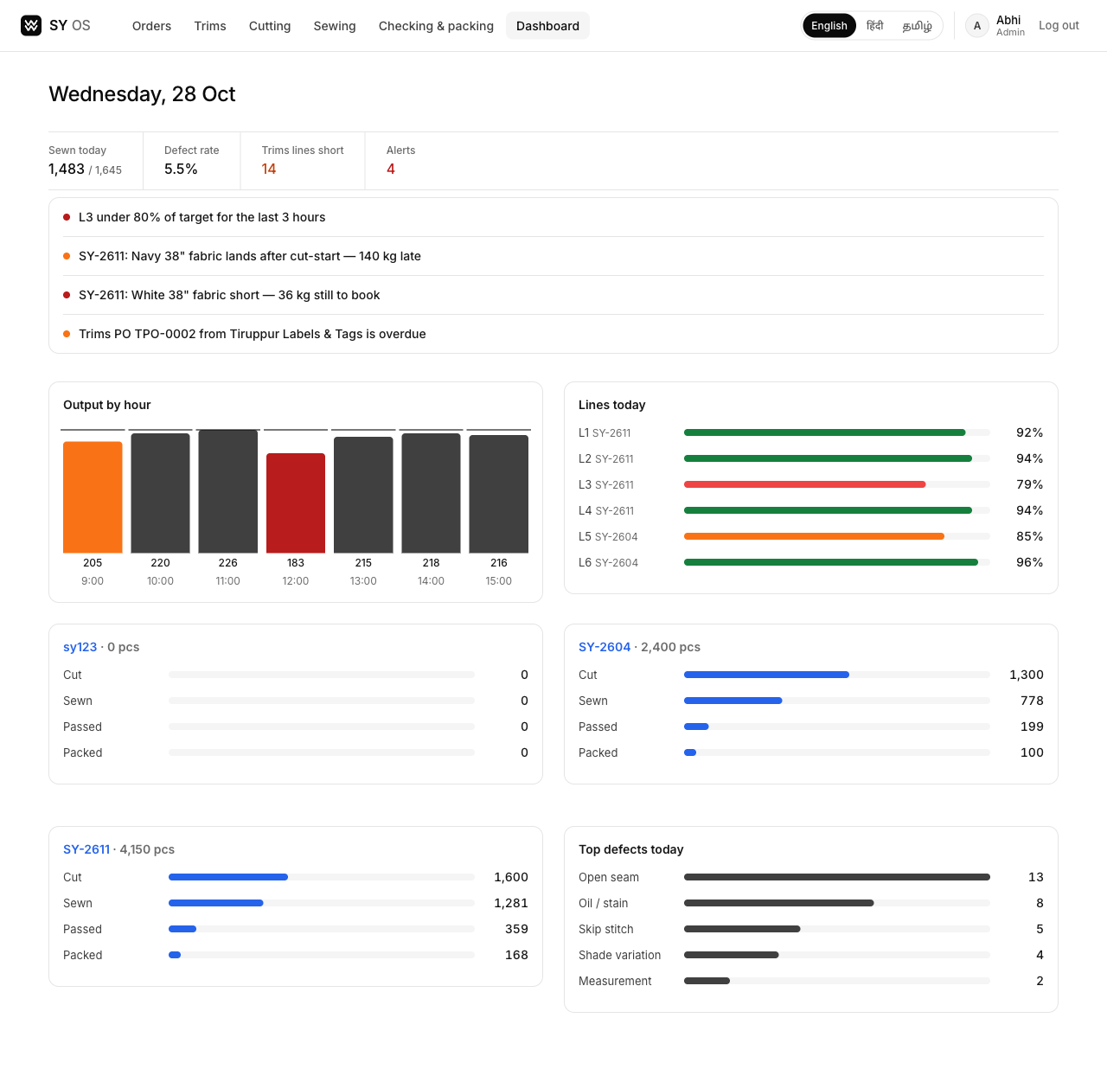
Today's output against target, line efficiency, each order's progress, top defects and rule-based alerts

4. How we will build it
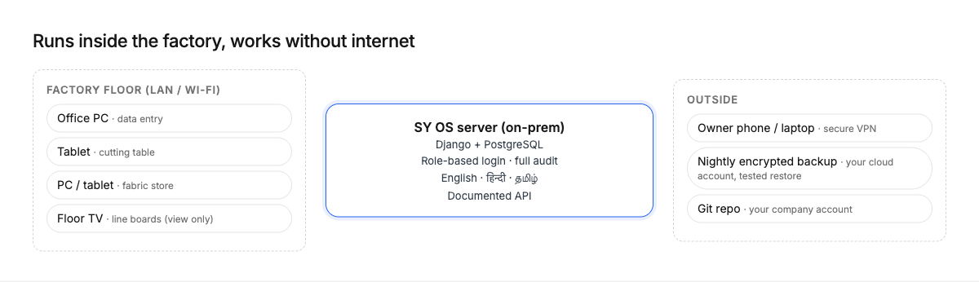
On-prem server on the factory LAN; nightly encrypted backup to your cloud account
Area | Our approach
Stack | Python / Django 5 + PostgreSQL 17. Server-rendered pages: fast on the factory LAN and easy for any Django developer to take over.
Hosting | One server inside the factory; works fully without internet. Nightly encrypted off-site backup with a tested restore.
Ownership | All code, database and data are yours. Git repository under your company account from day one.
Audit | Every record stores who, when and source (manual / scan / device). No hard deletes — corrections are new entries or logged amendments.
Security | Role-based login. Costing enforced on the server and API, not hidden on screen.
Settings, not code | Sizes, stages, lines, defect types, wastage %, tolerances and alert thresholds editable by Admin, per buyer or style.
Speed | Every screen under 2 s on the LAN; hourly grid for all lines in under 2 minutes.
Languages | English, Hindi and Tamil for all labels, alerts and user guides; terms agreed with the floor team.
Interfaces | Documented API so a future ERP, buyer portal, device or AI layer can read and write data.

5. Fabric traceability
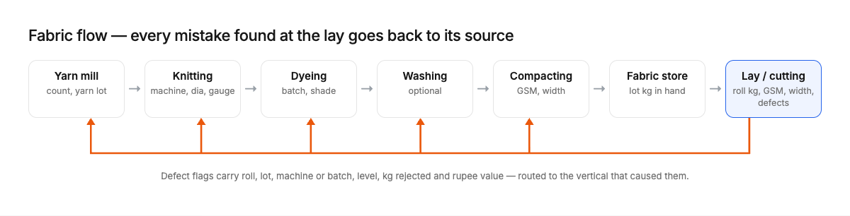
Each stage records party, machine or batch and kg — so a fault at the lay is traced back
Each fabric lot is tracked through its stages with date, kg, party and who updated it. At the lay, every defect is routed to the vertical that caused it, with roll, lot, machine or batch, level, kg rejected and rupee value.

6. Built to automate later
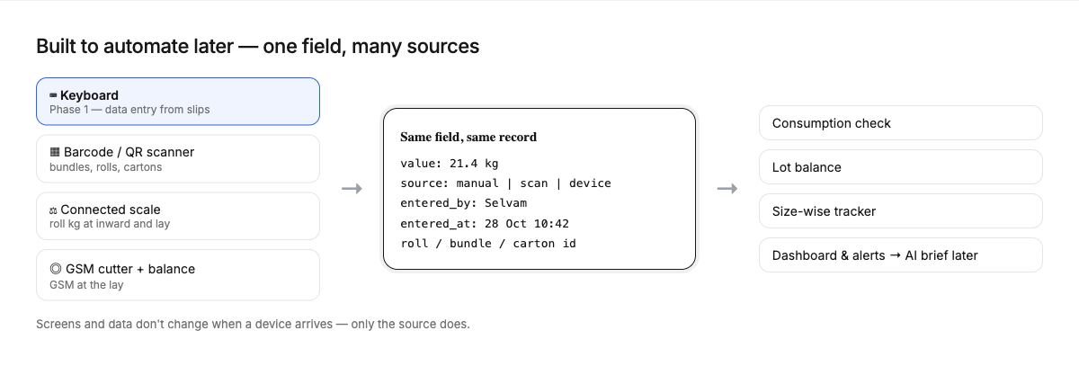
Devices fill the same fields the keyboard fills today
You asked how our design takes on each future automation. In short: the data model already stores the source of every entry and the IDs a device would read, so adding a device is an input change, not a rebuild.
Manual now | Planned later | How our design takes it on
Hourly sewing slips | Bundle barcode at end of line | Entries already keep bundle numbers; a scan creates the same sewing row with source = scan.
Hourly checking slips | Checker scans bundle, taps pass / rework / reject | Checking rows are per bundle-ready; defect types are a settings list the scan screen reuses.
Packing entry | Pieces scanned into cartons; labels printed | Carton numbers are first-class records; label printing reads the same carton data.
Typed fabric kg | Connected weighing scale | kg fields accept a device reading via the API with source = device; tolerances unchanged.
Typed GSM | GSM cutter with connected balance | Same GSM field and ±5% check; the balance posts the reading.
Manual bundle numbers | Printed bundle tickets with QR | Bundle ranges are generated and blocked per order already; QR encodes the same number.
Rule-based alerts | AI morning brief, cause finding, forecasts | Full audit history and the API give an AI layer clean, timestamped data to read.

7. Milestones and acceptance tests
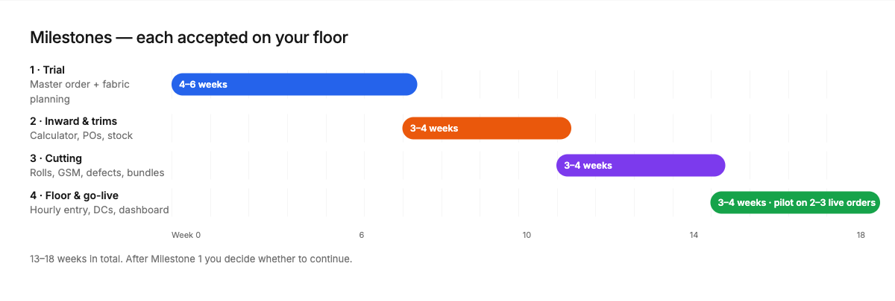
Indicative timeline from signing
Milestone | Scope | Time | Passes when
1 · Trial | Master order sheet with size grid, bundles, consumption, dia program, admin-only costing; fabric follow-up and planning tab | 4–6 weeks | A 2-colour, 5-size order entered in under 10 min; fabric window shows the correct kg gap for a late lot; costing invisible to data entry
2 · Inward & trims | Fabric inward, trims calculator, POs per supplier, repeat PO, trims inward, stock, re-order suggestions, follow-ups | 3–4 weeks | Size-wise trims POs for a 5-colour order in one step with wastage; trims stock matches a physical count
3 · Cutting | Cut lots with rolls, GSM, width, defects, kg returned, consumption check, bundle numbers, fabric flags, DC to line | 3–4 weeks | Wrong-dia roll blocked; consumption matches hand calculation on 3 real lots; overlapping bundles refused; lot balances within 1%
4 · Floor & go-live | Hourly sewing, checking, packing; internal DCs; size-wise tracker; dashboard and alerts; pilot on 2–3 live orders | 3–4 weeks | Full hour for all lines entered in under 2 min; tracker matches a physical count; two weeks live with no lost data
Already in the demo: the late-lot kg gap and the hidden costing (Milestone 1), size-wise trims POs in one step (2), a wrong-dia roll blocked and overlapping bundles refused (3), and checking never above sewn, packing never above passed (4). We will run every test again on your real orders and on your floor.

8. What we would add or do differently
- Hindi as a third language. Much of the floor is migrant workers who read Hindi, not Tamil. Supervisor boards, floor screens and printed slips should be available in Hindi.
- Consumption changes are amendments too. Changing kg per piece changes fabric need, so the demo already logs it with a reason, like quantity changes.
- Two-sided tolerances. The brief gives width as −0.5″ and consumption colours only for over-use. We propose upper and lower limits for both, so wide fabric and suspicious under-consumption are flagged too.
- Rework counted across hours. Rework found at 10:00 is often cleared at 14:00. We will track rework per order, colour and size, not per hour, so “passed” never double-counts.
- Yarn quantity from process loss. Fabric needed is finished kg. We propose back-calculating yarn to book from the loss % at each stage (knitting, dyeing, washing, compacting), set per fabric quality.
- Master data the brief doesn’t list. Supplier/party master, buyer master, checking tables, cartons/packing list and a trim PO header — needed for clean POs and export paperwork.
- Secure remote access. The owner uses a phone or laptop outside the factory; we will set up a VPN to the on-prem server rather than exposing it to the internet.

9. Questions before we start
These change the size of the work, so we would like answers — or a floor walkthrough — before we start building.
- Trim PO rates: the data-entry person raises trim POs, which carry rates. Should data entry see PO rates, or are rates admin-only like costing?
- Fabric lots: does one lot always stay one order × colour × dia line, or do dye batches combine several orders / yarn lots split across lots? This decides the lot data model.
- Tolerances: upper width limit, and what colour/limit applies when consumption is under the costed kg?
- Bundle tickets: should SY OS print bundle and part tickets in Phase 1, and on what printer?
- Packing list: do buyers need a packing list / carton labels (any GS1 standard) from SY OS in Phase 1?
- Volumes: number of sewing lines, checking tables and shifts; active POs and styles in a typical and a peak month.
- Day-one data: which open orders, stock and suppliers must be migrated, and from which Excel files?
- Languages per person: who reads Tamil, Hindi or English; should printed POs and DCs be bilingual?
- Sign-off: who accepts each milestone, how long is the review window, and which real orders are the test data?
Documents that would help most: 2–3 sample buyer POs (one amended, one repeat), the Excel master order sheet, the fabric follow-up sheet, a trim PO and trim card, a cutting slip and bundle ticket, and photos of one full day of hourly sewing, checking and packing slips.

10. Next steps
- Review the demo together (30 minutes, on a call or at the factory).
- Floor walkthrough: fabric store → cutting → sewing → checking → packing.
- You share the sample documents listed in section 9.
- We send the trial plan with written acceptance criteria, and Milestone 1 starts on your server and Git account.

