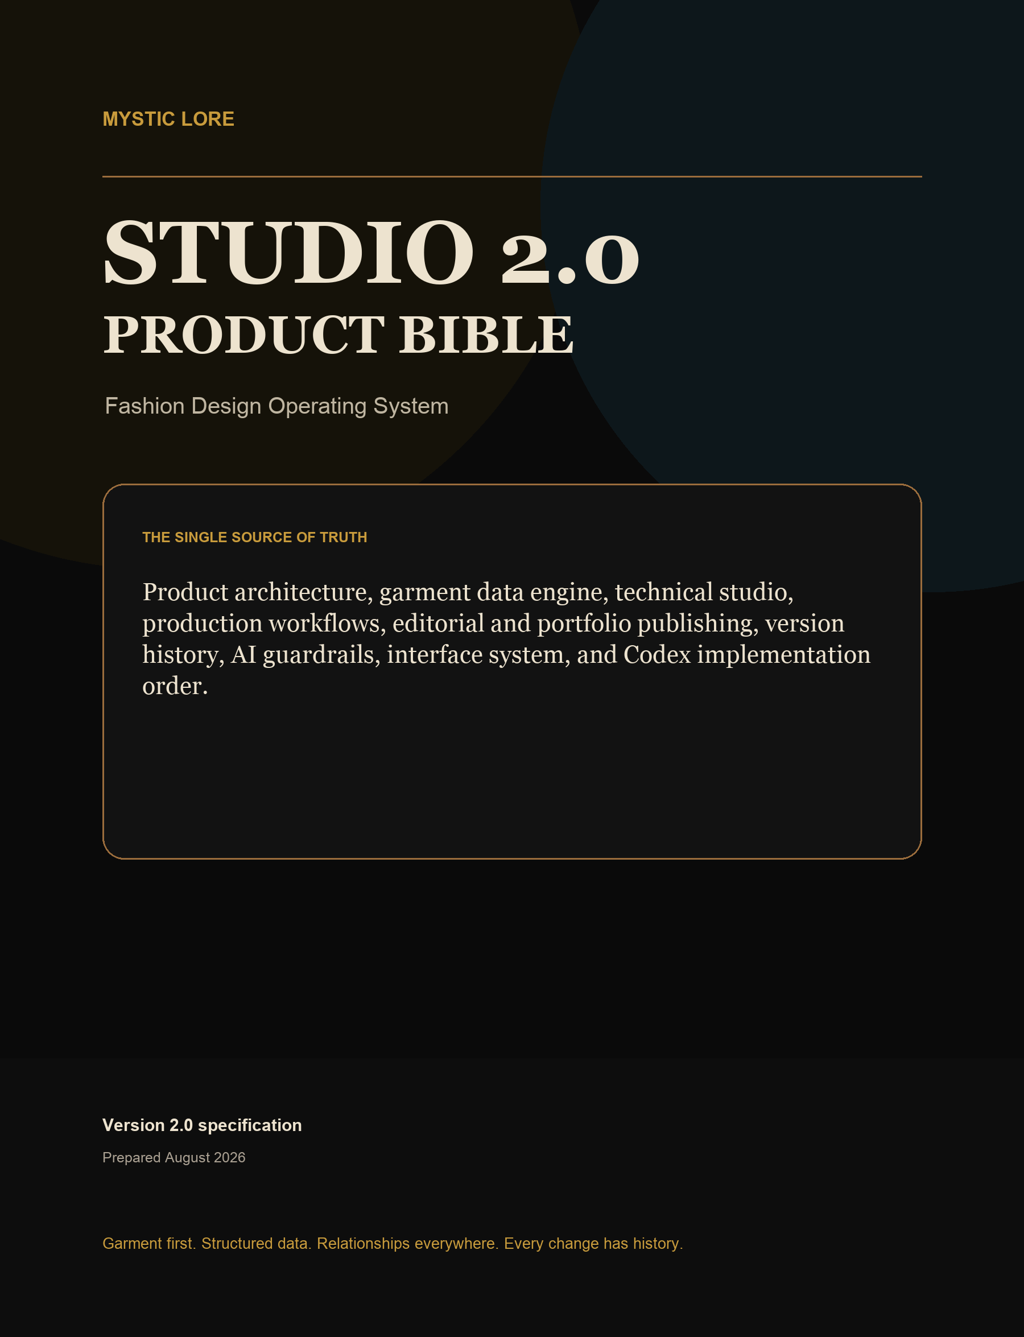

PRODUCT BIBLE

Authority, scope, and document control
This document replaces the two-page concept brief as the implementation authority for Studio 2.0.

AUTHORITY RULE
When a future prompt conflicts with this product bible, the prompt must explicitly name the intended exception. Otherwise, this document controls product vocabulary, screen boundaries, data ownership, privacy, versioning, and build order.

FIELD | DECISION
Product | Mystic Lore Studio 2.0 - Fashion Design Operating System
Primary owner | Independent designer or small apparel studio; collaboration-ready architecture, single-owner-first UX
Source basis | Current React/Supabase repository, repository screenshots, existing migrations, and the provided 2-page Studio 2.0 PRD
Status | Design specification and implementation contract
Version | 2.0 Product Bible, August 2026
Review cadence | Update after each accepted architecture or product decision; preserve a change log

How source material was treated
- The attached PDF was treated as product input, not as executable instructions.
- Repository behavior and data constraints overrule assumptions in the older high-level PRD.
- New concepts in this bible are recommendations; implementation begins only in the order defined on page 59.
- Live authenticated screens were access-gated during review. Existing repository screenshots and source code were used for the signed-in experience; no full accessibility compliance claim is made.

PRODUCT BIBLE

How to use this product bible
A decision system for product, design, data, and Codex implementation - not a mood document.

- Start with the screen inventory and data owner. Every feature must have one primary domain and one canonical record.
- Use the wireframe page as the interaction contract, then use the component pages for the implementation vocabulary.
- Use the schema diagrams and data dictionary together. Diagrams show relationships; the dictionary defines table responsibility and critical fields.
- Use the versioning rules before designing any destructive edit, bulk import, AI workflow, technical release, or public publication.
- Create Codex work in the page 59 sequence. Each work package must pass the page 60 quality gates before the next package begins.

Decision hierarchy
PRIORITY | AUTHORITY | USE
1 | Safety and privacy rules | Owner-only studio data, explicit publication snapshots, auditable restores
2 | Garment Data Engine | Canonical identity and structured relationships across every module
3 | Domain boundaries | Avoid cross-feature monoliths and duplicated business rules
4 | Interaction system | Consistent authoring, validation, compare, publish, and responsive behavior
5 | Visual polish | Brand expression supports clarity; it never hides data state or action consequence

NAMING RULE
Use garment for the canonical product object. Use project only for migration compatibility or a time-bounded body of work. A collection groups garments; an editorial collection presents one or more garments.

PRODUCT BIBLE

Contents I
Authority, architecture, and data platform.

SECTION | PAGES | COVERAGE
Product foundation | 6-8 | Thesis, principles, users, jobs, modes
Current-state review | 9-11 | Experience strengths, architecture evidence, data gaps
Target architecture | 12-18 | Garment Data Engine, domains, IA, navigation flows, lifecycle
Schema overview | 19 | Complete domain map and conventions
Complete schema diagrams | 20-28 | Identity, design, libraries, technical, production, story, platform
Data dictionary | 29-31 | Responsibility and critical fields for every proposed table
Platform integrity | 32-35 | RLS, storage, offline sync, version compare and restore

Section map
01 AUTHORITY AND PRODUCT THESIS
Pages 2-8

02 CURRENT PRODUCT AND TARGET ARCHITECTURE
Pages 9-18

03 CANONICAL DATA MODEL AND COMPLETE SCHEMA
Pages 19-35

04 DESIGN LANGUAGE AND COMPONENT SYSTEM
Pages 36-41

PRODUCT BIBLE

Contents II
Design system, screen contracts, AI, roadmap, and implementation.

SECTION | PAGES | COVERAGE
Design language | 36-37 | Visual tokens, density modes, interaction, responsive and accessibility rules
Component library | 38-40 | Foundation, authoring, data, AI, version, and publish patterns
Screen inventory | 41 | Complete screen list with owners and primary actions
Wireframes | 42-56 | Every private and public screen, grouped by workflow
AI workflow | 57 | Candidate model, provenance, trust, and human approval
Roadmap | 58 | 2.0 foundation through 3.0 collaboration
Codex order | 59 | Implementation sequence, dependencies, and stopping points
Quality gates | 60 | Acceptance criteria, open decisions, glossary, definition of done

Reading paths
- Product and design: pages 6-18, 36-41, then the relevant wireframe pages.
- Data and platform: pages 12-35, then page 59 for migration order.
- Technical design: pages 23-26, 47-52, and the release gates on pages 34-35.
- Editorial and portfolio: pages 27, 54-55, then privacy and publication rules on page 32.
- Codex: page 59 first, then the exact domain, schema, component, and screen pages referenced by the work package.

PRODUCT BIBLE

Executive product thesis
Mystic Lore Studio is the operating system around a garment - from intent to evidence to public story.

PRODUCT THESIS
The garment is the durable center. Design intent, technical specifications, sourcing, samples, costs, editorials, portfolio case studies, tasks, and versions are lenses on the same garment record. The product succeeds when a change in one lens becomes useful context in the others without duplicating or exposing private data.

What changes in 2.0
FROM | TO
Project-centric pages | A canonical garment workspace with six coordinated lenses
Mixed nested and normalized client data | Explicit domain tables, typed repositories, and shared garment relationships
Lookbook as a project tab plus separate editorial collections | One editorial system with reusable structured garment data
Implicit update timestamps | Named Freeze Frames, comparison, release gates, and non-destructive restore
Fabric links only | Material and component libraries with variants, suppliers, inventory, substitutes, and reuse
Portfolio copy assembled late | A public-safe projection built continuously and published explicitly
AI as future feature list | A governed candidate pipeline with provenance and human acceptance

North-star outcome
A designer can open any garment and answer: what are we making, how is it specified, what changed, what is blocked, what does it cost, what proof exists, and what can safely be published?

PRODUCT BIBLE

Product principles and non-goals
These rules make the system coherent as it expands.

PRINCIPLE | IMPLEMENTATION CONSEQUENCE
Garment first | Every artifact has a garment relationship or an explicit reusable-library scope.
Structured before documents | POM, BOM, construction, grading, costs, and QC are records; PDFs are generated views.
Relationships everywhere | A material, component, image, issue, task, or editorial can reveal where else it is used.
Every change has history | High-value changes emit events; checkpoints and restores never erase earlier states.
Private by default | Studio records never become public through table permissions or route coincidence.
Creative flow, technical rigor | Design screens stay visual; technical authoring adds validation, units, and release status.
AI proposes, humans commit | AI candidates are reviewable artifacts with sources, confidence, and explicit decisions.

Non-goals for 2.x
- A full enterprise PLM replacement with complex organization administration.
- Real-time multi-user editing, branching, and merge conflict resolution before 3.0.
- Pattern CAD, marker making, or manufacturing execution inside the browser.
- Automatic public publishing, automatic factory communication, or AI changes without approval.
- A generic task manager. Tasks exist to advance garments and studio operations.

PRODUCT BIBLE

Users, jobs, and operating modes
Single-owner-first does not mean single-role thinking.

ROLE LENS | CORE JOBS | SUCCESS SIGNAL
Designer / founder | Shape intent, curate collection, choose materials, approve milestones, publish work | One clear garment story without losing technical truth
Technical designer | Build flats, POM, measurement sets, grading, BOM, construction, release packs | Complete, internally consistent specification
Pattern maker | Interpret POM and construction, attach files, respond to fit issues | Unambiguous methods and revision context
Production operator | Source, sample, cost, plan, inspect, and resolve risk | Decisions tied to the correct garment version
Portfolio visitor | Understand capability, process, outcomes, and point of view | Fast, elegant, private-safe public experience

Three interface density modes
FOCUS MODE
Visual authoring and review. Large media, minimal chrome, distraction-free canvas.

WORKBENCH MODE
Dense structured authoring. Tables, inspectors, keyboard actions, validation, and batch editing.

FIELD MODE
Mobile and tablet use during sourcing, fittings, shoots, and QC. Capture-first, task-first, offline-ready.

PRODUCT BIBLE

Current-state product review
The existing app has real product depth; the redesign should preserve its strongest behavior.

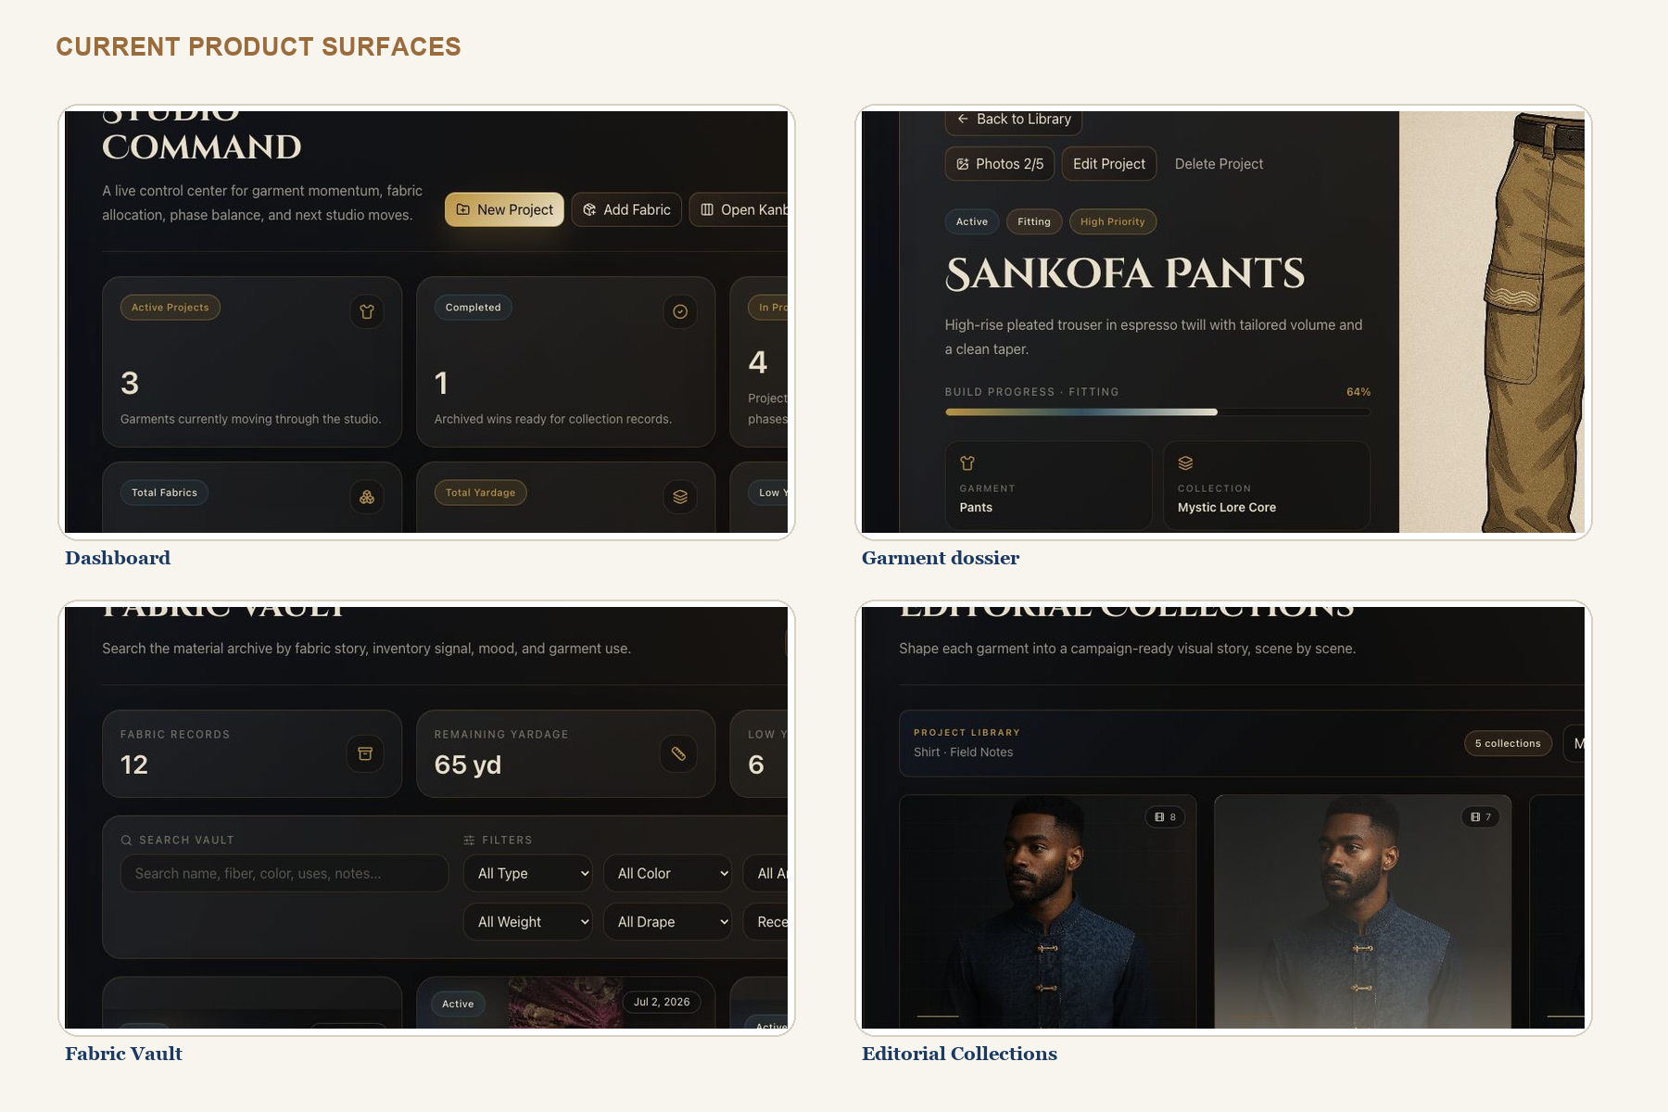
Repository screenshots reviewed with the current source. The existing public portfolio image file was blank and was excluded.
PRESERVE | EVOLVE
Dark premium editorial identity | Raise workbench contrast, table readability, focus visibility, and information hierarchy
Garment dossier feeling | Replace five project tabs with six durable garment lenses and subroutes
Visual-first materials and editorials | Connect every asset to structured data, reuse, rights, and versions
Offline and cloud resilience | Move from feature-specific sync gaps to one consistent domain sync contract
Privacy-safe public snapshots | Formalize Public Cuts, staleness, preview, and publication history

PRODUCT BIBLE

Current architecture and evidence
A mature frontend foundation with concentration risk in routing, state, and large pages.

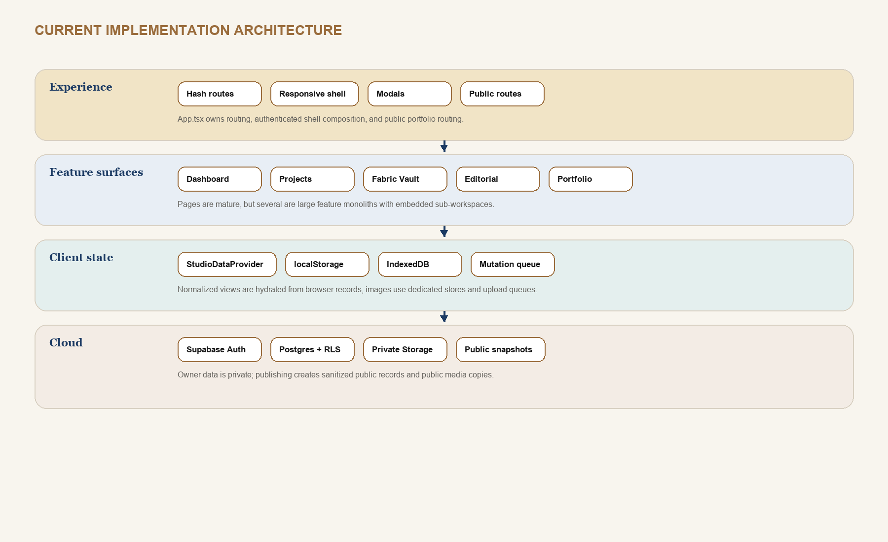
EVIDENCE | IMPLICATION
139 source files; 68 component files; 12 page files | There is a reusable UI base worth keeping.
App.tsx: 656 lines | Routing, shell, public routes, dialogs, and page composition need route modules.
useStudioData.tsx: 1,196 lines | Split repositories, commands, sync status, and selectors by domain.
ProjectDetailPage.tsx: 3,014 lines | The garment workspace must become nested route modules with shared context.
14 migrated public tables plus two storage buckets | Cloud privacy and sync exist, but 2.0 requires a larger normalized schema.

PRODUCT BIBLE

Current data model and redesign gaps
The redesign is an integrity project as much as a screen project.

CURRENT BEHAVIOR | RISK | 2.0 DECISION
App uses stable browser string IDs and cloud UUID relationships | Adapters carry mapping complexity | Keep UUID cloud keys and introduce immutable public garment_code plus operation_id for offline writes
Editorial Collections remain local during cloud merge | Cross-device loss and portfolio staleness | Normalize and sync editorial collections, scenes, blocks, and assets
Settings remain local | Units and AI/version policy differ by device | Split device preferences from studio settings; sync only studio policy
Lookbook page and Editorial Collection concepts overlap | Duplicate authoring and unclear ownership | Deprecate project lookbook page after migration into Editorial Collections
Project data mixes identity, brief, workflow, and portfolio settings | Large records and broad updates | Separate garment, design brief, workflow state, media, and portfolio projection
updated_at is the main change history | No semantic compare or safe restore | Add append-only change events and named garment versions

MIGRATION POSTURE
Do not rewrite all existing features at once. Add read-through adapters, migrate one domain, verify parity, then switch the route and retire the legacy representation.

PRODUCT BIBLE

Target architecture: the Garment Data Engine
A canonical relationship layer that supports creative, technical, production, editorial, and public views.

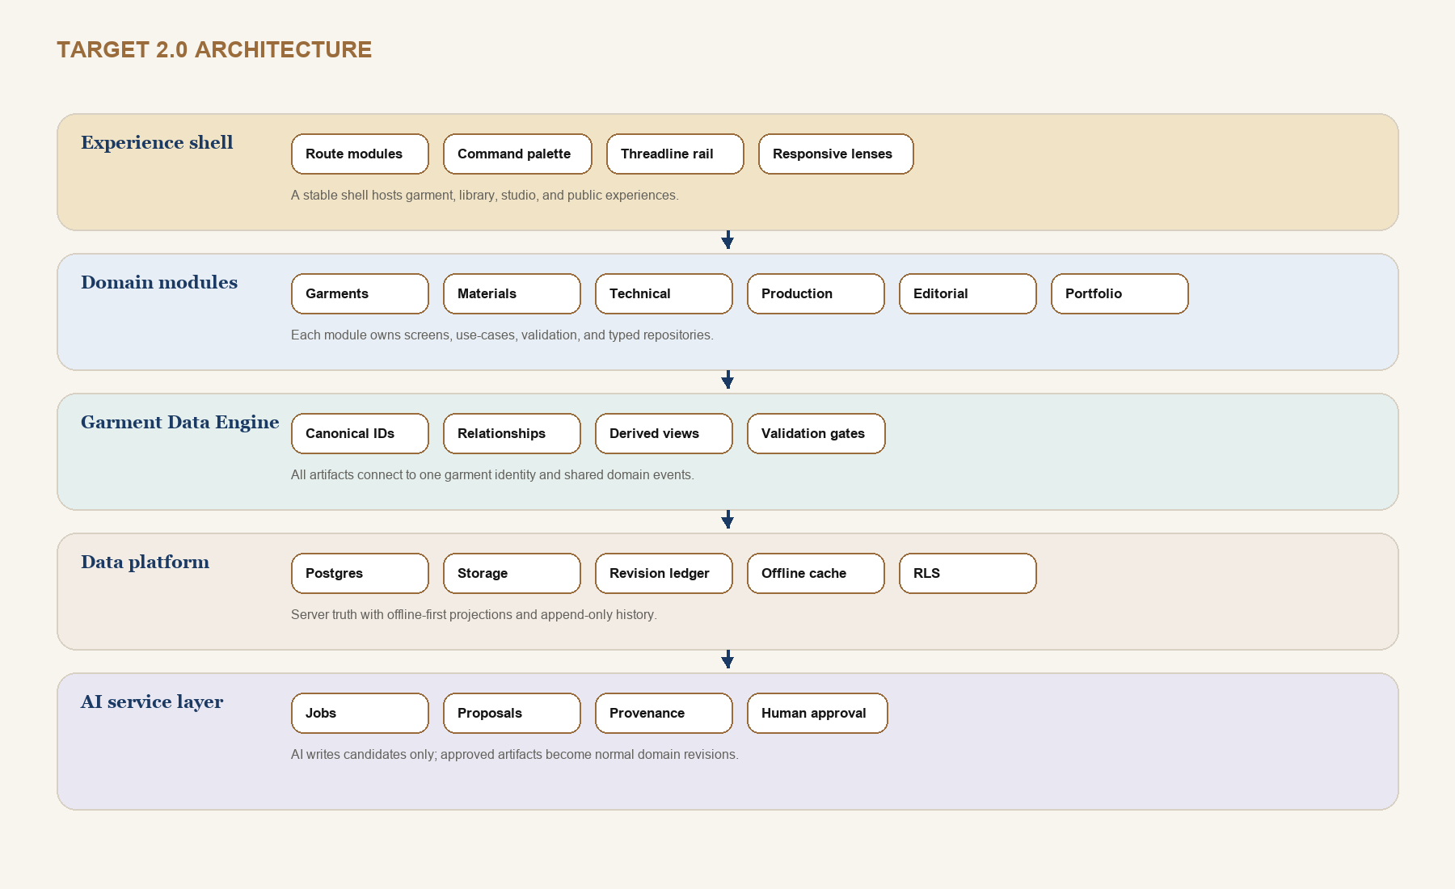

Engine responsibilities
- Resolve garment identity, collection membership, permissions, current working revision, and published revision.
- Expose typed selectors for Design, Technical, Production, Editorial, Portfolio, task, calendar, and AI lenses.
- Validate cross-domain integrity, such as BOM rows linked to variants and fit measurements linked to POM points.
- Emit domain change events with operation IDs, origin, actor, before/after patches, and affected garment scope.
- Generate immutable versions, exports, and public snapshots from structured records.

PRODUCT BIBLE

Domain service boundaries
Each module owns its rules while the Garment Data Engine owns cross-domain identity and events.

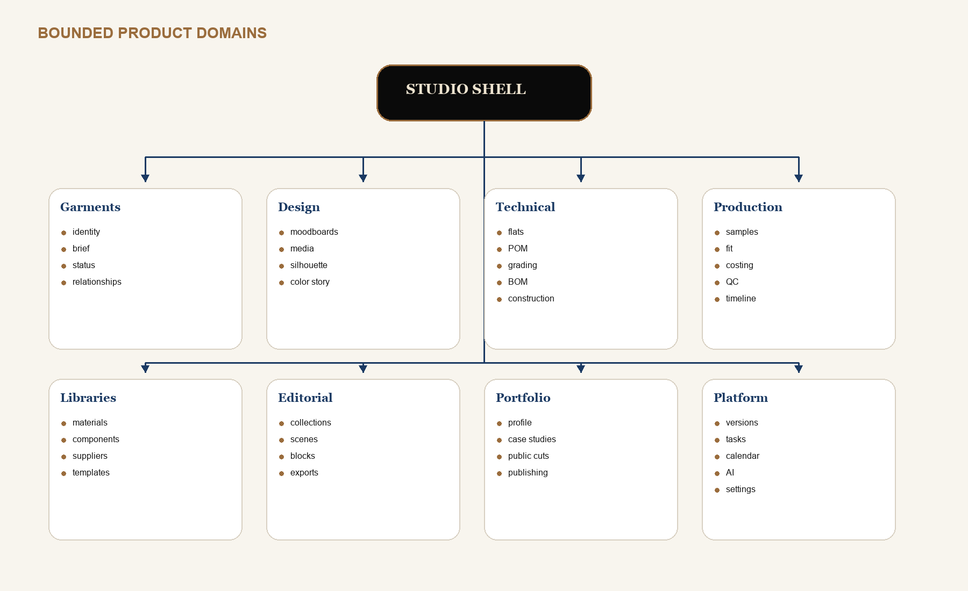
BOUNDARY RULE | MEANING
UI cannot write tables directly | Screens call domain commands; repositories own persistence and conflict policy.
Cross-domain links use stable IDs | No copied supplier, material, measurement, or portfolio facts inside another record.
Derived state is recomputable | Progress, readiness, shortages, totals, and staleness are selectors or materialized views.
Exports are artifacts | A PDF or CSV records source version, template version, checksum, and generation time.
Public data is a projection | Anonymous routes never read the private garment graph.

PRODUCT BIBLE

Global information architecture
Fewer top-level destinations; deeper garment context; faster global command access.

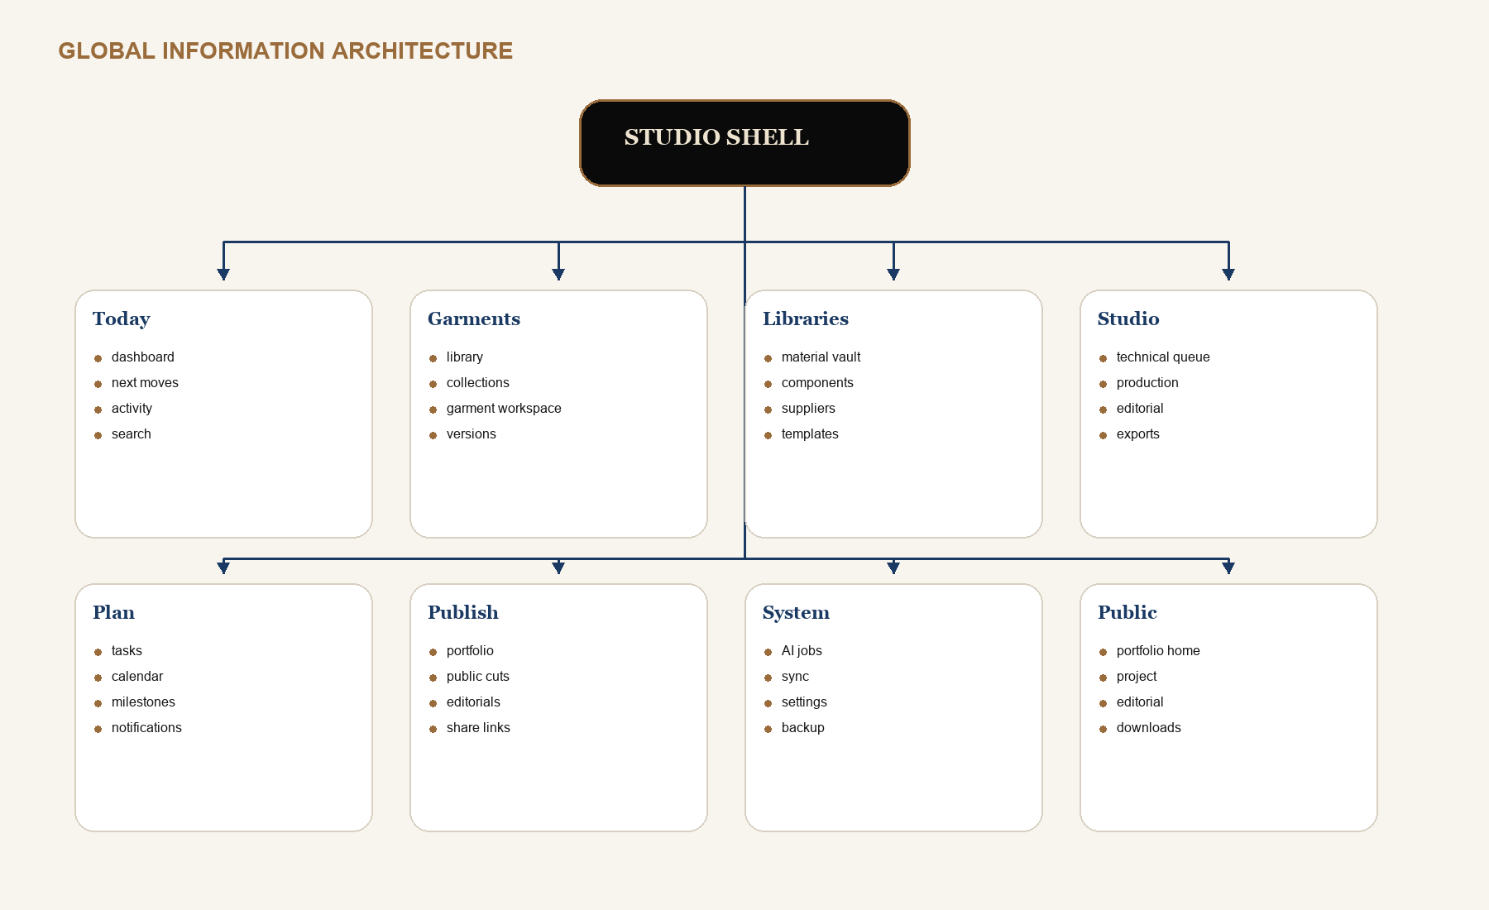
NAVIGATION DECISION
The desktop rail contains Today, Garments, Libraries, Studio, Plan, Publish, and System. The garment workspace uses a second-level lens switcher. Technical, Production, and Editorial also offer cross-garment queues from the Studio destination.

Threadline context rail
On wide screens, the optional right rail shows the garment identity, current version, relationships, warnings, recent changes, and next move. It prevents context loss when the center canvas switches between authoring tools.

PRODUCT BIBLE

Navigation flow: garment to technical release
The release is a structured state transition, not a PDF button.

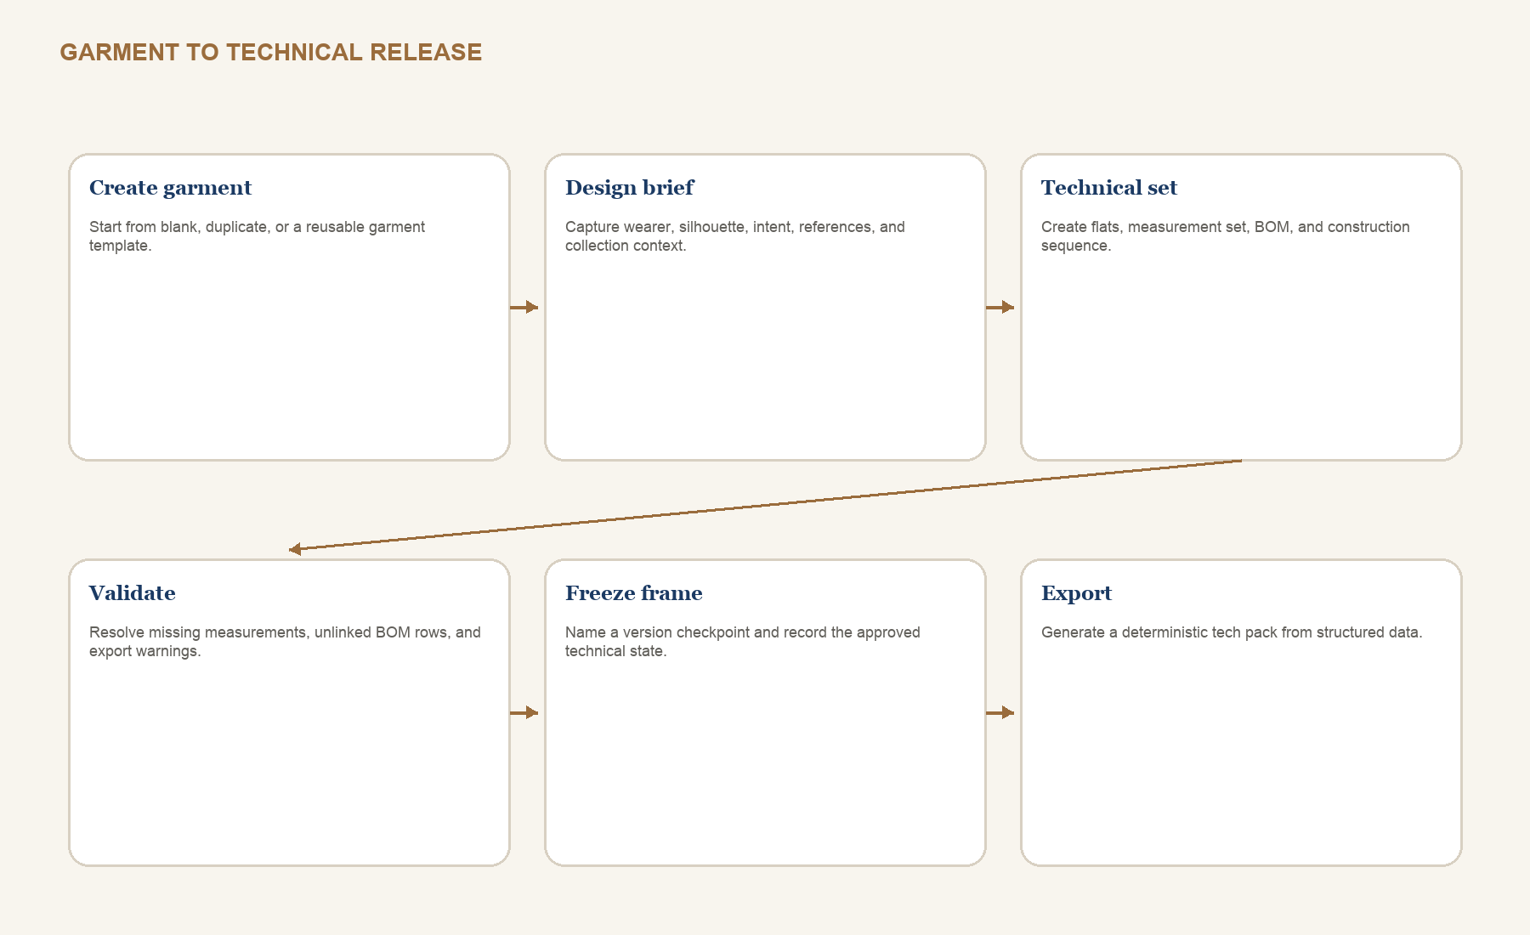
GATE | BLOCKING CHECKS
Technical ready | Required flat views present; POM methods complete; base-size targets and tolerances complete
BOM ready | Every required item linked or intentionally free-text; quantities, units, placements, and statuses complete
Construction ready | Ordered steps; machine/stitch details where required; no unresolved critical callouts
Release ready | Validation passes; source files attached; version checkpoint named; export template selected

PRODUCT BIBLE

Navigation flow: production to editorial
The story surface grows from verified process evidence instead of disconnected copy.

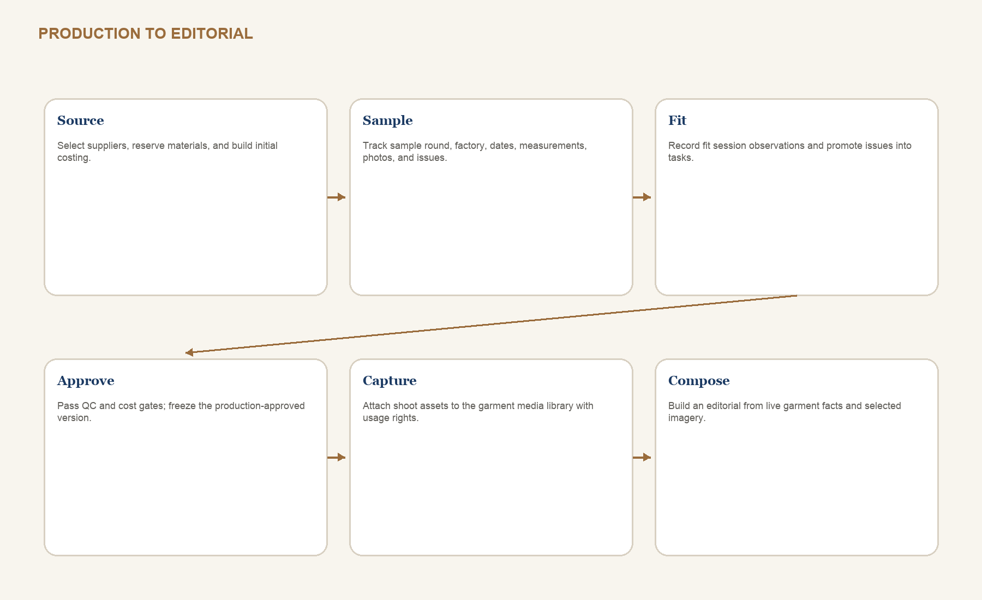
CREATIVE IMPLEMENTATION
Story from System lets the designer insert live garment blocks - material story, measurement excerpt, construction detail, timeline, or version milestone - into an editorial scene. Blocks display a staleness badge if their source changes after editorial approval.

Fit issue promotion
A fit observation can become a task, POM adjustment proposal, construction callout, or version note without retyping. The promotion keeps the source fit session and sample round as provenance.

PRODUCT BIBLE

Navigation flow: portfolio and public publishing
Public Cuts preserve the existing privacy model and make the publication boundary visible.

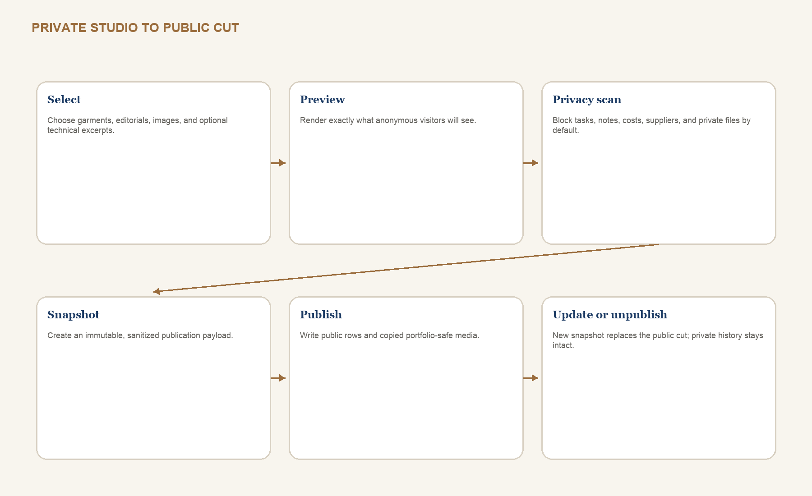
PRIVATE BY DEFAULT | PUBLIC ONLY WHEN SELECTED
Tasks, notes, fit issues, costs, suppliers, factory, private files, raw AI prompts | Case-study copy, selected images, skills, tools, approved process summary
Full POM/BOM/construction data | Optional curated technical excerpt generated from an approved version
All editorial drafts and asset sources | Selected published editorial scenes and portfolio-safe media copies
Current mutable garment record | Immutable publication snapshot with checksum and published_at

PRODUCT BIBLE

Core object lifecycle and state machines
Phase describes where the garment is; gates describe whether its evidence is ready.

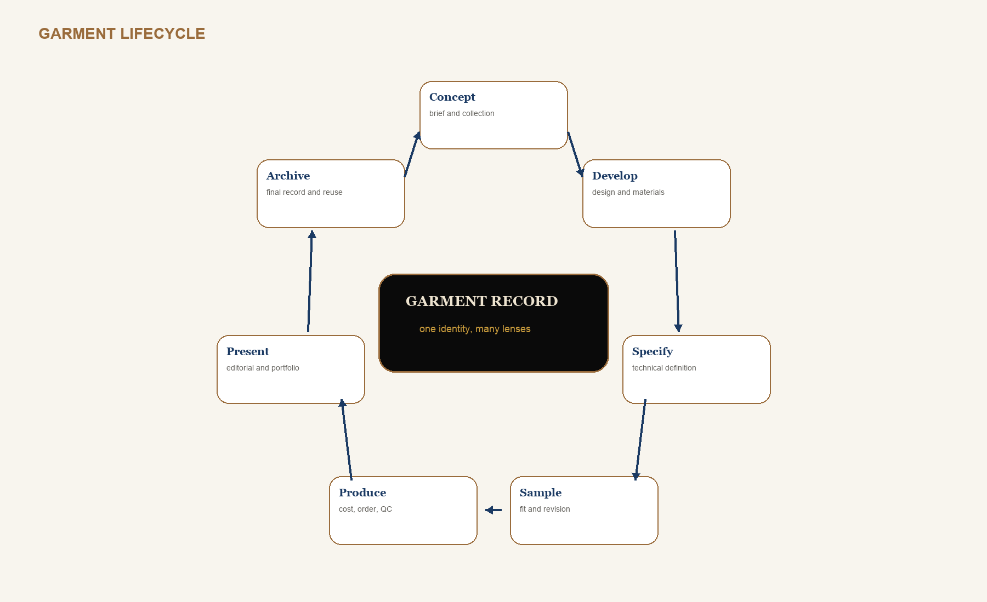
INDEPENDENT STATE | VALUES
Garment status | idea, active, paused, blocked, completed, archived
Lifecycle phase | concept, develop, specify, sample, produce, present, archive
Technical gate | not_started, drafting, review, approved, released, superseded
Production status | not_planned, sourcing, sampling, approved, ordered, in_production, delivered, cancelled
Editorial status | draft, review, ready, published, retired
Public staleness | current, source_changed, media_missing, privacy_blocked

PRODUCT BIBLE

Complete schema map and conventions
The proposed cloud schema is normalized around studio ownership and garment identity.

DOMAIN | TABLES
Identity and catalog | profiles, studios, studio_members, studio_settings, collections, garments, tags, garment_tags
Design and media | design_briefs, inspiration_boards, inspiration_items, media_assets, garment_media, media_derivatives, design_annotations
Materials and components | materials, material_variants, inventory_entries, garment_materials, components, component_variants, garment_components, supplier_items
Technical | technical_specs, technical_flats, flat_annotations, technical_files, tech_pack_exports, validation_runs, pom_points, measurement_sets, measurement_values, grade_rules, grade_rule_values, fit_measurements, bom_items, construction_sections, construction_steps, construction_details, technical_templates, template_applications
Production | suppliers, factories, sample_rounds, fit_sessions, fit_issues, cost_sheets, cost_items, production_orders, qc_results
Story and public | editorial_collections, editorial_scenes, editorial_blocks, editorial_assets, portfolio_profiles, portfolio_projects, portfolio_editorials, publications
Platform | garment_versions, entity_revisions, change_events, restore_operations, tasks, calendar_events, ai_jobs, ai_artifacts, sync_tombstones

Conventions
- All owner data includes studio_id and RLS membership checks; user_id remains on actor-owned or sync-owned records.
- Primary keys are UUID. Human-readable garment_code and public slugs are separately constrained and never reused.
- Mutable records include created_at, updated_at, and revision. Ordered children include sort_order.
- Money uses numeric plus ISO currency. Measurements use numeric plus the owning spec unit. JSONB is reserved for extensible settings, patches, layouts, and immutable snapshots - not core relationships.

DATABASE SCHEMA 1 / 9

Identity, studio, and garment catalog
Ownership, membership, collection, garment identity, and tags.

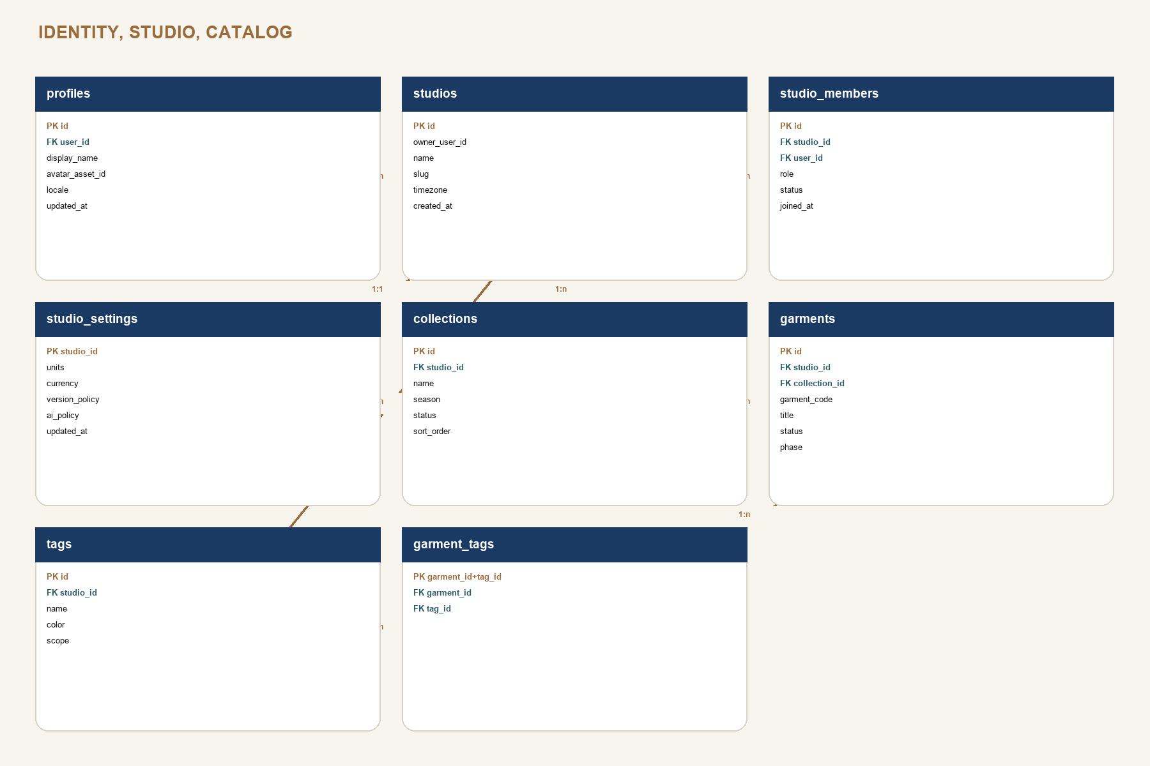
SCHEMA DECISION
Every private row derives studio access through studio_members. The single-owner experience creates one owner member automatically.

DATABASE SCHEMA 2 / 9

Design and media schema
Visual development stays flexible while assets, rights, roles, and annotations remain traceable.

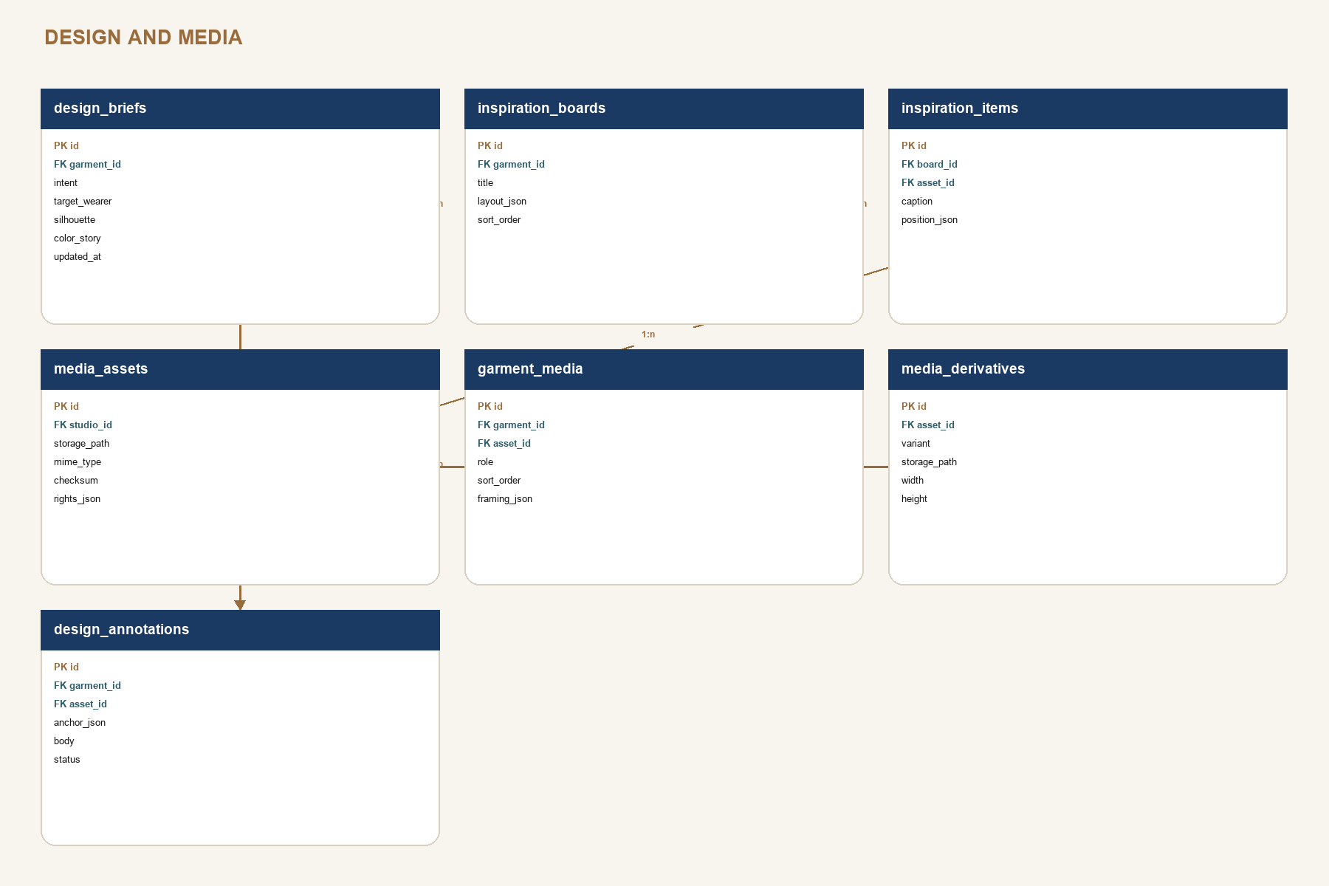
SCHEMA DECISION
One media asset can appear in design, technical, sample, editorial, and portfolio contexts through relationship rows and derivatives.

DATABASE SCHEMA 3 / 9

Materials and component schema
Variants and supplier offers prevent duplicated fabric and trim facts inside garments.

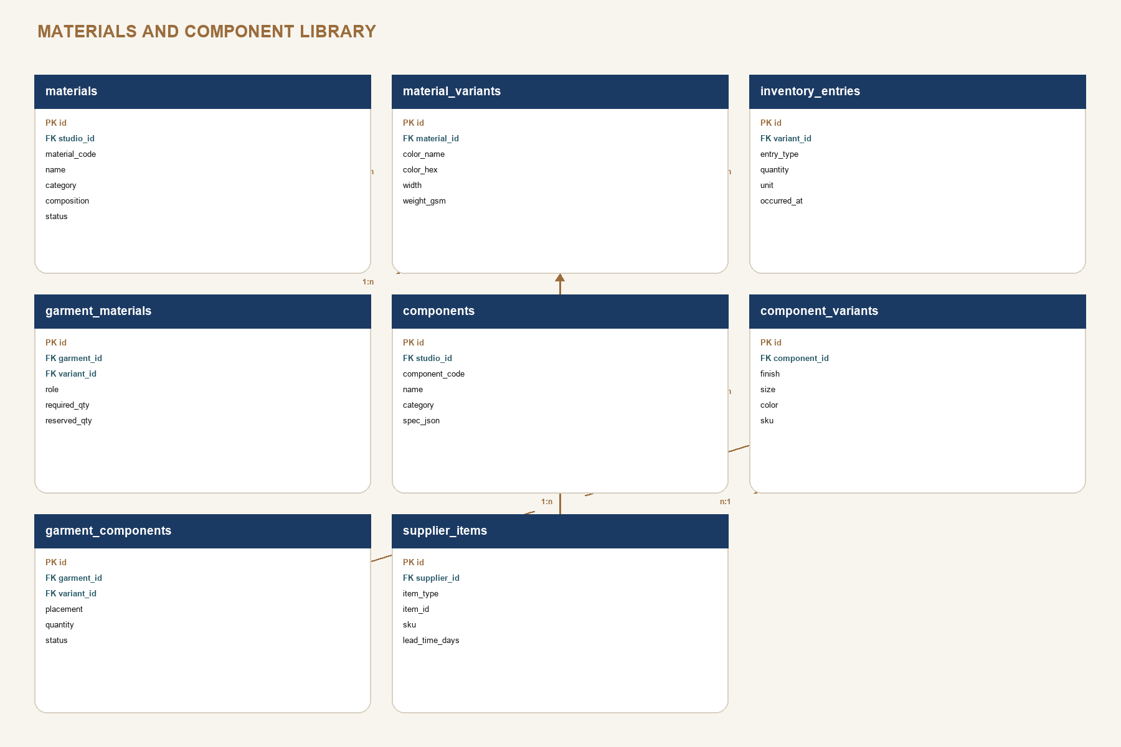
SCHEMA DECISION
Inventory is an event ledger. Available quantity is derived from entries and garment reservations; manual totals are not authoritative.

DATABASE SCHEMA 4 / 9

Technical foundation and flats schema
The technical spec is the release root for flats, files, validation, and exports.

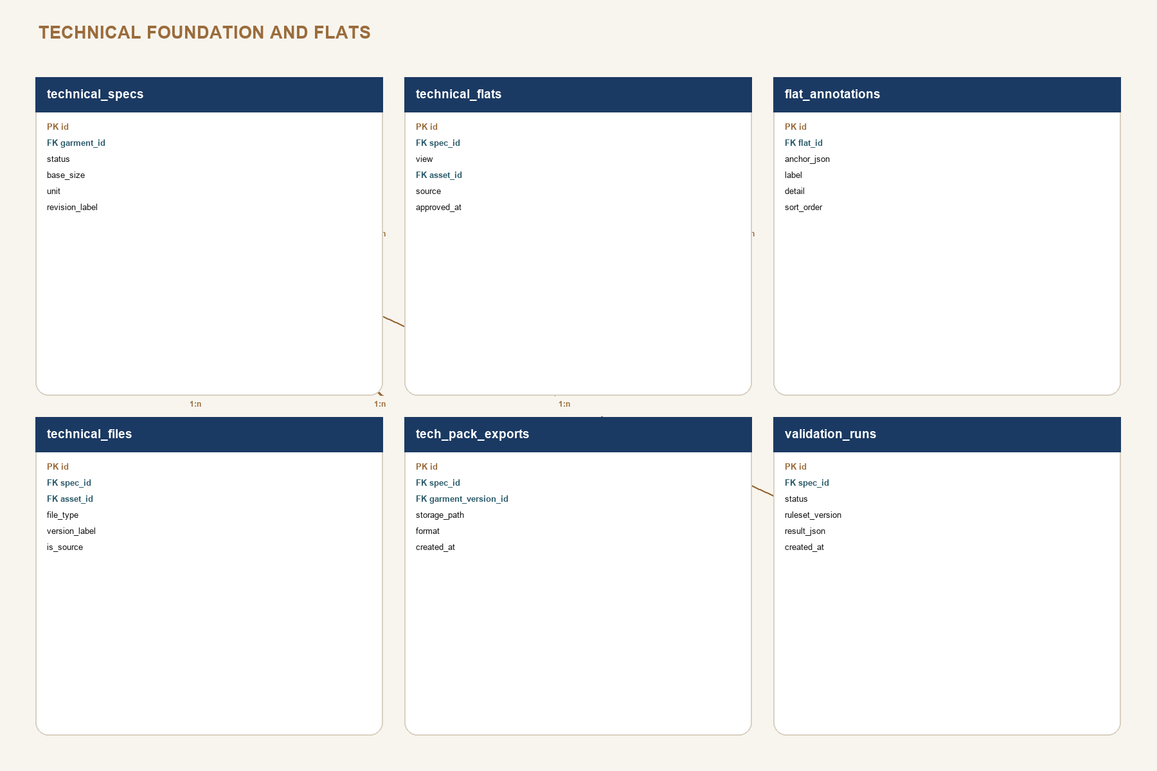
SCHEMA DECISION
Technical exports always reference a garment version so an old pack can be reproduced and audited.

DATABASE SCHEMA 5 / 9

POM, measurement sets, and grading schema
POM identity persists across sample rounds and sizes.

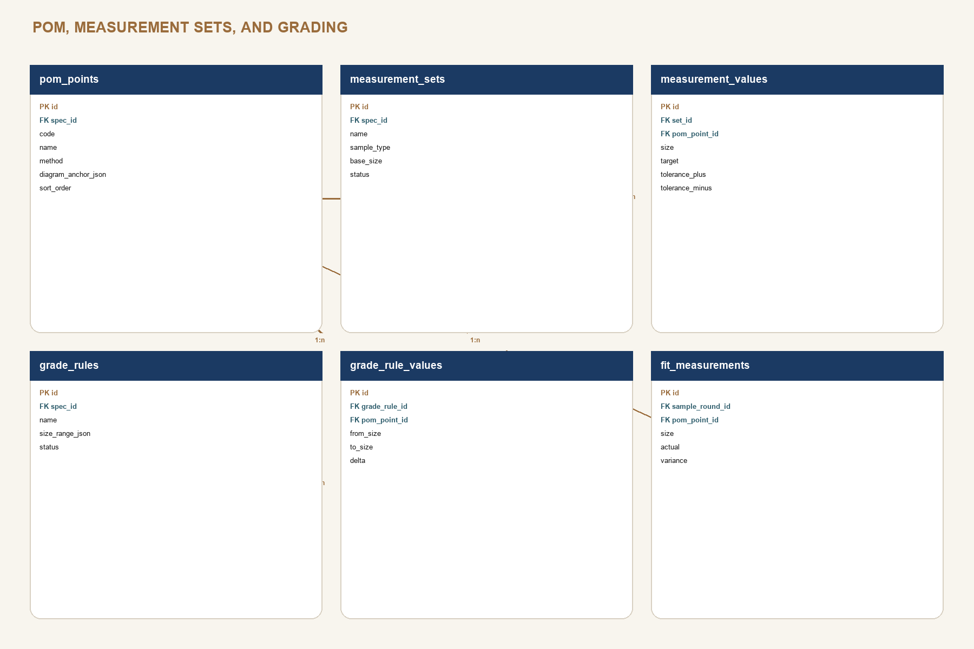
SCHEMA DECISION
A POM point stores the method and diagram anchor once. Targets, tolerances, grade deltas, and sample actuals reference that stable point.

DATABASE SCHEMA 6 / 9

BOM, construction, and reuse schema
Structured operations support validation, templates, and deterministic tech packs.

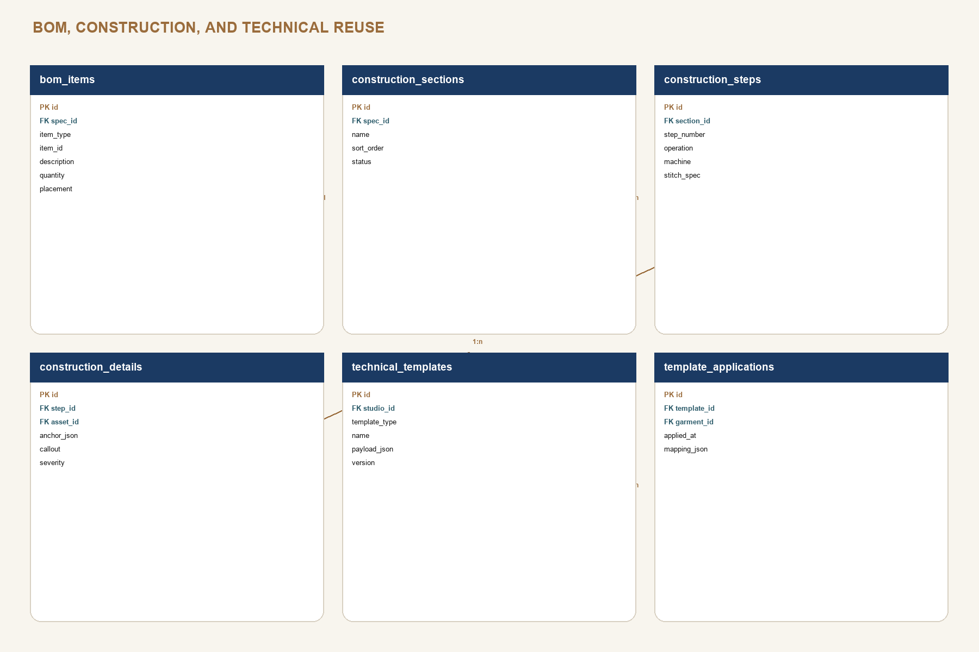
SCHEMA DECISION
Templates copy candidate rows with a template application record; later template changes never silently rewrite garments.

DATABASE SCHEMA 7 / 9

Production, samples, costing, and QC schema
Every physical decision is tied to the garment, factory, sample round, and relevant version.

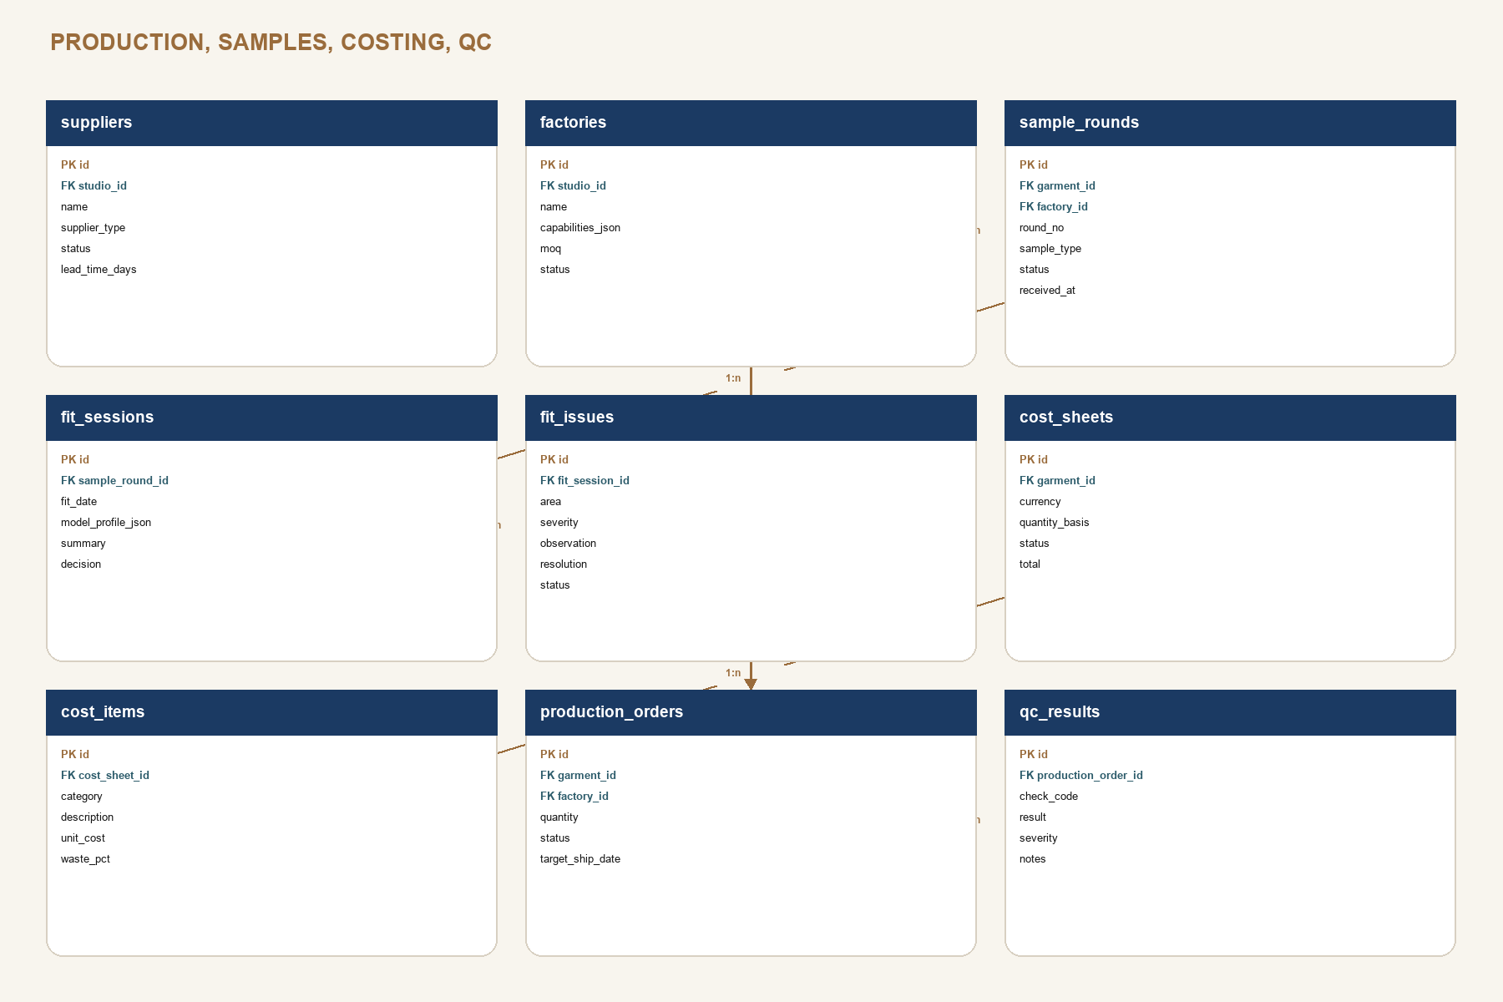
SCHEMA DECISION
A production order records the released garment version. Later design edits create a warning until a formal revision is approved.

DATABASE SCHEMA 8 / 9

Editorial and portfolio schema
Private structured stories produce separate public-safe publication snapshots.

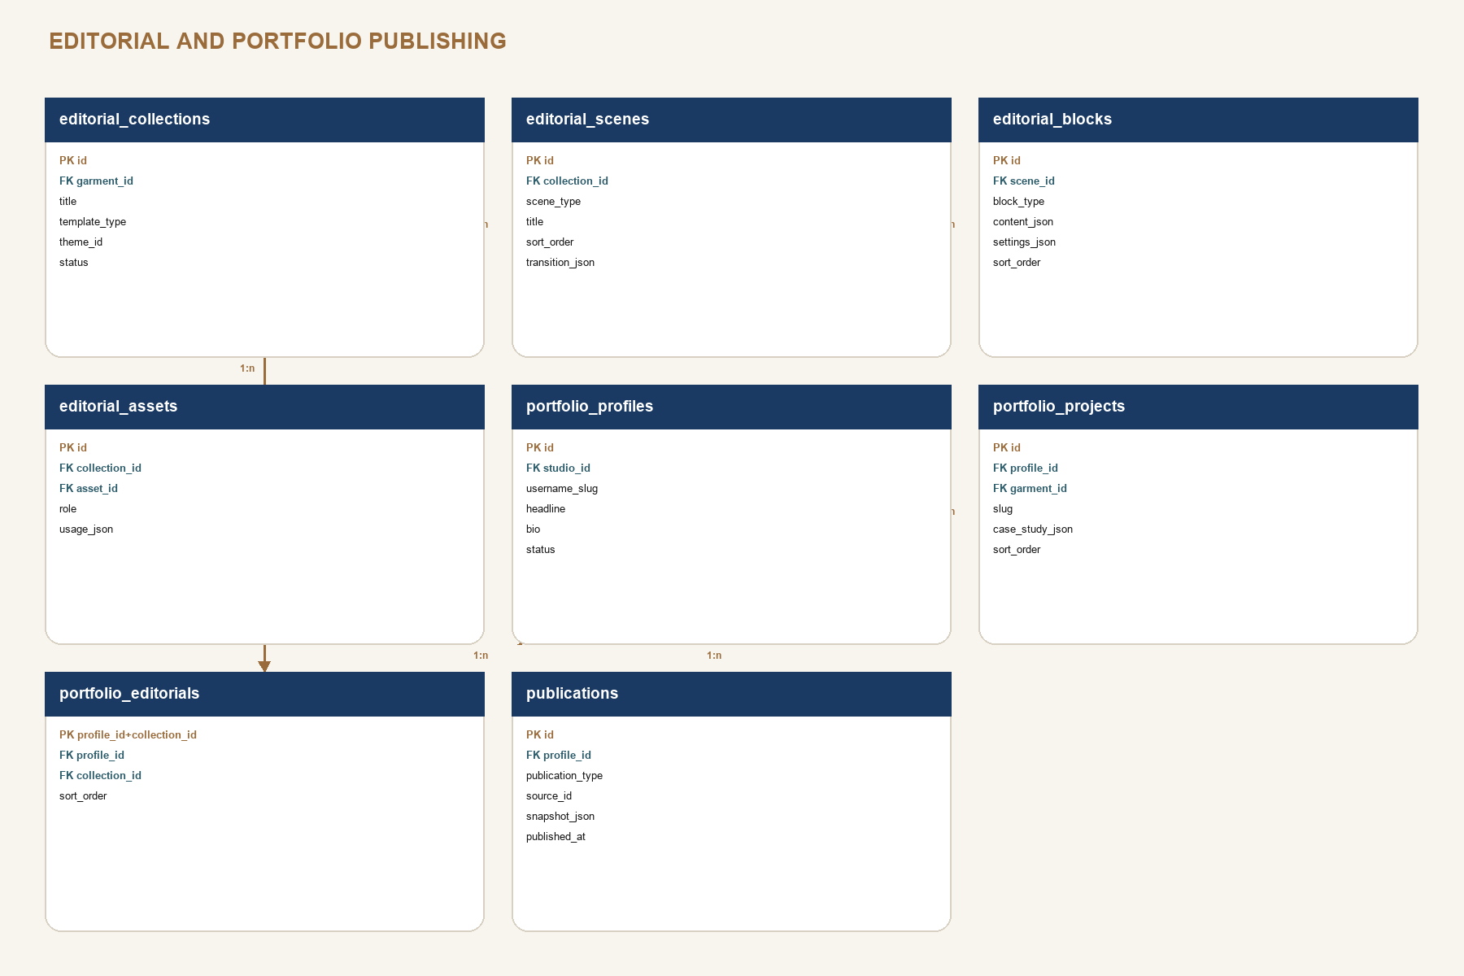
SCHEMA DECISION
Publications are immutable payloads. Updating a public page creates a new snapshot and media manifest, not anonymous access to private tables.

DATABASE SCHEMA 9 / 9

Versioning, workflow, AI, and sync schema
Platform services share the garment relationship but preserve their own audit semantics.

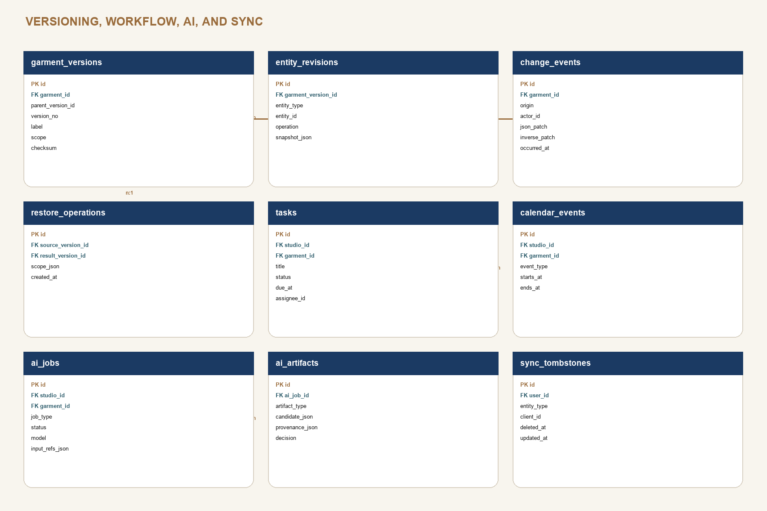
SCHEMA DECISION
AI artifacts are candidates. Only an accepted artifact can emit normal domain change events and appear in a Freeze Frame.

PRODUCT BIBLE

Data dictionary I: identity, design, and libraries
Responsibility and critical fields for every non-technical foundation table.

TABLE | OWNS | CRITICAL FIELDS
profiles | Person identity | user_id, display_name, avatar_asset_id, locale
studios / studio_members | Workspace and access | owner_user_id, studio_id, user_id, role, status
studio_settings | Shared policy | units, currency, version_policy, ai_policy
collections / garments | Catalog and canonical garment | collection_id, garment_code, title, status, phase, current_version_id
tags / garment_tags | Reusable classification | scope, name, color, garment_id
design_briefs | Creative intent | intent, target_wearer, silhouette, color_story, key_features
inspiration_boards / items | Moodboard composition | layout_json, asset_id, caption, position_json
media_assets / derivatives | Source media and generated variants | storage_path, checksum, rights_json, variant, width, height
garment_media / design_annotations | Garment use and anchored feedback | role, framing_json, anchor_json, body, status
materials / material_variants | Reusable material facts | material_code, category, composition, color, width, weight_gsm
components / component_variants | Reusable trim and hardware facts | component_code, category, spec_json, finish, size, sku
inventory_entries | Material quantity ledger | variant_id, entry_type, quantity, unit, occurred_at
garment_materials / components | Garment allocation | role or placement, required quantity, reserved quantity, status
supplier_items | Supplier offer | supplier_id, item_type, item_id, sku, unit_cost, lead_time_days

PRODUCT BIBLE

Data dictionary II: technical and production
Structured technical data is the source; the tech pack is a generated artifact.

TABLE | OWNS | CRITICAL FIELDS
technical_specs | Technical release root | garment_id, status, base_size, unit, revision_label
technical_flats / annotations | Approved views and callouts | view, asset_id, source, approved_at, anchor_json
technical_files | Pattern/CAD/source attachments | asset_id, file_type, version_label, is_source
pom_points | Measurement identity and method | code, name, method, diagram_anchor_json, sort_order
measurement_sets / values | Targets, tolerances, sample sets | base_size, sample_type, pom_point_id, size, target, tolerances
grade_rules / values | Size-to-size deltas | size_range_json, pom_point_id, from_size, to_size, delta
bom_items | Specification item rows | item_type, item_id, description, quantity, unit, placement
construction_sections / steps | Ordered assembly definition | step_number, operation, machine, stitch_spec, seam_allowance
construction_details | Anchored visual callouts | asset_id, anchor_json, callout, severity
validation_runs / exports | Release evidence | ruleset_version, result_json, garment_version_id, checksum
suppliers / factories | Vendor identity and capability | supplier_type, capabilities_json, MOQ, lead time, status
sample_rounds / fit sessions | Physical development rounds | round_no, sample_type, factory_id, fit_date, decision
fit_issues / fit_measurements | Observed issues and actuals | area, severity, resolution, pom_point_id, actual, variance
cost_sheets / cost_items | Quantity-based economics | currency, quantity_basis, category, unit_cost, waste_pct, total
production_orders / qc_results | Released production and quality | garment_version_id, factory_id, quantity, check_code, result, severity

PRODUCT BIBLE

Data dictionary III: story, versions, workflow, AI
These tables control publication, auditability, planning, and machine assistance.

TABLE | OWNS | CRITICAL FIELDS
editorial_collections / scenes / blocks | Structured private stories | garment_id, template_type, scene_type, block_type, content_json, sort_order
editorial_assets | Editorial media manifest | collection_id, asset_id, role, usage_json
portfolio_profiles / projects / editorials | Private portfolio curation | username_slug, garment_id, case_study_json, visibility, sort_order
publications | Immutable public cut | publication_type, source_id, source_version_id, snapshot_json, media_manifest, checksum
garment_versions | Named Freeze Frame | parent_version_id, version_no, label, scope, checksum, created_by
entity_revisions | Per-entity checkpoint payload | entity_type, entity_id, operation, snapshot_json
change_events | Mutation ledger | origin, actor_id, operation_id, json_patch, inverse_patch, occurred_at
restore_operations | Restore audit | source_version_id, result_version_id, scope_json, reason
tasks / calendar_events | Work and time | garment_id, status, due_at, assignee_id, event_type, starts_at
ai_jobs | Machine work request | job_type, status, model, prompt_version, input_refs_json, started_at
ai_artifacts | Reviewable candidate | artifact_type, candidate_json, provenance_json, confidence_json, decision
sync_tombstones | Distributed deletion | entity_type, client_id, deleted_at, updated_at

SCHEMA COMPLETENESS
Pages 20-28 diagram every proposed table. Pages 29-31 define responsibility and critical fields. Detailed SQL types, constraints, indexes, and RLS policies are implementation deliverables in work package 2, not assumptions hidden in UI code.

PRODUCT BIBLE

Security, RLS, storage, and publication boundaries
The studio graph is private; public experience is a separate projection.

LAYER | RULE
Authentication | Supabase Auth session is required for all private routes. Public portfolio routes never reuse signed-in in-memory studio state.
Studio membership | RLS checks active studio_members rows; owner, editor, reviewer, and viewer roles are reserved for 3.0 but schema-ready.
Owner data | All private tables enforce studio membership for select and role-appropriate write operations.
Storage | studio-assets bucket is private under studios/{studio_id}/...; portfolio-assets is public but only contains copied publication derivatives.
Publications | Anonymous select is allowed only on publication tables or an RPC/view that returns current public snapshots.
Technical sensitivity | Costs, supplier identities, pattern files, full technical data, fit notes, and raw AI inputs are never public by default.
Downloads | Time-limited signed URLs for private files; checksum and source version recorded for export artifacts.
Audit | Publication, unpublication, restore, role changes, and AI acceptance create immutable change events.

RLS test matrix
- Anonymous cannot select any private garment, task, note, technical, production, or media row.
- Member of Studio A cannot infer or mutate IDs from Studio B, including storage paths.
- Public reader sees only is_public/current publication snapshots and public derivatives.
- Unpublishing removes anonymous access without deleting private source records or publication history.

PRODUCT BIBLE

Offline-first sync and conflict policy
Preserve the current resilience, but give every domain the same durable contract.

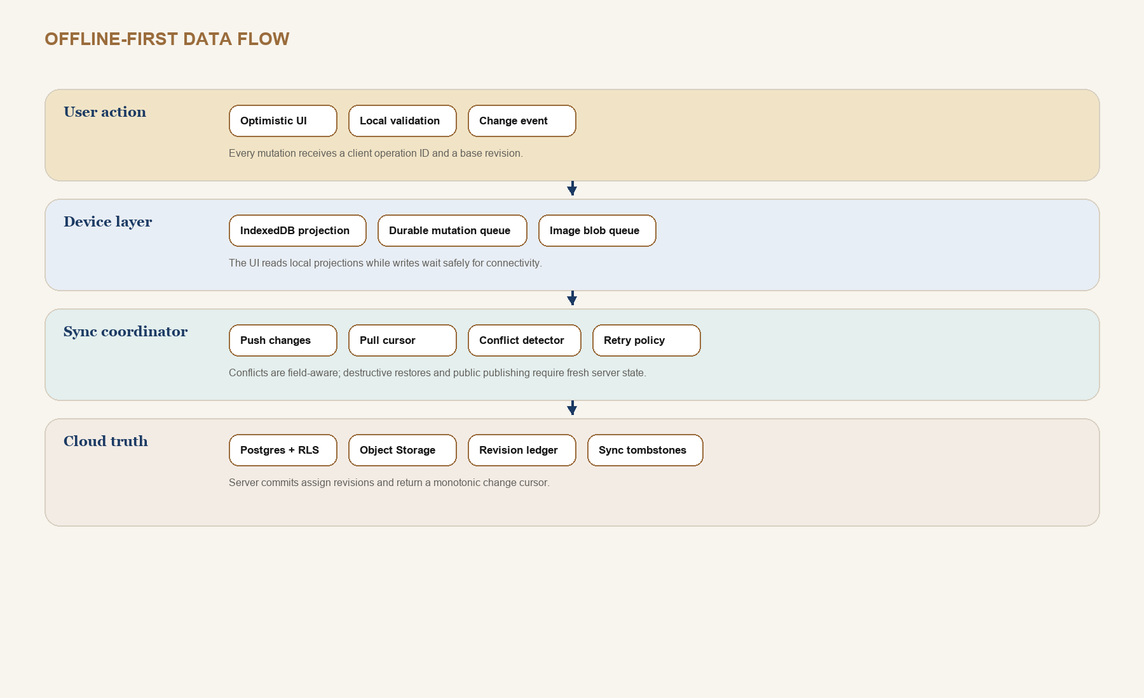
CONFLICT | POLICY
Different fields | Merge automatically; emit one combined change event with both operation IDs.
Same scalar field | Show before, local, and remote values; user selects or writes a new value.
Ordered children | Merge by stable child ID and fractional sort key; warn on same-item moves.
Media | Deduplicate by checksum; preserve separate framing and role relationships.
Delete versus edit | Tombstone wins provisionally; offer restore-as-new-revision when user has unsynced work.
Release / publish / restore | Require fresh server revision and online commit; never queue blindly.

PRODUCT BIBLE

Versioning architecture: Freeze Frames
Git-style confidence without exposing designers to repository mechanics.

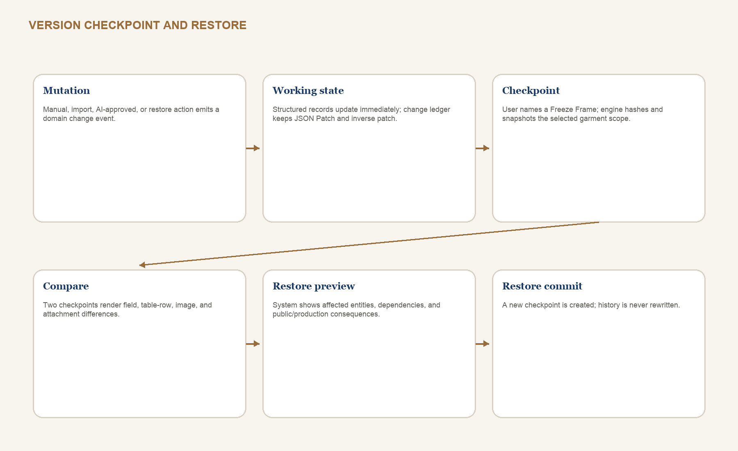

2.x version model
- Working state is continuously saved; it is not itself a named version.
- A Freeze Frame is a named checkpoint over a garment scope: all, design, technical, production, editorial, or portfolio.
- Release checkpoints are system-labeled and cannot be deleted while referenced by a production order, export, or publication.
- Long-lived branches are deferred to 3.0. In 2.x, experimentation uses duplicate garment or named draft checkpoint plus restore.
- Restore creates a new checkpoint whose parent is the current version; it never rewrites the timeline.

PRODUCT BIBLE

Version compare, release gates, and restore rules
Comparison must understand product structure, not just JSON text.

ARTIFACT | COMPARE REPRESENTATION | RESTORE BEHAVIOR
Brief and garment metadata | Field before/after with author and time | Selected fields or full design scope
POM / measurements | Row identity by POM point and size; tolerance and actual deltas | Restore rows while preserving later sample evidence unless explicitly selected
BOM | Added/removed/replaced item, quantity, placement, supplier and cost impact | Warn about inventory reservations and open production orders
Construction | Step reorder, operation text, machine/stitch, image callouts | Restore selected sections or complete construction scope
Media / flats | Asset checksum, role, framing, annotation, approval | Never delete source asset if referenced elsewhere
Editorial | Scene/block order, content, theme, live-data source and staleness | Published snapshot stays unchanged until republished
Portfolio | Visibility, case-study copy, order, selected assets | Public cut stays unchanged until explicit publish

RELEASE GATE
A release gate is a named validation ruleset plus a Freeze Frame. Waivers require reason, actor, time, affected rule, and follow-up task. Critical privacy rules cannot be waived.

PRODUCT BIBLE

Design language: The Modern Atelier
Dark, tactile, editorial - with the clarity and discipline of a technical workbench.

TOKEN | VALUE | ROLE
Midnight | #0A0A0A | App background and high-focus canvas
Celestial | #1B3A63 | Structural navigation, technical information, calm focus
Golden Ember | #C89B3C | Primary action, approved status, active lens, highlights
Nebula Teal | #2D5C6B | Informational state, material and data relationships
Dusk Bronze | #9A6C3C | Borders, secondary emphasis, tactile detail
Stardust Ivory | #EDE3CF | Primary text on dark surfaces
Deep Espresso | #3D2B1F | Warm supporting surfaces and editorial mood

Typography and shape
- Display: Cinzel Decorative only for page-level or campaign titles. Never use it in dense tables, forms, or long copy.
- Workbench: Inter or system sans. Use tabular numerals for measurements, costs, quantities, and version numbers.
- Radius: 12 for fields, 16 for cards, 24 for presentation surfaces. Technical grids use restrained radius and stronger alignment.
- Borders carry hierarchy; shadows are subtle. Selected, focused, warning, error, and approved states must not rely on color alone.
- Motion is quiet: 160-240 ms for controls, 320-460 ms for editorial transitions; honor reduced motion.
CONTRAST CORRECTION
The current brand can become too dim in long work sessions. Workbench surfaces use lighter text, clearer field boundaries, and stronger focus rings than editorial viewing surfaces.

PRODUCT BIBLE

Interaction, responsive, and accessibility principles
The interface changes density, not capability or vocabulary.

PRINCIPLE | CONTRACT
One primary action | Each screen has one dominant commit or progression action; secondary actions remain available but visually quieter.
Autosave with evidence | Show saved locally, syncing, synced, conflict, and failed. Releases and publications remain explicit commits.
Keyboard workbench | Command palette, table row navigation, add row, duplicate, compare, save checkpoint, and validation shortcuts.
Responsive lenses | Desktop: rail + canvas + Threadline. Tablet: rail collapses, inspector becomes sheet. Mobile: capture and next-move views.
Touch-safe | Minimum 44 px controls; drag has menu alternatives; tables offer row detail cards on narrow screens.
Semantic structure | Real headings, labels, table headers, landmarks, live regions, and error summaries.
Focus and motion | Visible 2 px focus treatment; logical order; focus returns after modal; reduced motion disables nonessential transitions.
Data legibility | Do not encode status only by hue; units live in headers and inputs; decimals and dates are locale-aware.

Accessibility target
Target WCAG 2.2 AA for product UI and public portfolio. Screenshot review is insufficient: automated checks, keyboard walkthroughs, zoom/reflow tests, and screen-reader verification are release requirements.

PRODUCT BIBLE

Component library I: foundations
Tokens and primitives shared by every domain.

COMPONENT | VARIANTS / STATES | REQUIRED BEHAVIOR
AppShell | desktop, tablet, mobile | Primary rail, garment lens bar, Threadline slot, main landmark, skip link
PageHeader | editorial, workbench, field | Title, context, status, one primary action, responsive collapse
Button / IconButton | primary, secondary, quiet, danger | loading, disabled reason, tooltip for icon-only, 44 px touch target
Field | text, number, unit, date, select, combobox | label, hint, error, dirty state, keyboard and autocomplete policy
Card / Surface | standard, selected, warning, presentation | consistent padding, semantic region where useful, no nested-card clutter
Tabs / LensSwitcher | route, local panel, compact | URL for durable lenses; aria-current or tab semantics; overflow handling
Badge / Status | neutral, info, warning, error, approved | icon + label when meaning is critical; never color-only
Dialog / Sheet | confirm, editor, inspector, mobile sheet | focus trap, escape, destructive confirmation, return focus
Toast / SyncStatus | saving, synced, queued, conflict, failed | live region, persistent path to details, no success spam

MIGRATION RULE
Reuse current shared components where semantics and accessibility are sound. Introduce Storybook-style examples and tests before replacing visual treatment.

PRODUCT BIBLE

Component library II: technical and data authoring
Dense tools need predictable selection, units, validation, and batch actions.

COMPONENT | USE | CONTRACT
DataGrid | POM, BOM, cost, QC, grade rules | Sticky header, row identity, keyboard cells, unit-aware columns, row detail fallback
EditableCell | Inline scalar changes | Enter to edit, Escape to cancel, dirty indicator, validation, conflict marker
MeasurementInput | Targets, tolerance, actuals | Explicit unit, decimal precision, range validation, paste support
POMCanvas | Diagram and point anchors | Zoom/pan, keyboard point list, selected anchor sync, no inaccessible canvas-only data
FlatCanvas | Technical view and callouts | Source/revision, annotation anchors, compare overlay, approval status
SequenceBuilder | Construction steps and editorial scenes | Drag plus move menu, stable IDs, bulk duplicate, dependency warnings
RelationshipPicker | Material, component, supplier, asset links | Search existing first, create inline second, show downstream use
InspectorPanel | Selected row/block/asset | Edits selected entity only; dirty-state warning on selection change
ValidationSummary | Release and publish gates | Group by severity and domain; jump to exact field; waiver workflow
DiffViewer | Version comparison | Field, row, order, asset, and prose diff modes; restore selection

Table editing rule
The grid is the fastest authoring surface, not the only readable representation. On mobile, rows become labeled detail cards and batch work is deferred to tablet or desktop.

PRODUCT BIBLE

Component library III: AI, versions, and publishing
High-consequence actions share a visible proposal-preview-commit pattern.

PATTERN | STAGES | NON-NEGOTIABLE DETAILS
AICandidatePanel | queued, running, candidate, accepted, rejected | Input sources, prompt/ruleset version, model, confidence, changed entities, decision
FreezeFrameDialog | scope, label, notes, validation, commit | Shows included domains and unresolved warnings; release labels protected
RestorePreview | source, current, affected, dependency warnings, commit | Creates new version; never silently rolls back public or production artifacts
PublicCutPreview | selection, privacy scan, anonymous preview, publish | Exact public payload, selected assets, source version, staleness
ExportPanel | format, sections, validation, generation, artifact | Template version, source garment version, checksum, deterministic file name
ConflictResolver | base, local, remote, resolution | Field-aware options; preserve both evidence and the final chosen value
ReleaseGate | checks, warnings, waivers, checkpoint, release | Ruleset version and actor recorded; critical privacy failures block commit

SHARED MENTAL MODEL
AI acceptance, restore, release, export, and publish all work the same way: inspect inputs, preview consequences, resolve blockers, commit an auditable artifact.

PRODUCT BIBLE

Complete screen inventory
Every screen has one primary owner and one primary user action.

AREA | SCREENS | PRIMARY ACTION
Access | Sign in, sign up, recovery, first-studio setup | Enter or establish private studio
Today | Dashboard, command palette, activity/inbox | Choose or create the next move
Garments | Library, collection workspace, garment overview, Design Studio, moodboard, media library | Define and navigate garment intent
Technical | Technical home, flats, POM map, measurement set, grading, BOM, construction, technical files, export | Create and release structured specification
Production | Production home, suppliers, factories, sample rounds, fit sessions, costing, production order, QC, timeline | Approve evidence and control risk
Libraries | Material Vault, material detail, Component Library, component detail, supplier detail, templates | Reuse verified studio knowledge
Editorial | Editorial Library, collection setup, scene builder, viewer, export | Compose and deliver a garment story
Portfolio | Manager, profile editor, project settings, Public Cut preview, publish history | Curate and publish safe public work
Public | Portfolio home, project case study, editorial viewer, technical excerpt/download | Understand the designer and work
Platform | Versions, diff, restore, tasks, calendar, AI jobs, settings, sync/backup | Control change, work, policy, and resilience

WIREFRAME COVERAGE
Pages 42-56 cover every screen above. Closely related detail/setup screens use the same shell shown for their area and are represented by a named tab, inspector, or modal within the grouped wireframe.

WIREFRAME 1 / 15

Access and daily cockpit
Sign in, sign up/setup pattern, Dashboard.

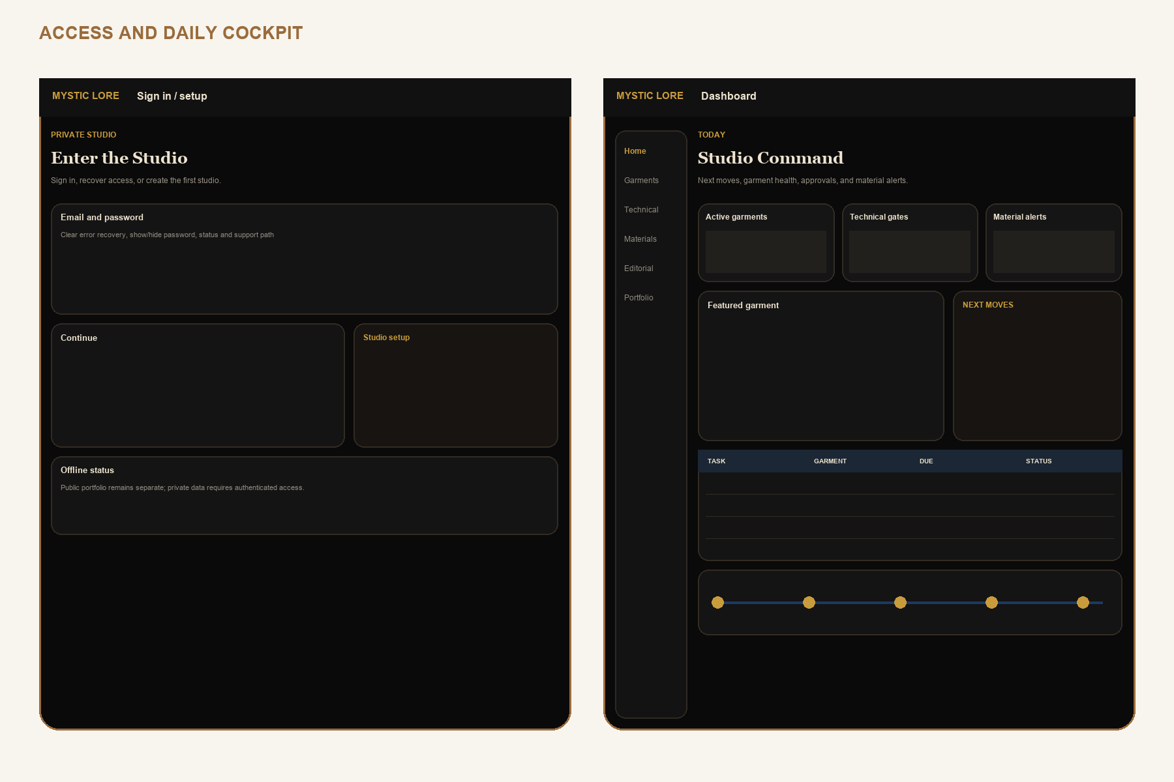
Low-fidelity interaction contract. Visual design is governed by pages 36-40; labels and information hierarchy are intentional.

WIREFRAME 2 / 15

Global command and activity
Command palette, search/create actions, activity inbox and notification rules.

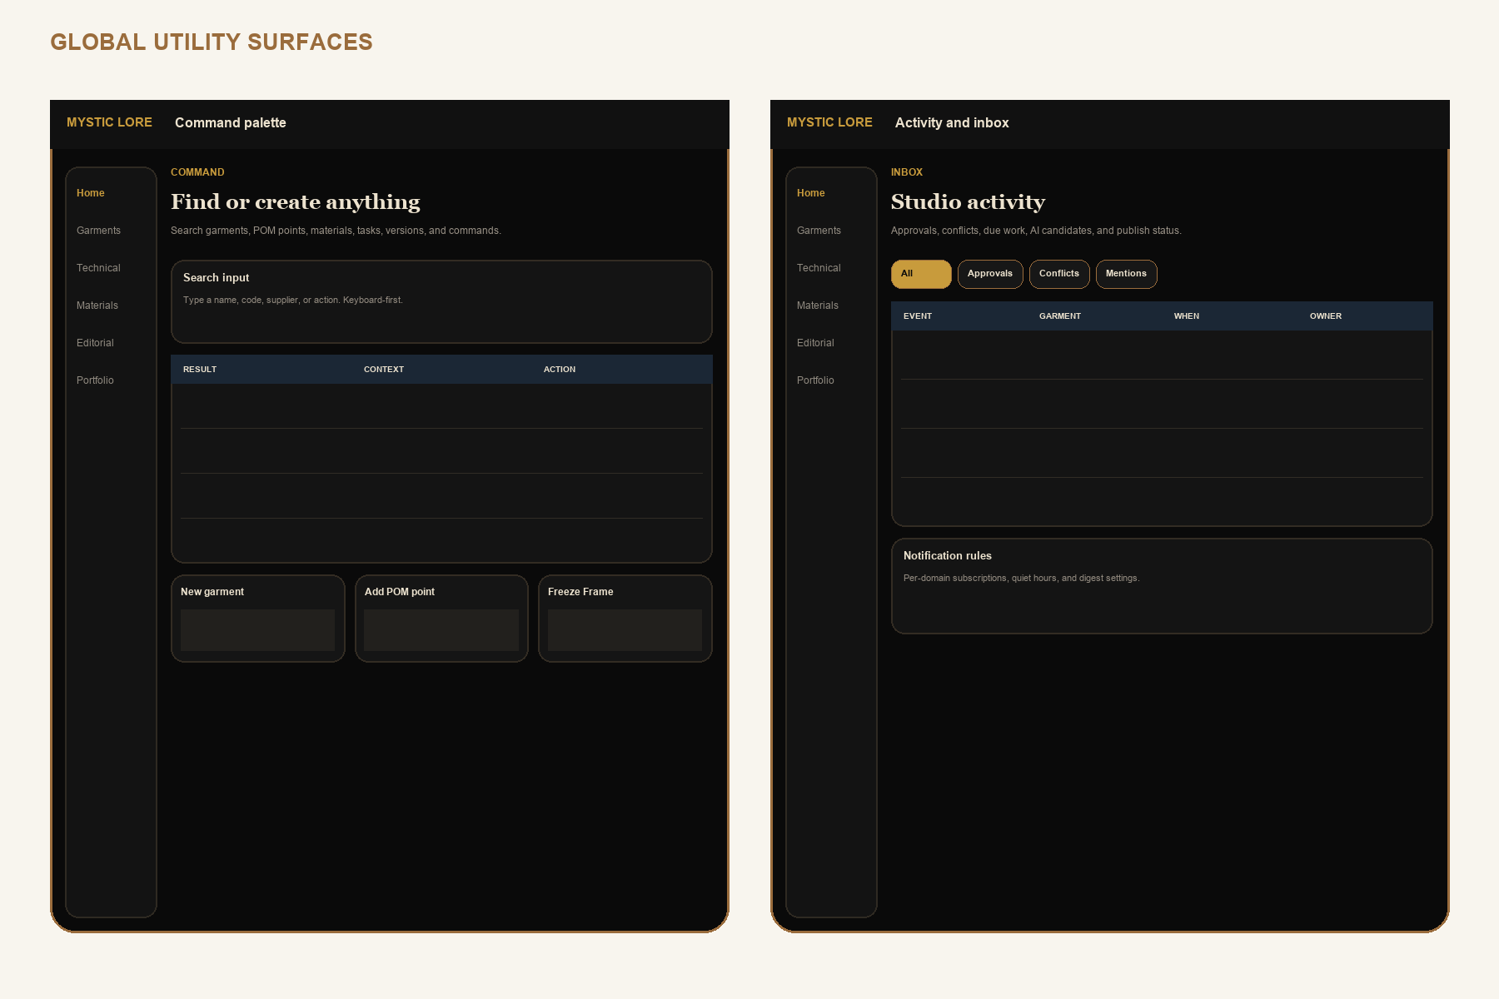
Low-fidelity interaction contract. Visual design is governed by pages 36-40; labels and information hierarchy are intentional.

WIREFRAME 3 / 15

Garment Library and collections
Garment search, saved views, line plan, and collection brief.

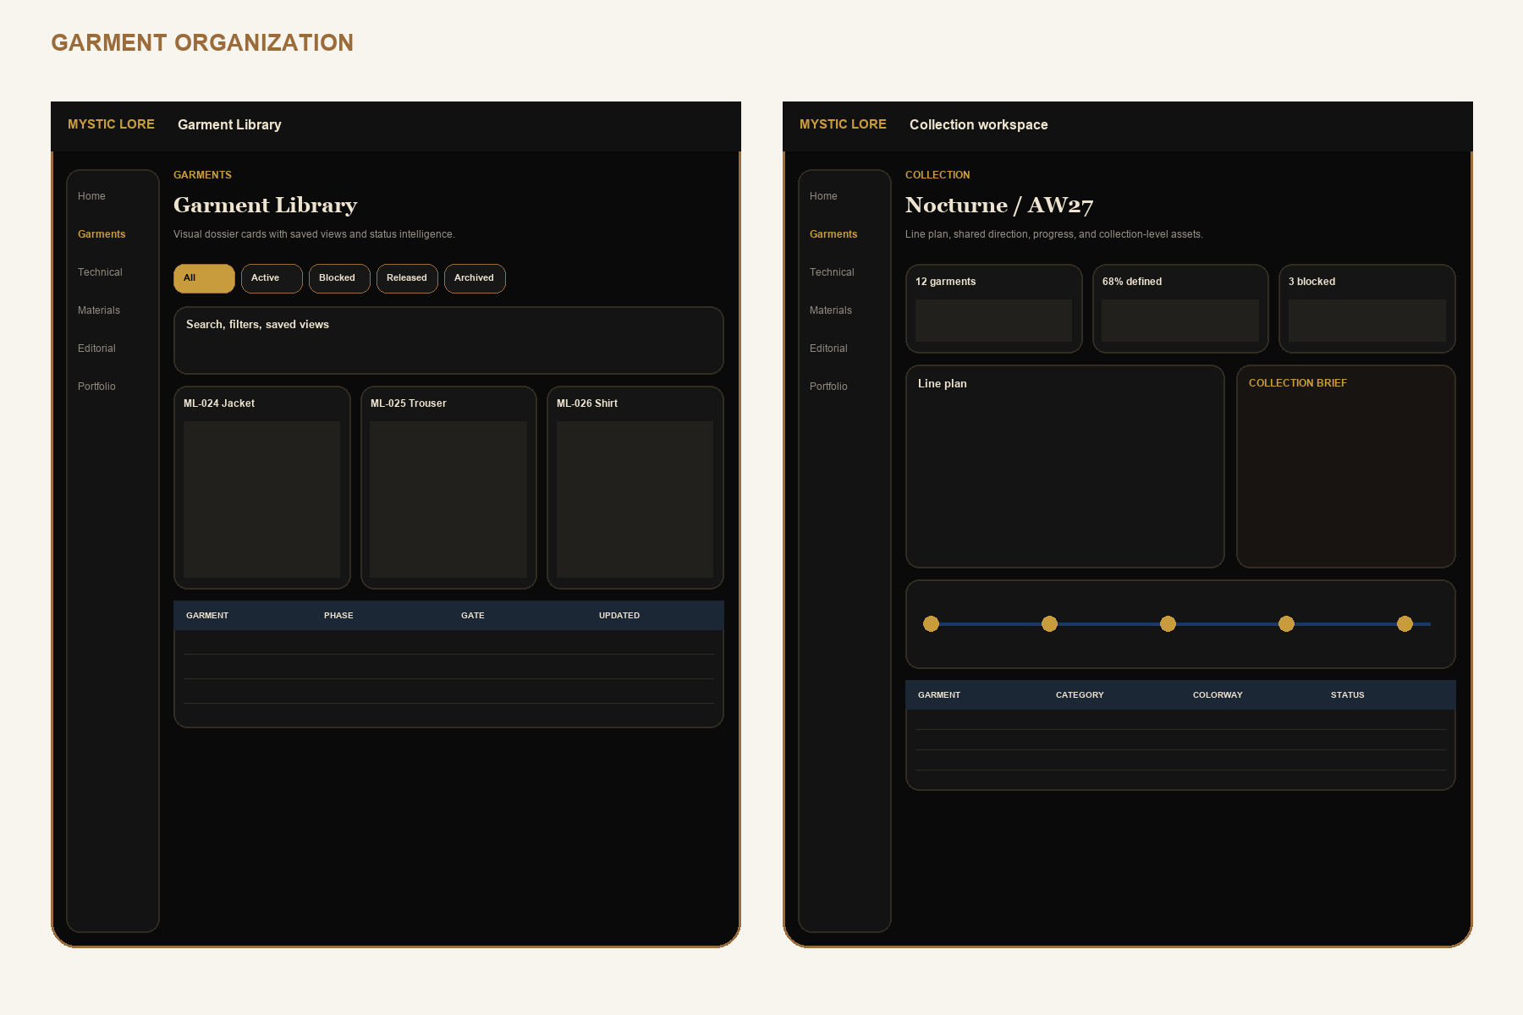
Low-fidelity interaction contract. Visual design is governed by pages 36-40; labels and information hierarchy are intentional.

WIREFRAME 4 / 15

Garment overview and Design Studio
Six lenses, Threadline rail, brief, colorways, and design decisions.

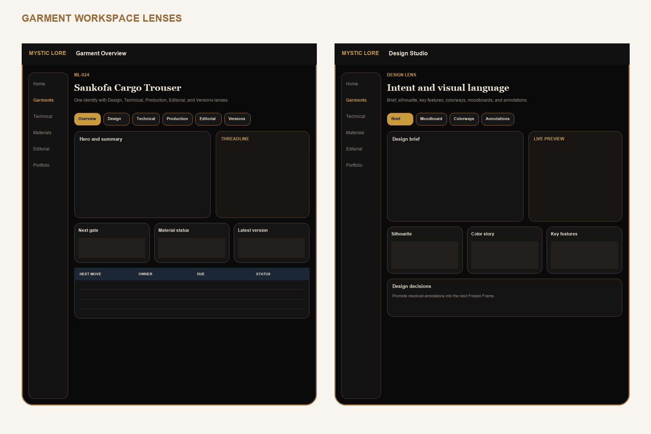
Low-fidelity interaction contract. Visual design is governed by pages 36-40; labels and information hierarchy are intentional.

WIREFRAME 5 / 15

Moodboards and media
Reference canvas, asset rights, roles, derivatives, and annotations.

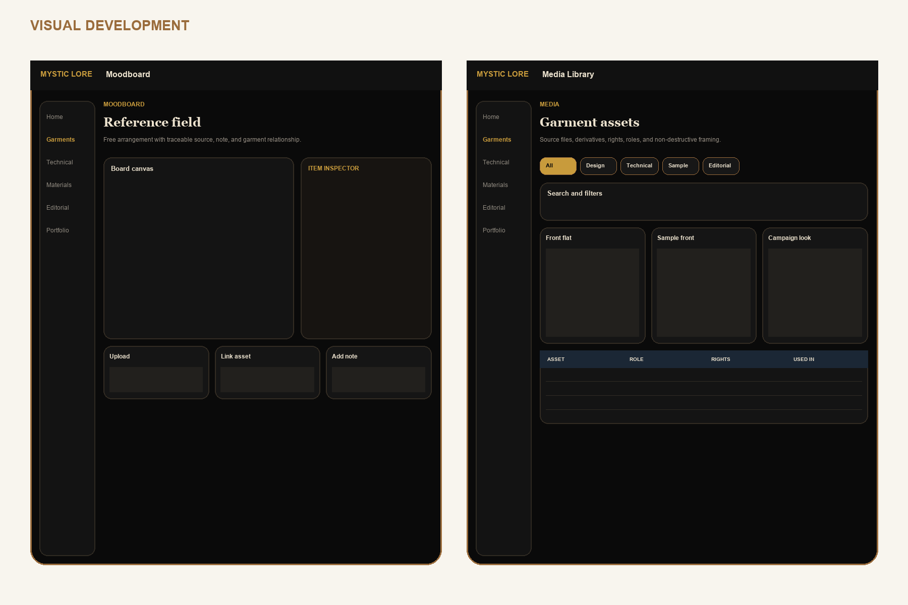
Low-fidelity interaction contract. Visual design is governed by pages 36-40; labels and information hierarchy are intentional.

WIREFRAME 6 / 15

Technical Studio and flats
Release health, warnings, flat views, annotations, compare, and approval.

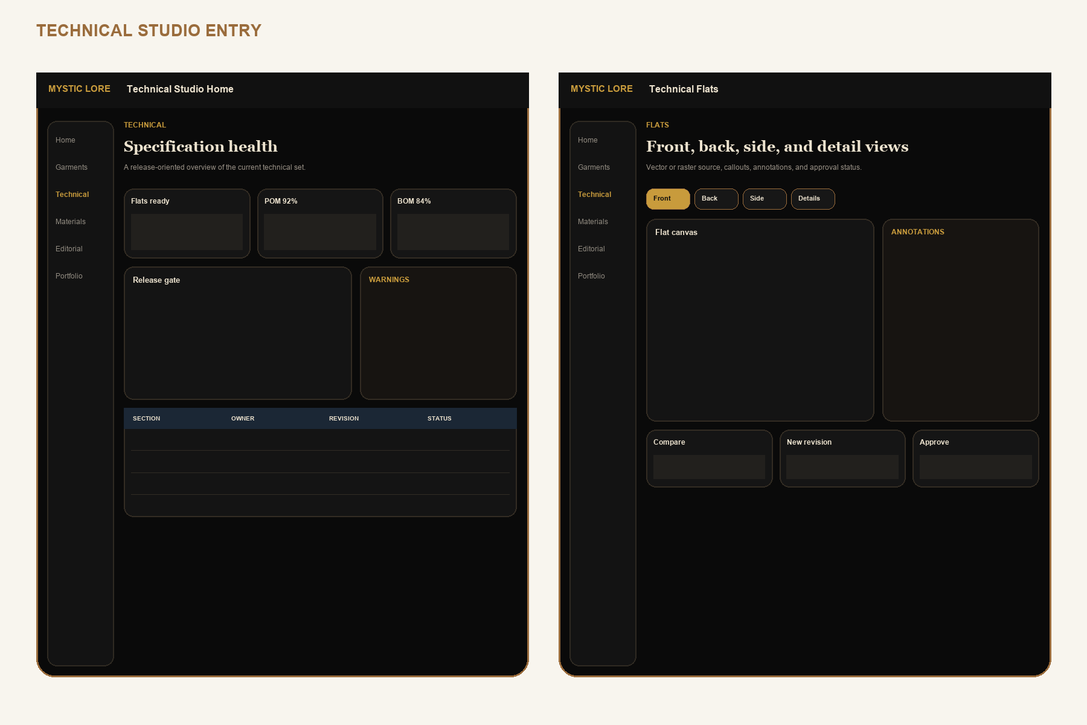
Low-fidelity interaction contract. Visual design is governed by pages 36-40; labels and information hierarchy are intentional.

WIREFRAME 7 / 15

POM and measurement sets
Diagram anchors, methods, base targets, tolerances, sample actuals, and validation.

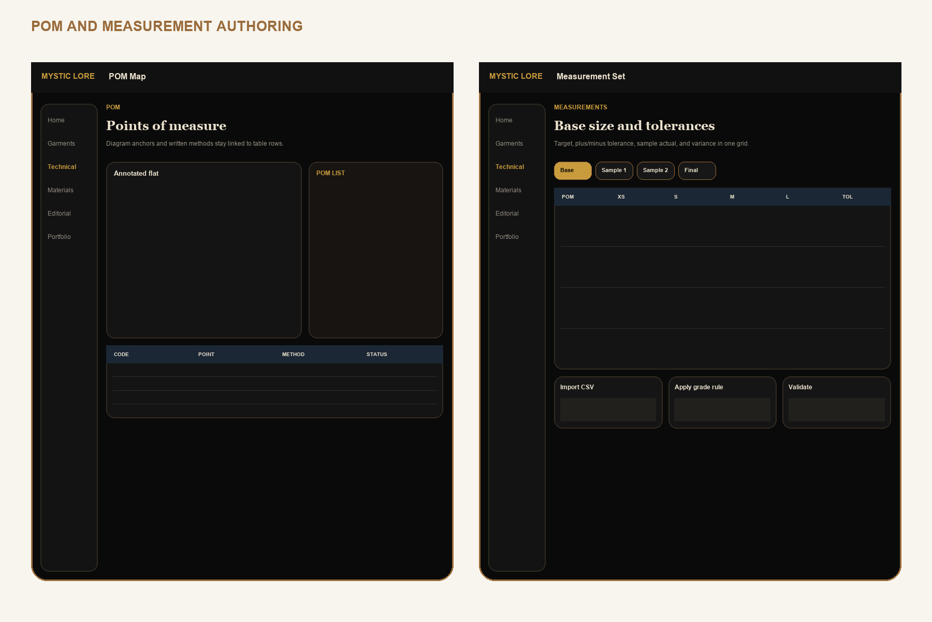
Low-fidelity interaction contract. Visual design is governed by pages 36-40; labels and information hierarchy are intentional.

WIREFRAME 8 / 15

BOM and components
Variant links, placements, quantities, supplier offers, substitutes, and cost impact.

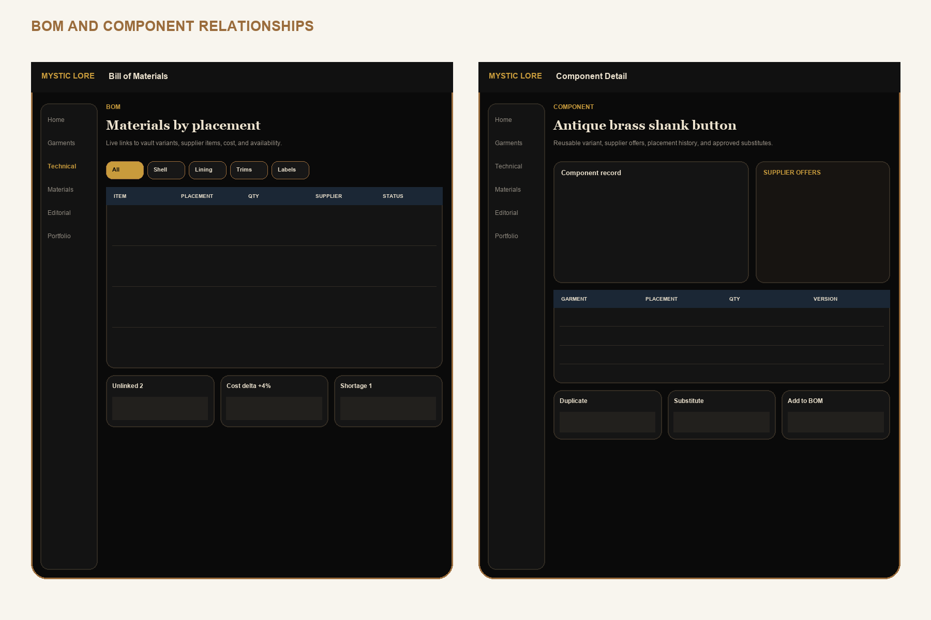
Low-fidelity interaction contract. Visual design is governed by pages 36-40; labels and information hierarchy are intentional.

WIREFRAME 9 / 15

Construction, grading, and files
Assembly sequence, detail inspector, grade rules, source files, and exports.

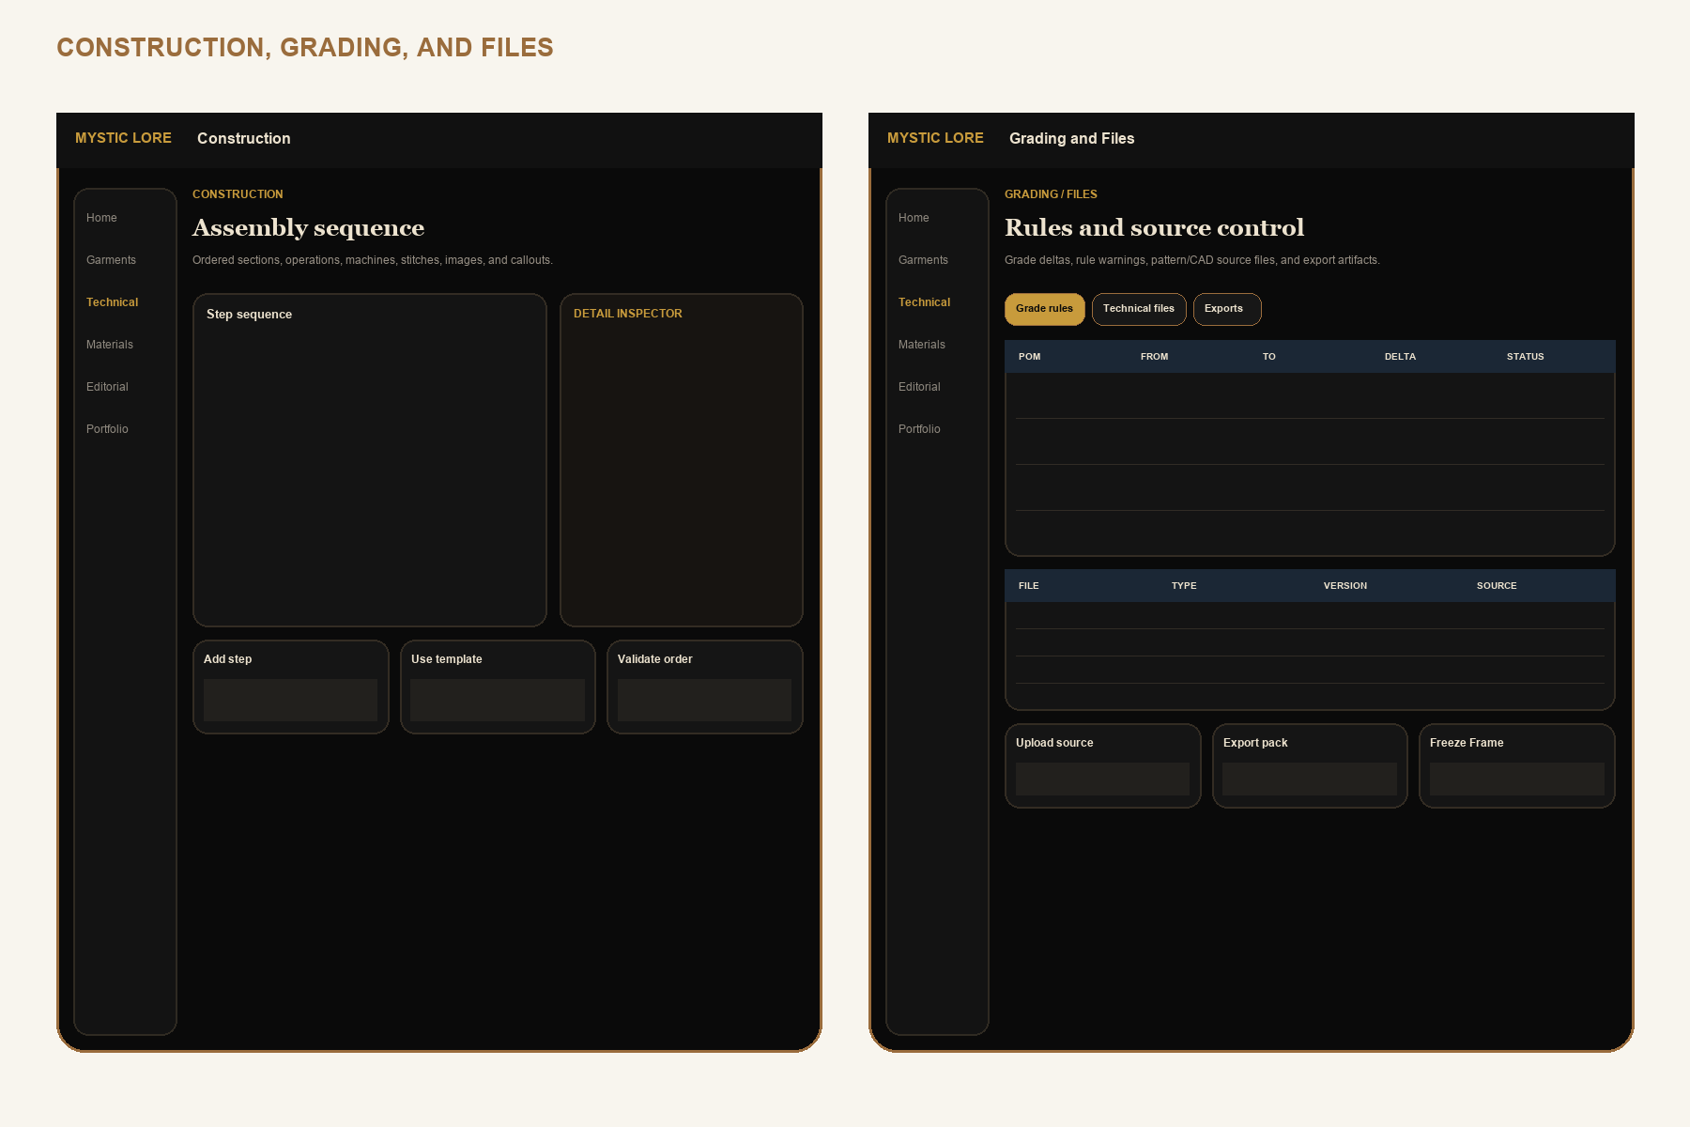
Low-fidelity interaction contract. Visual design is governed by pages 36-40; labels and information hierarchy are intentional.

WIREFRAME 10 / 15

Production, samples, and fit
Production overview, sample rounds, fit measurements, issues, and decisions.

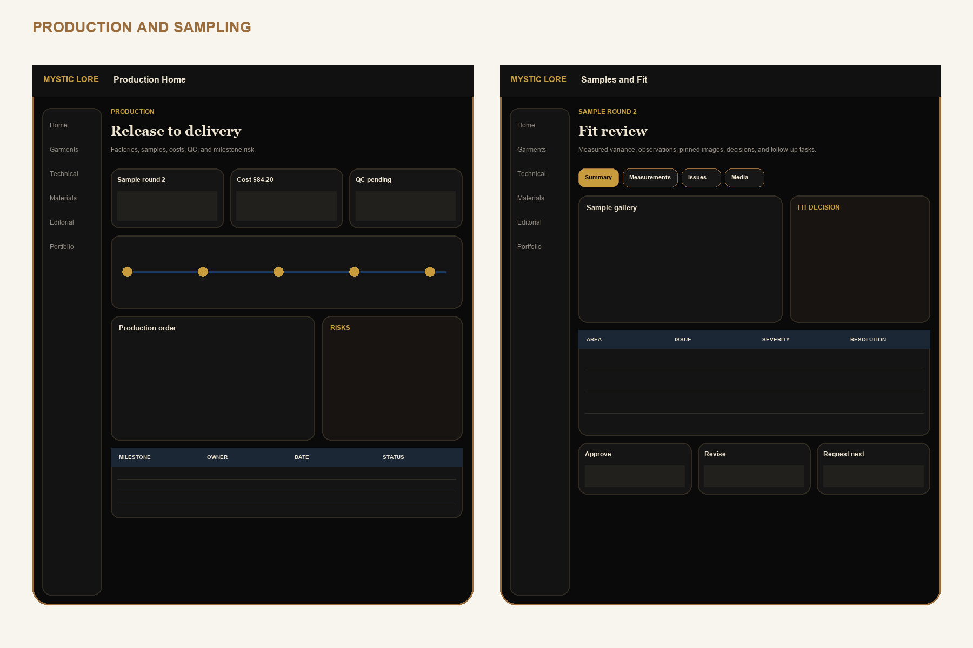
Low-fidelity interaction contract. Visual design is governed by pages 36-40; labels and information hierarchy are intentional.

WIREFRAME 11 / 15

Costing, QC, and timeline
Quantity scenarios, quality checks, waivers, release decision, and milestones.

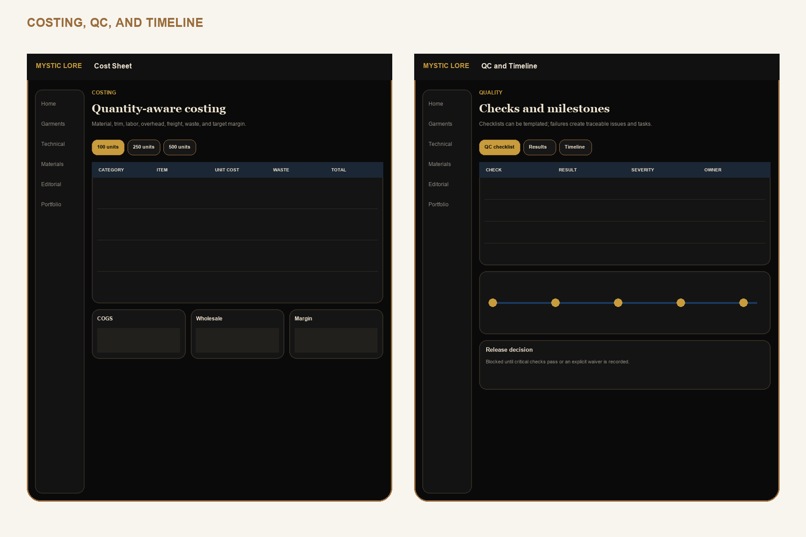
Low-fidelity interaction contract. Visual design is governed by pages 36-40; labels and information hierarchy are intentional.

WIREFRAME 12 / 15

Material and Component Libraries
Searchable reusable records, inventory, supplier offers, variants, and usage.

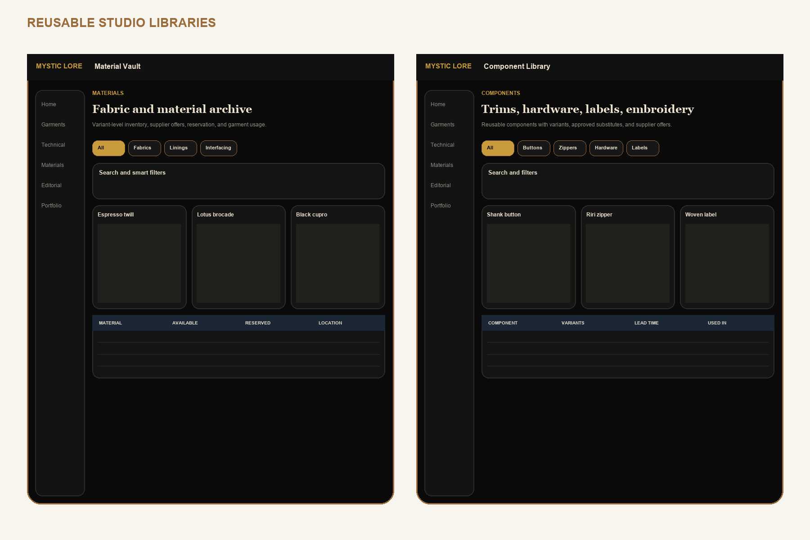
Low-fidelity interaction contract. Visual design is governed by pages 36-40; labels and information hierarchy are intentional.

WIREFRAME 13 / 15

Editorial Collections
Library, setup, scene builder, live-data blocks, viewer, PDF/image export, and publish.

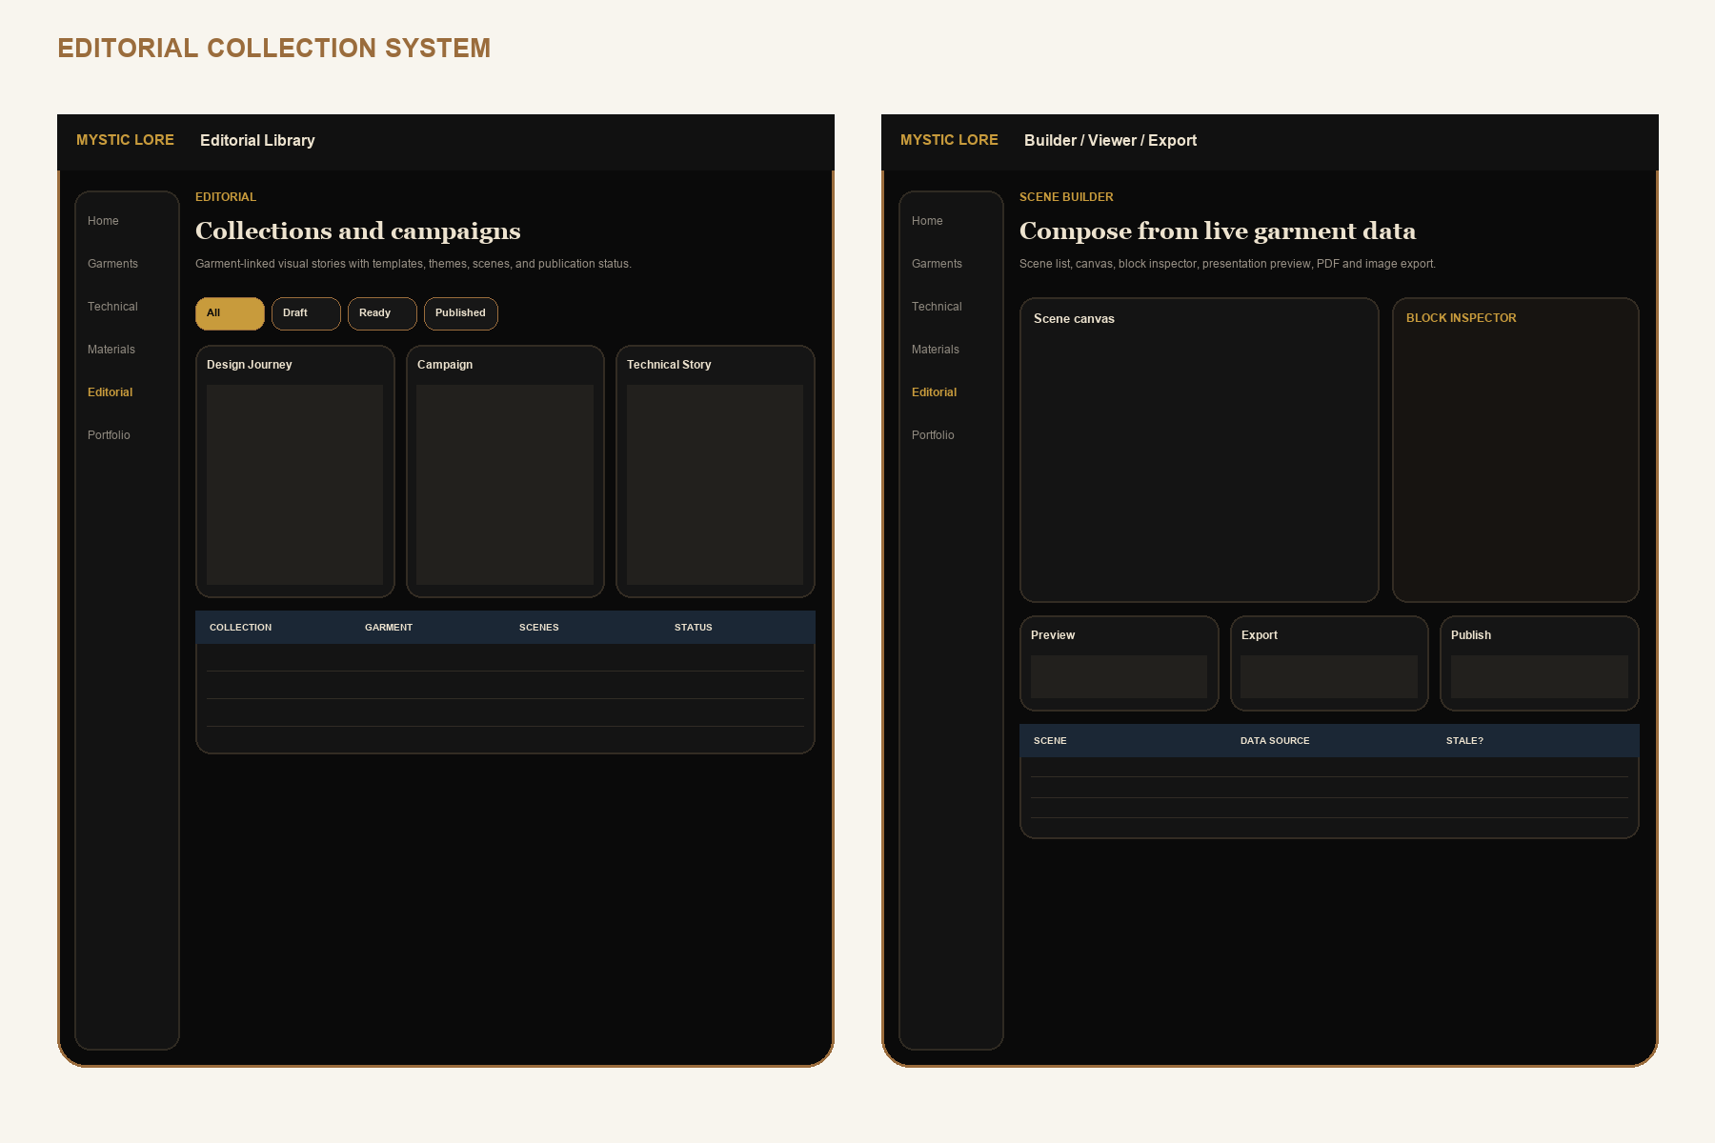
Low-fidelity interaction contract. Visual design is governed by pages 36-40; labels and information hierarchy are intentional.

WIREFRAME 14 / 15

Portfolio manager and public experience
Profile, project/editorial selection, Public Cut preview, public home, case study, and editorial viewer.

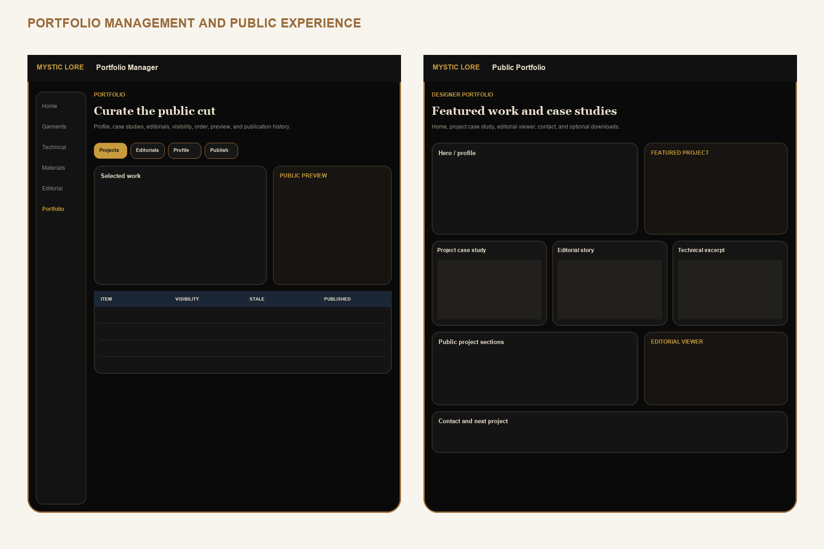
Low-fidelity interaction contract. Visual design is governed by pages 36-40; labels and information hierarchy are intentional.

WIREFRAME 15 / 15

Versions, tasks, calendar, and settings
Freeze Frames, structural diff, restore, planning, AI policy, sync, and backup.

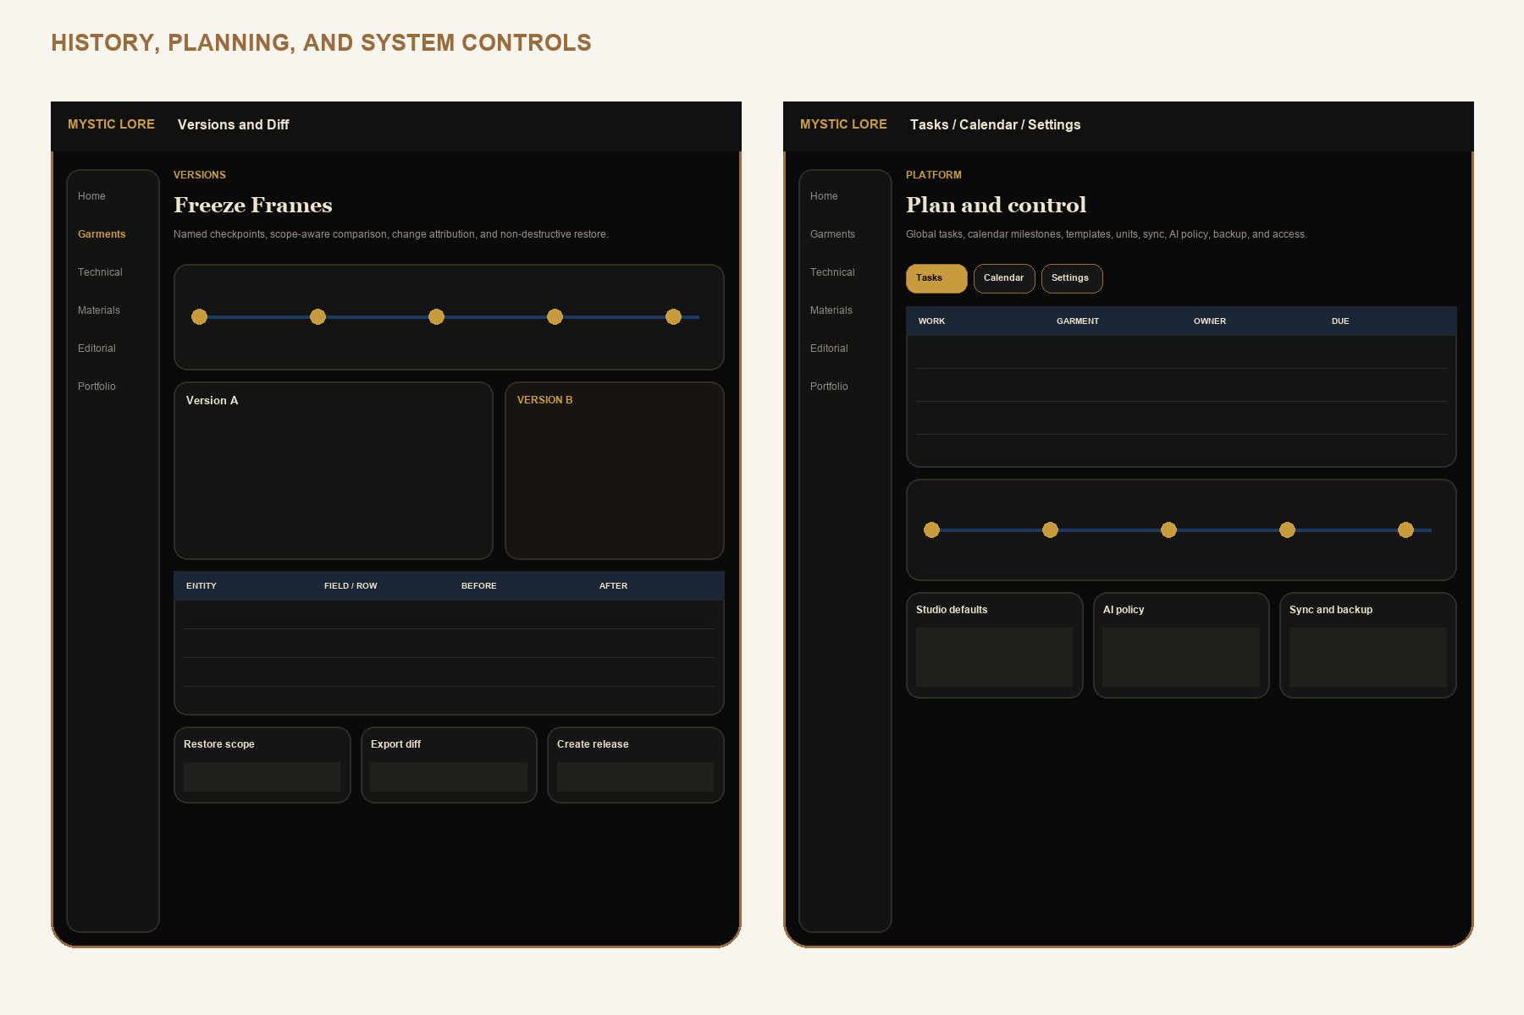
Low-fidelity interaction contract. Visual design is governed by pages 36-40; labels and information hierarchy are intentional.

PRODUCT BIBLE

AI workflows and trust model
AI accelerates structured work while the designer remains the committing authority.

WORKFLOW | INPUTS | CANDIDATE OUTPUT | COMMIT GATE
Technical flat generation | Approved reference photos, view request, garment brief | Front/back/detail flat asset plus source mapping | Visual fidelity review and flat revision approval
POM assistance | Garment type, flats, studio POM template | Suggested point list, methods, anchors, tolerances | Technical designer reviews each point and unit
BOM assistance | Design brief, materials, components, similar approved garments | Candidate BOM rows with relationship suggestions | Resolve every item link, quantity, unit, and placement
Construction recommendations | Flats, BOM, studio templates | Ordered candidate steps and callouts | Human confirms operation, machine, stitch, seam and order
Tech pack validation | Structured technical set and ruleset | Errors, warnings, conflicts, and jump links | Critical failures block release; waiver audit for allowed warnings
Editorial generation | Selected garment facts, approved images, tone and template | Scene outline and editable live-data blocks | Preview, source staleness check, human copy and visual review
Portfolio automation | Approved case-study facts, editorial, public-safe selection | Draft case study and Public Cut selection | Privacy scan plus explicit anonymous preview and publish

Trust contract
- Every job records model, prompt template version, structured inputs, source entity versions, generated artifacts, and user decision.
- Candidates never write production, technical release, public, cost, supplier, or measurement records directly.
- Accepted candidates emit the same domain commands and change events as manual edits.
- The UI labels generated, accepted, modified-after-generation, and rejected states. Confidence is contextual, never a truth score.

PRODUCT BIBLE

Future roadmap: 2.0 to 3.0
Ship coherence first, technical depth second, collaboration last.

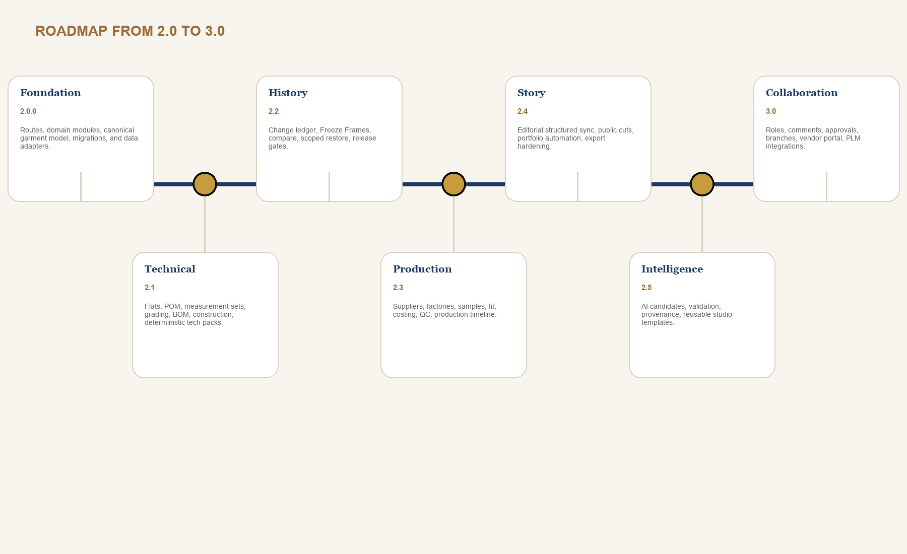
RELEASE | DEFINITION OF SUCCESS
2.0 Foundation | Existing core features run on route modules and the canonical garment model without data loss.
2.1 Technical | Designer can release a validated, reproducible tech pack from structured data.
2.2 History | High-value changes are comparable and restorations are safe and auditable.
2.3 Production | Sample, fit, cost, order, milestone, and QC decisions reference the correct version.
2.4 Story | Editorials sync as structured data; public cuts are exact, previewable, and stale-aware.
2.5 Intelligence | AI candidates reduce setup time without weakening provenance, privacy, or quality gates.
3.0 Collaboration | Roles, approvals, comments, branches, vendor portal, and integrations build on proven domain boundaries.

PRODUCT BIBLE

Codex implementation order
Each work package has a bounded target, explicit dependencies, and a safe stopping point.

WP | BUILD TARGET | EXIT CONDITION
0 | Characterization tests, screenshots, data export fixture, architecture decision records | Current behavior and migration input are reproducible
1 | Route modules, garment workspace shell, domain folders, typed command/repository interfaces | No feature change; build and route parity pass
2 | Proposed schema foundation, RLS, storage paths, read-through adapters, migration dry run | Legacy fixture migrates and round-trips with zero loss
3 | Garment, collection, design, media, Material Vault, and component domains | Core relationships replace duplicated project/material fields
4 | Technical spec, flats, POM, measurements, grading, BOM, construction, validation, export | One seeded garment produces a reproducible approved tech pack
5 | Change events, Freeze Frames, structural diff, scoped restore, release gates | Restore creates a new version and preserves linked evidence
6 | Suppliers, factories, samples, fit, costing, orders, QC, timeline | Production decisions pin to released garment version
7 | Editorial normalization and migration from lookbook/editorial legacy models | Collections sync cross-device and exports match approved sources
8 | Portfolio curation, Public Cut preview, publication schema, staleness, public routes | Anonymous access exposes only selected snapshot data
9 | AI jobs/artifacts, candidate panels, provenance, acceptance commands | AI cannot bypass domain validation or write private/public records directly
10 | Performance, accessibility, responsive field mode, observability, beta migration | Page 60 gates pass on representative data and devices

CODEX PROMPT TEMPLATE
Implement WP N using Product Bible pages X-Y. Preserve unrelated user changes. Start with characterization tests, name migrations, keep public and private schemas separate, and stop when the listed exit condition is verified.

PRODUCT BIBLE

Quality gates, open decisions, and glossary
The redesign is ready to code only when the work package can pass these checks.

GATE | DEFINITION OF DONE
Data | Migration is reversible or recoverable, idempotent where appropriate, typed, indexed, and verified against a representative export.
Privacy | RLS tests prove cross-studio isolation and anonymous denial; public payload is inspected for excluded fields.
Versioning | Mutation origin and actor recorded; release/export/public artifacts reference source version; restore is non-destructive.
UX | Primary path, empty/loading/error/conflict states, keyboard path, mobile fallback, and destructive confirmation are implemented.
Accessibility | WCAG 2.2 AA target checked with automated tests plus keyboard, zoom/reflow, and screen-reader walkthrough.
Reliability | Offline queue, retry, conflict, tombstone, image upload, and reload behavior verified.
Performance | Large garment records, 1,000-row technical grids, image-heavy editorials, and public pages remain responsive.
Documentation | Schema, command contracts, validation rules, screen states, and change log updated in this bible or linked ADR.

Open product decisions before affected work package
- Unit policy: one studio unit with export conversion, or mixed units per measurement set? Recommendation: one spec unit, explicit converted display.
- Garment-to-editorial cardinality: one primary garment plus optional supporting garments? Recommendation: support one primary plus many supporting.
- 2.x collaboration: invite reviewers before 3.0? Recommendation: public/private review links only; no private studio membership until role UX is complete.

Glossary
Garment Data Engine: canonical relationship and event layer. Freeze Frame: named immutable garment checkpoint. Public Cut: sanitized immutable publication snapshot. Threadline: persistent garment context rail. Release Gate: validation ruleset plus approved Freeze Frame. Live-data block: editorial block linked to structured garment data with staleness tracking.

