DIGITAL ASSIGNMENT – 02
DATABASE MANAGEMENT SYSTEMS
TEAM :
PRABHGUN SINGH (25BRS1240)
ISHAN (25BAI1114)
ANNAY(

DATABASE CREATION
SQL QUERY:
CREATE DATABASE IF NOT EXISTS mydb;
USE mydb;


2. Tables and Constraints
The WattUp system requires five main tables.
2.1 Users Table
This table stores information about registered users.
SQL QUERY:
CREATE TABLE users (
user_id INT AUTO_INCREMENT PRIMARY KEY,
name VARCHAR(100) NOT NULL,
email VARCHAR(150) NOT NULL UNIQUE,
password VARCHAR(255) NOT NULL,
phone VARCHAR(15) UNIQUE
);
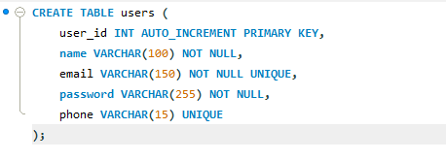
2.2 Vehicle Table
A user can have a vehicle associated with their account.
SQL QUERY:
CREATE TABLE vehicle (
vehicle_id INT AUTO_INCREMENT PRIMARY KEY,
user_id INT NOT NULL,
vehicle_number VARCHAR(20) NOT NULL UNIQUE,
vehicle_model VARCHAR(100) NOT NULL,
battery_capacity DECIMAL(6,2) NOT NULL,

CONSTRAINT fk_vehicle_user
FOREIGN KEY (user_id)
REFERENCES users(user_id)
ON DELETE CASCADE
ON UPDATE CASCADE
);
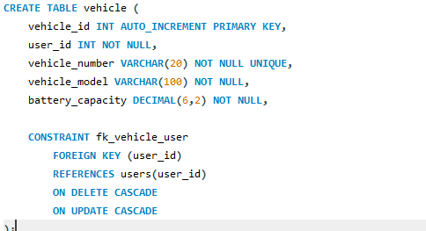
2.3 Charging Station Table
This is the actual table we created for the real-world charging-station dataset.
SQL QUERY:
CREATE TABLE charging_station (
station_id INT PRIMARY KEY,
station_name VARCHAR(255),
state VARCHAR(100),
city VARCHAR(100),
address VARCHAR(500),
latitude DECIMAL(10,6),
longitude DECIMAL(10,6)
);
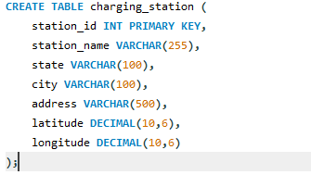
The database contains approximately 1321 real-world charging stations from the dataset used for the WattUp application.
2.4 Charger Table
A charging station can have multiple chargers.
SQL QUERY:
CREATE TABLE charger (
charger_id INT AUTO_INCREMENT PRIMARY KEY,
station_id INT NOT NULL,
charger_type VARCHAR(50) NOT NULL,
power_rating DECIMAL(6,2),
status VARCHAR(30) DEFAULT 'Available',

CONSTRAINT fk_charger_station
FOREIGN KEY (station_id)
REFERENCES charging_station(station_id)
ON DELETE CASCADE
ON UPDATE CASCADE
);
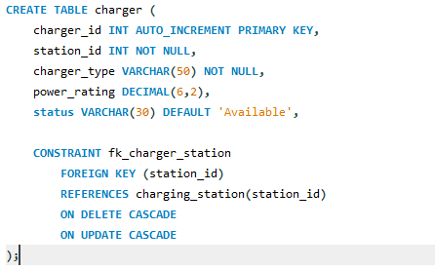
2.5 Charging Session Table
This table records charging sessions.
SQL QUERY:
CREATE TABLE charging_session (
session_id INT AUTO_INCREMENT PRIMARY KEY,
user_id INT NOT NULL,
vehicle_id INT NOT NULL,
station_id INT NOT NULL,
charger_id INT NOT NULL,
start_time DATETIME NOT NULL,
end_time DATETIME,
energy_consumed DECIMAL(8,2),
amount DECIMAL(10,2),

CONSTRAINT fk_session_user
FOREIGN KEY (user_id)
REFERENCES users(user_id),

CONSTRAINT fk_session_vehicle
FOREIGN KEY (vehicle_id)
REFERENCES vehicle(vehicle_id),

CONSTRAINT fk_session_station
FOREIGN KEY (station_id)
REFERENCES charging_station(station_id),

CONSTRAINT fk_session_charger
FOREIGN KEY (charger_id)
REFERENCES charger(charger_id)
);
FINAL CONNECTION:
users
│
├──── vehicle
│
└──── charging_session
│
├──── vehicle
├──── charging_station
└──── charger
TEST FOR TABLES:
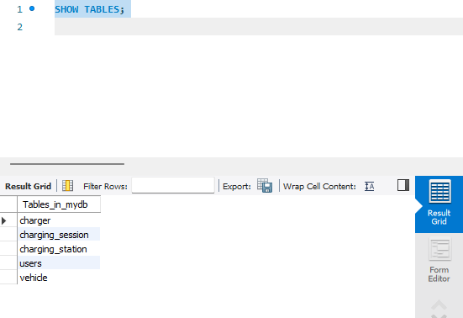

Primary Keys
Primary keys uniquely identify records.
Our primary keys are:
users
user_id
vehicle
vehicle_id
charging_station
station_id
charger
charger_id
charging_session
session_id
Foreign Keys
Foreign keys establish relationships between tables.

Vehicle → Users
FOREIGN KEY (user_id)
REFERENCES users(user_id);

Charger → Charging Station
FOREIGN KEY (station_id)
REFERENCES charging_station(station_id);

Charging Session → Users
FOREIGN KEY (user_id)
REFERENCES users(user_id);

Charging Session → Vehicle
FOREIGN KEY (vehicle_id)
REFERENCES vehicle(vehicle_id);

Charging Session → Station
FOREIGN KEY (station_id)
REFERENCES charging_station(station_id);

Charging Session → Charger
FOREIGN KEY (charger_id)
REFERENCES charger(charger_id);

Data Insertion Using Real-World Dataset
The charging_station table was populated using a real-world EV charging station dataset.
The dataset contains station information such as:
station_id
station_name
state
city
address
latitude
longitude
Example insertion:
SQL:
INSERT INTO charging_station
(station_id, station_name, state, city, address, latitude, longitude)
VALUES
(1, 'Example Charging Station', 'Maharashtra', 'Mumbai',
'Mumbai Central', 18.9696, 72.8194);
For the actual project, the complete dataset was imported rather than manually inserting all 1321 records.
To verify:
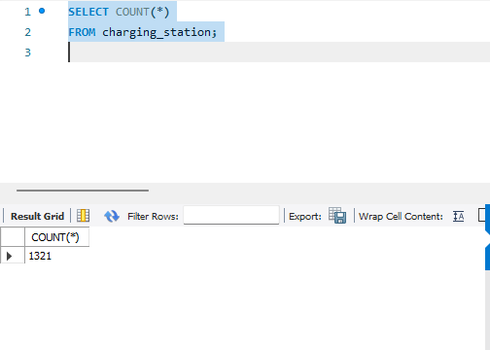
Insert Sample Users
For testing the other tables:
SQL QUERY:
INSERT INTO users
(name, email, password, phone)
VALUES
('Rahul Sharma', 'rahul@example.com', 'password123', '9876543210'),
('Aman Singh', 'aman@example.com', 'password456', '9876543211'),
('Priya Verma', 'priya@example.com', 'password789', '9876543212');
TO VERIFY:
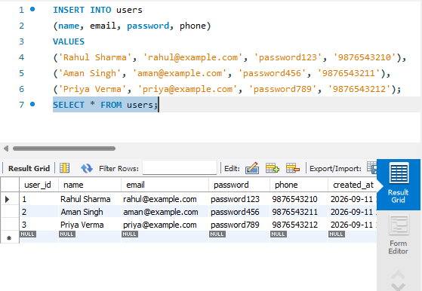
Insert Sample Vehicles
SQL QUERY:
INSERT INTO vehicle
(user_id, vehicle_number, vehicle_model, battery_capacity)
VALUES
(1, 'PB10AB1234', 'Tata Nexon EV', 40.50),
(2, 'DL01CD5678', 'MG ZS EV', 50.30),
(3, 'HR26EF9012', 'Hyundai Ioniq 5', 72.60);

Insert Sample Chargers
Use an existing station ID from the dataset.
For example:

SQL QUERY:

INSERT INTO charger
(station_id, charger_type, power_rating, status)
VALUES
(1, 'CCS2', 60.00, 'Available'),
(1, 'Type 2', 22.00, 'Available'),
(1, 'CCS2', 120.00, 'Occupied');

Insert Charging Session
SQL QUERY:
INSERT INTO charging_session
(
user_id,
vehicle_id,
station_id,
charger_id,
start_time,
end_time,
energy_consumed,
amount
)
VALUES
(
1,
1,
1,
1,
'2026-09-11 10:00:00',
'2026-09-11 11:00:00',
25.50,
510.00
);
CRUD Operations
CREATE
Insert a new user:
SQL QUERY
INSERT INTO users
(name, email, password, phone)
VALUES
('Karan Mehta', 'karan@example.com', 'pass123', '9876543213');

READ
Display all users:
SQL QUERY:
SELECT *
FROM users;
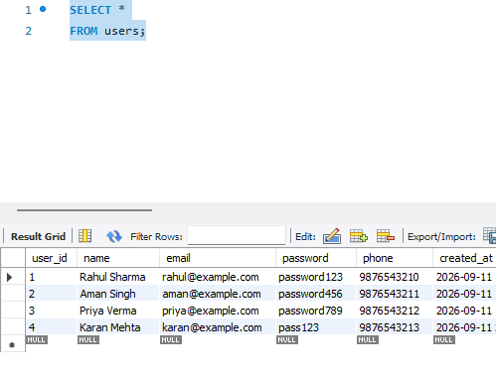

Display all charging stations:
SQL QUERY:
SELECT *
FROM charging_station;
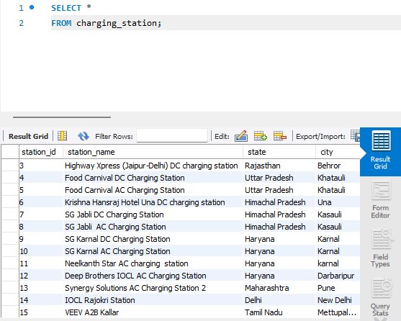
Find Mumbai stations:
SQL QUERY:
SELECT *
FROM charging_station
WHERE city LIKE '%Mumbai%';
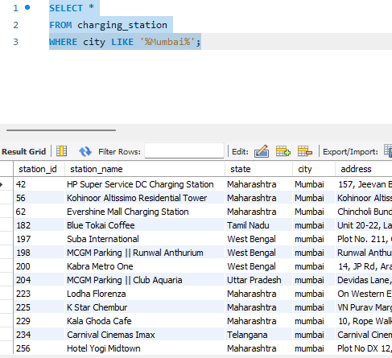
UPDATE
Update a user's phone number:
SQL QUERY:
UPDATE users
SET phone = '9999999999'
WHERE user_id = 1;
DELETE
Delete a user:
SQL QUERY:
DELETE FROM users
WHERE user_id = 3;

Because vehicle has:
ON DELETE CASCADE
the user's associated vehicles will also be removed.

SQL Commands
Some basic SQL commands used in the project:
SELECT
WHERE
ORDER BY
DISTINCT
LIKE
BETWEEN
Joins
Joins combine information from multiple tables.
INNER JOIN
Display users and their vehicles:
SQL QUERY:
SELECT
u.user_id,
u.name,
v.vehicle_model,
v.vehicle_number
FROM users u
INNER JOIN vehicle v
ON u.user_id = v.user_id;
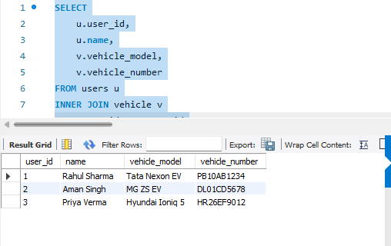
Multiple Table JOIN
Display charging session details:
SQL QUERY:
SELECT
u.name AS user_name,
v.vehicle_model,
cs.station_name,
c.charger_type,
s.start_time,
s.end_time,
s.energy_consumed,
s.amount
FROM charging_session s
INNER JOIN users u
ON s.user_id = u.user_id
INNER JOIN vehicle v
ON s.vehicle_id = v.vehicle_id
INNER JOIN charging_station cs
ON s.station_id = cs.station_id
INNER JOIN charger c
ON s.charger_id = c.charger_id;

Aggregate Functions
Aggregate functions perform calculations on multiple rows.
COUNT by State
SQL QUERY:
SELECT
state,
COUNT(*) AS station_count
FROM charging_station
GROUP BY state;
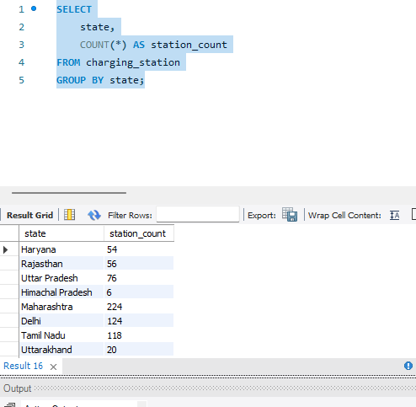

SUM
Total energy consumed:
SQL QUERY:
SELECT
SUM(energy_consumed) AS total_energy
FROM charging_session;

AVG
Average energy consumed:
SQL QUERY:
SELECT
AVG(energy_consumed) AS average_energy
FROM charging_session;

MAX
Maximum energy consumed in a session:
SQL QUERY:
SELECT
MAX(energy_consumed) AS maximum_energy
FROM charging_session;

MIN
Minimum energy consumed:
SQL QUERY:
SELECT
MIN(energy_consumed) AS minimum_energy
FROM charging_session;

Views
A view is a virtual table based on an SQL query.
For WattUp, we can create a view containing station and charger information.
SQL QUERY:

CREATE VIEW station_charger_view AS
SELECT
cs.station_id,
cs.station_name,
cs.state,
cs.city,
cs.address,
c.charger_id,
c.charger_type,
c.power_rating,
c.status
FROM charging_station cs
INNER JOIN charger c
ON cs.station_id = c.station_id;

Use the view:
SELECT *
FROM station_charger_view;

Stored Procedures
A stored procedure is a precompiled group of SQL statements stored in the database.
Procedure to Get Stations by City
SQL QUERY:

DELIMITER //

CREATE PROCEDURE GetStationsByCity(IN city_name VARCHAR(100))
BEGIN
SELECT *
FROM charging_station
WHERE city LIKE CONCAT('%', city_name, '%');
END //

DELIMITER ;

Call it:
CALL GetStationsByCity('Mumbai');

This is directly related to the search functionality we implemented in the WattUp application.

Functions
A MySQL function returns a single value.
For example, calculate charging cost based on energy consumed and rate per unit.
SQL QUERY:

DELIMITER //

CREATE FUNCTION CalculateChargingCost(
energy DECIMAL(8,2),
rate DECIMAL(8,2)
)
RETURNS DECIMAL(10,2)
DETERMINISTIC
BEGIN
RETURN energy * rate;
END //

DELIMITER ;

Use it:
SELECT CalculateChargingCost(25.5, 20.0)
AS charging_cost;

Triggers
A trigger automatically executes when an event such as INSERT, UPDATE, or DELETE occurs.
Trigger for Charger Status
We can also automatically change a charger to Occupied when a charging session starts.
SQL QUERY:

DELIMITER //

CREATE TRIGGER charger_occupied
AFTER INSERT ON charging_session
FOR EACH ROW
BEGIN
UPDATE charger
SET status = 'Occupied'
WHERE charger_id = NEW.charger_id;
END //

DELIMITER ;

Transactions
Transactions allow multiple SQL operations to be treated as one unit.
The important commands are:
START TRANSACTION
COMMIT
ROLLBACK
SAVEPOINT
COMMIT

SQL QUERY:
START TRANSACTION;

UPDATE charger
SET status = 'Occupied'
WHERE charger_id = 1;

COMMIT;
The change becomes permanent.

ROLLBACK
SQL QUERY:
START TRANSACTION;

UPDATE charger
SET status = 'Occupied'
WHERE charger_id = 1;

ROLLBACK;
The update is cancelled.
The charger returns to its previous state.

SAVEPOINT
A savepoint allows us to partially roll back a transaction.
SQL QUERY:
START TRANSACTION;

UPDATE charger
SET status = 'Occupied'
WHERE charger_id = 1;

SAVEPOINT charger_update;

UPDATE charger
SET status = 'Occupied'
WHERE charger_id = 2;

ROLLBACK TO charger_update;

COMMIT;
Here:
First update → kept
Second update → rolled back

Testing SQL Scripts
Testing is necessary to make sure that the database operations work correctly.
Test 1: Check database
SQL QUERY:
SHOW DATABASES;
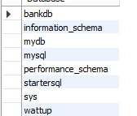
Test 2: Check tables
SHOW TABLES;
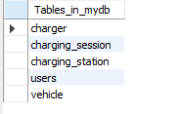
Test 3: Check table structure
DESCRIBE users;
DESCRIBE vehicle;
DESCRIBE charging_station;
DESCRIBE charger;
DESCRIBE charging_session;
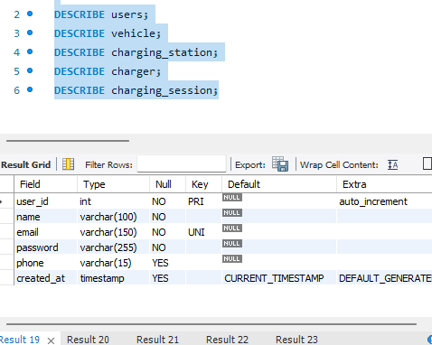

Check real-world station data
SQL:
SELECT COUNT(*)
FROM charging_station;
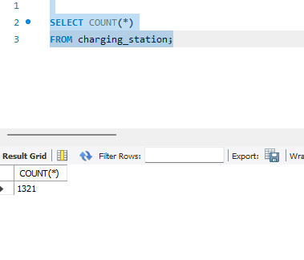

Test 5: Test search
SELECT *
FROM charging_station
WHERE city LIKE '%Mumbai%';
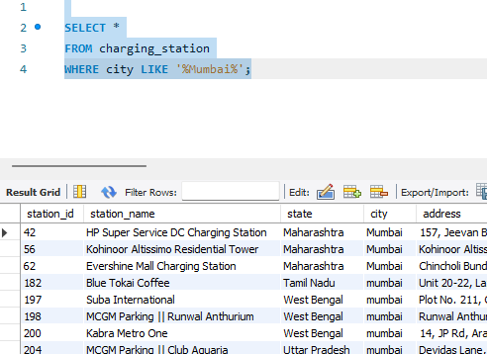
Test 6: Test foreign key
Try inserting a vehicle for a nonexistent user:
SQL:
INSERT INTO vehicle
(user_id, vehicle_number, vehicle_model, battery_capacity)
VALUES
(99999, 'TEST123', 'Test EV', 50);
This should fail because user_id = 99999 does not exist.

Test 7: Test UNIQUE constraint
Try inserting a duplicate email:
SQL:
INSERT INTO users
(name, email, password, phone)
VALUES
('Test User', 'rahul@example.com', 'test123', '9999999998');
This should fail because the email already exists.

Test 8: Test trigger
SQL:
INSERT INTO charging_session
(
user_id,
vehicle_id,
station_id,
charger_id,
start_time,
energy_consumed,
amount
)
VALUES
(
1,
1,
1,
1,
NOW(),
-5,
100
);
Expected:
Energy consumed cannot be negative

