Part 3

We want to show a FSM (finite state machine) example in the correctness verification for Supermatrix run-time system in the DLA (dense linear algebra) domain. Supermatrix is a run-time system for task scheduling. In the first stage of Supermatrix run-time system, we need to generate the DAG (directed acyclic graph) for the dependency relations for the tasks of linear algebra subroutine. The following DAG is for a 4x4 Cholesky decomposition.

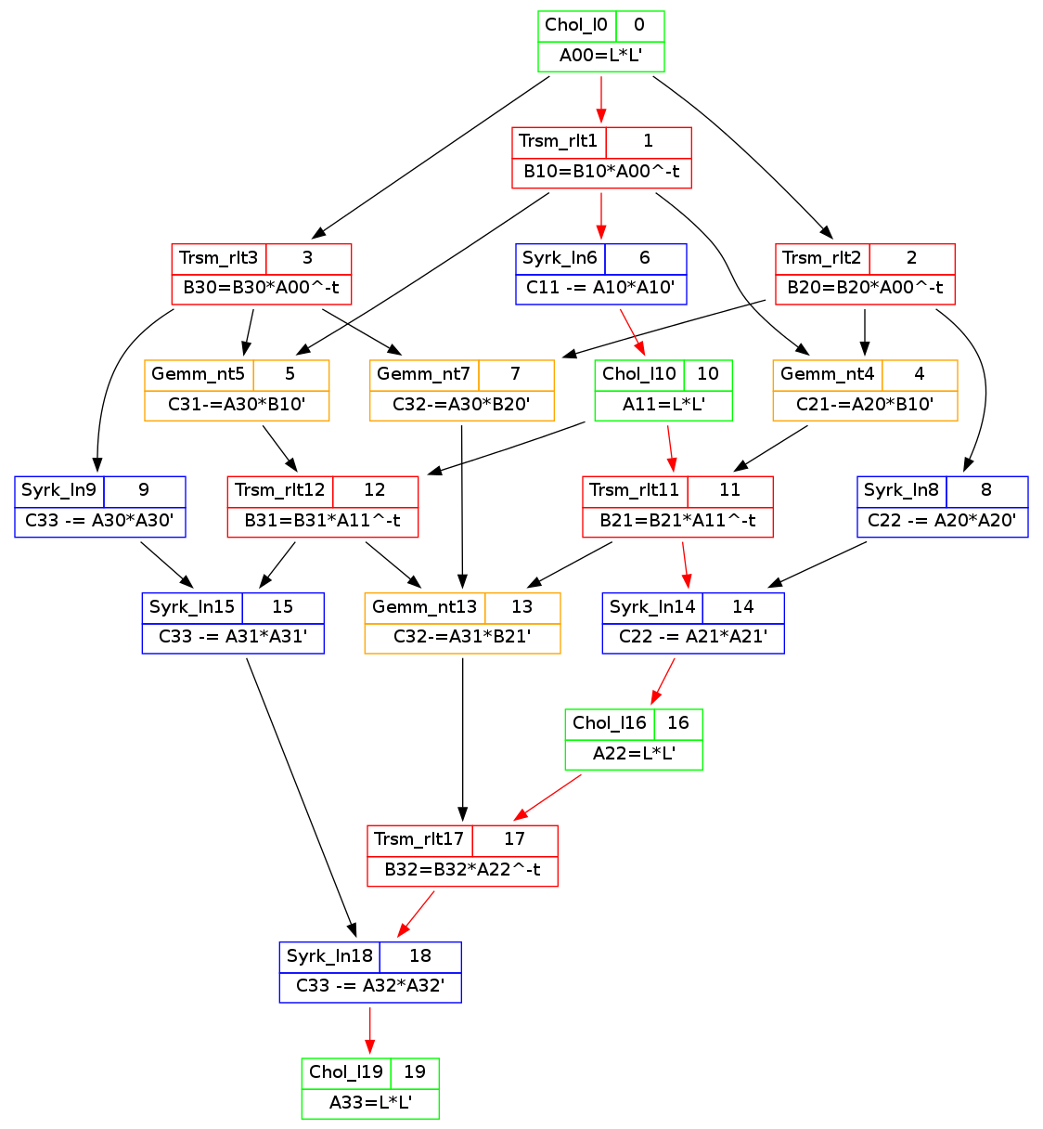

FSM for a correct dependency path should be



We use Prolog to represent the above FSM:

|  |
| --- |
| %dbase(fsm,[node,transition]).  %table(node,[nodeid,name,type]).  node(nStart, start, start).  node(nChol, CHOL, state).  node(nTrsm, TRSM, state).  node(nSyrk, SYRK, state).  node(nGemm, GEMM, state).  node(nStop, stop, stop).  %table(transition,[transid,startsAt,endsAt]).  transition(t1, nStart, nChol).  transition(t2, nChol, nTrsm).  transition(t3, nTrsm, nGemm).  transition(t4, nGemm, nGemm).  transition(t5, nGemm, nTrsm).  transition(t6, nTrsm, nSyrk).  transition(t7, nSyrk, nSyrk).  transition(t8, nSyrk, nChol).  transition(t9, nChol, nStop). |

We use this FSM to verify the correctness of one specific dependency path (the red path in the DAG). The app.java is as the follows,

|  |
| --- |
| import myfsm.*;  public class app {  public static void main(String[] args) {  System.out.println("----");  paces( new fsm() );  System.out.println("----");  }  public static void paces( fsm f ) {  f.gotoCHOL();  f.gotoTRSM();  f.gotoSYRK();  f.gotoSYRK();  f.gotoCHOL();  f.gotoTRSM();  f.gotoSYRK();  f.gotoCHOL();  f.gotostop();  System.out.println(f.getName());  }  } |

With the help of VM2T tools and our general .vm files (model-to-text mappings), we can easily generate the code for our FSM, thus we can verify the correctness of the red path in DAG.

|  |
| --- |
| ----  go to CHOL  go to TRSM  go to SYRK  go to SYRK  go to CHOL  go to TRSM  go to SYRK  go to CHOL  go to stop  stop  ---- |

There is no “ignoring transition to …” message in the output. So we can verify that that specific task dependency path is correct.