CS392F: Automatic Software Design

P3: BMW (Series 2) Feature Model

Xiaohui Chen

[xhchen0328@utexas.edu](mailto:xhchen0328@utexas.edu)

Jianyu Huang

[jianyu@cs.utexas.edu](mailto:jianyu@cs.utexas.edu)

# Constraint Description

1. A BMW (Series 2) has all of the following features: Body, DriveTrain, Fuel, MSRP, HorsePower, FuelEfficiency.

2. Drive Train can be one of the following options: xDrive, RearWheel.

3. Body can be one of the following features: Sedan, Coupe, Gran Coupe, Convertible, Sports Activity Vehicle, Roadster, Sports Activity Coupe, Sports Wagon, Gran Tuismo.

4. Fuel can be one of the following options: Hybrid, Gasoline, Electric, Diesel.

5. MSRP can be one of the following options: $32100, #33900, $43100, $44900.

6. HorsePower can be one of the following options: HP240, HP320.

7. FuelEfficiency can be one of the following options: MPG30, MPG32, MPG35, MPG36.

# Feature Diagram

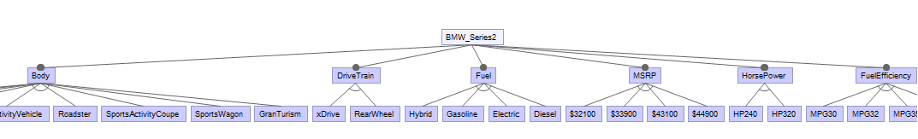

Figure 1 Feature Diagram for BMW (Series 2)

Due to size restriction, we cannot include the whole model diagram in this document. Please check our FeatureIDE project for details.

The feature model is designed in *model.xml*. In reality we discover that only one feature in a parent feature can be selected (choose one constraint). We do not discover any cross-tree constraints.

# FM Configurator

Here are all the features of BMW 2 Series:

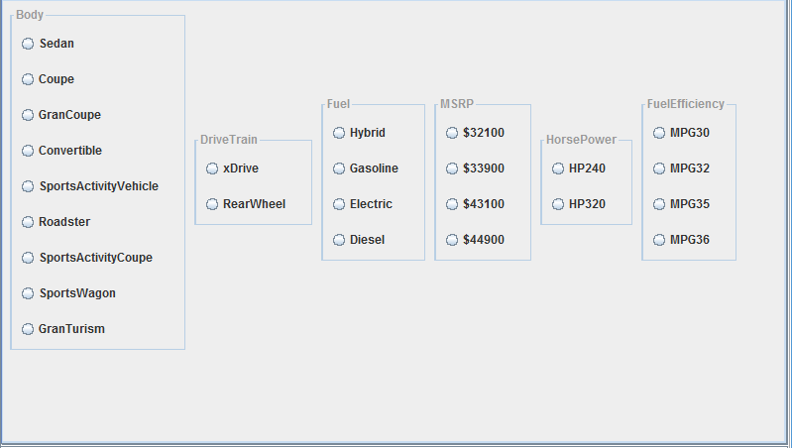

Figure 2 FM Configurator for BMW (Series)

In addition to the feature model, we also created the four BMW 2 series products in the configuration files. Each configuration corresponds to one product. As a matter of fact, all the 4 products can be fully described by the feature model.