Project title: Electro Sense

Names and email addresses of team members:

Marko Vukasinovic: mvukasinovic2019@my.fit.edu

Katie Canedo: kcanedo2020@my.fit.edu

Alexis Haley: ahaley2019@my.fit.edu

Aveisha Maharaj: amaharaj2019@my.fit.edu

Kayla Mastin: kmastin2019@my.fit.edu

Faculty advisor: Khaled Salhoub

Client: Venkat Keshav Chivukula

Meeting(s) with the Client for developing this Plan: Tuesday, January 17th, 2023 (1/17/23), Tuesday, January 24th, 2023 (1/24/23), Tuesday, January 31st, 2023 (1/31/23), Tuesday, February 7th, 2023 (2/7/23), Tuesday, February 14th, 2023 (2/14/23), Tuesday, February 21st, 2023 (2/21/23), Tuesday, February 28th, 2023 (2/28/23), Tuesday, March 7th, 2023 (3/7/23), Tuesday, March 14th, 2023 (3/14/23), Tuesday, March 21st, 2023 (3/21/23), Tuesday, March 28th, 2023 (3/28/23), Tuesday, April 4th, 2023 (4/4/23), Tuesday, April 11th, 2023 (4/11/23),Tuesday, April 18th, 2023 (4/18/23), Tuesday, April 25th, 2023 (4/25/23,Tuesday, May 2nd, 2023 (5/2/23)

Goal and motivation: Discuss the overall goal (help make the intended users "happier") and motivation (why are the intended users not too "happy"? limitations/pains of current systems)

The goal of our project is to create a hospital mattress designed for ICU patients that incorporates sensors within. This would help healthcare workers know when something is wrong with their patients which would help make sure the ICU patients are safe and Comfortable.

Approach (key features of the system): The main system consists of a mattress attached to various sensors connected to a central processing unit. This goes along with an IOS app to connect to the bed via Bluetooth to be able to alert nurses of rapid changes in vitals.It will also assist CNAs who are understaffed in collecting basic vitals such as heart rate and pulse oximetry as well as preventing bed sores. The system is comprised of: Pressure sensors for body pressure mapping which will provide things like weight distribution and sleep analysis throughout the night Heart rate and pulse oximetry sensors to provide around-the-clock updates of basic vitals Bed alarm sensor to detect when the patient is rapidly moving (which could indicate convulsion activity) or when a patient on bed rest is trying to get up Temperature sensors that will be adjustable in 3 regions Circulation compression pumps combined with the massager to prevent bed sores and rotate bed-bound patients Each of the aforementioned sensors comes with specific data gathering libraries available which will be used in order to gather acquired data in one place. We will then use a different script to send the collected data over Bluetooth, to be received over the phone app

So far we have fully completed scripts for gathering the heart rate and pulse oximetry data, and for sending said data to the phone application whose basic framework and data display for the aforementioned sensors has been completed.

The script for the temperature sensor is done but will need revision due to hardware changes.

Algorithms and tools (libraries/api/frameworks/languages) for the key features: Discuss how and which algorithms and tools are used to achieve the features:

The sensors we have built so far had prebuilt libraries for gathering their data. The pressure sensor does not since it is going to rely on copper wires reading vibrations. The first algorithm will have to deal with converting raw electrical pulses to a reading map.

Since we have successfully tackled the reading of data and sending it over Bluetooth from the Arduino to the app, our next step will be to do the reverse. The circulation pump will have to physically manipulate the mattress based on phone app input. We will have to create GUI for that and make sure the critical sections of the code for sending data from Arduino to the phone do not intersect with the critical sections of the code for reverse communication.

The final algorithm will have to tackle the alarm component which will have to allow the medical operator to set a time frame in the GUI for when they want the patient to wake up. The Arduino will have to store that data and use it to wake up the patient.

Novel features: Discuss which features/functionalities are novel and why.

The team has decided to cut out built redundancies for the project. We have simplified the hardware and the software components.

Technical Challenges: Discuss three main technical challenges for this semester (for example, "we plan to find the shortest path from A to B, but don't know which algorithm to use."):

The main technical challenge for this semester will be to improve the in-app graphical user interface and to make sure it follows proper user design guidelines.

The second technical challenge will be facilitating communication from the application to the Arduino in such a way that it doesn’t interfere with the communication from the Arduino to the phone.

The final technical challenge will be converting analog inputs into digital and the other way around in order to surpass hardware limitations. This effort will require a lot of cooperation between the software team and the hardware team.

Design Diagram:

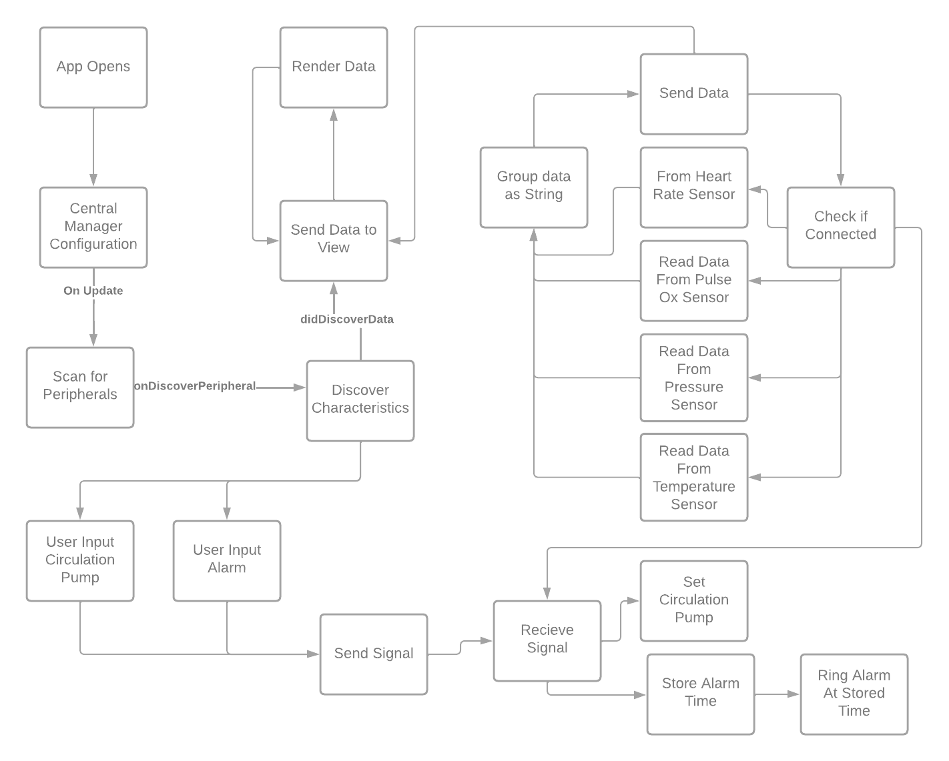

Hardware Diagram:

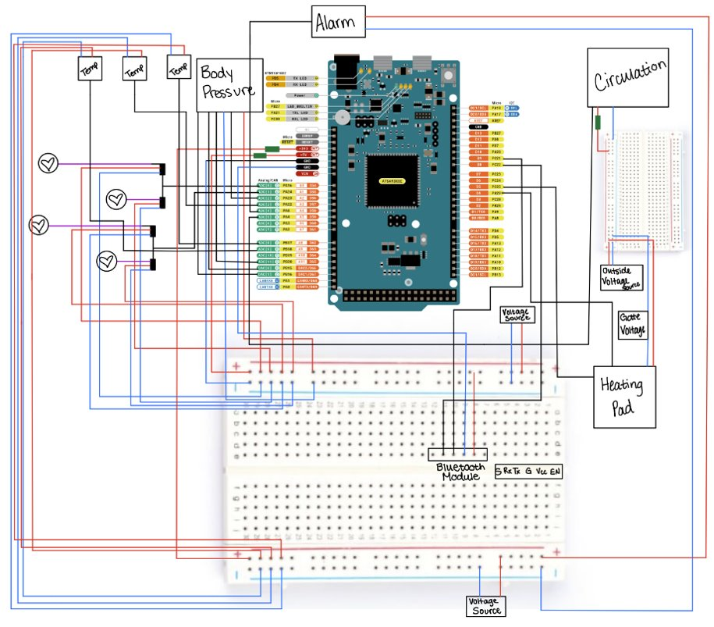

Evaluation: how to measure success? Some ideas:

There is a lot of leeway regarding the speed of the software due to the fact that the sensors read data at preconditioned intervals, and each piece of data has 100-200 ms (not decided upon yet) to fully process each data transaction.

Due to the fact that this is only a prototype that uses prebuilt sensors, we don’t have much control over the accuracy of the heart rate and the pulse ox values they have been tested to be within 10% when compared to commercialized sensing equipment, what we can focus on is the cleaning of the extreme values that can be input into the system due to external factors.

When it comes to the pressure sensor, its accuracy will depend on the hardware team's ability to build a foolproof device. The goal is to display where the patient is leaning on the most so out of the three pressure sensors on the bed we only need to make sure that one of the sensors registers a discernable difference in the signal when compared to the other ones.

Due to the fact that the system is meant to be used in a hospital environment the reliability of the system takes major priority. We’re hoping to have no discrepancies when the system is used. This will depend on our ability to clean undesired/corrupted received data from each sensor.

During the testing stage of the system, we plan to have multiple people of different heights and weight use it.

Progress Summary:

| Module/feature | Completion % | To do |
| --- | --- | --- |
| Build, Implement, and Test Heart Rate Sensor | 100% |  |
| Build, Implement, and Test Pulse Ox Sensor | 99% | Create a demo video |
| Build, Implement, and Test Temperature Sensor | 90% | Wait for hardware and test |

* 1. Milestone 4 (Feb 13): itemized tasks:
     + Implement, test, and demo Pressure Sensor
     + Improve Graphical User Interface
     + Send basic signal from Phone to Arduino
  2. Milestone 5 (Mar 20): itemized tasks:
     + Implement, test, and demo Alarm
     + Implement Circulation Pump
  3. Milestone 6 (Apr 17): itemized tasks:
     + Test, and demo Circulation Pump
     + Test/demo of the entire system
     + Conduct evaluation and analyze results
     + Create user/developer manual
     + Create demo video
  4. Task matrix for Milestone 4 (teams with more than one person)

| Task | Marko |
| --- | --- |
| Implement, test, and demo which features/modules Pressure Sensor | 100% |
| Improve Graphical User Interface | 100% |
| Send basic signal from Phone to Arduino | 100% |

Description (at least a few sentences) of each planned task for Milestone 4:

Task 1: The pressure sensor will require reading of electrical signals and their interpretation. The interpreted signals will then have to be sent to the phone app where they will be rendered

Task 2: The heart rate display should have a graph showing the heart rate changes as they progress.

Task 3: There will be a test button for sending a basic integer from the phone to Arduino in such a way that it doesn’t interfere with the data sent from Arduino to the phone.

Approval from Faculty Advisor

"I have discussed with the team and approve this project plan. I will evaluate the progress and assign a grade for each of the three milestones."

Signature: _______________________________ Date: ________