|  |
| --- |
| 1. **Implement sessions handling in Laravel web application** |

**web.php**

<?php

use Illuminate\Support\Facades\Route;

Route::get('session/get',"App\Http\Controllers\SessionController@accessSessionData");

Route::get('session/set',"App\Http\Controllers\SessionController@storeSessionData");

Route::get('session/remove',"App\Http\Controllers\SessionController@deleteSessionData");

**SessionsController**

<?php

namespace App\Http\Controllers;

use Illuminate\Http\Request;

use App\Http\Requests;

use App\Http\Controllers\Controller;

class SessionController extends Controller

{

//

public function accessSessionData(Request $request) {

if($request->session()->has('my_name'))

echo $request->session()->get('my_name');

else

echo 'No data in the session';

}

public function storeSessionData(Request $request) {

$request->session()->put('my_name','Virat Gandhi');

echo "Data has been added to session";

}

public function deleteSessionData(Request $request) {

$request->session()->forget('my_name');

echo "Data has been removed from session.";

}

}

**Output**

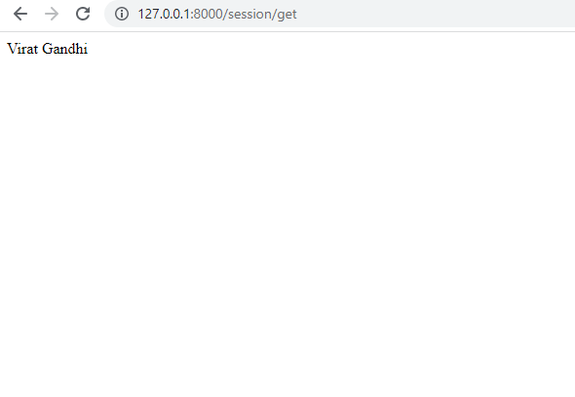

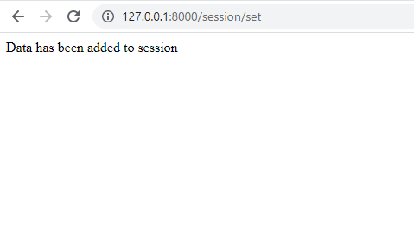

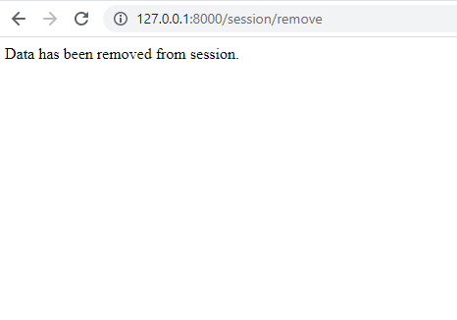

|  |
| --- |
| 1. **Create a simple database application using Laravel** |

**Migrations**

<?php

use Illuminate\Database\Migrations\Migration;

use Illuminate\Database\Schema\Blueprint;

use Illuminate\Support\Facades\Schema;

class CreateTestimonialsTable extends Migration

{

/**

* Run the migrations.

*

* @return void

*/

public function up()

{

Schema::create('testimonials', function (Blueprint $table) {

$table->id();

$table->string('title');

$table->text('body');

$table->timestamps();

});

}

/**

* Reverse the migrations.

*

* @return void

*/

public function down()

{

Schema::dropIfExists('testimonials');

}

}

**Controller**

<?php

namespace App\Http\Controllers;

use Illuminate\Http\Request;

class Testimonial extends Controller

{

/**

* Display a listing of the resource.

*

* @return \Illuminate\Http\Response

*/

public function index()

{

//

$datas=\DB::select('select * from testimonials');

return view('Testimonials\index',['data'=>$datas]);

}

/**

* Show the form for creating a new resource.

*

* @return \Illuminate\Http\Response

*/

public function create()

{

//

}

/**

* Store a newly created resource in storage.

*

* @param \Illuminate\Http\Request $request

* @return \Illuminate\Http\Response

*/

public function store(Request $request)

{

//

}

/**

* Display the specified resource.

*

* @param int $id

* @return \Illuminate\Http\Response

*/

public function show($id)

{

//

}

/**

* Show the form for editing the specified resource.

*

* @param int $id

* @return \Illuminate\Http\Response

*/

public function edit($id)

{

//

}

/**

* Update the specified resource in storage.

*

* @param \Illuminate\Http\Request $request

* @param int $id

* @return \Illuminate\Http\Response

*/

public function update(Request $request, $id)

{

//

}

/**

* Remove the specified resource from storage.

*

* @param int $id

* @return \Illuminate\Http\Response

*/

public function destroy($id)

{

//

}

}

**Model**

<?php

namespace App\Models;

use Illuminate\Database\Eloquent\Factories\HasFactory;

use Illuminate\Database\Eloquent\Model;

class Testimonial extends Model

{

use HasFactory;

public $fillable = ['title','body'];

}

**View**

@extends('Layouts/app')

@section("page-content")

<!DOCTYPE html>

<html lang="en">

<head>

<meta charset="UTF-8">

<meta http-equiv="X-UA-Compatible" content="IE=edge">

<meta name="viewport" content="width=device-width, initial-scale=1.0">

<title>Document</title>

</head>

<body>

<table border="2">

<tr>

<td>Title<h1></h1></td>

<td><h1>body</h1></td>

</tr>

@foreach($data as $res)

<tr>

<td>

<h1>{{$res->title}}</h1>

</td>

<td>

<h3>{{$res->body}}</h3>

</td>

</tr>

@endforeach

</table>

<!-- @foreach($data as $res)

<h1>{{$res->title}}</h1>

<h3>{{$res->body}}</h3>

@endforeach -->

</body>

</html>

@endsection

**Web.php**

<?php

use Illuminate\Support\Facades\Route;

Route::get('/',"App\Http\Controllers\Testimonial@index");

**Output**

