Lead Conversion Intelligence System
Data Analytics Capstone Project Report
A Streamlit Dashboard for Lead Analysis, Conversion Prediction, and Sales Prioritisation

Project detail | Information
Submitted by | Sudarshan Kajmani
Internship | Bharat CA Data Analytics Internship
Dataset | X Education Lead Scoring Dataset
Technology | Python, Streamlit, Pandas, Plotly, scikit-learn
Repository | https://github.com/SuduOps/lead-conversion-intelligence-system
Submission date | 23 September 2026

Project purpose: The system helps sales and marketing teams identify high-potential leads, understand the drivers of conversion, and assign practical follow-up actions based on predicted conversion probability.

Abstract
This project develops a Lead Conversion Intelligence System for analysing historical marketing leads from X Education. The application combines data-quality assessment, exploratory analysis, diagnostic comparisons, predictive machine learning, and prescriptive sales recommendations in a single Streamlit dashboard. The dataset contains 9,240 leads and 37 attributes, including lead source, website activity, occupation, last activity, and a binary Converted outcome.
The dashboard reports an overall conversion rate of 38.5 percent, compares Logistic Regression and Random Forest classifiers, and selects Random Forest as the best model using ROC-AUC. The selected model achieved a ROC-AUC of 0.9793 on the held-out test split. Each lead is then categorised as Hot, Warm, or Cold, enabling sales teams to prioritise actions and use lower-cost nurture tactics where appropriate.

Keywords
Lead generation, lead scoring, conversion prediction, Streamlit, Random Forest, marketing analytics, prescriptive analytics.

Contents
1. Introduction
2. Problem Statement and Objectives
3. Dataset and Technology Stack
4. System Design and Methodology
5. Analytics Findings
6. Predictive Model Results
7. Prescriptive Recommendations
8. Conclusion and Future Scope
References

1. Introduction
Marketing teams often receive more leads than sales teams can contact effectively. Treating every lead in the same way wastes time, delays follow-up, and can reduce the chance of conversion. This project addresses that challenge by transforming historical lead data into a prioritised worklist for sales teams.

1.1 Problem Statement
The aim is to identify which leads are most likely to convert into customers and to recommend an appropriate sales or nurture action. The system must explain the data, identify conversion drivers, evaluate predictive models, and present the results in a usable dashboard.

1.2 Objectives
- Assess the quality and completeness of the lead dataset.
- Describe overall conversion performance and lead behaviour patterns.
- Diagnose differences between converted and non-converted leads.
- Predict conversion probability using supervised classification models.
- Categorise leads into Hot, Warm, and Cold groups and recommend actions.
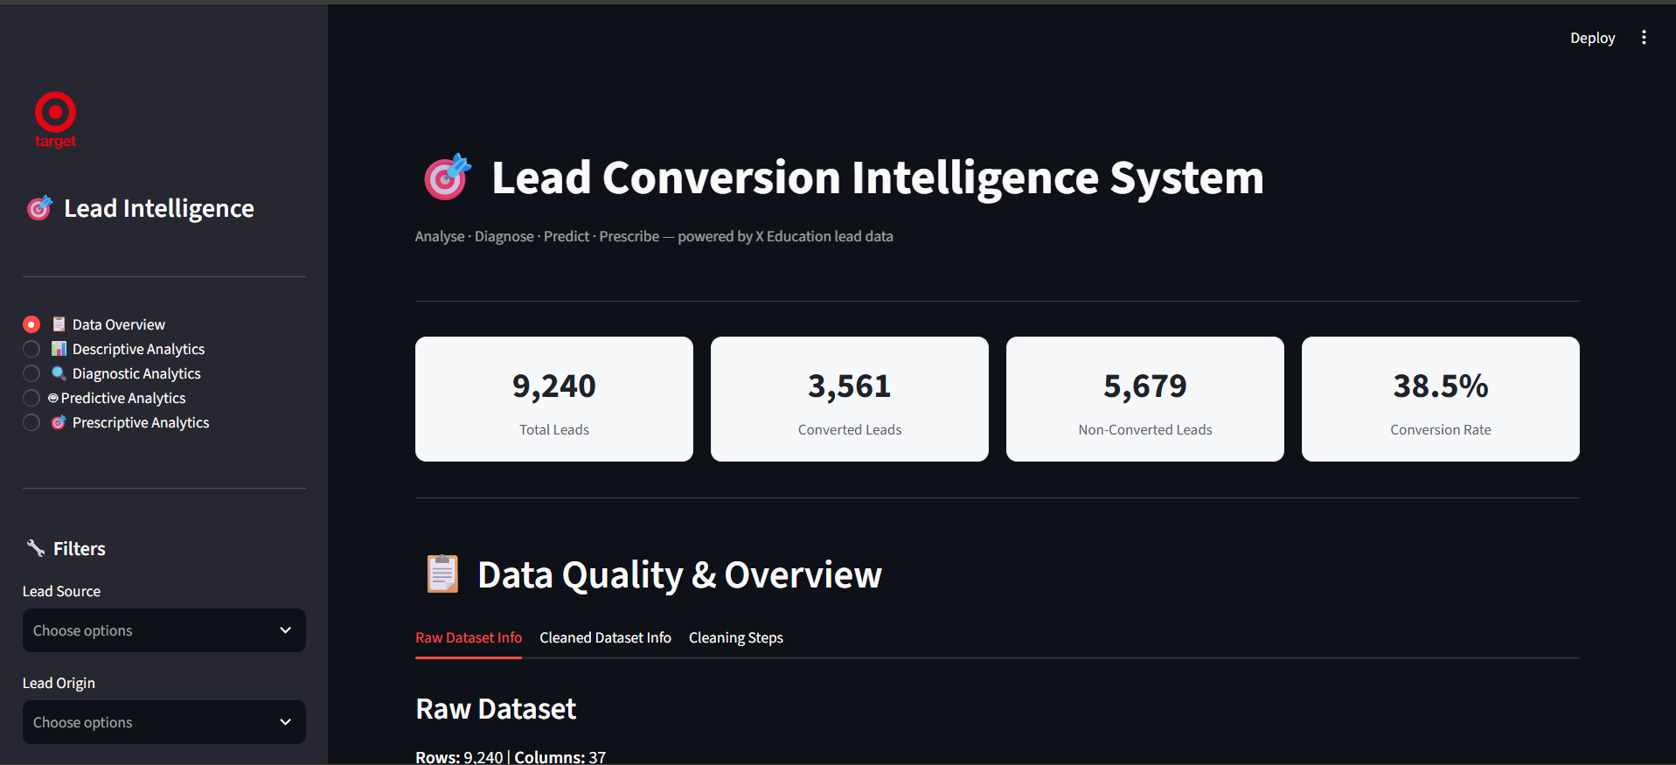
Figure 1. Dashboard landing view with headline KPIs and navigation.

2. Dataset and Technology Stack
The project uses the X Education Lead Scoring dataset. The original dataset contains 9,240 rows and 37 columns. The target variable is Converted, where 1 indicates a converted lead and 0 indicates a non-converted lead.
Measure | Value
Total leads | 9,240
Converted leads | 3,561
Non-converted leads | 5,679
Overall conversion rate | 38.5%
Number of columns | 37

Component | Use in the project
Python | Core programming language
Pandas and NumPy | Data loading, cleaning, and transformation
Streamlit | Interactive web dashboard
Plotly | Interactive charts and visualisations
scikit-learn | Preprocessing pipeline, classification models, and evaluation

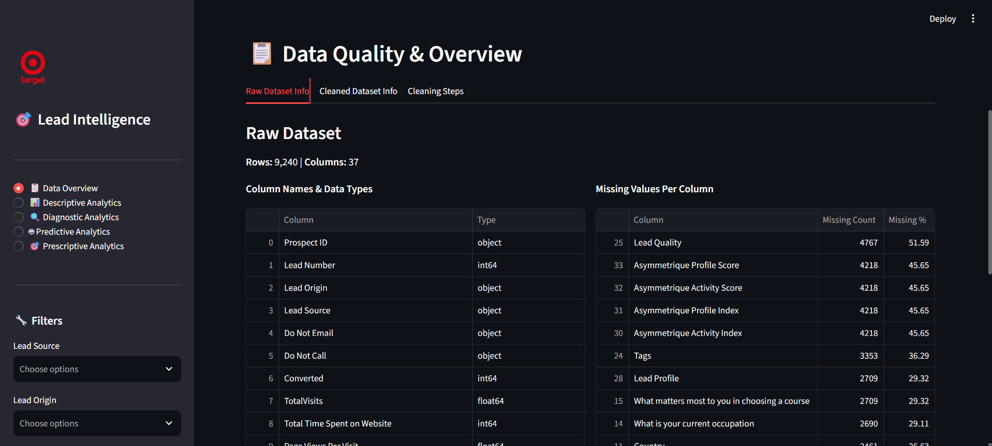
Figure 2. Raw dataset information and missing-value profile.

3. System Design and Methodology

3.1 Data Preparation
The original CSV is retained unchanged. Cleaning is performed on an in-memory copy so that the source data remains available for audit and comparison. The workflow removes duplicate records, interprets Select as a missing value, imputes numeric missing values with the median, imputes categorical fields with Unknown or the mode, removes surrounding whitespace, and standardises Lead Source formatting.
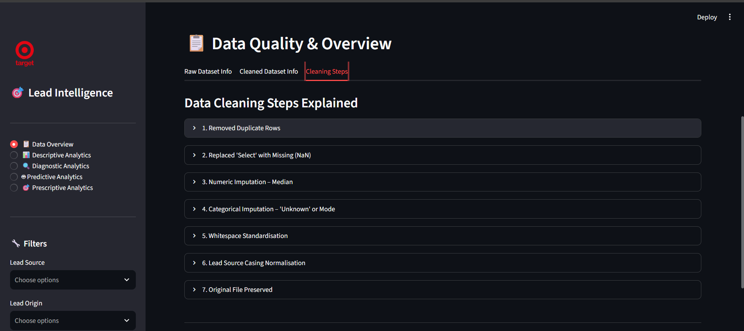
Figure 3. Cleaning steps implemented in the dashboard.

3.2 Four Tier Analytics Framework
Tier | Question | Implementation
Descriptive | What happened? | KPIs, conversion split, source and behaviour distributions
Diagnostic | Why did it happen? | Numeric and categorical comparisons plus written insights
Predictive | What is likely to happen? | Logistic Regression and Random Forest classification
Prescriptive | What should we do? | Probability-based lead categories and follow-up actions

3.3 Predictive Modelling Workflow
Prospect ID and Lead Number are excluded from modelling because they are identifiers rather than meaningful predictors. Numeric fields are median-imputed and standardised. Categorical fields are imputed and one-hot encoded with unknown-category handling. The data is split into training and test sets using an 80:20 stratified split with random state 42. Logistic Regression and Random Forest are trained in scikit-learn pipelines and compared using accuracy, precision, recall, F1-score, and ROC-AUC.

4. Analytics Findings

4.1 Descriptive Analytics
The dashboard shows that 38.5 percent of the available leads converted. The majority, 61.5 percent, did not convert, which establishes the opportunity for prioritised outreach and more targeted nurture campaigns.
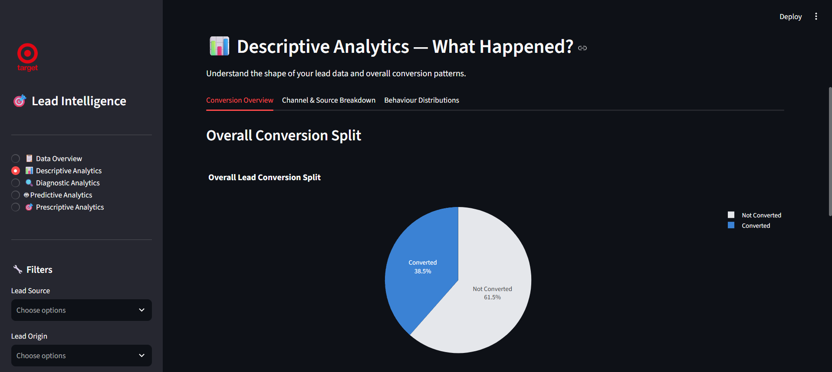
Figure 4. Overall lead conversion split.
Channel analysis highlights the importance of lead source and recent engagement. Welingak Website and Reference are among the strongest visible sources, while the highest conversion rates in the activity view appear for leads approached upfront, leads with a phone conversation, and leads receiving an SMS.
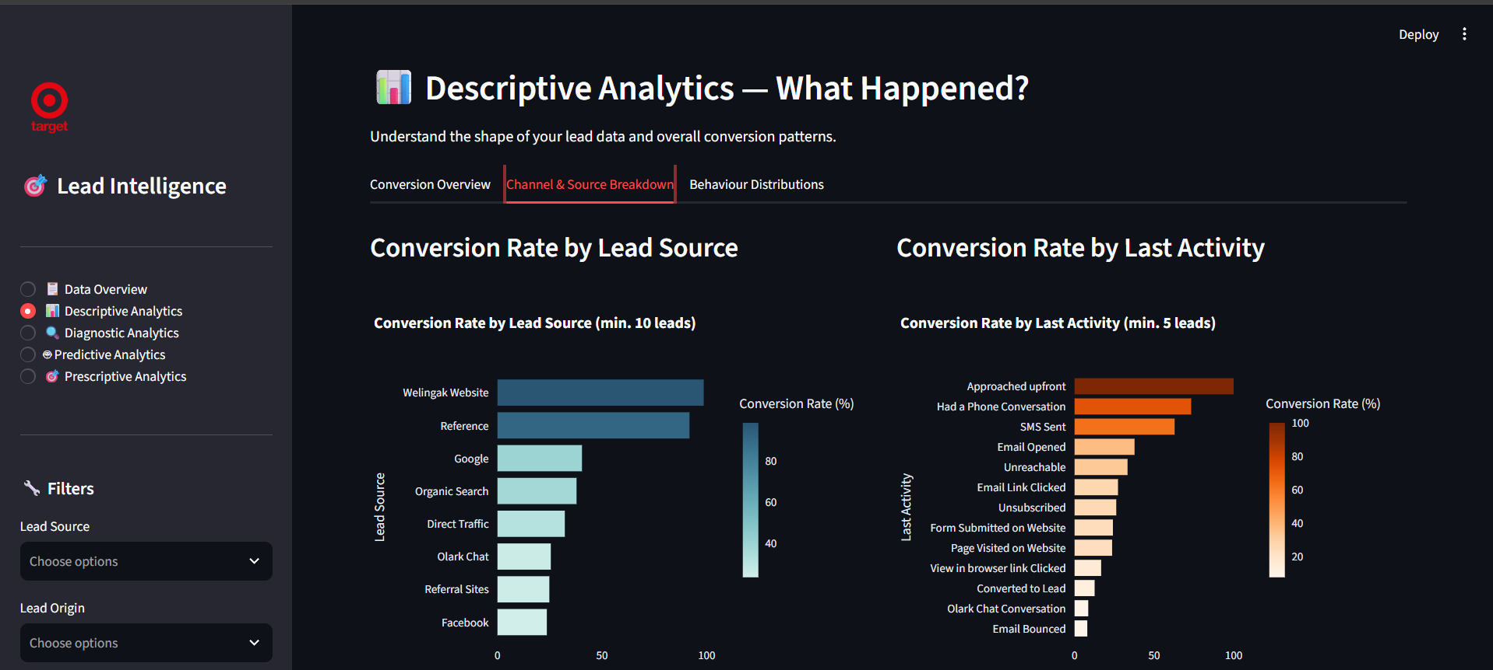
Figure 5. Conversion-rate comparison by lead source and last activity.

4.2 Behavioural Patterns
The TotalVisits distribution is right-skewed: most leads make relatively few visits while a small number of leads account for high visit counts. This makes median-based summaries more appropriate than relying only on means. Engagement variables should be considered together with source and last activity rather than in isolation.
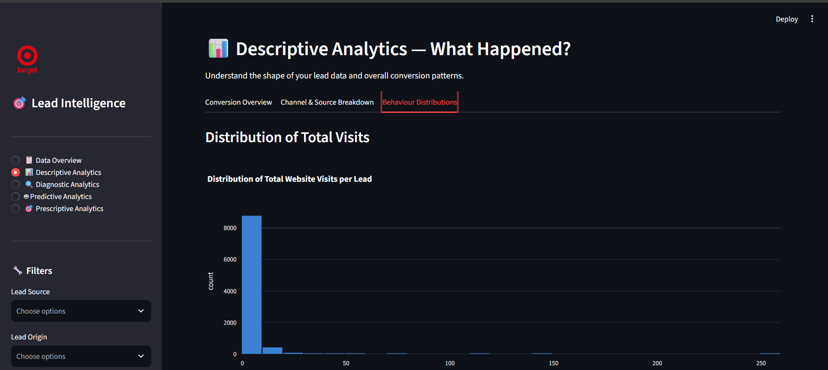
Figure 6. Distribution of total website visits per lead.

4.3 Diagnostic Analytics
Converted leads spent a median of 832 minutes on the website, compared with 179 minutes for non-converted leads. This is a strong engagement signal in the data. In contrast, both groups show a median of three website visits, suggesting that time spent exploring content is more discriminating than the median visit count alone.
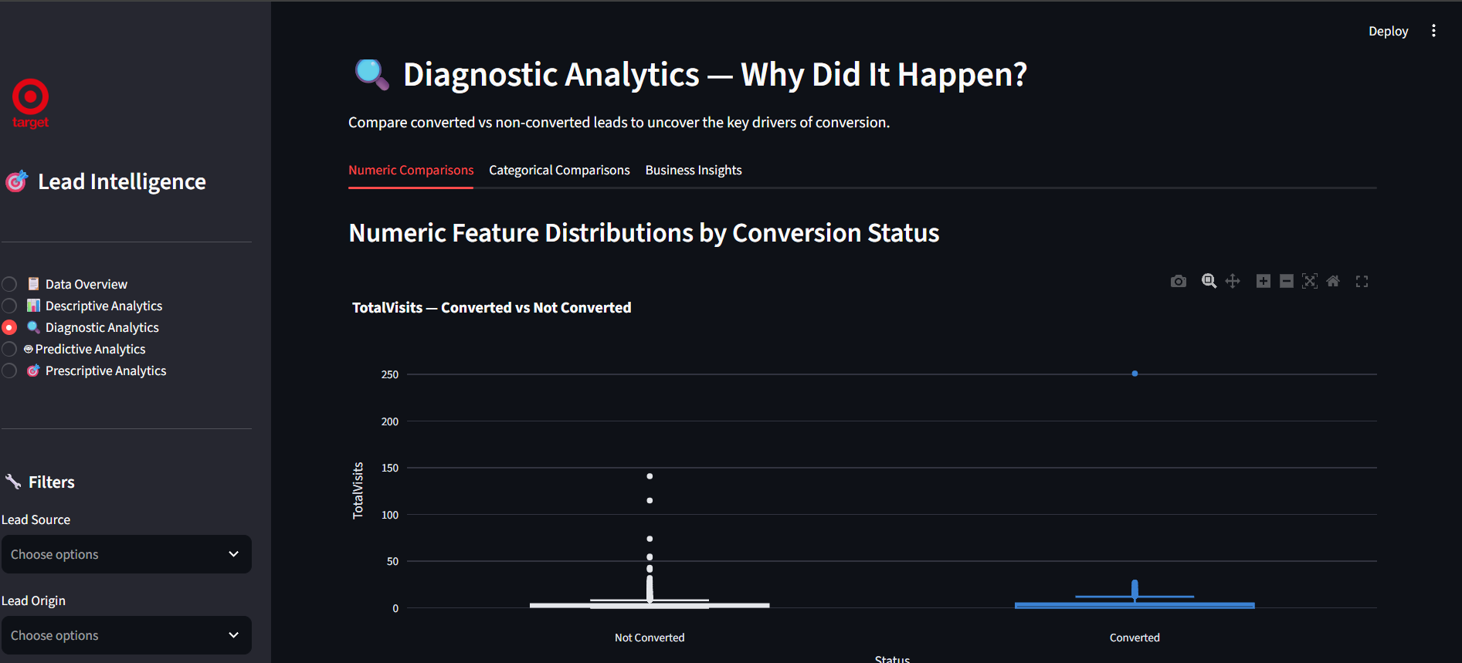
Figure 7. TotalVisits distribution by conversion status.
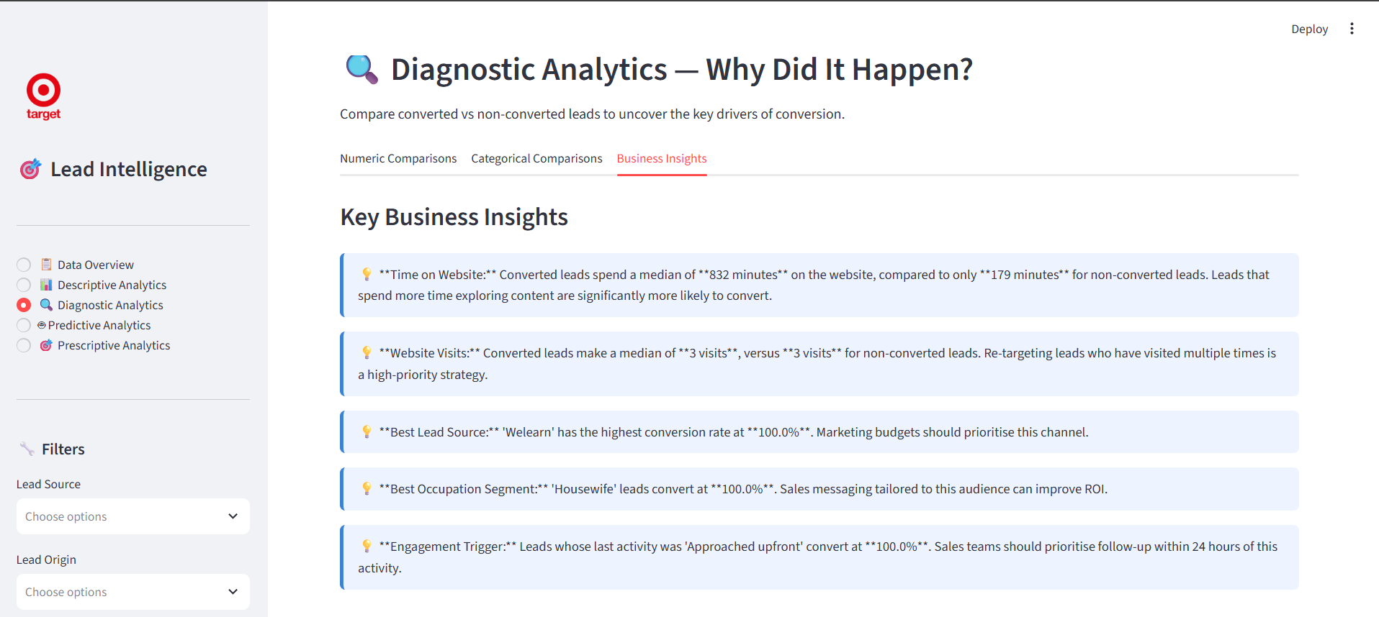
Figure 8. Dashboard-generated diagnostic business insights.

5. Predictive Model Results
Two supervised classifiers were evaluated. Random Forest was selected because it achieved the highest ROC-AUC on the test set. Its performance indicates strong separation between converted and non-converted leads in this dataset. These results should be validated on new, future leads before a production deployment.
Model | Accuracy | Precision | Recall | F1-score | ROC-AUC | Selection
Logistic Regression | 0.9351 | 0.9302 | 0.8989 | 0.9143 | 0.9788 | Not selected
Random Forest | 0.9383 | 0.9296 | 0.9087 | 0.9190 | 0.9793 | Selected

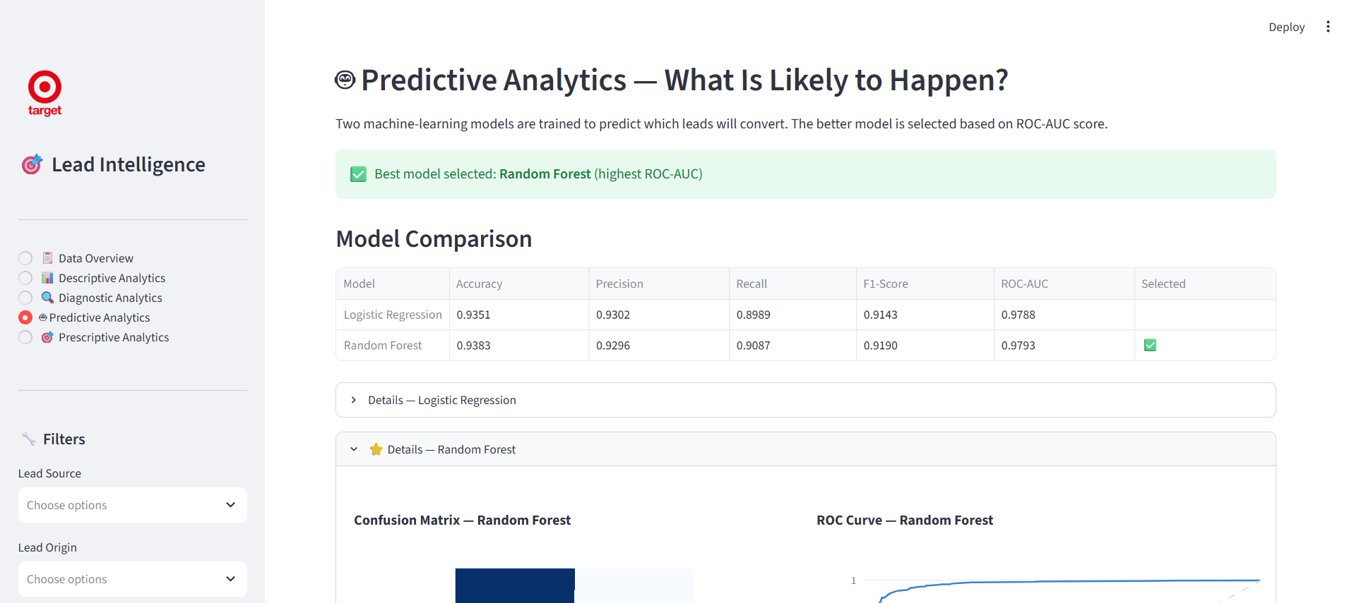
Figure 9. Model comparison with Random Forest selected by ROC-AUC.
The feature-coefficient view supports interpretation of the fitted model. Some tags and activity signals have strong positive or negative relationships with the model score. These variables should be reviewed with business stakeholders to ensure that they are available at scoring time and do not reflect information obtained only after a conversion decision.
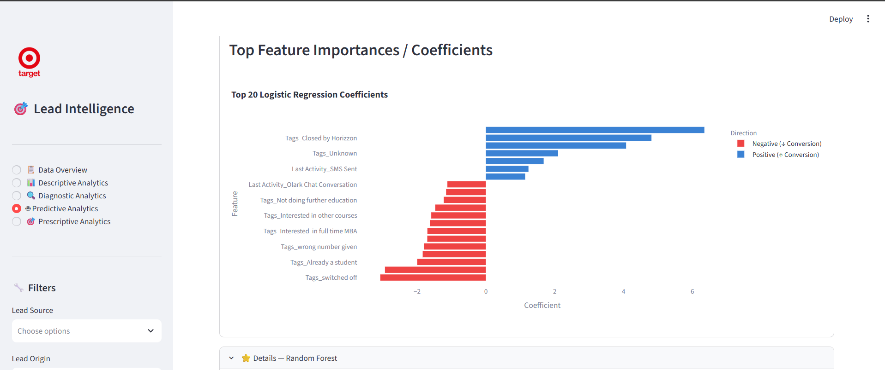
Figure 10. Logistic Regression coefficients for prominent model features.

6. Prescriptive Recommendations
The selected Random Forest model scores every lead and assigns it to a practical priority group. A Hot Lead has a predicted conversion probability of at least 70 percent; a Warm Lead is from 40 to 69 percent; and a Cold Lead is below 40 percent. The system produces 3,388 Hot Leads, 203 Warm Leads, and 5,649 Cold Leads.
Category | Count | Share | Recommended action
Hot Lead | 3,388 | 36.7% | Assign to a senior sales representative within 24 hours; offer a consultation or demo.
Warm Lead | 203 | 2.2% | Use a 3-5 email nurture sequence, webinar invitations, and a follow-up call after seven days.
Cold Lead | 5,649 | 61.1% | Use low-cost email re-engagement and newsletters; avoid expensive outbound calling unless engagement changes.

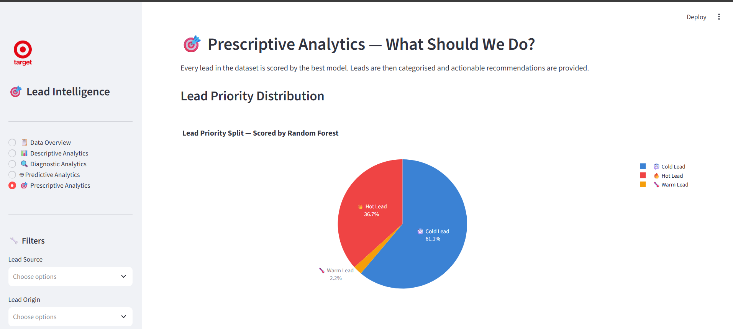
Figure 11. Predicted lead-priority distribution.
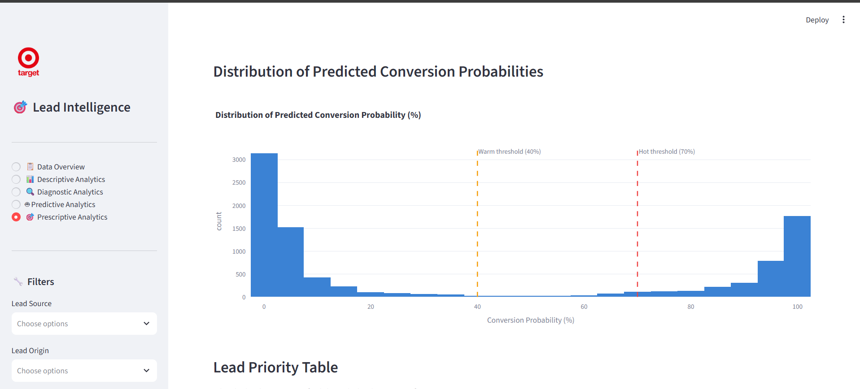
Figure 12. Distribution of predicted conversion probabilities and scoring thresholds.

6.1 Lead Priority Table and Operational Actions
The lead-priority table provides a practical handoff from analytics to sales operations. It includes lead identifiers, source, origin, city, occupation, last activity, predicted conversion probability, and category. The table is designed to be filtered so that sales teams can focus on the most valuable leads first.
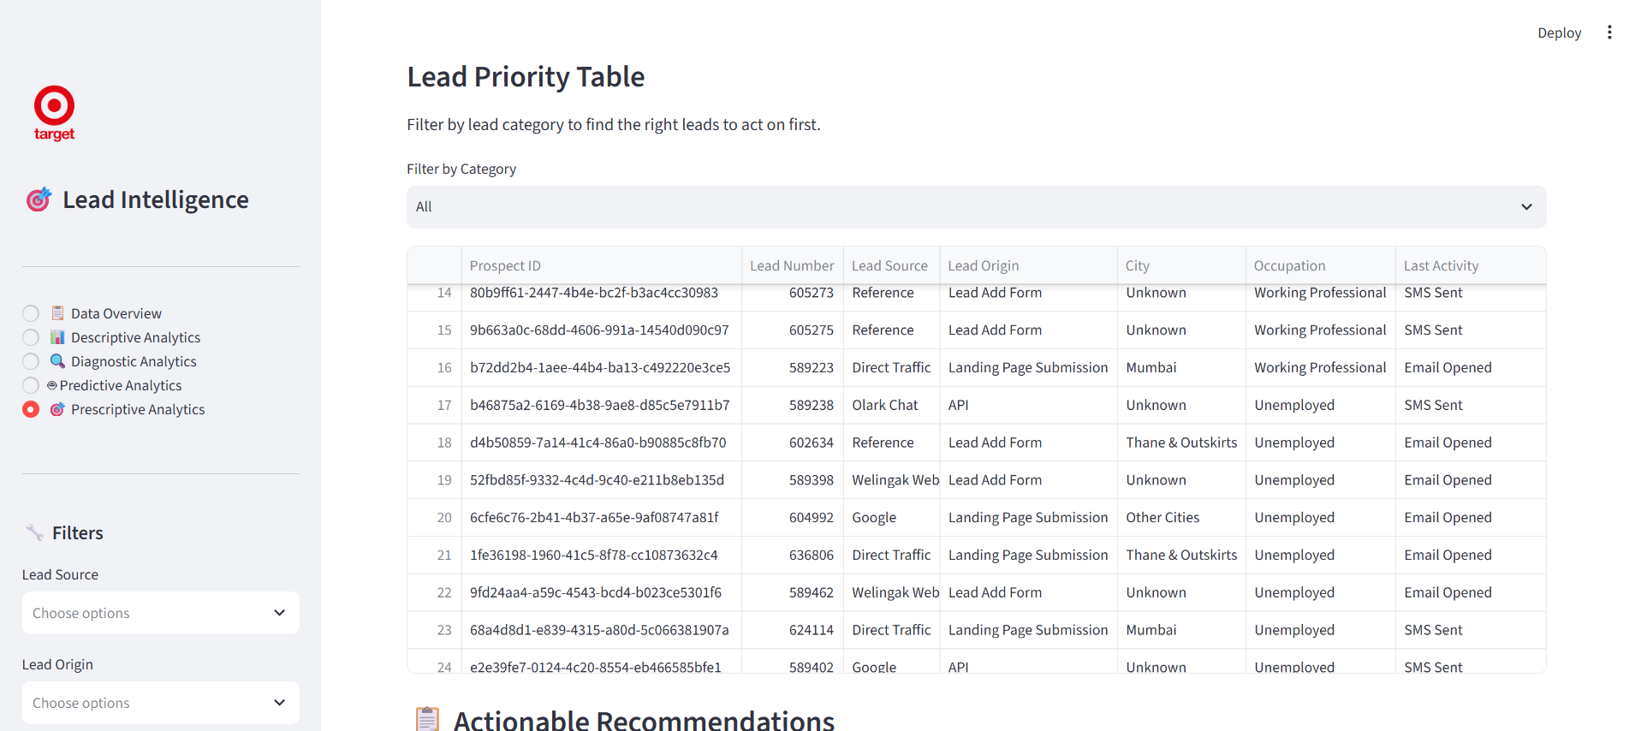
Figure 13. Lead-priority table for operational filtering and follow-up.
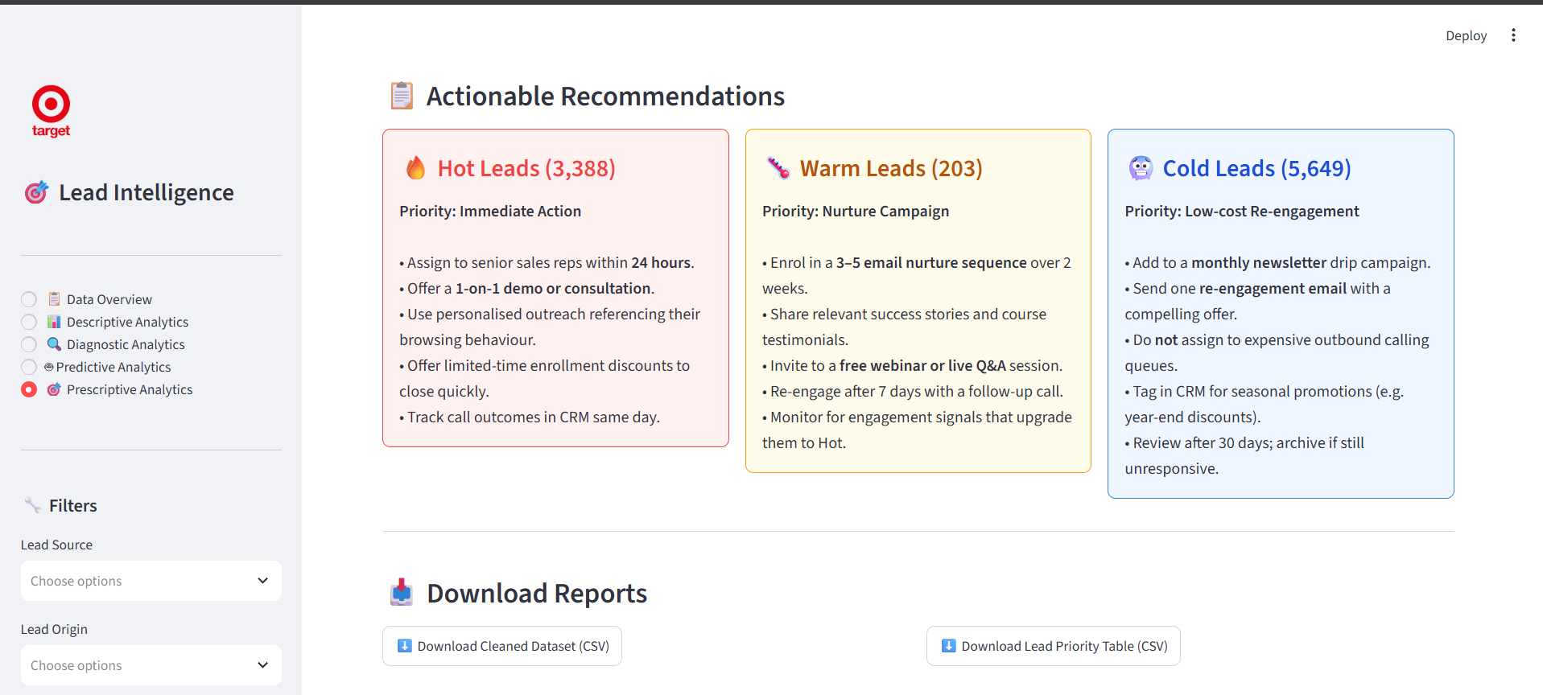
Figure 14. Actionable recommendations for Hot, Warm, and Cold Leads.

7. Conclusion and Future Scope
The Lead Conversion Intelligence System demonstrates an end-to-end analytics workflow for lead prioritisation. It turns a historical lead dataset into an interactive dashboard that answers what happened, why it happened, what is likely to happen, and what the business should do next. The dashboard provides a defensible starting point for focusing sales resources, improving response speed for high-potential leads, and reducing spend on low-probability outreach.

7.1 Recommended Next Steps
- Validate model performance on new leads collected after the training period.
- Monitor conversion rates and ROC-AUC over time to detect data or model drift.
- Review highly predictive fields with domain experts to prevent post-conversion leakage.
- Connect the lead-priority output to a CRM system and track whether recommended actions improve conversion.
- Add campaign cost and revenue data to evaluate return on marketing investment.

8. Repository and References
Project repository: https://github.com/SuduOps/lead-conversion-intelligence-system
Dataset: X Education Lead Scoring Dataset, Kaggle: https://www.kaggle.com/datasets/ashydv/leads-dataset
Libraries: Streamlit, Pandas, Plotly, and scikit-learn documentation.
All screenshots in this report were captured from the locally running Lead Conversion Intelligence System dashboard on 23 September 2026.

