Министерство образования и науки Российской Федерации

Федеральное государственное бюджетное образовательное учреждение высшего образования

**«Пермский национальный исследовательский политехнический университет»**

Кафедра **«**Информационные технологии и автоматизированные системы**»**

**ОТЧЕТ**

Дисциплина: «Основы алгоритмизации и программирования»

Семестр 2

Тема: хэш-таблицы.

Выполнил работу

Студент группы РИС-22-1Б

Карнаухов М. Е.

Проверил

Доцент кафедры ИТАС

Полякова О.А.

г. Пермь-2023

**Введение**

Для выполнения лабораторной работы требуется сделать отчет программы. Создание программ – отличный способ практики программирования.

**Код программы**

#include <iostream>

#include <ctime>

#include <string>

#include <vector>

#include <list>

using namespace std;

string full_name[5] = { "Смирнов Андрей Андреевич", "Маслов Иван Иванович", "Сафонов Петр Петрович","Кузнецов Дмитрий Дмитриевич", "Горбачёв Евгений Евгеньевич" };

string dates[5] = { "15.11.1969", "27.01.1996", "23.10.1972", "13.04.1993", "20.07.1985" };

string number_phone[5] = { "88422352177", "84959631102", "88005553535", "84953584156", "84959524920" };

int collisions_count = 0;

struct Data

{

string full_name = "NULL";

string date_of_birth = "NULL";

string address = "NULL";

};

class HashTable

{

int capacity;

list<Data>* table;

vector<Data>* array;

public:

HashTable(int V);

int hashFunction(string full_name);

~HashTable();

void insertItem(string full_name, const list<Data>::iterator& it);

void deleteItem(string full_name);

void displayHash();

void add(string full_name, const vector<Data>::iterator& it);

void displayHash2();

void find_index(string date_of_birth);

void pop(string date_to_delete);

};

HashTable::HashTable(int c)

{

this->capacity = c;

table = new list<Data>[capacity];

array = new vector<Data>(c);

}

int HashTable::hashFunction(string full_name)

{

int sum = 0;

for (size_t i = 0; i < full_name.length(); i++)

sum += (unsigned char)full_name[i];

return (sum % capacity);

}

HashTable::~HashTable()

{

table->clear();

}

void HashTable::insertItem(string full_name, const list<Data>::iterator &it)

{

int index = hashFunction(full_name);

if (table[index].size() != 0)

++collisions_count;

table[index].push_back(*it);

}

void HashTable::deleteItem(string full_name)

{

int index = hashFunction(full_name);

bool f = 0;

for (auto& i : table[index])

{

if (i.full_name == full_name)

{

i.full_name = "NULL";

i.date_of_birth = "NULL";

i.address = "NULL";

cout << "person with the full name \"" << full_name << "\" was successfully deleted\n\n";

f = 1;

break;

}

}

if (f == 0)

cout << "person with a full name \"" << full_name << "\" could not be found\n\n";

}

void HashTable::displayHash()

{

cout << "-----------| enter hashTable |-----------\n";

for (int i = 0; i < capacity; i++)

{

cout << "table[" << i << "]";

for (auto x : table[i])

cout << " --> " + x.full_name + "; " + x.date_of_birth + "; " + x.address;

cout << endl;

}

cout << "-----------| end hashTable |-----------\n";

}

void HashTable::add(string full_name, const vector<Data>::iterator& it)

{

int hash = hashFunction(full_name);

int index = hash;

if ((*array)[index].full_name == "NULL")

{

(*array)[index] = *it;

return;

}

else

{

++index;

while (index < capacity)

{

if ((*array)[index].full_name == "NULL")

{

(*array)[index] = *it;

return;

}

++index;

++collisions_count;

}

if (index == capacity)

{

index = 0;

++collisions_count;

while (index < hash)

{

if ((*array)[index].full_name == "NULL")

{

(*array)[index] = *it;

return;

}

++index;

++collisions_count;

}

}

}

}

void HashTable::find_index(string full_name)

{

int hash = hashFunction(full_name);

int index = hash;

while (index < capacity && (*array)[index].full_name != full_name )

++index;

if (index == capacity)

{

index = 0;

while (index < hash && (*array)[index].full_name != full_name)

++index;

if (index == hash)

cout << "person with a full name \"" << full_name << "\" could not be found\n\n";

else

cout << "person with the full name \"" << full_name << "\" was successfully found by the index " << index << endl << endl;

}

else

cout << "person with the full name \"" << full_name << "\" was successfully found by the index " << index << endl << endl;

}

void HashTable::pop(string full_name)

{

int hash = hashFunction(full_name);

int index = hash;

if ((*array)[index].full_name == full_name)

{

(*array)[index].full_name = "NULL";

(*array)[index].date_of_birth = "NULL";

(*array)[index].address = "NULL";

cout << "person with the full name \"" << full_name << "\" was successfully deleted by the index " << index << endl << endl;

return;

}

else

{

++index;

while (index < capacity)

{

if ((*array)[index].full_name == full_name)

{

(*array)[index].full_name = "NULL";

(*array)[index].date_of_birth = "NULL";

(*array)[index].address = "NULL";

cout << "person with the full name \"" << full_name << "\" was successfully deleted by the index " << index << endl << endl;

return;

}

++index;

}

if (index == capacity)

{

index = 0;

while (index < hash)

{

if ((*array)[index].full_name == full_name)

{

(*array)[index].full_name = "NULL";

(*array)[index].date_of_birth = "NULL";

(*array)[index].address = "NULL";

cout << "person with the full name \"" << full_name << "\" was successfully deleted by the index " << index << endl << endl;

return;

}

++index;

}

}

}

cout << "person with a full name \"" << full_name << "\" could not be found\n\n";

}

void HashTable::displayHash2()

{

cout << "-----------| enter hashTable |-----------\n";

int number = 0;

for (auto it = array->begin(); it != array->end(); ++it)

{

cout << "(" << number++ << "):\n";

cout << (*it).full_name << endl;

cout << (*it).date_of_birth << endl;

cout << (*it).address << endl;

}

cout << "-----------| end hashTable |-----------\n";

}

void fillList(list<Data>& obj, int size)

{

for (size_t i = 0; i < size; i++)

{

Data data;

data.address = number_phone[rand() % 5];

data.full_name = full_name[rand() % 5];

data.date_of_birth = dates[rand() % 5];

obj.push_back(data);

}

}

void fillVector(vector<Data>& obj, int size)

{

for (size_t i = 0; i < size; i++)

{

Data data;

data.address = number_phone[rand() % 5];

data.full_name = full_name[rand() % 5];

data.date_of_birth = dates[rand() % 5];

obj.push_back(data);

}

}

int main()

{

srand(time(0));

system("chcp 1251 >> null");

int size = 0;

cout << "size(for table): "; cin >> size;

int choice = -1;

cout << "\n\t1 - method chain\n\t2 - method open address\n\nyour answer: "; cin >> choice;

switch (choice)

{

case 1:

{

list<Data> lst1;

system("cls"); cout << "----------| enter List |----------\n";

fillList(lst1, size);

int number = 0;

for (auto it = lst1.begin(); it != lst1.end(); ++it)

{

cout << "(" << number++ << ")" << endl;

cout << (*it).full_name << endl;

cout << (*it).date_of_birth << endl;

cout << (*it).address << endl;

}

cout << "-----------| end List |-----------\n\n";

HashTable h(size);

for (auto it = lst1.begin(); it != lst1.end(); ++it)

h.insertItem((*it).full_name, it);

h.displayHash(); cout << endl;

h.deleteItem("Маслов Иван Иванович");

h.displayHash();

}

break;

case 2:

{

vector<Data> array;

system("cls"); cout << "----------| enter Vector |----------\n";

fillVector(array, size);

int number = 0;

for (auto it = array.begin(); it != array.end(); ++it)

{

cout << "(" << number++ << ")" << endl;

cout << (*it).full_name << endl;

cout << (*it).date_of_birth << endl;

cout << (*it).address << endl;

}

cout << "-----------| end Vector |-----------\n\n";

HashTable h2(size);

for (auto it = array.begin(); it != array.end(); ++it)

h2.add((*it).full_name, it);

h2.displayHash2(); cout << endl;

h2.find_index("Маслов Иван Иванович");

h2.pop("Маслов Иван Иванович");

h2.displayHash2();

}

break;

default:

break;

}

cout << endl << "collisions: " << collisions_count << endl;

}

**Вывод программы**

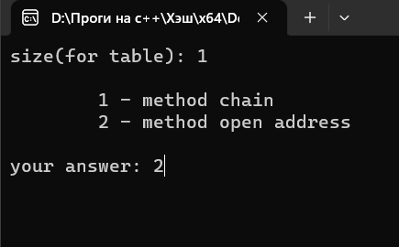

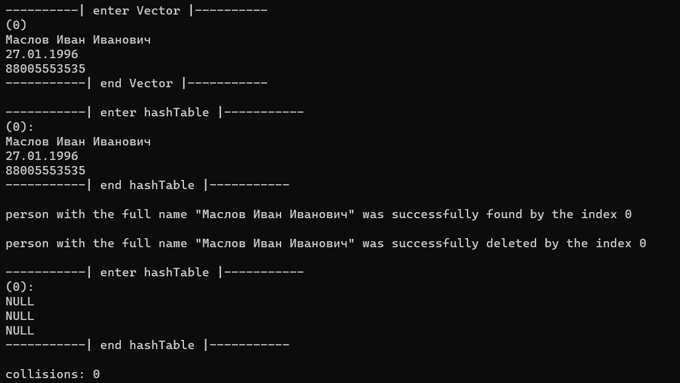

***Рисунок 1 – вывод программы***

**Блок-схема**

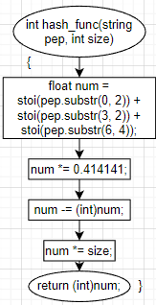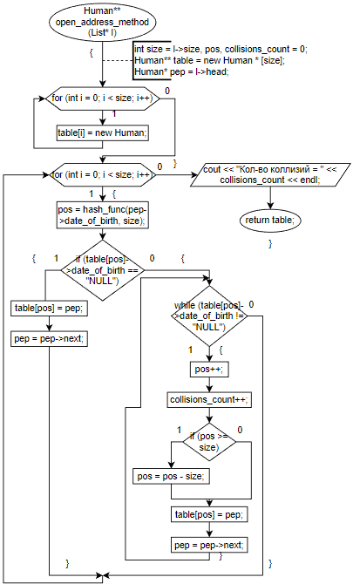

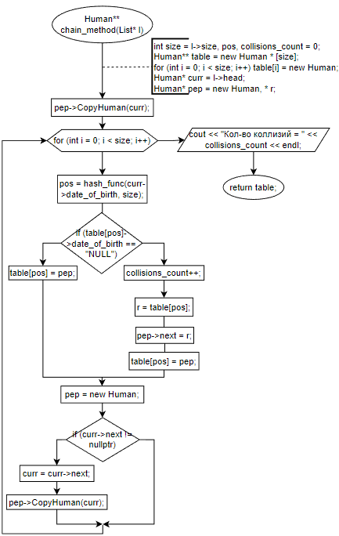

***Рисунок 3 – Схема алгоритма программы***