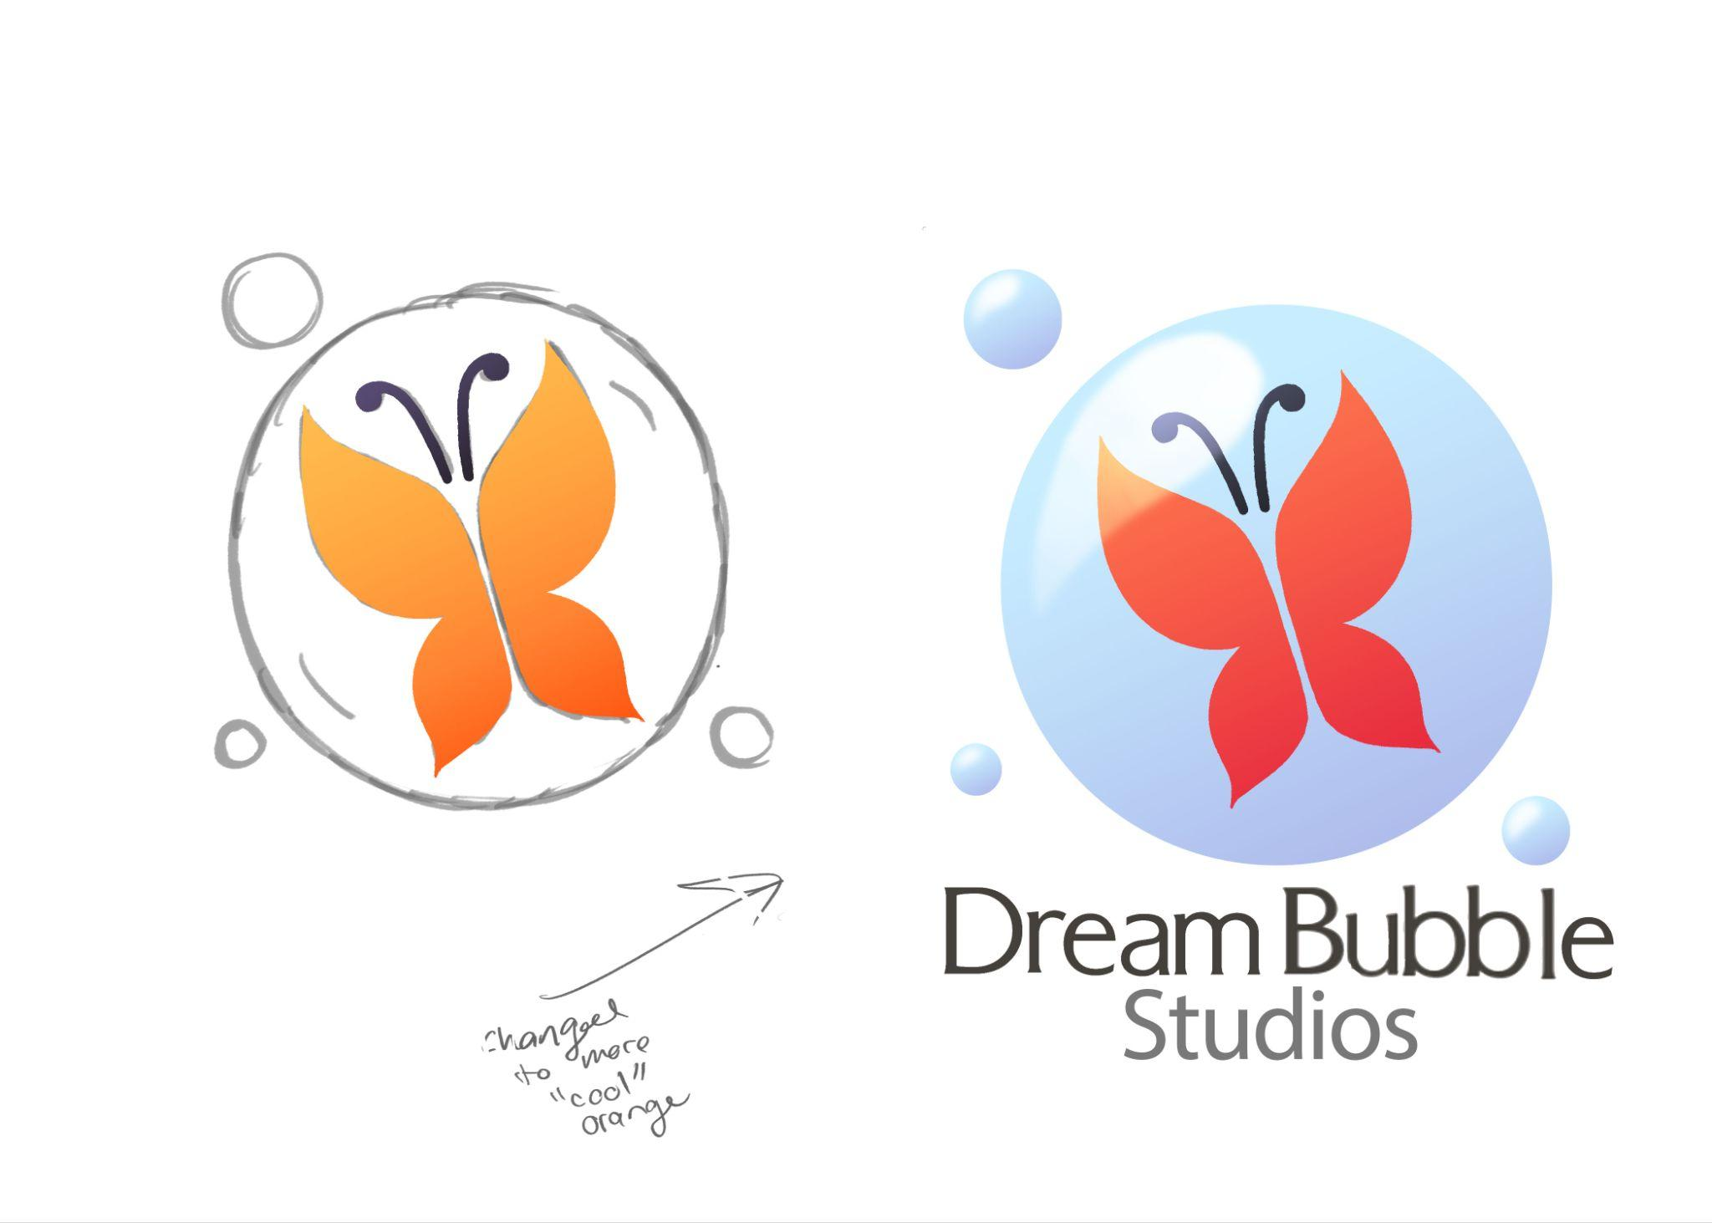

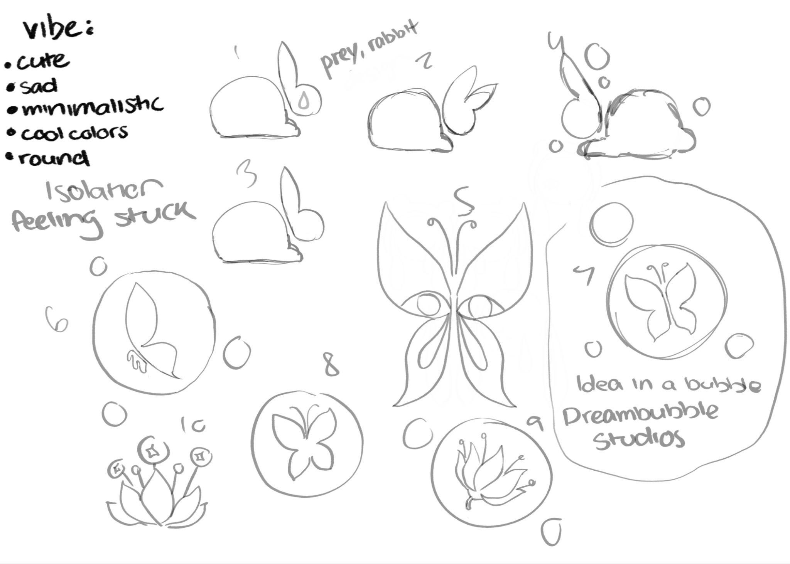

Lauryn Wade

GIMM 100

Prof. Damle

Dec 7 2023

Logo Write Up

At first it was difficult initially coming up with the concept of what my logo would be, I hadn’t yet considered what the purpose or vibe of my game goals or portfolio goals would be. Usually when I created things, it was whatever isolated ideas I would have at the time. My first approach was to jump straight in with at least getting something on the page. I knew that for the most part, my work tends to be dreary and dark, so I figured that leaning towards more of a mascot may be able to get me off my feet. The “mascot” I chose was a rabbit, I used two base shapes that made up the whole body, and I chose to stick with that for all iterations afterwards. I found that having as little lines intersecting the silhouette made the object itself very clear and not visually confusing. I also designed it with the fact simple logos are more likely to be recognized and remembered in mind. Detailed logos look cluttered and can become unrecognizable. The bunnies were intended to be a design primarily centered on distinct and recognizable silhouettes. The next idea was actually brought about to me by my partner. He said that a butterfly could make sense, based on the concept that my ideas are always fleeting. Borrowing from the previous “small and delicate” concepts of the rabbit, I decided to put the butterflies into bubbles. This supports my general behavior in having isolated and fleeting ideas. The butterfly concepts also allowed me to come up with a good name for the studio I would like to represent myself as when creating stories and games. Subtly influenced and inspired by retro gaming, like the Nintendo 64, Dreamcast, and early Windows, I wanted to implement the style of shading and lighting, while keeping the butterfly dark enough and the bubble perfectly circular to be able to be scaled down. I had a version where the butterfly was more orange and lighter, however I considered it would not contrast as well with the bubble background in grayscale, nor would it follow my original goals to keep the logo related to me– as I like cool soft and rendered colors.