Coursera Reproducible Research – Week 2 project 1

Susan Dunham

Loading the Activity Monitoring Data

> mydata <- read.csv("./ReproducibleResearch/activity.csv", header = TRUE)

Q1: What is the mean total number of steps taken per day?

Calculate total number of steps taken per day:

> dailysteps <- tapply(mydata$steps, mydata$date, sum)

Histogram of total number of steps taken each day

> hist(dailysteps,xlab = "Number of Steps", main = "Histogram: Steps per Day")

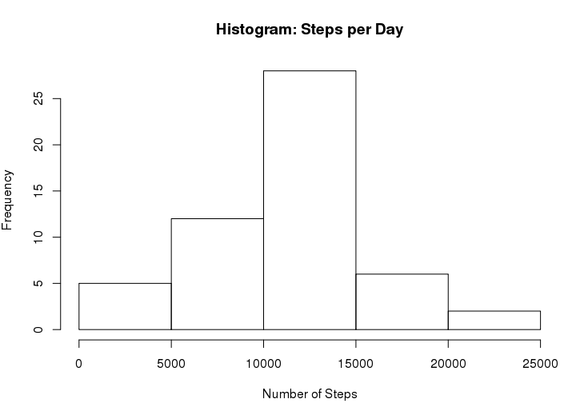

Calculate and report the mean and median total number of steps taken per day

> MeanDaily <- mean(dailysteps, na.rm = TRUE)

> MedianDaily <- median(dailysteps, na.rm = TRUE)

MeanDaily = 10766.1887

MedianDaily = 10765

**Q2: What is the average daily activity pattern?**

Create a time series plot of the 5-minute interval and the average number of steps taken, averaged across all days

> StepsperInterval <- tapply(mydata$steps, mydata$interval, mean, na.rm=TRUE)

> plot(as.numeric(names(StepsperInterval)),

+ StepsperInterval,

+ xlab = "Interval",

+ ylab = "Steps",

+ main = "Average Daily Activity Pattern",

+ type = "l")

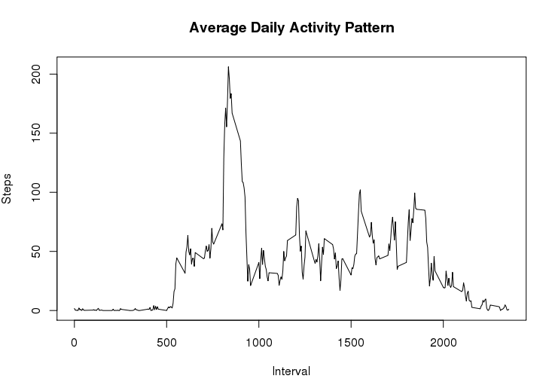

Which 5-minute interval, on average across all of the days in the dataset, contains the maximum number of steps?

> maxInterval <- names(sort(StepsperInterval, decreasing = TRUE)[1])

> maxSteps <- sort(StepsperInterval, decreasing = TRUE)[1]

The interval associated with maximum activity is interval 835, at 206 steps

**Q3: Inputing missing values**

Calculate and report the total number of missing values in the dataset

> TotNAs <- sum(is.na(mydata$steps))

There are 2304 missing values in the dataset

Strategy for filling in the missing values in the dataset.

I will be using the mean steps per interval for missing data values.

Create a new dataset that has the missing values filled in.

Splitting up the data by interval

> activity_split <- split(mydata, mydata$interval)

Filling in the missing data in each interval

> for(i in 1:length(activity_split)){

+ activity_split[[i]]$steps[is.na(activity_split[[i]]$steps)] <- StepsperInterval[i]

+ }

> activity_added <- do.call("rbind",activity_split)

> activity_added <- activity_added[order(activity_added$date),]

Histogram of total number of steps taken each day.

> StepsPerDay_added <- tapply(activity_added$steps,activity_added$date,sum)

> hist(StepsPerDay_added, xlab ="Number of Steps", main ="Steps per Day: NAs replaced")

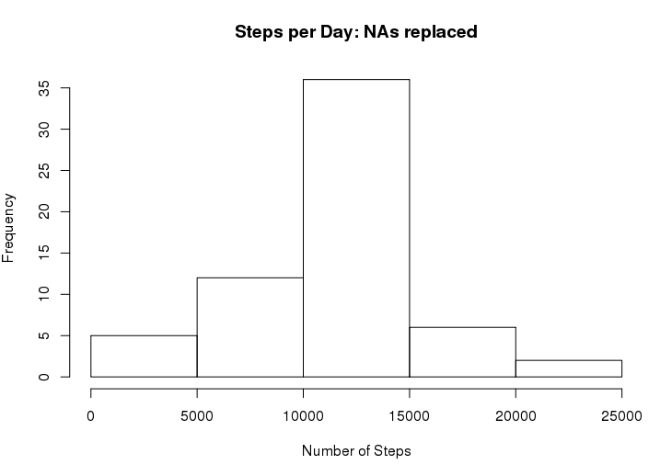

Calculate and report the mean and median total number of steps taken per day.

> MeanDaily_added <- mean(StepsPerDay_added, na.rm =TRUE)

> MedianDaily_added <- median(StepsPerDay_added, na.rm =TRUE)

The mean number of steps per day including replaced data is 10766.1887

The median value is 10766.1887

The mean value stayed the same, the median value increased.

**Q4: Are there differences in activity patterns between weekdays and weekends?**

Create a new factor variable in the dataset with two levels “weekday” and “weekend”

> activity_added$day <- ifelse(weekdays(as.Date(activity_added$date))=="Saturday" | weekdays(as.Date(activity_added$date))=="Sunday", "weekend", "weekday")

Panel plot containing a time series plot of the 5-minute interval and the average number of steps taken, averaged across all weekday days and weekend days.

Calculates average steps per interval for weekend days

> StepsPerInterval_weekend <- tapply(activity_added[activity_added$day == "weekend",]$steps, activity_added[activity_added$day == "weekend",]$interval,mean, na.rm =TRUE)

Calculate average steps per interval for weekday days

> StepsPerInterval_weekday <- tapply(activity_added[activity_added$day == "weekday",]$steps, activity_added[activity_added$day == "weekday",]$interval, mean, na.rm =TRUE)

Creating a 2 panel plot

> par(mfrow=c(1,2))

> ##Plotting weekday activity

> plot(as.numeric(names(StepsPerInterval_weekday)),

+ StepsPerInterval_weekday,

+ xlab = "Interval",

+ ylab = "Steps",

+ main = "Activity Pattern: Weekdays",

+ type = "l")

> ##Plotting weekend activity

> plot(as.numeric(names(StepsPerInterval_weekend)),

+ StepsPerInterval_weekend,

+ xlab = "Interval",

+ ylab = "Steps",

+ main = "Activity Pattern: Weekends",

+ type = "l")

