ENSE707 Week 9 Lab Report
TDD and QA in CI/CD
Name: Suemon Solution: Week09QualityLab (C# / .NET 10 / MSTest)

1. Setup (Part 1)
A new solution, Week09QualityLab, was created with two projects:
- Week09QualityLab.Core – Class Library containing the production code.
- Week09QualityLab.Tests – MSTest Test Project containing the automated tests, with a project reference to Week09QualityLab.Core.
Tests can be run with Test > Run All Tests in Visual Studio (Test Explorer) or with dotnet test.

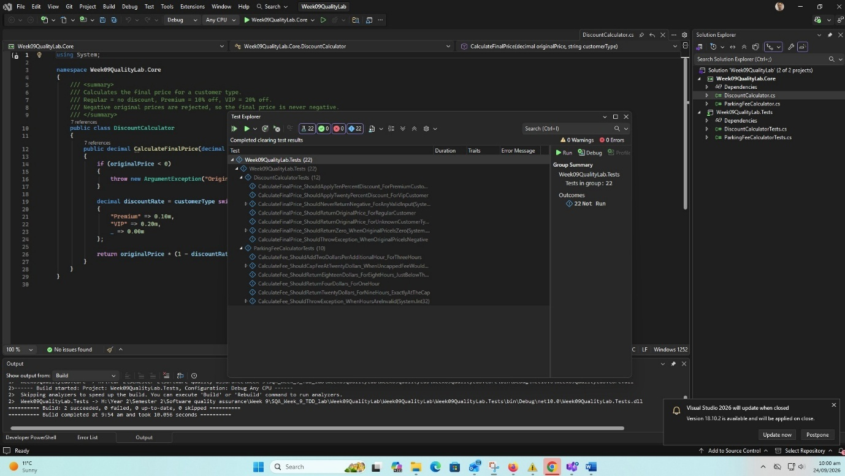

2. Discount Calculator using TDD (Part 2)
Rules: Regular = no discount, Premium = 10% off, VIP = 20% off, and the final price is never negative. Each rule was added in a Red–Green–Refactor cycle; no rule was implemented before a failing test existed for it.
Step | Test written first | Red (failing) | Minimum code change | Green
1 | Regular customer, 100 returns 100 | Fails: DiscountCalculator does not exist (compile error) | Create DiscountCalculator that returns originalPrice | Pass
3 | Premium customer, 100 returns 90 | Fails: expected 90, actual 100 | If Premium, return price × 0.90 | All pass
4 | VIP customer, 100 returns 80 | Fails: expected 80, actual 100 | If VIP, return price × 0.80 | All pass
5 | Negative price throws ArgumentException | Fails: no exception thrown | Guard clause: throw if originalPrice < 0 | All pass
6 | Refactor (no new test) | n/a | Replace if-chain with a switch expression and a discountRate variable | All still pass

Extra edge-case tests added after reviewing the requirements: zero price for all three customer types, a check that valid inputs never produce a negative result, and a test documenting that unknown customer types are treated as Regular (a design decision noted in the reflection).
Suggested commit message: Add TDD discount calculator

3. Second Business Rule: Parking Fee Calculator (Part 3)
The first hour costs $4, each additional hour costs $2, the full-day maximum is $20, and invalid hours throw an exception.
Test | Input | Expected
First hour | 1 hour | $4
Additional hours | 3 hours | $8 (4 + 2 + 2)
Just below the cap | 8 hours | $18
Exactly at the cap | 9 hours | $20 (4 + 8 × 2)
Above the cap | 10, 12, 24 hours | $20 (capped)
Invalid hours | 0, -1, 25 | ArgumentException

Assumptions: hours are whole, already-rounded chargeable hours for a single-day stay (1 to 24). Part-hours and multi-day stays are not part of this exercise and would need new requirements and tests. Every test uses the Arrange–Act–Assert structure.
Suggested commit message: Add second TDD business rule example

4. GitHub Copilot Use (Part 4)
All suggested tests or code were checked against the following list before being kept:
Check | What was looked for
Matches the requirement | The test checks the written rule, not just what the current code does.
Correct expected values | Expected results were worked out by hand (for example 4 + 2 × 2 = 8).
Meaningful assertions | Each test asserts a specific outcome, not just that no error occurred.
Boundary cases | Values just below, at, and just above limits (8, 9, 10 hours; price 0; negative price).
Behaviour, not implementation | Tests use only the public method and its inputs and outputs.
Readable and simple | Suggestions that were more complex than needed were simplified.
Prompt 1
Suggest MSTest unit tests for a C# DiscountCalculator with a method CalculateFinalPrice(decimal originalPrice, string customerType). Requirements: Regular customers get no discount, Premium customers get 10% off, VIP customers get 20% off, and a negative original price must throw an ArgumentException. Use the Arrange-Act-Assert pattern and clear test names in the form Method_ShouldDoX_WhenY. Use MSTest 3.x (Assert.ThrowsException). Give me the expected value for each test and show how you calculated it.

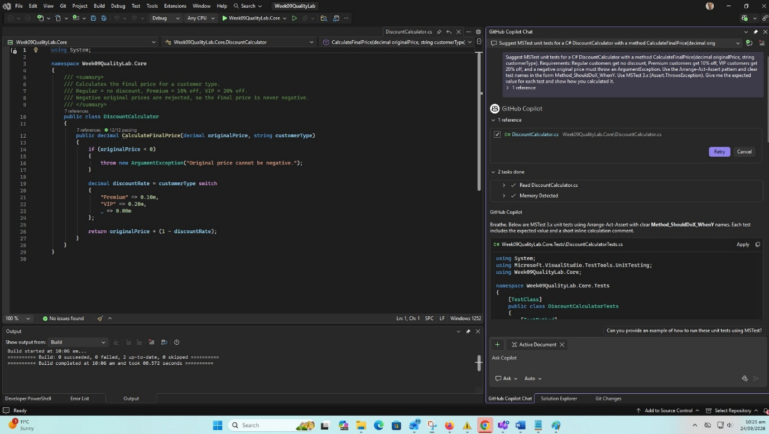

Prompt 2
Suggest edge cases and boundary values I should test for a C# discount calculator where Regular = 0%, Premium = 10%, VIP = 20%, and negative prices are invalid. Also list any ambiguities in these requirements that I should clarify (for example unknown customer types, null values, casing, and rounding). Do not write code yet, just list the cases.

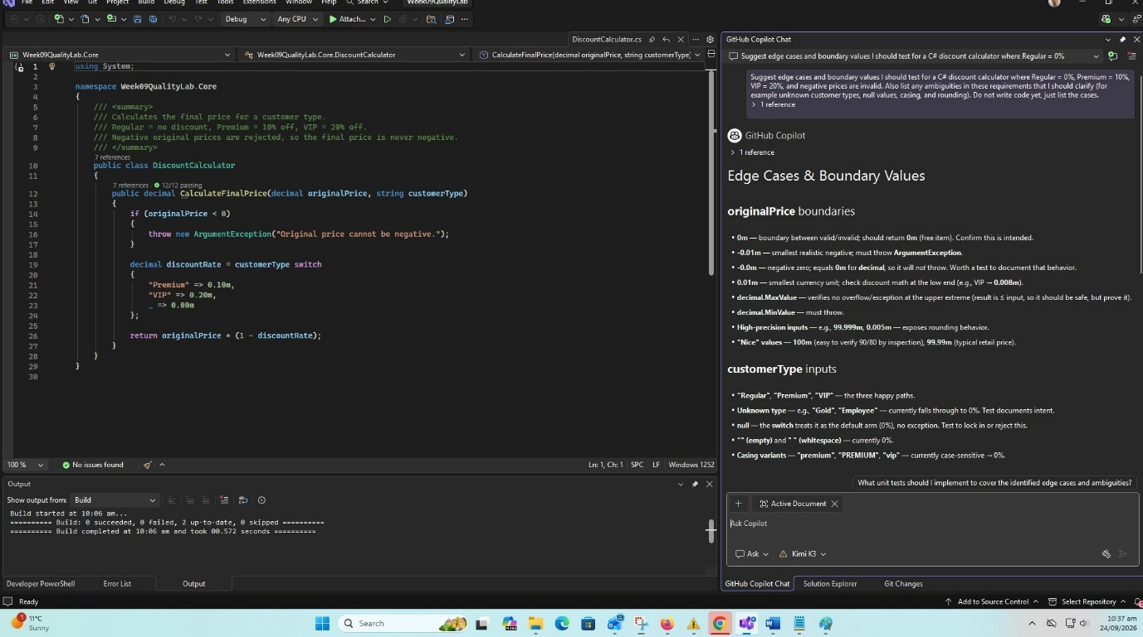

Prompt 3
Refactor this C# method while keeping exactly the same behaviour. Make it more readable and avoid repeated code, but do not add new features or change how invalid input is handled. Explain what you changed and why the behaviour is the same.

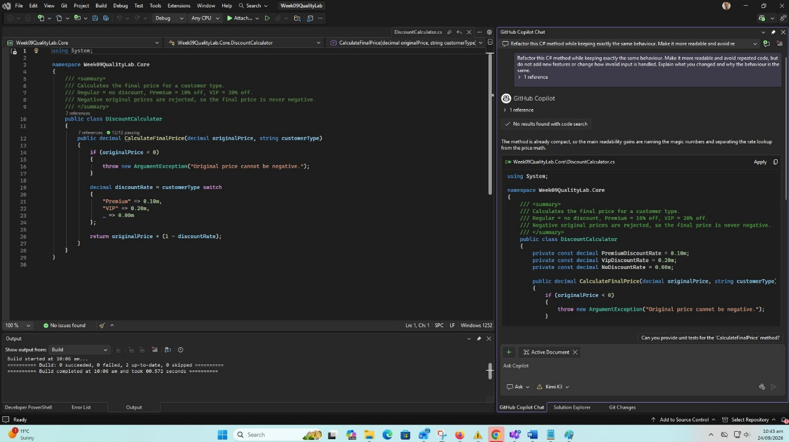

Prompt 4
Create MSTest tests using Arrange-Act-Assert for a C# ParkingFeeCalculator with a method CalculateFee(int hours). Rules: the first hour costs 4 dollars, each additional hour costs 2 dollars, the full-day maximum fee is 20 dollars, and invalid hours must throw an ArgumentException. Include boundary tests around the 20 dollar cap and around the valid range of hours. Show how each expected value is calculated.

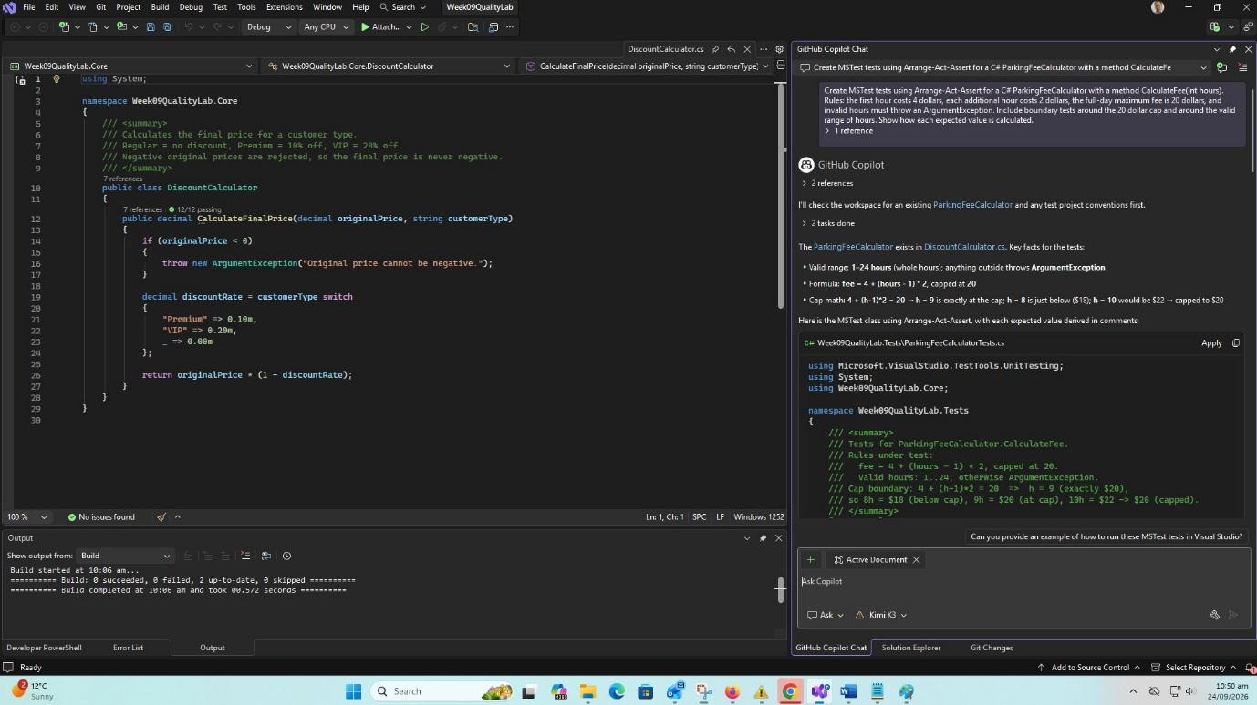

Prompt 5
Review the tests you just wrote. Which expected values could be wrong, which requirements are not covered, and are any of the tests only checking the implementation rather than the requirement?

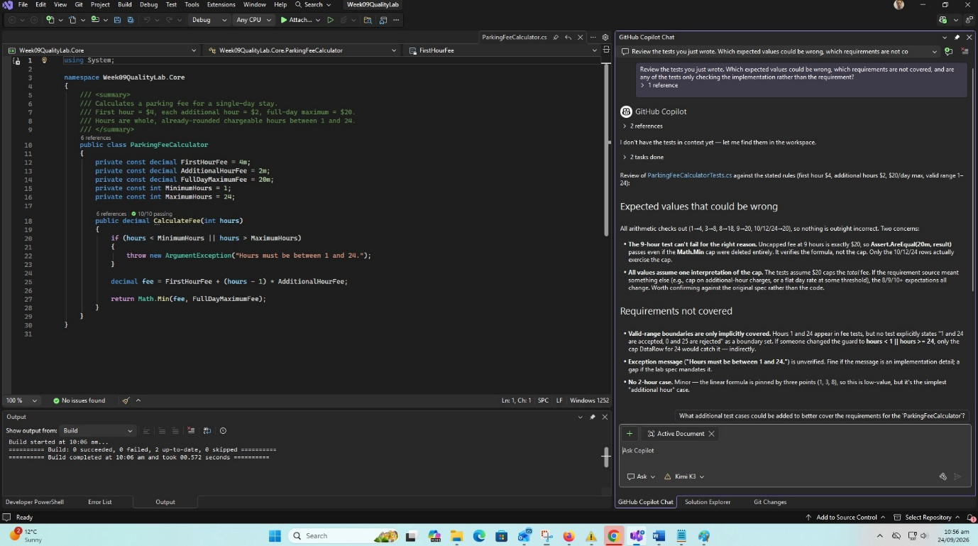

5. QA in CI/CD (Part 5)
The full answers to Tasks 1–6 are in PipelineQualityNotes.md (included in the zipped solution). In summary:
- Pipeline: checkout, restore, build, MSTest, publish results and coverage, report pass/fail. Failed tests block the merge so main always stays releasable.
- Stages: ten stages from source checkout to optional test-environment deployment, each mapped to the quality risk it reduces.
- Quality gates: build succeeds, all tests pass, test failures block merge, 80% coverage, no critical vulnerabilities, no secrets, no blocker static-analysis issues, and a reviewer approves.
- Regression testing: the lab tests protect the discount and parking rules from accidental changes, for example a wrong percentage or a changed daily cap, and the pipeline reports the failure within minutes.
- Failures: build failure, failing test, low coverage, detected secret, vulnerable package, static-analysis issue and flaky tests, each with a team response.
- Test data: should be repeatable, isolated and safe. Tests that depend on the current time or on shared state are unreliable, and flaky tests erode trust in the pipeline.
An example GitHub Actions workflow (.github/workflows/ci.yml) is included in the solution to show these stages in practice.

6. Test Results
The solution contains 22 test cases (12 for DiscountCalculator and 10 for ParkingFeeCalculator, counting each data row separately). All 22 pass.

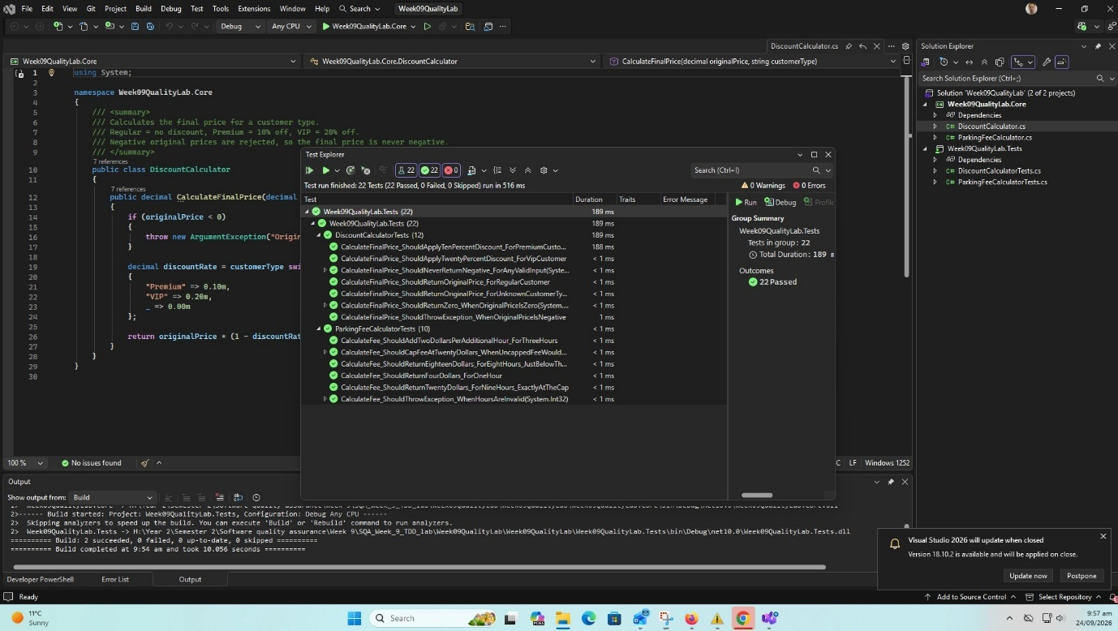

7. Conclusion
Writing each test first made the requirements precise, especially the hidden rule that a negative final price can only be caused by a negative input, and the exact point where the parking cap applies. The refactoring step was safe because the tests were already in place. Running the same tests automatically in a CI/CD pipeline turns them into regression tests and quality gates, so accidental changes to business rules are caught before they reach users. See Week09Reflection.md for the full reflection.

