Raw data
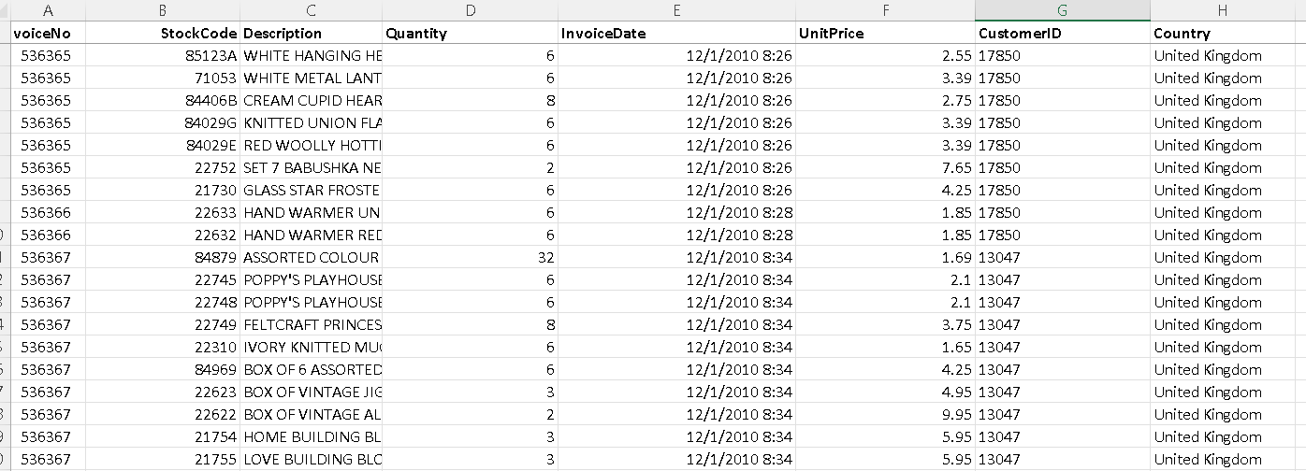
Dataset Source: UCI Machine Learning Repository
Dataset: Online Retail
Creator: Daqing Chen
Year: 2015
Original Records: 541,909
Period: 1 December 2010 – 9 December 2011
Source URL: UCI Online Retail dataset(https://archive.ics.uci.edu/dataset/352/online+retail )

Transformations
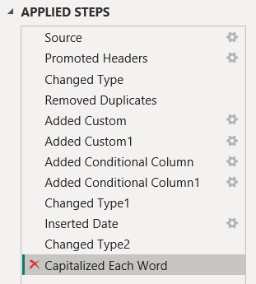

Model View
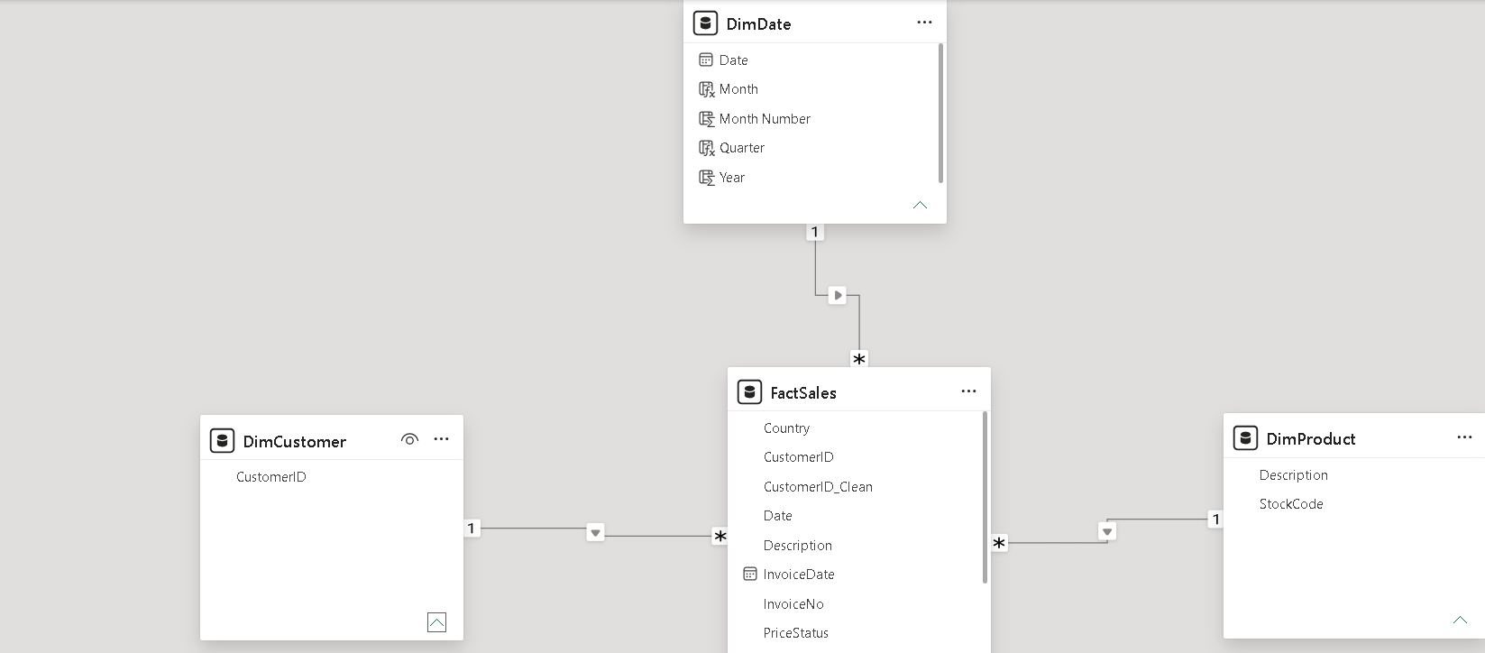
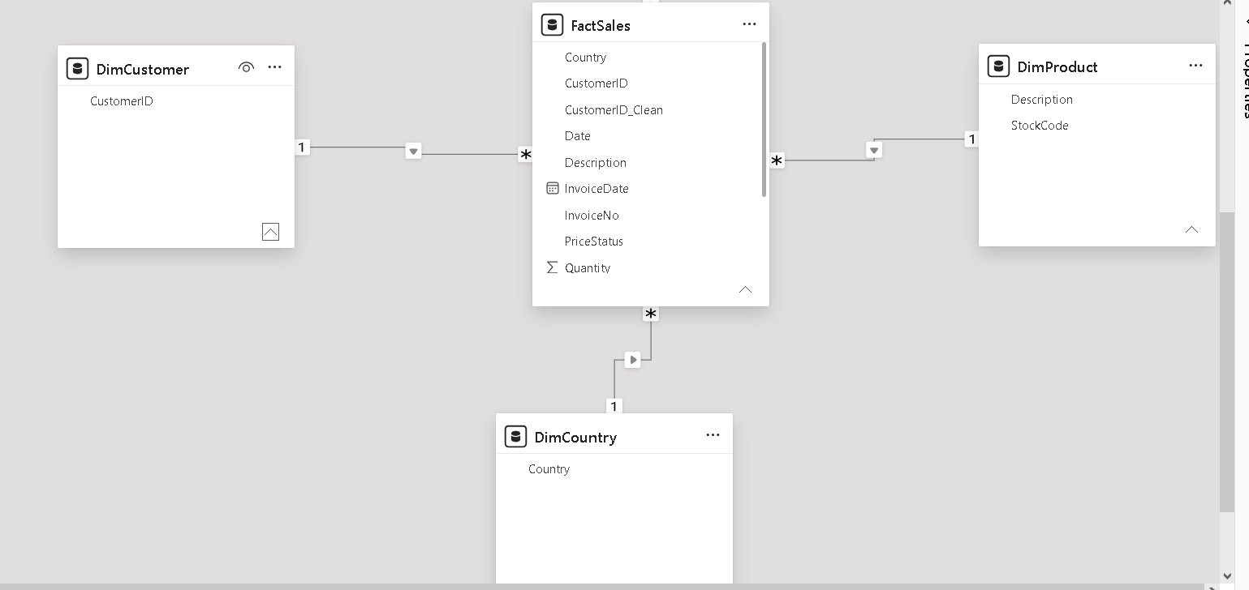

Dashboard
Page 1 – Executive Sales
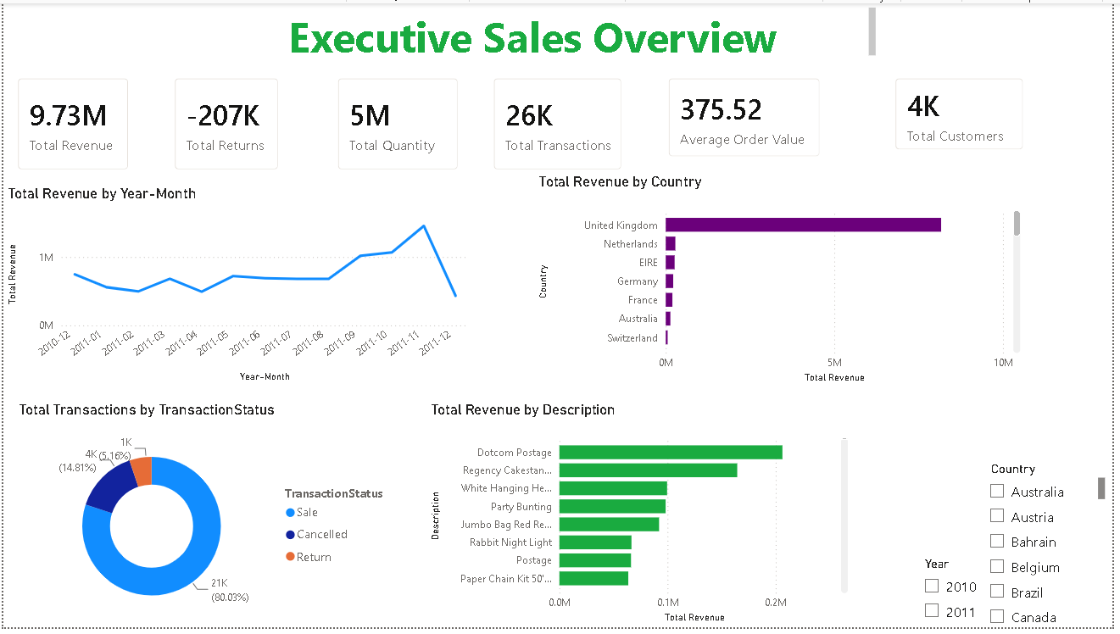

Page 2 – Customer Analysis
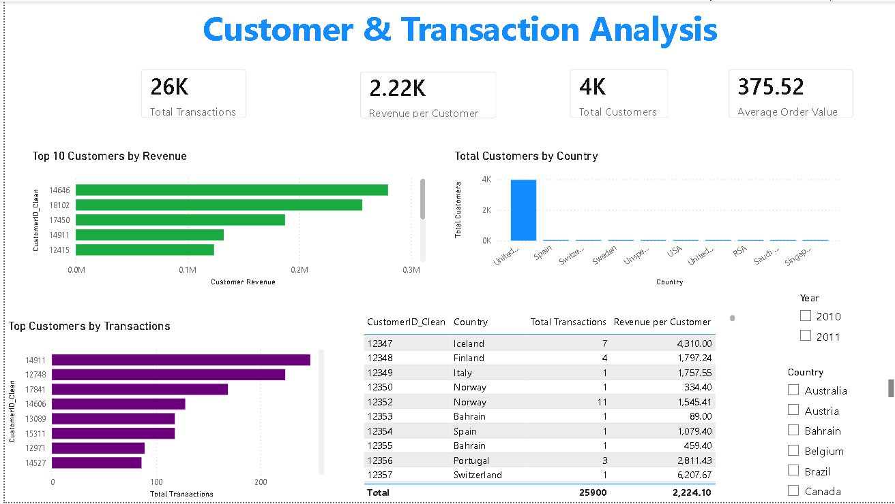

Page 3 – Advanced Analysis
