Test 1 — GET all users
Screenshot
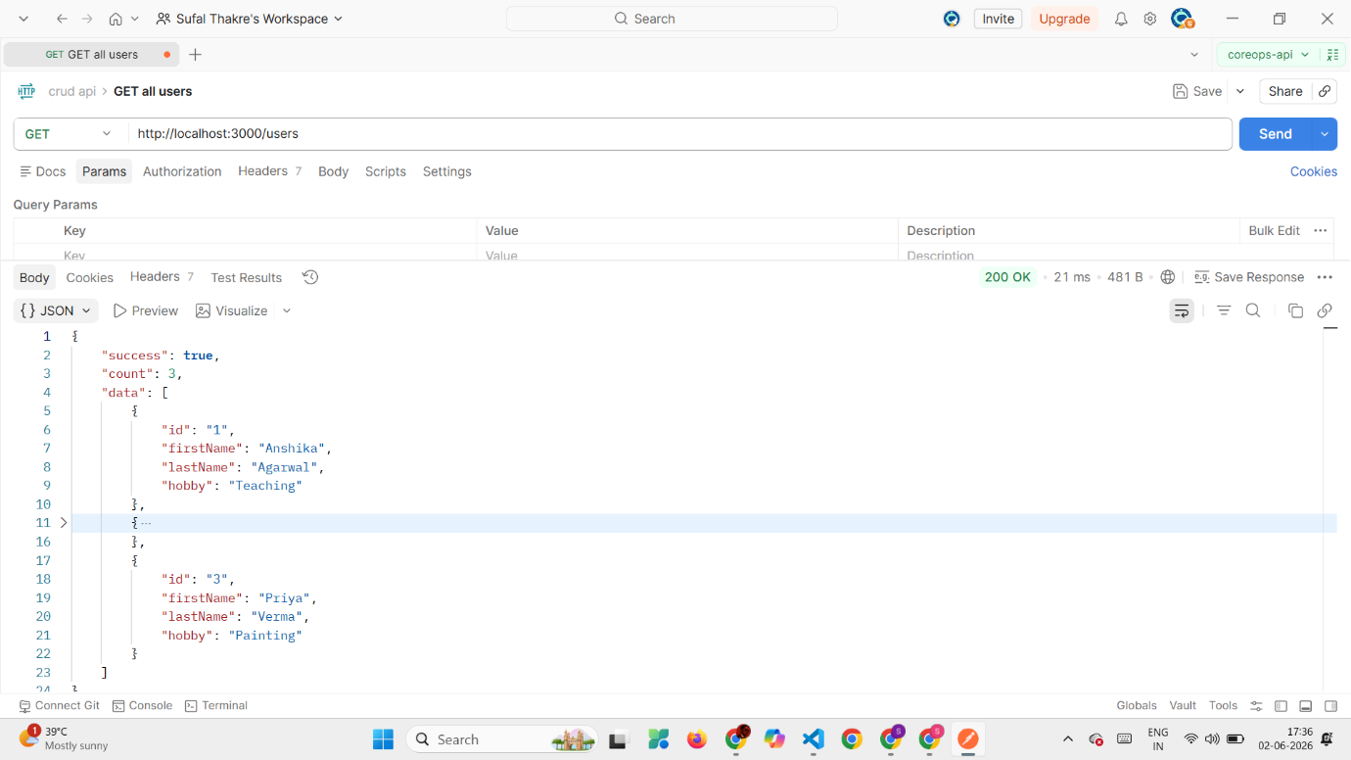

Test 2 — GET single user (found)
Screenshot
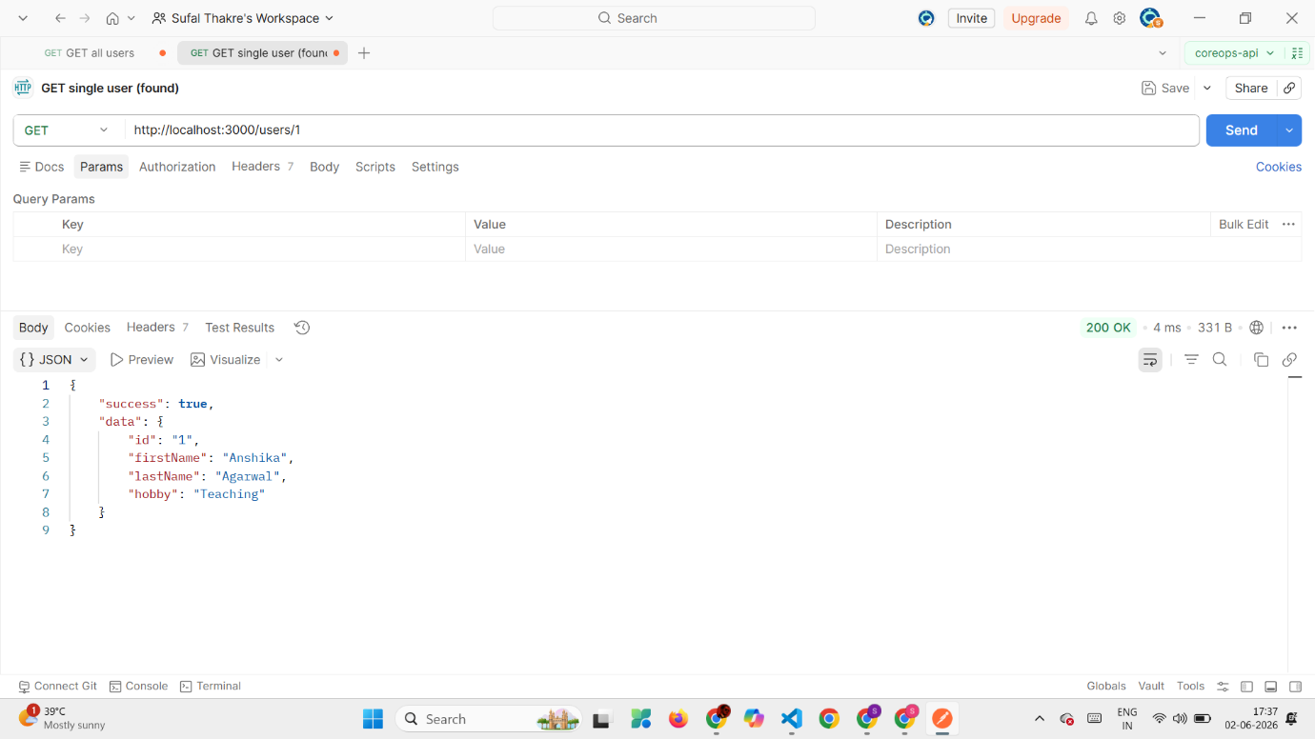
Test 3 — GET single user (not found)
screenshot
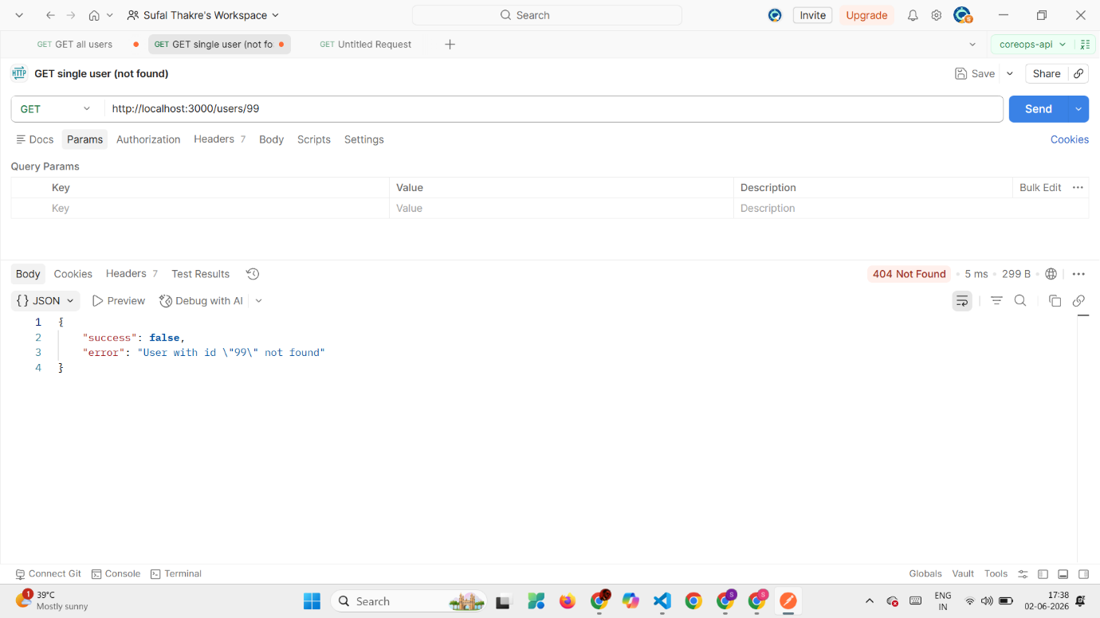

Test 4 — POST create user (valid)
Screenshot
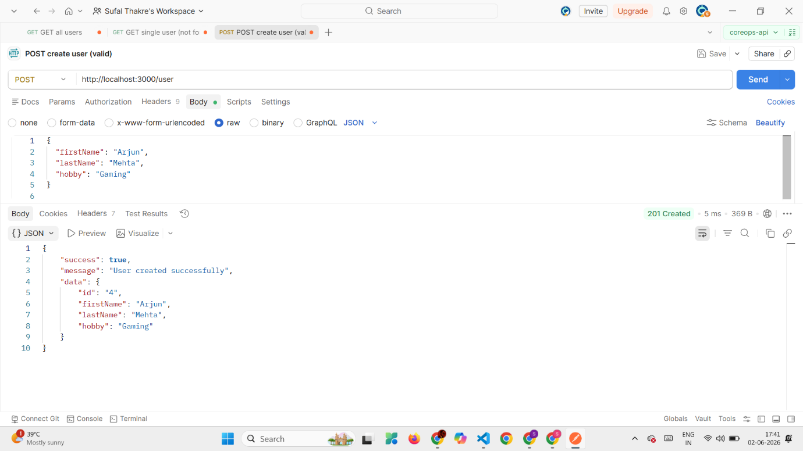
Test 5 — POST create user (missing fields — validation)
screenshot
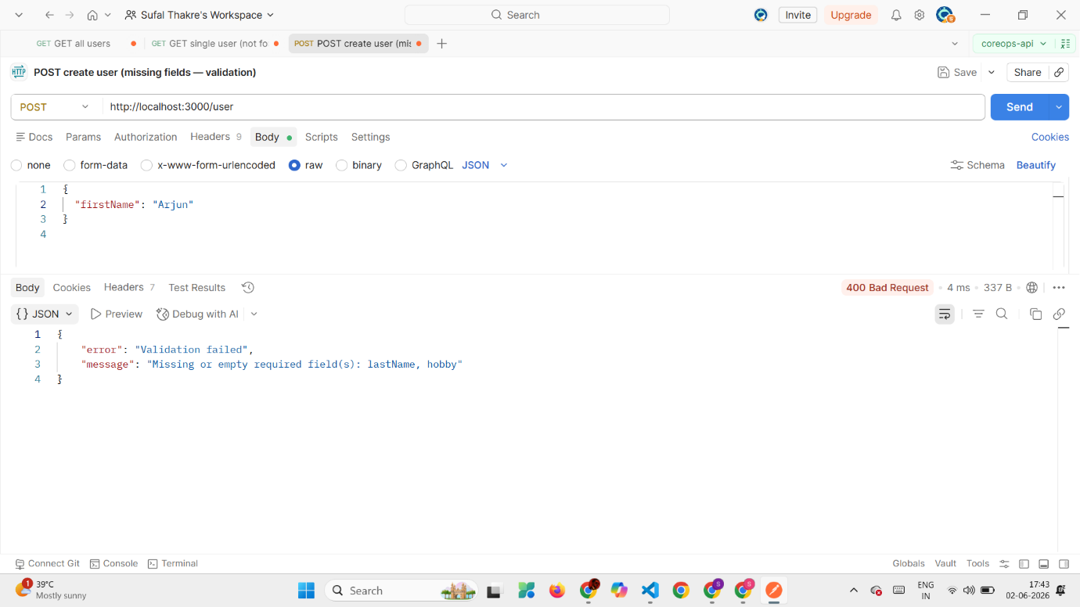
Test 6 — PUT update user (valid)
screenshot
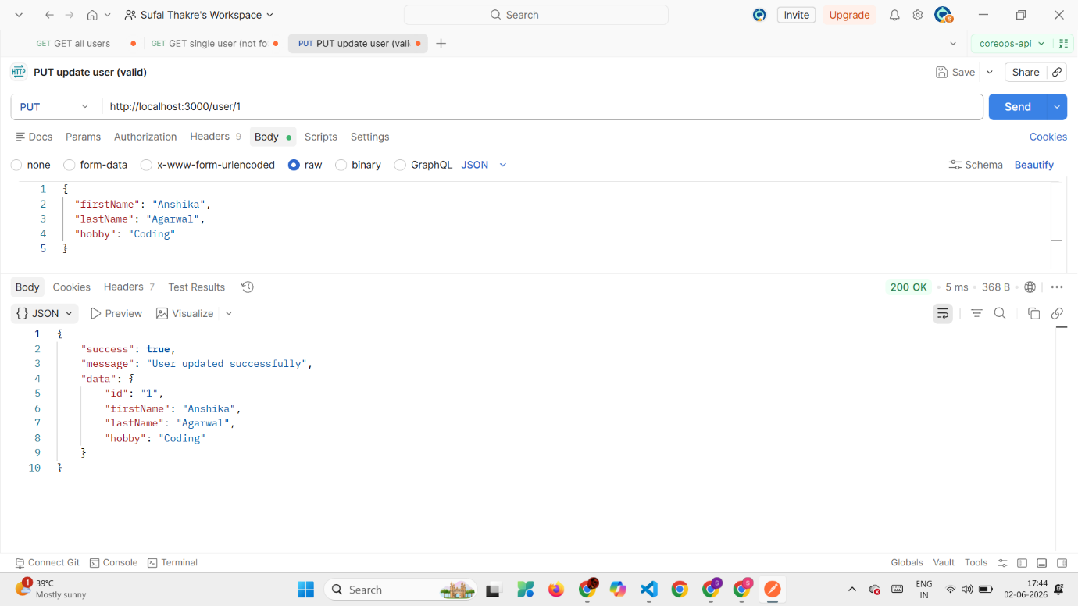

Test 7 — PUT update user (not found)
SCREENSHOT
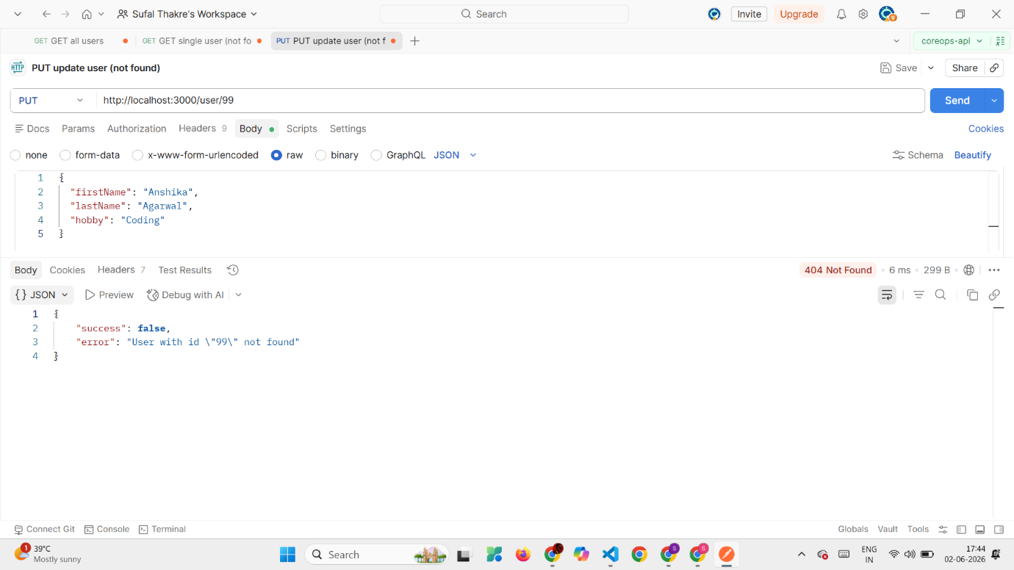

Test 8 — DELETE user (success)
SCREENSHOT
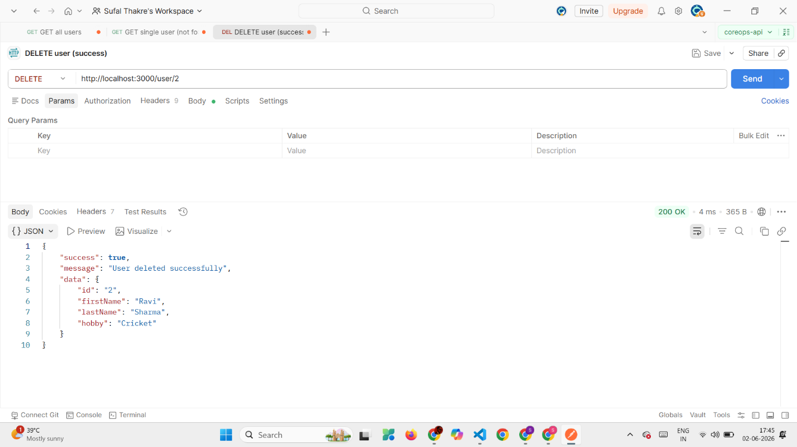
Test 9 — DELETE same user again (already gone)
SCREENSHOT
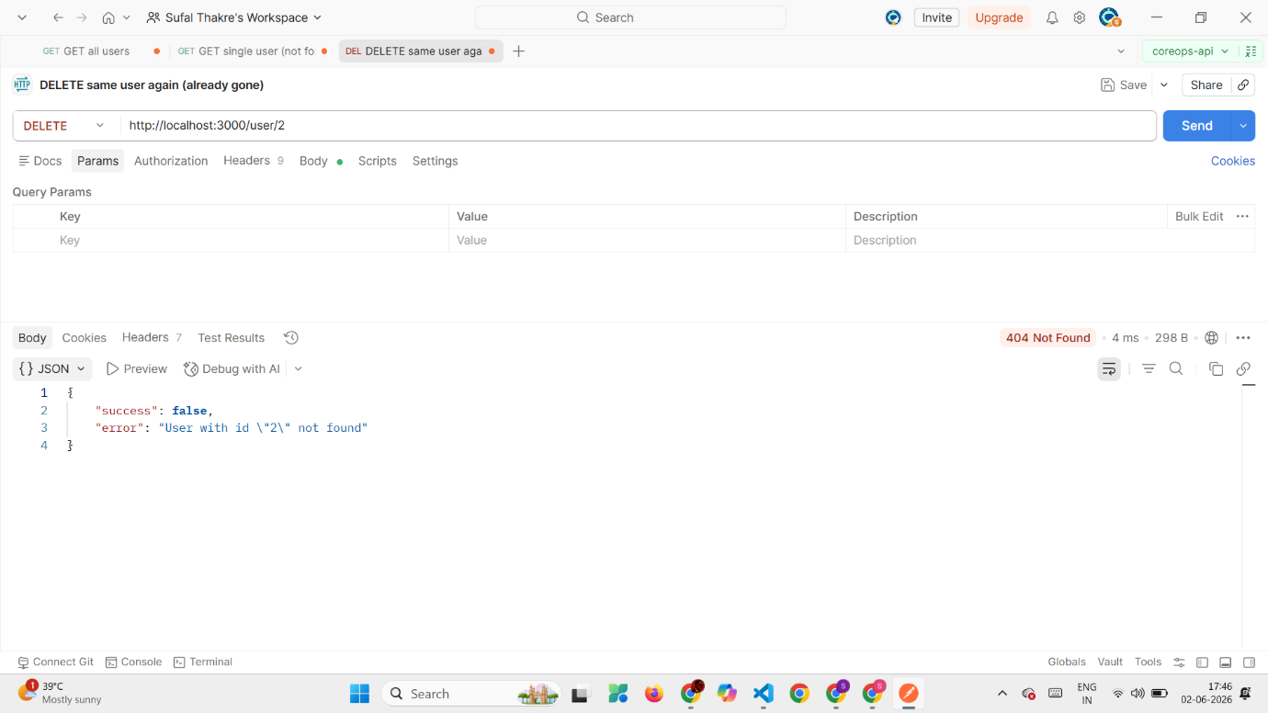
Test 10 — Terminal logs (bonus proof)
SCREENSHOT
