

**Ministry of Education, Culture and Research of the Republic of Moldova**

**Technical University of Moldova**

**Department of Software and Automation Engineering**

**REPORT**

Laboratory work no. 2

*Keyboard Input*

Elaborated:

st. gr. FAF-213 Botnari Ciprian

Verified:

lect. univ. Rostislav Călin

Chişinău – 2023

Table of Contents

Topic: Keyboard Input 3

Tasks 3

Requirements 3

Code 3

Conclusion 8

GitHub 8

## Topic: Keyboard Input

## Tasks

1. Create a program in assembler which will "echo" what is typed from the keyboard. Each ASCII

character which will be pressed from the keyboard should appear on the screen and the cursor should move to the next position.

1. Special actions need to be implemented only for 2 special keys from the keyboard:
   1. "backspace key" - in this case symbol from the left side of the cursor should disappear and the cursor should be moved one position back (If the cursor already is in the first position, then nothing should happen. Special case is if the cursor is on the next line, then when is pressed Backspace in the first column, then cursor should move to the previous line in last column);
   2. "enter key" - in this case all previously introduced string should be printed to the screen starting with the next line and after one "empty" line (but if "enter key" will be pressed as the first key, in this case NO "empty" line should be added and the action should just go to the next line)
2. (OPTIONAL)

The maximum length of input string should not exceed 256 characters. If the user will want to input more than 256 characters than the input should be stopped and in this case only "backspace" or "enter" keys should be accepted.

## Requirements

* Compiled program should be used in order to create a floppy image and it should be bootable. Use this image to boot the OS in a Virtual Box VM and the text which you intended to print should appear on the screen.
* You can use any assembly compiler.
* You should be able to modify the code, to recompile it and to boot the VM with new version of program.
* In order to use documentation from TechHelp / XView DOS application, you can install DosBox.

## Code

**build.sh**

#!/bin/bash

if [ $# -ne 1 ]; then

  echo "Usage: $0 <filename.asm>"

  exit 1

fi

filename_with_extension="$1"

filename="${filename_with_extension%.*}"

asm_file="$filename_with_extension"

com_file="$filename.com"

flp_file="$filename.flp"

# Step 1: Compile the assembly code to a .com file

nasm -f bin -o "$com_file" "$asm_file"

if [ $? -ne 0 ]; then

  echo "Compilation failed. Check your assembly code."

  exit 1

fi

echo "Step 1: Compilation completed."

# Step 2: Copy the .com file to a .flp file

cp "$com_file" "$flp_file"

echo "Step 2: Copied $com_file to $flp_file."

# Step 3: Resize the .flp file to 1.44MB

truncate -s 1474560 "$flp_file"

echo "Step 3: Resized $flp_file to 1.44MB."

# Step 4: Change the storage to $flp_file in VirtualBox

VM_NAME="BestOS"

VBoxManage storageattach "$VM_NAME" --storagectl "Floppy" --port 0 --device 0 --type fdd --medium "$flp_file"

echo "Step 4: Storage in VirtualBox changed to $flp_file."

echo "All steps completed successfully."

**keyboard.asm**

section .data

  row db 0                 ; x

  column db 0              ; y

  buffer times 256 db 0    ; 256 bytes buffer

section .text

  global _start

_start:

  ; Set up the stack

  mov ax, 0x0000

  mov ss, ax

  mov sp, 0x7C00

  ; Call BIOS to clear the screen

  call clear_screen

  ; Initialize the cursor position (row and column)

  mov si, buffer

  mov byte [row], 0

  mov byte [column], 0

main:

  call read_char

  ; Backspace

  cmp al, 0x08

  je backspace

  ; Enter

  cmp al, 0x0D

  je enter

  call print_char

  jmp main

backspace:

  ; Check if we are at the beginning of the current line

  cmp byte [column], 0

  je prev_line

  ; Backspace, Print a space, Backspace again

  mov ah, 0x0E

  mov al, 0x08

  int 0x10

  mov al, 0x20

  int 0x10

  mov al, 0x08

  int 0x10

  ; Update the current column

  dec byte [column]

  ; Buffer is empty

  cmp si, buffer

  je main

  ; Remove the last character from the buffer

  dec si

  mov byte [si], 0

  jmp main

prev_line:

  ; Check if we are at the beginning of the screen

  cmp byte [row], 0

  je main

  ; Move the cursor to the beginning of the previous line

  dec byte [row]

  mov byte [column], 79

  mov ah, 0x02

  mov dh, byte [row]

  mov dl, byte [column]

  int 0x10

  jmp main

; Copy a string from SI to the screen

copy_string_loop:

  lodsb

  cmp al, 0

  je copy_string_exit

  int 0x10

  jmp copy_string_loop

copy_string_exit:

  ret ; return to the caller

enter:

  ; Check if we are at the end of the screen

  cmp byte [row], 24

  je main

  call new_line

  ; check if the buffer is empty

  mov si, buffer

  cmp byte [si], 0

  je main

  ; Print the buffer

  mov ah, 0x0E

  mov si, buffer

  call copy_string_loop

  ; Clear the buffer, reset the buffer pointer

  mov si, buffer

  xor cx, cx

  fill_buffer_loop:

    mov byte [si], 0

    inc si

    inc cx

    cmp cx, 256

    jl fill_buffer_loop

  ; Move the cursor to the beginning of the next line

  call new_line

  call new_line

  ; Reset the buffer pointer, reset the current column

  mov si, buffer

  mov byte [column], 0

  jmp main

new_line:

  inc byte [row]

  mov byte [column], 0

  mov ah, 02h           ; update cursor position

  mov bh, 0             ; page number

  mov dh, byte[row]     ; row

  mov dl, byte[column]  ; column

  int 0x10              ; call BIOS

  ret ; return to the caller

read_char:

  mov ah, 0x00 ; read char from keyboard

  int 0x16     ; call BIOS

  ret ; return to the caller

print_char:

  inc byte [column]     ; Update the current column

  cmp byte [column], 80 ; Check if we are at the end of the screen

  je enter

  mov [si], al    ; Store the character in the buffer

  inc si          ; Update the buffer pointer

  mov ah, 0x0E  ; print char

  int 0x10      ; call BIOS

  ret ; return to the caller

clear_screen:

  mov ah, 06h   ; scroll window up

  mov al, 0     ; clear entire screen

  mov cx, 0     ; upper left corner (0, 0)

  mov dx, 184fh ; lower right corner (24, 79)

  mov bh, 1Eh   ; yellow on blue

  int 0x10

  ret ; return to the caller

**Results**

Below is an example of the running program for different inputs. When Enter is pressed, the line is duplicated and a new line is added.

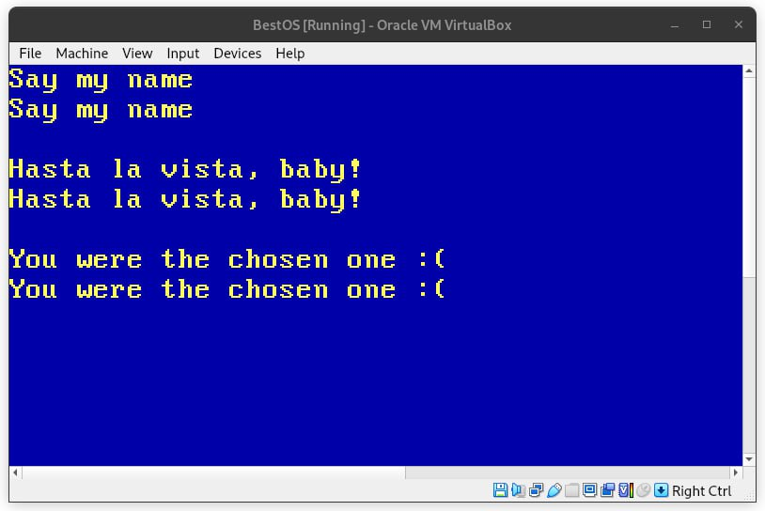

**Figure 1**. *Example of different inputs*

## Conclusion

In a nutshell, this project was quite the journey into the world of assembly programming for me. I had to create a program that echoes whatever I type on the screen, with some special tricks for the "backspace" and "enter" keys. The handy build script made testing and tweaking my code a breeze. Knowing I can always go back and make improvements is reassuring. Overall, this laboratory work taught me a lot about low-level programming and its role in building an operating system.

## GitHub

[Sufferal/os (github.com)](https://github.com/Sufferal/os)