Отчет по
Современным технологиям программирования 1
_____________________________________________________________________
Задание 1. Построение УГП
_____________________________________________________________________
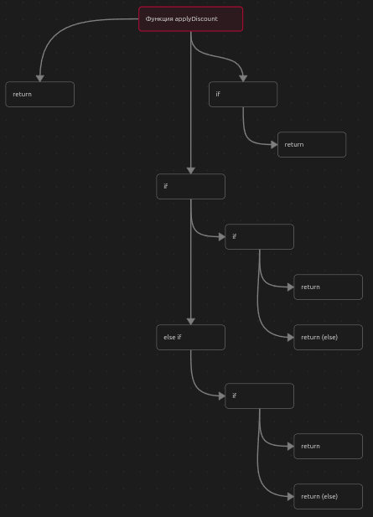
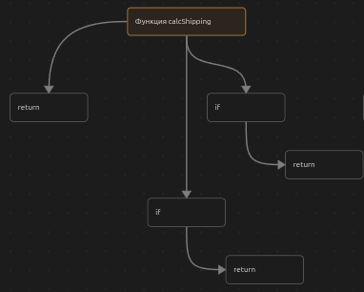
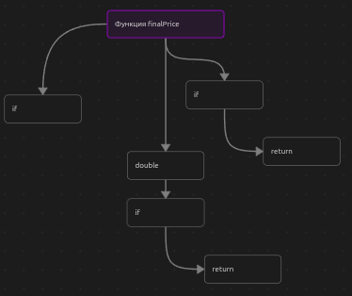
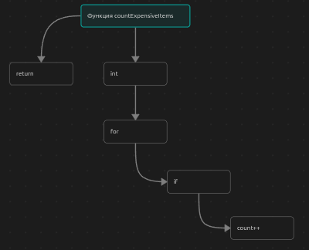
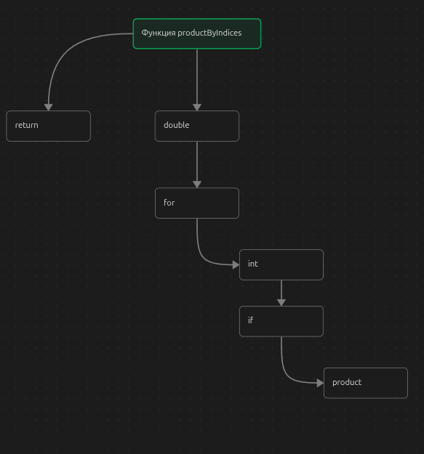
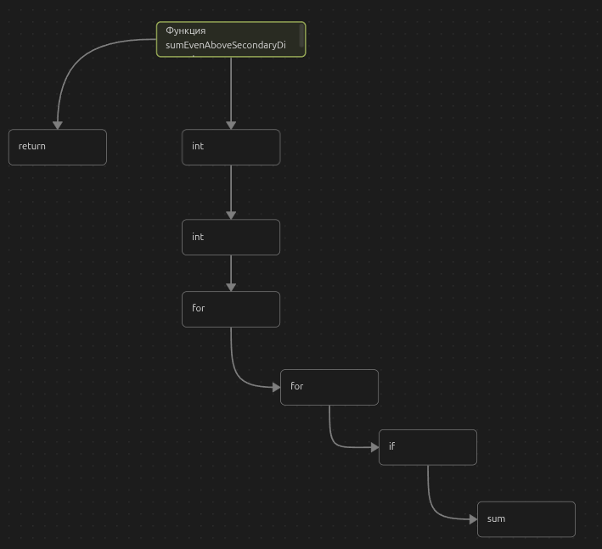

_____________________________________________________________________
Задание 2. Разработка тестов
Функция applyDiscount

№ | Входные данные | Ожидаемый рез. | Узлы | Покрывает?
1 | total = -5.5 | -1 | 1->2 | 1-true
2 | total = 12000  isPremium = yes | 9600 | 1->3->4->5 | 1-false,  3-true,  4-true
3 | total = 12000  isPremium = no | 10200 | 1->3->4->6 | 4-false
4 | total = 7600  isPremium = yes | 6840 | 1->3->7->8->9 | 3-false,  7-true,  8-true
5 | total = 7600  isPremium = no | 7220 | 1->3->7->8->10 | 8-false
6 | total = 3000  isPremium = no | total = 3000 | 1->3->7->11 | 7-false

Функция calcShipping

№ | Входные данные | Ожидаемый рез. | Узлы | Покрывает?
1 | total = -5.5 | -1 | 1->2 | 1-true
2 | total = 4600 | 0.0 | 1->3->4 | 1-false,  3-true
3 | total = 5001 | 300 | 1->3->5 | 1-false,  3-false

Функция finalPrice
№ | Входные данные | Ожидаемый рез. | Узлы | Покрывает?
1 | total = -5.5  discount = -5  shipping = -5 | -1 | 1->2 | 1-true
2 | Total = 100,  Discount = 200  Shipping = 0 | 0.0 | 1->3->4->5 | 1-false,  4-true
3 | Total = 1000,  Discount = 300  Shipping = 40 | 740 | 1->3->4->6 | 4-false

Функция countExpensiveItems

№ | Входные данные | Ожидаемый рез. | Узлы | Покрывает?
1 | Prices= пусто,  Threshols =10 | 0 | 1->2 | 2-false
2 | Prices= 16,  Threshols =10 | 1 | - >2->3->4->2  ->5 | 2-True  3-true  2-false
3 | Prices= 6,  Threshols =10 | 0 | 1->2->3->2->5 | 2-true  3-false  2-false

Функция productByIndices

№ | Входные данные | Ожидаемый рез. | Узлы | Покрывает?
1 | indices  =пусто  Values=10,20 | 1 | 1->2->6 | 2-false
2 | indices  =0  Values=5 | 5 | 1->2->3->4->5->2->6 | 2-True  4-true  2-false
3 | indices  =5  Values=1,2 | 1 | 1->2->3->4->2->6 | 2-true  4-false  2-false

Функция sumEvenAboveSecondaryDiagonal

№ | Входные данные | Ожидаемый рез. | Узлы | Покрывает?
1 | N=0  A=пусто | 0 | 1->2->3-.7 | 3-false
2 | N=1  A=4 | 0 | 1->2->3->4->7 | 3-True  4-false
3 | N=2  A=(2,4)(1,3) | 2 | 1->2->3->4->5->6->7 | 3-true  4-true  5-true
4 | N=3  A=(1,2,3)  (4,5,6)  (7,8,9) | 6 | 1->2->3->4->5->6->7 | 3-true  4-true  5-true

_____________________________________________________________________
Задание 3. Реализация тестов (Google Test)
_____________________________________________________________________
#include <gtest/gtest.h>
#include <order_calc.h>

//applyDiscount
TEST(ApplyDiscountTest, NegativeTotal){
EXPECT_DOUBLE_EQ(applyDiscount(-5.5, false), -1.0);
}
TEST(ApplyDiscountTest, isPremium){
EXPECT_DOUBLE_EQ(applyDiscount(7600, true), 6080);
}
TEST(ApplyDiscountTest, isPremium){
EXPECT_DOUBLE_EQ(applyDiscount(7600, false), 6460);
}
TEST(ApplyDiscountTest, isPremium){
EXPECT_DOUBLE_EQ(applyDiscount(4600, true), 4140);
}
TEST(ApplyDiscountTest, isPremium){
EXPECT_DOUBLE_EQ(applyDiscount(4600, false), 4370);
}
TEST(ApplyDiscountTest, isPremium){
EXPECT_DOUBLE_EQ(applyDiscount(3000, false), 3000);
}

//calcShipping
TEST(CalcShippingTest, NegativeTotal){
EXPECT_DOUBLE_EQ(calcShipping(-5.5), -1.0);
}
TEST(CalcShippingTest, NormalCalculation){
EXPECT_DOUBLE_EQ(calcShipping(4600), 0);
}
TEST(CalcShippingTest, HighTotal){
EXPECT_DOUBLE_EQ(calcShipping(5001), 300);
}

//finalPrice
TEST(FinalPriceTest, NegativeTotal){
EXPECT_DOUBLE_EQ(finalPrice(-5.5, -5.0, -5.0),-1.0);
}
TEST(FinalPriceTest, DiscountGreaterThanTotal){
EXPECT_DOUBLE_EQ(finalPrice(100.0, 200.0, 0.0),0.0);
}
TEST(FinalPriceTest, NormalCalculation){
EXPECT_DOUBLE_EQ(finalPrice(1000.0, 300.0, 40.0),740.0);
}

//countExpensiveItems
TEST(CountExpensiveItemsTest, NegativeTotal){
vector<double> prices = {};
EXPECT_EQ(countExpensiveItems(prices, 10.0), 0);
}
TEST(CountExpensiveItemsTest, NegativeTotal){
vector<double> prices = {16.0};
EXPECT_EQ(countExpensiveItems(prices, 10.0), 1);
}
TEST(CountExpensiveItemsTest, NegativeTotal){
vector<double> prices = {6.0};
EXPECT_EQ(countExpensiveItems(prices, 10.0), 0);
}

//productByIndices
TEST(ProductByIndicesTest, EmptyIndicesReturnsOne){
vector<double> value = {10.0, 20.0};
vector<int> indices;
EXPECT_EQ(productByIndices(value, indices), 1.0);
}
TEST(ProductByIndicesTest, EmptyIndicesReturnsOne){
vector<double> value = {5.0};
vector<int> indices = {0};
EXPECT_EQ(productByIndices(value, indices), 5.0);
}
TEST(ProductByIndicesTest, EmptyIndicesReturnsOne){
vector<double> value = {1.0,2.0};
vector<int> indices = {5};
EXPECT_EQ(productByIndices(value, indices), 1.0);
}

//sumEvenAboveSecondaryDiagonal
TEST(SumEvenAboveSecondaryDiagonalTest, NegativeTotal){
vector<vector<int>> A;
EXPECT_EQ(sumEvenAboveSecondaryDiagonal(A), 0);
}
TEST(SumEvenAboveSecondaryDiagonalTest, NegativeTotal){
vector<vector<int>> A = {{4}};
EXPECT_EQ(sumEvenAboveSecondaryDiagonal(A), 0);
}
TEST(SumEvenAboveSecondaryDiagonalTest, NegativeTotal){
vector<vector<int>> A = {{2,4},{1,3}};
EXPECT_EQ(sumEvenAboveSecondaryDiagonal(A), 2);
}
TEST(SumEvenAboveSecondaryDiagonalTest, NegativeTotal){
vector<vector<int>> A = {{1,2,3},{4,5,6},{7,8,9}};
EXPECT_EQ(sumEvenAboveSecondaryDiagonal(A), 6);
}

_____________________________________________________________________
Распределение заданий
_____________________________________________________________________

Одномерная – номер (3-1) % 8 + 1 = 3
Двумерная – номер (3-1) % 5 + 1 = 3
_____________________________________________________________________
Задание 4. Самостоятельная работа
_____________________________________________________________________
Добавленно в order_calc.h
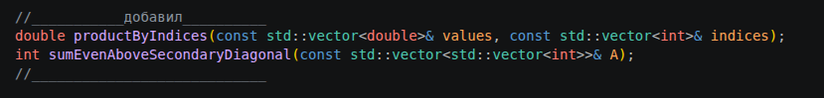

Добавленно в order_calc.cpp
