|  |
| --- |
| Ask for a Name Change (Adult) |

Congratulations {{ user_name_first_new }}! You have finished all the forms you need to ask for a name change. The rest of the pages in this packet are your petition in **In the matter of {{ users }}** (your request for a name change).

## Next steps

1. **Get a notary** to witness your signature of the petition.
2. File this petition together with your certified documents.
3. **Keep a copy for yourself.**
4. Wait for instructions from the court.
5. Follow the court's instructions to **publish your citation** and notify anyone else who needs to know about your new name.

## To get your petition notarized

1. You must have your signature witnessed by a notary. Do not sign the petition until you are in front of a notary.
2. You may be able to find a notary at your local bank. Bring a state-issued ID or other proof of your identity with you.
3. Sign on page 2, on the line with the large black arrow:

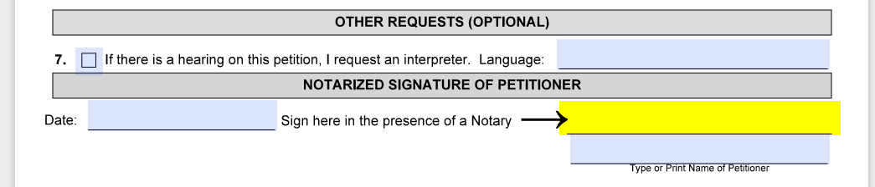

## To file your application right away

1. Look over the forms below, one more time. Make sure everything is correct.
2. Get a **certified** copy of your birth certificate.{% if past_names.there_are_any %} Also, get a **certified** copy of the court orders, marriage certificate, or other official documents from each time you changed your name in the past.{% endif %}
3. Call the {{ trial_court }}: **{{ trial_court.phone }}** to find out how they want you to send your forms to them.
4. You can also mail the forms. The address of your court, if you need it, is:   
   {{ trial_court.address.block() }}

## What can the judge do?

The judge can do one of two things:

1. Grant your order right away. This is the most common outcome for a name change.
2. Ask you to explain why you need the name change at a hearing. You can present evidence and make your argument at a hearing.
3. Your hearing may happen over the telephone or over "Zoom."

## What happens if the judge makes the order?

If the judge decides to grant your order, you must:

1. Publish the "citation" in a local newspaper. You can ask to waive this requirement. The court will give you more instructions.
2. {%p if name_change_special_circumstances.any_true() %}
3. You must also mail a copy to the{% if name_change_special_circumstances['in_jail'] or name_change_special_circumstances['on_parole'] %} Department of Correction or Parole board {% else %} Sex Offender Registry Board{% endif %} and the prosecuting official where you were convicted or found dangerous.
4. {%p endif %}



Learn more: https://www.mass.gov/name-changes