# Suffolk County LIMS Interface Control Document

## Document Control

|  |  |  |
| --- | --- | --- |
| Date | Author | Note |
| 11/20/2018 | Dane Quatacker | Initial |
| 12/07/2018 | Dane Quatacker | Added translations from Becky |
| 01/11/2019 | Deanna Hoops | Updates from configuration |
| 06/17/2019 | Becky Rudd | Added combination analyte calculations |
| 06/19/2019 | Becky Rudd | Added HerbMets changes |
| 08/05/2019 | Becky Rudd | Added changes for <MDL |

Contents

Suffolk County LIMS Interface Control Document 1

Document Control 1

Overview 2

Technical Overview 2

Data Flow Overview 3

LIMS Interface Details 5

Interface Process 5

Input File 6

File Map 6

Computed Results Analytes 7

Accela Record Information 8

Custom Fields Output 8

Custom List Output 8

Screenshots 10

Appendix A – Translations 13

Units – Pending (std choice DEQ_UNITS) 13

Analysis Code Translation 13

Text Results Translation (DEQ_TEXT_RESULTS) 14

Results Notation Translation 15

Analyte Translation 15

HerbMets 15

< MDL 16

Appendix B – Issues 17

Implementation Details 17

# Overview

The LIMS interface is used to programmatically import Lab Results into the EHIMS (Accela) system based upon sample inspections that were collected by field inspectors and sent to the Public Health Laboratory for sampling.

## Technical Overview

The LIMS interface is a Batch Process that is designed to consume lab result CSV files produced by the Public Health Laboratory out of their existing LIMS system. The batch process will be designed to run Daily and consume all files that have been produced and uploaded to the shared drive.

The Batch Process will consume CSV flat files for processing into the Accela Civic Platform using the construct API. The five files will be produced using the following terminology. Not all flat files will be produced daily. Only new flat files added to the network drive since the prior run will be picked up by the interface for processing.

This interface needs to be able to rerun an input file and not create duplicates.

## Data Flow Overview

The following diagram shows the overall interaction between the EHIMS (Accela) system and the Public Health Laboratory (LIMS) and the LIMS Batch Integration (to be developed under this specification).

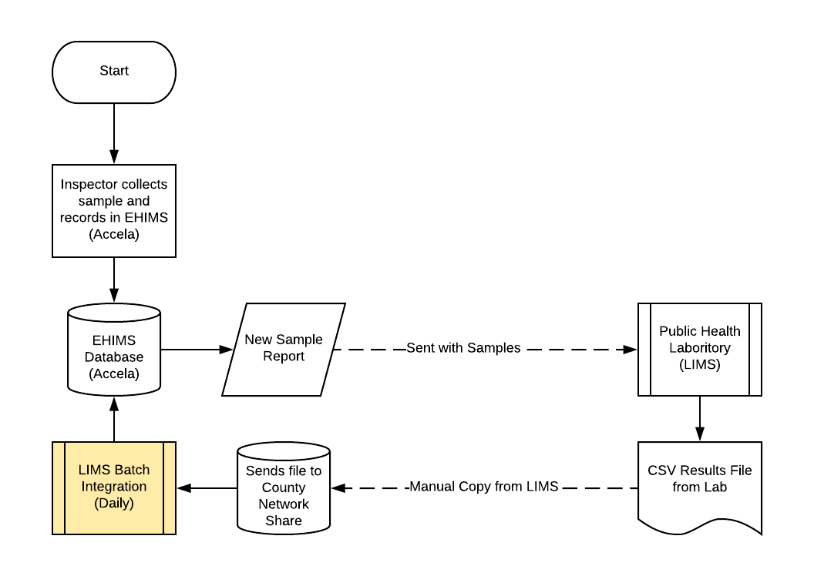

| Step | Action | Action By | Additional Notes |
| --- | --- | --- | --- |
| 1 | Inspection information with Sample Details entered Accela | County Inspector | Inspector does a field visit and collects sample. The sample details are entered into Accela and the Samples sent to the Public Health Laboratory with the report in step 2 |
| 2 | A report is generated with the inspector’s sample information as is sent to the Laboratory with the samples | County Inspector | Report will be named “Lab Analysis Report” |
| 3 | Public Health Laboratory processes the samples | Public Health Lab |  |
| 4 | Public Health Laboratory creates CSV Files with Sample Results on a per program basis and sends to county | Public Health Lab |  |
| 5 | CSV Files are placed on a County Network Share | County EHIMS program managers? |  |
| 6 | LIMS Batch Interface reads CSV file and creates EHIMS Results Records | LIMS Interface | This process is being developed per this Interface Specification Document. |
| 7* | Email Error Reports | LIMS Interface | *Optional if System Error found then Email Administrator  *Optional if Lab Accident or NR results Email to Inspector owning issues |

# LIMS Interface Details

The to-be developed interface will adhere to the following interface specification design.

|  |  |
| --- | --- |
| Interface Name | LIMS Batch Interface |
| Interface Type | Batch Program |
| Development Language | C# and Accela EMSE Script |
| Interface Input | Pre-defined CSV format defined (5 files) |
| Interface Source | LIMS |
| Interface Destination | Accela Civic Platform |
| Interface Output | Accela Sample Results Records |
| Logging Methodology | Rolling log4net file writer |

## Interface Process

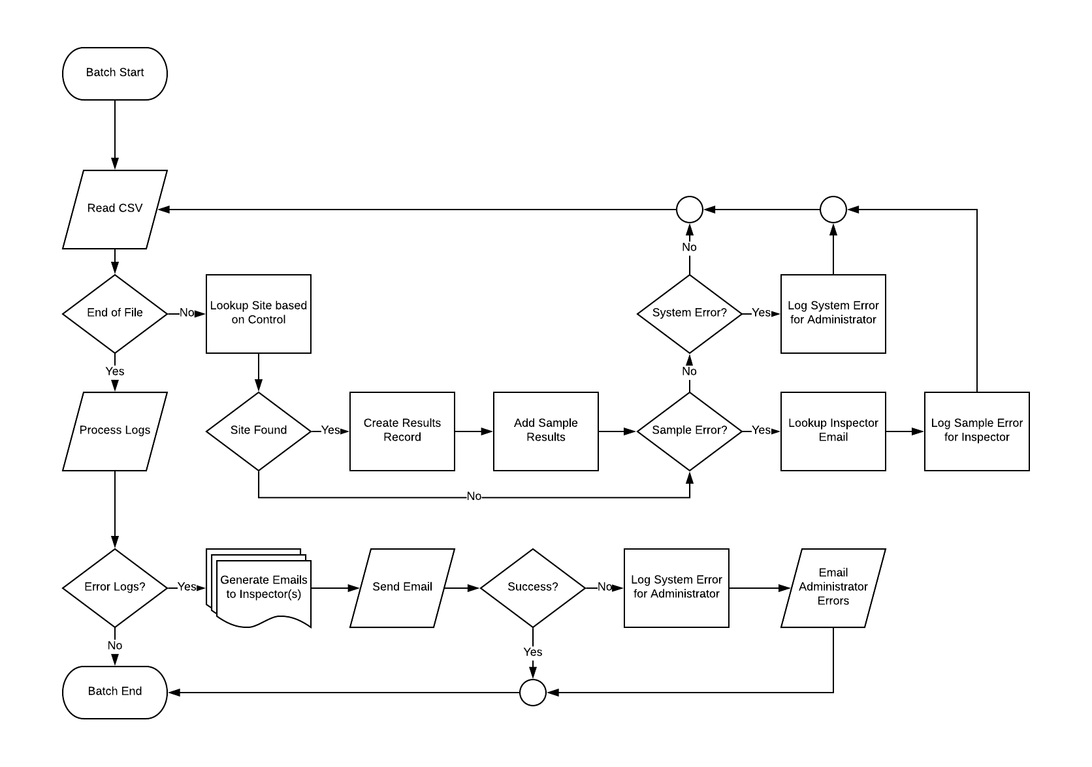

## Input File

The following Files will be formats will be consumed and processed by the integration:

**File Name Format:** <date>.csv

### File Map

|  |  |  |
| --- | --- | --- |
| Input  (From CSV) | Destination (Results Table) | Processing Notes |
| Field Number | Field Number,  ASI field “Sample Event #” | 14-character EHIMS inspection sequence number 0 padded. Sample Event # in ASI, Field Number in ASIT, Inspection sequence number on the site record. For legacy records, look in the Vehicle ID field. Look in Vehicle ID field for all records. Don’t look in the Vehicle ID, look for the checklist ID of Lab Methods checklist of the Sampling Event Inspection. But only on legacy records. For new records it will be inspection sequence number. |
| Analysis Code | Lab Analysis Code |  |
|  | Lab Number | Always “1” but will be parameterized in the event of future changes |
|  | Lab Name | Always “Suffolk County Department of Health Services” but will be parameterized in the event of future changes |
|  | Group | REMOVED |
|  | Group Name | *See Analyte Translation in Appendix |
| Analyte Name | Analyte Name | Key to lookup other values in Analyte Translation |
|  | C Number | *See Analyte Translation in Appendix |
|  | DMDL Notation | *See Analyte Translation in Appendix |
|  | DMDL | *See Analyte Translation in Appendix |
|  | MCL | *See Analyte Translation in Appendix |
|  | MCL Notation | *See Analyte Translation in Appendix |
|  | Default Units | *See Analyte Translation in Appendix |
|  | CAS Number | *See Analyte Translation in Appendix |
| Numeric Result | Numeric Results | -0- = null |
|  | Flag | Add Asterisk when conditions me   1. Numeric Result > Analyte MCL 2. Text Result field = P and No Analyte MCL   (*lookup Analyte MCL from Analyte Translation in Appendix) |
| Text Result | Text Results | Dropdown in Accela *See Text Result Translation in Appendix |
|  | Results Notation | *See Results Notation Translation in Appendix |
| Combination Result | Combination Result |  |
| Analyte MDL | Analyte MDL | -0- = null |
| Units |  | *See Unit Translations in Appendix |
| Remark1 | Remark1 |  |
| Remark2 | Remark2 |  |
| Remark3 | Remark3 |  |
| Remark4 | Remark4 |  |
| Remark5 | Remark5 |  |
| Lab Sample Number | Lab Sample Number |  |
| Analysis Date | Analysis Date |  |
| Analysis Time | Analysis Time |  |
| Trace Results | Trace Results |  |

### Computed Results Analytes

After initial processing of a Sample Number, the following Analytes will be computed if any Lab Provided analytes trigger the equations below.

#### Aldicarb

Entered Analytes

|  |  |  |  |  |
| --- | --- | --- | --- | --- |
| ALDICARB PESTICIDES | Aldicarb | SM 21 6610B | $TEMIK | C0223 |
| ALDICARB PESTICIDES | Aldicarb-Sulfoxide | SM 21 6610B | $TEMIK | C0525 |
| ALDICARB PESTICIDES | Aldicarb-Sulfone | SM 21 6610B | $TEMIK | C0526 |

Any of the above analytes must exist on the same lab result record to create the additional analyte.

Additional Analyte

|  |  |  |  |  |
| --- | --- | --- | --- | --- |
| ALDICARB PESTICIDES | Total Aldicarb (calc) |  |  | C0575 |

#### Metals

Entered Analytes

|  |  |  |  |  |
| --- | --- | --- | --- | --- |
| METALS | Iron (Fe) | EPA 200.7 | $FLAME | C0100 |
| METALS | Manganese (Mn) | EPA 200.8 | $DWICP | C0101 |

****Important note: Manganese result if reported as ug/L, is first converted from ug/L to mg/L by dividing by 1000 because the MCL is in mg/L.

Both analytes must exist on the same lab result record to create the additional analyte.

Additional Analyte

|  |  |  |  |  |
| --- | --- | --- | --- | --- |
| METALS | Iron + Manganese (Combined, Calc) | EPA 200.8 | $DWICP | C0150 |

#### SVOC

Entered Analytes

|  |  |  |  |  |
| --- | --- | --- | --- | --- |
| SEMI-VOLATILE ORGANICS METHOD 525 | Simazine | EPA 525.2 | $NVOC | C0056 |
| SEMI-VOLATILE ORGANICS METHOD 525 | Atrazine | EPA 525.2 | $NVOC | C0055 |

Any of the above analytes must exist on the same lab result record to create the additional analyte.

Additional Analyte

|  |  |  |  |  |
| --- | --- | --- | --- | --- |
| SEMI-VOLATILE ORGANICS METHOD 525 | Total Triazines + Metabolites (Calc) | EPA 525.2 | $NVOC | C0036 |

#### RAD

<need RAD calc> - calculation was not added because these samples are no longer processed by the county lab

## Accela Record Information

The **DEQ/General/Lab/Results** Record Type will be created under the site the sample was taken from. One Results record will be created for each unique Lab Sample Number / Field Number returned from LIMS. The new Lab Results record will be created as a child to the site record the inspection is attached to.

The interface will update the inspection to a status of “Lab Results Returned” and set the Desired Date on the inspection to the Date of the interface run. i.e. the same value as the ASI Field below.

The interface will also create a parent child relationship between the newly created Lab Results record and all child records listed in the ASIT on the Lab Methods checklist on the Sampling Event inspection on the site record.

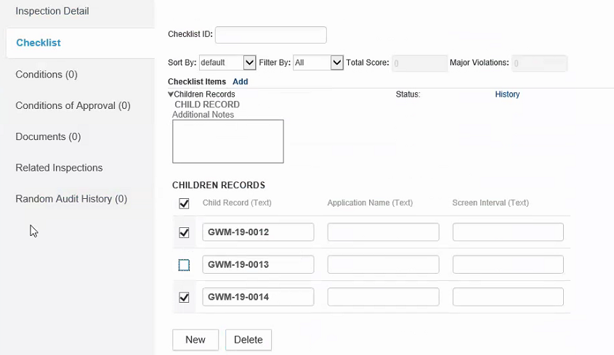

**Record Type:** DEQ/General/Lab/Results

### Custom Fields Output

In addition to recording the Results in the “Sample Results” Custom list the following two Custom Fields will be populated based for each record processed.

|  |  |
| --- | --- |
| Field Name | Notes |
| Sample Event Number | Lab Sample Number from LIMS (Field Number) |
| Lab Results Returned | Date of Interface run |

### Custom List Output

|  |  |  |
| --- | --- | --- |
| Column Name | Orign/Notes | Ordinal in input file |
| Field Number | Field Number | 1 |
| Analysis Date | DateAnalyzed | 2 |
| Analysis Time | TimeAnalyzed | 3 |
| Lab Method | REMOVED |  |
| Lab Name | “Suffolk County Department of Health Services” |  |
| Group Name | Mapping from DEQ_ANALYTE_NAME (child) To DEQ_GRP_NAME (parent). |  |
| Analyte & Method (key) | Pipe concat of Analyte Name and Certified Method. | 5 & 4 |
| Analyte Information | Mapping from DEQ_ANALYTE_NAME to DEQ_ANALYTE_INFO, using Analyte & Method value. If no value found in DEQ_ANALYTE_NAME for Analyte & Method add it to the error reporting. |  |
| C_Number | Will be removed? |  |
| Certified Method | Lookup of the AnaylsisCode in std choice DEQ_LABCODE_TO_METHOD | 4 |
| Analyte Name | Lookup of pretty name from DEQ_ANALYTENAME_TO_PRETTYNAME (std choice to be built) | 5 |
| DMDL Notation | From Analyte Info item 1 |  |
| DMDL | From Analyte Info item 2 |  |
| MCL | From Analyte Info item 3 |  |
| MCL Notation | From Analyte Info item 4 |  |
| Units | Lookup translation from std choice DEQ_UNITS. No. use item 5 from Analyte Info | 10 |
| CAS Number | From Analyte Info - item 6 |  |
| Numeric Result | NumResult - Translate -0- to 0 | 6 |
| Results | See <MDL section for rules on populating |  |
| Text Results | TextResult – lookup from std choice (DEQ_TEXT_RESULTS). If no entry, pass as is. If “Invalid” or “LA”, skip adding record and add to Sample error for inspector | 7 |
| Combination Results | CombResult – No translation | 8 |
| Analyte MDL | MDL – Translate -0- to empty string | 9 |
| Result Notation | Expression written to obtain value from ?? JIRA1120 | 7 |
| Flag | Expression written to obtain value JIRA 1121 |  |
| Remarks1 | Remark1 - Translate -0- to empty string | 11 |
| Remarks2 | Remark2 - Translate -0- to empty string | 12 |
| Remarks3 | Remark3 - Translate -0- to empty string | 13 |
| Remarks4 | Remark4 - Translate -0- to empty string | 14 |
| Remarks5 | Remark5- Translate -0- to empty string | 15 |
| Lab Sample Number | LabNumber – No translation | 16 |
| Lab Analysis Code | AnalysisCode – no translation | 4 |

### Screenshots

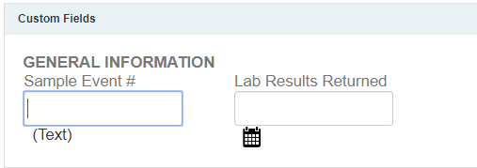

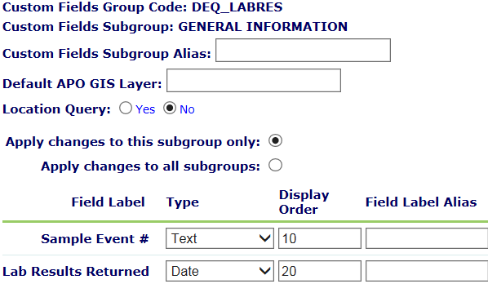

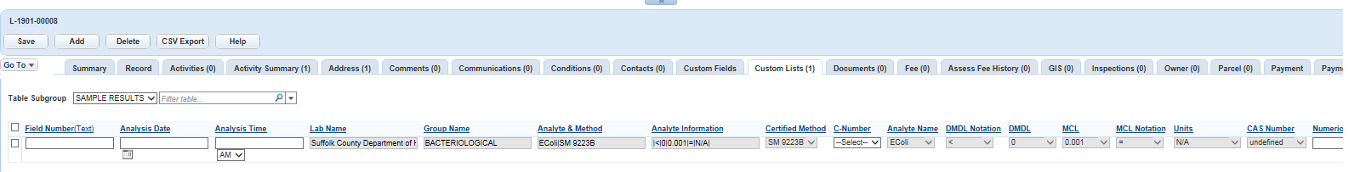

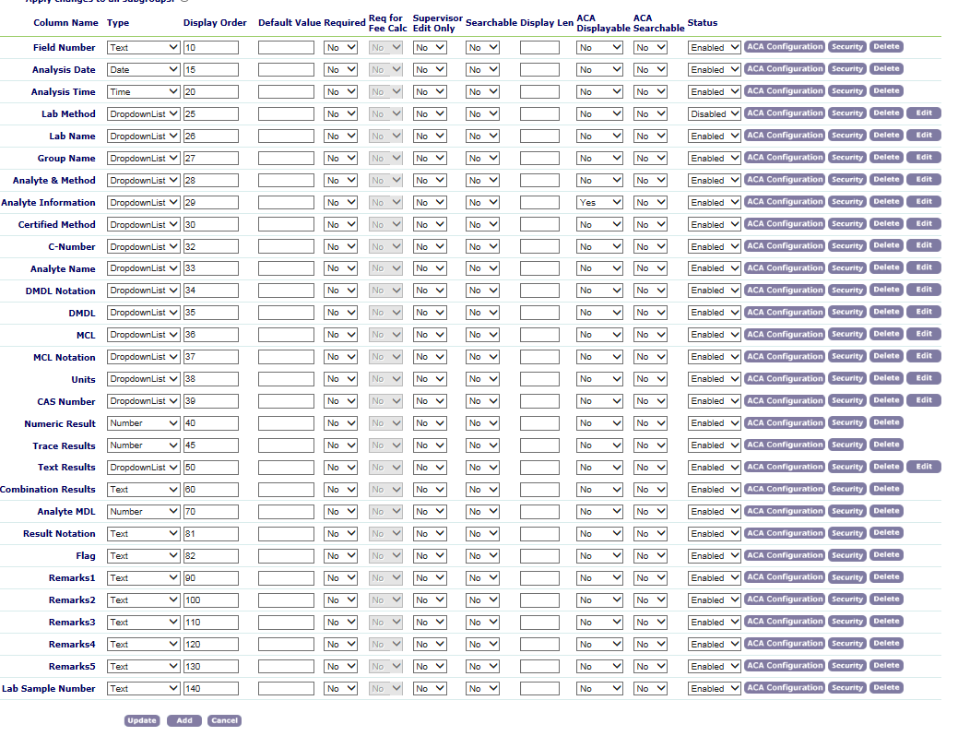

The analysis code will be added to the ANALYTE_INFO standard choice.

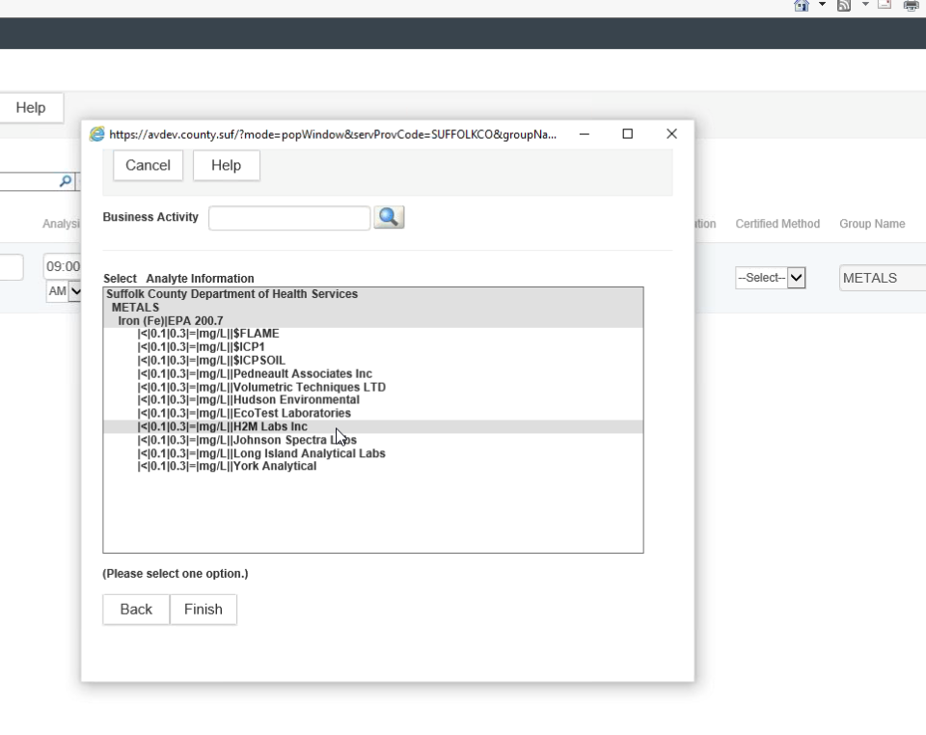

# Appendix A – Translations

## Units – Pending (std choice DEQ_UNITS)

|  |  |  |
| --- | --- | --- |
| **Lab Units** | **EHIMS / Accela Units** | **Notes** |
| -0- |  | Indicates blank value |
| ppb | ug/L |  |
| ppm | mg/L |  |
| umho | um/cm |  |
| mg/L SO4 | mg/L |  |
| mg/L N | mg/L |  |
| mg/L P | mg/L |  |
| MG CACO3/L | mg/L |  |

The value in the std choice DEQ_ANALYTE_NAME contains the analyte name | method

$ - means more than one analyte

_ - means single analyte

## Analysis Code Translation

| **Analysis Code** | **Translated Name** | **Note** |
| --- | --- | --- |
| !MICRO |  |  |
| !REMARKS |  |  |
| $CLPEST |  |  |
| $DACTHAL |  |  |
| $DWICP |  |  |
| $FLAME |  |  |
| $HERB555 |  |  |
| $HERBMET |  |  |
| $ICP1 |  |  |
| $IWVOC |  |  |
| $MEX |  |  |
| $NVOC |  |  |
| $SVOC526 |  |  |
| $SVOC527 |  |  |
| $TEMIK |  |  |
| $VITEK |  |  |
| $VOC |  |  |
| _AMMONIA |  |  |
| _CLO4 |  |  |
| _FLUORID |  |  |
| _HEXCR |  |  |
| _MBAS |  |  |
| _NITRATE |  |  |
| _NITRITE |  |  |
| _NO3&NO2 |  |  |
| _O-PHOS |  |  |
| BROMIDE |  |  |
| CHLORATE |  |  |
| CHLORIDE |  |  |
| CLO4 |  |  |
| CN |  |  |
| COLI |  |  |
| COND |  |  |
| DIOXANE |  |  |
| E-COLI |  |  |
| ECTRAY |  |  |
| GALPHAE |  |  |
| GALPHAP |  |  |
| GBETA |  |  |
| IONBAL |  |  |
| NITRITE |  |  |
| O&G |  |  |
| PH |  |  |
| SPC |  |  |
| SULFATE |  |  |
| T-ALK |  |  |
| TCTRAY |  |  |
| TRITIUM |  |  |

## Text Results Translation (DEQ_TEXT_RESULTS)

If translated value is not in this table it will be passed into Text Results as provided by the Lab in CSV

| **Text Results** | **Text Results Translated** | **Note** |
| --- | --- | --- |
| (Other) |  |  |
| ~17 | ~17 or ~(anything) |  |
| ~(anything) | ~17 or ~(anything) |  |
| <1 | <1 or <MRL or <(anything) |  |
| <MRL | <1 or <MRL or <(anything) |  |
| <(anything) | <1 or <MRL or <(anything) |  |
| >16,000 |  |  |
| 1.4+/-0.1 | CONC |  |
| Below Det LIM |  |  |
| CONC |  |  |
| Invalid |  | Skip adding record and add to Sample error for inspector |
| LA | Lab Accident | Skip adding record and add to Sample error for inspector |
| Less than |  |  |
| Less than MRL |  |  |
| N | Negative |  |
| NA |  |  |
| N/A |  |  |
| Not detected |  |  |
| NR | Not Reportable | Add to Sample error for inspector |
| P | Positive / Present |  |
| Present < MDL |  |  |
| Trace |  |  |

## Results Notation Translation

|  |  |  |
| --- | --- | --- |
| **Text Results** | **Result Notation** | **Note** |
| Trace | < |  |
| Present < MDL | < |  |
| Less than | < |  |
| Less Than MRL | < |  |
| Below Det Lim | < |  |
| LA | < |  |
| > 800 | > |  |
| CONC | = |  |
| P | Present |  |
| N | Absent |  |
| ~17 | Present |  |
| ~(anything) | Present |  |
| <1 | < |  |
| <MRL | < |  |
| <(anything) | < |  |
| > 16,000 | > |  |
| > anything | > |  |
|  |  |  |

## Analyte Translation

This follows the drill down configuration.

## HerbMets

The HERBMET analyte group may be sent twice in the lab file. Below is an example of an incomplete HerbMet row from the import file. This row should be skipped because the second column is not a date. Any row in the import file that does not have a valid date in the second column should be skipped, because this row will be resent in a future import file once the results have been completed. The log file should indicate that the row was skipped.

|  |
| --- |
| 002-944-180801,"-0-","00:00","$HERBMET","G-28273","-0-","NC","NC","-0-","ug/L","-0-","-0-","-0-","-0-","-0-","ZH00055","-0-" |

Note: If the import file sends a row that has previously been send, then the data will be duplicated. The Lab said that a separate file could be sent for the HERMET results that follow different rules from the other analytes.

## < MDL

When the Numeric Result is not detected, this needs to display as less than the Analyte MDL value. It is against best practice to change data during an import process. Therefore, a new column has been configured called ‘Results’ to hold the calculated values in the custom list. The new ‘Results’ column should be populated with the value from the ‘Numeric Results’ column, except:

1. When the ‘Numeric Result’ value is -0- or 0, then the ‘Results’ column should be populated with the ‘Analyte MDL’ value from the import file. If the ‘Analyte MDL’ is blank, then the ‘Results’ columns should be blank.
2. When the analyte name is TCOLI = “Colilert” or ECOLI = “E.Coli” from the import file and the ‘Text Results’ column = N, then the ‘Results’ column should be “0” and the ‘Flag’ column should be ’*’. 10/16/2019 Josh changed this to make the Flag column blank.
3. When the analyte name is TCOLI = “Colilert” or ECOLI = “E.Coli” from the import file and the ‘Text Results’ column = P, then the ‘Results’ column should be “> 0” and the ‘Flag’ column should be ’*’. 10/16/2019 Josh changed this to make the Results column be “1.1”
4. When the analyte name is “Gross Alpha E” or “Gross Alpha P“ or “Gross Beta” or “Tritium” and the ‘Text Result’ column = ‘CONC’, then the ‘Results’ column should be the combination result column from the import file and the ‘Result Notation’ column should be ‘=’.

# Appendix B – Issues

1. Attempting to find the entry in the DEQ_ANALYTE_NAME standard choice based on analyte name and certified method. Lab results come back with an analyte name of “Iron” but the entries in the standard choice will have analyte names such as “Iron (Fe)”. Not all analyte names do this but many do. Proposed solution would be to modify all the entries in the DEQ_ANALYTE_NAME to remove the extra characters. Need to find out if the lab ever returns an analyte name with parenthesis or can we just ignore those characters? No, we cannot.

Can create another standard choice table, mapping the analyte name from the lab to the pretty name. DEQ_ANALYTENAME_TO_PRETTYNAME

1. One analyte name and method combination can be in more than one group. No way to know which group. Example a key of “IRON (Fe)|EPA 200.7” maps to groups METALS and METALS (NON-POTABLE ANALYSIS). This was determined to be dirty data. Client and Ryan are going to clean it up.

1. Field Number has been moved from the Vehicle ID field to the CheckList ID for the Lab Methods checklist on the “Sampling Event” inspection type. The legacy data, for future it will be the inspection ID. Lab Methods checklist on the Sample Event Inspections.
2. Do all comparisons as uppercase in the interface. Request from Pat. This is not possible due to the way the Accela object model performs comparisons.

# Implementation Details

Stored in the file suffolklims.exe.config file:

1. <add key="AccelaAccessTokenUrl" value="https://auth.accela.com/oauth2/token"/> - URL to use for authorization with the Construct API
2. <add key="AccelaRequestUrl" value="https://apis.accela.com"/> - URL for the Construct API
3. <add key="AccelaAgency" value="SUFFOLKCO"/> - service provider code
4. <add key="AccelaUsername" value="admin"/> - username to log into Accela Automation
5. <add key="AccelaPassword" value="admin1"/> - password to log into Accela Automation
6. <add key="AccelaClientId" value="636852418729795015"/>
7. <add key="AccelaClientSecret" value="ae44b889b78a458ab1cf271ed65b29bf"/>
8. <add key="AccelaEnvironment" value="TEST"/> - Accela Automation environment
9. <add key="AccelaScope" value="records run_emse_script"/>
10. <add key="AccelaGrantType" value="password"/>
11. <add key="InputPath" value="c:\\temp\\in"/> - input directory
12. <add key="OutputPath" value ="c:\\temp\\out"/> - output directory