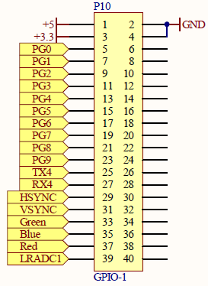

COM2

VGA

Display 7

segments

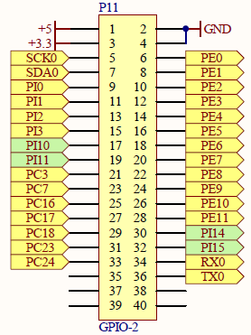

GSM

General

Port D

I2C

Console

Port C

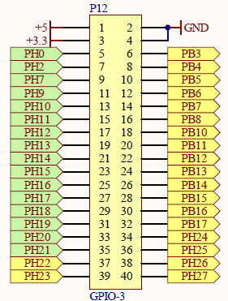

Port C

Port B

Port B

Port A