|  |
| --- |
| **MediaController Class**   * In Android, a MediaController is a class that provides a standardized way to control media playback, such as audio or video, within a user interface. * The MediaController class offers a set of playback controls that allow users to perform actions like play, pause, rewind, fast-forward, and adjust the volume. These controls are typically displayed on the screen while the media is being played, making it easier for users to manage playback without directly interacting with the underlying media player APIs. * Key features and components of the MediaController class include: * Transport Controls: Play, pause, stop, rewind, and fast-forward buttons that control media playback. * SeekBar: A visual component that allows users to scrub through the media timeline to seek to a specific position. * Volume Controls: Buttons or sliders for adjusting the media volume. * Callbacks: Listeners that can be registered to receive events when the user interacts with the media controls.   **Example:**  **MediaController mediaController = new MediaController(this);**  **MediaPlayer mediaPlayer = new MediaPlayer();**  **mediaPlayer.setDataSource("path_to_your_media_file");**  **mediaPlayer.prepare();**  **mediaPlayer.start();** |
| **Question**   |  | | --- | | **Create the media API in android to play a video file.** | |
| **Activity_main.xml**  **Drag and drop VideoView and Button from Palette**  *<?***xml version="1.0" encoding="utf-8"***?>* <**RelativeLayout xmlns:android="http://schemas.android.com/apk/res/android"  xmlns:app="http://schemas.android.com/apk/res-auto"  xmlns:tools="http://schemas.android.com/tools"  android:layout_width="match_parent"  android:layout_height="match_parent"  tools:context=".MainActivity"**>   <**VideoView  android:id="@+id/videoView"  android:layout_width="wrap_content"  android:layout_height="wrap_content"** />   <**Button  android:id="@+id/btnPlay"  android:layout_width="wrap_content"  android:layout_height="wrap_content"  android:layout_alignParentEnd="true"  android:layout_alignParentRight="true"  android:layout_alignParentBottom="true"  android:layout_marginEnd="151dp"  android:layout_marginRight="151dp"  android:layout_marginBottom="274dp"  android:onClick="playVideo"  android:text="Play Video"** />  </**RelativeLayout**> |
| **Main_Activity.java**  **package** com.maharashtracollege.profmohdshahid; **import** androidx.appcompat.app.AppCompatActivity; **import** android.media.MediaPlayer; **import** android.net.Uri; **import** android.os.Bundle; **import** android.os.Environment; **import** android.util.Log; **import** android.view.View; **import** android.widget.Button; **import** android.widget.ImageButton; **import** android.widget.MediaController; **import** android.widget.Toast; **import** android.widget.VideoView;  **public class** MainActivity **extends** AppCompatActivity {  VideoView **videoview**;  Button **btn**;   @Override  **protected void** onCreate(Bundle savedInstanceState) {  **super**.onCreate(savedInstanceState);  setContentView(R.layout.***activity_main***);   }  **public void** playVideo(View view)  {  **videoview** = (VideoView) findViewById(R.id.***videoView***);   **try** {  MediaController mediacontroller = **new** MediaController(  MainActivity.**this**);  mediacontroller.setAnchorView(**videoview**);  Uri uri = Uri.*parse*(**"android.resource://"** + getPackageName() + **"/"** + R.raw.***myvideo***);  **videoview**.setMediaController(mediacontroller);  **videoview**.setVideoURI(uri);   } **catch** (Exception e) {  Log.*e*(**"Error"**, e.getMessage());  e.printStackTrace();  }  **videoview**.requestFocus();  **videoview**.setOnPreparedListener(**new** MediaPlayer.OnPreparedListener() {  **public void** onPrepared(MediaPlayer mp) {   **videoview**.start();  }  });  }} |

Note: For this practical we to copy the .mp4 file and create the folder raw in the res as follows

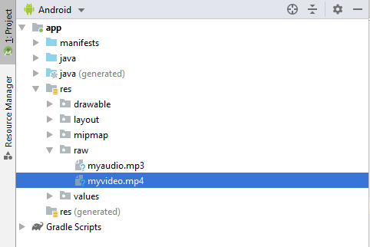

myvideo.mp4 is used for video playing

|  |  |
| --- | --- |
| Click to Play Video |  |