**Oligoli: A Bridge between the Common People and the Local Entrepreneurs**

Arafat Habib, Syeda NoorJaha Azim, Tajul Islam, Md. Asif Ibtehaz,

Razia Sultana, Abu Sufian

Abstract. This paper aims at giving the web based solution to build a bridge between the small entrepreneurs and the common people hiring them. Both entrepreneurs and their hirers will be able to create their profile to bid for a task and post for a task. The hirer can search for his desired service providers within his territory via map. Good and interactive online platform for the small entrepreneurs and the people hiring their services can precipitate the downfall of the unemployment rate and lessen sufferings of the common people. Versatile and wide use of this platform can reduce unemployment rate up to 0.1-0.2 percent within 2017-2018. As promoting local entrepreneurs can flourish our economy to a great extent, this web based solution to link the local entrepreneurs with the common people will be a step to opt for.

**Introduction**

Can you imagine the pain of shifting to a new area and not finding anyone close to you from whom you can have services? On the other hand, behind the scene, service providers are not getting enough works to deal with. We propose a web based software solution “Biz oligoli” to solve these concurrent problems by building a platform where both of these types can communicate, post tasks, bid for tasks, quest for tasks and find service providers. Local entrepreneurs are quite important for the economy as this type of occupation can drive away unemployment problem to a good extent. Kerri Tesreau and Veronica Gielazauskas in their paper Entrepreneurship: A Driving Force in the New Economy says that local entrepreneurs help build communities in ways such as providing jobs, conducting business locally, creating and participating in entrepreneurial networks and investing in community projects. So, promoting them will be nothing but good for the society. Again, lessened suffering of the common people is also another point adopting which we can denote the problem as a must to solve. The problem is quite challenging to solve as we have to make people technology oriented to such an extent where a wide range of uneducated, undereducated local entrepreneurs will use the web to quest for his tasks. This technology orientation will take time. Again, security issue will be a huge fact to deal with. These hindrances will be quite hard to overcome, but they are not formidable at all which we will discover in the later parts of our paper. In “Oligoli”, both the service providers and their hirers will have their profile. Someone questing for service can find related entrepreneurs by searching in the map. The entrepreneurs can quest for the tasks whereas the service hirers will be able to post for the tasks. Attempt like ours were taken earlier to solve the problem we are dealing with. Considering our one to be more interactive and territory specific, we believe that it is going to help people a lot.

**Motivation**

If the project turns to be a successful one it will be quite ubiquitous throughout the country and as years pass by significant downfall of the unemployment rate is a must. We all know that unemployment problem is a prior reason behind poverty. Reducing unemployment rate on the other hand will alleviate the poverty too. This reduction along with the promotion of the local entrepreneurs will change the economy of ours to a good state. Considering all these, we have been on our feet to build the system that can change the country to be a poverty free one.

**Background study**

The first question that may come to the reader’s mind that if it is possible to solve the problems with the existing systems. We have analyzed the existing systems for a certain time. We ended up in a decision that international free lancing sites cannot fulfill the demand that we propose to fulfill. Language and payment system are two big issues here. Not everyone in our country has some sort of card and bank accounts to cope with the international sites. When we are considering the web orientation to be an issue, English as a language in international sites will also be an issue not to be solved. Now, considering the scenario of our country, we have two existing systems. Shondhan.com and handymama.co, both these systems do not allow users to search for service providers via map. The goal to promote local entrepreneurship is no way fulfilled in these sites. Again, we want give ease not only to the people hiring services but also to the service providers. They (service providers) will be able to search for the tasks, bid for the tasks and also they can update their profile anytime. This feature is not available in the existing systems. Below is the table in which you will find the comparison between our system and all the other existing system.

|  |  |  |  |  |
| --- | --- | --- | --- | --- |
| Name of the System | Local language  Issue | Ease of the Payment System | Map to Find Workers | Interaction between Service Providers and local Entrepreneurs |
| Elance | Yes | No | No | Yes |
| Odesk | Yes | No | No | Yes |
| shondhan.com | No | Not Applicable | No | No |
| Handymama | No | Not Applicable | No | No |
| Oligoli | Yes | Yes | Yes | Yes |

**Strong Points and their relationship with Unemployment rate and Software Engineering**

Comparing all the systems and analyzing all the specifications required to build the whole system, we have noted down all the strong points we have. **Interaction** between the users and the service providers and **review system,** where both the customers and the service providers can give reviews to each other are the two strong points we have in our already built and existing system. As we have the plan to make the system in both Bangla and English, **language ease** is also a strong point of our system. Embedding the system with the **local payment system** like bKash and others will also be a strong point of our system which we intend to implement further. Not a single existing system in our country has the feature that can help the customers and service providers interact with each other. An interactive system will surely bring an easy relation between a customer and user that can put a great impact on alleviating the unemployment rate. Review system can also bring faith among the customers as they can be assured of security due to the extreme level of filtration of the service providers based on their reviews. On the other hand, the service providers can reject his task assigner if s/he finds that the customer has a bad review regarding the payment issue. Therefore, the implemented review system is a very congenial one to increase the users. As the number of the users increase in the system, higher the probability is to decrease the unemployment rate. It can be predicted that undereducated service providers will also be there in the system. They will be very much keen to use our system if and only if they find that the system is comprehensive to them. Developing the site in Bangla will give them the ease to use the system. Let alone this, we cannot expect that all the customers will either hold a credit card or have an international payment system within hand to pay for their services on line. Implementing the whole system that is payable through bKash or any other local payment system will greatly attract the customers to use our system. More the root level service providers and customers use the system, greater the chance is in case of decreasing the unemployment rate. In our design phase, we developed detailed design for the software data structures, software architecture procedural detail, interfaces. The requirement analysis phase was the phase from which we derived the strong points and the strong pints were reflected luminously while noting down specifications. Strong points like interaction, review system have greatly helped us while designing interfaces, detail and architecture. For example, our system is a two way login system. This specific design was easy to be a decided structure as one of the strong points of our system is the interaction between the customers and service providers. Maintenance, another part of software engineering that includes error correction and enhancement of the system is also greatly related to the strong points that include language and payment system ease. These two features are fully to be implemented in the maintenance section.

**Approach**

First we created a login system where both the user and service providers can log in and create their profiles. We have given the ease to update the profile especially for the service providers so that they may change their hourly wage any time and add new experiences to top among the best ten service providers within his territory and of his type of work. Users can post the tasks they want to get done by the local entrepreneurs. On the contrary, the service providers can bid for the posted tasks. There will be user reviews based on which the top ten service providers will be selected. There position will fluctuate as the ratings given by the users vary. Users will also be able to comment about the service providers. 10 Consecutive bad reviews and negative comments will ban the service provider from the system. Automatic emails will be sent to a particular service provider if any posted task matches with his criteria. To help the users who will hire different service providers, there is a map where selecting a particular area will give the users ten best service providers of his wanted type and service. To make it even easier for the users, they can sign up using their Google or Facebook account. The following diagram represents our approach,

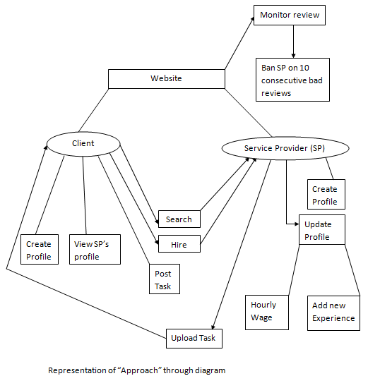

Fig. no. 1: Representation of our “Approach” through diagram

**Cost and Benefit**

We want to build a system with fewer flaws to make it popular as early as possible. We will require near about 8, 65,000 dollar while building the system. The cost estimation of different tools and hired people are given in the following table. 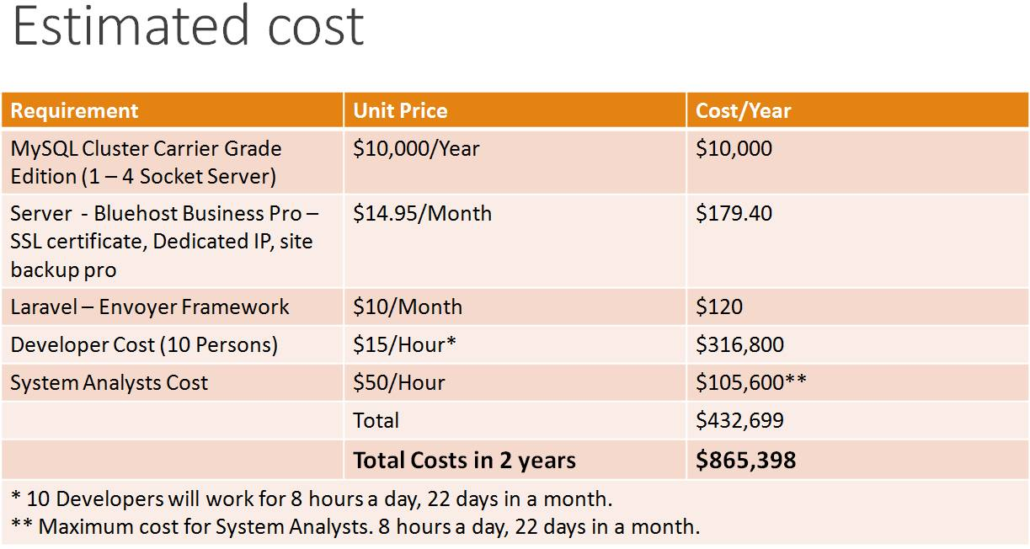

Fig. no. 2: The left most column describes the required software, server, framework and Cost to develop the system along with hiring developers. The middle (Unit) and right most column (Cost/Year) describes the cost in amount (dollar)

The cost is huge and we need investors for our system. Total investment in two years for our project will be $12, 00,000 and expenditure will be $8, 65,398. We expect to earn $64, 35, 000 in two years (**Break even**). The primary source of our income will be advertisement business.

**Methodology**

We did not provide the whole system within single delivery. The development and delivery was broken down into increments delivering part of the required functionality. We divided all the works based on the priorities and highest prioritized features were in early increments. For example, in our first increment included the UI design, Database design. In the second increment, the customers were being able to post task and assign task to a particular service provider. On the contrary, third increment opened up the horizon for the service providers within the system as they can accept and reject any work assigned to them. The review system was also a part of this increment. Our Overall, we implied “Incremental development” method to build up the whole system. The following table shows different functionalities of the software done in different increments. Our last increment consisted graph showcasing which displayed to the system buyer if the system is working and the number of hits and users are increasing. These graphs are the mirror for the system owners if their invested money is actually going to earn them something good.

|  |  |
| --- | --- |
| 1st increment | UI design, Database design, Inclusion of the map, Sign up and Login, Profile creation. |
| 2nd increment | Customer being able to post task and assign task to a particular service provider. |
| 3rd increment | Service provider being able to accept or reject any assigned work, and Review System |
| 4th increment | Graph showcasing using the information of user, service providers posted tasks |

Table: Different increments of the software

After every increment, customer feedback was taken strongly and practically tested by the customer if everything is satisfactory. Their suggestions and wants were taken on account very seriously and changes were made accordingly. After merging the whole system with all the increments, final feedbacks were taken from the customers and the system was given a fine tuning to make the software prepared for launching.

The following figure represents the flow we followed to provide the software, 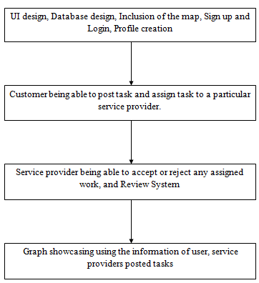

Fig. no. 3: Every block represents the service pack we provided

The use case diagram for the admin in our system is given below, 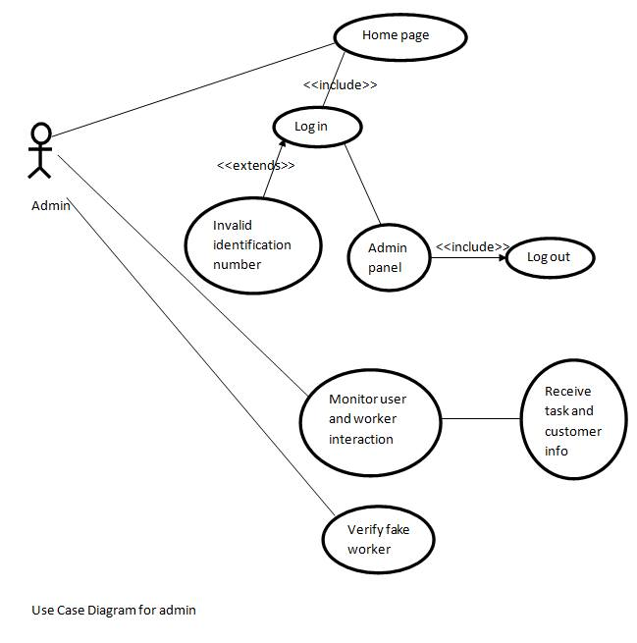

Fig. no. 4-Use case diagram for the admin

The admin logs in and monitors the system, as well as verifies the service provider.

The use case diagram for the service provider/ worker is given below,

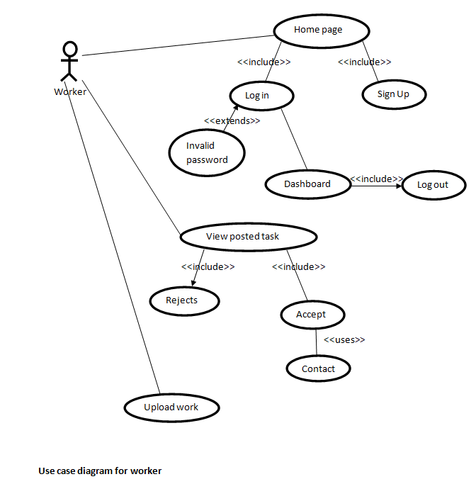

Fig. no. 5 -Use case diagram for the worker

The service provider/worker logs in and views posted task by client. He/she can decide whether to perform the task or not. The worker contacts client if he accepts. After completion the worker uploads the task.

The use case diagram for the user is given below,

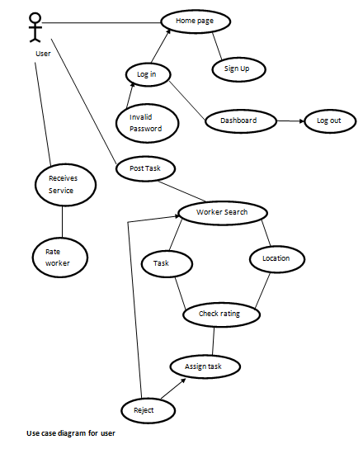

Fig. no. 6-Use case diagram for the client/user

The client logs in and task post. Then look for worker based on location/task and rating/review. Assigns task after finding the worker suitable for his task. If the selected worker accepts the task they communicate with each other else looks for another worker. After receiving the service the client gives feedback.

The data flow diagram for the client/customer is given below,

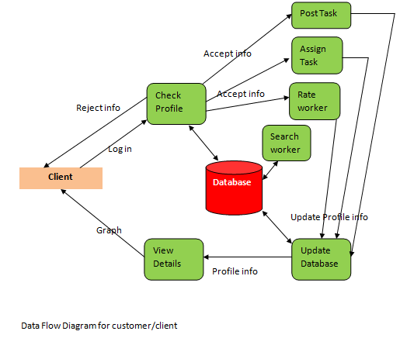

Fig. no. 7:The database updates whenever the client posts and assigns task, as well as rates the worker based on the quality of service. Client looks for worker from the database. This as a result affects the client status graph.

The data flow diagram of the admin is given below,

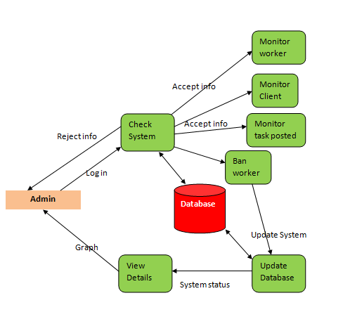

Fig. no.8: Admin monitors the worker, client, task posted as well as their interactions. The admin can update the database by banning the service provider for poor service quality. This as a result affects the overall system graph.

The data flow diagram of the service provider/worker is given below

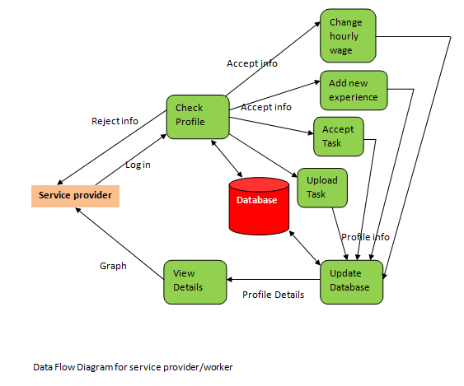

Fig.no.9:The database updates whenever the service provider changes hourly wage, whenever adds in new experience. Moreover the database also updates when the worker accepts or upload task. This as a result causes a change in the worker status graph.

**Rational**

We talked with 400 local entrepreneurs of different areas. We went to 16 various areas including Dhanmondi, Gulshan, Uttara, Moahakhali, Banani, etc and talked with 25 local entrepreneurs. On an average 15 among 25 do not get satisfactory amount of jobs and at least 1 out of 400 people remain totally workless. If our software solution can employ that one unemployed worker, the whole unemployment rate can be decreased 0.25 percent. For the worst case if we just can reduce it down to 0.1 percent that will be also a great achievement for us. As our initiative is at its infant stage, we have taken Dhaka as a scenario. If we can implement it within the entire country, unemployment rate will confront a significant fall.

Let,

The number of the surveyed local entrepreneurs be N,

Number of the locations covered is L,

Number of the unemployed entrepreneur is U.

N=L×25=16×25=400

Percentage of the unemployment rate to alleviate is $,S=\frac{U×100}{N}\frac{1×100}{400}$ =0.25%

Where,

U=1, N=400, L=16

The following table shows how much we expect the down fall of the unemployment rate within next 3 years

|  |  |
| --- | --- |
| Year | Unemployment rate |
| 2006 | 4.3 |
| 2010 | 5.1 |
| 2012 | 4.5 |
| 2015(Current) | 4.5 |
| 2017-18(Expected) | 4.3 |

The following bar diagram shows how much we expect the down fall of the unemployment rate within next 3 years

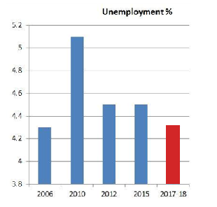

Fig. no. 10: The X axis has the values of unemployment rate and the Y axis represents the year. The blue bars represent the previous years and the current one. The red color represents the expected output of next 2-3 years.

**System Compatibility**

It is possible to measure if the running system is compatible enough with the current time usages. Though our project is a demo one and not has been used in reality, we can check the following things in the system.

The graph given below is represents the posted tasks in accordance with dates. 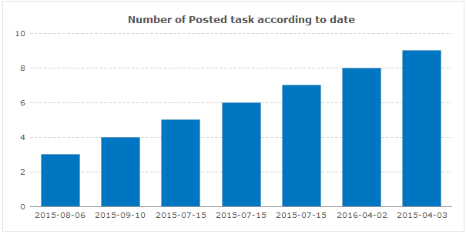

Fig.no.11: X axis represents the date and the Y axis represents the number of posted tasks

The graph given below represents the number of taskers/service providers, 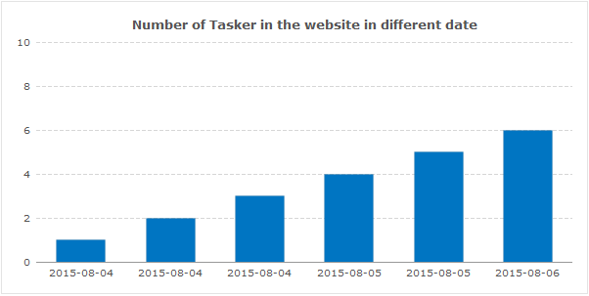

Fig.no.12: X axis represents the date and the Y axis represents the number of taskers/ service providers

The graph given below represents the number of user/client/customer available in the system in accordance with the date.

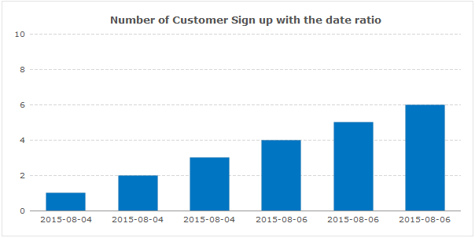

Fig.no.13: X axis represents the date and the Y axis represents the number of users/client/customers in the system

All these graphs can be seen just by one single click on a button having the name dashboard. Anyone can check and assess the system’s compatibility and stability via these graphs.

**Limitation and Future work**

The system has some limitations but as we said earlier they are not formidable enough to stay beyond solution. First of all, the security issue comes upon as no one knows that the hired service provider coming to your home will cause you no harm by tracking your house pattern for future theft or robbery. As you know that every system needs time to get into its healthiest state, our system can also remit this threat regarding security issue if used for a certain time as there will be user reviews and comments. 10 consecutive low ratings will ban the service provider from the system. In future we have the target to make it more mobile oriented and there will be options that we will imply retina scanning system to ensure that the same person the hirer hired has come to provide services. Another limitation is that we have to make a huge number of people web oriented to make our software solution successful. Considering the amount of people using smart phones and mobile based internet services, we will be able to grab a huge mass in future.

**Conclusion**

To conclude, we would like to mention that our system is not flawless but it is not at all fundamentally flawed. Limitations can be overcome as the number of users increase. We have mentioned that we will be able to reduce unemployment rate up to 0.1-0.2 percent within 3 years.Reducing unemployment problem means to alleviate poverty and decreasing crimes. Our goal is to come up with a solution that will do something good for the society. We leave the choice among common people whether to accept the digitalization of local entrepreneurship.

Citation

Kerry Tesreau, and Veronica Gielazauskas. N.p., n.d. Web. 12 June 2015. <https://www.missourieconomy.org/community/econ_policy/entrepreneurship.stm>.