PROJECT DOCUMENTATION

FINGERPRINT-BASED
ELECTRONIC VOTING MACHINE
(EVM)

INDEX

SR no | Content | Page no.
1 | Abstract | 3
2 | Introduction | 4
3 | Problem Statement | 5
4 | Problem Solution | 6
5 | Hardware Components | 7
6 | Methodology | 9
7 | Connections & Working | 11
8 | Business Impact | 16
9 | Future Enhancements | 18
10 | Conclusion | 20

Abstract

This project is about a Fingerprint Based Electronic Voting Machine. We made it using the Arduino UNO microcontroller and the R305 Fingerprint Sensor. The main goal of this system is to make voting more secure and reliable. We want to make sure that votes are counted correctly and that only real voters can vote.

Traditional voting systems have a lot of problems. Sometimes people vote votes or vote more than once. They might even pretend to be someone. Our Fingerprint Based Electronic Voting Machine solves these problems. It makes sure that only voters who are registered and verified can cast their votes.

Our system uses fingerprints to check who the voters are. When voters register their fingerprints are stored in the fingerprint sensor with an ID. When they want to vote the system checks their fingerprint against the ones stored. If it matches they can vote. If not they cannot. A warning message comes up. This way we can be sure that only real voters are voting.

We also made sure that people cannot vote more than once. The system keeps track of who has voted using a memory. If someone tries to vote the system says no and shows a warning message, on the screen. This way we can be sure that votes are counted correctly and that the election is fair. The Fingerprint Based Electronic Voting Machine is a way to make voting more secure and reliable.

Introduction

Electronic Voting Machines are an improvement over the old paper ballot systems. They make elections faster and more accurate. With Electronic Voting Machines we can count votes quickly. Reduce mistakes. They also help prevent votes and give us results faster. That is why many places use Electronic Voting Machines to have organized elections.

There are still some problems with the old Electronic Voting Machines. They use things like identity cards or voter slips to check who people are. These methods are not very good. Can be fooled. Someone might try to vote than once or use a fake identity card to vote for someone else. This can make the election not fair or trustworthy.

So we made a kind of Electronic Voting Machine that uses fingerprints to check who people are. This is called a Fingerprint Based Electronic Voting Machine. Fingerprints are unique to each person so they are a good way to check someones identity. When we use fingerprints to check who people are we can be sure that only the right people are voting.

Here is how it works. First voters have to put their fingerprints in the database. The machine stores the fingerprint with a number. Then when it is time to vote the voter has to put their finger on the machine. The machine checks the fingerprint to see if it matches the one in the database. If it does the voter can vote. If not the machine says no. This way we can stop people from voting who should not be voting.

We also made sure that people can only vote once. When someone votes the machine remembers that they voted. If they try to vote the machine says no. This way we can be sure that each person only votes one time. This makes the election more fair and trustworthy. Electronic Voting Machines with fingerprints are an improvement, over the old way of voting. They make sure that elections are fair and that each person only votes one time.

Problem Statement

Voting systems that use paper ballots and are checked by hand have a lot of problems. These problems are about security. Making sure everything is accurate and fair. One big issue is that someone can pretend to be another voter by using stolen identification. This is not fair. Can make people lose trust in the voting system. Also when people are checking the votes by hand it takes a time and they can make mistakes. This is because they have to rely on their eyes to make sure everything is correct.

There is another problem with the old way of voting. Sometimes people try to vote than once. This is called voting. It is hard to catch people who are doing this especially when there are a lot of voters. This can make the results of the election not fair. Also when we use paper ballots it is easy, for someone to tamper with them or make mistakes when they are counting the votes. This makes the whole voting process not reliable.

The old way of voting also needs a lot of people to help. It takes a long time to collect and count all the votes. When people are counting the votes by hand they can make mistakes. It takes a long time to get the final results. In elections it can take hours or even days to count all the votes. This is not efficient. It is very complicated. All these problems show that we need a way to vote one that is more secure and reliable. We need a voting system that is automated and can help us get the results quickly and accurately.

Problems in Traditional Voting Systems
- Voter impersonation using fake identities
- Duplicate voting by the same person
- Manual errors during verification and counting
- Delayed result processing due to manual counting
- Ballot tampering and election fraud
- High manpower and operational cost
- Lack of transparency and reliability

Limitations of Existing EVMs
- Dependence on manual voter verification
- No biometric authentication system
- Possibility of fake voting still exists
- Limited security against impersonation
- Human involvement increases chances of errors

Proposed Solution

1. Fingerprint Authentication For Voting
The new system uses a fingerprint sensor with the Electronic Voting Machine. Every voter has to put their fingerprint on the sensor before they can vote. This is a way to keep things secure because every persons fingerprints are different.

2. Checking If A Voter Is Registered
Before the election voters put their fingerprints into the systems database. When they go to vote the sensor checks their fingerprint against the ones, in the database. If it finds a match then they can vote.

3. Stopping People From Voting Twice
The system remembers who has already voted. It does this by storing the information in its memory. If someone tries to vote the system will not let them.

4. Making Voting Faster And More Accurate
Using fingerprints to check who people are and recording votes electronically makes the process faster. It also reduces mistakes that people might make when counting votes.

5. Getting The Results Quickly
Because votes are stored electronically it is easy to count them and show the results away. This saves a lot of time.

6. Keeping The Election Secure
The system is secure because it uses fingerprints to check who people are stores votes electronically. Does not let people vote twice.

7. Making The System Easy To Use
The system has a things that make it easy to use:
- A screen that shows instructions and whether a vote has been counted
- Buttons to select a candidate
- Lights that flash to show what is happening
- A buzzer that beeps to alert people

Hardware Components

- Arduino UNO:
Acts as the central controller and processing unit of the complete Fingerprint Based Electronic Voting Machine (FEVM). It coordinates all system operations including fingerprint verification, vote recording, button input handling, LCD message display, LED and buzzer control, and result processing. The Arduino UNO processes data received from the fingerprint sensor and executes the programmed voting logic efficiently.
- R305 Fingerprint Sensor:
Used for biometric voter authentication by capturing, storing, and matching voter fingerprints. During registration mode, the sensor enrolls fingerprints into its internal memory with unique IDs. During voting mode, it scans and verifies the fingerprint of the voter before granting permission to vote. This ensures secure authentication and prevents unauthorized or fake voting.
- 16x2 LCD Display:
Provides a user-friendly interface by displaying system messages, instructions, voter authentication status, candidate selection prompts, successful vote confirmation messages, and final election results. The LCD helps users interact with the system easily and improves overall usability.
- Push Buttons:
Used for candidate selection and system control operations. Each button represents a candidate, allowing authenticated voters to cast their vote by pressing the corresponding button. Additional buttons can also be used for mode selection, result display, or system reset operations.
- EEPROM (Electrically Erasable Programmable Read Only Memory):
Used to permanently store vote counts and voter status information even when power is turned off. EEPROM helps in preventing duplicate voting by saving whether a voter has already voted. It also preserves election data securely until the system is reset for the next election.

- LED Indicators:
LEDs are used to provide visual indications for different system conditions and operations. For example:
  - Green LED indicates successful fingerprint verification or successful vote casting.
  - Red LED indicates invalid fingerprint detection or duplicate voting attempts.
  - Additional LEDs may indicate system power status or active voting mode.
These indicators improve user interaction and system monitoring.
- Buzzer:
Provides audible alerts and notifications during system operation. The buzzer sounds when:
  - A fingerprint is successfully verified
  - A vote is successfully cast
  - An unauthorized or duplicate voting attempt is detected
  - System errors or warnings occur.This enhances user feedback and increases system security awareness.

- Connecting Wires and Breadboard:
Used for establishing electrical connections between all hardware components during circuit implementation and testing. They help in creating a structured and organized hardware setup for the voting machine prototype.

Methodology

The Fingerprint Based Electronic Voting Machine is a system that works in three ways: Registration Mode, Voting Mode and Result Display Mode. These ways make sure that voters are enrolled properly votes are cast securely. Results are managed efficiently. The whole system is controlled by the Arduino UNO, which's like the brain of the project.

Registration Mode:
When we use the Fingerprint Based Electronic Voting Machine in Registration Mode new voters are added to the system. They put their finger on the R305 Fingerprint Sensor. It saves their fingerprint in its memory with a special number. The LCD display shows the user what to do. Confirms that everything is okay. This way only people who are registered can vote.

Voting Mode:
In Voting Mode the voter has to prove who they are using the fingerprint sensor. The system checks the fingerprint to see if it matches one that is already stored. If it does and the voter has not voted before they can choose their candidate using buttons connected to the Arduino UNO. After they vote the system remembers that they voted so they cannot vote again. The LCD display shows messages and lights. A buzzer tell the voter if their vote was successful or not.

Result Display Mode:
This mode shows how votes each candidate got after the election. The Arduino UNO gets the vote counts from memory. Shows them on the LCD screen. This makes it easy to see who won without counting votes by hand.

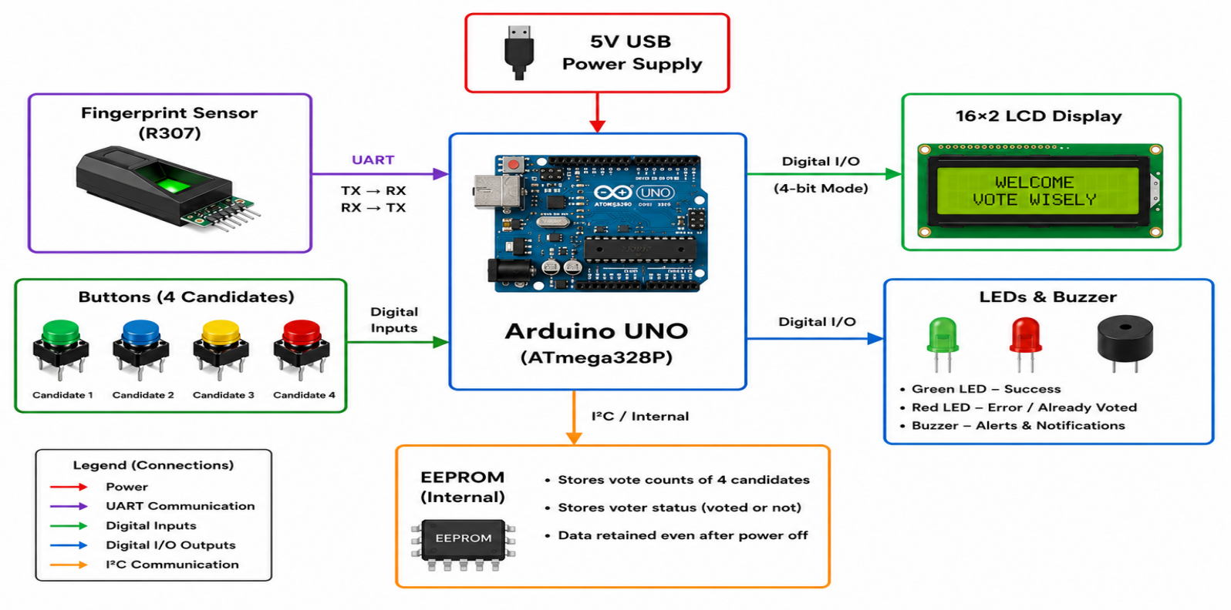

The Arduino UNO is the part of the system. It works with all the parts, like the fingerprint sensor, LCD display, buttons, lights, buzzer and memory. It gets input, from the user checks who they are stores vote data and makes sure everything works together.

The Arduino UNO talks to the fingerprint sensor using a way of communicating called UART. This lets the microcontroller and fingerprint module exchange data using pins. The Arduino UNO sends commands to the fingerprint sensor and the sensor sends back the answers. This makes the system work securely and efficiently.

The Fingerprint Based Electronic Voting Machine is a system that's easy to use and makes sure that votes are counted accurately. It has good features that make it secure and efficient. The Arduino UNO and fingerprint sensor work together to make voting easy and secure. The system is a way to manage elections.

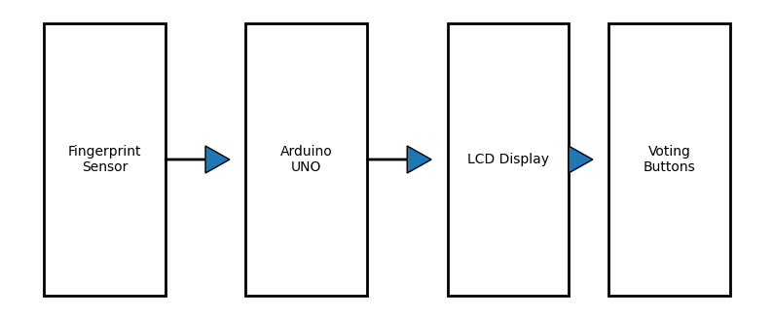
System Block Diagram

Connections And Working

Fingerprint Based Electronic Voting Machine (FEVM). It shows how different hardware components are connected to the Arduino UNO and explains the function of each pin used in the system. Proper pin mapping ensures smooth communication and operation of all modules in the voting machine.

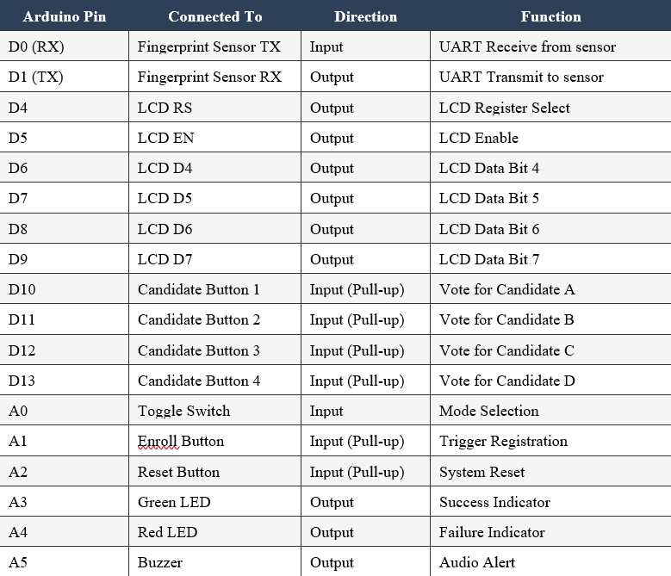

1. UART Communication Pins
- D0 (RX) → Fingerprint Sensor TX
  - Configured as an input pin.
  - Receives serial data from the R305 Fingerprint Sensor.
  - Used for receiving fingerprint matching and authentication data.

- D1 (TX) → Fingerprint Sensor RX
  - Configured as an output pin.
  - Sends commands from Arduino to the fingerprint sensor.
  - Used for enrollment, fingerprint scanning, and verification operations.
These two pins use UART serial communication for reliable data exchange between Arduino and the fingerprint module.

2. LCD Display Connections
The 16×2 LCD operates in 4-bit mode, which reduces the number of Arduino pins required.
- D4 → LCD RS
  - Controls whether data or commands are sent to the LCD.
- D5 → LCD EN
  - Enables communication with the LCD display.
- D6 → LCD D4
  - Transfers data bit 4 to the LCD.
- D7 → LCD D5
  - Transfers data bit 5 to the LCD.
- D8 → LCD D6
  - Transfers data bit 6 to the LCD.
- D9 → LCD D7
  - Transfers data bit 7 to the LCD.
The LCD displays:
- Voter instructions
- Authentication status
- Voting confirmation
- Error messages
- Election results

3. Candidate Voting Buttons
- D10 → Candidate Button 1
  - Vote input for Candidate A.
- D11 → Candidate Button 2
  - Vote input for Candidate B.
- D12 → Candidate Button 3
  - Vote input for Candidate C.
- D13 → Candidate Button 4
  - Vote input for Candidate D.
These buttons are configured as Input Pull-up pins:
- Default state is HIGH.
- When pressed, the pin becomes LOW.
- This reduces external resistor requirements and improves stability.
After fingerprint verification, voters can press one of these buttons to cast their vote.

4. Mode and Control Buttons
- A0 → Toggle Switch
  - Used for selecting system modes such as:
    - Registration Mode
    - Voting Mode
    - Result Mode
- A1 → Enroll Button
  - Starts the fingerprint enrollment process.
  - Used during voter registration.
- A2 → Reset Button
  - Resets the entire system.
  - Clears vote data and voter status for a new election cycle.
These control inputs help manage the complete operation of the FEVM system.

5. Status Indicators
- A3 → Green LED
  - Indicates successful operations such as:
    - Fingerprint matched
    - Vote successfully cast
- A4 → Red LED
  - Indicates failed or invalid operations such as:
    - Fingerprint mismatch
    - Duplicate voting attempt
LED indicators provide clear visual feedback to users.

6. Audio Alert System
- A5 → Buzzer
  - Generates sound alerts for system events.
  - Used for:
    - Successful authentication
    - Vote confirmation
    - Warning or error alerts
The buzzer improves user interaction and security awareness.

WORKING:

1. Start
- The system is powered ON.
- The Arduino UNO initializes all connected components such as the fingerprint sensor, LCD display, push buttons, LEDs, buzzer, and EEPROM memory.

2. Initialize System
- The LCD displays a welcome message such as:
  - “Fingerprint Voting System”
  - “Place Finger”
- The system prepares all modules for operation and loads stored voter and vote data from EEPROM memory.

3. Place Finger
- The voter places their finger on the R305 Fingerprint Sensor.
- The sensor captures the fingerprint image and sends the fingerprint data to the Arduino UNO through UART communication.

4. Fingerprint Verification
- The system compares the scanned fingerprint with the stored fingerprint templates.
- If a valid match is found, the voter is authenticated successfully.
- The LCD displays:
  - “Fingerprint Matched”
  - “Proceed to Vote”
- Green LED glows and the buzzer gives a confirmation beep.

5. Allow Voting
- After successful authentication, the voter is allowed to vote.
- The voter selects a candidate by pressing the corresponding push button.
- Each button represents one candidate.

6. Store Vote
- The selected candidate’s vote count is increased.
- The system stores the voter status in EEPROM memory to indicate that the voter has voted.
- This prevents duplicate voting.
- The LCD displays:
  - “Vote Successfully Cast”
- Green LED blinks and buzzer gives a confirmation sound.

7. Display Results
- In Result Mode, the Arduino retrieves vote counts from EEPROM memory.
- The LCD displays the total votes received by each candidate.
- Results are displayed instantly and accurately without manual counting.

8. End
- The voting process is completed successfully.
- The system returns to standby mode and waits for the next voter or further operations.

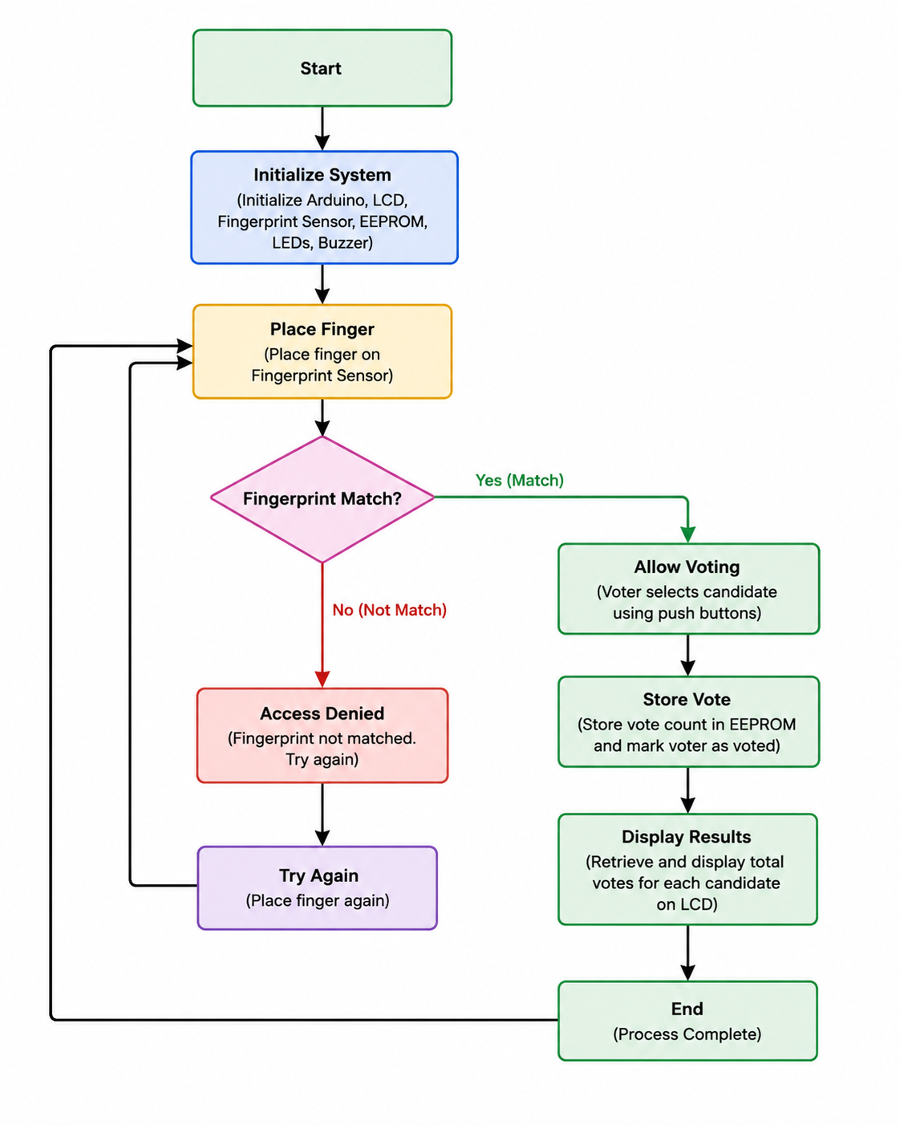

Business Impact

The Fingerprint Based Electronic Voting Machine (FEVM) is not just an embedded systems project—it represents a modern and secure approach to digital election management. By integrating biometric authentication with electronic voting, the system addresses critical issues such as voter impersonation, duplicate voting, manual verification delays, and election fraud. The project demonstrates how low-cost embedded technology can improve transparency, efficiency, and trust in voting systems across educational institutions, organizations, and future smart governance applications.

5.1 The Core Business Value: Solving the “Election Security and Trust” Problem
At its core, the FEVM solves one of the biggest challenges faced by traditional and electronic voting systems — ensuring secure and trustworthy voter authentication.
Current voting systems generally face two major limitations:
- Manual Verification-Based Voting Systems
Existing voting methods rely heavily on voter ID cards, polling officers, and manual checking processes. These methods are time-consuming and vulnerable to human error, fake voting, and impersonation.
- Traditional Electronic Voting Machines Without Biometric Security
Although EVMs improve vote counting speed and reduce paper usage, many systems still lack strong authentication mechanisms. This creates opportunities for unauthorized voting and duplicate voting attempts.

The integration of the R305 Fingerprint Sensor with the Arduino UNO creates a secure biometric verification system that directly addresses these issues. By allowing only authenticated and registered voters to cast votes, the FEVM establishes a secure and transparent voting environment.
The system creates a trusted digital election platform where:
- Voters gain confidence in fair election processes.
- Organizations receive accurate and tamper-resistant results.
- Election management becomes faster and more efficient.
In essence, the FEVM modernizes the voting process by combining biometric security, automation, and embedded technology into a reliable and scalable solution.

5.2 Impact on Key Stakeholders
For Voters and Users
The FEVM improves the voting experience by making elections more secure, transparent, and user-friendly.
- Improved Security and Trust
Fingerprint authentication ensures that only genuine voters can participate in elections, increasing confidence in election fairness.

- Faster Voting Process
Automated fingerprint verification reduces long queues and minimizes manual verification time.
- Simple and User-Friendly Interface
LCD displays, LEDs, buzzer alerts, and push-button voting make the system easy to operate for users.
- Prevention of Duplicate Voting
EEPROM-based voter tracking guarantees that each voter can cast only one vote.
- Quick Result Processing
Electronic vote storage and automatic counting provide instant and accurate election results.

5.3 Long-Term Market Impact
The FEVM has the potential to influence the future voting technology market in several ways:
- Encourages modernization of traditional voting systems.
- Promotes adoption of secure biometric authentication technologies.
- Increases public confidence in electronic voting systems.
- Reduces election fraud and operational inefficiencies.
- Creates opportunities for smart election infrastructure development.
- Supports environmentally friendly and paperless voting solutions.

Future Enhancements

Future improvements to the Fingerprint Based Electronic Voting Machine (FEVM) can significantly enhance its security, scalability, accessibility, and efficiency. By integrating advanced technologies such as cloud computing, Internet of Things (IoT), blockchain, and mobile authentication systems, the project can evolve from a small-scale embedded voting prototype into a modern smart election platform suitable for large-scale real-world applications.
- Cloud-Based Voting System:
Future versions of the FEVM can integrate cloud computing technology to store voter data and election results securely on cloud servers. Instead of relying only on local EEPROM memory, votes and voter records can be synchronized with a centralized cloud database in real time. This would enable:
  - Remote result monitoring and centralized election management
  - Secure backup of voting data
  - Faster result aggregation from multiple polling stations
  - Improved scalability for large elections
Cloud integration can also help election authorities access voting statistics and manage election operations more efficiently from different locations.
- IoT Integration:
The incorporation of Internet of Things (IoT) technology can transform the voting machine into a smart connected system. IoT-enabled FEVMs can communicate with centralized monitoring platforms through wireless technologies such as Wi-Fi or GSM modules. This enhancement would allow:
  - Real-time transmission of voting data
  - Remote health monitoring of voting machines
  - Instant alerts for system failures or unauthorized access attempts
  - Centralized management of multiple voting stations
IoT integration improves automation, operational efficiency, and remote accessibility of election systems.
- Blockchain-Based Security:
Blockchain technology can provide an additional layer of security and transparency for the voting process. By storing votes in a blockchain ledger, each vote becomes encrypted, time-stamped, and tamper-resistant. This can help:
  - Prevent modification or deletion of votes
  - Increase transparency and trust in election results

  - Create secure and verifiable voting records
  - Eliminate risks of data manipulation and cyberattacks
Blockchain-based voting systems can provide decentralized security, making elections more reliable and resistant to fraud.
- Mobile-Based Authentication Systems:
Future systems may include mobile application support for voter authentication and election management. Mobile integration can enable:
  - OTP-based voter verification
  - Mobile fingerprint or face authentication
  - Secure voter notifications and election updates
  - Remote voter registration and status checking
Mobile-based systems can improve user convenience and accessibility while maintaining secure authentication standards.
- Face Recognition Integration:
The system can be enhanced with AI-powered face recognition technology alongside fingerprint authentication for multi-factor biometric verification. This would improve voter identity accuracy and further reduce impersonation risks.
- Wireless Communication Modules:
Integrating Wi-Fi, Bluetooth, or GSM modules can allow wireless synchronization of election data between voting units and central servers, reducing dependency on physical data transfer.
- Advanced Data Analytics:
Future versions can include analytical dashboards for monitoring voter turnout, election trends, and system performance. These insights can help authorities manage elections more effectively.
- Touchscreen Interface:
Replacing push buttons with touchscreen displays can provide a more modern and interactive user experience while simplifying candidate selection and navigation.
- Solar Power Support:
Adding solar-powered backup systems can improve reliability in remote or rural areas where uninterrupted electricity supply may not always be available.
- Large-Scale Deployment Capability:
With improved networking, cloud infrastructure, and enhanced security mechanisms, the FEVM can be adapted for larger organizational or governmental elections requiring multiple interconnected voting stations.

Conclusion

The Fingerprint Based Electronic Voting Machine is a way to make voting more secure and honest. The old ways of voting often have problems like people voting than once or someone voting for someone else. The Fingerprint Based Electronic Voting Machine uses fingerprints to make sure only the right people can vote. Since everybodys fingerprints are different this makes voting a lot safer. Reduces cheating.

This project combines computers, fingerprint technology and memory into a small and efficient voting system. The Arduino UNO is like the brain of the system it checks fingerprints, records votes shows messages on a screen and stores information. The R305 Fingerprint Sensor is used to add and check fingerprints. The system also has a way for people to use it with messages on a screen, lights and sounds.

The Fingerprint Based Electronic Voting Machine is an alternative to the old ways of voting because it is safe, cheap and efficient. It automates the process of checking who is voting and counting the votes. This reduces the chance of error and makes it faster to get the results. The Fingerprint Based Electronic Voting Machine shows how biometric security and small computers can be used to make voting. In the future we can make it even better, by adding internet connection storing information online using security and letting people vote with their phones.

