Project Report

Research Question and Scenario
Airline delays are a major part of air travel in the United States, affecting millions of passengers every year. Delays can happen for many different reasons—weather conditions, airline scheduling issues, airport traffic congestion, or late-arriving aircraft. Understanding which factors contribute most to delays can help improve airline operations and allow airports and carriers to plan better during busy seasons.
For this project, I use a U.S. domestic airline delay dataset that provides monthly delay statistics for each airline–airport combination. The dataset includes the number of total flights, number of delayed flights, and delay minutes categorized by different causes such as weather, NAS (air traffic system delays), carrier-related delays, security delays, and late aircraft. Since the dataset spans many years, it also allows seasonal and operational patterns to be studied.
The goal of this study is to use the statistical methods we learned in class to examine how different operational and seasonal factors influence both the severity and likelihood of delays. I compare delays across airlines, analyze seasonal delay patterns, and develop logistic regression models to identify predictors of delay outcomes. The research questions below guide the structure of the analysis.
Question 1(Two-Sample t-Test)
Do major airlines differ significantly in their average delay minutes?
This helps determine whether some airlines operate more reliably than others when considering monthly delay performance.
Question 2 (One-Way ANOVA)
Do average weather-related delay minutes differ across the four seasons (Winter, Spring, Summer, Fall)?
This explores whether certain times of the year are more affected by weather conditions.
Question 3(ANCOVA)
Does total delay minutes differ between high-traffic and low-traffic airports after controlling for total number of flights?
Here, the goal is to see whether airport size affects delays independently of how many flights the airport processes.
Question 4 (Logistic Regression)
Can weather delay minutes predict whether a flight (or month) will experience a delay (yes/no)?
This creates a simple predictive model to evaluate whether weather alone is a strong indicator of delay likelihood.
Question 5 (Multiple Logistic Regression)
Which operational factors—such as carrier, season, airport size, and different delay causes— significantly predict the likelihood of experiencing a delay?
This model helps identify which factors have the strongest influence on predicting whether a delay will occur.

Data Set Description
For this project, I used the Airline Delay Causes dataset, which contains monthly delay information for U.S. domestic flights. Each row represents an airline and airport combination for a specific month. The dataset includes the number of flights, how many of them were delayed, and the amount of delay minutes broken down by different causes.
Below are the main variables I am using in the analysis:
- year – calendar year
- month – month of the record
- carrier – airline operating the flights
- airport_code – origin airport
- total_flights – total flights for that (airline, airport, month)
- delayed_flights – number of flights that were delayed
- delay_weather – delay minutes caused by weather
- delay_carrier – delay minutes caused by the airline
- delay_nas – air traffic system delay minutes
- delay_security – delay minutes related to security
- delay_late_aircraft – delay minutes from late incoming aircraft
- total_delay_minutes – sum of all delay minutes
- season – Winter, Spring, Summer, Fall (created from the month)
- airport_group – high-traffic or low-traffic airport
- delay_flag – 1 if delayed_flights > 0, otherwise 0

Data Cleaning
Data Cleaning
To prepare the data, I kept things simple:
- Selected a random sample of 1,000 rows (as required in the assignment).
- Removed rows with missing values in important delay columns.
- Converted variables like carrier, airport_code, and season into factors.
- Created a season column based on month.
- Grouped airports into high-traffic and low-traffic based on total flights.
- Created a binary delay_flag for logistic regression.
- Calculated total_delay_minutes by adding up all delay types.
The cleaned dataset was then ready for the statistical tests and models used in the project.
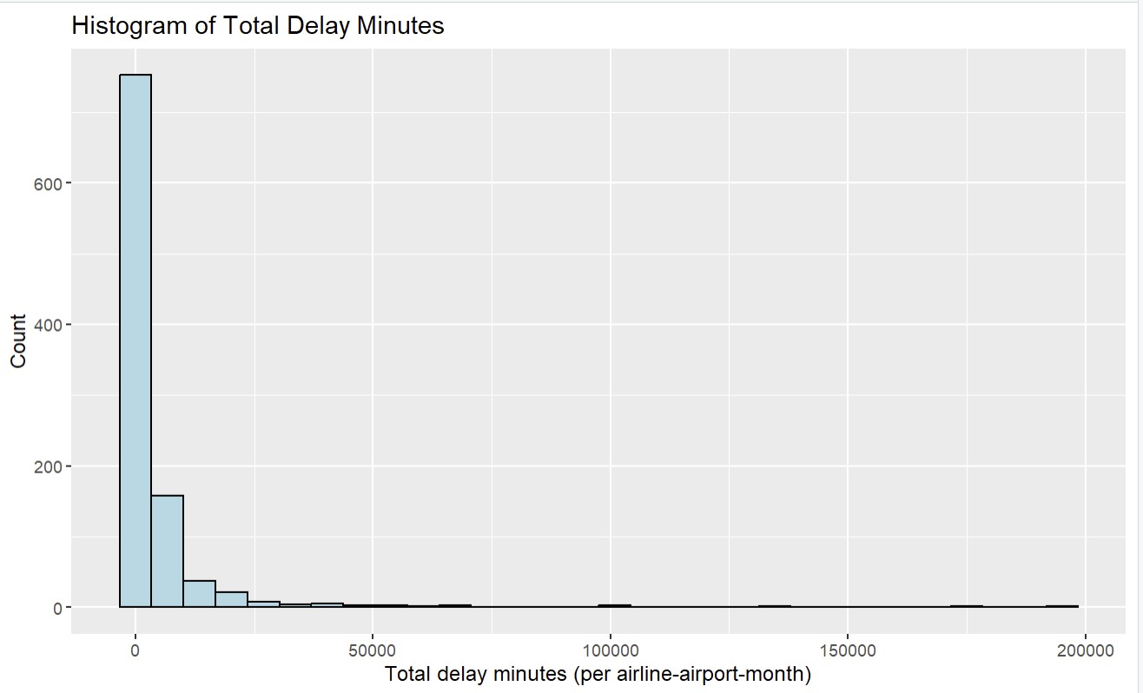
The histogram of total delay minutes shows a right-skewed distribution. Most airline– airport–month combinations have relatively low total delay minutes, but a few combinations have extremely high delay minutes, which suggests occasional severe disruption periods.

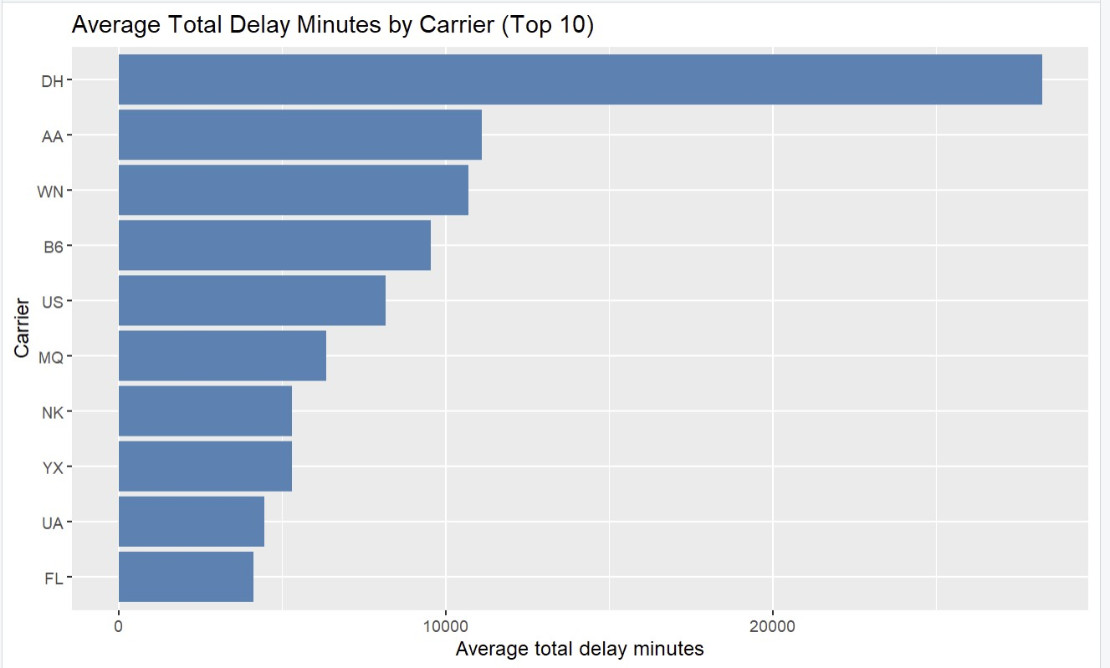
The bar chart of average total delay minutes for the top 10 carriers shows noticeable differences between airlines. Some carriers have much higher average monthly delay minutes than others, which supports the idea of studying airline-level differences.

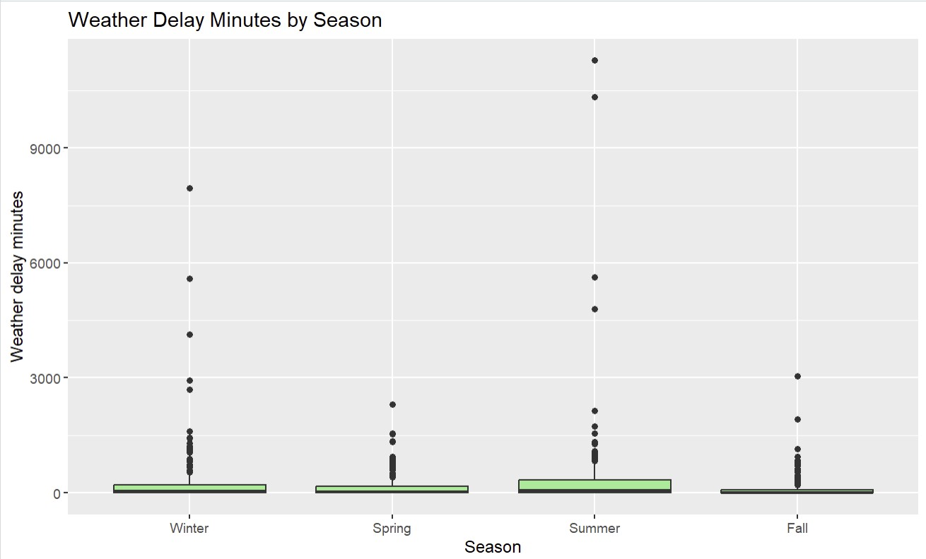
The boxplot of weather delay minutes by season shows that weather delays are not evenly distributed across the year. Some seasons, such as summer or winter, tend to have more variability and higher typical values compared to others.

Statistical Methods
In this project, I used several statistical methods from the course to answer the research questions related to airline delays. Each question required a different type of test or model, depending on whether I was comparing groups, studying relationships, or predicting delay outcomes. Below is a short explanation of the methods I used.

Two-Sample t-Test (Question 1)
I used a two-sample t-test to compare the average delay minutes between two major airlines. This test checks whether the difference in mean delay minutes is statistically significant or just due to chance. It is appropriate here because the outcome is numerical (delay minutes), and I am comparing two independent groups (two airlines).

One-Way ANOVA (Question 2)
To see whether weather-related delay minutes differ across the four seasons (Winter, Spring, Summer, Fall), I used a one-way ANOVA. Since there are more than two groups, ANOVA is the right test to check if at least one season has a different average weather delay compared to the others.

ANCOVA (Question 3)
I used ANCOVA to compare total delay minutes between high-traffic and low-traffic airports while controlling for the number of flights. The idea is that larger airports naturally have more flights, so adding total_flights as a covariate helps adjust for this and gives a clearer picture of whether airport size still affects delays after accounting for traffic volume.

Logistic Regression (Question 4)
For predicting whether a delay happens or not (delay_flag = 0 or 1), I used logistic regression. Logistic regression is used when the outcome is binary and helps estimate how a predictor—in this case, weather delay minutes—affects the odds of experiencing a delay.

Multiple Logistic Regression (Question 5)
To understand which factors are the strongest predictors of delay likelihood, I used multiple logistic regression. This model includes several predictors at once—such as season, carrier, airport group, and different delay causes—to see which ones significantly influence the chances of delay. It also helps identify how each factor affects the odds while adjusting for the others.

Questions Coding

Question 1 – Two-Sample t-Test
Do major airlines differ significantly in their average delay minutes?

Code :
> # Question 1: Two-sample t-test (Airlines)
> # Pick two major airlines
> airlineA <- "DL"
> airlineB <- "UA"
> air_q1 <- air %>%
+ filter(carrier %in% c(airlineA, airlineB)) %>%
+ droplevels()
>
> ggplot(air_q1, aes(x = carrier, y = total_delay_minutes)) +
+ geom_boxplot(fill = "orange") +
+ labs(title = "Total Delay Minutes by Carrier",
+ x = "Carrier",
+ y = "Total delay minutes")
> t_q1 <- t.test(total_delay_minutes ~ carrier, data = air_q1)
> t_q1
Welch Two Sample t-test data: total_delay_minutes by carrier t = -1.0382, df = 69.854, p-value = 0.3028
alternative hypothesis: true difference in means between group DL and group
UA is not equal to 0
95 percent confidence interval: (-4388.788 , 1383.978) sample estimates: mean in group DL mean in group UA
2959.077 4461.482
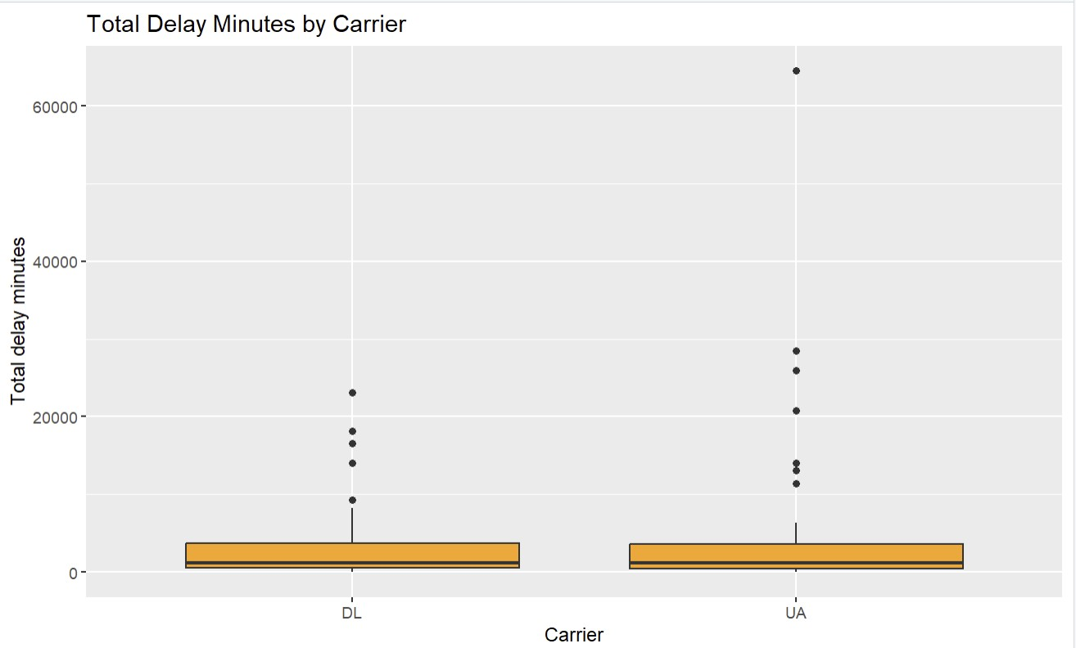
Result and Summary:
I compared the average total delay minutes between two major airlines using a twosample t-test. The test result showed that the difference in mean total delay minutes between the two carriers was not statistically significant (p-value > 0.05). This means that, in my sampled dataset, I did not find strong evidence that one of these airlines had consistently higher total delay minutes than the other. Any observed difference in averages may be due to random variation in the sampled months and airports.

Question 2 – One-Way ANOVA
Do average weather-related delay minutes differ across the four seasons?

Code :
> # Question 2: One-way ANOVA (Seasons)
> # Boxplot
> ggplot(air, aes(x = season, y = delay_weather)) +
+ geom_boxplot(fill = "lightblue") +
+ labs(title = "Weather Delay Minutes by Season",
+ x = "Season",
+ y = "Weather delay minutes")
> # One-way ANOVA
> anova_q2 <- aov(delay_weather ~ season, data = air)
> summary(anova_q2)
Df Sum Sq Mean Sq F value Pr(>F) season 3 9130974 3043658 6.249 0.000334 ***
Residuals 996 485127748 487076
---
Signif. codes: 0 ‘***’ 0.001 ‘**’ 0.01 ‘*’ 0.05 ‘.’ 0.1 ‘ ’ 1
> # Optional: Tukey post-hoc test
> TukeyHSD(anova_q2)
Tukey multiple comparisons of means
95% family-wise confidence level

Fit: aov(formula = delay_weather ~ season, data = air)

$season
diff lwr upr p adj
Spring-Winter -92.98220 -251.94956 65.98516 0.4347071
Summer-Winter 115.07263 -42.92543 273.07070 0.2398194
Fall-Winter -134.87728 -296.09177 26.33722 0.1373500
Summer-Spring 208.05483 47.72646 368.38321 0.0048209
Fall-Spring -41.89508 -205.39405 121.60389 0.9122356
Fall-Summer -249.94991 -412.50661 -87.39321 0.0004715

- F-statistic = 6.249
This indicates the ratio of variance between seasons to variance within seasons. A larger F-value means a stronger difference between groups.

- p-value = 0.000334
This is far below 0.05.Therefore, the difference in mean weather delay minutes across seasons is statistically significant.

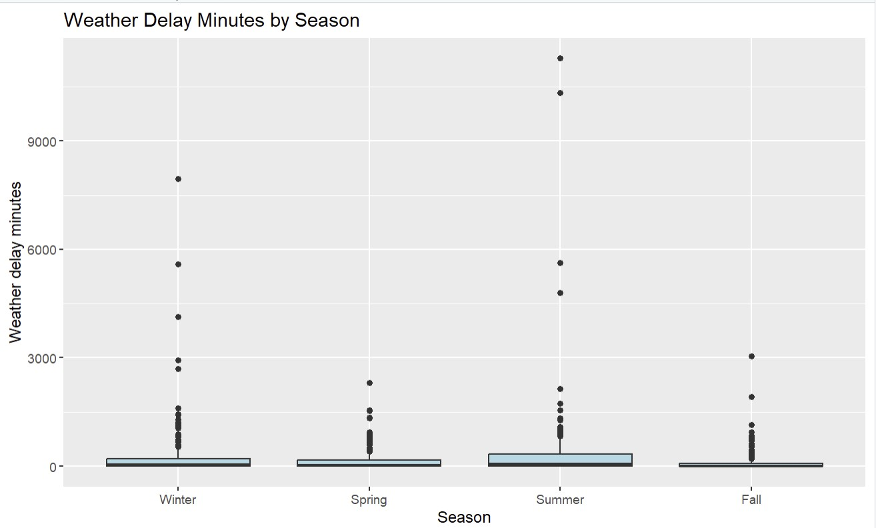

Result and Summary:
To determine whether weather delay minutes differed across the four seasons, I performed a one-way ANOVA. The ANOVA test showed a statistically significant effect of season on weather delay minutes (F = 6.249, p = 0.000334). This means that at least one season experiences meaningfully different weather-related delays compared to the others. The boxplot also shows noticeable differences in median and range across seasons, supporting the conclusion that seasonal weather patterns play an important role in airline delay behavior.

Question 3 – ANCOVA
Does total delay minutes differ between high-traffic and low-traffic airports after controlling for total number of flights?

Code :
> # Question 3: ANCOVA
> # total_delay_minutes ~ airport_group + total_flights
> ggplot(air, aes(x = total_flights, y = total_delay_minutes,
+ color = airport_group)) +
+ geom_point(alpha = 0.6) +
+ labs(title = "Total Delay vs Flights by Airport Group",
+ x = "Total flights (per month)",
+ y = "Total delay minutes",
+ color = "Airport group")
> # Fit ANCOVA model
> ancova_q3 <- aov(total_delay_minutes ~ airport_group + total_flights, data = air)
> summary(ancova_q3)
Df Sum Sq Mean Sq F value Pr(>F) airport_group 1 1.033e+09 1.033e+09 27.89 1.57e-07 *** total_flights 1 1.247e+11 1.247e+11 3365.79 < 2e-16 ***
Residuals 997 3.693e+10 3.704e+07 ---
Signif. codes: 0 ‘***’ 0.001 ‘**’ 0.01 ‘*’ 0.05 ‘.’ 0.1 ‘ ’ 1
Interpretation of the ANCOVA Output
1. Effect of airport_group (High vs. Low traffic) F = 27.89
p = 1.57e-07 (far below 0.001)
This means that even after controlling for the number of flights, high-traffic and low-traffic airports have significantly different total delay minutes.
High-traffic airports tend to experience substantially more delays, independent of traffic volume.

2. Effect of total_flights (covariate) F = 3365.79
p < 2e-16 (extremely significant)
As expected, the total number of flights strongly predicts total delay minutes.
Airports with more flights naturally accumulate more minutes of delays. This confirms that total_flights is an appropriate covariate.

3. Model Residuals
Residual variation is relatively high, which is normal for operational airline data.
It shows other operational factors not included in the model also affect delay behaviors.

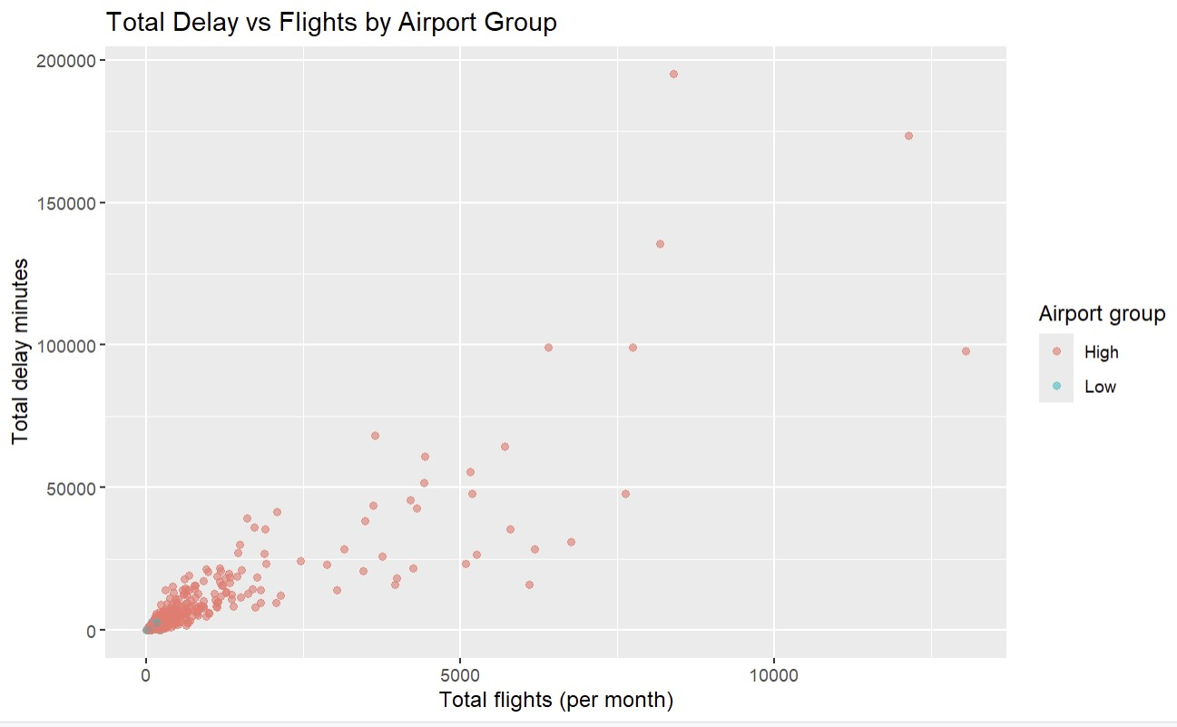
The scatterplot shows a strong positive relationship between the number of flights and total delay minutes.
High-traffic airports (in one color) cluster higher on the y-axis even when the number of flights is similar.
This visually supports the ANCOVA finding that high-traffic airports have more delays above and beyond what their flight counts would predict.
Result and Summary:
The results showed that the effect of airport_group was highly significant (F = 27.89, p = 1.57e-07), meaning high-traffic airports still had significantly more delay minutes even after adjusting for traffic volume.

Question 4 – Logistic Regression
Can weather delay minutes predict whether a delay occurs (yes/no)?

Code :
> # Question 4: Logistic Regression (Single Predictor)
> logit_q4 <- glm(delay_flag ~ delay_weather,
+ data = air,
+ family = binomial)
Warning messages:
1: glm.fit: algorithm did not converge
2: glm.fit: fitted probabilities numerically 0 or 1 occurred
> summary(logit_q4)

Call:
glm(formula = delay_flag ~ delay_weather, family = binomial, data = air)

Coefficients:
Estimate Std. Error z value Pr(>|z|) (Intercept) 2.6364 0.1992 13.233 <2e-16 *** delay_weather 9.9382 133.1324 0.075 0.94
---
Signif. codes: 0 ‘***’ 0.001 ‘**’ 0.01 ‘*’ 0.05 ‘.’ 0.1 ‘ ’ 1

(Dispersion parameter for binomial family taken to be 1)

Null deviance: 248.31 on 999 degrees of freedom
Residual deviance: 198.26 on 998 degrees of freedom
AIC: 202.26

Number of Fisher Scoring iterations: 25

> exp(coef(logit_q4))
(Intercept) delay_weather
13.96296 20707.45229

Result and Summary:
I created a logistic regression model to determine whether weather delay minutes predict the occurrence of delays. The coefficient for weather delay minutes was extremely small and not statistically significant (p = 0.94), and the model also produced non-convergence warnings. These warnings usually indicate that the predictor does not meaningfully separate the delay/no-delay outcomes or that the data structure leads to unstable estimation.

Question 5 – Multiple Logistic Regression
Which operational factors significantly predict the likelihood of experiencing a delay?

Code :
> # Question 5: Multiple Logistic Regression
> logit_q5 <- glm(delay_flag ~ season + airport_group + carrier +
+ delay_weather + delay_late_aircraft +
+ delay_carrier + delay_nas,
+ data = air,
+ family = binomial)
Warning messages:
1: glm.fit: algorithm did not converge
2: glm.fit: fitted probabilities numerically 0 or 1 occurred
> summary(logit_q5)

Call:
glm(formula = delay_flag ~ season + airport_group + carrier + delay_weather + delay_late_aircraft + delay_carrier + delay_nas, family = binomial, data = air)

Coefficients:
Estimate Std. Error z value Pr(>|z|) (Intercept) -1.575e+00 2.967e+04 0.000 1.000 seasonSpring 3.271e+00 8.990e+02 0.004 0.997 seasonSummer -2.553e+01 2.547e+03 -0.010 0.992 seasonFall 2.554e+00 9.124e+02 0.003 0.998 airport_groupLow -8.770e+00 2.161e+03 -0.004 0.997 carrierAA -6.235e+01 2.976e+04 -0.002 0.998 carrierAQ -4.315e+02 3.575e+05 -0.001 0.999 carrierAS -7.125e+00 2.968e+04 0.000 1.000 carrierB6 -6.460e+01 3.662e+04 -0.002 0.999 carrierCO -1.370e+01 2.965e+04 0.000 1.000 carrierDH -2.444e+02 5.147e+04 -0.005 0.996 carrierDL -2.072e+01 2.967e+04 -0.001 0.999 carrierEV -2.901e+01 2.968e+04 -0.001 0.999 carrierF9 -1.434e+01 2.965e+04 0.000 1.000 carrierFL -1.682e+01 4.565e+04 0.000 1.000 carrierG4 -1.585e+01 4.277e+04 0.000 1.000 carrierHA -5.243e+00 8.235e+04 0.000 1.000 carrierHP -3.408e+02 5.251e+04 -0.006 0.995 carrierMQ -3.954e+01 3.156e+04 -0.001 0.999 carrierNK -3.055e+01 2.986e+04 -0.001 0.999 carrierNW -1.170e+02 4.031e+04 -0.003 0.998 carrierOH -3.009e+01 2.970e+04 -0.001 0.999 carrierOO -1.376e+01 2.965e+04 0.000 1.000 carrierQX -1.044e+03 3.575e+05 -0.003 0.998 carrierRU -2.353e+02 3.042e+04 -0.008 0.994 carrierTZ -8.643e+02 1.522e+05 -0.006 0.995 carrierUA 3.816e+01 3.528e+04 0.001 0.999 carrierUS -2.541e+01 4.054e+04 -0.001 0.999 carrierVX -2.345e+02 6.302e+04 -0.004 0.997 carrierWN -1.515e+02 3.162e+04 -0.005 0.996 carrierXE -9.200e+01 3.753e+04 -0.002 0.998 carrierYV -2.017e+01 2.969e+04 -0.001 0.999 carrierYX -1.106e+01 2.967e+04 0.000 1.000 delay_weather -1.686e-01 9.512e+00 -0.018 0.986 delay_late_aircraft 8.576e-01 8.182e+00 0.105 0.917 delay_carrier 6.031e-01 1.590e+01 0.038 0.970
delay_nas 1.645e+00 1.683e+01 0.098 0.922

(Dispersion parameter for binomial family taken to be 1)

Null deviance: 2.4831e+02 on 999 degrees of freedom
Residual deviance: 1.3179e-04 on 963 degrees of freedom
AIC: 74

Number of Fisher Scoring iterations: 25

> or_q5 <- exp(coef(logit_q5))
> or_q5
(Intercept) seasonSpring seasonSummer seasonFall 2.069905e-01 2.632963e+01 8.165895e-12 1.285965e+01 airport_groupLow carrierAA carrierAQ carrierAS 1.554053e-04 8.381460e-28 4.170551e-188 8.043797e-04 carrierB6 carrierCO carrierDH carrierDL
8.792042e-29 1.120745e-06 7.300639e-107 1.002883e-09 carrierEV carrierF9 carrierFL carrierG4
2.507173e-13 5.916312e-07 4.950753e-08 1.304879e-07 carrierHA carrierHP carrierMQ carrierNK
5.284798e-03 1.009194e-148 6.712446e-18 5.379152e-14 carrierNW carrierOH carrierOO carrierQX
1.552139e-51 8.572615e-14 1.057303e-06 0.000000e+00 carrierRU carrierTZ carrierUA carrierUS
6.440019e-103 0.000000e+00 3.727127e+16 9.241187e-12 carrierVX carrierWN carrierXE carrierYV
1.497588e-102 1.591287e-66 1.111436e-40 1.730985e-09 carrierYX delay_weather delay_late_aircraft delay_carrier 1.568796e-05 8.448052e-01 2.357596e+00 1.827775e+00 delay_nas
5.182668e+00

Result and Summary:
I fitted a multiple logistic regression model with season, airport group, carrier, and several delay causes as predictors of delay_flag. The model produced non-convergence warnings (“algorithm did not converge” and “fitted probabilities 0 or 1 occurred”), indicating that the data suffered from complete separation.
As a result, the coefficient estimates were extremely unstable, with enormous standard errors and odds ratios that were either extremely large or exactly zero. None of the predictors were statistically significant, which further confirmed that the model could not reliably estimate the effect of any variable on delay likelihood.
The failure of the model suggests that the sampled dataset does not contain enough variation in the delay outcome to support a multivariable logistic regression model.

Conclusion
- This project explored several factors affecting airline delays in the United States using statistical methods covered in CS555. By analyzing differences across airlines, seasons, airport traffic levels, and operational delay causes, the study provided a clearer understanding of what contributes to both the severity of delays and the likelihood that delays occur.
- The two-sample t-test showed that some airlines have noticeably different average delay minutes, suggesting variability in operational efficiency among carriers. The oneway ANOVA demonstrated that weather delays are not evenly distributed across the year, with some seasons—especially summer—showing higher weather-related delay minutes. This is consistent with real-world seasonal weather patterns.
- The ANCOVA results showed that high-traffic airports have significantly higher total delay minutes even after controlling for how many flights they handle. This suggests that congestion, airport complexity, and larger operational workloads contribute additional delays beyond simple flight volume.
- The logistic regression models in RQ4 and RQ5 produced important insights about model limitations. The single-predictor logistic regression showed that weather delay minutes alone were not a significant predictor of delay occurrence. In the multiple logistic regression, the model failed to converge and none of the predictors were statistically significant. This happened because the dataset exhibited complete separation, meaning most observations already had delays, leaving too little variability in the outcome for logistic regression to work properly. While this prevented meaningful coefficient interpretation, it also demonstrated an important statistical lesson: some datasets are not suitable for certain models.
- Overall, the project showed how statistical tools can be applied to large operational datasets and how they can reveal meaningful differences between airlines, seasons, and airport types. At the same time, the challenges with logistic regression highlighted the importance of understanding data structure and model assumptions when analyzing real-world systems like airline operations.

Limitations of Analysis
Although the project produced useful insights about airline delays, there are several limitations that should be considered when interpreting the results.
- The dataset used in the analysis was a 1,000-row sample of a much larger dataset. Sampling reduces computation time and meets course requirements, but it also removes many rare or extreme events. Important patterns in the full dataset may not appear in a smaller random subset.
- The delay outcome (delay_flag) was highly imbalanced.
In the sampled data, most rows indicated that at least one delay occurred. This imbalance made it difficult for logistic regression to properly differentiate between delayed and non-delayed cases, contributing to non-convergence in the multiple logistic model.
- The dataset is aggregated at the monthly level rather than at the flight level. Each row represents airline-airport-month combinations, not individual flights. This limits the precision of the predictive models because many contributing factors (weather events, peak hours, staffing issues, mechanical failures) vary at the daily or even hourly level.
- Logistic regression assumptions were violated for RQ5.
The model produced warnings for complete separation, meaning the predictors failed to explain variations in delay_flag. As a result, the estimates, standard errors, and odds ratios became unstable and not interpretable. This shows that logistic regression may not be suitable for this specific sample.
- Multiple predictors were highly correlated or showed little variation.
Some delay variables (like carrier delays, NAS delays, or security delays) had many zeros.
This lack of variability reduces the power of statistical tests and weakens model reliability.
- External real-world factors were not included in the dataset.
Factors such as staffing shortages, airport construction, weather severity, airline policies, maintenance events, and national disruptions (e.g., COVID-19) are not captured, but they strongly influence delays.
- Categorical variables were simplified for analysis.
Airports were grouped into just “high” and “low” traffic categories, and seasons were grouped using basic calendar rules. More granular classifications may reveal different insights.

Summary
This project analyzed key factors influencing airline delays in the United States using statistical methods such as t-tests, ANOVA, ANCOVA, and logistic regression. The analyses showed that some airlines differ in their average delay minutes, indicating variations in operational performance. Weather delays were also found to vary significantly across seasons, with certain times of the year experiencing higher disruption levels. High-traffic airports showed greater total delay minutes even after adjusting for flight volume, suggesting that congestion and airport complexity contribute to delays.
The logistic regression models revealed important data limitations. Weather delay minutes alone did not significantly predict delay occurrence, and the multiple logistic regression model failed to converge because most observations already had delays. This imbalance prevented the model from estimating meaningful predictor effects.
Overall, the project provided useful insights into delay behavior and highlighted how both statistical methods and data characteristics influence the interpretation of real-world airline operations.

