**Recognizing Traffic Signs**

* Speed limit
* Turn right/left
* No passing
* No passing for vehicle 3.5 meters
* 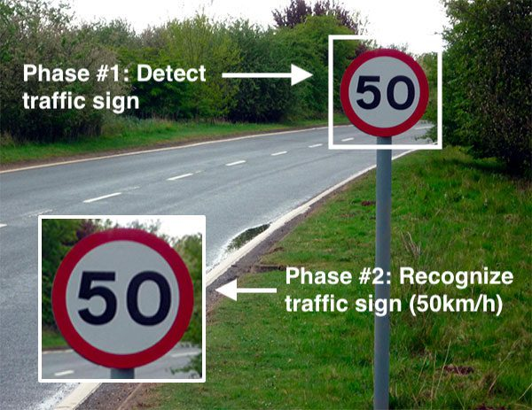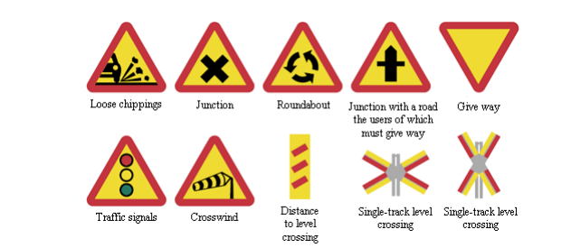CNN and Keras library

*Research Paper:*

Traffic sign detection and recognition based on convolutional neural networks

**Emotion recognition software**

* Support Vector Machine
* [RNN](https://www.upgrad.com/blog/recurrent-neural-network-in-python/) algorithm
* Convolutional Neural Network
* Vox celebrity dataset (For training)
* The Librosa package (For extract and classify audio samples)

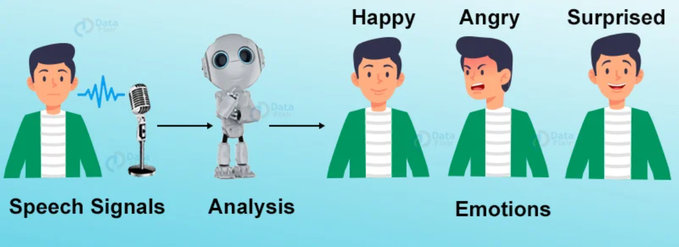

#### Relevant:

#### Gender and Age Detection with Data Science

*Research Paper:*

A Study on Emotion Recognition Method and Its Application using Face Image

(Angry, Disgust, Fear, Happy, Sad, Surprise, and Neutral)

#### **Android Chabot**

* Understand users’ queries and the intent behind them
* Analyze the keywords and generate an appropriate response
* Sports, health, education, entertainment, etc.

*Research Paper:*

# An android Chabot application for human interaction

#### **Online examination and evaluation system**

* Admission test online
* Multiple-choice options, and built-in AI verifies the answers
* Immediately results
* Generate a list of colleges fit for a student
* Quick and hassle-free process

*Research Paper:*

Secure Online Examination System for e-learning

#### **Driver Drowsiness detection**

* Detect sleepy drivers and also alert them by beeping alarm

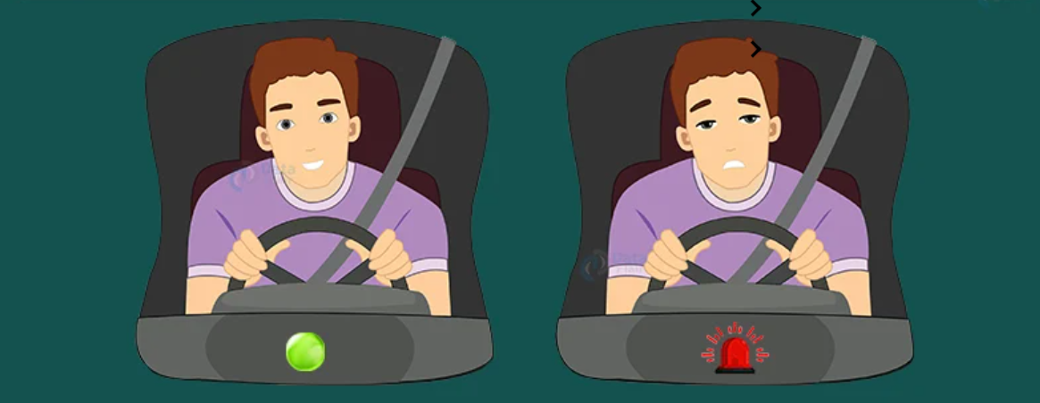

#### Relevant:

Road Lane Line Detection

*Research Paper:*

Driver Drowsiness Detection

#### **Image Caption Generator Project**

* Understand what is in the image
* Generating the description in Natural language
* 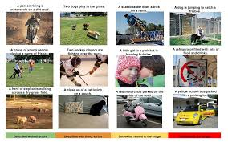(CNN) with Recurrent Neural Network (LSTM)