# Instructions for how to compile and run the software

**Prerequisites**

* Before compiling and running the software, ensure that you have the following prerequisites installed on your system:
* **Visual Studio 2022**: You will need to have Visual Studio installed to compile and run the software.

**Unzipping the Folder**

* **Download the Zip File:**
  + Download the zip file containing the project files from the provided link or from my GitHub link repository.
* **Extract the Folder:**
  + Locate the downloaded zip file on your computer.
  + Right-click on the zip file and select "Extract All" from the context menu.
  + Choose the destination folder where you want to extract the files which should be under a similar location like this (C:\Users\sufi\source\repos).
  + Click on the "Extract" button to unzip the folder.

**Compilation Steps**

Follow these steps to compile the software:

**1. Open Solution in Visual Studio:**

* Navigate to the directory where you extracted the folder.
* Open the solution file (`RecipeApplicationWPF.sln`) in Visual Studio.

**2. Build the Solution:**

* Once the solution is opened in Visual Studio, build the solution by selecting `Build > Build Solution` from the menu bar.

**Running the Software**

After successfully compiling the software, follow these steps to run it:

**1. Set Startup Project:**

* In Visual Studio, set the startup project to `RecipeApplicationWPF`.

**2. Run the Application:**

* Press F5 or click on the Start button in Visual Studio to run the application.
* The application should launch, displaying the main menu.

**Using the Application**

1. **Main Menu:**

* When you launch the application, you will see the main menu on the left with several options:
* Enter a new Recipe: Add a new recipe by providing details like the recipe name, ingredients and cooking steps.
* Display a Recipe: View all saved recipes, filter them based on ingredients, food groups, and max calories, and view detailed steps and ingredients.
* Scale a Recipe: Adjust the quantities of ingredients in a recipe by scaling factors (0.5, 2, 3).
* Reset Quantities: Restore the original quantities of ingredients in a recipe.
* Clear All Data: Remove all recipes from the application.
* Exit: Close the application.

1. **Entering Recipes:**

* Click "Enter a new Recipe" and follow the prompts to input the recipe name, number of ingredients, and number of steps. Enter details for each ingredient and each step. Save the recipe when finished.

1. **Displaying Recipes:**

* Click "Display a Recipe" to view and filter recipes. Select a recipe to see detailed information including ingredients, steps, and total calories.

1. **Scaling Recipes:**

* Click "Scale a Recipe", select a recipe, and choose a scaling factor. The ingredient quantities will be adjusted accordingly.

1. **Resetting Quantities:**

* Click "Reset Quantities", select a recipe, and confirm to reset the ingredient quantities to their original values.

1. **Clearing Data:**

* Click "Clear Data" and confirm to remove all recipes from the application.

1. **Exiting the Application:**

* Click "Exit" and confirm to close the application.

**Additional Notes**

* If you encounter any issues during the compilation of the software, please refer to the User Manual in this zipped file for in depth detail on how to run the application.

# Link to the GitHub Repository

You can find all the source code for this project on my GitHub repository:

<https://github.com/Sufyaan-Cassim/Recipe_Application_WPF_POE.git>

# A brief description of the lecturer’s feedback

Based on the lecturer’s feedback, several improvements were made to enhance the functionality and usability of the Recipe Application:

1. **User Interface Enhancements:**

* Converted the recipe application from a console version to a user interface using WPF.
* Improved the layout and formatting of the recipe display to ensure steps and ingredients are clearly shown.
* Added checkboxes for steps to allow users to mark them off as they complete each step, making the cooking process more interactive.

1. **Functionality Improvements:**

* Implemented a filtering functionality for recipes based on ingredient name, food group, and maximum number of calories.

1. **Error Handling and Feedback:**

* The application checks for invalid or missing inputs when adding a new recipe. Users are prompted to fill in all required fields, such as recipe name, ingredients, and steps.
* Added confirmation messages for actions like scaling, resetting, and clearing data to ensure user awareness of changes.
* When adding ingredients, the application verifies that each ingredient's details are complete and correctly formatted. This includes checking that the ingredient name, amount, measurement unit, food group, and calories are all provided.

# GitHub commit history screenshots

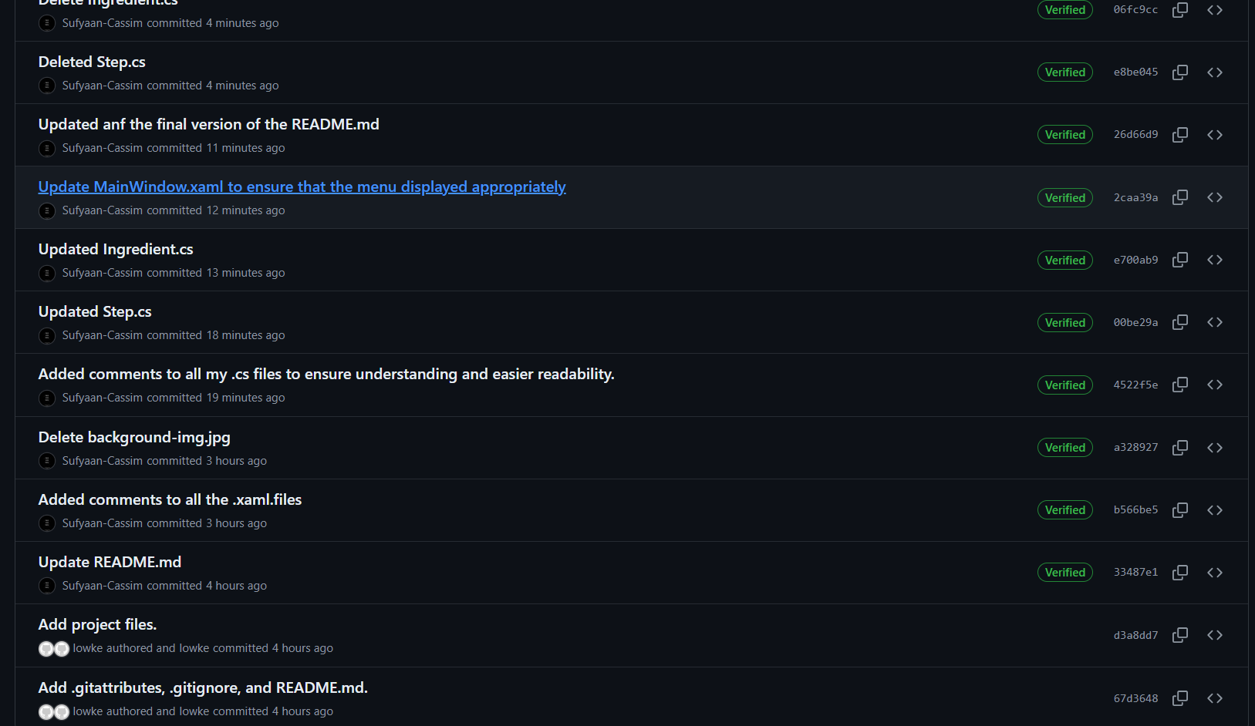

A total of 17 commits were made.