

l.

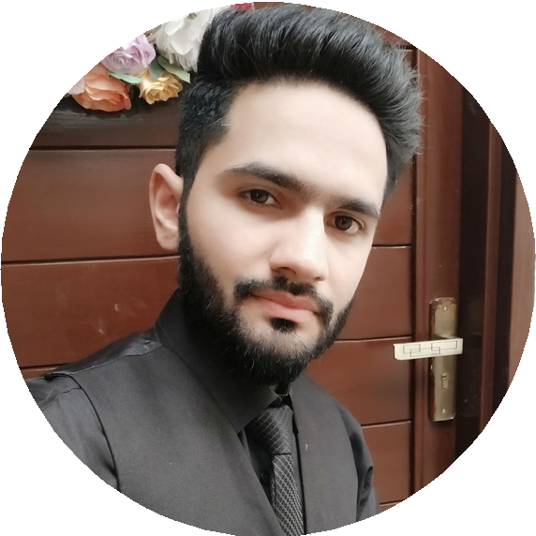

SUFYAN **F AROOQ**

F R O N T E N D W E B D E V E L O P E R

|  |  |
| --- | --- |
| +92-306-1863600  [sufyanfarooq68@gmail.com](mailto:sufyanfarooq68@gmail.com)  Nighabanpura, St# C Block, H#551, Faisalabad  [Sufyanfarooq68@gmail.com](mailto:Sufyanfarooq68@gmail.com) | **P R O F I L E**  I am a qualified and professional web developer with 2 years of experience in front-end web development and adobe photoshop. Strong creative and analytical skills. Team player with an eye for detai |
| **S K I L L S** | **E X P E R I E N C E**  **FRONT- END WEB DEVELOPER**  Really Great Work  HTML5 CSS3  JAVASCRIPT (BASIC) BOOTSTRAP5  PSD TO HTML  **ONLINE WEB PROJECT**  Really Great work https://sufyanfarooq68.github.io/CV/ https://sufyanfarooq68.github.io/done/  https://sufyanfarooq68.github.io/design.github.io/  **PERSONAL INFORMATION**  Father’s Name: Muhammad Farooq Nationality: Pakistani  N.I.C. #: 33303-9026502-5  Date of Birth: 25/05/1995 Marital Status: Single  Religion: Islam |
| Web Design |
| Design Thinking |
| Wireframe Creation |
| Front End Coding |
| Problem-Solving |
| Computer Literacy |
| Project Management Tools |
| Strong Communication |
| **E D U C A T I O N** |
| **MATRIC ( ARTS)** |
| BISE FAISALABAD  2012 - 2014 |
| **INTERMEDIATE ( I . C. S)** |
| BISE FAISALABAD  2018 - 2019 |



