**Assignment 1 – A Synopsis on Process Improvement and Capability Maturity Model**

**Muhammad Sufyan Siddiqui**

**18K-1161**

**Section C**

**Software Engineering**

# **Capability Maturity Model (CMM)**

Capability Maturity Model is used as a benchmark to measure the maturity of an organization's software process.

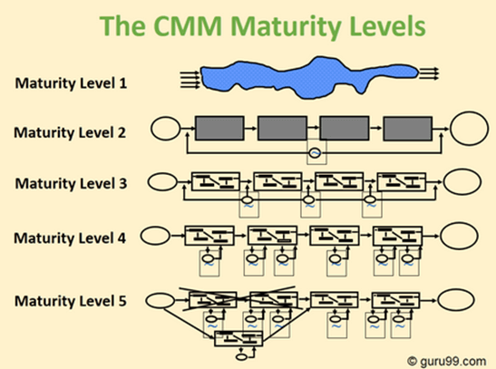

A visual representation of how the CMM works.

## **History**

It was developed at the Software engineering institute in the late 80's as a result of a study to evaluate the work of subcontractors.

## **Levels**

Each maturity level comprises a set of process goals that, when satisfied, stabilize an important component of the process. Achieving each level of maturity framework establishes a different component in the software process, resulting in an increase in the process capability of the organization.

The levels of CMM are:

* **Initial**
* **Repeatable/Managed**
* **Defined**
* **Quantitatively Managed**
* **Optimizing**

### **Level 1 – Initial**

the process is usually chaotic and ad hoc. A capability is characterized on the basis of the individuals and not of the organization. Progress is not measured. Products developed are often schedule and over budget. Wide variations exist in the schedule, cost, functionality, and quality targets.

### **Level 2 – Managed/Repeatable**

A basic and consistent project management processes to track cost, schedule, and functionality. The process is in place to repeat the earlier successes on projects with similar applications. Program management is a key characteristic of a level two organization.

### **Level 3 – Defined**

The software process for both management and engineering activities are documented, standardized, and integrated into a standard software process for the entire organization and all projects across the organization use an approved, tailored version of the organization's standard software process for developing, testing and maintaining the application.

### **Level 4 – Quantitatively Managed**

A quantitative quality goal for both software process and software maintenance is set. At this maturity level, the performance of processes is controlled using statistical and other quantitative techniques, and is quantitatively predictable.

### **Level 5 – Optimizing**

Focuses on continually improving process performance through both incremental and innovative technological improvements. At this level, changes to the process are to improve the process performance and at the same time maintaining statistical probability to achieve the established quantitative process-improvement objectives.

## **Implementation Duration**

CMM takes quite a long time in any organization in implementing.

It usually takes 6 Months to 1 year in implementation and thus ending up a long process.

## **References:**

* [Guru99](https://www.guru99.com/capability-maturity-model-cmm-cmm-levels-a-fool-s-guide.html)
* [TutorialsPoint](https://www.tutorialspoint.com/software_testing_dictionary/capability_maturity_model.htm)
* [ITGovernanceAsia](https://www.itgovernance.asia/capability-maturity-model)