|  |  |
| --- | --- |
| **Sprouts : money manager and budget**  **User Guide** | Abstract  **This document contains all the information of the application including the description of each functionality it performs along with the procedure to make the most out of the functionalities**  Sufyan Siddiqui, Muhammad Mudassir & Ammarah Abid  **18K-1161, 18K-1042, 18K-0214** |

Table of Contents

1. Introduction 2

2. Features (Version 8.9.2) 2

3. Functions 3

3.1. Installation 3

3.2. How to Use 4

3.2.1. Registration 4

3.2.2. Add Account 5

3.2.3. Add Transaction 6

3.2.4. Add Cycle Transaction 9

3.2.5. Add Monthly Budget 12

3.2.6. Statistical Analysis 13

3.2.6.2. Daily Trend 13

3.2.6.3. Monthly Stat 14

3.2.7. Book Management 14

3.2.8. Profile Management 15

3.2.9. Invite Member 16

3.3. Settings 16

3.3.1. Account 17

3.3.2. Options 18

3.3.3. Security Settings 19

3.3.4. Backup Settings 20

3.3.5. Sync Settings 21

4. Language 22

5. Troubleshooting/FAQs 23

6. System Requirements 23

7. Contact Us 23

# Introduction

Sprouts is an application that falls in the category of Finance. It is a virtual assistant designed to keep track of your budget, transactions, assets, liabilities and your bills. Sprouts intelligently manages your finance by providing you with the strong statistical analysis for daily till monthly usage of your finances. It also enables you to make books of different types along with the support for multi-user interface and multi-currency management at one place.

# Features (Version 8.9.2)

The features of Sprouts are listed below:

* **Account Tracking**
* Net Assets
* Assets
* Liabilities
* Debit Card
* Credit Card
* Cash
* Online Payment Account
* Investment Account
* Account Receivable
* Account Payable
* **Budget Management**
* Income
* Expense
* Surplus
* Average Left
* Total Left
* **Accounts Management**
* Add Accounts
* Multi-Currency
* Multi-Users
* Net Assets
* Multiple Categories’ Accounts
* Hide/Show Account Details
* **Statistical Analysis**
* Category Stats
* Daily Trends
* Monthly Stats
* Custom Stats
* Descriptive Tags
* **Advanced**
* Daily Savings
* Monthly Savings
* Yearly Savings
* Total Monthly Budget
* Daily Use
* Cycle Transactions
* Installments
* Reimbursements
* Borrowings
* Lending
* Financial Contacts
* **User Settings**
* Profile
* Invite Member
* Reminders
* Exchange Rates
* Feedback
* General Settings

# Functions

The Major Functions of Sprouts are described below

## Installation

* Go to Google Play Store
* Search for ‘Sprouts : Money Manager and Budget’
* Tap on Install
* The product is installed

## How to Use

### Registration

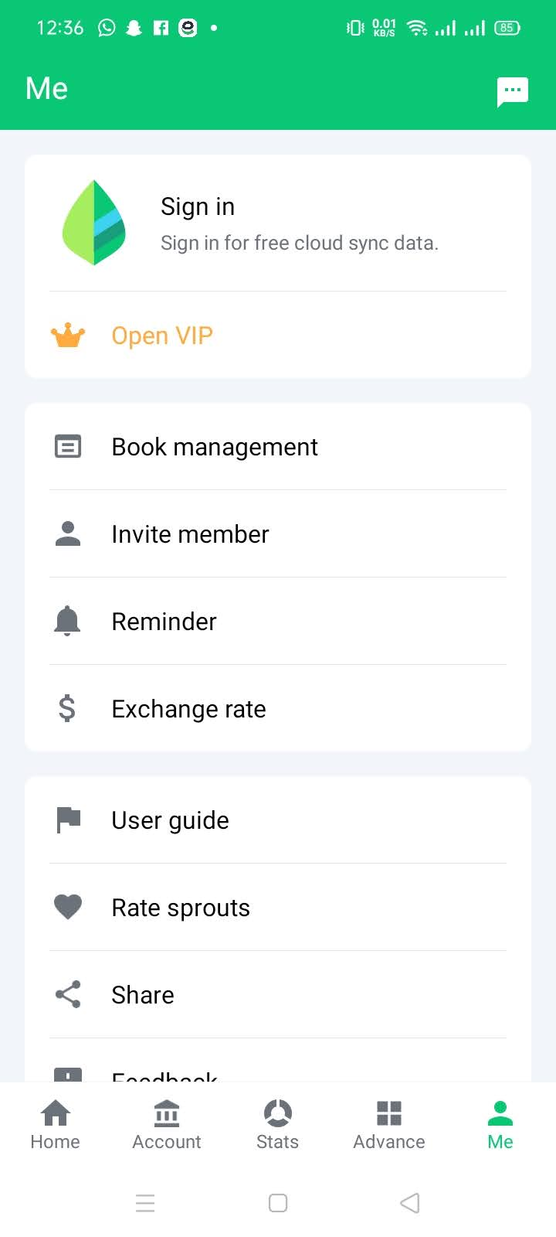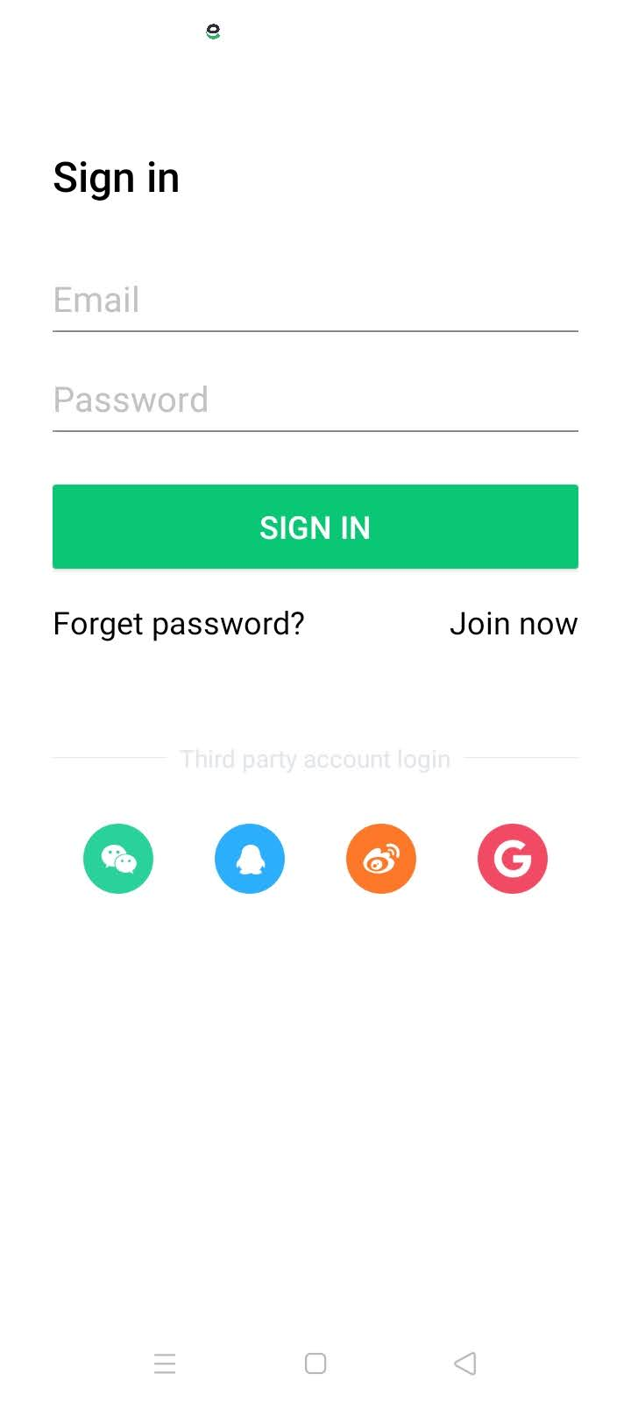

* Open Sprouts application
* On the bottom navigation bar, tap on ‘Me’ tab
* On the top of the page, tap on Sign In
* Enter the credentials and tap on sign in
* Alternatively, you can also connect your Google, WeChat and other Social Accounts to continue with the application

### Add Account

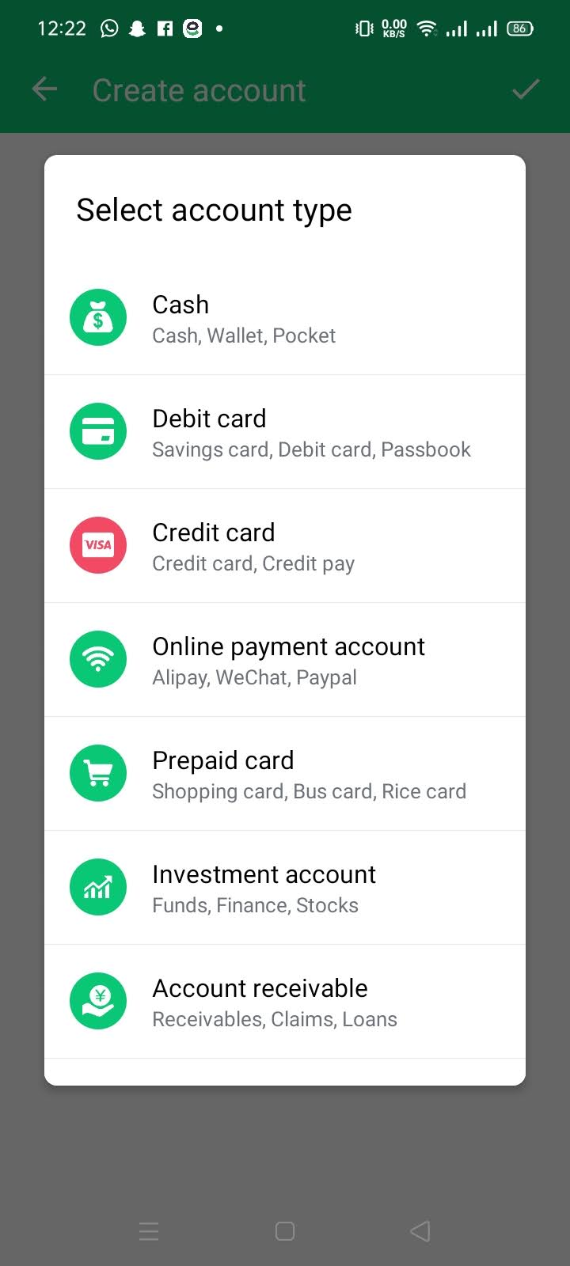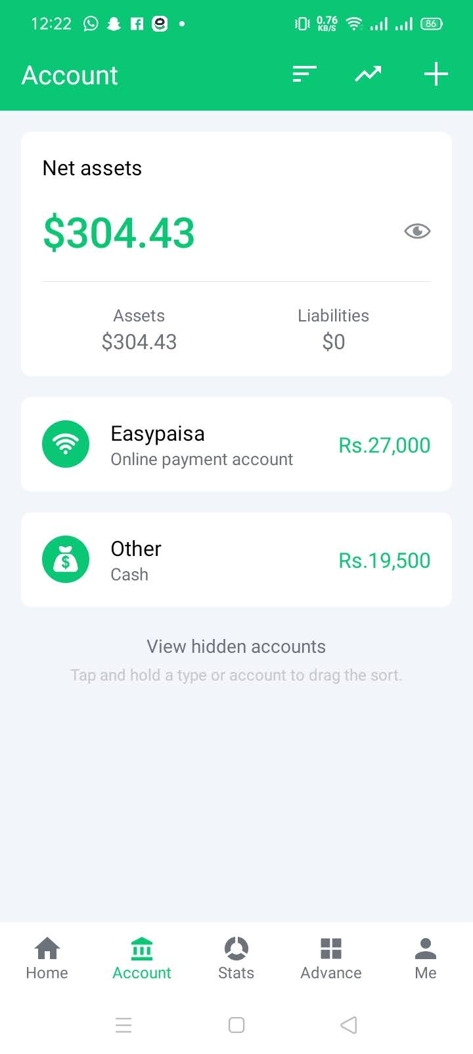

* Open Sprouts application
* On the bottom navigation bar, tap on ‘Accounts’ tab
* On the top-right of the screen, tap on the ‘+’ icon
* Select Account Type
* Select Currency
* Add Amount
* Add relevant details of the account type
* Tap on save

### Add Transaction

##### Expense

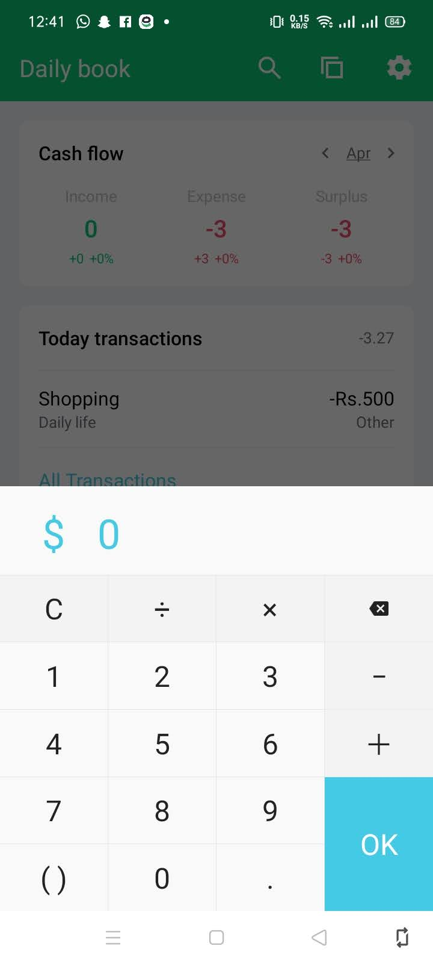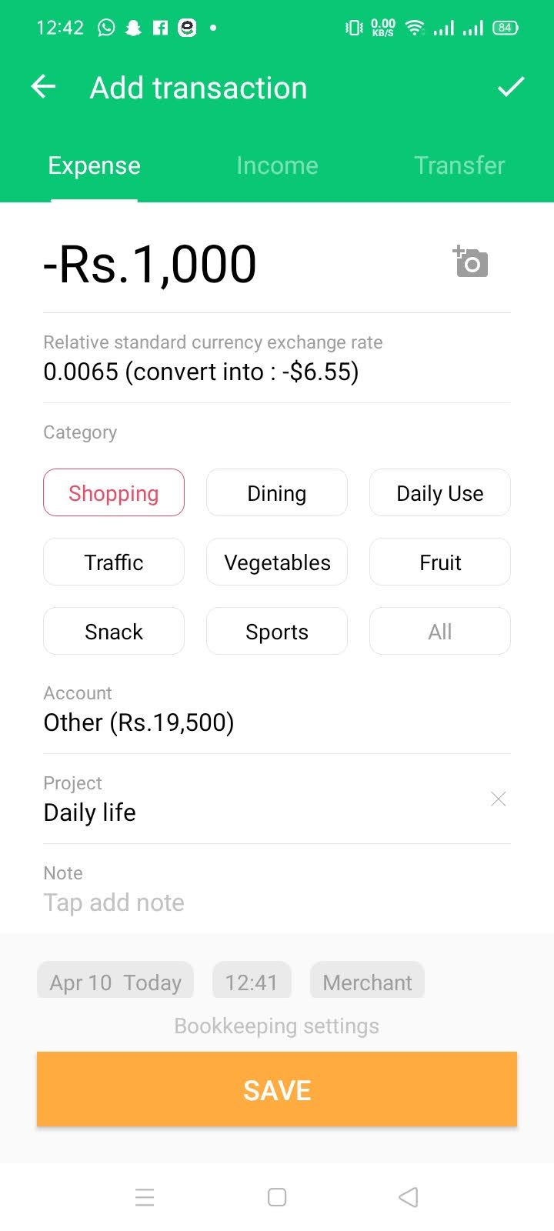

* Open Sprouts application
* On the bottom navigation bar, tap on ‘Home’ tab
* On the bottom-right of the screen, tap on the ‘+’ icon
* Add Amount
* Select Currency
* Tap ‘OK’
* Select Category
* Choose which account should be used for this transaction
* Add Notes
* Tap on the labels to add this transaction in the specified Cashbook
* Tap on Save
* Transaction is saved

##### Income

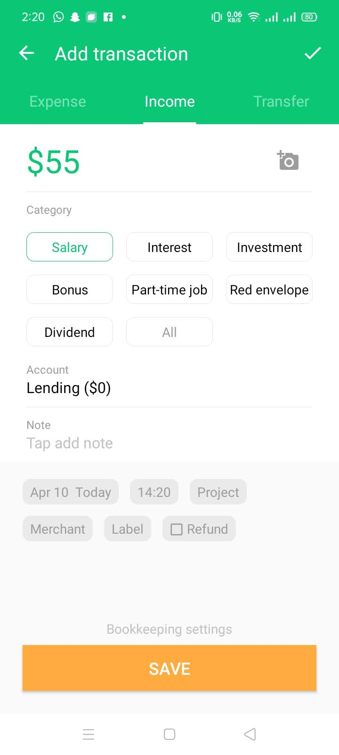

* Open Sprouts application
* On the bottom navigation bar, tap on ‘Home’ tab
* On the bottom-right of the screen, tap on the ‘+’ icon
* Swipe Right once
* Add Amount
* Select Currency
* Tap ‘OK’
* Select Category
* Choose which account should be used for this transaction
* Add Notes
* Tap on the labels to add this transaction in the specified Cashbook
* Tap on Save
* Transaction is saved

##### Transfer

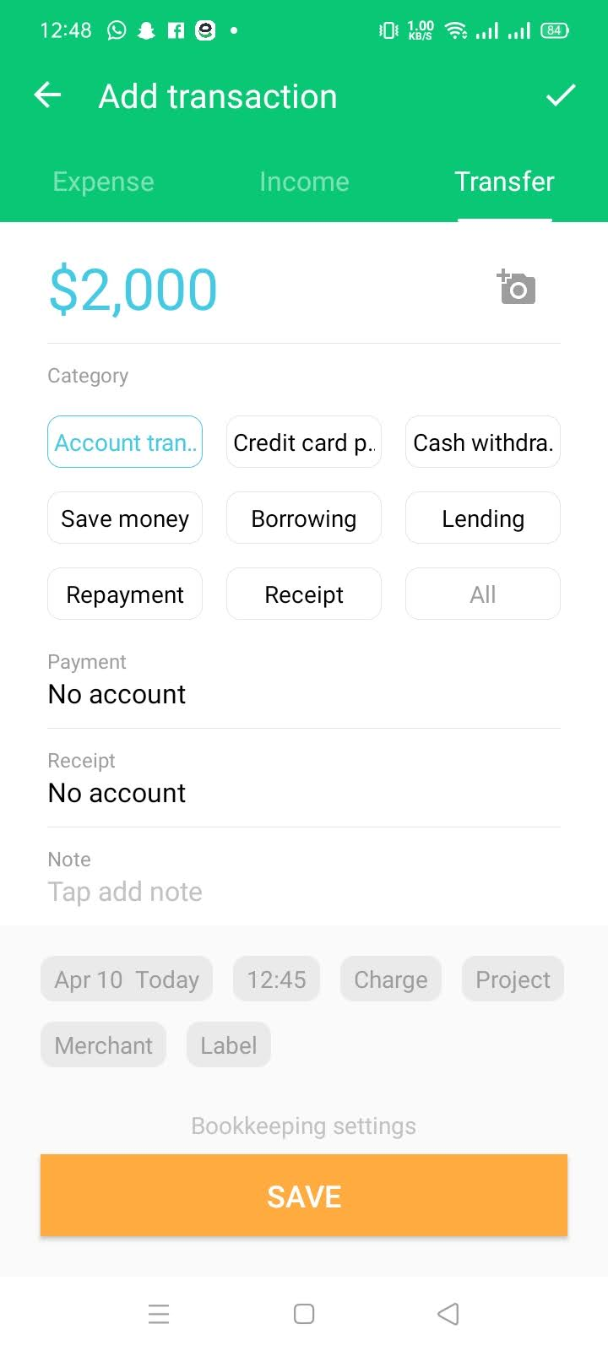

* Open Sprouts application
* On the bottom navigation bar, tap on ‘Home’ tab
* On the bottom-right of the screen, tap on the ‘+’ icon
* Swipe Right twice
* Add Amount
* Select Currency
* Tap ‘OK’
* Select Category
* Choose which account should be used for this transaction
* Add Notes
* Tap on the labels to add this transaction in the specified Cashbook
* Tap on Save
* Transaction is saved

### Add Cycle Transaction

##### Expense

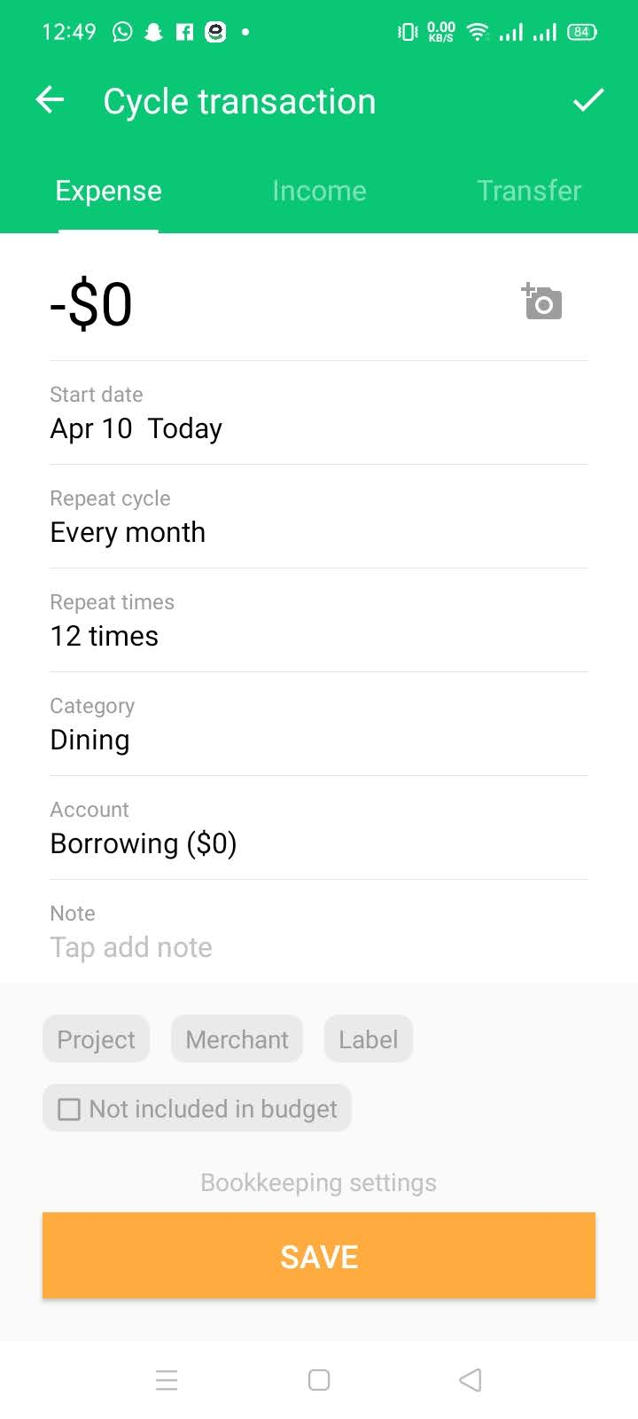

* Open Sprouts application
* On the bottom navigation bar, tap on ‘Advance’ tab
* Scroll Down till you see ‘Cycle Transaction’ label
* On the right of this label, tap on the ‘+’ icon
* Add Amount
* Select Currency
* Tap ‘OK’
* Select Start Date
* Select Repetition Period
* Select Category
* Choose which account should be used for this transaction
* Add Notes
* Tap on the labels to add this transaction in the specified Cashbook
* Tap on Save
* Transaction is saved

##### Income

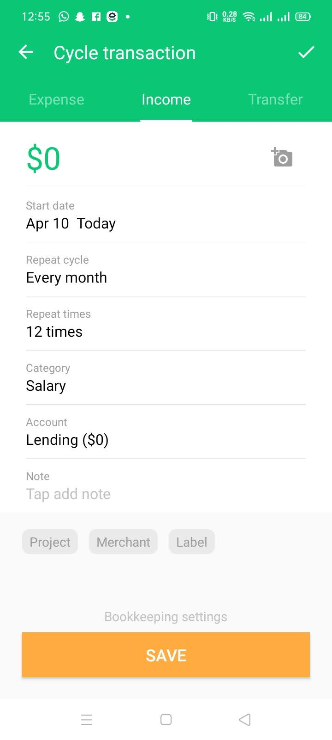

* Open Sprouts application
* On the bottom navigation bar, tap on ‘Advance’ tab
* Scroll Down till you see ‘Cycle Transaction’ label
* On the right of this label, tap on the ‘+’ icon
* Swipe right once
* Add Amount
* Select Currency
* Tap ‘OK’
* Select Start Date
* Select Repetition Period
* Select Category
* Choose which account should be used for this transaction
* Add Notes
* Tap on the labels to add this transaction in the specified Cashbook
* Tap on Save
* Transaction is saved

##### Transfer

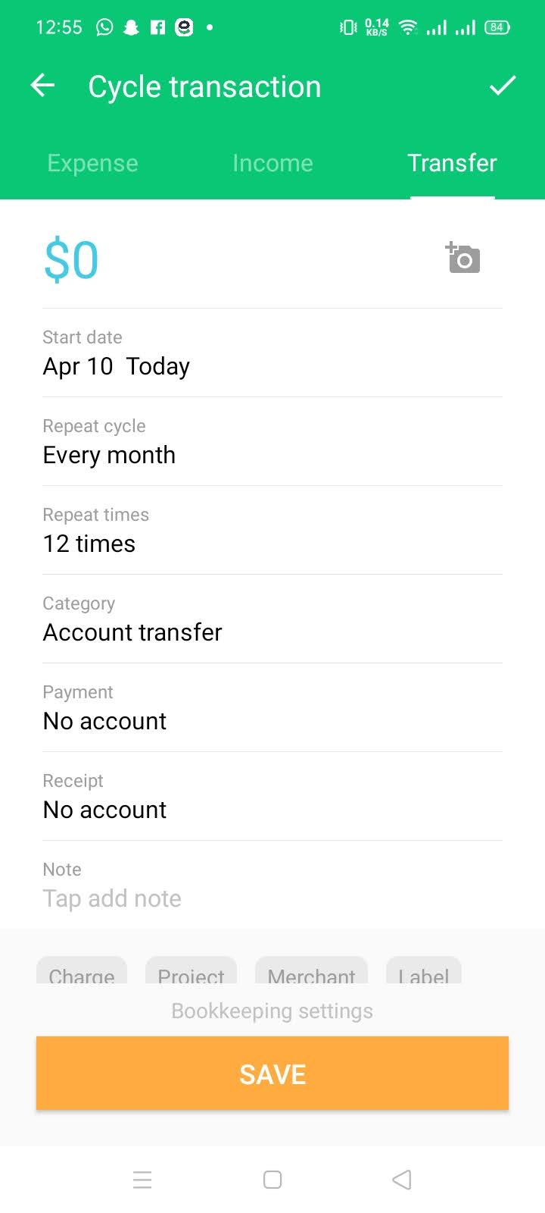

* Open Sprouts application
* On the bottom navigation bar, tap on ‘Advance’ tab
* Scroll Down till you see ‘Cycle Transaction’ label
* On the right of this label, tap on the ‘+’ icon
* Swipe right twice
* Add Amount
* Select Currency
* Tap ‘OK’
* Select Start Date
* Select Repetition Period
* Select Category
* Choose which account should be used for this transaction
* Add Notes
* Tap on the labels to add this transaction in the specified Cashbook
* Tap on Save
* Transaction is saved

### Add Monthly Budget

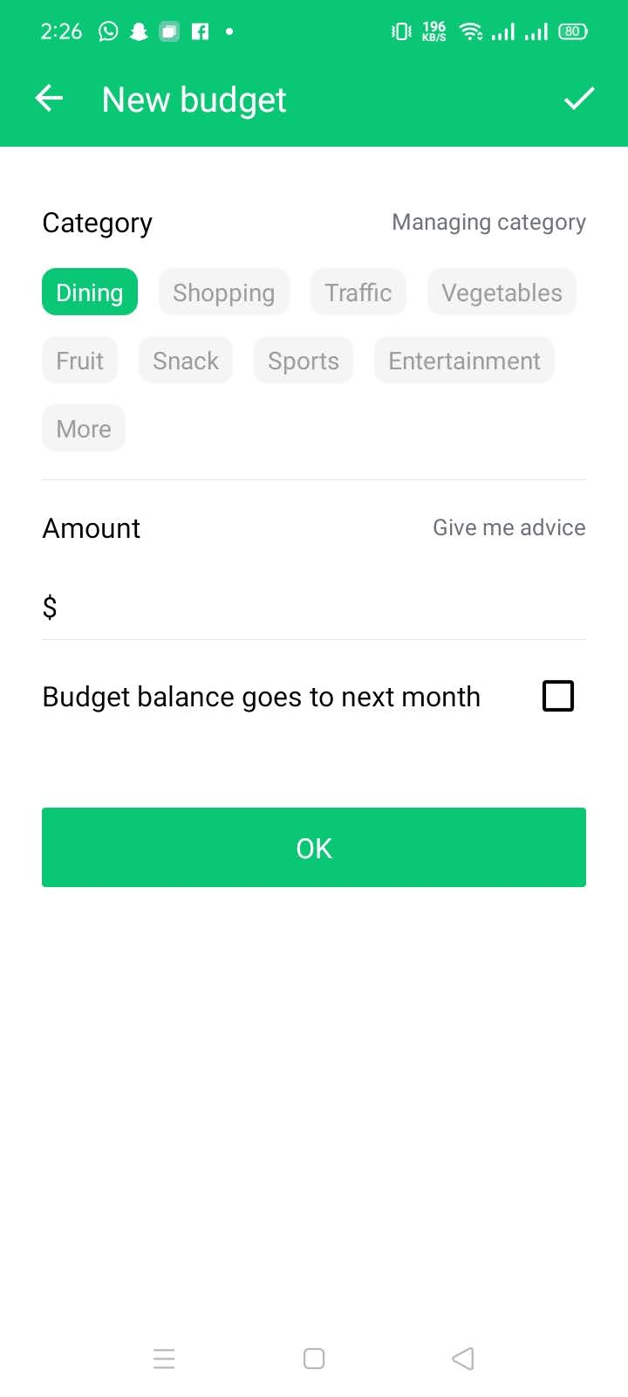

* Open Sprouts application
* On the bottom navigation bar, tap on ‘Advance’ tab
* Tap on the ‘+’ icon on the right of “Budget’ label
* Select category
* Enter Amount
* Check whether the budget continues to next month or not
* Tap ‘Ok’
* Budget is added

### Statistical Analysis

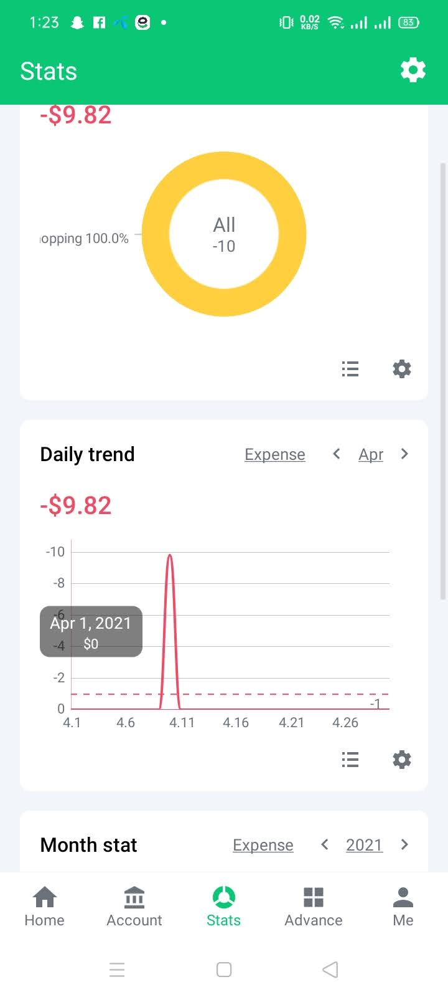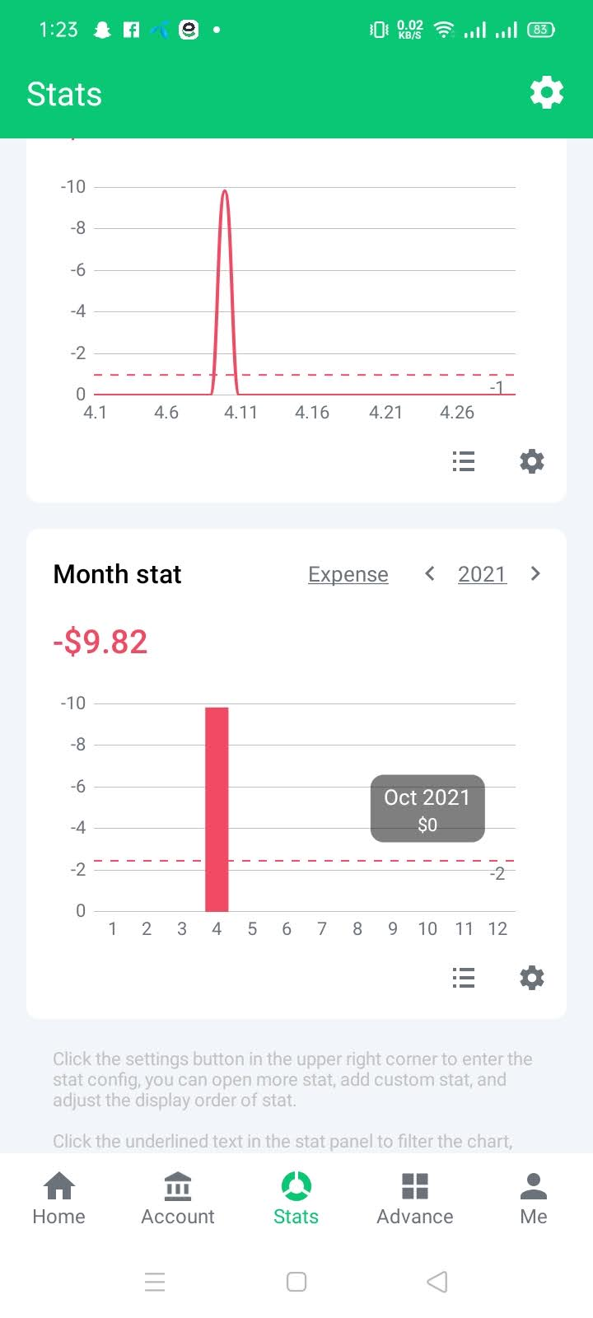

##### Category Stats

* Open Sprouts application
* On the bottom navigation bar, tap on ‘Stats’ tab
* View the pie chart made for you based on your expense, income or transfer of money
* Tap on the chart for useful labels
* On the bottom of the chart, click on the options to see detailed description of the chart
* You can see the stat of any month by just changing the month

### Daily Trend

* Open Sprouts application
* On the bottom navigation bar, tap on ‘Stats’ tab
* View the graph made for you based on your daily expense, income or transfer of money
* Tap on the graph for useful labels
* On the bottom of the graph, click on the options to see detailed description of the graph
* You can see the stat of any month by just changing the month

### Monthly Stat

* Open Sprouts application
* On the bottom navigation bar, tap on ‘Stats’ tab
* View the bar-graph made for you based on your monthly expense, income or transfer of money for the year
* Tap on the Bar-graph for useful labels
* On the bottom of the Bar-graph, click on the options to see detailed description of the Bar-graph
* You can see the stat of any year by just changing the year

### Book Management

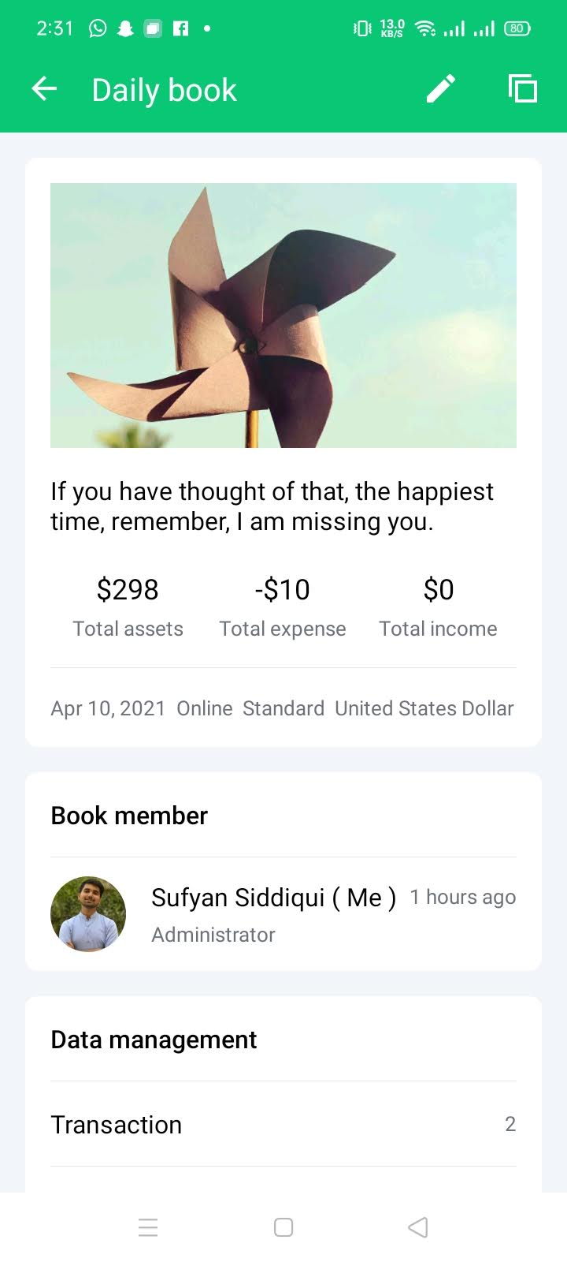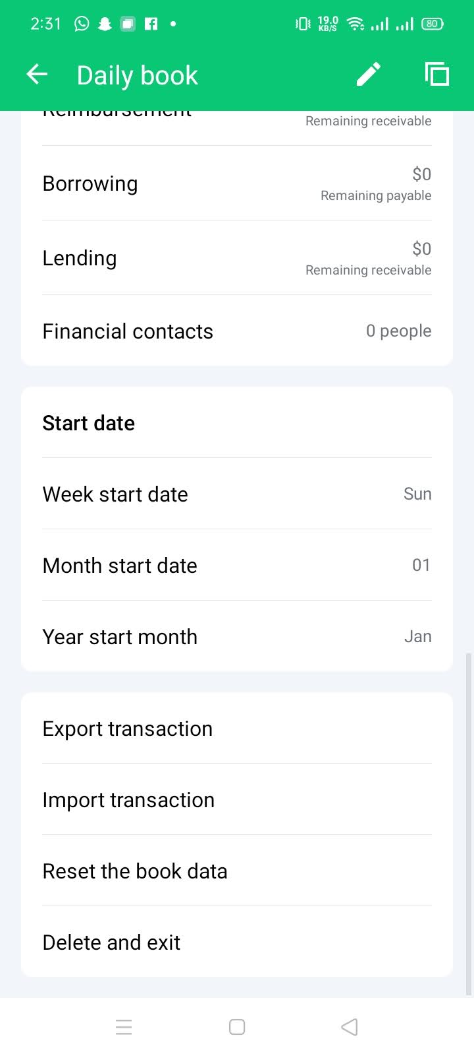

* Open Sprouts application
* On the bottom navigation bar, tap on ‘Me’ tab
* Tap on Book Management
* See your current book
* Add transactions directly from the book
* Add/Remove Labels
* Add/Remove Categories
* Add/Remove Projects
* Add/Remove Merchants
* Add/Remove Cycle Transactions
* Add/Remove Reimbursements
* Add/Remove Lending
* Add/Remove Financial Contacts
* Modify Week Start Date
* Modify Month Start Date
* Import/Export Transactions
* You can also reset or delete the book data

### Profile Management

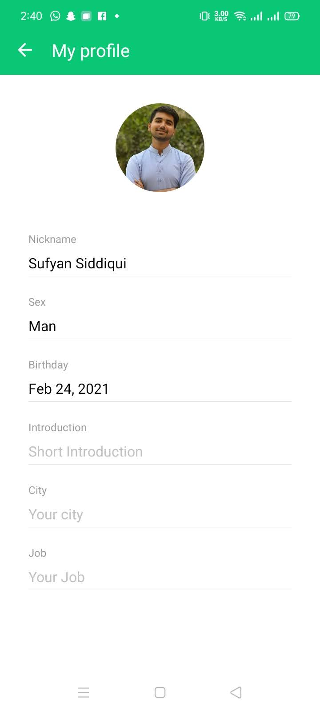

* Open Sprouts application
* On the bottom navigation bar, tap on ‘Me’ tab
* Click on your profile
* You can change/update your profile by just tapping on the picture
* Set your Nickname
* Set your Sex
* Set your birthday
* Set your Introduction
* Set your city
* Set your job

### Invite Member

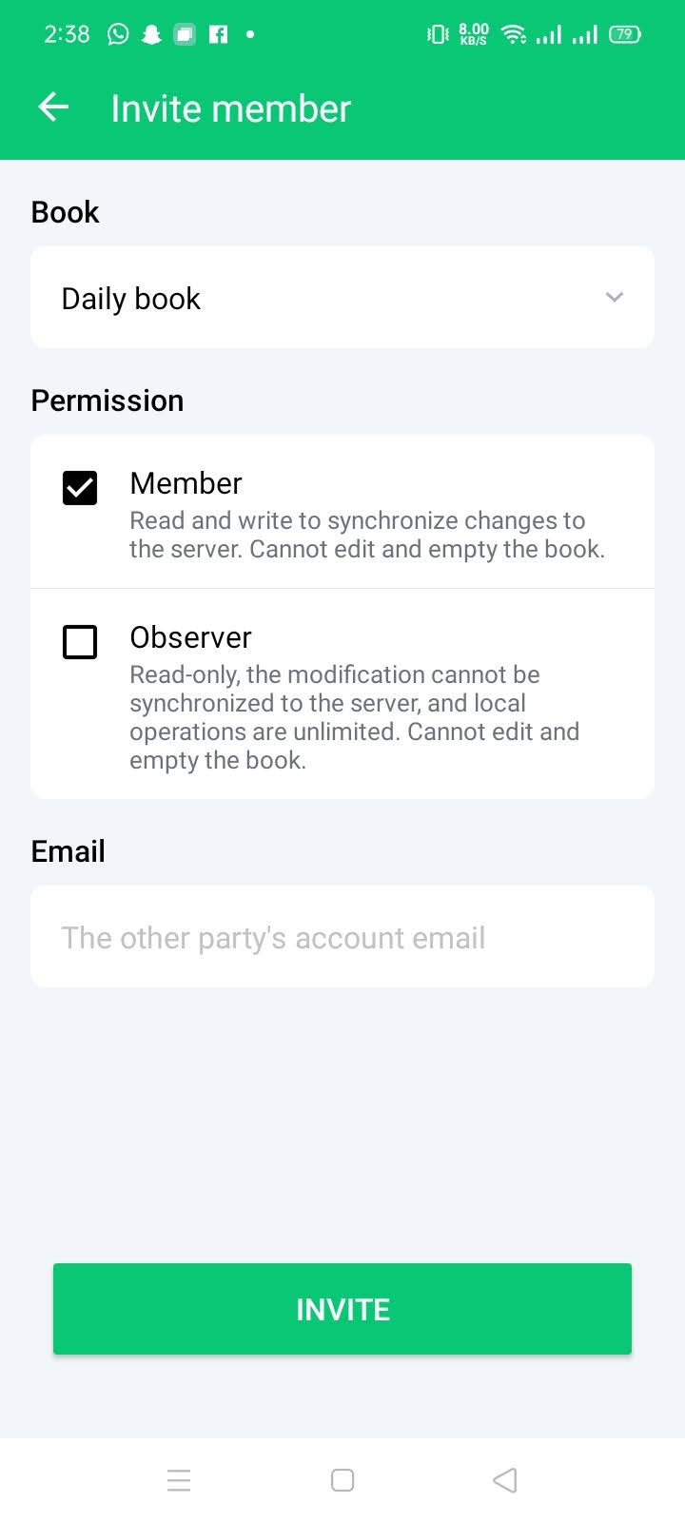

* Open Sprouts application
* On the bottom navigation bar, tap on ‘Me’ tab
* Tap on ‘Invite Member’
* Grant Permissions
* Provie email of the member
* Tap on ‘Invite’
* Invitation sent

## Settings

The settings of Sprouts are defined below:

### Account

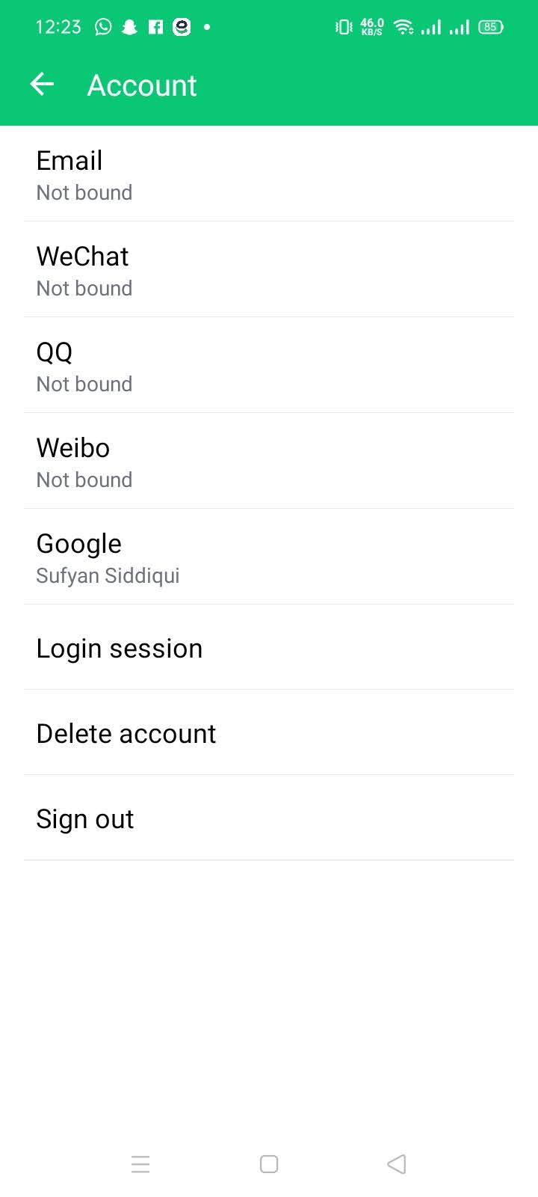

* Open Sprouts application
* On the bottom navigation bar, tap on ‘Me’ tab
* Scroll down till you see ‘General Settings’
* Tap on the label
* Tap on Account
* See Login Session
* See Linked Accounts
* You can delete the account by tapping on ‘Delete Account’
* You can also Sign out by tapping on ‘Sign Out’

### Options

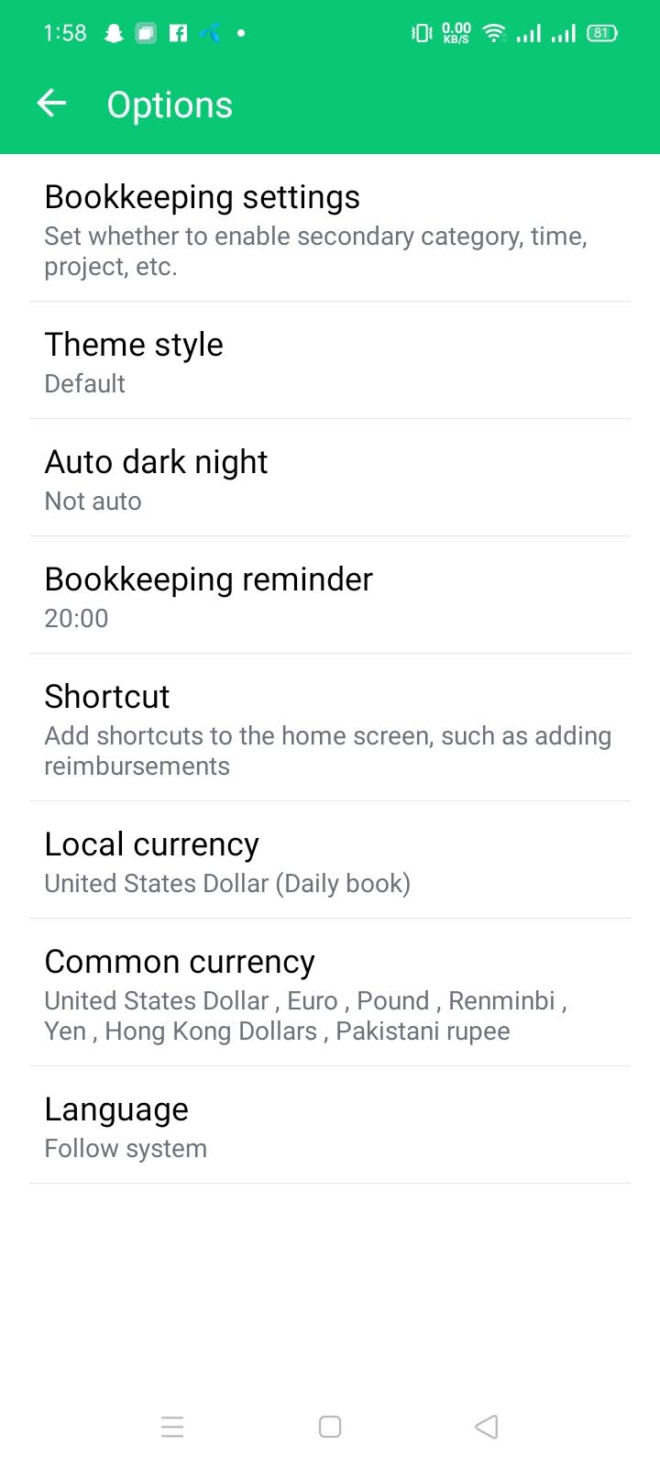

* Open Sprouts application
* On the bottom navigation bar, tap on ‘Me’ tab
* Scroll down till you see ‘General Settings’
* Tap on the label
* Tap on the Options Label
* Control Bookkeeping settings
* Modify Theme
* Set Bookkeeping reminder
* Add Shortcuts
* Set Local Currency
* Set Common Currencies
* Set Language

### Security Settings

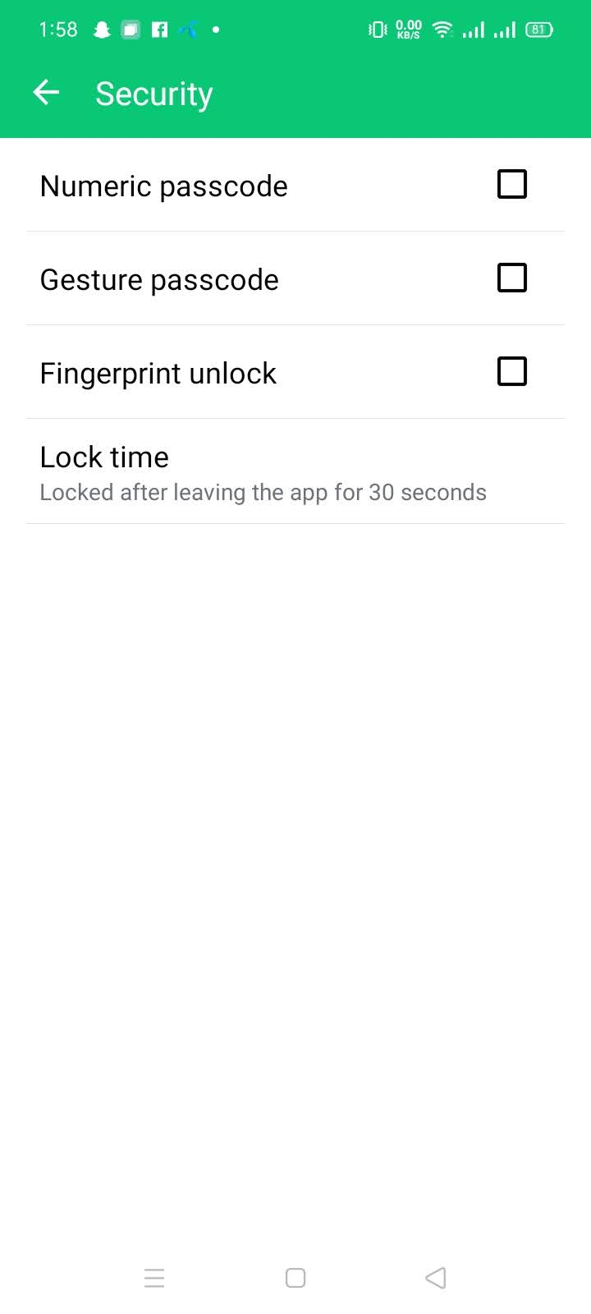

* Open Sprouts application
* On the bottom navigation bar, tap on ‘Me’ tab
* Scroll down till you see ‘General Settings’
* Tap on the label
* Tap on Security Label
* Set Numeric Password
* Set Gesture Passcode
* Set Fingerprint Unlock
* Set Auto-lock time

### Backup Settings

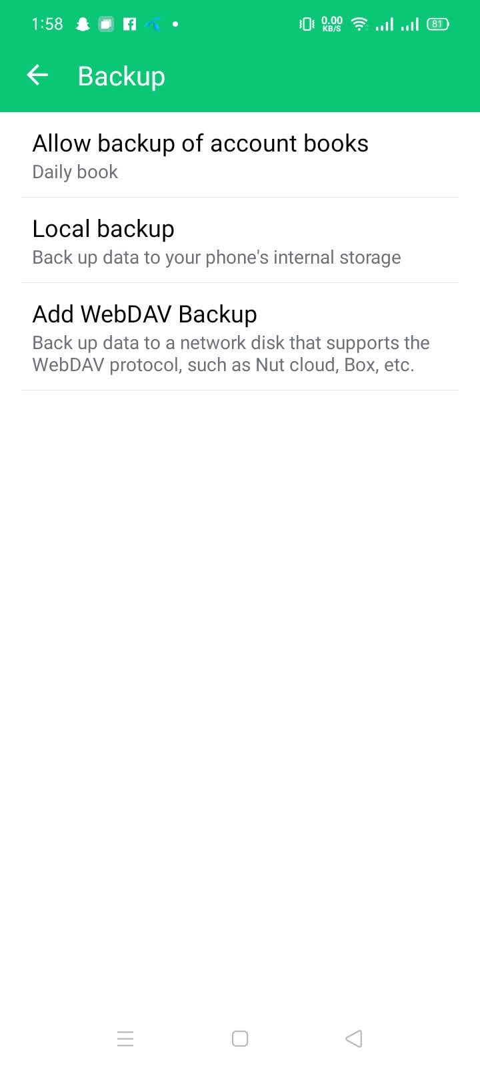

* On the bottom navigation bar, tap on ‘Me’ tab
* Scroll down till you see ‘General Settings’
* Tap on the label
* Tap on the ‘Backup’ label
* Allow/Disallow Backups of cashbooks
* Set Local Backup
* Set Cloud-based backup

### Sync Settings

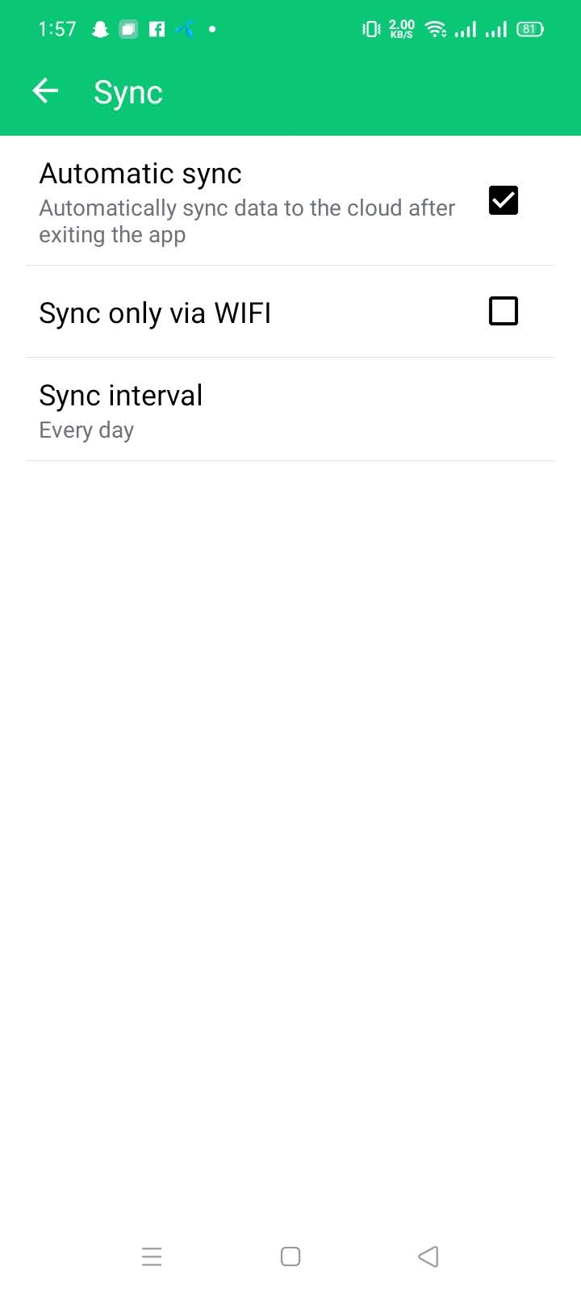

* On the bottom navigation bar, tap on ‘Me’ tab
* Scroll down till you see ‘General Settings’
* Tap on the label
* Tap on ‘Sync’ label
* Choose Automatic Sync
* Choose Interval
* Choose network for Sync

# Language

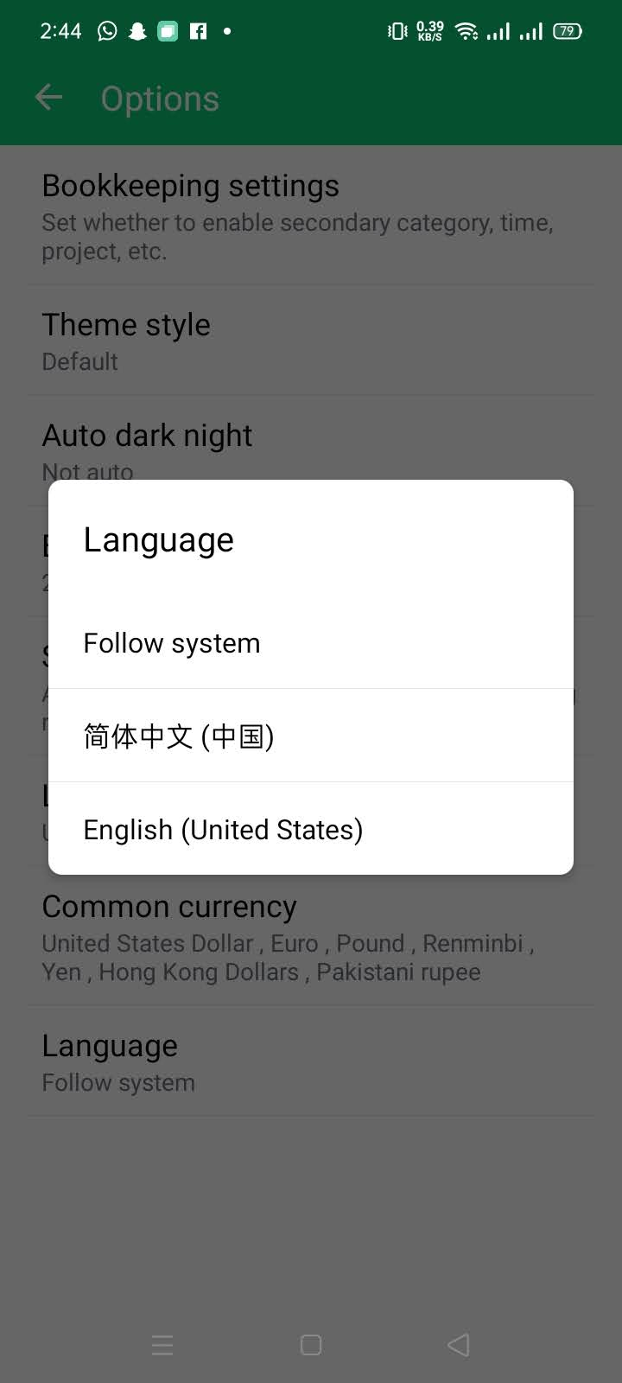

Sprouts supports three options for language:

* System based
* Chinese
* English (United States)

# Troubleshooting/FAQs

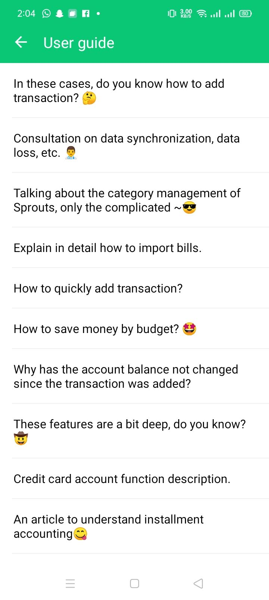

For your help and troubleshooting, Sprouts has a dedicated section named ‘User Guide’

* On the bottom navigation bar, tap on ‘Me’ tab
* Scroll down till you see ‘User Guide’
* Tap on the label
* Select your desired question from the FAQs list
* Read the detailed descriptions and answers

# System Requirements

For smooth experience of Sprouts, the system should have the following specifications

* Android: 4.1 or higher
* Space: 25 MB+

# Contact Us

Email Address: [work_zyb@126.com](mailto:work_zyb@126.com)