1 INTRODUCTION

This technical document is a reference document which can be used to design and develop the tool to Extract and monitor payload files generated by the back-office system.

* 1. PURPOSE

This document provides a brief overview of the file processing tool and its architecture. It also provides step-by-step guidance to build this tool. It is designed to assist the users of the system in monitoring the system generated payload files.

This document aims to develop the software which will serve the following tasks:

a. Monitor the network folder where the XML and payload files are generated.

b. Validate both XML file specific to payload file matches the specified schema and the payload file itself matches the standard naming format.

c. Send email containing payload files as attachment to concerned users of the system

d. Store the relevant audit record in the database.

e. Move the files to archive folder or error folder respectively depending on whether files are validated successfully or not.

2.1 System ARCHITECTURE

The proposed tool will comprise of the following 4 modules:

1. Network monitoring and File Validation module
2. Email Generation module
3. Audit record Storage module
4. File transfer module

Below is the high level design of the process:

Move files to Archive folder

Update audit record in DB

Email Sent?

XML file matches specified schema?

Move files to Error folder

Payload File name=XML filename?

Send Email

XML file age> 1 min

XML file exists

Monitor Network Path

Yes Yes

Yes

Yes Yes

No No

Yes

1. System Object Model
   1. Introduction

The system comprises of the following three classes:

1. MonitorFiles
2. XMLFileInfo
3. AuditTable

MonitorFiles class is an aggregation of XMLFileInfo and AuditTable classes

The following class diagram describe the System structure:

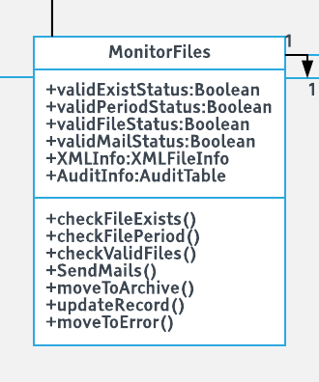

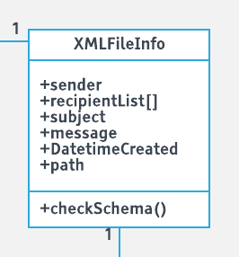 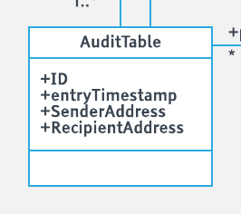

* 1. Class Diagram description

Each class is described below:

3.2.1

|  |  |
| --- | --- |
| **Class Name:** MonitorFiles | |
| **Description: This class is** | |
| **Attributes** | **Attribute description** |
| validExistStatus |  |
| validPeriodStatus |  |
| validFileStatus |  |
| validMailStatus |  |
| XMLInfo |  |
| AuditInfo |  |
|  |  |
| **Methods Method Description** | |
| checkFileExists() |  |
| checkFilePeriod() |  |
| checkValidFiles() |  |
| SendMails() |  |
| updateRecord() |  |
| moveToArchive() |  |
| moveToError() |  |

3.2.2

|  |  |
| --- | --- |
| **Class Name:** XMLFileInfo | |
| **Description: This class is** | |
| **Attributes** | **Attribute description** |
| sender |  |
| recipientList[] |  |
| subject |  |
| message |  |
| dateTimeCreated |  |
| filePath |  |
| **Methods Method Description** | |
| checkSchema() |  |

3.2.3

|  |  |
| --- | --- |
| **Class Name:** AuditTable | |
| **Description: This class is** | |
| Attributes | Attribute description |
| ID |  |
| entryTimeStamp |  |
| senderAddress |  |
| recipientAddress |  |