Project 12: Kubernetes Deployment Strategies with Monitoring
Objective
To demonstrate Kubernetes deployment strategies including rolling updates and rollback, along with real-time monitoring using Prometheus and Grafana.
Project Overview
This project implements a 2-node Kubernetes cluster (Master + Worker) on virtual machines. A containerized application is deployed and upgraded using Kubernetes rolling updates. In case of failure, rollback is performed. Monitoring is implemented using Prometheus and Grafana.
Architecture
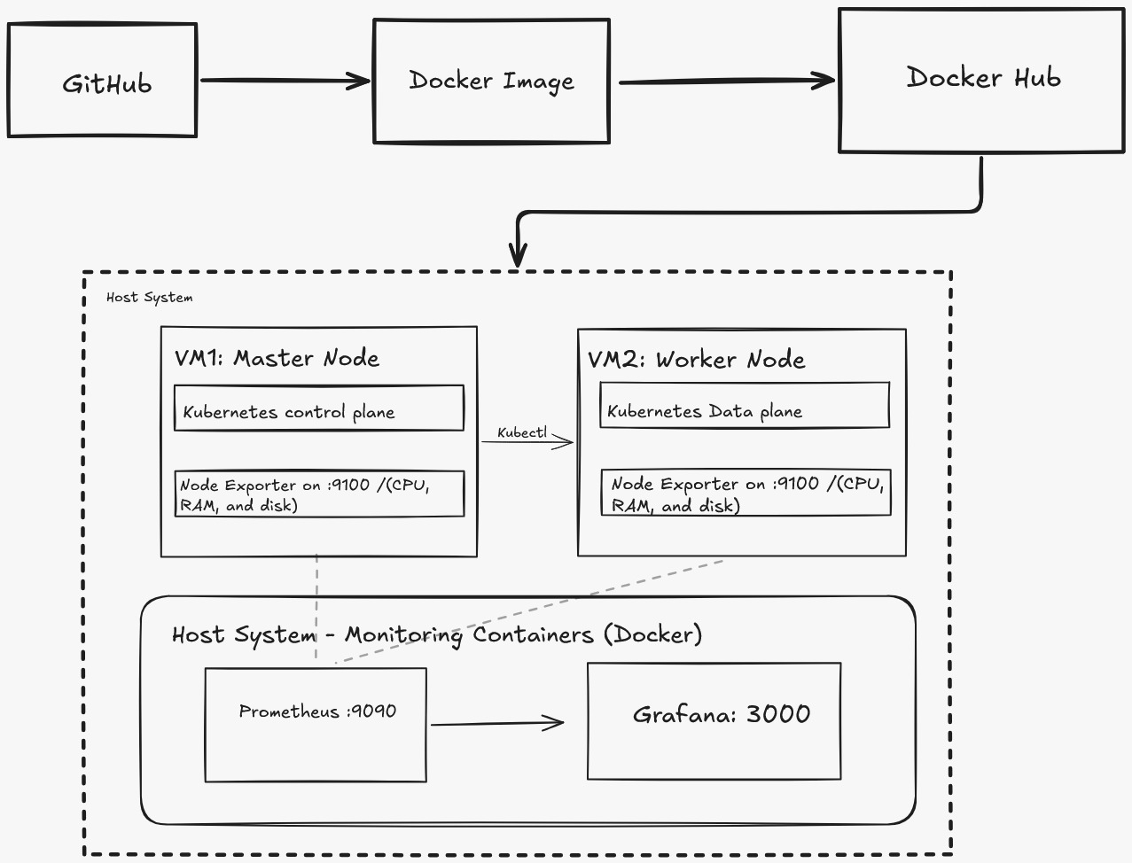
Components:
- Web Application
- Kubernetes Master Node (Control Plane)
- Kubernetes Worker Node
- Docker (Containerization)
- Prometheus (Metrics collection)
- Grafana (Visualization dashboard)
Tools & Technologies
- Kubernetes (kubeadm)
- Docker
- Prometheus
- Grafana
- Virtual Box (Virtual Machine)

Infrastructure Setup
Node | Role | RAM | CPU
Master | Control Plane | 4GB | 2
Worker | Compute Node | 4GB | 2

Virtual Machines

Implementation Steps
1. Kubernetes Cluster Setup
Environment Details
Node | Role | OS
Master | Control Plane | Ubuntu 22.04
Worker | Compute Node | Ubuntu 22.04

System Preparation
- Updated the system packages using:
sudo apt update
- Installed OpenSSH server to enable remote access:
sudo apt install openssh-server -y
Required Packages Installation
- Installed required dependencies:
sudo apt install -y apt-transport-https ca-certificates curl gpg
- Created directory for storing Kubernetes keys:
sudo mkdir -p /etc/apt/keyrings
Kubernetes Repository Configuration
- Added Kubernetes GPG key:
curl -fsSL https://pkgs.k8s.io/core:/stable:/v1.29/deb/Release.key | gpg --dearmor -o /etc/apt/keyrings/kubernetes-apt-keyring.gpg
- Added Kubernetes repository:
echo "deb [signed-by=/etc/apt/keyrings/kubernetes-apt-keyring.gpg] https://pkgs.k8s.io/core:/stable:/v1.29/deb/ /" | sudo tee /etc/apt/sources.list.d/kubernetes.list
Container Runtime Setup
- Installed containerd:
sudo apt install -y containerd
- Generated default configuration:
sudo mkdir -p /etc/containerd
sudo containerd config default | sudo tee /etc/containerd/config.toml
- Restarted and enabled containerd:
sudo systemctl restart containerd
sudo systemctl enable containerd
Kubernetes Components Installation
- Installed Kubernetes tools:
sudo apt update
sudo apt install -y kubelet kubeadm kubectl
- Prevented automatic upgrades:
sudo apt-mark hold kubelet kubeadm kubectl
System Configuration
- Disabled swap:
sudo swapoff -a
free -m
Network Configuration
- Set hostname for nodes:
sudo hostnamectl set-hostname k8nworker1
- Updated hosts file to map master and worker IPs:
sudo nano /etc/hosts
- Configured static IP using Netplan:
sudo nano /etc/netplan/01-netcfg.yaml
Example configuration:
network:
version: 2
renderer: networkd
ethernets:
enp0s3:
dhcp4: no
addresses:
- 10.92.185.54/24
gateway4: 10.92.185.1
nameservers:
addresses: [8.8.8.8,8.8.4.4]
- Applied network configuration:
sudo netplan apply
Cluster Initialization (Master Node)
- Initialized Kubernetes cluster:
sudo kubeadm init --pod-network-cidr=192.168.0.0/16
kubectl Configurati on
- Configured kubectl for cluster management:
mkdir -p $HOME/.kube
sudo cp -i /etc/kubernetes/admin.conf $HOME/.kube/config
sudo chown $(id -u):$(id -g) $HOME/.kube/config
Worker Node Integration
- Joined worker node to cluster using:
kubeadm join <MASTER-IP>:6443 --token <TOKEN> --discovery-token-ca-cert-hash sha256:<HASH>
Pod Network Setup
- Installed Flannel network plugin:
kubectl apply -f https://github.com/flannel io/flannel/releases/latest/download/kube-flannel.yml
Cluster Verification
- Verified cluster status:
kubectl get nodes
- Observed that both master and worker nodes were in Ready state
2. Application Containerization using Docker
Docker Installation
- Installed Docker on the system:
sudo apt install docker.io -y
- Started and enabled Docker service:
sudo systemctl start docker
sudo systemctl enable docker
Docker Login
- Logged into Docker Hub:
docker login
Docker Image Build – Version 1 (v1)
- Created Docker image using the following Dockerfile:
FROM node:22-alpine AS build
WORKDIR /app
COPY package.json package-lock.json ./
RUN npm install
COPY . .
RUN npm run build

FROM nginx:alpine
COPY --from=build /app/dist /usr/share/nginx/html
COPY nginx.conf /etc/nginx/conf.d/default.conf
EXPOSE 80
CMD ["nginx","-g","daemon off;"]
- Built the image:
docker build -t manisarma/app:v1 .
Docker Image Build – Version 2 (v2)
- Created Docker image using the following Dockerfile:
FROM node:20-alpine AS build
WORKDIR /app
COPY package.json package-lock.json ./
RUN npm ci
COPY src ./src
COPY static ./static
COPY tailwind.config.js ./
RUN npm run build:css
FROM nginx:alpine
COPY --from=build /app/static /usr/share/nginx/html
EXPOSE 80
- Built the image:
docker build -t manisarma/app:v2 .
Image Tagging
- Tagged the images for versioning:
docker tag manisarma/app:v1 manisarma/app:v1
docker tag manisarma/app:v2 manisarma/app:v2
Push Images to Docker Hub
- Pushed both images to Docker Hub:
docker push manisarma/app:v1
docker push manisarma/app:v2
3. Kubernetes Deployment, Rolling Update and Rollback
Initial Deployment (Version 1)
- Created a Kubernetes deployment using the Docker image (v1):
kubectl create deployment moviehub --image=manisarma/moviehub:v1
- Exposed the deployment as a NodePort service:
kubectl expose deployment moviehub --type=NodePort --port=80 --target-port=80
- Accessed the application through the assigned NodePort and verified that Version 1 was running.
Rolling Update (v1 → v2)
- Updated the deployment to use the new image (v2):
kubectl set image deployment moviehub moviehub=manisarma/moviehub:v2
- Observed that Kubernetes performed a rolling update, gradually replacing old pods with new ones without downtime.
- Verified that the application was updated to Version 2.
Rollback
- Performed rollback to the previous stable version:
kubectl rollout undo deployment moviehub
- Verified that the application reverted back to Version 1.
4. Monitoring Setup using Prometheus and Grafana
Running Prometheus and Grafana using Docker
- Pulled Prometheus image:
docker pull prom/prometheus
- Ran Prometheus container:
docker run -it -d --name prom -p 9090:9090 prom/Prometheus
docker exec -d prom bin/sh
- Pulled Grafana image:
docker pull grafana/grafana
- Ran Grafana container:
docker run -d --name prom -p 3000:3000 grafana/grafana

Prometheus Setup
- Navigated to Prometheus configuration directory:
cd /etc/prometheus/
- Viewed configuration file:
cat prometheus.yml
- Configured Prometheus to monitor Master and Worker nodes:
global:
scrape_interval: 15s
evaluation_interval: 15s
alerting:
alertmanagers:
- static_configs:
- targets:
rule_files:
scrape_configs:
- job_name: "Master"
static_configs:
- targets: ["10.1.7.165:9100"]
labels:
app: "Master"
- job_name: "Worker"
static_configs:
- targets: ["10.1.7.166:9100"]
labels:
app: "Worker"
Metrics Collection
- Prometheus collects metrics from:
Master Node → 10.1.7.165:9100
Worker Node → 10.1.7.166:9100
- Node Exporter is used on both nodes to expose system metrics.
Grafana Setup
- Opened Grafana in browser
- Added Prometheus as Data Source:
  - Type: Prometheus
  - URL: http://<prometheus-ip>:9090
- Verified connection successfully
Dashboard
- Imported dashboards to monitor:
  - CPU usage
  - Memory usage
  - System performance
- Verified that both nodes' metrics are visible
OUTPUT

