Step1: Resource group: **DXP-Hospitality-DEV-R-Compute**

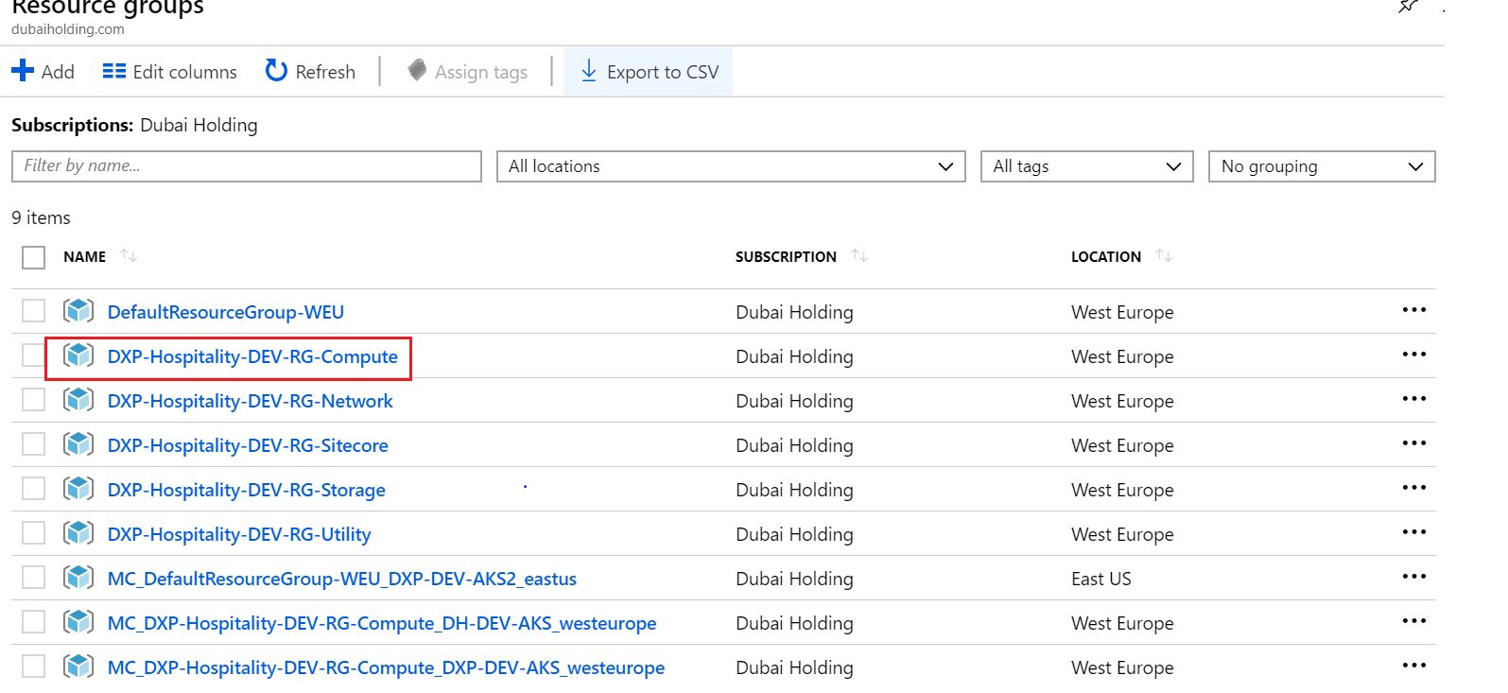

Step 2: select Container Registry “**DHDEVREGISTRYPOC**”

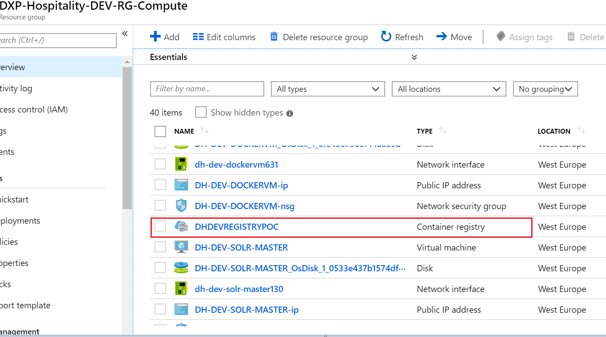

Step 3: click Access Control (IAM)

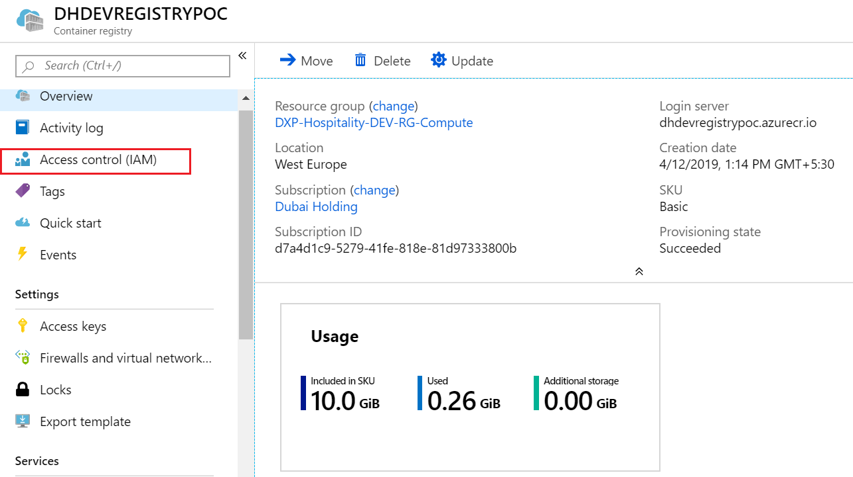

Step 4: click the Role Assignment

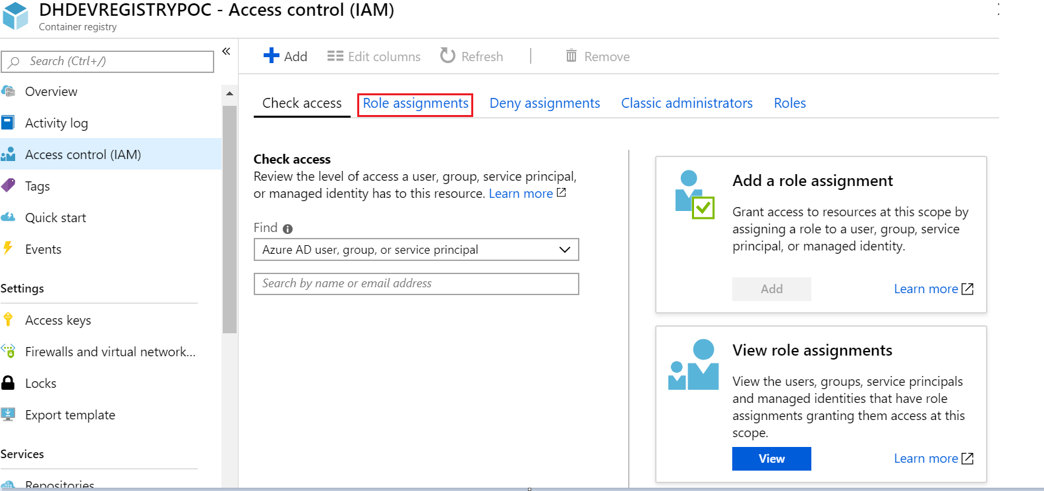

Step 5 :Click add and select Add Role Assignment

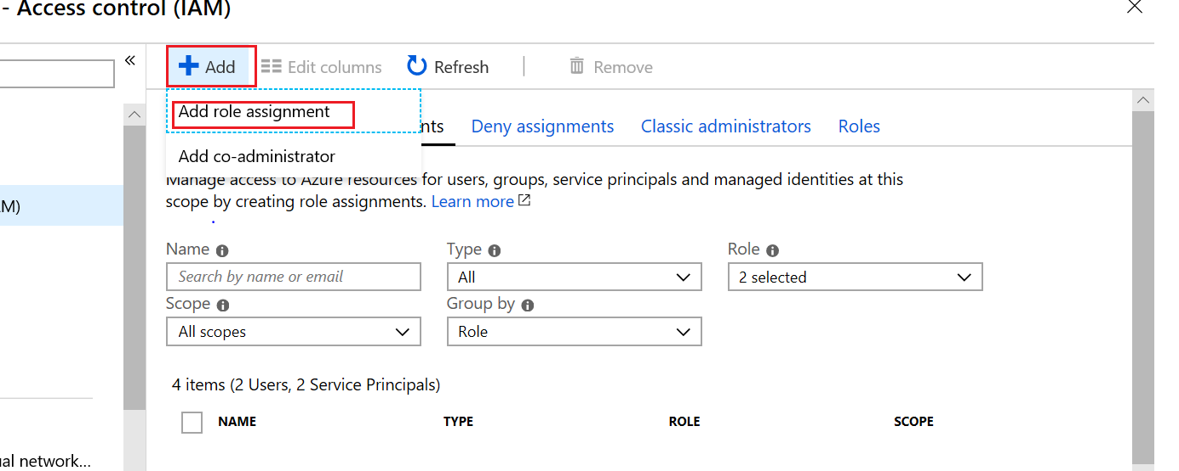

Step 6: Select Role – “**AcrPull**” and search “**hospitalitydxpdevaks**” SPN in “Select” textbox and select the SPN and then save it.

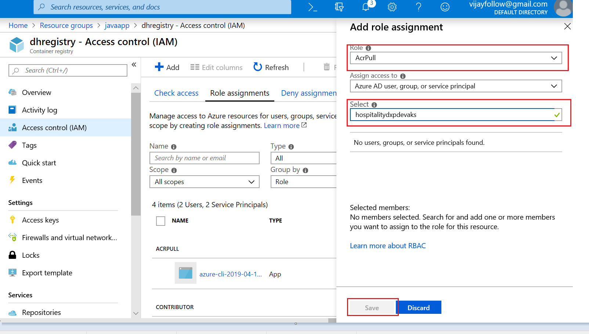

Step 7: please verify “ACRpull” role assigned or not.

