**SaaS**

* Just like User interacting with software
* No installation or license
* Access from any platform
* No patch updates because vendor provide all updates
* software is ready you just do the config based on your preference
* office 365, gmail

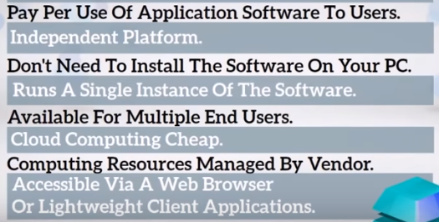

**PaaS**

* A complete platform is offered in PaaS in which the client can host their applications without the need to worry about the maintenance of the servers and its operating systems.
* PaaS offers application developers the ability to create applications using the in-build software components of PaaS
* PaaS is designed to support the complete web application lifecycle: building, testing, deploying, managing, and updating.”
* Companies had to purchase complex software stacks and invest large amounts of time and money into technology which very quickly becomes outdated.
* PaaS reduces these costs, while the number of automation possibilities also reduces labor costs for companies. It makes sense to use shared applications and take advantage of an infrastructure that has been pre-built and is continuously maintained

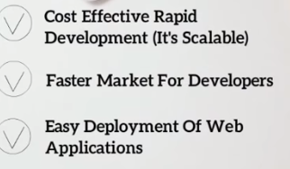

**IaaS**

* Admin
* providing infrastructure, services for developer
* rent virtual machine
* except hardware everything is responsible for us
* Clients can install and use whatever operating systems and tools they like on the infrastructure they get
* Azure vm, vnet

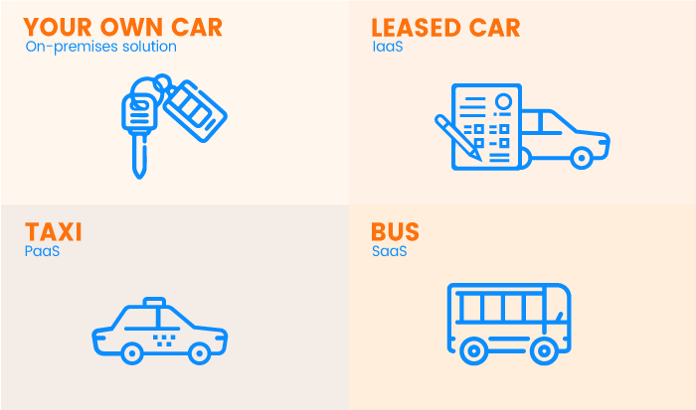

* **On-premises IT infrastructure is like owning a car.**When you buy a car, you’re responsible for its maintenance, and upgrading means buying a new car.
* **IaaS is like leasing a car.**When you lease a car, you choose the car you want and drive it wherever you wish, but the car isn’t yours. Want an upgrade? Just lease a different car!
* **PaaS is like taking a taxi.**You don’t drive a taxi yourself, but simply tell the driver where you need to go and relax in the back seat.
* **SaaS is like going by bus.**Buses have assigned routes, and you share the ride with other passengers