Today, a web-based application is not enough to reach it's customers. People are very smart, they are using iphone, mobile, tablets etc

devices its changes daily

Actually, we are moving from the web towards apps world

if you like to expose your service data to the browsers and as well as all these modern devices apps in fast and simple way, you should have an API which is compatible with browsers and all these devices.

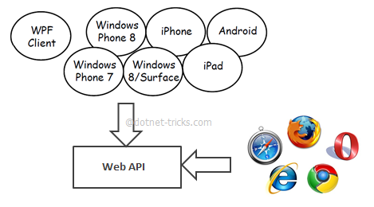

Web API is the great framework for exposing your data and service to different-different device

Web API is open source an ideal platform for building REST-ful services over the .NET Framework.

APIs are the most optimized way of sharing data or providing services, where technology is not a limitation

It means one can use a Java API for fetching data in .Net application

Major drawback for APIs is that one cannot track the utilization of the APIs or cannot analyze the performance directly

Features

1. OWIN

Use OWIN to self-host asp.net web api

Basically it used for authentication

OWIN decouples the web application from the server

It makes OWIN ideal for self-hosting a web application in your own process, outside of IIS

1. ODATA

The Open Data Protocol (OData) is actually a web protocol for querying and updating data.

ASP.NET Web API 2 has added support for $expand, $select, and $value options for OData