**ADO.Net**

* ActiveX Data Object
* It is set of classes that can be used to interact with data sources like Databases
* Then this data can be used in any .net applications
* Following few .net applications used ado.net to connect Database and execute commands and retrieve data

Web, Windows, console

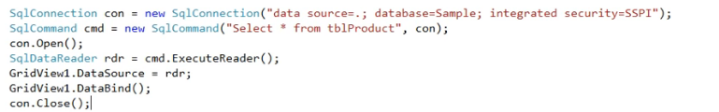

**SqlConnection** - This provides connectivity to the data source

**SqlCommand** - This executes the database statements needed to retrieve data, modify data or execute stored procedures.

**SqlDatareader** –

* The ADO.NET DataReader is used to retrieve read-only (cannot update data back to a datasource) and forward-only (cannot read backward/random) data from a database. You create a DataReader by calling Command.ExecuteReader after creating an instance of the Command object

**Dataset** –

* A DataSet behaves like real Database and it represents a complete set of data that includes tables, constraints, and relationships among the tables.
* Using the **DataAdapters** you can fill DataSet and use this dataset for retrieving and storing information.
* When all the tasks get completed, update Real Database with datasets.

A dataset is a collection of DataTable objects and relationships among them. It works as a container that stores returned data from a database in cached from. You can fill a dataset with the data retrieved from multiple tables of a database. Once you have a dataset (which is disconnected data, stored on your local machine), you treat the dataset changes final to the actual database. You call the Update method to make dataset changes final to the actual database. You can even read and update a dataset from different data sources

**DataAdapter** –

* DataAdapters are used for controlling Datasets and it provides communication between DataSets and DataSource.
* DataAdapters make a connection with Data Source
* Then Fill Data to Datasets.
* It also Updates Data Source with DataSets

**ExecuteReader** :

* ExecuteReader used for getting the query results as a DataReader object.
* It is read-only forward only retrieval of records and it uses select command to read through the table from the first to the last.
* It expects to have one or more resultsets to return

cmd.Connection.Open();  
SqlDataReader dr = cmd.ExecuteReader();  
// process the resultset(s) here  
cmd.Connection.Close()

**ExecuteNonQuery** :

* ExecuteNonQuery used for executing queries that does not return any data.
* It is used to execute the sql statements like update, insert, delete etc.
* ExecuteNonQuery executes the command and returns the number of rows affected

**ExecuteScalar :**

* The ExecuteScalar() in C# SqlCommand Object is using for retrieve a single value from Database after the execution of the SQL Statement.
* The ExecuteScalar() executes SQL statements as well as Stored Procedure and returned a scalar value on first column of first row in the returned Result Set.
* If the Result Set contains more than one columns or rows , it will take only the value of first column of the first row, and all other values will ignore.
* If the Result Set is empty it will return a NULL reference.
* It is very useful to use with aggregate functions like Count(*) or Sum() etc. When compare to ExecuteReader() , ExecuteScalar() uses fewer System resources