A content delivery network (CDN) is a distributed network of servers that can efficiently deliver web content to users

CDNs store cached content on edge servers in point-of-presence (POP) locations that are close to end users, to minimize latency.

Azure Content Delivery Network (CDN) offers developers a global solution for rapidly delivering high-bandwidth content to users by caching their content

Let’s assume an application’s source is far away from the end user and many tours are taken over the internet to fetch data; the CDN offers a very competent solution to improve performance in this case

The benefits of using Azure CDN

Better performance and improved user experience for end users, especially when using applications in which multiple round-trips are required to load content

Distribution of user requests and serving of content directly from edge servers so that less traffic is sent to the origin server

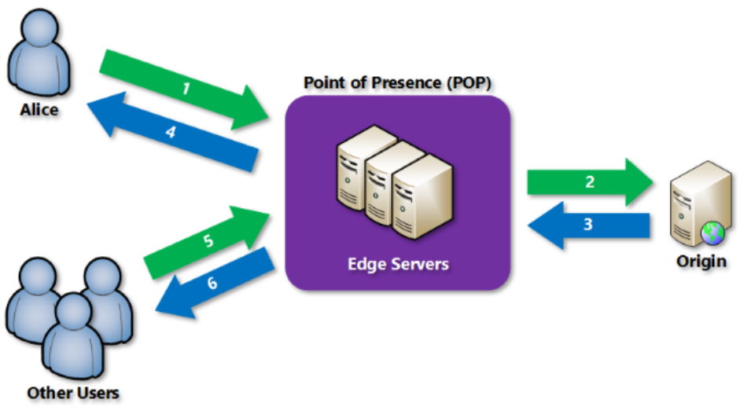

POP – It’s like location (south India, Central US) , that contains list of servers

So when user requesting from nearest POP, it fetch the data from origin server and stores it in cache

Default storage time is 7 days. When often user requesting from same endpoint it will give from stored cache in POP

1. A user (Alice) requests a file (also called an asset) by using a URL with a special domain name, such as <endpoint name>.azureedge.net. This name can be an endpoint hostname or a custom domain. The DNS routes the request to the best performing POP location, which is usually the POP that is geographically closest to the user.
2. If no edge servers in the POP have the file in their cache, the POP requests the file from the origin server. The origin server can be an Azure Web App, Azure Cloud Service, Azure Storage account, or any publicly accessible web server.
3. The origin server returns the file to an edge server in the POP.
4. An edge server in the POP caches the file and returns the file to the original requestor (Alice). The file remains cached on the edge server in the POP until the time-to-live (TTL) specified by its HTTP headers expires. If the origin server didn't specify a TTL, the default TTL is seven days.
5. Additional users can then request the same file by using the same URL that Alice used, and can also be directed to the same POP.
6. If the TTL for the file hasn't expired, the POP edge server returns the file directly from the cache. This process results in a faster, more responsive user experience

STEPS

Create resource🡪Web🡪CDN

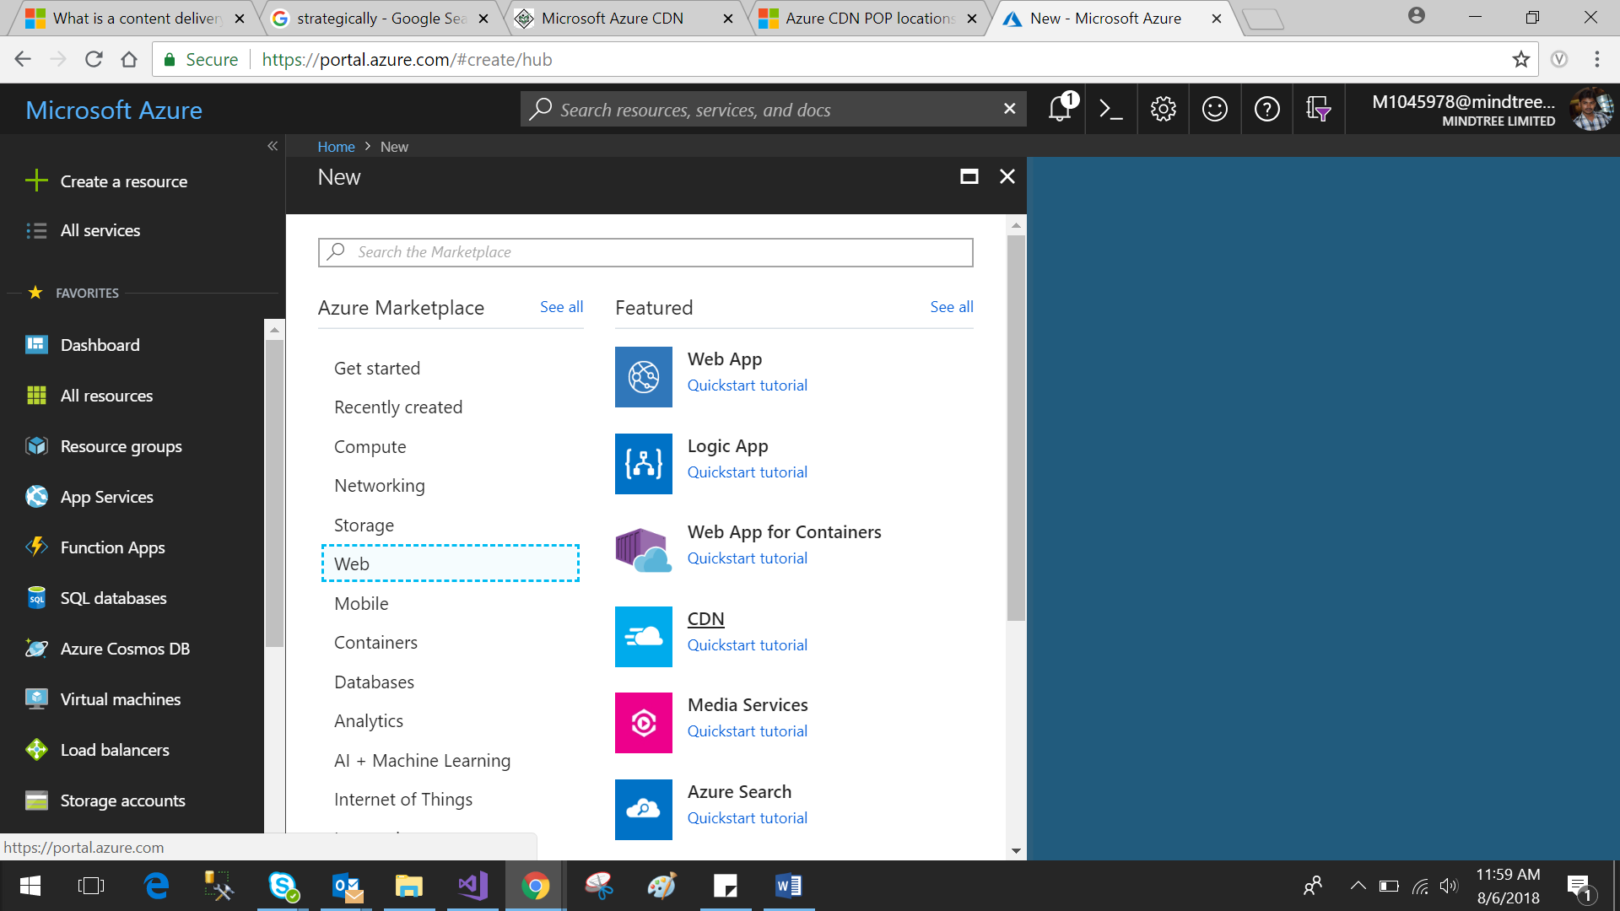

Fill the required details and click create

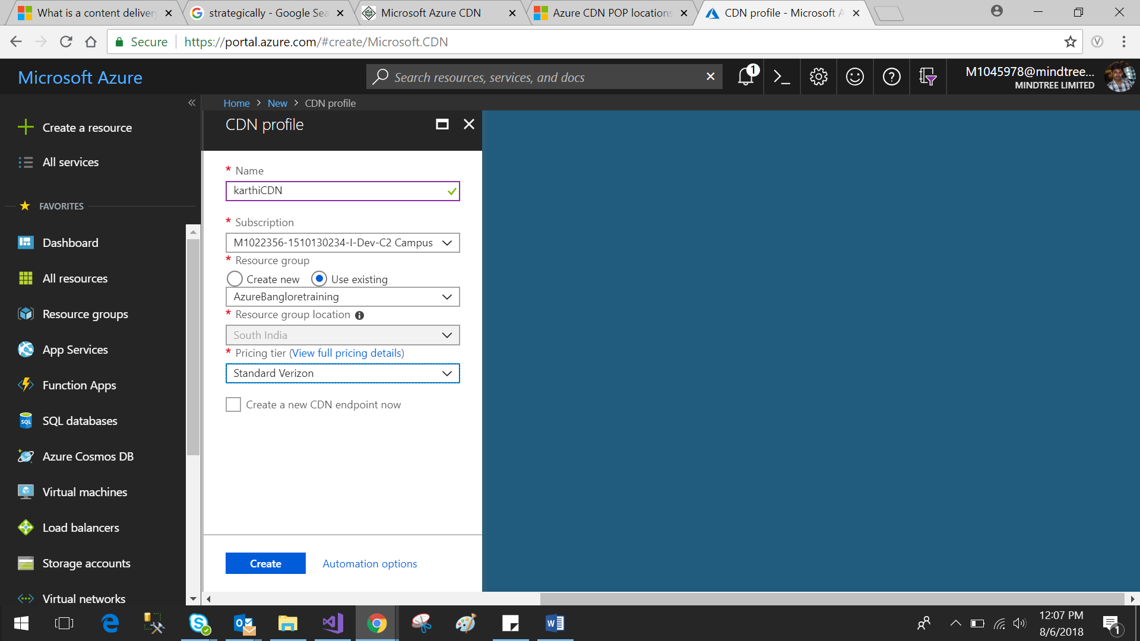

Go to CDN 🡪Endpoint

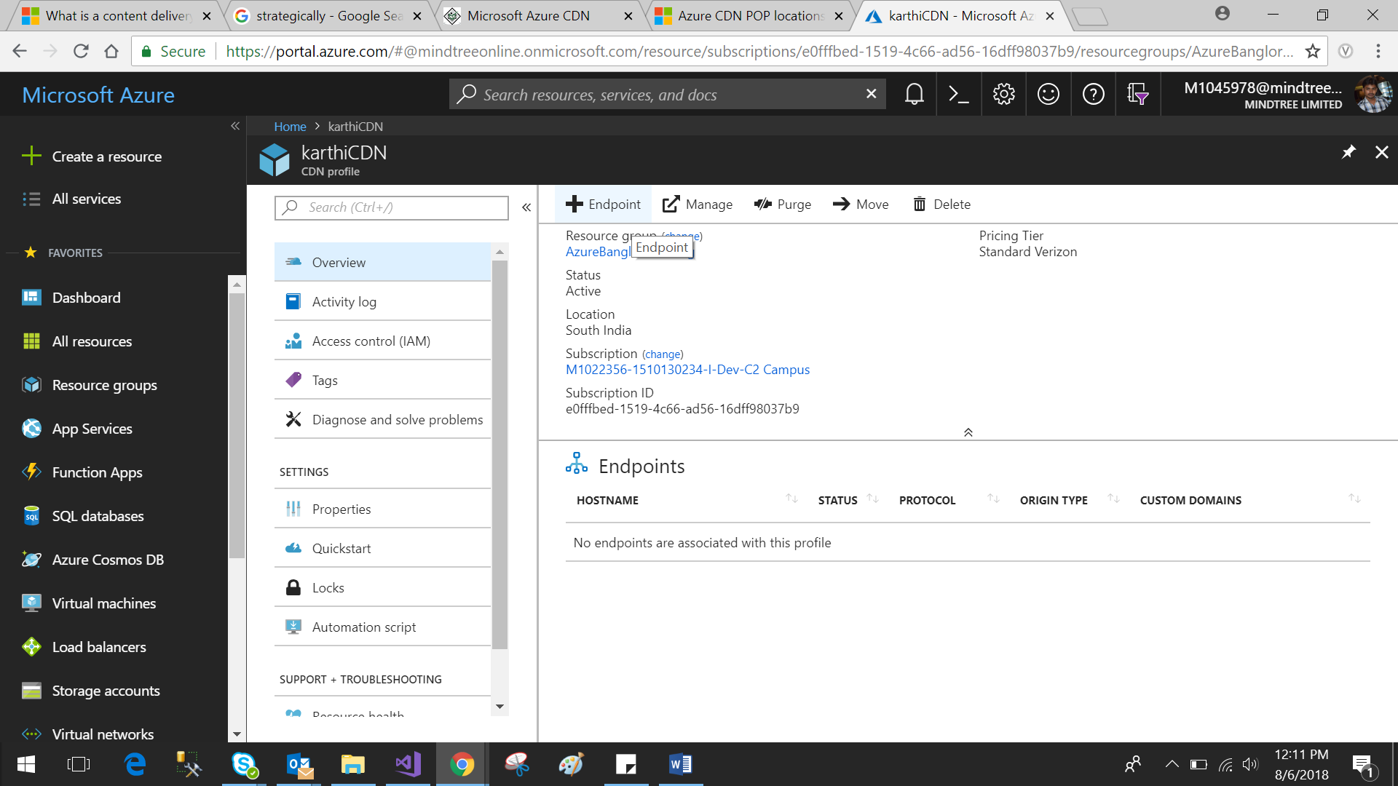

Fill required details like storage account

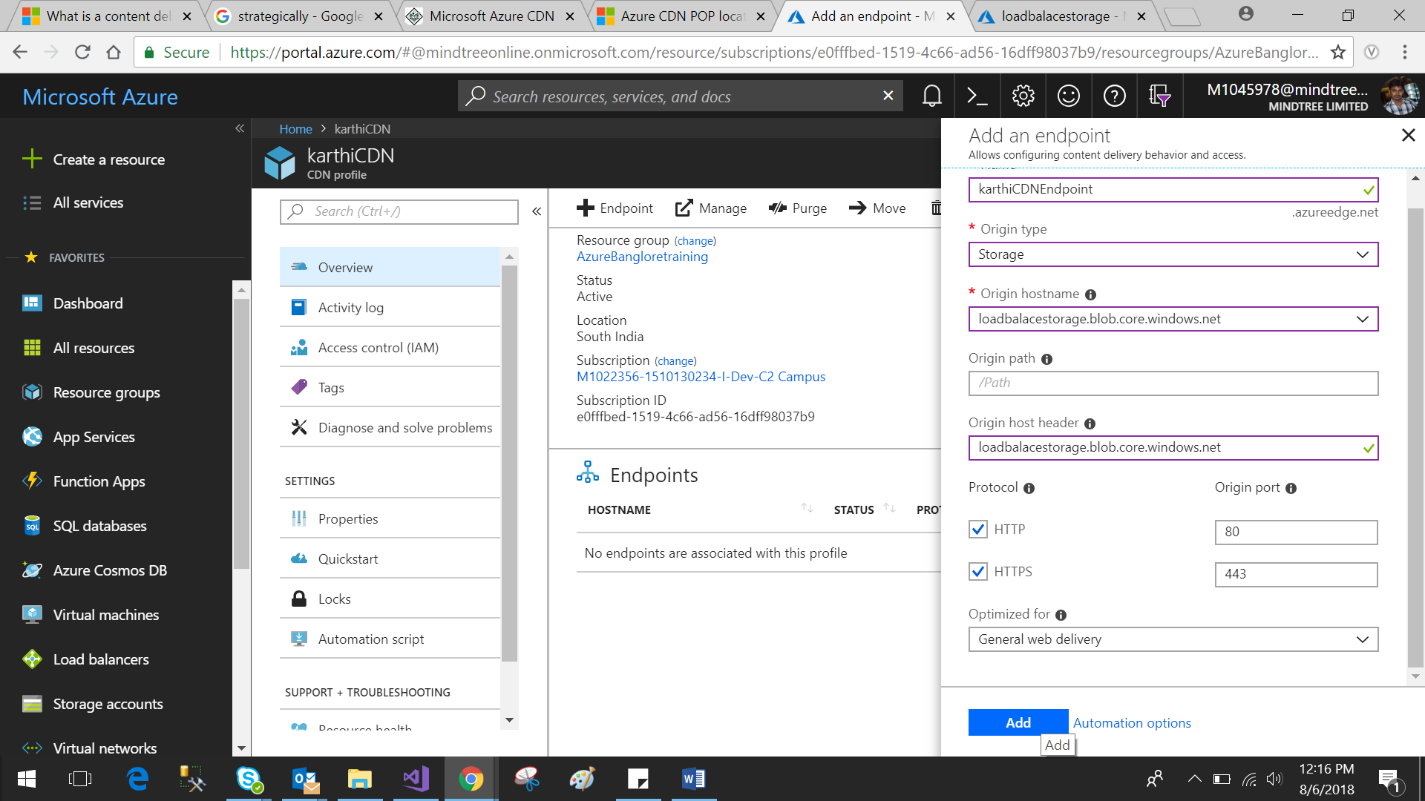

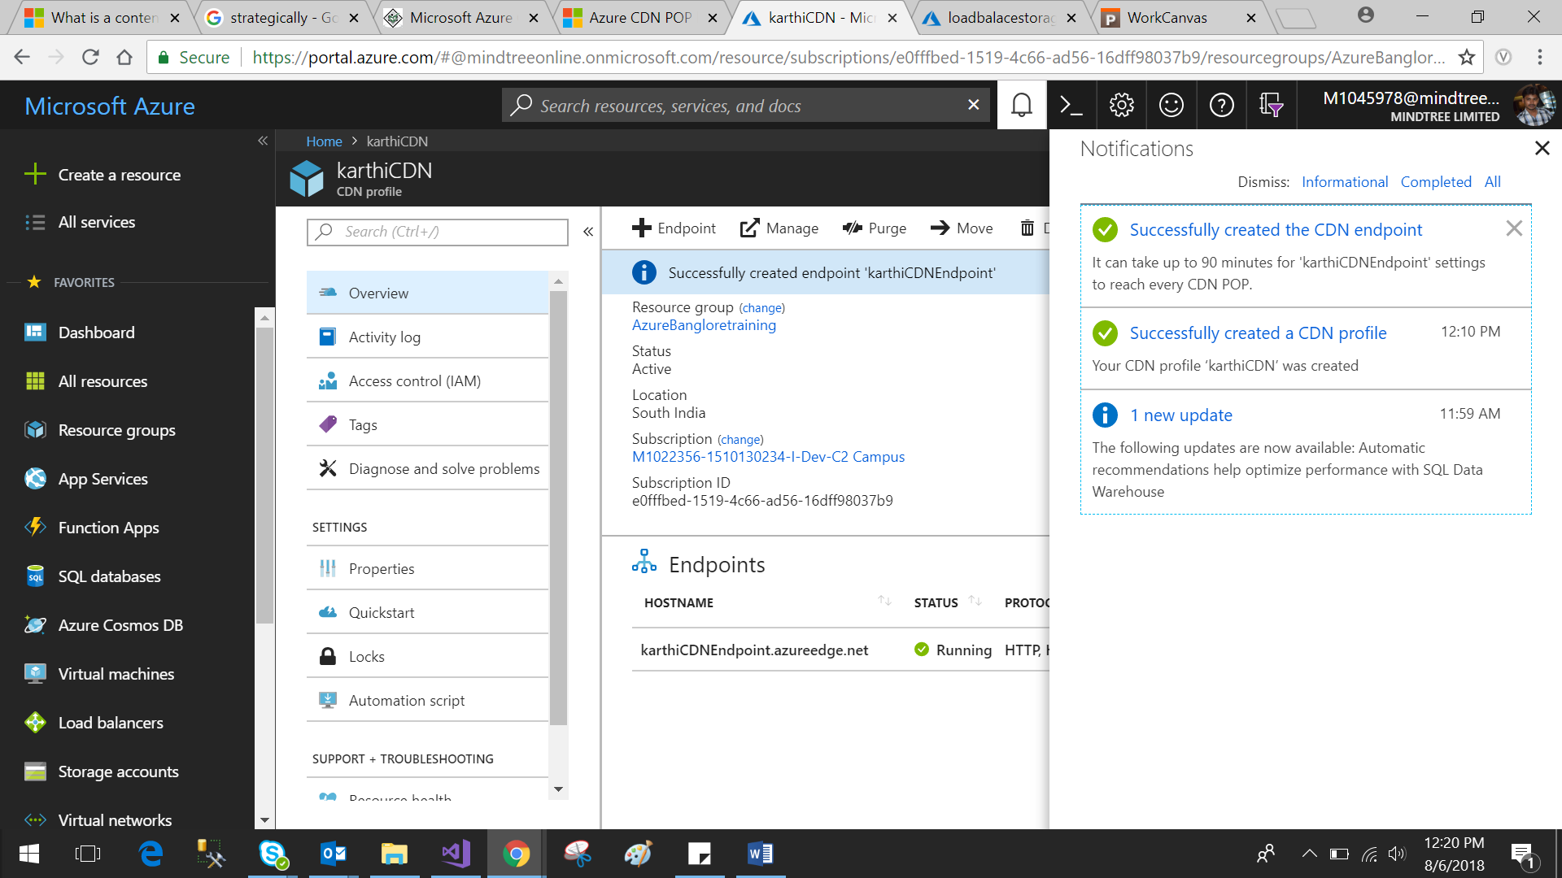

**Access CDN content**

To access cached content on the CDN, use the CDN URL provided in the portal. The address for a cached blob has the following format:

http://<*EndpointName*>.azureedge.net/<*myPublicContainer*>/<*BlobName*>