**When to use availability set**

When you have two or four VM predictable workload

You use an availability set when you have a predictable workload that you want to protect against downtime. In other words, if you know your solution can run on a single VM, you would create two VMs in an availability set to ensure that at least one VM is running at all times, and a load balancer to route traffic to an active VM

It has two methods 1) update domain 2) fault domain

Fault and update domains are automatically assigned when you place two or more virtual machines in an availability set. So, when you create your VMs, just provide the name of the availability set to which they should be assigned, and Azure will take care of the rest.

There are 3 fault domains and 5 update domains per availability set, by default.

You can change the number of fault and update domains in an availability set. To change the fault domain count, you need to contact Azure support.

**Scale set**

You use scale sets when the workload on your solution changes a lot or is unpredictable. For example, if you have a solution that normally works using only one VM, but may need up to 5 VMs to work under heavy demand, you would use a scale set to ensure that your solution quickly scales to demand. Scale sets pre-provision your VM instances so that when they need to scale out, it is just a matter of starting them, rather than having to wait for Azure to actually create the VMs.

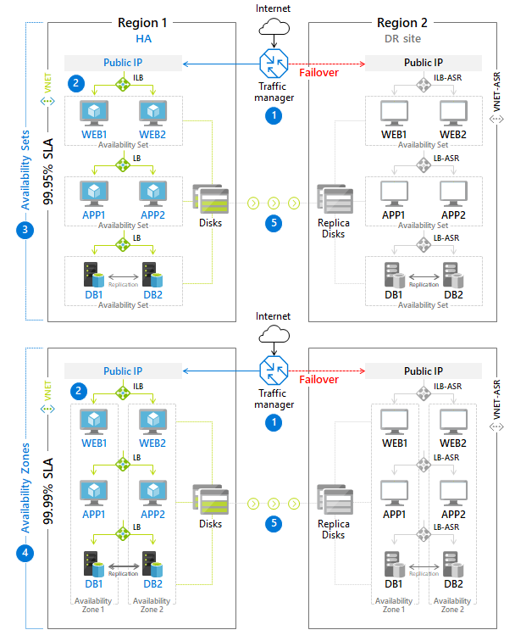

Here why we are using traffic manager, there is multiple region