By default, WSDL doesn’t support operation overloading. Overloading behavior can be achieved by using "Name" property of OperationContract attribute.

Hide   Copy Code

[ServiceContract]

interface IMyCalculator

{

[OperationContract(Name = "SumInt")]

int Sum(int arg1,int arg2);

[OperationContract(Name = "SumDouble")]

double Sum(double arg1,double arg2);

}

**Explain the components used in WCF?**

Below are the essential components of WCF –

* Service class
* End point
* Hosting Environment

**Mention the list of bindings supported by WCF?**

Below are the list of schemas supported by WCF –

* TCP
* HTTP
* MSMQ
* IPC
* Peer Network

**12) Explain the ways to host the WCF Service?**

Below are ways to host WCF Service –

IIS

Self Hosting

* WAS
* **Explain “Service Contracts” in WCF?**
* it will give you the list of operations that can be performed from that service.
* Service Contracts can be defined like –

Service contracts define the operations that a service will perform when executed. They tell the outside world a lot about the service such as message data types, operation locations, the protocols the client will need in order to communicate with the service, and the operations the service provides

**Why to use DataContarcts in WCF?**

In WCF we can communicate with server from our client through message. So messages will be going to and fro between server and client. For security purpose we are serializing the messages sent across the wire.

“[DataContact]” attribute given at class level to serialize the class by using “[Datamember]” attribute over properties.

**What are different modes of communication in WCF?**

Below are the list of modes of communication between server and client –

* One-Way
* Request-Reply
* Callback

**Explain “Callback” mode in WCF?**

This is the special mode of WCF where WCF on call back calls the method of client and in this scenario WCF service acts like a client and client acts like a service. But “HTTPBinding” does not support this mode we have to switch to “WSDualHttpBinding”.

**What are different instance modes in WCF?**

Below are the list of instance modes in WCF –

* Per Call
* Singleton
* Per Session
* Per Call: This instance is created for each call, efficient in terms of memory but need to maintain session
* Per Session: For a complete session of a user instance are created
* Single: One instance is created which is shared among all the users and shared among all.  In terms of memory it is least efficient.
* What are the advantages of hosting WCF services in IIS?
* **Advantages of hosting WCF services in IIS:**  
    
  1. Provides process activation and recycling ability, thereby increasing reliability.  
    
  2. It is a simplified way of deployment and development of hosted services.  
    
  3. Hosting WCF services in IIS can take advantage of the scalability and density features of ASP.NET.  
    
  4. It is easy to use, with only a few lines of code you have service running.  
    
  5. It supports all bindings and transports.  
    
  6. It is easy to debug WCF services.

**What is End Points and how many types of End points?**

All communication with a Windows Communication Foundation (WCF) service occurs through the endpoints of the service

|  |
| --- |
|  |
|  | * In WCF, services and clients communicate through endpoints. * An endpoint is the point where the services and clients meet and exchange messages. * A single WCF service can have one or more endpoints |

An endpoint consists of the three things address, binding and contract

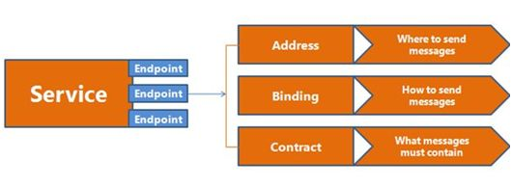

* **Address**: It specifies the location of the service which will be like [http://Myserver/Myservice](http://myserver/Myservice).  To communicate with our service client it will use this location
* **Contract**: It specifies the interface between the server and client. It’s a simple interface with some attribute
* **Binding**: It decides how two parties will communicate with each other in terms of transport and encoding and protocols

.

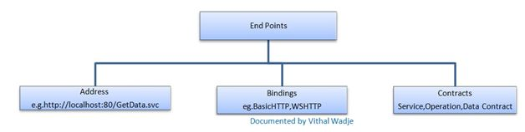

The following table gives some list of protocols supported by WCF binding.

|  |  |
| --- | --- |
| **Binding** | **Description** |
| BasicHttpBinding | Basic Web service communication. No security by default. |
| WSHttpBinding | Web services with WS-* support. Supports transactions. |
| WSDualHttpBinding | Web services with duplex contract and transaction support. |
| WSFederationHttpBinding | Web services with federated security. Supports transactions. |
| MsmqIntegrationBinding | Communication directly with MSMQ applications. Supports transactions. |
| NetMsmqBinding | Communication between WCF applications by using queuing. Supports transactions. |
| NetNamedPipeBinding | Communication between WCF applications on same computer. Supports duplex contracts and transactions |
| NetPeerTcpBinding | Communication between computers across peer-to-peer services. Supports duplex contracts |
| NetTcpBinding | Communication between WCF applications across computers. Supports duplex contracts and transactions |

**Explain what is SOA?**

SOA (Service Oriented Architectural) is a collection of services that determines how two computing entities will communicate with each other to achieve certain business functionality and also how one entity can work on behalf of another entity

**Name the namespace that is used to access WCF service?**

System.ServiceModel is used to access WCF service

DUPLEX

In **WCF**, a service can call back to its clients. That is to say that, at the time of call back, the service behaves as a client as well as the client becomes the service, and the client must assist hosting the call back object. To support call back, the underlying transport of the binding must support bidirectional. So, for the nature of connectionless, we cannot use all bindings for the call back operation. For instance, BasicHttpBinding or WsHttpBindingdoes not support callback while WsDualHttpBinding supports it

TRANSACTIONS

A Transaction is a **set of complex operations**, where **failure of any single operation causes entire set to fail**.

Suppose you have ordered an LCD television from an online store and you are going to pay the amount by your credit card. When you enter the requisite information to place the order, two operations occur simultaneously.

One, the specified amount gets debited from your bank account and second, the vendor account is credited with the same amount. Both the operations must execute successfully in order to have a successful transaction.

MESSAGE CONTRACT

|  |  |
| --- | --- |
| **Fault contract** | This contract is used to raise the error from service side or in simple words client will come to know about the service error from fault contract. |

**OData** or Open Data protocol is used to access the information exposed by data sources like SQL, Cloud Storage etc

|  |
| --- |
|  |
|  | **The different isolation levels**:   * READ UNCOMMITTED * READ COMMITTED * REPEATABLE READ * SERIALIZABLE |