Accident research analysis:

Objective:
Identify pattern and risk factors in truck-related road accidents in india using multi-source data.
Vehicle type descriptions:
Truck could be
- Truck
- Lorry
- Heavy Motor Vehicle
- Goods Carrier
- HMV
- Commercial Vehicle

Data Architecture:
RAW
- MoRTH (PDF)
- OGD (Excel/CSV)
- Kaggle (CSV)
- News_paper
- News_API
- Youtube
↓
INGESTION (src/ingestion)
↓
INTERMEDIATE
- Cleaned tables
- Column standardized
↓
CURATED
- Unified schema
- Only truck-related records
Pandas
↓
ML + Dashboards
↓
Power BI
↓
CI/CD pipeline (Github)

Actions:
Source: data.gov.in
- Created data inventory notebook in data_gov
- Did basic set up like importing libraries
- Loaded
- RA2021_A15.csv ,
- RA2021_A16.csv,
- RA2021_A17.csv
- Road_Accidents_2017-Tables_4.1 (2016 and 2017 data for all type of vehicles)
- Found all files have consolidated values for the year and no specific information on truck involved accidents.
- Data from data.gov.in has consolidated data not row level but helpful to identify the yearly trends.
Source: Kaggle
accident_prediction_india.csv, this file has 3000 rows, but truck related around 450 rows. This data will be considered as it is useful for ML pipeline as this data is structured.

It has 3000 records out of which 449 belongs truck category.
Useful data shape - 449,22
AccidentsBig.csv
Downloaded from Kaggle but this data is US data not India accidents data
Road.csv
It has 12316 records out of which 2727 belongs truck category.
Useful data shape – 2727,32

News scrapping using NLTK and Pandas:
Tried with Times of india news scrapping for 2022 & 2023.
1128 records found for Truck related vehicles.
This is using subscription account.
Tried same with Normal account not able to fetch as the data is available for free.
Also tried data scrapping techniques using selenium with subscription account and beautiful soup parse with normal account on India today, NDTV, TOI which yielded 4500+ records out of which 270 accidents truck involved.

After removing duplicates 160 records area stored for final dataset addition
News_Api using NLTK:
Got 1 record from last one month of data as this is only available for free subscription.
Youtube_scrapping with Youtube API using Google cloud API:
Got 9 records from this search.
Used youtube_scraper.py code for execution.
All scripts pertaining to scrapping are stored in src/scrapper folder.

DATA MERGING AND ANALYSIS:
Kaggle data_set and Social_media data merged.
Script saved in src/merger/merger.py
Final data set shape – 4733 records that only has truck related accidents in india.

Visualization:

Univariate analysis:
Data schema in feature engineering.ipynb notebook (Intermediate folder)
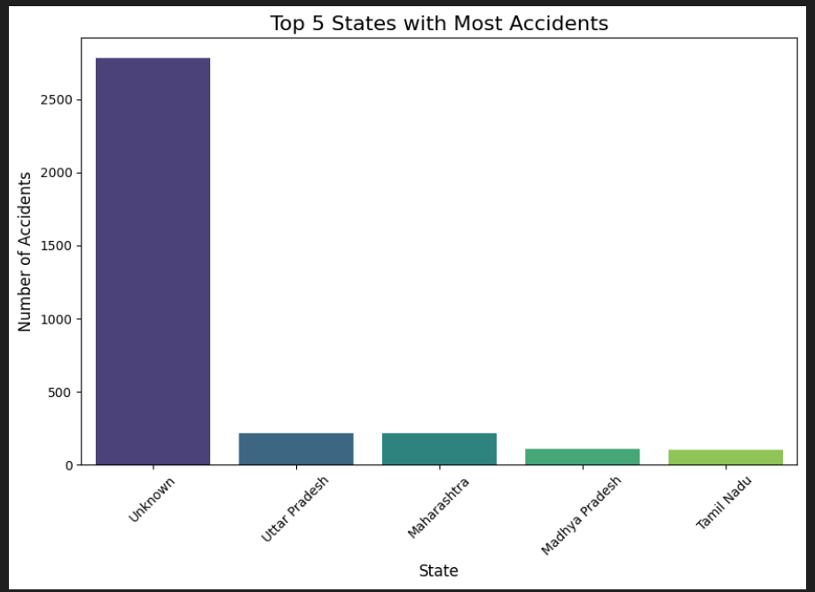

### OBSERVATION: State information was missing in a subset of the Kaggle and scraped datasets. To maintain data integrity and avoid introducing bias, these records were retained as 'Unknown' rather than being imputed.

Month data visualization:
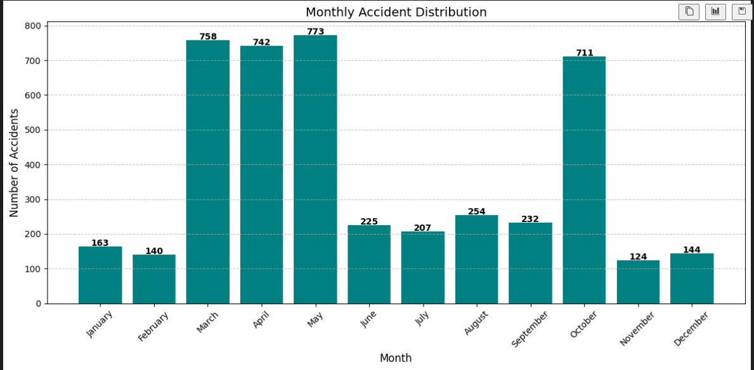
Observation: Accident frequency peaks during March–May and again in October, indicating strong seasonal patterns.
Mid-year months show comparatively fewer incidents.
Box plot for fatalities and injuries column:

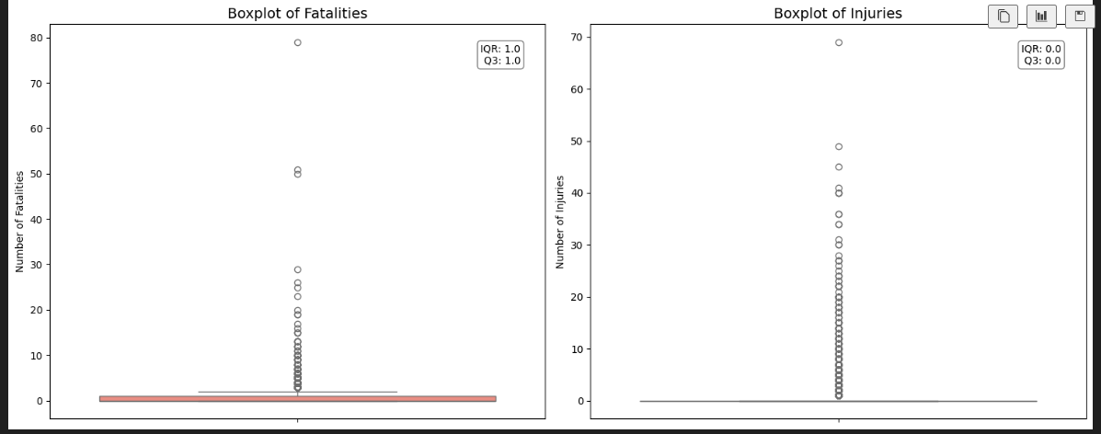
Observation: No negative values were found in the dataset. The NLP-extracted records were validated visually, confirming that the extraction quality is strong.
Vehicle_1 distribution:
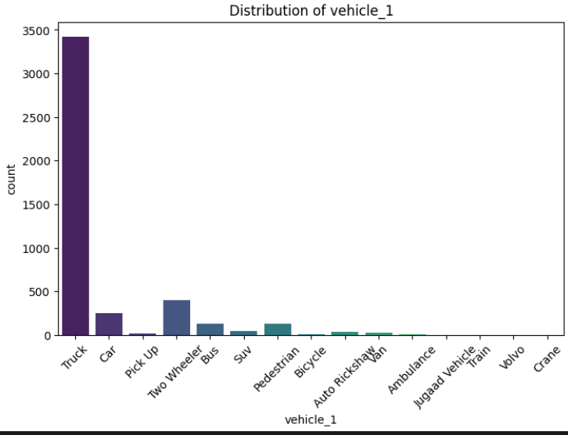
Observation: Truck is by far the dominant primary vehicle in the dataset, with counts an order of magnitude higher than any other category (car, pickup, two-wheeler, bus, etc.).
This aligns with the project’s truck-focused filtering, so the distribution confirms correct data curation while still showing a small tail of other vehicle types involved in truck crashes.

Vehicle_2 distribution:
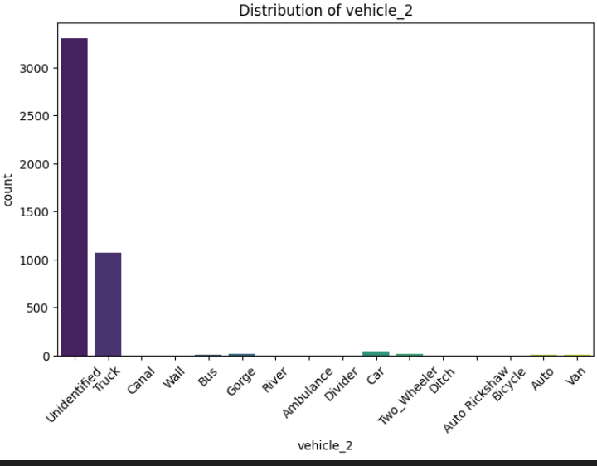
Observation: Most secondary vehicles involved in truck accidents are labelled as “Unidentified”, indicating missing or unclear reporting across sources.
Trucks still appear as the second most common Vehicle_2 type, confirming many crashes involve truck-to-truck interactions.
Vehicles_involved column:
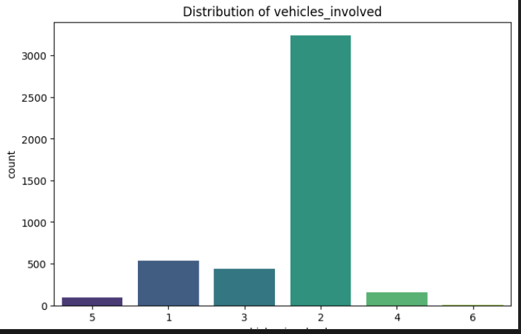
Observations: Most accidents involve exactly two vehicles, which aligns with typical collision patterns in road crashes.
Multi-vehicle crashes (3 or more) are far less frequent, indicating they are more exceptional and occur only in rare, staggered collision scenarios.
Sub plot for party age group and victim age group
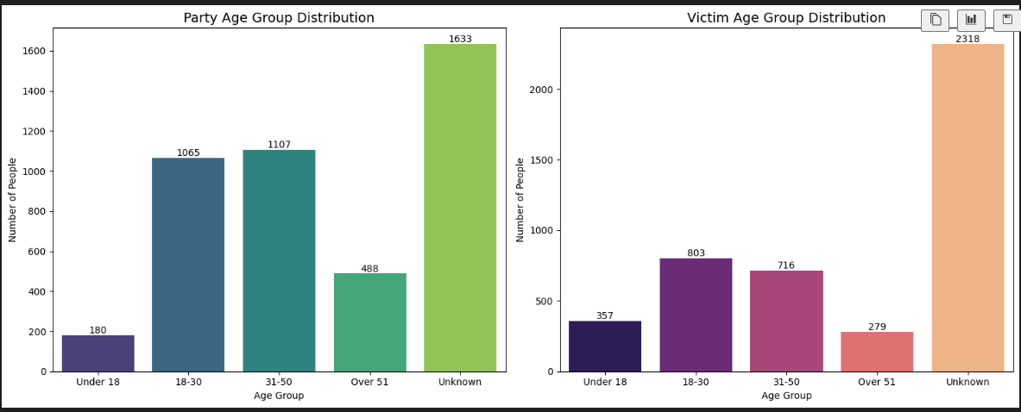
Observations:
A large portion of both driver (party) and victim age groups are recorded as “Unknown”, reflecting incomplete age reporting across news-based sources.
Among known ages, the 18–30 and 31–50 groups show the highest involvement, indicating that most accidents affect active working-age individuals.

Cause of accident classes and its spread against severity:
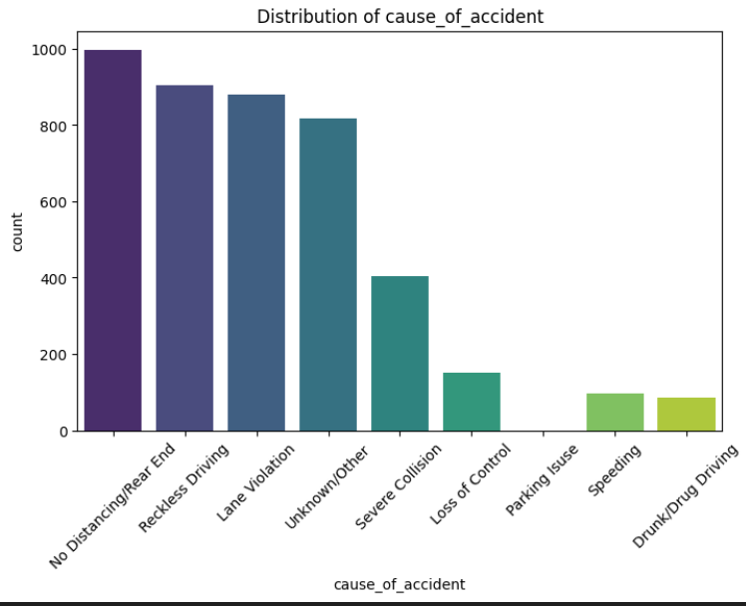
Observations: Rear-end collisions and “no distancing” incidents are the leading causes of accidents, indicating that sudden braking and inadequate following distance are major contributors.
Reckless driving and lane violations also appear prominently, while causes like speeding and drunk driving are comparatively less frequent in the dataset.
Weather conditions:
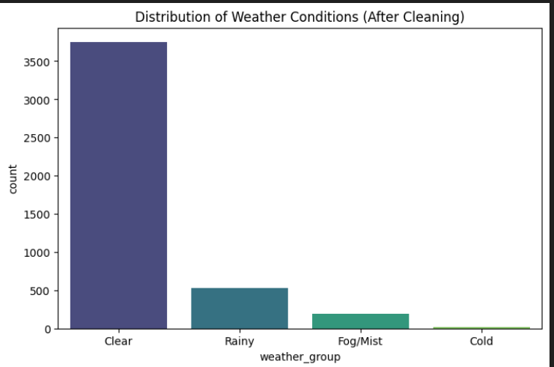
Observations:
Most accidents occur under clear weather conditions, indicating that good visibility does not necessarily prevent collisions.
Rainy and foggy conditions contribute to a smaller share of accidents, while cold-weather incidents are extremely rare in the dataset.

Road conditions:
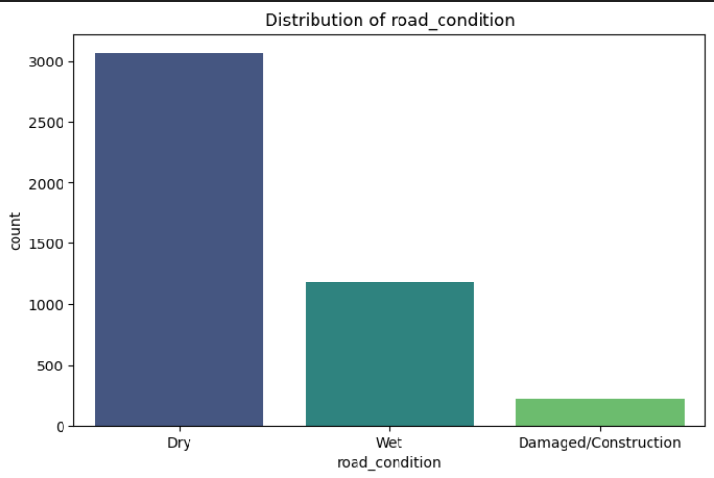
Observations:
Most accidents occurred on dry road surfaces, showing that crashes are not limited to adverse road conditions.
Wet and damaged/construction roads contribute to a smaller share, but still represent meaningful risk factors in specific scenarios.

Lighting conditions:

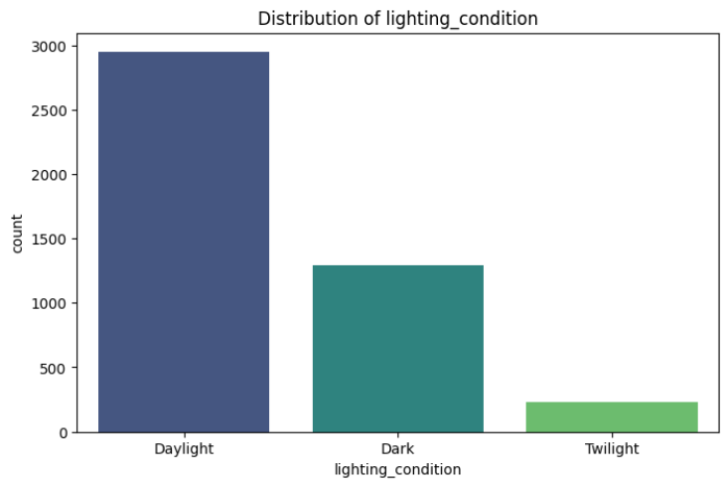
Observations:
A majority of accidents occur during daylight, indicating that high visibility alone does not eliminate crash risk.
Accidents in dark and twilight conditions are fewer but still significant, reflecting the added challenges of reduced visibility.
Severity distribution:
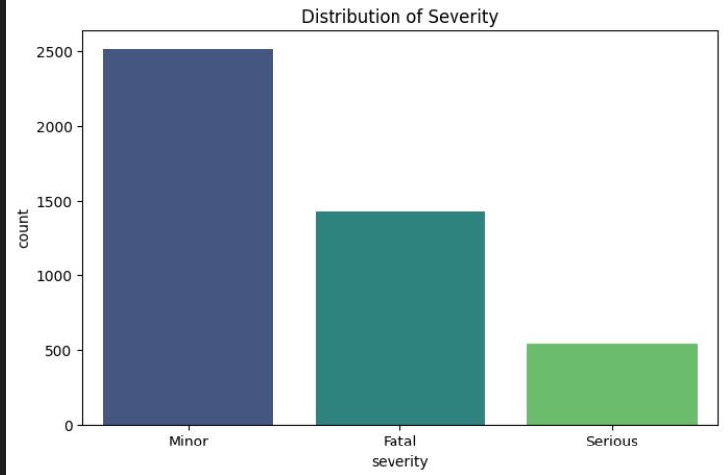
Observations: Minor-severity accidents form the largest share of the dataset, followed by a substantial number of fatal cases.
Serious-injury accidents are comparatively fewer, indicating that extreme outcomes (minor or fatal) occur more frequently than mid-severity cases.

Final Data Schema:

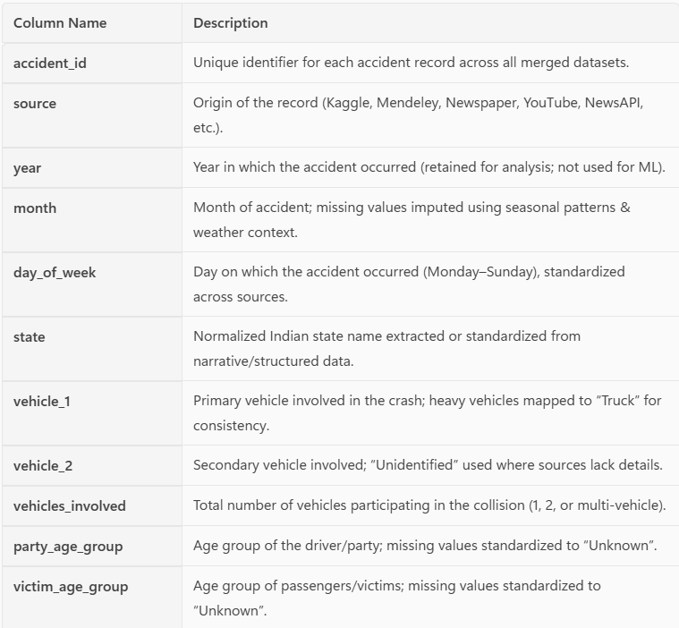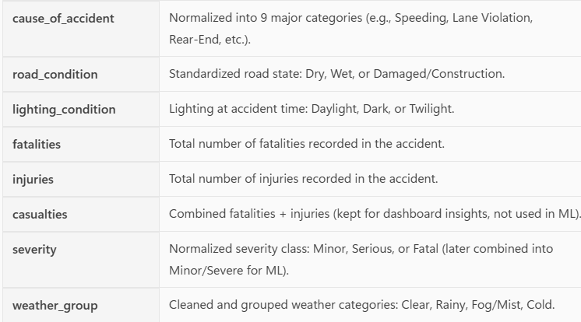

ML Model build steps and Visulizations:
Dropped columns 'casualties','year','accident_id','source'
- Categorize columns:
- 1.a. Cat cols & Numerical cols
- cat_cols = [
- 'month', 'day_of_week', 'state',
- 'vehicle_1', 'vehicle_2',
- 'party_age_group', 'victim_age_group',
- 'cause_of_accident',
- 'weather_group', 'road_condition', 'lighting_condition',
- 'severity'
- ]
- num_cols = ['vehicles_involved', 'fatalities', 'injuries']

2. Label encoding and Manual mapping
Columns Month, dayof week, severity and Age are custom mapped to avoid ordinal mapping
Label encoding method for remaining features:
Feature: state
{0: 'Andhra Pradesh', 1: 'Arunachal Pradesh', 2: 'Assam', 3: 'Bihar', 4: 'Chandigarh', 5: 'Chhattisgarh', 6: 'Delhi', 7: 'Goa', 8: 'Gujarat', 9: 'Haryana', 10: 'Himachal Pradesh', 11: 'Jammu and Kashmir', 12: 'Jharkhand', 13: 'Karnataka', 14: 'Kerala', 15: 'Madhya Pradesh', 16: 'Maharashtra', 17: 'Manipur', 18: 'Meghalaya', 19: 'Mizoram', 20: 'Nagaland', 21: 'Odisha', 22: 'Puducherry', 23: 'Punjab', 24: 'Rajasthan', 25: 'Sikkim', 26: 'Tamil Nadu', 27: 'Telangana', 28: 'Tripura', 29: 'Unknown', 30: 'Uttar Pradesh', 31: 'Uttarakhand', 32: 'West Bengal'}
Feature: vehicle_1
{0: 'Ambulance', 1: 'Auto Rickshaw', 2: 'Bicycle', 3: 'Bus', 4: 'Car', 5: 'Crane', 6: 'Jugaad Vehicle', 7: 'Pedestrian', 8: 'Pick Up', 9: 'Suv', 10: 'Train', 11: 'Truck', 12: 'Two Wheeler', 13: 'Van', 14: 'Volvo'}
Feature: vehicle_2
{0: 'Ambulance', 1: 'Auto', 2: 'Auto Rickshaw', 3: 'Bicycle', 4: 'Bus', 5: 'Canal', 6: 'Car', 7: 'Ditch', 8: 'Divider', 9: 'Gorge', 10: 'River', 11: 'Truck', 12: 'Two_Wheeler', 13: 'Unidentified', 14: 'Van', 15: 'Wall'}

Feature: cause_of_accident
{0: 'Drunk/Drug Driving', 1: 'Lane Violation', 2: 'Loss of Control', 3: 'No Distancing/Rear End', 4: 'Parking Issue', 5: 'Reckless Driving', 6: 'Severe Collision', 7: 'Speeding', 8: 'Unknown/Other'}
Feature: weather_group
{0: 'Clear', 1: 'Cold', 2: 'Fog/Mist', 3: 'Rainy'}
Feature: road_condition
{0: 'Damaged/Construction', 1: 'Dry', 2: 'Wet'}
Feature: lighting_condition
{0: 'Dark', 1: 'Daylight', 2: 'Twilight'}

RANDOM FOREST CLASSIFIER MODEL BUILS FOR SEVERITY PREDICTION:
1.a Data split for training and testing:
Data Split Successfully!
Training Data: (3578, 12)
Testing Data: (895, 12)
Result:
Overall Accuracy: 79.55%
Detailed Classification Report:
precision recall f1-score support
Minor 0.80 0.90 0.85 514
Serious 0.30 0.13 0.18 123
Fatal 0.89 0.90 0.89 258
For serious the prediction isnot perfect as the test set is small. So combining 2 data (serious/fatal severe) Binary conversion
Class 0 >> Minor ---Count : 2511
Class 1 >> Severe ---Count : 1962
1.b Retracing the model
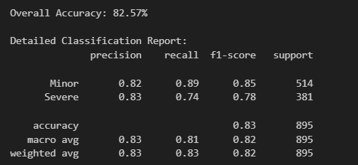
1.c. RISK SCORE GENERATION
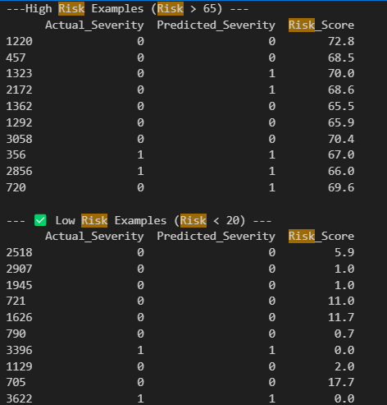

Visulazation of driving factors:
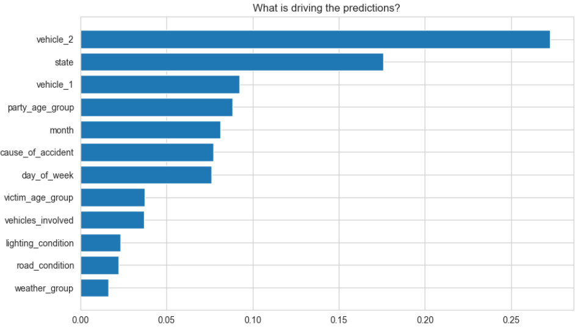
Observations:
The model shows that Vehicle_2 and State are the two strongest predictors, indicating that the type of secondary vehicle and regional crash characteristics significantly influence severity.
Vehicle_1 and driver age group also contribute meaningfully, reflecting the role of vehicle pairing and human factors in crash outcomes.
Mid-level factors such as month, cause of accident, and day of week provide additional temporal and behavioural context.
Environmental attributes like weather, road condition, and lighting have comparatively lower influence, showing that vehicle and contextual features dominate severity prediction.
MODEL 2 LOGISTIC REGRESSION
MODEL-2
LOGISTIC REGRESSION: Good for Binary classes
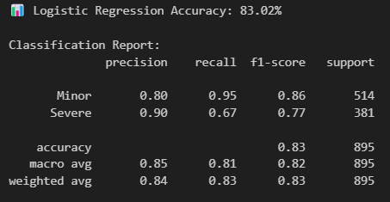

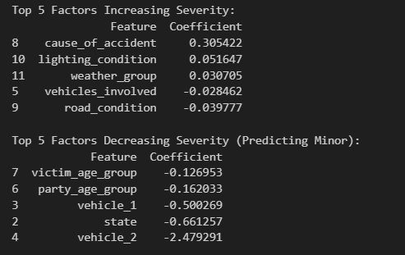
Factors that influencing the result
MODEL 3 XG BOOST

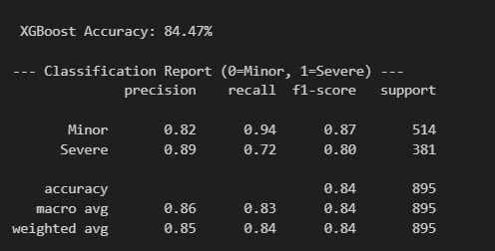

Observation: The XG booster Algorithm results are better than other 2 models

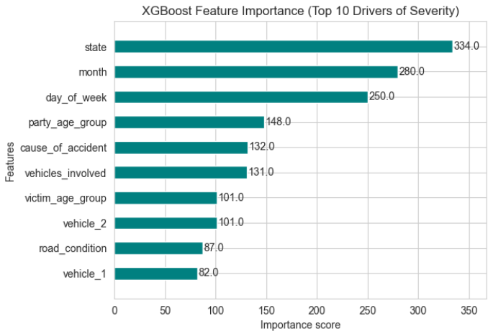
Observations: State could not be considered as it is having lot of unknown values. This can be safely ignored to understand other factors
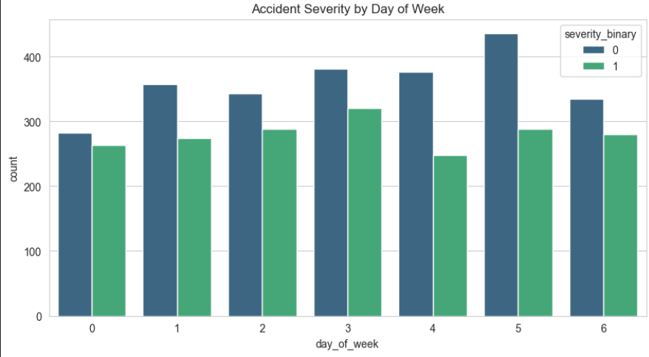

Observations: Most of the accidents happens on Friday due to intercity movement ahead of weekend
Optional:
Building Cause of accident prediction model
Result:
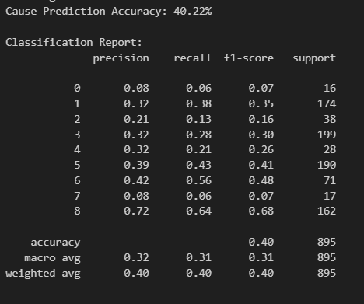

Observations:
The cause-of-accident model struggles because the dataset contains nine different cause classes, many of which have very similar patterns (e.g., speeding vs reckless driving).
Several classes also have low sample counts, making it difficult for the model to learn distinct patterns and achieve high recall.
As a result, overall accuracy is limited (~40%) and performance varies widely across categories, with only the majority classes achieving reasonable scores.
This confirms that multi-class cause prediction is challenging with the current dataset size, and would require more data or simplified grouping for reliable modelling.

2. SHAP: Explainable AI
SHAP XG booster model chosen as it performs better than other 2 models
hyper tuning parameters:
n_estimators=100, random_state=42,
scale_pos_weight=(len(y[y==0])/len(y[y==1])
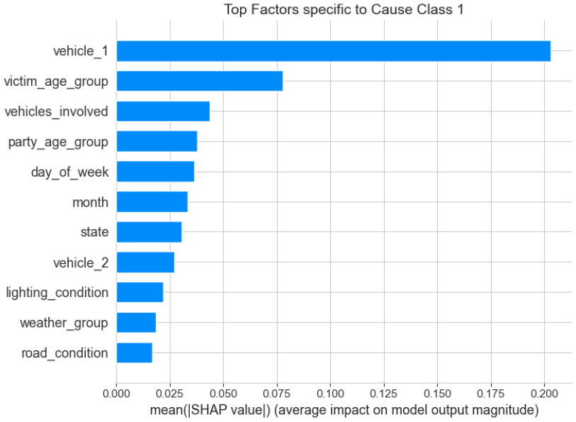

Observation:
SHAP values show how much each feature contributes to predicting a specific accident cause.
For Cause Class 1, vehicle_1 is the strongest driver, followed by victim age group and the number of vehicles involved.
Lower-ranked features like lighting, weather, and road condition have minimal impact for this class.
SHAP helps validate that the model’s decisions are grounded in meaningful crash patterns rather than noise.

Inverse mapping to export data for importing in Power BI for creating confusion matrix
Data export:
/data/final/Full_Accident_Risk_Analysis.csv'

Confusion Matrix in POWER BI:
Created DAX formulas, Matrix table to understand the confusion matrix and assess model behaviour.

Slider value for dynamic:
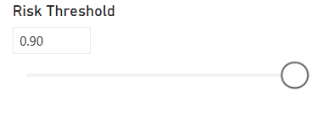

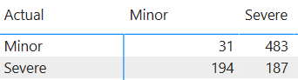

Correct Prediction Matrix:
- True Minor Predicted Correctly = 31
- True Severe Predicted Correctly = 187
False Prediction matrix: (Biased towards Severe )
- Severe misclassified as Minor = 194 (FN)
- Minor misclassified as Severe = 483 (FP)

This model is biased towards severe class which can be seen in false positives.

