**Internship at Skill Lync**

**Complete Responsive Flower Website Design**

**By M. Suganya**

**INTRODUCTION**

**1.Overview**

Basics of HTML and CSS along with building a project which will be a complete responsive flower website design page website. This is a simple flower website design and inventory of products. This system was programmed through the use of visual studio code. This features is purchasing products of cashiering, flower product in best review of customers.

**2.Purpose**

Flower website design using HTML& CSS . I create in Just using HTML and CSS. This Is Very Easy to create this flower Website Design using HTML. After Creating the File I make the website Structure Using HTML And Design The Site Using cascading style sheets "CSS". I Make Five Sections, the first section is the home section, the second is about section, the third is products section, and fourth is the review section, fifth is a contact section . last is the footer section. After Making Structure and Designing.

**3.Flowchat**

products

about

home

Flower website design

review

about

**4.System Design**

**4.1 Home**

First have a look at the HTML components that create each section of this homepage. The picture below shows different HTML elements with its name that gives you a rough idea of how to create the HTML structure of the home page. The main section contains almost everything that you want to show on the homepage so it is also bigger than any other section. we are just using the about fresh flowers, shop now. From the image, you can get a rough idea of the structure of the main section. We have created the HTML part then style the elements using CSS. To select the element to style using CSS SELECTOR. We are going to use CSS FLEXBOX to align the elements horizontally and vertically.

**4.2 About**

The **about** page contains insightful information about the website. It contains information about the purpose of the website, why we use?, learn more details about the flower website design. This page is widely used especially in the flower website. The about us page may contain some heading text, images,video. Wrap all the contents within  element and set the add some background color,width also. Style each component with CSS properties and use Font Awesome.

**4.3 Products**

Products page in create Latest products Tables provide the simplest method of building an online catalog in HTML. A three-column table gives you room for a product image, prics, added to cart and like/share information. Inserting information into tables reduces the amount of time required to justify text. In addition, tables give you control of the white space surrounding the information on our page to enhance the appearance and clarity of website. Create a table. Tables are defined with the tag. Each table can be divided into rows and each row into data cells. Adjust the table's border properties. Add CSS cellpadding or cellspacing. Cellpadding is the amount of white space between the border and cell content. Cellspacing is the distance between cells. These tags are applied within the table tag. It isn't a requirement to have cellpadding or cellspacing active.

**4.4 Review**

Reviews on the website using HTML and CSS. Add a reviews section on your website using HTML and CSS. easily make this Reviews Section by folIowing star, rating for customers, also provide you HTML, CSS. Add CSS in review section and background colors.

**4.5 Contact**

Contact section using form tag Collect user input with a simple contact form with ‘Name’, ‘Email’, ‘Number’,‘Message’ fields. Add image in contact page. then quick link have about all section pages. Extra link have add my account,my order, my favorite. Locations add the state. Contact info include phone numbers, email, payment link also. Add CSS background color,flexbox,border size,width all are included.

**Hardware and Software Requirement**

**5.1 Hardware Required**

Processor: 11th Gen Intel(R) Core(TM) i3-1115G4 @ 3.00GHz 3.00 GHz

RAM:8GB

Input Devices : Keyboard, Mouse

Output Devices : Monitor

**5.2 Software Required**

**Operating System**: Windows 11

**Front end:** Visual studio code,HTML,CSS

**Visual studio code**

Visual Studio Code is a lightweight but powerful source code editor which runs on your desktop and is available for Windows, macOS and Linux. It comes with built-in support for JavaScript, TypeScript and Node.js and has a rich ecosystem of extensions for other languages and runtimes (such as C++, C#, Java, Python, PHP, Go, .NET). Visual Studio Code for the Web provides a free, zero-install Microsoft Visual Studio Code experience running entirely in your browser, allowing you to quickly and safely browse source code repositories and make lightweight code changes.

**HTML**

HTML standards for Hyper Text Markup Language, which is the structural description of contents of a file. It is the arrangement of text, image and other multimedia contents on the display. HTML was developed with the intent of defining the structure of documents like headings, paragraphs, lists, and so forth to facilitate the sharing of scientific information between.

**CSS**

CSS is basically a style sheet language which presents a document written in a markup language as like as HTML. It separates contents like layout colors, fronts and improves control over the contents. CSS handles the look and feel part of a web page. Using CSS, you can control the color of the text, the style of fonts, the spacing between paragraphs, how columns are sized and laid out, what background images or colors are used, layout designs,variations in display for different devices and screen sizes as well as a variety of other effects. CSS is easy to learn and understand but it provides powerful control over the presentation of an HTML document. Most commonly, CSS is combined with the markup languages HTML or XHTML.

**6.Output Screenshot**

**6.1 Home**

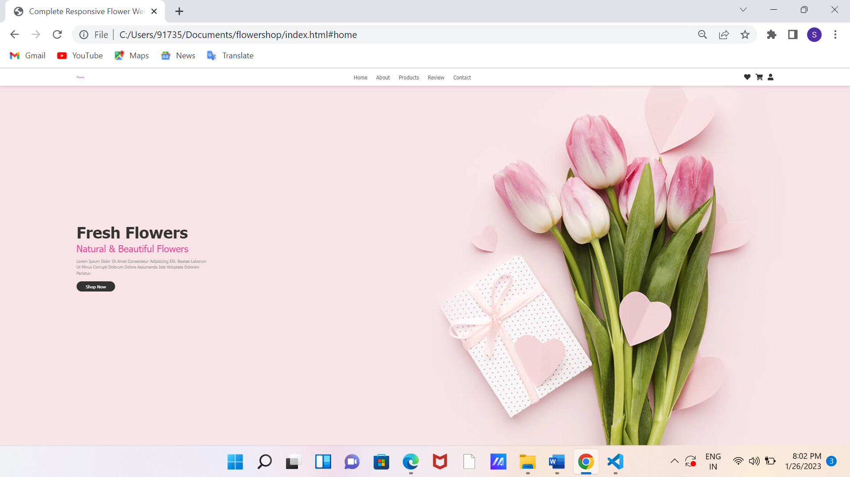

**6.2 About**

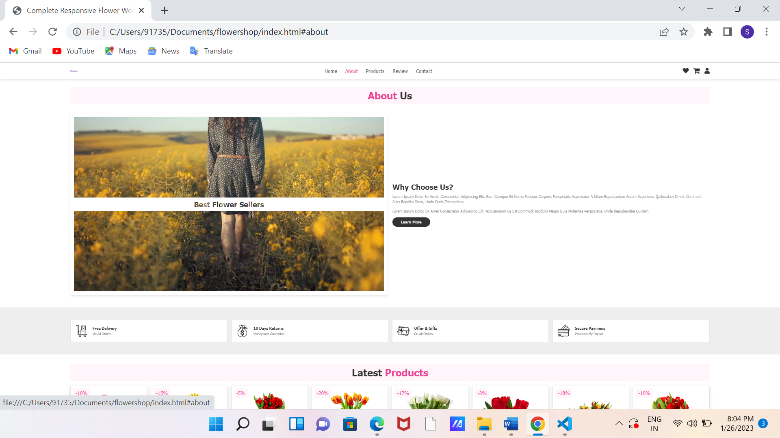

**6.3 Products**

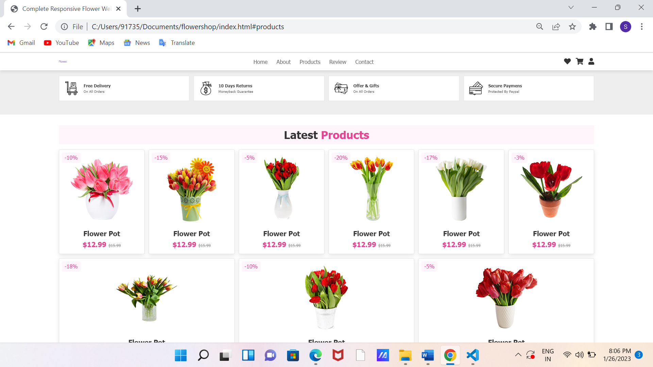

**6.4 Review**

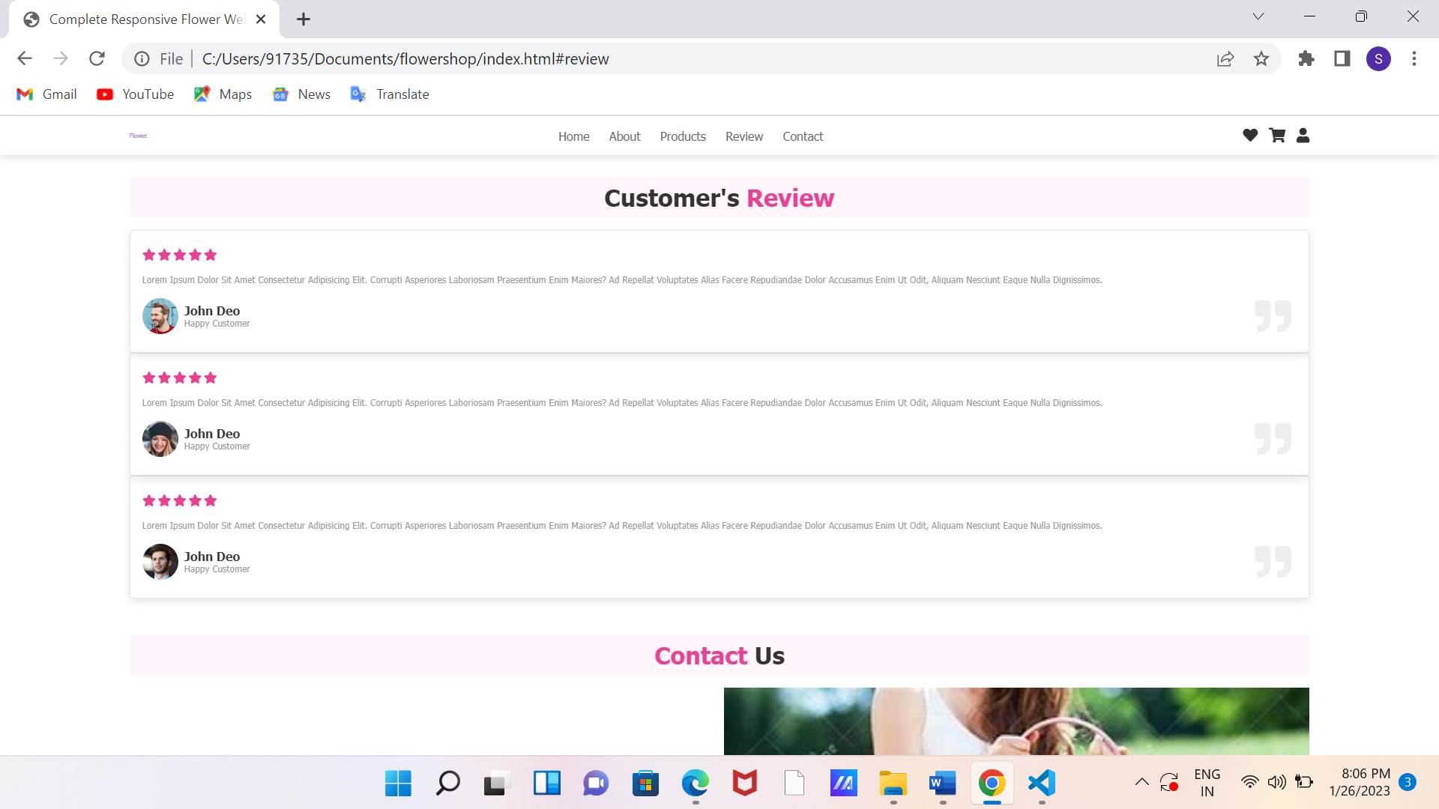

**6.5 Contact**

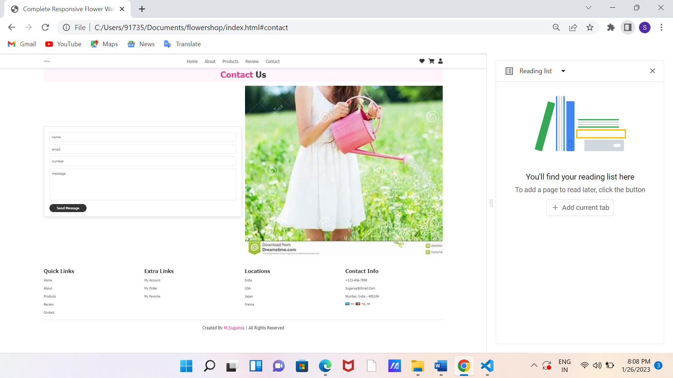

**Conclusion**

This concludes the create Flower website design using HTML& CSS . design which I create in Just using HTML and CSS. This flower Website Design using HTML. After Creating the File I make the website Structure Using HTML And Design The Site Using cascading style sheets "CSS". created webpage simple flower website using html&css.