**Internship at Skill Lync**

**CRUD Operation Using Swing and Mysql**

**By M. Suganya**

**INTRODUCTION**

**1.Overview**

MySQL is an RDBMS (Relational Database Management System) database. we will learn using JDBC (Java Database Connectivity) to insert, update and delete data into MySQL database using the NetBeans IDE. Basic database operations (CRUD - Create, Retrieve, Update and Delete) using JDBC (Java Database Connectivity) API. These CRUD operations are equivalent to the INSERT, SELECT, UPDATE and DELETE statements in SQL language. Although the target database system is MySQL, but the same technique can be applied for other database systems as well because the query syntax used is standard SQL which is supported by all relational database systems. i am doing insert, update and delete database records by writing code to manage records of a table.

**2.Purpose**

The data modification clauses in SQLite are INSERT, UPDATE, and DELETE statements. It is used for inserting new rows, updating existing values, or deleting rows from the database. The INSERT statement is used to add new rows to a table. The UPDATE statement is used to edit and update the values of an existing record. The DELETE statement is used to delete records from a database table. The following SQL stored procedure is used insert, update, delete, and select rows from a table, depending on the statement type parameter.

**3.System Design**

**3.1 Insert**

 INSERT statement is used to store or add data in MySQL table within the database. We can perform insertion of records in two ways using a single query in MySQL:

1. Insert record in a single row
2. Insert record in multiple rows

**Syntax:**

Insert into  table_name ( field1, field2,...fieldN )  values  ( value1, value2,...valueN );

**3.2 Delete**

MySQL DELETE statement is used to remove records from the MySQL table that is no longer required in the database. **This query in MySQL deletes a full row from the table and produces the count of deleted rows**. It also allows us to delete more than one record from the table within a single query, which is beneficial while removing large numbers of records from a table. By using the delete statement, we can also remove data based on conditions.

**Once we delete the records using this query, we cannot recover it**. Therefore before deleting any records from the table, it is recommended to **create a backup of your database**.

**Syntax:**

**Delete from table_name where condition;**

**3.3 Update**

MySQL UPDATE query is a DML statement used to modify the data of the MySQL table within the database. In a real-life scenario, records are changed over a period of time. So, we need to make changes in the values of the tables also. To do so, it is required to use the UPDATE query.

The UPDATE statement is used with the **SET** where clauses. The SET clause is used to change the values of the specified column. We can update single or multiple columns at a time.

**Syntax:**

 Update table_name  SET column_name1 = new-value1,

column_name2=new-value2, ...    [WHERE Clause]

**3.4 Select**

The select statement is used to select data from a database.

The data returned is stored in a result table, called the result-set.

**Syntax:**

Select * fromtable_name;

**Hardware and Software Requirement**

**4.1 Hardware Required**

Processor: 11th Gen Intel(R) Core(TM) i3-1115G4 @ 3.00GHz 3.00 GHz

RAM:8GB

Input Devices : Keyboard, Mouse

Output Devices : Monitor

**4.2 Software Required**

**Operating System**: Windows 11

**Backend:** Java, Swings, Mysql, JDBC, Netbeans

**JAVA**

Java is a popular programming language, created in 1995.It is owned by Oracle, and more than **3 billion** devices run Java .It is used for: Mobile applications (specially Android apps),Desktop applications, Web applications, Web servers and application servers, Games, Database connection, Java works on different platforms (Windows, Mac, Linux, Raspberry Pi, etc.),It is one of the most popular programming language in the world, It has a large demand in the current job market, It is easy to learn and simple to use, It is open-source and free, It is secure, fast and powerful, It has a huge community support (tens of millions of developers),Java is an object oriented language which gives a clear structure to programs and allows code to be reused, lowering development costs

**Swings**

In simple words, Swing is the graphical user interface toolkit that is used for developing windows based java applications or programs. It is the successor of AWT, known as the Abstract window toolkit API for Java, and AWT components are mainly heavyweight. The components are lightweight as compared to AWT components. It provides an excellent interface to the user for all the platforms. It is not specifically for one platform. The components are written in Java and platform-independent as well. The Java foundation classes first appeared in 1997, then later called Swing. To use the swing in java, javax. A swing package needs to be used or imported. It is also known as Java Swing.

**MYSQL**

SQL is a standard language for accessing and manipulating databases. SQL stands for Structured Query Language. SQL lets you access and manipulate databases. SQL became a standard of the American National Standards Institute (ANSI) in 1986, and of the International Organization for Standardization (ISO) in 1987. SQL can execute queries against a database, SQL can retrieve data from a database, SQL can insert records in a database, SQL can update records in a database, SQL can delete records from a database, SQL can create new database, SQL can create new tables in a database, SQL can create stored procedures in a database, SQL can create views in a database, SQL can set permissions on tables, procedures, and views

**JDBC**

**Java Database Connectivity** (**JDBC**) is an application programming interface (API) for the java programming language, which defines how a client may access a database. It is a Java-based data access technology used for Java database connectivity. It is part of the java standard Edition platform, from oracle corporation. It provides methods to query and update data in a database, and is oriented toward relational databases. A JDBC-to-ODBC bridge enables connections to any ODBC-accessible data source in the java virtual machine (JVM) host environment. JDBC ('Java Database Connectivity') allows multiple implementations to exist and be used by the same application. The API provides a mechanism for dynamically loading the correct Java packages and registering them with the JDBC Driver Manager. The Driver Manager is used as a connection factory for creating JDBC connections.JDBC connections support creating and executing statements. These may be update statements such as SQL INSERT, UPDATE and DELETE, or they may be query statements such as SELECT.

**NETBEANS**

Netbeans is an open-source Integrated Development Environment (IDE). It is used to develop applications with Java, PHP, C++, HTML and many other programming languages. The applications are developed using modules in Java. NetBeans can run on any operating system such as Windows, MacOS, Linux etc.

**5.Output Screenshot**

**5.1 Insert Data**

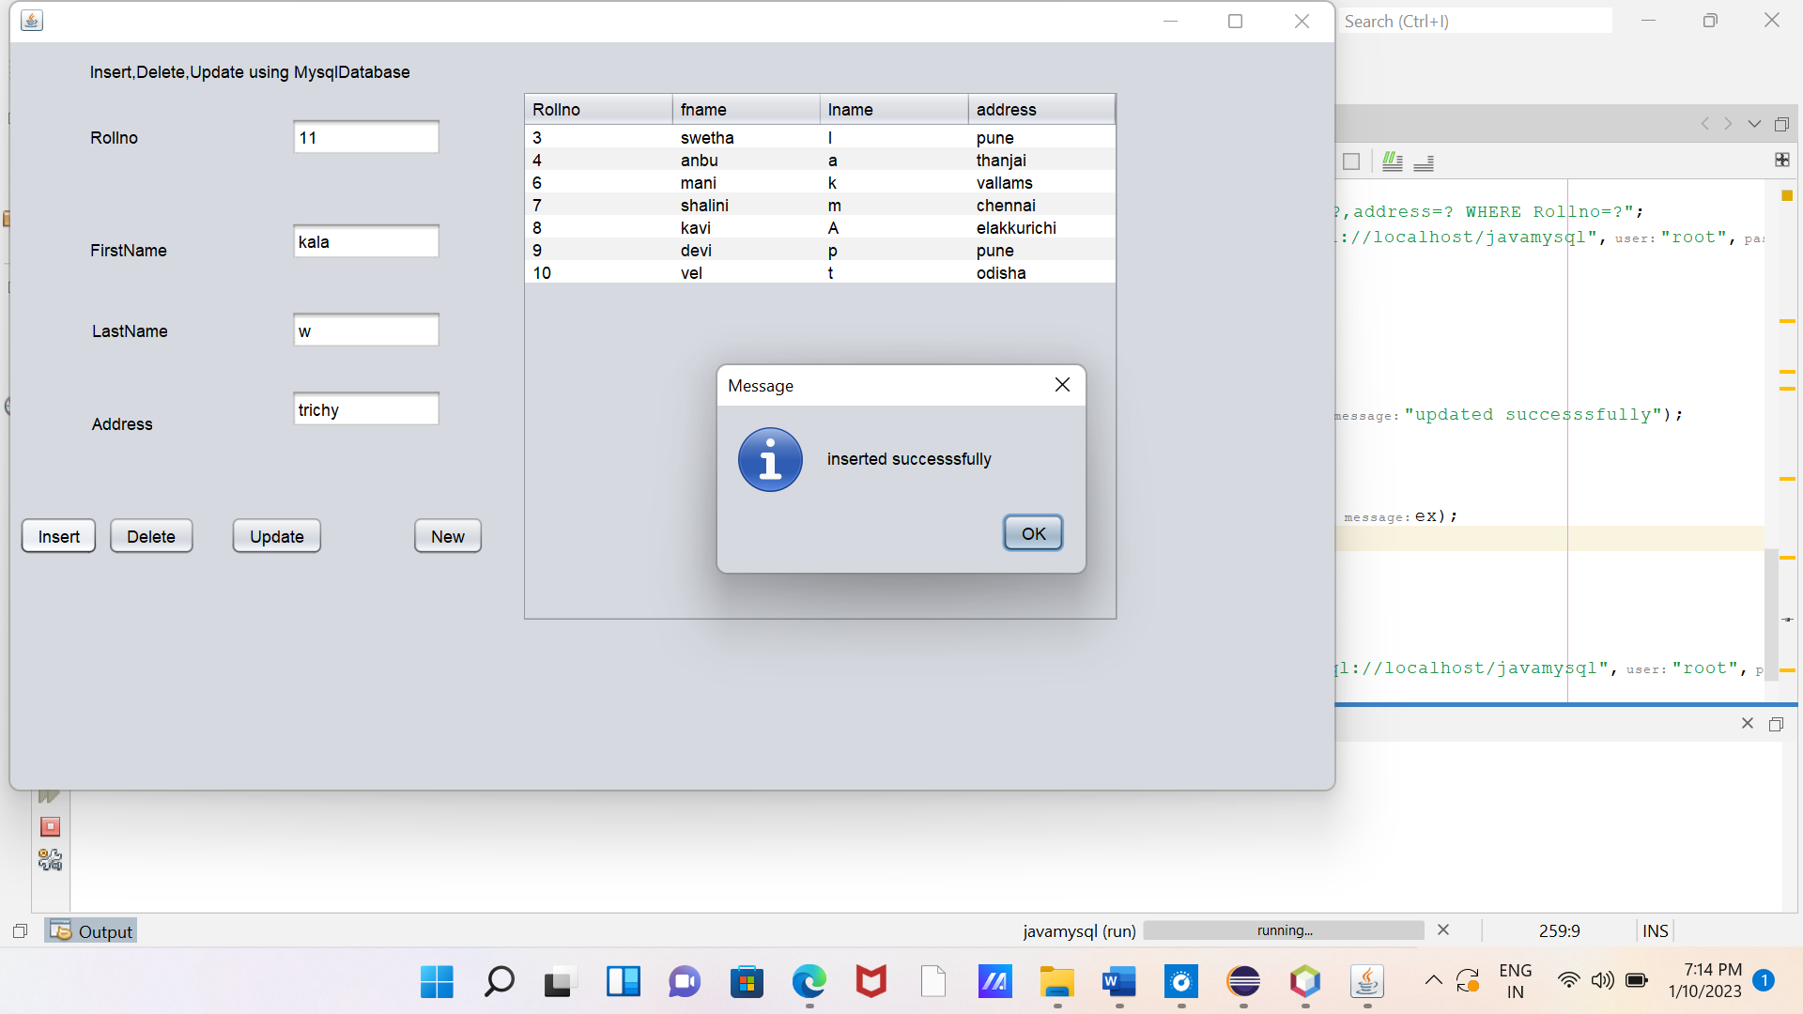

**5.2 Delete Data**

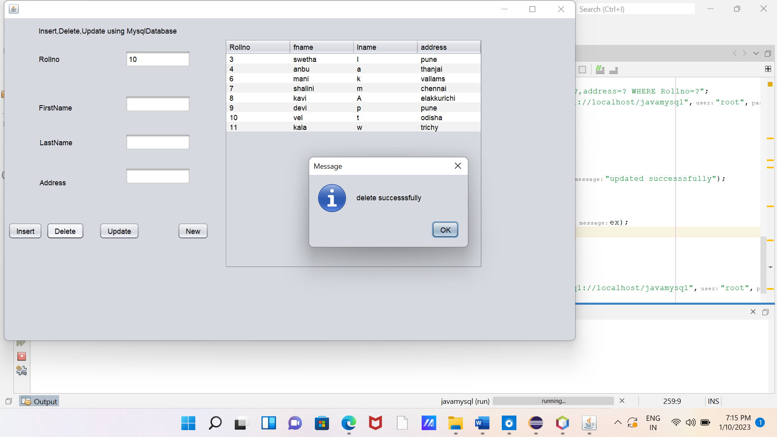

**5.3 Update Data**

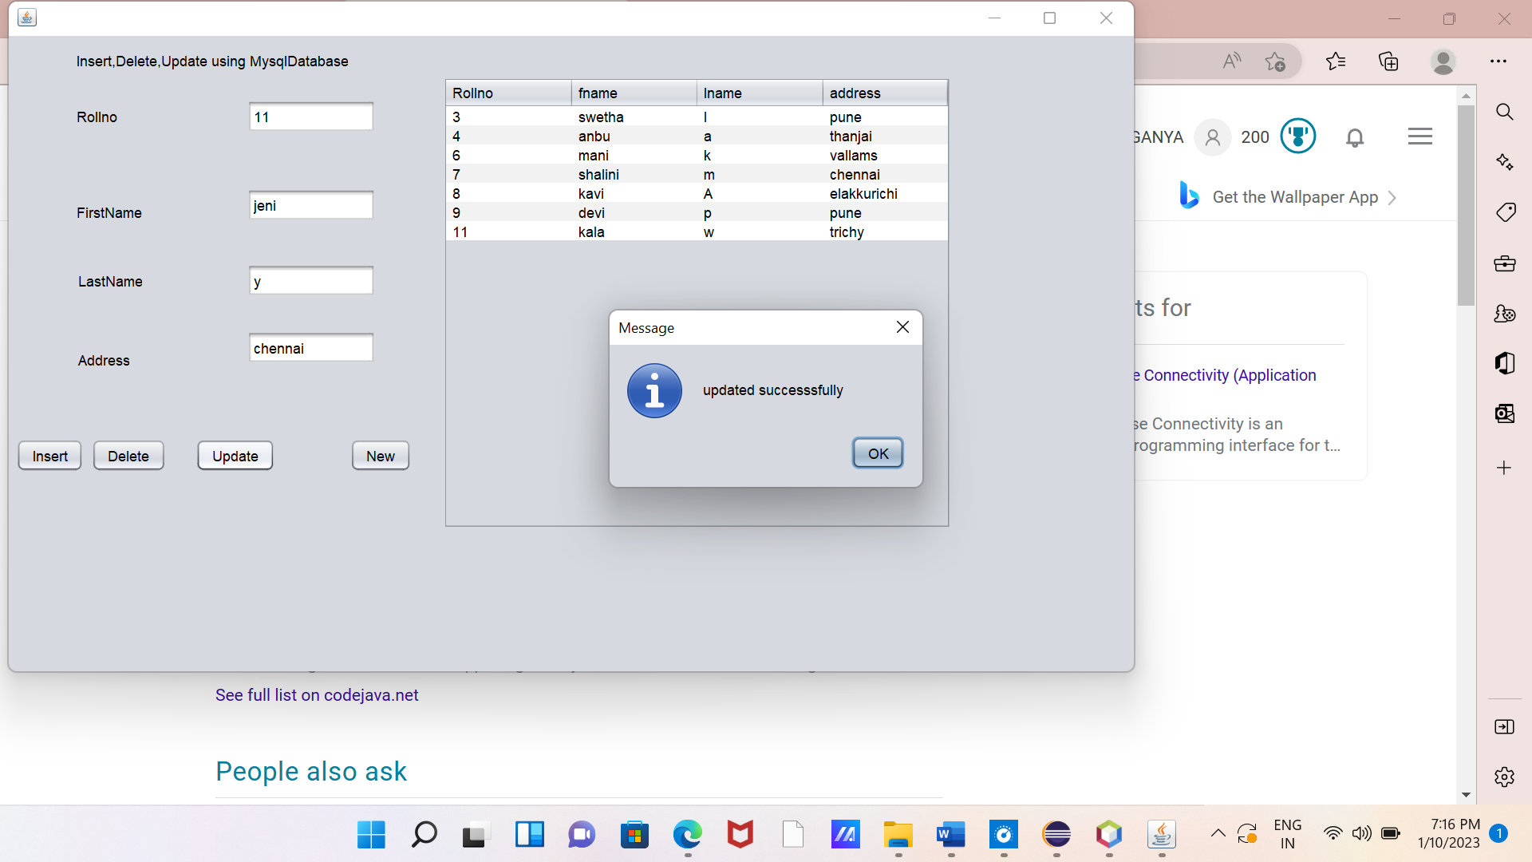

**Conclusion**

This concludes the Connecting to a MySQL Database. This document demonstrated how to configure MySQL on your computer and set up a connection to the database server from NetBeans IDE. It also described how to work with MySQL in the IDE’s Database Explorer by creating new database instances and tables, populating tables with data, and running SQL queries**.** To manipulate data like insert, update, select or delete records in MySQL Table using JDBC. It shows output of using jtable.