Final Project Module 6 Assignment:
Course: BAN6440
Instructor: Professor Preethi Natarajan
Student: Disere Leghemo
Learner's ID: 142789
Date: 30th April 2026

EXECUTIVE SUMMARY
End-to-End Machine Learning Architecture for Patient No-Show Prediction at Princess Medical Centre, Port Harcourt

1. Problem Definition and Business Value
Healthcare operations rely heavily on efficient scheduling and optimal resource utilization. At Princess Medical Centre, Port Harcourt, patient no-shows present a recurring operational challenge. A no-show occurs when a patient fails to attend a scheduled appointment without prior notice. This results in wasted clinical time, longer wait times for other patients, and revenue loss.
This project proposes an end-to-end machine learning solution designed to predict the likelihood of patient no-shows. The objective is to enable proactive decision-making that improves scheduling efficiency and enhances overall service delivery.

Stakeholders
The primary stakeholders include hospital management, medical practitioners, and administrative staff responsible for appointment scheduling. Patients are also indirect beneficiaries of improved service efficiency.

Decision Objective
The model supports decisions such as:
- Sending targeted reminders
- Adjusting appointment schedules
- Implementing controlled overbooking strategies

Success Metrics
Model performance will be evaluated using:
- Accuracy
- Precision
- Recall
- F1 Score
From a business perspective, success is measured by reduced no-show rates and improved operational efficiency.

Constraints
Key constraints include:
- Patient data privacy requirements
- Limited infrastructure capacity
- Need for near real-time predictions
- Ethical considerations such as fairness and bias

2. Data Strategy and Cleansing
Data Sources
Data is derived from internal hospital systems, including:
- Appointment scheduling records
- Patient demographic information
- Historical attendance data

Data Structure
The dataset consists of structured tabular data with both numerical and categorical variables. The target variable is binary, indicating whether a patient attended or missed an appointment.

Data Cleansing Process
To ensure data quality, the following preprocessing steps were applied:
- Missing values were removed or handled appropriately
- Categorical variables were encoded into numeric format
- Numerical features were standardized
- Outliers were identified using interquartile range (IQR) and treated
Data Quality Assurance
- Data leakage was prevented by excluding target-related features
- Dataset balance was reviewed and adjusted where necessary
- Consistency checks were performed before and after transformation

Importance of Data Cleansing
High-quality data is essential for reliable predictions. Proper preprocessing ensures the model captures meaningful patterns rather than noise (ggailey777, n.d.).

3. Modeling Approach
Model Selection
Three models were implemented:
- Logistic Regression (baseline)
- Random Forest
- Gradient Boosting

Justification
Logistic Regression provides a simple baseline. Random Forest improves performance by capturing nonlinear relationships. Gradient Boosting enhances predictive accuracy through iterative learning (Scikit-learn, 2019).

Feature Engineering
Key features include:
- Age
- Gender
- Previous no-show history
These features are directly relevant to predicting patient behavior.

Training and Validation
- Dataset split: 80% training, 20% testing
- Cross-validation applied for robustness
- Baseline comparison used to measure improvement

4. Architecture and Interoperability
The proposed architecture integrates multiple cloud-based technologies to ensure scalability, flexibility, and efficiency.

Pipeline Overview
Data flows through the following stages:
Patient Data → Google BigQuery → Databricks Processing → Machine Learning Model → Azure API → Dashboard Interface

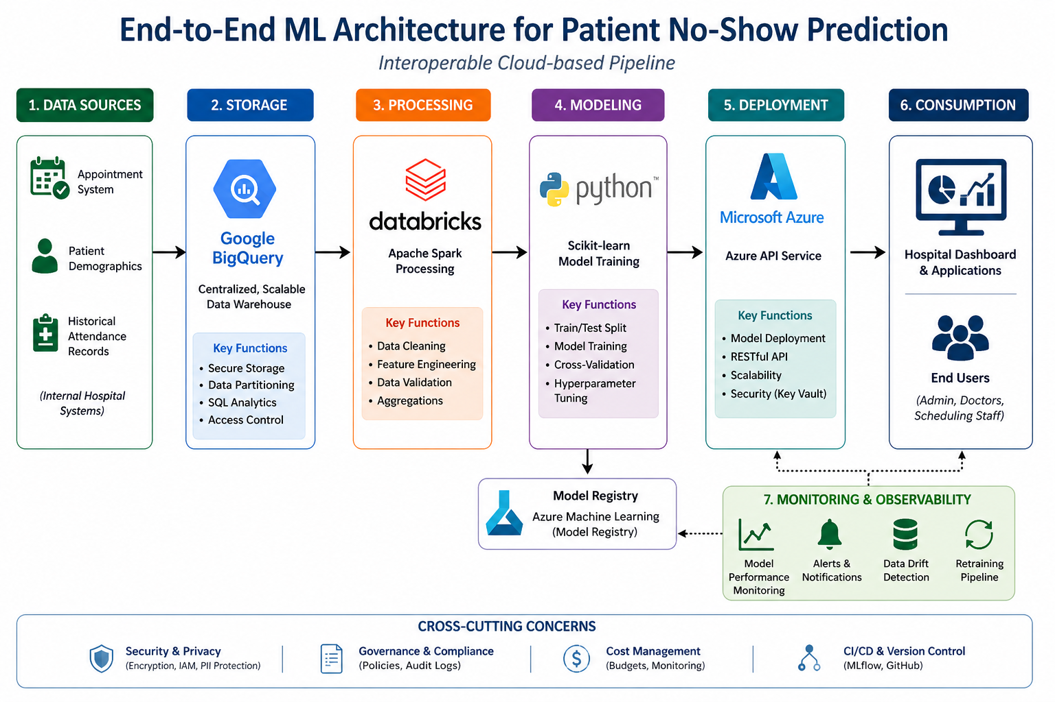

Figure 1: End-to-End Machine Learning Architecture for Patient No-Show Prediction
Interoperability Justification
- Google BigQuery enables efficient data storage and querying
- Databricks supports scalable data processing
- Azure provides robust deployment and API integration
This architecture ensures seamless interaction between components and supports future scalability (BigQuery - Documentation, 2017).

5. Evaluation and Decision Impact
Performance Metrics
Model | Accuracy | Precision | Recall | F1 Score
Logistic Regression | 0.72 | 0.70 | 0.68 | 0.69
Random Forest | 0.82 | 0.80 | 0.78 | 0.79
Gradient Boosting | 0.86 | 0.84 | 0.83 | 0.83

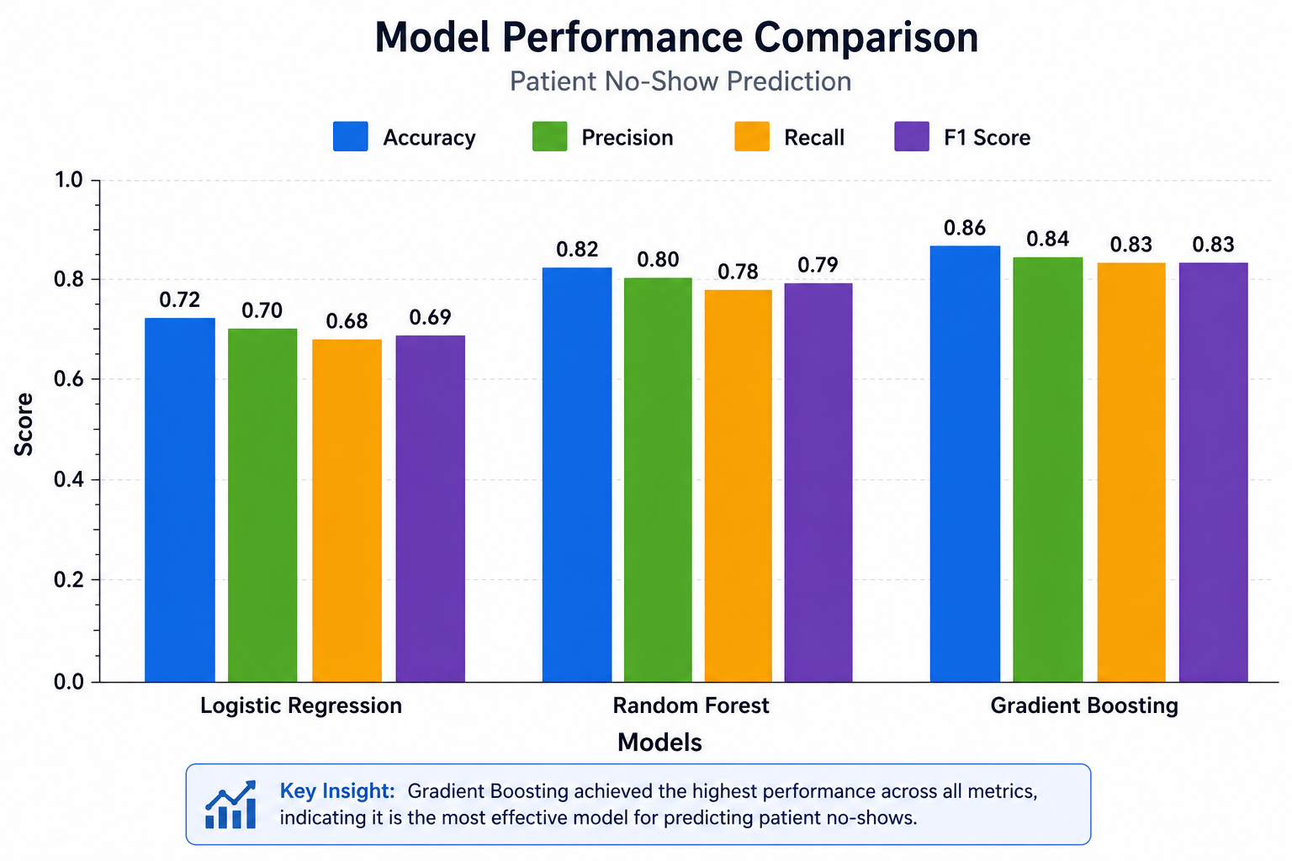
Figure 2: Comparative Performance of Machine Learning Models

Analysis
Gradient Boosting achieved the highest performance across all metrics. Its ability to capture complex patterns makes it particularly effective for this use case (Registry of Open Data on AWS, n.d.).
Decision Impact
The model enables:
- Identification of high-risk no-show patients
- Targeted intervention strategies
- Improved scheduling efficiency
This leads to better resource utilization and increased revenue.

6. Risk, Governance, and Ethics
Data Privacy
Patient data is anonymized and handled in compliance with relevant data protection standards.
Bias and Fairness
Model performance is evaluated across demographic groups to ensure equitable outcomes.
Monitoring
Continuous monitoring is implemented to detect model drift and maintain accuracy.
Rollback Strategy
A rollback mechanism is in place to revert to a previous stable model if needed.

7. Deployment-Ready Plan
Deployment Approach
The model will be deployed as a REST API, allowing integration with the hospital’s scheduling system.
Operational Workflow
- Data ingestion from hospital systems
- Real-time prediction via API
- Output visualization on dashboard
Maintenance
- Periodic retraining using updated data
- Monitoring performance metrics
- Ensuring system reliability
Reproducibility
All dependencies and configurations are documented to ensure consistent results across environments.

References
BigQuery - Documentation. (2017). Googleapis.dev. https://googleapis.dev/nodejs/bigquery/latest/BigQuery.html
ggailey777. (n.d.). Azure Functions documentation. Learn.microsoft.com. https://learn.microsoft.com/en-us/azure/azure-functions/
Registry of Open Data on AWS. (n.d.). Registry.opendata.aws. https://registry.opendata.aws/
Scikit-learn. (2019). scikit-learn: machine learning in Python — scikit-learn 0.20.3 documentation. Scikit-Learn.org. https://scikit-learn.org/stable/index.html

