

TIC3251

DECISION SUPPORT SYSTEM

TRIMESTER 2 2016/2017

ASSIGNMENT 2

Research Topic:

Assignment Problem (Optimization Methods)

|  |  |  |  |
| --- | --- | --- | --- |
| Student ID | Name | Email | Contribution |
| 1131123101 | Bong Ching Chia | bongchingchia@gmail.com | Literature Review (Simplex and Hungarian Method), Abstract |
| 1132702398 | Thong Yong Lin | sugarlin09@gmail.com | Proposed Solution, Implementation Results,  Conclusion |
| 1132701492 | Yap Jian Ying | jianying_711@hotmail.com | Literature Review (Complete Enumeration and Transportation Method), Methodology |
| 1132702814 | Yeoh Qi Jun | qjyeoh@hotmail.com | Introduction, Analysis and Discussion |

FACULTY OF COMPUTING AND INFORMATICS

MULTIMEDIA UNIVERSITY

10 FEBRUARY 2017

Table of Contents

Abstract 1

Chapter 1: Introduction 2

Chapter 2: Literature Review 4

2.1 Complete Enumeration Method 4

2.2 Simplex Method 6

2.3 Transportation Model 9

2.4 Hungarian Method 12

Chapter 3: Methodology 19

3.1 Data Gathering and Analysis 19

3.2 Literature Review 19

3.3 Review and Compare on Existing Algorithm 19

3.4 Implementation of chosen solution 20

3.5 Testing 20

Chapter 4: Proposed Solution 21

Chapter 5: Implementation Results 23

Chapter 6: Analysis and Discussion 26

Chapter 7: Conclusion 27

References 28

# Abstract

Nowadays, many companies are facing with the problem of allocating different personnel or workers to different jobs depends on their ability that expressed in terms of cost, profit, or time involved in executing a given job. If a job is assigned to a suitable worker, not only time but also the cost of performing such job will be minimized. Therefore, it’s important to decide how to assign different workers to different jobs so that a company can gain the biggest benefit from that. And this problem is known as the assignment problem. As mentioned, assignment problem deals with the allocation of the various resources to the various activities on one to one basis. It does it in such a way that the cost or time involved in the process is minimum and profit or sale is maximum.

There are four existing algorithms that solve assignment problem which is Enumeration method, Simplex method, Hungarian method, and Transportation model. A research and analysis of these 4 algorithms will be conducted. Research methodology is crucial in conducting a research to write a reliable paper. Every step will list out and explain in a more detailed way. Next, an algorithm among those 4 algorithms will be chosen and implement it. After complete the implementation, results of the prototype will present and discuss. In order to determine the chosen algorithm whether it is the best among the existing algorithm or not, the pros and cons of 4 algorithms will review and compare with each other.

# Chapter 1: Introduction

The assignment problem is one of the fundamental [combinatorial optimization](https://en.wikipedia.org/wiki/Combinatorial_optimization) problems in the branch of [optimization](https://en.wikipedia.org/wiki/Optimization_(mathematics)) or [operations research](https://en.wikipedia.org/wiki/Operations_research) in [mathematics](https://en.wikipedia.org/wiki/Mathematics).  The assignment problem is a special type of linear programming problem. We know that linear programming is an allocation technique to optimize a given objective. In linear programming we decide how to allocate limited resources over different activities so that, we maximize the profits or minimized the cost.

Assignment problems deal with the question how to assign n objects to other objects in an injective fashion in the best possible way. An assignment problem is completely specified by its two components the assignments, which represent the underlying combinatorial structure, and the objective function to be optimized, which models "the best possible way”. The assignment problem refers to another special class of linear programming problem where the objective is to assign a number of resources to an equal number of activities on a one to one basis so as to minimize total costs of performing the tasks at hand or maximize total profit of allocation. In other words, the problems is, how should the assignment be made so as to optimize the given objective. Different methods have been presented for assignment problem and various articles have been published.

In real life, we are faced with the problem of allocating different personnel/ workers to different jobs. Not everyone has the same ability to perform a given job. Different persons have different abilities to execute the same task and these different capabilities are expressed in terms of cost/profit/time involved in executing a given job. Therefore, we have to decide how to assign different workers to different jobs so that, cost of performing such job is minimized. And such assignment problems and methods of their solutions is the subject matter of this paper.

**Objectives and Scope:**

In real life, we often deal with the problem of allocating different customers for the taxi drivers. The taxi company are facing this problem every day. The company wanted to have a minimum cost and have a maximum profit. This paper will focus on how to assign the customers to the drivers with minimum cost. Therefore, the main objective of this paper is to deal with this situation which is assignments of jobs to different drivers in a taxi company to minimize the cost.

The following are the objective we have discussed:

* To study how existing work or application solve assignment problem.
* To implement a program that could help a taxi company in assigning passenger to drivers.
* To review and analyse methods or algorithm that are able to solve assignment problem.

**Optimization problem:**

In [mathematics](https://en.wikipedia.org/wiki/Mathematics) and [computer science](https://en.wikipedia.org/wiki/Computer_science), an optimization problem is the [problem](https://en.wikipedia.org/wiki/Computational_problem) of finding the best solution from all [feasible solutions](https://en.wikipedia.org/wiki/Feasible_solution). The main problem of this paper is to deal with multiple drivers for a specific customer. The company wanted to have a minimum cost and have a maximum profit. In this paper we will describe numerous existing algorithms such as Enumeration method, Simplex method, Hungarian method, and Transportation model to solve assignment problem. Each and every algorithm has their own pros and cons catering to their domain and requirements. The existing algorithm has to review and compare to discover their shortcomings and choose a best algorithm among of them.

# Chapter 2: Literature Review

This chapter discussed the existing algorithms to solve assignment problem. Every algorithm will explain and given an example to illustrate the algorithm in a more detailed way. The assignment problem can be solved by the following four methods: complete enumeration method, simplex method, transportation model, and Hungarian method.

## 2.1 Complete Enumeration Method

An enumeration is a complete and ordered listing of all the elements of a set. In this method, a list of all possible assignments among the given resources and activities is prepared. Then an assignment involving the minimum cost, time or distance or maximum profits is selected. If two or more assignments have the same minimum cost, time or distance, the problem has multiple optimal solutions. However, this method can be used only if the number of assignments is less. It is unsuitable for manual calculations if the number of assignments is large.

For instance, a taxi company has to assign each taxi to each passenger as fast as possible. The numbers in the table below represent the time to reach the passenger.

|  |  |  |  |
| --- | --- | --- | --- |
|  | Time in Minutes | | |
|  | Passenger 1 | Passenger 2 | Passenger 3 |
| Taxi 1 | 12 | 20 | 8 |
| Taxi 2 | 5 | 25 | 14 |
| Taxi 3 | 6 | 16 | 30 |

First, we have to calculate the total possible assignment. In general, if an assignment problem involves *n* taxi, then there are in total *n!* possible assignment. In this case, there are 3 taxies, therefore the total possible assignment is 6.

*n! = 3!*

*= 3 x 2 x1*

*= 6*

Next, all possible assignment will identify out and calculate times. The calculation is present in the table below.

|  |  |
| --- | --- |
| **Assignment** | **Time (Minutes)** |
| P1T1 – P2T2 – P3T3 | 12 + 25 + 30 = 67 |
| P1T1 – P2T3 – P3T2 | 12 + 16 + 14 = 42 |
| P1T2 – P2T1 – P3T3 | 5 + 20 + 30 = 55 |
| P1T2 – P2T3 – P3T1 | 5 + 16 +8 = 29 |
| P1T3 – P2T1 – P3T2 | 8 + 20 + 14 = 42 |
| P1T3 – P2T2 – P3T1 | 8 + 25 + 8 = 31 |

After completed the calculation, the best assignment is identified which is the assignment that has the shortest time will be chosen. In this example, the shortest path will be P1T3 – P2T2 – P3T1 which saying that:

1. Taxi 1 has to assign to passenger 3.
2. Taxi 2  has to assign to passenger 2.
3. Taxi 3  has to assign to passenger 1.

From the example above, we can see that every possible assignment must manually calculate their time which is not practical for a large number assignments although it’s not complicated and easy.

## 2.2 Simplex Method

Since each assignment problem can be formulated as a 0 or 1 which becomes integer linear programming problem. Therefore, a problem can be solved by the simplex method also. As can be seen in the general mathematical formulation of the assignment problem, there are n×n decision variables and n+n or 2n equalities. For example, a problem involving 5 workers/jobs, there will be 25 decision variables and 10 equalities.

This is the initial system we have:

Minimize: C = 3x1 + 9x2

Subject to :     2x1 + x2 ≥ 8

        x1 + 2x2 ≥ 8

        x1 , x2 ≥ 0

Convert into matrix.

2   1   | 8

1   2   | 8

3   9   | 1

After that transpose and label is as y to become maximize problem.

y1  y2

2   1   | 3

1   2   | 9

8   8   | 1

Maximize: C = 8y1 + 8x2 = p

Subject to :     2y1 + y2 ≤ 3

        y1 + 2y2 ≤ 9

Then converting the ≥ constraints into = constraints by adding a slack variable.

Minimize: C = -8y1  -  8y2   + p   = 0

Subject to :     2y1  +    y2   + x1 = 3

        y1  +  2y2     + x2    = 9

        y1  +    y2 ,    x1 ,   x2 ≥ 0

Rewrite it in tableau form.

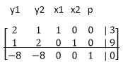

Now we have to check the bottom row, and select the most negative value, in this case, is -8. Since there is two -8, so we select the 1st column.

Then we take the constant on the rhs to divide the coefficient  of y1 column. So is

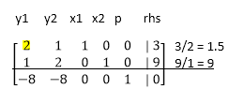

Compare the answer, the smallest value’s row of y1 will become the pivot number. Then we have to get zero in the column beneath the pivot element. To do that we have to do row operation, the other row remain the same

½ R1 -> R1

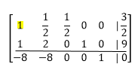

-1R1 + R2 -> R2

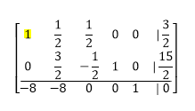

8R1 + R3 -> R3

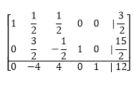

Then we move to the second column and repeat the steps. In this case, the 1st row of y2 column is the pivot number.

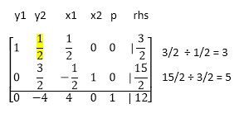

Repeat the row operation again to make the non pivot number to become zero.

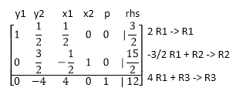

After the row operation, it become

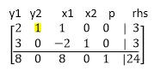

From the matrix above, we can clearly see that the optimize result is:

x1 = 8, x2 = 0, C = 24

According to Tang. G (2012), Simplex method feasible to solve assignment problem by. However, it requires more variables and more slack variables result in in a sparse dictionary matrix, which may lead to more iterations. Thus, it is inefficient to use in assignment problem.

## 2.3 Transportation Model

For a given supply at each source and a given demand at each destination, transportation model studies the shipping schedule that minimizes the total shipping cost or time while satisfying the demand and supply limit. Nonetheless, the degeneracy problem of solution makes the transportation method computationally inefficient for solving the assignment problem. Degeneracy occurs whenever one or more of the basic variables are zero. Assignment problem has the property that every basic solution is degenerate, since exactly *n* basic variables must receive unit value, and the remaining *n-1* basic variable must, therefore, all be zero.

As assignment is a special case of transportation problem, it can also be solved using transportation model. For the assignment problem, the number of supply and demand points are both *n*. The supply points correspond to each person, and the demand points correspond to each task. Furthermore, every supply amount is 1 and every demand amount is 1. Each person must be assigned to a task and each task has a person assigned.

For instance, a taxi company has to assign each taxi to each passenger as fast as possible. The numbers in the table below represent the time to reach the passenger.

|  |  |  |  |  |
| --- | --- | --- | --- | --- |
|  | Time in Minutes | | | |
|  | Passenger 1 | Passenger 2 | Passenger 3 | Passenger 4 |
| Taxi 1 | 12 | 20 | 8 | 25 |
| Taxi 2 | 5 | 25 | 14 | 19 |
| Taxi 3 | 6 | 16 | 30 | 11 |
| Taxi 4 | 33 | 23 | 10 | 14 |

First, convert the table above into a balanced transportation table. As mentioned above, set the supply amount and demand amount to 1.

|  |  |  |  |  |
| --- | --- | --- | --- | --- |
| Passenger | P1 | P2 | P3 | Supply |
| Taxi |
| T1 | 8 | 3 | 7 | 1 |
| T2 | 12 | 10 | 3 | 1 |
| T3 | 6 | 5 | 4 | 1 |
| Demands | 1 | 1 | 1 | 3 |
| 3 |

In order to solve transportation model, there are 3 initial solution which is Northwest-Corner method, Least-cost method, and Vogel’s approximation method (VAM) for developing an optimal solution. In this paper, we choose Vogel’s approximation method (VAM) to solve the assignment problem since it’s the best among these 3 algorithms according to the Abdallah and Mohammad (2012).

VAM can be summarized into following three main steps:

1. For each remaining row and column, determine the difference between the **lowest** two remaining costs; these are called the *row and column penalties*.
2. Select the row or column with the **largest** penalty found in step 1.
3. Allocate the supply or demand associated with the basic variable in the selected row or column with the **lowest** remaining unit cost. Cross out the row or column.
4. Repeat steps 1 - 3 until all supplies have been allocated.

Based on the example above, the steps of calculation is presented in the table below.

|  |  |  |  |  |  |  |  |
| --- | --- | --- | --- | --- | --- | --- | --- |
| Iteration | Differences in rows | | | Differences in columns | | | Allocated Cell |
| T1 | T2 | T3 | P1 | P2 | P3 |
| 1 | 4 | **7** | 1 | 2 | 2 | 1 | T2-P3 |
| 2 | **4** | - | 1 | 2 | 2 | 3 | T1-P2 |
| 3 | - | - | 1 |  |  |  | T3-P1 |

As the table above, we can conclude that:

1. Taxi 3 has to assign to Passenger 1.
2. Taxi 1 has to assign to Passenger 2.
3. Taxi 2 has to assign to Passenger 3.

Assignment problems can be solved by the transportation method. However, it may be an inefficient way of solving assignment problems due to high degree of degeneracy in assignment problems. For this reason and the fact that the algorithm is even simpler than the transportation model, the Hungarian method is usually used to solve assignment problems which will discuss afterwards.

## 2.4 Hungarian Method

Hungarian method is divided into two phase, which are:

1. Rule and column reductions.
2. Optimation of the problem.

In order to solve assignment problem, we have to check whether the total number of rows is equal to total number of columns or not. If yes, we can proceed to phase 1, else we have to convert the unbalance matrix by adding dummy row / dummy column with zero value.

On phase 1, we have to

* 1. Subtract the minimum value of each row from the entries of that row.
  2. Subtract the minimum value of each column from the entries of that column.

For example, assign the each taxi to each passenger as soon as possible. The numbers in the matrix represent the time taken to reach the passenger.

|  |  |  |  |  |  |
| --- | --- | --- | --- | --- | --- |
|  | Passenger 1 | Passenger 2 | Passenger 3 | Passenger 4 | Passenger 5 |
| Taxi 1 | 9 | 11 | 14 | 11 | 7 |
| Taxi 2 | 6 | 15 | 13 | 13 | 10 |
| Taxi 3 | 12 | 13 | 6 | 8 | 8 |
| Taxi 4 | 11 | 9 | 10 | 12 | 9 |
| Taxi 5 | 7 | 12 | 14 | 10 | 14 |

Identify the minimum value of each row:

|  |  |  |  |  |  |
| --- | --- | --- | --- | --- | --- |
|  | Passenger 1 | Passenger 2 | Passenger 3 | Passenger 4 | Passenger 5 |
| Taxi 1 | 9 | 11 | 14 | 11 | 7 |
| Taxi 2 | 6 | 15 | 13 | 13 | 10 |
| Taxi 3 | 12 | 13 | 6 | 8 | 8 |
| Taxi 4 | 11 | 9 | 10 | 12 | 9 |
| Taxi 5 | 7 | 12 | 14 | 10 | 14 |

Then subtract the minimum value of each row from the entries of that row. And determine the minimum values from each column.

|  |  |  |  |  |  |
| --- | --- | --- | --- | --- | --- |
|  | Passenger 1 | Passenger 2 | Passenger 3 | Passenger 4 | Passenger 5 |
| Taxi 1 | 2 | 4 | 7 | 4 | 0 |
| Taxi 2 | 0 | 9 | 7 | 7 | 4 |
| Taxi 3 | 6 | 7 | 0 | 2 | 2 |
| Taxi 4 | 2 | 0 | 1 | 3 | 0 |
| Taxi 5 | 0 | 5 | 7 | 3 | 7 |

Then subtract the minimum value of each column from the entries of that column.

|  |  |  |  |  |  |
| --- | --- | --- | --- | --- | --- |
|  | Passenger 1 | Passenger 2 | Passenger 3 | Passenger 4 | Passenger 5 |
| Taxi 1 | 2 | 4 | 7 | 2 | 0 |
| Taxi 2 | 0 | 9 | 7 | 5 | 4 |
| Taxi 3 | 6 | 7 | 0 | 0 | 2 |
| Taxi 4 | 2 | 0 | 1 | 1 | 0 |
| Taxi 5 | 0 | 5 | 7 | 1 | 7 |

We can proceed to phase 2 after subtract all the minimum values. Phase 2 consists of 5 steps, which are:

**Step 1: Draw a minimum number of line to cover all the zeroes of the matrix.**

A. Row Scanning

Begin from the first row of the matrix, check is there only 1 zero in that row. If yes, make a mark to that zero and draw a **vertical line** passing through that zero. Else, skip that row.

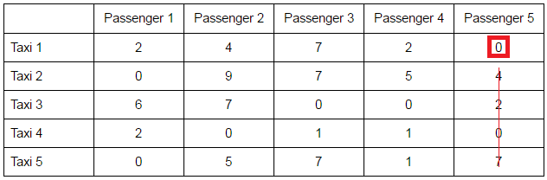

Note that the entire column cross with the vertical line is deleted and not consider anymore on the row scanning. The table below show the result of row scanning.

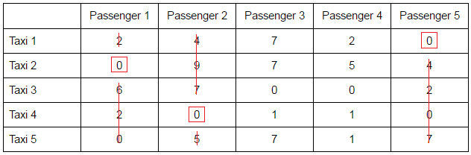

After scanning the last row,if all the zero are not cross with line then proceed to step 2, otherwise proceed to column scanning. Since the zeroes in row 3 are not cross with line, then we proceed to column scanning.

B. Column Scanning

Begin from the first column of the matrix, check if there is only 1 zero in that column. If yes, mark a square to that zero and draw a **horizontal line** passing through that zero. Else, skip that column. Note that the entire column cross with the vertical line is deleted and not consider anymore. Therefore, we begin from column 3.

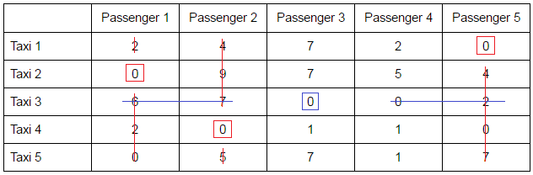

Since the only zero from column 4 is considered as deleted, therefore the column is considered complete. After scanning the last column, check whether all the zero are covered with lines.

**Step 2: Check whether number of square marked is equal to the number of rows of matrix. If yes, proceed to Step 5, else proceed to Step 3.**

Based on our example, the number of square is 4 and the total number of original row is 5, they are not equal. Therefore, we are proceed to Step 3.

**Step 3: Identify the minimum value of underlying cell values.**

1. Add the minimum undeleted cell value at the intersection points of the present matrix.
2. Subtract the minimum undeleted cell value from the undeleted cell values.
3. All other entries remain the same.

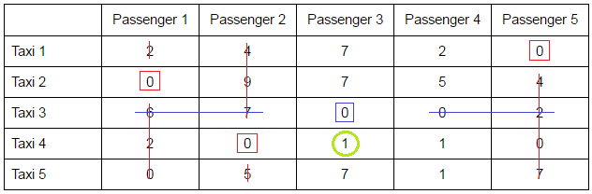

Based on the example above, we can identity that the minimum undeleted value is 1. 1 is add with the number located at the intersection point, which is 6, 7, and 2.

After that, perform minus the minimum value from the undeleted cell values to form table below.

|  |  |  |  |  |  |
| --- | --- | --- | --- | --- | --- |
|  | Passenger 1 | Passenger 2 | Passenger 3 | Passenger 4 | Passenger 5 |
| Taxi 1 | 2 | 4 | 7-1 = 6 | 2-1 = 1 | 0 |
| Taxi 2 | 0 | 9 | 7-1 = 6 | 5-1 = 4 | 4 |
| Taxi 3 | 6+1 = 7 | 7+1 = 8 | 0 | 0 | 2+1 = 3 |
| Taxi 4 | 2 | 0 | 1-1 = 0 | 1-1 = 0 | 0 |
| Taxi 5 | 0 | 5 | 7-1 = 6 | 1-1 = 0 | 7 |

All the other values are remain the same. The final result is show as table below.

|  |  |  |  |  |  |
| --- | --- | --- | --- | --- | --- |
|  | Passenger 1 | Passenger 2 | Passenger 3 | Passenger 4 | Passenger 5 |
| Taxi 1 | 2 | 4 | 6 | 1 | 0 |
| Taxi 2 | 0 | 9 | 6 | 4 | 4 |
| Taxi 3 | 7 | 8 | 0 | 0 | 3 |
| Taxi 4 | 2 | 0 | 0 | 0 | 0 |
| Taxi 5 | 0 | 5 | 6 | 0 | 7 |

Then proceed to Step 4.

**Step 4: Repeat all the steps again until get the number of square is equal to number of row.**

Step 1 is repeated and the result is shown as below.

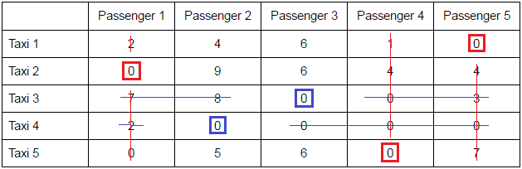

Based on the result, we can identify clearly determine the number of square is 5, which is equal to the number of rows. This is known as the optimal solution. Therefore, we can proceed to step 5.

**Step 5: Assign row to the column according to the square located in the matrix based on the duration given from the original table.**

The square is copied to the original matrix table and the taxi is assigned to the passenger as below.

|  |  |  |  |  |  |
| --- | --- | --- | --- | --- | --- |
|  | Passenger 1 | Passenger 2 | Passenger 3 | Passenger 4 | Passenger 5 |
| Taxi 1 | 9 | 11 | 14 | 11 | 7 |
| Taxi 2 | 6 | 15 | 13 | 13 | 10 |
| Taxi 3 | 12 | 13 | 6 | 8 | 8 |
| Taxi 4 | 11 | 9 | 10 | 12 | 9 |
| Taxi 5 | 7 | 12 | 14 | 10 | 14 |

Taxi 1 is assigned to passenger 5 with duration 7.

Taxi 2 is assigned to passenger 1 with duration 6.

Taxi 3 is assigned to passenger 3 with duration 6.

Taxi 4 is assigned to passenger 2 with duration 9.

Taxi 5 is assigned to passenger 4 with duration 10.

# Chapter 3: Methodology

This chapter describes the research methodology used in this paper. Research methodology is a set of procedures or method used to conduct research.

## 3.1 Data Gathering and Analysis

Basically, this research is based on previous research works and studies, which covers and focuses on all the aspect of assignment problem and the existing algorithm. First, the concept of assignment problem are studied and analysed from related materials such as journals, articles and so on. Next, several solutions to solve the problem will identify and analysed. Standards and procedures are specifically identify, gather, and interpret from the existing solution to fit in the implementation of a new system.

## 3.2 Literature Review

In order to have a more understanding of the algorithms, literature review will carry out from study the existing papers. A literature review discusses published information in a particular subject area, and sometimes information in a particular subject area within a certain time period. This ***paper/project*** will review on the paper, article, or journal from 2007 year. The review is focuses widely on the existing systems to solve assignment problem, the criteria involved in developing a suitable algorithm to implement.

## 3.3 Review and Compare on Existing Algorithm

There are numerous existing algorithm such as Enumeration method, Simplex method, Hungarian method, and Transportation method to solve assignment problem. Each and every algorithm has their own pros and cons catering to their domain and requirements. The existing algorithm has to review and compare to discover their shortcomings and choose a best algorithm among of them.

## 3.4 Implementation of chosen solution

The chosen solution is Hungarian Algorithm, which using matrix interpretation to achieve an optimal solution. We used C++ language to create a simple program for implementation of Hungarian Algorithm. In order to design the program, all necessary procedures in this algorithm are identified and coded step by step in CodeBlocks platform, until it is able to reach the correct solution.

## 3.5 Testing

After the implementation is completed, system testing will conduct to make sure there were no errors or fault in prototype. Testing will carry out by the working group which consist of the group of people involved in the initial requirement stage. They will perform validation of the implementation, to show if it complies with the original requirements, specifications and design.

# Chapter 4: Proposed Solution

The proposed solution we decided is Hungarian Algorithm. Based on the research we did, Hungarian Algorithm is a [combinatorial optimization](https://en.wikipedia.org/wiki/Combinatorial_optimization) [algorithm](https://en.wikipedia.org/wiki/Algorithm) and also one of the popular methods to solve assignment problem. It is also as known as Kuhn–Munkres algorithm or Munkres assignment algorithm. This method involves matrix interpretation and two phases that require several steps to find the solution.

**Phase one:**

1. Find the minimum value of each row and subtract the value from each entries of that particular row, then make a new matrix.
2. In the new matrix, find the minimum value of each column and subtract the value from each entries of that particular column.

**Phase two:**

1. **Row Scanning:** Find which row contains only one “0” entry. Delete the column that contains that particular “0” by drawing a vertical line cross through the “0” and then draw a square on that particular “0” entry. Check row by row until the last row, then check whether all the “0” entries are crossed with lines. If yes, skip column scanning, else proceed to column scanning.
2. **Column Scanning:** Find which column contains only one “0” entry. Delete the row that contains that particular “0” by drawing a horizontal line cross through the “0” and then draw a square on that particular “0” entry. Check row by row until the last row, then check whether all the “0” entries are crossed with lines.
3. Check the number of square is equal to number of row in the matrix. If they are equal, directly proceed to Step 5, else proceed to next step.
4. Find the minimum value among all the undeleted values, and add the minimum value found into the intersection point values in the matrix. Then, subtract the minimum value found from all undeleted values in the matrix. Other entries are remaining the same. Repeat steps from Step 1.
5. An optimal solution is achieved as the squares are the solution of assignment problem.

The procedures will be easier to understand with demonstration or examples showing in next section.

# Chapter 5: Implementation Results

We have implemented a proof of concept of Hungarian Method to solve a taxi company’s assignment problem. It is a simple program built by using C++ language that allow users to enter driver’s information including names and cost. In this case, cost is referring to the cost that the driver would spend to pick up a customer regarding time taken and distance.

At the very beginning, user is required to enter the number of customer and driver.

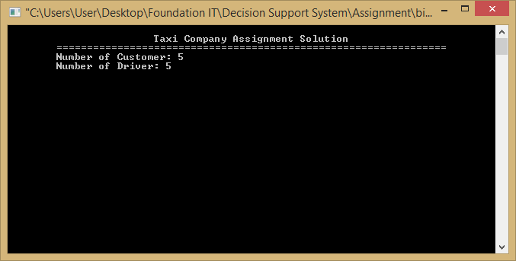

After that, program will ask for the driver names.

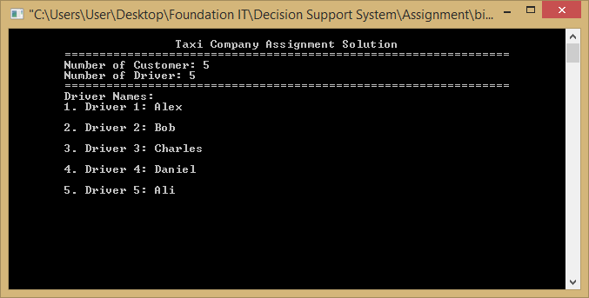

In order to calculate the optimal solution, user is also required to enter the cost that would be spent for every driver to pick up a customer.

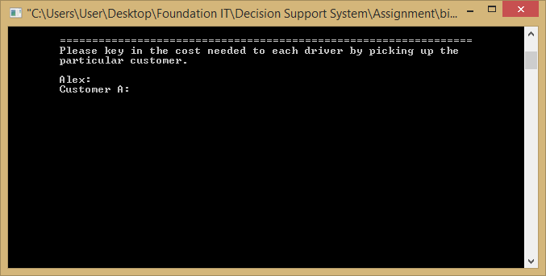

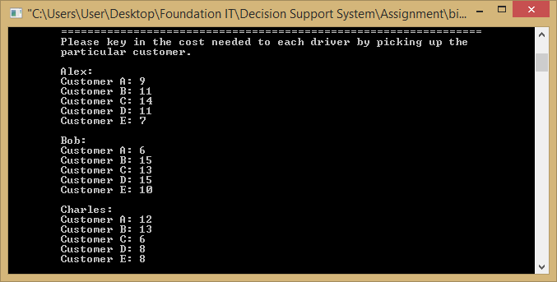

Once all required information is entered, the program will find the way assigning task to taxi driver which spend the least cost. A table is created as the optimal solution showing which driver should pick up which customer that would use minimum cost.

The following example is showing the result after calculation. There are five customer calling for picking up at the same time. Meanwhile, driver Alex, Bob, Charles, Daniel and Ali are standing by to work. The person in charge has to decide which customer should be assigned to which driver, with the purpose of spending the least cost in these deals. At last, the solution is showing that Customer E is assigned to Alex, Customer A to Bob, Customer C to Charles, Customer B to Daniel and Customer D to Ali. The total cost after optimization is 38.

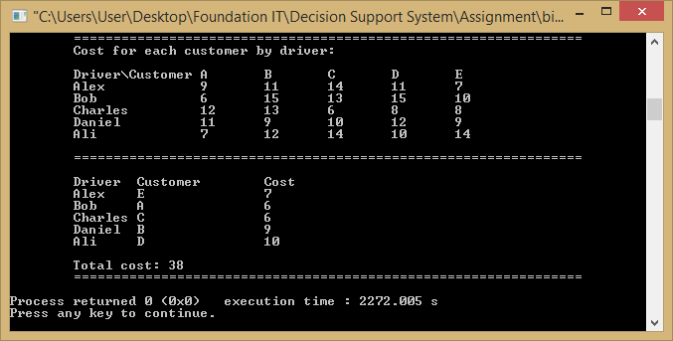

# Chapter 6: Analysis and Discussion

This chapter compares the Hungarian method with other algorithms used in this paper. Basically, this research is based on previous research works and studies, which covers and focuses on all the aspect of assignment problem and the existing problem. There are numerous existing algorithms such as Enumeration method, Simplex method, Hungarian method, and Transportation method to solve assignment problem. Each and every algorithm has their own pros and cons catering to their domain and requirements.

The existing algorithm has to review and compare to discover their shortcomings and choose a best algorithm among of them. All those algorithms we have explained and gave an example to illustrate the algorithm in detailed way in our literature review part. For example, we found that according to Tang. G (2012), Simplex method feasible solve assignment problem. However, it requires more variables and more slack variables result in in a sparse dictionary matrix, which may lead to more iterations. Thus, it is inefficient to use in assignment problem.

So, the chosen solution is Hungarian Algorithm, which using matrix interpretation to achieve an optimal solution. According to our implementation, the Hungarian method is much easier than other algorithms. The Hungarian method is also easy to implement, simple and easy to understand. In our result, by using the Hungarian method the result is so much understandable. In our implementation, we implemented a proof of concept of Hungarian method to solve a taxi company’s assignment problem. After all the required information is entered, we can clearly see that by using the Hungarian method, the program will find the minimum cost of assigning the task to the taxi drivers. It shows that the Hungarian method is easy to use and have an understandable result for the users. In the nutshell, the method that most adaptable to this assignment problem we found is Hungarian Method.

# Chapter 7: Conclusion

Throughout this research, we have observed that assignment to taxi drivers in a taxi company can be solved in different methods such as Complete Enumeration Method, Simplex Method, Transportation Model, and Hungarian Method. However, the method that most adaptable to this assignment problem we found is Hungarian Method. Compared to others, Hungarian algorithm is more straightforward, easier to implement.

In addition, implementation that has been carried out is able to assist taxi company solving their assignment issue. Cost could be minimized as well as profit is maximized. From drivers’ perspective, they can save time and energy when going to pick up a passenger. As the result, we have achieved our objective stated in Introduction.

However, during this assignment period, our group were also being in difficult time, since assignment problem is a new thing to us. All of the algorithms we found are also a new knowledge, we took quite a long time to read research papers and tutorials online. On the other hand, the research process helped to gain our knowledge as well. Besides, coding is also quite challenging, but it’s completed on time.

Everything has their own weakness, same as the implementation of Hungarian Method. It is actually quite difficult when deal to large assignment problem. Unbalanced assignment problem also hasn’t be included in the program built. Besides that, in real situation, there might be many circumstances should be concerned when dealing to assignment issue. Nevertheless, we still believe that it can be adapted and improved in the future.

# References

Abdallah A. Hlayel; Mohammad A. Alia. (2012, October). SOLVING TRANSPORTATION PROBLEMS. *2*, 30. Retrieved January 2017, from http://airccse.org/journal/cseij/papers/2512cseij03.pdf

Cheung, R. (2011). *The Geometry of the Simplex Method and Applications to the Assignment.* UNIVERSITY OF CALIFORNIA, COLLEGE OF LETTERS AND SCIENCE. Retrieved January 2017, from https://www.math.ucdavis.edu/files/7013/5794/9936/CheungThesis.pdf

G. Ayorkor Korsah, Anthony (Tony) Stentz , and M Bernardine Dias. (2007, July). The Dynamic Hungarian Algorithm for the Assignment Problem with Changing Costs. 19. Retrieved January 2017, from Carnegie Mellon University: The Robotics Institude: http://www.ri.cmu.edu/publication_view.html?pub_id=5805

Jones, J. (2017, July 19). *The Linear Programming Problem*. Retrieved January 2017, from Linear Programming: Simplex Method: https://people.richland.edu/james/ictcm/2006/simplex.html

Khan, N. S. (2011, October 20). *MB0048 : State and discuss the methods for solving an assignment problem. How is Hungarian method better than other methods for solving an assignment problem?* Retrieved January 2017, from Learning Curve…: https://nikhatshahin.wordpress.com/2011/10/20/mb0048-q5-state-and-discuss-the-methods-for-solving-an-assignment-problem-how-is-hungarian-method-better-than-other-methods-for-solving-an-assignment-problem/

Nui Ruppert; David Lenh; Amir Farshchi Tabrizi. (2013, July). *Assignment problem: Hungarian method 3.* Retrieved January 2017, from wiwi: https://www.wiwi.uni-kl.de/bisor-orwiki/Assignment_problem:_Hungarian_method_3

Tang, G. (2012, November 21). *Assignment Problem.* Retrieved January 2017, from http://bioinfo.ict.ac.cn/~dbu/AlgorithmCourses/Lectures/Lec10-Hungarian-GuomingTang.pdf